**EXPERIMENT – 6**

**AIM:** To write a Servlet to demonstrate session tracking using HttpSession. Implement a simple login system where the user's session is tracked.

**SOURCE CODE:**

**LoginServlet.java:**

import java.io.IOException;

import java.io.PrintWriter;

import javax.servlet.ServletException;

import javax.servlet.annotation.WebServlet;

import javax.servlet.http.HttpServlet;

import javax.servlet.http.HttpServletRequest;

import javax.servlet.http.HttpServletResponse;

import javax.servlet.http.HttpSession;

@WebServlet("/LoginServlet")

public class LoginServlet extends HttpServlet {

protected void doPost(HttpServletRequest request, HttpServletResponse response) throws ServletException, IOException {

response.setContentType("text/html");

PrintWriter out = response.getWriter();

String username = request.getParameter("username");

String password = request.getParameter("password");

// Simple authentication (Replace with database authentication in real-world apps)

if ("admin".equals(username) && "password".equals(password)) {

HttpSession session = request.getSession(); // Create session

session.setAttribute("user", username);

out.println("<h3>Login Successful! Welcome, " + username + "</h3>");

out.println("<a href='DashboardServlet'>Go to Dashboard</a>");

} else {

out.println("<h3>Invalid username or password.</h3>");

out.println("<a href='index.html'>Try Again</a>");

}

}

}

**LogoutServlet.java:**

import java.io.IOException;

import java.io.PrintWriter;

import javax.servlet.ServletException;

import javax.servlet.annotation.WebServlet;

import javax.servlet.http.HttpServlet;

import javax.servlet.http.HttpServletRequest;

import javax.servlet.http.HttpServletResponse;

import javax.servlet.http.HttpSession;

@WebServlet("/LogoutServlet")

public class LogoutServlet extends HttpServlet {

protected void doGet(HttpServletRequest request, HttpServletResponse response) throws ServletException, IOException {

response.setContentType("text/html");

PrintWriter out = response.getWriter();

HttpSession session = request.getSession(false);

if (session != null) {

session.invalidate(); // Destroy session

}

out.println("<h3>You have been logged out.</h3>");

out.println("<a href='index.html'>Login Again</a>");

}

}Bottom of Form

**DashboardServlet.java:**

import java.io.IOException;

import java.io.PrintWriter;

import javax.servlet.ServletException;

import javax.servlet.annotation.WebServlet;

import javax.servlet.http.HttpServlet;

import javax.servlet.http.HttpServletRequest;

import javax.servlet.http.HttpServletResponse;

import javax.servlet.http.HttpSession;

@WebServlet("/DashboardServlet")

public class DashboardServlet extends HttpServlet {

protected void doGet(HttpServletRequest request, HttpServletResponse response) throws ServletException, IOException {

response.setContentType("text/html");

PrintWriter out = response.getWriter();

HttpSession session = request.getSession(false); // Get existing session, don't create a new one

if (session != null && session.getAttribute("user") != null) {

String user = (String) session.getAttribute("user");

out.println("<h3>Welcome to Dashboard, " + user + "!</h3>");

out.println("<a href='LogoutServlet'>Logout</a>");

} else {

out.println("<h3>You are not logged in. <a href='index.html'>Login Here</a></h3>");

}

}

}

**index.html:**

<!DOCTYPE html>

<html lang="en">

<head>

<meta charset="UTF-8">

<meta name="viewport" content="width=device-width, initial-scale=1">

<title>Login</title>

<link rel="stylesheet" href="https://cdn.jsdelivr.net/npm/bootstrap@5.3.0/dist/css/bootstrap.min.css">

<link rel="stylesheet" href="style.css">

</head>

<body>

<div class="container d-flex justify-content-center align-items-center min-vh-100">

<div class="card p-4 shadow-lg" style="width: 350px;">

<h3 class="text-center">🔐 User Login</h3>

<p class="text-center text-muted">Enter your credentials to access your account</p>

<form action="LoginServlet" method="post">

<div class="mb-3">

<label class="form-label">👤 Username</label>

<input type="text" name="username" class="form-control" placeholder="Enter username" required>

</div>

<div class="mb-3">

<label class="form-label">🔑 Password</label>

<input type="password" name="password" class="form-control" placeholder="Enter password" required>

</div>

<button type="submit" class="btn btn-primary w-100">Login</button>

</form>

<p class="text-center mt-3">

<a href="#" class="text-decoration-none">Forgot Password?</a>

</p>

</div>

</div>

</body>

</html>

**Style.css:**

body {

background: linear-gradient(to right, #00c6ff, #0072ff);

font-family: 'Arial', sans-serif;

}

.card {

border-radius: 15px;

background: #fff;

text-align: center;

}

h3 {

color: #007bff;

}

.form-control {

border-radius: 10px;

box-shadow: none;

border: 1px solid #ced4da;

}

.btn-primary {

background-color: #007bff;

border-radius: 10px;

font-weight: bold;

}

.btn-primary:hover {

background-color: #0056b3;}

**OUTPUT:**

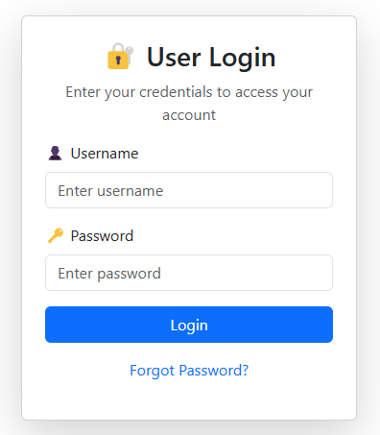

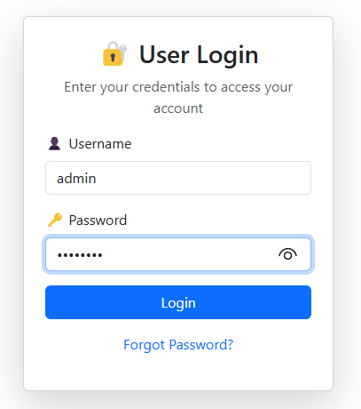

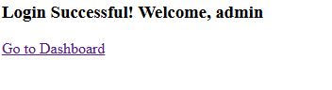

**RESULT:**

Thus the web application is created successfully.