**EXPERIMENT – 7**

**AIM:** To Write a Servlet program to store a user&#39;s preferences (like theme or language) using cookies. Retrieve and display these preferences on subsequent visits.

**SOURCE CODE:**

**PreferenceServlet.java:**

import java.io.IOException;

import javax.servlet.ServletException;

import javax.servlet.annotation.WebServlet;

import javax.servlet.http.*;

@WebServlet("/PreferencesServlet")

public class PreferenceServlet extends HttpServlet {

protected void doPost(HttpServletRequest request, HttpServletResponse response)

throws ServletException, IOException {

String theme = request.getParameter("theme");

String language = request.getParameter("language");

// Create cookies

Cookie themeCookie = new Cookie("theme", theme);

Cookie languageCookie = new Cookie("language", language);

// Set cookies to expire in 7 days

themeCookie.setMaxAge(7 * 24 * 60 * 60);

languageCookie.setMaxAge(7 * 24 * 60 * 60);

// Add cookies to response

response.addCookie(themeCookie);

response.addCookie(languageCookie);

// Redirect back to preferences.jsp

response.sendRedirect("index.html");

}

}

**index.html:**

<!DOCTYPE html>

<html lang="en">

<head>

<meta charset="UTF-8">

<title>User Preferences</title>

<link href="https://fonts.googleapis.com/css2?family=Quicksand:wght@500&display=swap" rel="stylesheet">

<style>

body {

margin: 0;

padding: 0;

font-family: 'Quicksand', sans-serif;

background: linear-gradient(135deg, #74ebd5, #9face6);

color: #333;

display: flex;

justify-content: center;

align-items: center;

height: 100vh;

}

.container {

background-color: #fff;

padding: 30px 40px;

border-radius: 20px;

box-shadow: 0 10px 25px rgba(0,0,0,0.1);

width: 100%;

max-width: 500px;

text-align: center;

transition: transform 0.3s ease;

}

.container:hover {

transform: translateY(-5px);

}

h2 {

margin-bottom: 20px;

color: #555;

}

p {

margin: 10px 0;

font-size: 1.1rem;

}

label {

display: block;

margin-top: 15px;

font-weight: bold;

color: #444;

text-align: left;

}

select {

width: 100%;

padding: 10px;

margin-top: 5px;

border-radius: 10px;

border: 1px solid #ccc;

background-color: #f9f9f9;

font-size: 1rem;

}

input[type="submit"] {

margin-top: 25px;

padding: 12px 25px;

border: none;

border-radius: 10px;

background-color: #6c63ff;

color: white;

font-size: 1rem;

cursor: pointer;

transition: background-color 0.3s ease;

}

input[type="submit"]:hover {

background-color: #4e4acb;

}

</style>

</head>

<body>

<div class="container">

<h2>🌐 User Preferences</h2>

<p>Theme: <span id="themeDisplay">light</span></p>

<p>Language: <span id="languageDisplay">English</span></p>

<form method="post" action="PreferencesServlet">

<label for="theme">Theme:</label>

<select name="theme" id="theme">

<option value="light">Light</option>

<option value="dark">Dark</option>

</select>

<label for="language">Language:</label>

<select name="language" id="language">

<option value="English">English</option>

<option value="Spanish">Spanish</option>

<option value="French">French</option>

</select>

<input type="submit" value="💾 Save Preferences">

</form>

</div>

<script>

// Optional JavaScript to read cookies and set form defaults

function getCookie(name) {

let match = document.cookie.match(new RegExp('(^| )' + name + '=([^;]+)'));

return match ? decodeURIComponent(match[2]) : null;

}

const theme = getCookie("theme") || "light";

const language = getCookie("language") || "English";

document.getElementById("theme").value = theme;

document.getElementById("language").value = language;

document.getElementById("themeDisplay").innerText = theme;

document.getElementById("languageDisplay").innerText = language;

</script>

</body>

</html>

**OUTPUT:**

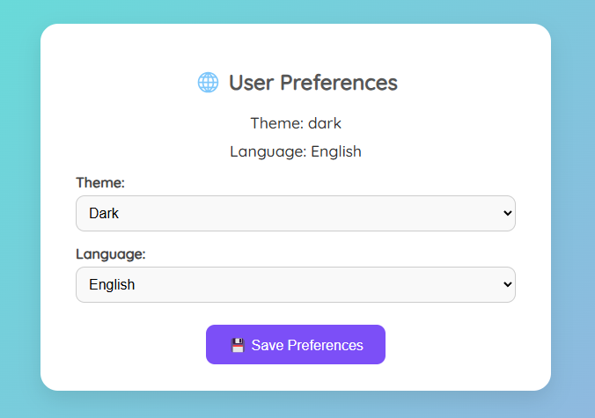

**RESULT:**

Thus the web application is created successfully.