https://colab.research.google.com/drive/1wOoJOdDizG0tqW-Ou-kq7VcbgoQURmB2#scrollTo=scx6Cg-FA8_K&printMode=true

EXP-2:
For a given set of training data examples stored in a .CSV file, implement and demonstrate the Candidate-Elimination algorithm in python to output a description of the set of all hypotheses consistent with the training examples.

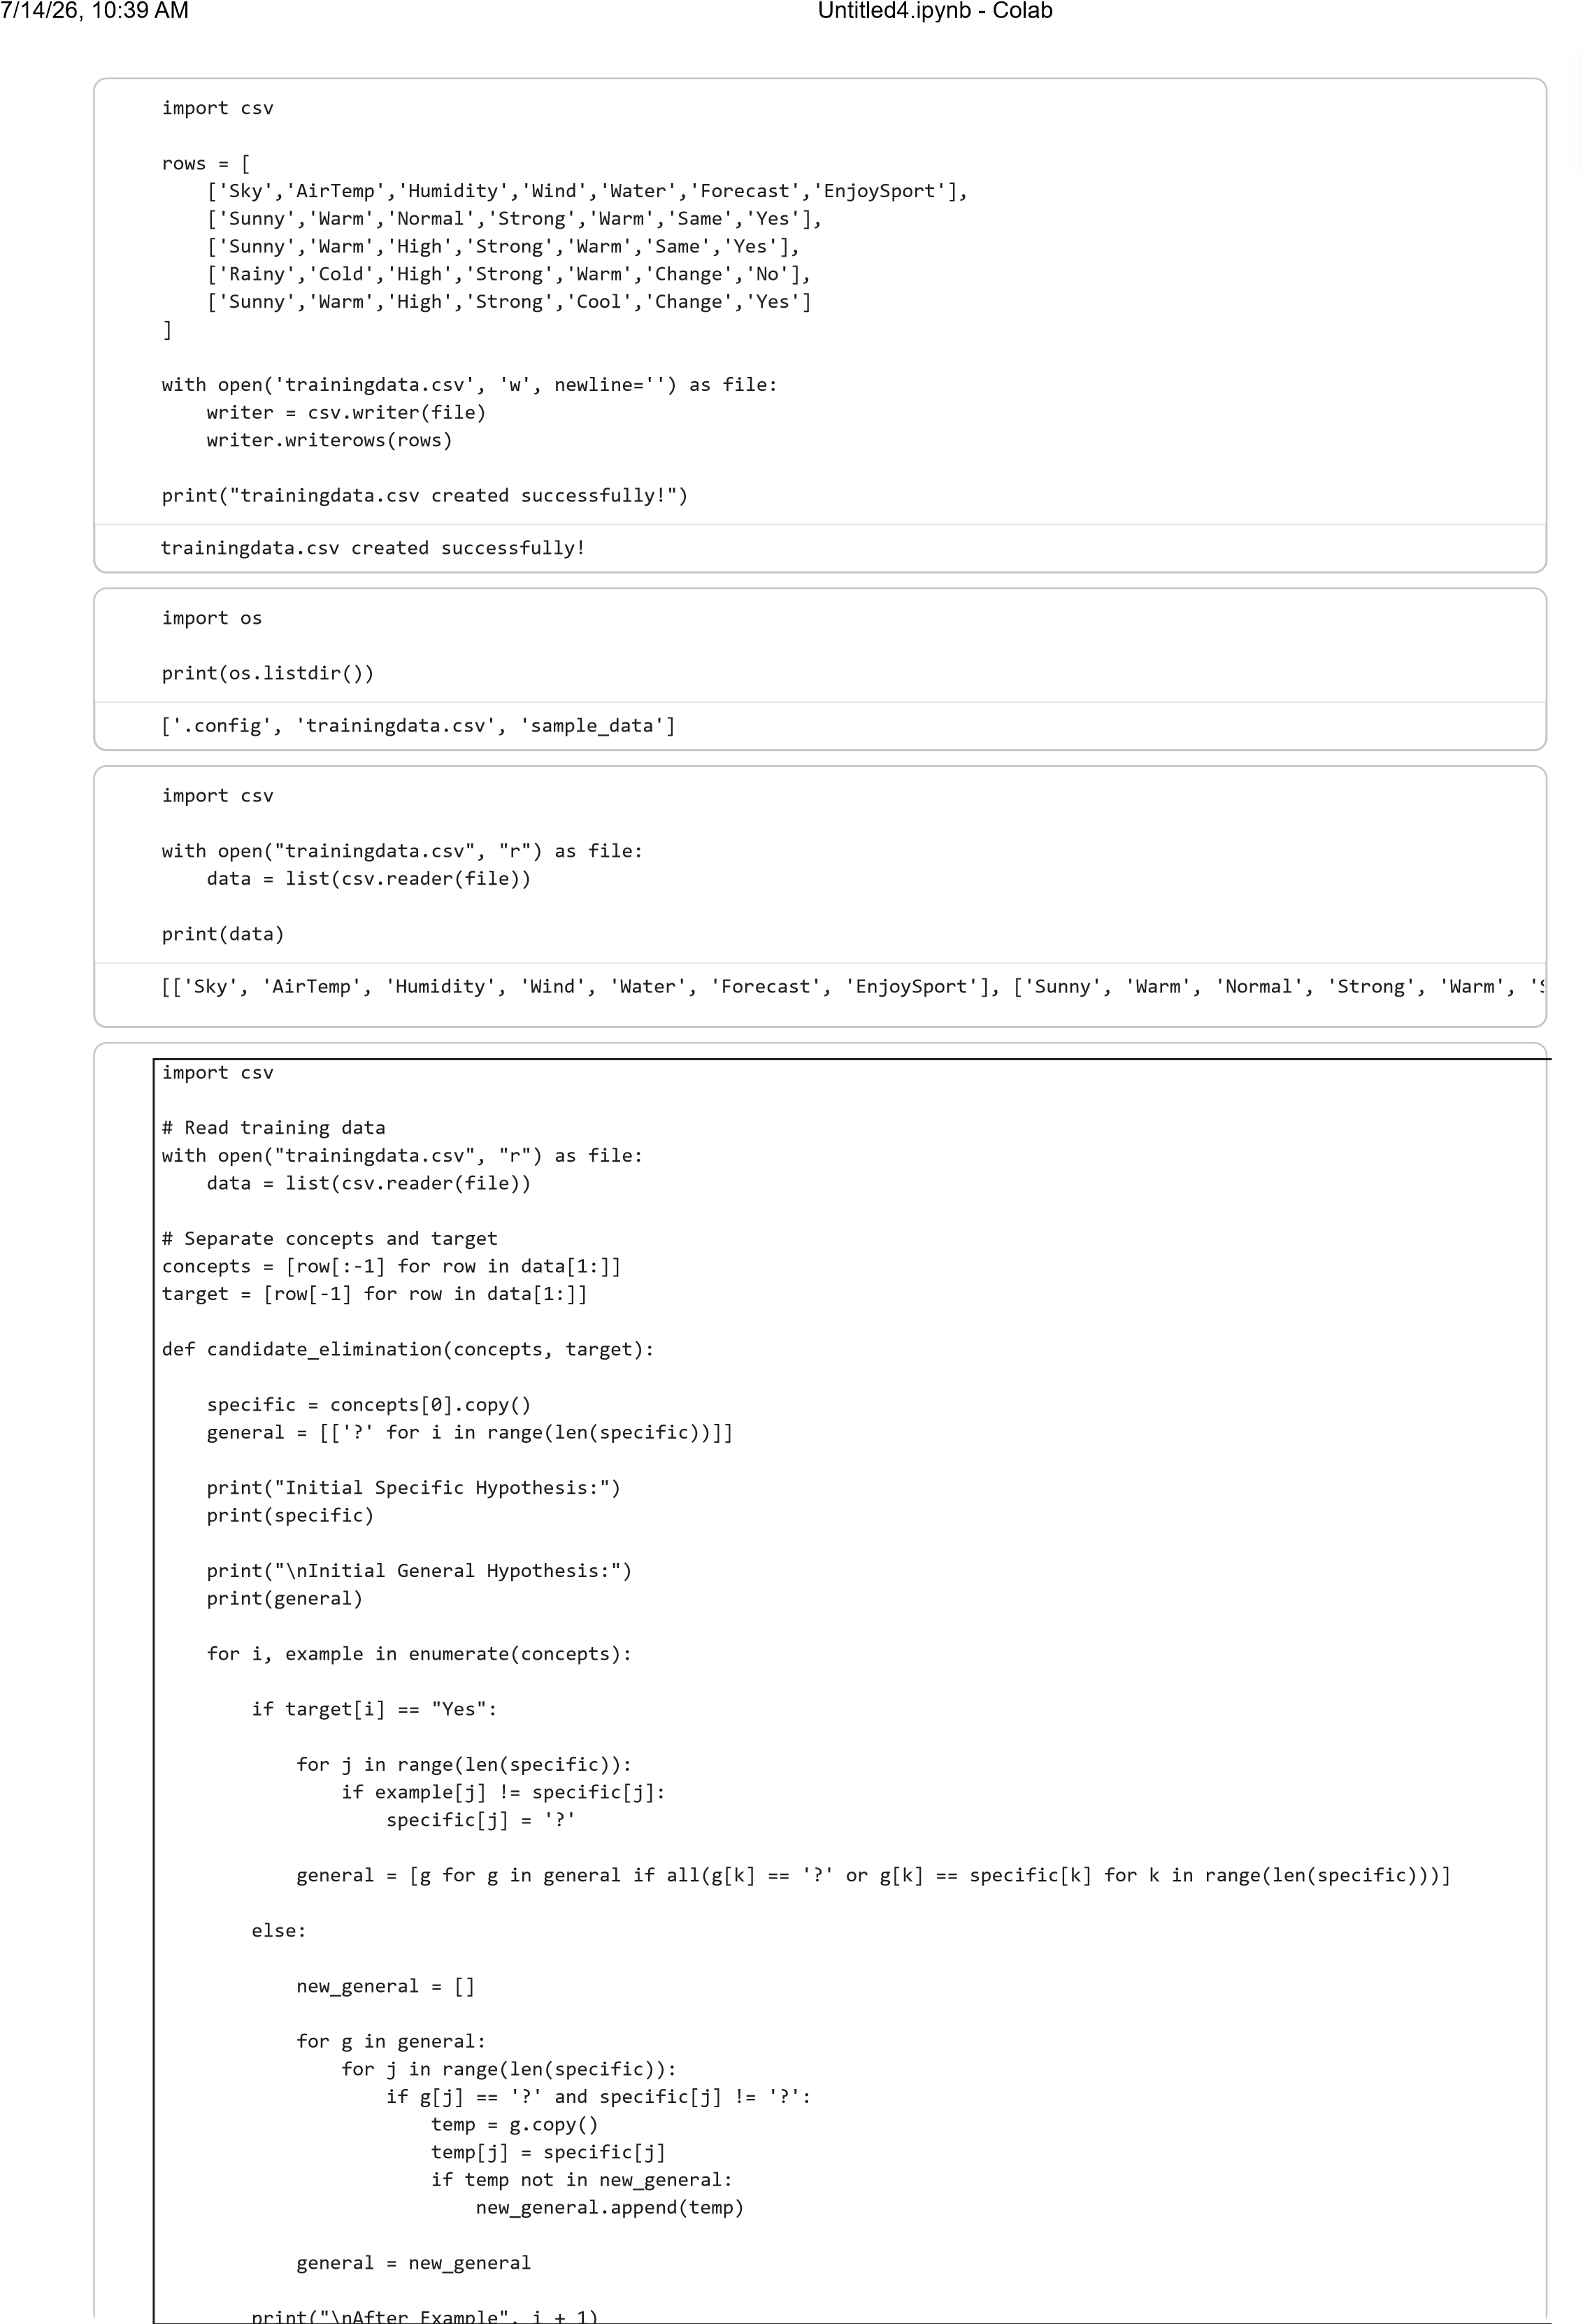

print
(
\nAfter Example
, i

1
)

print
(
"Specific:"
, specific
)

print
(
"General:"
, general
)

print
(
"\nFinal Specific Hypothesis:"
)

print
(
specific
)

print
(
"\nFinal General Hypothesis:"
)

for
g
in
general:

print
(
g
)
candidate_elimination
(
concepts, target
)
Initial Specific Hypothesis:
[
'Sunny', 'Warm', 'Normal', 'Strong', 'Warm', 'Same'
]
Initial General Hypothesis:
[[
'?', '?', '?', '?', '?', '?'
]]
After Example 1
Specific: ['Sunny', 'Warm', 'Normal', 'Strong', 'Warm', 'Same']
General: [['?', '?', '?', '?', '?', '?']]
After Example 2
Specific: ['Sunny', 'Warm', '?', 'Strong', 'Warm', 'Same']
General: [['?', '?', '?', '?', '?', '?']]
After Example 3
Specific: ['Sunny', 'Warm', '?', 'Strong', 'Warm', 'Same']
General: [['Sunny', '?', '?', '?', '?', '?'], ['?', 'Warm', '?', '?', '?', '?'], ['?', '?', '?', 'Strong', '?', '?'], ['?',
After Example 4
Specific: ['Sunny', 'Warm', '?', 'Strong', '?', '?']
General: [['Sunny', '?', '?', '?', '?', '?'], ['?', 'Warm', '?', '?', '?', '?'], ['?', '?', '?', 'Strong', '?', '?']]
Final Specific Hypothesis:
[
'Sunny', 'Warm', '?', 'Strong', '?', '?'
]
Final General Hypothesis:
[
'Sunny', '?', '?', '?', '?', '?'
]
[
'?', 'Warm', '?', '?', '?', '?'
]
[
'?', '?', '?', 'Strong', '?', '?'
]
Start coding or
g
enerate
with AI.
7
/14/26, 10:39 AM
Untitled4.ipynb - Colab

