7/14/26, 10:18 AM Welcome To Colab - Colab
EXP-1:
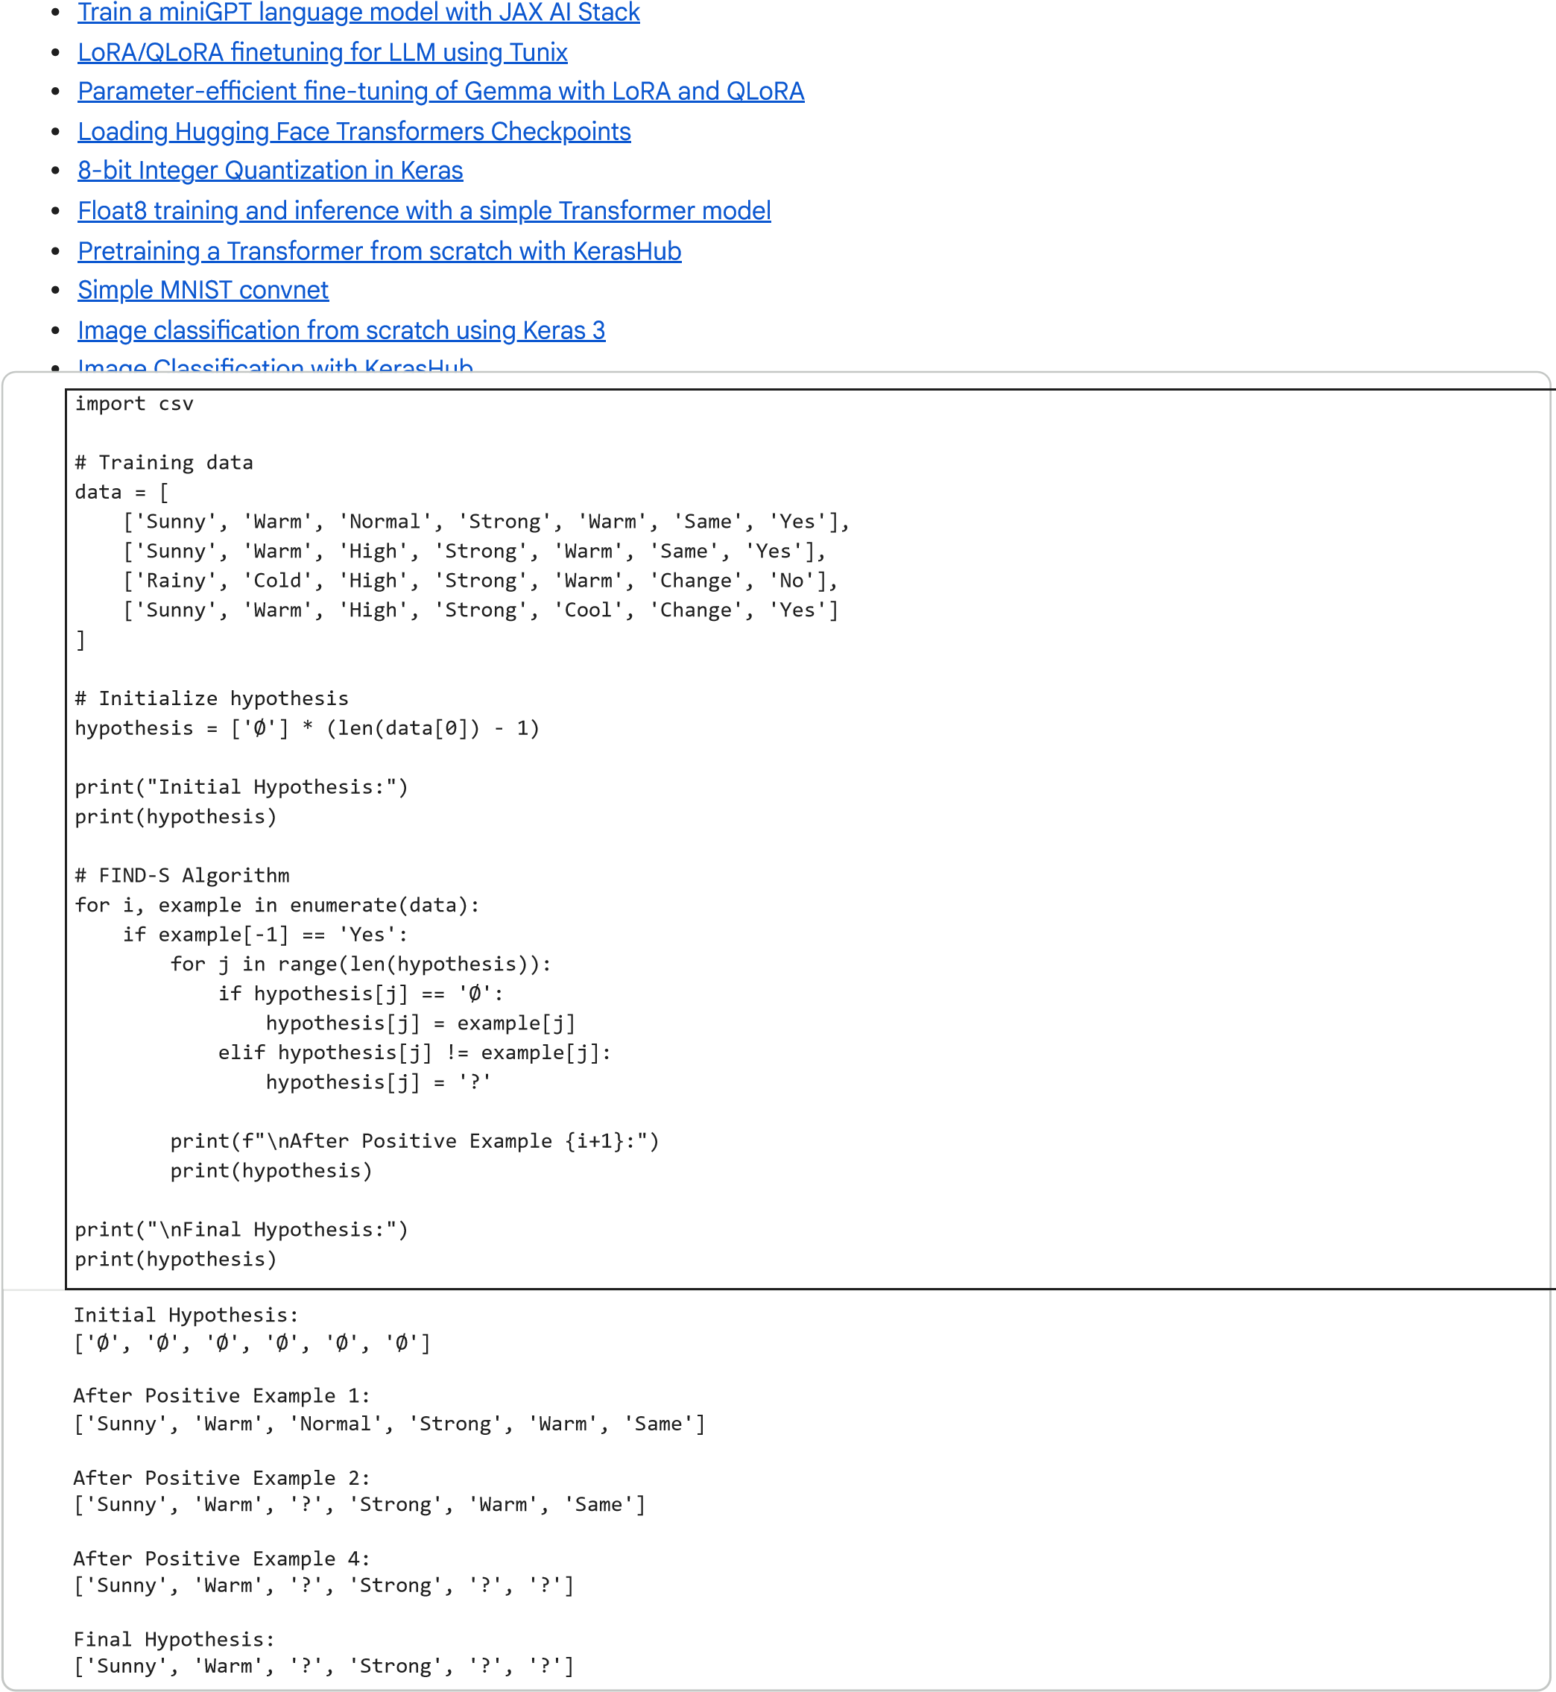
Implement and demonstrate the FIND-S algorithm for finding the most specific hypothesis based on a given set of training data samples.
https://colab.research.google.com/#scrollTo=T2OY58kC31Si&printMode=true 4/4

