

UNIVERSITY OF HERTFORDSHIRE

MSc COMPUTER SCIENCE WITH ADVANCE RESEARCH
7COM1039-0501-2021 - ADVANCE COMPUTER SCIENCE MASTER PROJECT
2nd DEC 2022

Final Project Report (FPR)

GENDER DETECTION USING SPEECH ANALYSIS AND CLASSIFICATION

MADHU ALEKHYA MADIREDDY
STUDENT NO: 20018725
BY
THIAGO MATOS PINTO

Project Declaration
I would like to share my sincere gratitude for the timely guidance and encouragement I received from Mr. Thiago Matos Pinto. Throughout the study, I appreciated his extreme patience and sincerity in trying to help me understand the topics.

Acknowledgement
The report has been submitted as part of the final fulfilment of the master’s degree requirement for the 7COM1039-0501-2021 - Advanced Computer Science Masters Project at the University of Hertfordshire (UH).
It is my own work except were indicated in the report. I did not use any human participants in my MSc project. I hereby give permission for the report to be made available on the university website provided the source is acknowledged.

Abstract
Speech processing is one of the important fields of study in signal processing. Different aspects and application areas are there including speech recognition and others. One of the important detection processes in signal and speech processing is to identify gender by analysing the speech signals. A combination of speech processing and machine learning was used in this study for the detection of gender. A speech database has been collected from Kaggle which contains instances of speech recordings. Firstly, the data has been prepared and the features have been extracted using Mel-Frequency Cepstral Coefficient with a sample rate of 16000 Hz and the feature data has been prepared. With the application of Principal Component Analysis, the outliers have been identified and those have been removed by normalizing the data. The detection process has been run on the actual data using the selected classifiers. However, the accuracies for all classifiers have been obtained to be low. So, the data resolution has been increased by employing data upscaling and the detection process has been run again. In addition, the detection accuracy has been found to be 99.51% using the K-nearest Neighbor classifier. This accuracy is also higher than other applied algorithms and existing approaches.

List of Abbreviations
MFCC: Mel-Frequency Cepstral Coefficient
ML: Machine Learning
PCA: Principal Component Analysis
CNN: Convolutional Neural Network
SVM: Support Vector Machine
NB: naïve Bayes

List of Figures
Figure 1 Proposed Methodology 30
Figure 2 Speech Database 31
Figure 3 Speech Metadata 31
Figure 4 Speech File Name Structure 36
Figure 5 Metadata 37
Figure 6 Data with ID and Gender 37
Figure 7 Gender Dataset for One Sentence 38
Figure 8 Gender Dataset for Multiple Sentence 39
Figure 9 Final Merge Data 39
Figure 10 Speech Feature Data 41
Figure 11 Speech Dataset 41
Figure 12 Cleaned Data 41
Figure 13 Class Distribution 42
Figure 14 Checking Data Outliers 42
Figure 15 Normalized Data 43
Figure 16 Test Supports 43
Figure 17 Linear SVC Results 44
Figure 18 K-Neighbors Results 44
Figure 19 Logistic Regression Results 45
Figure 20 Gradient Boosting Results 46
Figure 21 Decision Tree Results 46
Figure 22 Comparison of Performances for Actual Data 48
Figure 23 Comparison of Performances for Upscaled Data 49
Figure 24 Improvement in Research with Highest Accuracy 49

List of Tables
Table 1 Research Comparison 28
Table 2 Number of Files in the Directory 36
Table 3 Class Distribution of Upscaled Data 42
Table 4 Result Metrics for Linear SVC 43
Table 5 Result Metrics for KNN 44
Table 6 Result Metrics for Logistic Regression 45
Table 7 Result Metrics for Gradient Boosting 46
Table 8 Result Metrics for Decision Tree 46

Table of Contents
Chapter-1 Introduction 11
1.1 Human Speeches 11
1.1.1 Male Speech 11
1.1.2 Female Speech 11
1.2 Speech Analytics 12
1.2.1 Components of Speech 12
1.2.2 Speech Signal Analysis 12
1.3 Problem Statement 13
1.4 Research Questions 13
1.5 Research Aim 14
1.6 Research Objectives 14
1.7 Research Issues 14
1.7.1 Ethical Issues 14
1.7.2 Legal Issues 15
1.7.3 Professional Issues 15
1.7.4 Social Issues 15
Chapter-2 Background Study 16
2.1 Voice Signal or Speech processing 16
2.1.1 Overview 16
2.1.2 Operational Process 16
2.1.3 Application Areas 16
2.2 Process of Speech Recognition 17
2.2.1 Processing Speech Signals 17
2.2.2 Mechanisms to Recognize Speech 17
2.2.3 Application Areas 17
2.3 Speech Components 17
2.3.1 Speech Waveform 17
2.3.2 Speech Windowing 18
2.3.3 Speech Energy 18
2.3.4 Speech Spectrogram 18
2.3.5 Speech Autocorrelation 18
2.3.6 Fundamental frequency 19
2.3.7 Mel-frequency Cepstrum Coefficient 19
2.4 Speech Feature Extraction 19
2.4.1 Overview 19
2.4.2 Mel Frequency Cepstral Coefficients 19
2.4.3 Strength 20
2.4.4 Weakness 20
Chapter-3 Review of Previous Papers 21
3.1 Speech Processing 21
3.2 Feature Extraction from Speech Signals 23
3.2.1 Various processes of Feature Extraction 23
3.2.2 Feature Extraction using MFCC 24
3.3 Speech Classification 26
3.4 Gender Detection Using Speech Analytics 27
3.4.1 Application of Machine Learning 27
3.4.2 Application of Deep Learning 29
3.5 Comparison of Research 30
Chapter-4 Research Methodology 32
4.1 Proposed Model 32
4.2 Data Selection 32
4.3 Tool Selection 33
4.4 Technology for Research 34
4.4.1 Speech Analytics 34
4.4.2 Machine Learning 34
4.5 Selection of Algorithms for Research 35
4.5.1 Logistic Regression 35
4.5.2 Linear Support Vector Classifier 35
4.5.3 Gradient Boosting 35
4.5.4 K-Neighbors 36
4.5.5 Decision Tree 36
4.6 Process of Evaluation 36
4.6.1 Accuracy 36
4.6.2 Recall 36
4.6.3 Precision 36
4.6.4 F1-Score 37
Chapter-5 Analysis and Result 37
5.1 Reading Database 37
5.1.1 Load Speech Database 37
5.1.2 Detecting the Number of Files 38
5.1.3 Reading Metadata 38
5.1.4 Creating Data with ID and Gender 38
5.2 Data Formulation 39
5.2.1 Preparing Gender Dataset 39
5.2.2 Merging and Preparing Final Data 40
5.3 Speech Feature Extraction 41
5.3.1 Process of Feature Extraction 41
5.3.2 Feature-Extracted Data 42
5.4 Preparing Speech Dataset 42
5.4.1 Creating Speech Data 42
5.4.2 Data Cleaning 43
5.4.3 Class Distribution 43
5.4.4 Removing Data Outliers 43
5.4.5 Data Upscaling 44
5.4.6 Preparing Train and Test Sets 45
5.5 Gender Detection and Result 45
5.5.1 Gender Detection using Linear SVC 45
5.5.2 Gender Detection using K-Neighbors 46
5.5.3 Gender Detection using Logistic Regression 46
5.5.4 Gender Detection using Gradient Boosting 47
5.5.5 Gender Detection using Decision Tree 48
Chapter-6 Discussion and Conclusion 49
6.1 Evaluation of Research 49
6.1.1 Performance Evaluation of Gender Detection 49
6.1.2 Research Improvements 50
6.2 Discussion 51
6.2.1 Challenges Faced and Overcome 51
6.2.2 Research Questions Addressing 51
6.2.3 Discussion on RQ-1 51
6.2.4 Discussion on RQ-2 52
6.3 Conclusion 52
6.3.1 Research Limitations 52
6.3.2 Future Aspects 53
References 54
Appendix 59

Introduction

Human Speeches

Male Speech
The vocal tract is the medium for the generation of all human voices. It originates as air passes through the voice box and the produced inconveniences generate the voice. Voice features are described via the normal anatomical variations in the vocal apparatus of both sexes which are Pitch, Range, Register and Quality which is ultimately true that these alterations overlap (Kumari, et al., 2016). The discretion of voices between males and females is dependent on a combination of anatomical variations and cultural standardizations. It is essential to be understood that these classifications usually reflect biological distinctions among the sexes, but they also are the representatives of gender identities as well. The pitch of the male voice is categorized at a cycle ranging from 65 to 260 hertz, but men own the ability to adjust patterns that are not contemplated by males outright (Nitisara & Suyanto, 2020). These behavioural variations are either an outcome of upbringing differences or a personal desire too. In certain instances, men possess comparatively smaller voice boxes and are the ultimate reasons behind the generation of high-pitched voices (Kaur & Singh, 2016). Voice quality is another aspect of a male voice that is a consideration under voice pedagogy and although there prevail several voice categorization systems, the notable ones are:
Countertenors usually present the highest male voices generally reserved for portraying singing or speaking roles for castrati, Tenor is the maximum male voice between the modal register and it usually ranges between C3 and C5 respectively, Baritone exists between the tenor and Bass ranges of voice and is usually considered mid-ranged male voices, Bass is the ultimate and lowest male voice which is the epic description for the term Golden-Throated Narrator (Bunny Studio (Male Speech), 2022).

Female Speech
Women usually interact at a higher pitch than males which on average ranges between 165-255 hertz. Women also possess an expanded gap at the posterior part of their vocal cords which facilitates more air passage through it and thus facilitates them with the feature of Breathy texture than men's voices. The integration of high pitch with breathiness provides a more challenging aspect to women's voices especially when heard and it is mostly age-related as hearing loss is a common phenomenon during old age leading to the degradation of high-pitched voices. The interruptions occurring in women’s speeches are much more than in men’s which might be due to voice factors or for any other reason as well. As per certain research, it has been commonly noted that women with a low-pitched voice are looked sown to be more authoritative and dominating as well (Watson, 2019).

Speech Analytics

Components of Speech
Speech can be expressed as the definition of thoughts and feelings ascertained via sounds and is the most natural, instinctive, and considered means of interaction opted by humans. The conceptual difference of speech exists in the proforma of variable languages, tones, accents, speech vocab, etc. and this is enhanced at a regular pace. The delicate differences in speech turn it to be more complex to be assessed but present additional information utilizing the tone and amplitude differences. There prevail certain present-day implementations of Speech analytics where the speech signals can be successfully segregated into a series of phenomes and non-speech parts as well with the phenomes mapped into the written speech form utilizing phenome to grapheme mapping. Speech analytics can be successfully utilized to recognize segments in an audio waveform where only speech exists ignoring the non-speech and silent parts, via filtration and separation of the noise in the speech parts, the quality of the speech signal can be improved, Although altering speech signal into text is a challenging issue, recognition can be both dependant or independent of vocabulary, making the speech to appear natural even in the presence of emotions is a challenging task and can be successfully achieved via Text-to-speech process. Speech modifications like emotion alteration, tone, or altering the speech delivered by another individual are some of the challenging tasks undertaken by Speech analytics. (Girish, 2019)

Speech Signal Analysis
Speech analysis is the method of translating a recorded conversation like that occurring between an employer and an employee or customer within a commercial organization and followed by its assessment for acquiring vital information from it. It can be described as a three-tiered process named:
Data processing is the phase involving the recording of a continued conversation and then its transcription which can be processed manually or via modern automated speech recognition software that can be deployed for transcribing the audio document.
The data produced in the first phase is assessed as per pre-defined criteria and the team carrying out the analysis might be fascinated by browsing particular keywords spoken by more than one speaker along with a depiction of sentiments presented by more than one speaker or various other criteria of analysis. The step can be proceeded both manually or via software which can be used for carrying out particular variants of analysis.
The step of analysis is preceded by the Insights step which facilitates an in-depth description of the analysis in a report format facilitating the analysis group with the provision of access to vital knowledge regarding the conversation and also the speakers among whom the conversation is taking place (Speech Analysis, 2022).

Problem Statement
The main challenge in the research is the identification of speech types to detect gender. This is because, although the distinctive frequencies of males and females are different, however, in some cases, the frequencies coincide. In such cases, it may produce challenging issues to select the speeches by gender and classify those. In this project, this issue will be tried to overcome, and the detection of gender will be done with the application of speech analytics and machine learning.

Research Questions
The following are you Research questions:
- How does the process of feature extraction influence the detection of gender through speech analytics?
- Which model can detect gender by speech signals and how does it improve the research approach compared to existing models?

Research Aim
The aim of the research is to detect gender by analysing the speeches of different speakers with the techniques of Machine Learning and Signal Processing.

Research Objectives
The Detailed objectives of the research are presented below:
- To acquire the relevant information regarding speech processing and analytics
- To review the existing research papers based on speech analytics, speech classification and the detection of gender through speech detection.
- To select the database that will contain speech files which belong to male and female voices.
- To pre-process the speech files and extract the features; Preparation of the data file which will contain the features which have been extracted from those speech files.
- To normalize the data so that the data will not contain any outliers which will help to stop overfitting the machine learning classifiers.
- To select the classifiers of machine learning; Here each classifier will be chosen from different families which will imply the research to be done towards the investigation of the effectiveness of the models to detect gender from speech classification.
- To apply the classifiers and detect gender; Store the performance metrics of each classifier and compare those to find the most efficient model.
- A comparison of the findings from the literature review with the performance of the present-best model was conducted to determine the improvement in research over the existing approach.

Research Issues

Ethical Issues
It is crucial to follow the ethical guidelines for using Speech processing and Speech analytics for gender detection, which encourages data security as well as data confidentiality, as well as prioritizing web traffic monitoring when implementing these methodologies.

Legal Issues
The legal protocols that govern research are required to adhere to, and sometimes there are legal obstacles relating to cyber threats and cybercrimes that should be addressed and undertaken seriously. The integrity and confidentiality of the acquired data must be maintained especially for the purpose of conducting research while data protection must be well-assured.

Professional Issues
To perform Anomaly Detection efficiently, speech analytics needs to be capable of obtaining speech processing and classification using expert supervision. It is imperative that the experts have the knowledge and capability to handle any situation involving identity theft or data loss. They are also necessary to implement their abilities and expertise for evading any forms of data theft or other security concerns while proceeding forward with the research proceedings.

Social Issues
It must be kept in mind that the method used to detect gender through the application of speech analytics, including speech processing and classification, will not discriminate or violate certain data security protocols, and must also abide by user privacy and security protocols.

Background Study

Voice Signal or Speech processing

Overview
Voice signal or speech processing is one of the most important technologies adopted by humans to gather information, make navigation possible, translate voices into the form of text and provide voice assistants with several commands that can be turned into actions. In recent times most businesses are implementing voice and speech recognition technologies for their use in several ways to improve operations, and internal communications along with the growth as well (Tate, 2022).

Operational Process
Many years of deep research along the implementation of Machine Learning (ML) and Artificial Intelligence (AI) has assisted thoroughly in the development process of speech recognition technologies that are being widely used in the user interfaces associated with voice. Moreover, speech recognition relies upon analysing the features which stand as speaker-independent voice recognition. The method seems to be processing the voice input through the use of recognised phonetic units along with the finding of several similarities between the inputs expected and the actual digitized input of voice. The accuracy rate of speech recognition ranges from 90%- 95%. (Tate, 2022)

Application Areas
Some of the common uses of (Tate, 2022) speech recognition is as listed below:
- Taking down notes or else writing the portions as dictated is one of the most common uses of speech recognition that not only saves time but also labour as well.
- Speech recognition is also used for providing voice-operated devices with voice commands in order to make their use possible. Like in a car playing music or giving directions.
- Providing the hand of help to disabled people also is possible through speech recognition as it helps out the deaf and others with learning and other disabilities to use computers through some hardware called auto-captioning, Dictaphones, and text relays.

Process of Speech Recognition

Processing Speech Signals
Speech signals get mainly processed through acoustic signals which are basically used for making the identification of words in a proper sequence that gets uttered by the speaker itself (Tate, 2022).

Mechanisms to Recognize Speech
Speech Analytics
Speech analytics seems to be the process that analyses the voice recordings or customer calls that are life in order to contact the centres along with the software associated with speech recognition that intends to find useful information that provides assurance of quality. Speech analytics is that kind of software that identifies all of the words while analysing all the audio patterns that make detection of emotions along with the stress in the voice of a speaker (Biscobing, 2022).
Machine Learning
Machine Learning has been found to be that study field which gives computers the ability about learning without being programmed in an explicit way. ML is an exciting technology that anyone would appreciate as it probes very similarly to humans (Machine Learning, 2022).

Application Areas
A number of speech recognition technologies have changed people's way of interacting with devices, homes, cars, and jobs in recent years. These include Alexa, Cortana, Google Assistant, and Siri. Our brains can interpret what is being said so that we can interact with computers and devices by responding to their questions or commands.

Speech Components

Speech Waveform
Speech is a kind of sound signal described as pressure alterations traversing through the air and these alterations can be defined as waves and more specifically termed as sound waves. Waveforms can be defined as time domain representations as they depict the intensity variations over time. the intensity dimension originally depicts the sound pressure which is again a measure of tiny changes in air pressure that can be heard as sound (Backstrom, 2022).

Speech Windowing
A spoken sentence can be considered as a series of phenomes typically characterizing the speech signals as time-variant characters and thus for deriving the essential information from the speech signals they are required to be segmented into considerably small parts specifically comprising of a single phenome in every segment. Windowing can be regarded as a classical approach to signal processing, and it stands for dividing the input signal into temporal parts with the part boundaries as representatives of discontinuities which are improper in terms of the practical signals (Backstrom, 2022).

Speech Energy
Speech energy or signal energy in general terms usually depicts the alteration of the signal which is the mean squared deviation from the energy and as the amplitude of an oscillating signal alters via the period of oscillation and it does not generally make any meaning to assume the prompt energy but only mean over the certain window (Backstrom, 2022).

Speech Spectrogram
The Fourier Spectrum is the revealed frequency content of the signal as speech signals movable signals and by fragmenting the signal into smaller parts we can concentrate on the properties of a specific point in time. thus, by considering windowing and the Discrete Fourier spectrum of every window, the STFT can be obtained and is one of the most recognized equipment for speech analysis and processing describing the frequency contents evolution over time (Backstrom, 2022). Paralleled with the spectrum is the STFT complex valued where the spectrum is a vector and the Output of STFT is the matrix and thus are direct visualization restricted and can be visualized utilizing log-spectra. The heat map utilized for the 2D- Log-spectra visualization is termed Spectrogram.

Speech Autocorrelation
On an expanded scale, it is complex to determine a structure, but the signal seems to be continuous on a smaller scale and it comprises of structures sampling in near time to each other are amplitude-wise similar and are termed short-term temporal structure. In a speech signal, the time index is used for estimating the link between two-time indices and self-correlations are terms Autocorrelation (Backstrom, 2022).

Fundamental frequency
In speech signals, the fundamental frequency, shown as F0, indicates the approximate frequency of the periodic form of voiced sounds, based on oscillations emitted by the vocal folds when tensed in the air. Hertz is the rate at which oscillations occur per second, so fundamental frequency can be defined as the average rate of oscillations per second. (Backstrom, 2022).

Mel-frequency Cepstrum Coefficient
Log spectrum denotes an extensive number of structures which is a more likely continuous signal attributed to the smoother part of windowing. FT or more specifically DFT of the log-spectrum is usually utilized for assessing the periodic forms in a signal on variable scales for gaining the representation termed Cepstrum. Mel-frequency cepstrum coefficients of MFCCs are mostly utilized for enhancing the cepstral representation involving more auditory insight. (Backstrom, 2022)

Speech Feature Extraction

Overview
It can generally be defined as an approach to extracting speech features by altering the speech waveform into parametric presentations at a recognizably low data rate, which can be processed and analysed. Front-end signal processing can also be referred to as speech feature extraction. (Alim, 2018)

Mel Frequency Cepstral Coefficients
The coefficients jointly constructing the MFC are termed MFCC and are obtained as a kind of cepstral representation of audio parts. The difference between the cepstrum and the MFC is that frequency bands are impartially placed on the mel-scale which estimates the human hearing system’s response more accurately than the linearly located frequency bands utilized in the general spectrum. (Mel Frequency Cepstral Coefficients, 2022)

Strength
The basic strengths of MFCC are:
- Magnifies the overall shape of the spectrum which is essential for instance recognition of vowels in sentences. Simultaneously, it also performs for eradication of fine spectral forms which are noticeably less essential thereby prioritizing the informative portion of the signal.
- It is a clear-cut and computationally reasonable calculating approach.
- The conduct is properly tested and well comprehended as well (Backstrom, 2022).

Weakness
The basic weaknesses of MFCC are:
- MFCCs are non-robust to noise and their performance quality in presence of additional noise degrades in comparison to the other features.
- They seem to be troublesome for synthesis although proving beneficial for analysis. It is also impossible to locate an inverse transform that is also unbiased and compatible with its physical presentation.
- Perpetual scale selection is not worth motivation rather the ERB or Gamma-toned filter banks are suitable enough. But not enough advantages have been facilitated by these optional filter banks whereby the Mel Scale has kept it up (Backstrom, 2022).

Review of Previous Papers

Speech Processing
According to (Subramanian & Wang, 2019), Speech enhancement systems reforming distorted signals are generally improved as per the signal reconstruction principles inclusive of maximum resemblance and minimum MSE with the end-to-end enhancements systems aiming to improve the speech enhancement systems with more application-based objectives. The study facilitates system optimization depending on the ASR principles and enhances the speech enhancement quality on variable single parameters in addition to the WER metric. The latest evolved ME2E system combines neural distortion, beamforming, and attention-oriented SR within an individual network can be utilized. The experimental outcome demonstrates the correlation of the variable signal metrics with the WER metrics.
According to (Li & Wang, 2018), variable knowledgeable factors within speech signals lead to factor decoding difficulties with an innovative idea differentiating each speech frame into single knowledgeable factors with the recent discovery of the speaker traits to be short-time patterns instead of Long-term distributional aspects via DNN. The unravelling encourages the CDF structure proposed in the paper which decodes speech factors in a serial manner, and it can be depicted that the structure is suitable for factorizing speech signals and can be successfully utilized for recovery of the actual speech spectrum with improved accuracy.
According to (Subramanian & Weng, 2020), Target speech derivation is a particular case of source distinction where additional information like the location or some pre-saved anchor speech instances is utilized to solve the permutation vagueness. With the traditional aspects relying on the Signal reformation principles, presently, an ASR approach is enabled for improving source distinction systems depending only on the transcription-based objective solely. The paper combinedly presents a method for integrated optimization of an area-specific supported target speech derivation module along with ASR’s speech identification module with an error minimization clause. Comparative analysis of a traditional pipeline system authenticates that the task is suitable for end-to-end ASR training principles without the need for parallel clean data.
According to (Daalache & Addou, 2017), mobile communications are extensively influenced by environmental sounds that be the reason for a significant loss in ASR systems’ conduct. The study prioritizes an innovative structure combining a noise-powered front-end in distributed Speech recognition or DSR systems and utilizing the Aurora-2 database, the authors assess the generation of a new feature set for Mel-frequency ETSI—AFE which can be looked upon as PNCCs. The experimental outcomes depict the suitability of the proposal in achieving a noticeable improvement in word recognition efficiency and accuracy in comparison to the ETSI employed by the DSR methodology in present-day mobile devices.
According to (Pfeifenberger & Schrank, 2015), the identification of speech in noisy environment is among the most ill-recognized task of all, and the CHiME-3 challenge aims for powerful SR in practical ambiences like streets, buses, pedestrians, etc. and the variability of beamformers can be comprehended multi-channel recording pre-processing. In General, the three variants of GSC beamformers examined are named GSC with sparse BM, adjustive BM, and GSC with MVDR and ABM respectively. Moreover, variable speech filters can be implemented for further improvisation of the speech signals MaXpower post filters and DN post filters can be presented which surpasses the foundation systems when measured in terms of OPS. And PESQ specifically acquires a mean relative upgradation of OPS and PSPQ points with 173.54% and 18.28% leverage.
According to (Chai & Du, 2021), an innovative CEGM is presented to aslant predict the accuracies of ASR of deformed speeches with a speech improvisation front-end and without the need for directly carrying out ASR experiments with the presented CEGM can be formulated in three phases such as a degraded representation in terms of feature derivation, an enhanced non-linear mapping utilizing an acoustic model, and an ultimate CEGM estimation between the enhanced representations of the clean and improved speech. As a result of CEGM’s differentiability, it can be utilized for alternating the traditional MMSE category as an objective aspect for DNN-based speech development. Hence, the front end development structure could be enhanced to upgrade the efficiencies of the back end ASR systems. Experimental outcomes prove the efficiency of the CEGM in gaining the maximum WER which is generally expensive to assess.
According to (Ingleby & Li, 1990), commonly, the speech recognition fields comprise dual processing stages of low-level signal processing targeting segmentation and spectrally assessing input speech along with improved level syntactic and semantic processing, an aspect of NLP. Important aspects of speech are considered by both areas, but they are not ready to be attached together demanding maximum activity for associating these two not complete links. The bond between the two is considered to explain an in-between speech processing stage and process comprising the interface described by the author analysing the phenome lattice as the final product of the signal processing stage.

Feature Extraction from Speech Signals

Various processes of Feature Extraction
According to (Chadha & Zaveri, 2016), presently, Speech processing among others is a recognizable application with the study focusing on the essential parts of speech processing of which feature representation is essentially needed to be deployed. Relying on the variable applicability areas, speech processing demands variable feature sets and methodologies for obtaining them with a simultaneous need for selecting the optimal set of features or size of the feature vector for the need to minimize the span complexity. In this aspect, the variable features apt for speech processing are identified and their methods of identification are also recognized thereby demanding a lowering of the feature vector size along with the description of variable techniques for choosing the optimal set of features.
According to (Wang & Zhang, 2016), within the isolated word speech recognition approach, the derivation, and matching of the feature parameters is the fundamental connection. The study put forward innovative feature parameter-deriving method relying on the PCNNN or Pulse Coupled Neural Network for the recognition model. Via the visualization of the speech spectrogram, the PCNN can be utilized for deriving the time-series and entropy sequences from the word spectrogram and ultimately by the means of DTW algorithms to execute the function of isolated word recognition, the emulsification outcomes depict the adjustability and efficiency of the presented algorithm.
According to (Kaur & Singh, 2016), Punjabi phenome sounds are mostly tonal in nature prevailing in most of the Punjab regions, and recent studies on the said aspect present some less recognized progress in terms of SRS in Punjabi and the work must be carried out relying on the suitability and accuracy of variable feature derivation approaches. Preceding paper strategies, the implementation of Automated SR on linked words constituting HTK resources structured upon the Hidden Markov Model for system construction. The back end of the system can be strengthened for 150 noticeable Punjabi words from 16 noted speakers from the noiseless corpus and 12 speakers were involved in the gathering of noisy corpus inclusive of males and females. In the SR phase, the presented Feature extractor is PNCC, MFCC, and PLP following a mathematical comparison oriented to the accuracy and authenticity of the results and the accuracy can be enhanced in 34 phones in the Punjabi language by splitting every single word into small sound frames.
According to (Ijitona & Soraghan, 2017), the paper facilitates an automated Dysarthria detection utilizing expanded speech features named Centroid Formant, which is originally weighted means of the formants derived from a speech signal, including derivation of the initial four formants of a speech signal, and averaging their estimated counts. The weights are assessed by the highest energies of the bands of the resonance frequency, and formants and the Centroid Formant is the name for the concluding weighted formant. The presented technology facilitates three formants automatically identifying Dysarthric speech via the NN classification approach and the experimental outcomes depict an enhanced performance utilizing the NNs classification considering 200 speech samples from 10 Dysarthric speakers and 200 samples from 10 healthy individuals.
According to (Rehman & Hazarika, 2016), Speech Analysis comprises the initial layer in the procedure of Automated Speech recognition with all SR fundamentally carrying out pattern identification and thus they conduct well when input characters are supplied with specific properties. the Mel-Scale Cepstral co-efficient and LP coefficient translated into the cepstral coefficient are the suitable approaches for carrying out the automated SR. They are considered due to their strengths and power in terms of noise and the study has been facilitated for acquiring the MFCC and LFCC for the vowels in the MISSING language and to assess the parameters derived.

Feature Extraction using MFCC
According to (Do & Pastor, 2010), this correlation examines the identification of cochlear implant-like spectrally reduced speech or SRS utilizing MFCC and HMM model-oriented ASR. The SRS can be obtained from sub-group temporal envelopes derived from actual clean test speech while the acoustic models are fine-tuned on a varied set of actual clean speech signals of the same speech database. It is depicted that altering the bandwidth of the sub-grouped temporal envelopes significantly impart no influence on the ASR word accuracy and additionally, enhancing the count of frequency sub-groups of the SRS from 4-16 enhances the noticeably of system performance. In addition to the TI-digits speech database, the HTK SR toolkit can be used to conduct the experiments.
Based on (Hidayat & Bejo, 2018), For SRS, MFCC is a recognized feature derivation technique, but the system is highly prone to noise although providing improved accuracy. The traditional MFCC approach has a diminished outcome with noise-contained input signals. The incorporation of the noise removal process utilizing wavelet conversion is expected to upgrade the conduct of the MFCC on noisy signals and the study also exaggerates the application of denoising wavelet on the MFCC’s speech input feature derivation method. The study considers 120 speech data among which 30 were reference and 90 were testing datasets which in combination with Gaussian noise tests the SRS comprising of reference data. K-NN can be utilized as the classification approach with the Fejer-Korovkin 6 wavelet acquiring the maximum accuracy as the significant denoising SS method considering the input signals with SNR of 5 to 15dB.
Corresponding to (Likitha & Gupta, 2017), In speech, there is a wide range of information to be deciphered, including messages, speakers, languages, regions, sentiments, etc. and in the branches of Digital SP, Speech Processing is essential also obtains various implementations in Human-computer platforms, telecommunication, Assistive technologies, etc. SER is essential to have natural communication between human beings and machines. In the SEER, the emotional condition of a speaker is obtained from his or her speech. The acoustic features of the SS are feature and Feature derivation is the method that derives a little proportion of data from the SS that can be further utilized for representing every speaker. Among the variable feature extraction approaches, the MFCC is the most suitable one which can be successfully implemented for identifying the speaker’s emotion from their vocal tone.
Based on (Swedia & Mutiara, 2018), the paper facilitates Indonesian SD of decimal numbers 0-9 recognition utilizing DL LSTM, and the LPC and MFCC feature derivation can be utilized as an input on the LSTM structure followed by a comparison of the recognition accuracy. The LPC feature-derived speech is feature-oriented to the pitch or the fundamental frequency while the MFCC feature relies on the features oriented to the sound spectrum. Considering 7990 SD comprising 12 LPC coefficients and 12 MFCC coefficients as training attributes along with 790 data used or segregating LSTM has been fine-tuned. The outcomes depict that in comparison with the LSTM for Indonesian speech digit recognition, the MFCC feature derivation method depicts an accuracy gain of 96.58%.
According to (Winursito & Hidayat, 2018) in the pattern identification approach, there exist variable methods, and MFCC is the most recognized approach for SRS, but it is associated with certain drawbacks as well, especially in terms of accuracy and increased feature dimension the extraction approach. The study proposes an integration of MFCC with PCA for enhancing the accuracy of the Indonesian SRS and by assimilating both, it is expected to enhance the system’s accuracy while lowering the feature data measure. The outcomes of the MFCC data feature derivation approach combined with delta coefficients developed matrix information that would later be minimized utilizing PCA. PCA in the process of data minimization is structured in two forms and the outcome of the minimization data was processed utilizing the classification process via the K-NN method. The experimental outcomes depict that incorporating the PCA method 1 subsequently minimizes the feature measure from 26-12 with the same SR accuracy as that of the MFCC method devoid of PCA which is 86.43%.
According to (Jhawar & Nagraj, 2016), Speech impairment undertakes communication concerns incorporating hearing, speech, language, and fluency. SRS is presented to differentiate between a normal and an individual with speech impairment utilizing MFCC with the speech impairment work prioritizing stuttering which is performed on normal female speakers and stutter speakers respectively. The study facilitates with the ability of MFCC is deriving the features which could be utilized for assessing the level of speech impairment. This approach is a footstep for structuring and generating benchmarked telecommunication apparatus and services that can be utilized to reduce the negative impacts of speech impairment or any form of disability.

Speech Classification
According to (Tanuar & Lukas, 2020), Gender classification or identification seems to be an interesting area of research in the signal processing of speech or voice. It is noted as a promising area of research, where still room for improvement are present there, specifically inside the context of localization. This paper seems to be using all of the primary data, that are self-collected in Bahasa Indonesia for the identification of the gender with the use of the supervised machine learning algorithm. Here MFCC gets to be used as the algorithm for feature extraction for input inside the machine learning. After making a comparison among the several algorithms: Artificial Neural Network has been found to be showing a satisfactory result as compared to others to detect gender from speeches with 98.6% accuracy.
According to (Qaisar & Hammad, 2019), The recent advancements in the process of technology get to be focused on the development of smart systems to simplify the subscribers to make improvements in their lifestyle. The algorithms associated with machine learning and artificial intelligence hence become the fundamental tools, that are being used with a view towards the formation of smart cities and buildings globally. In this research paper, a method for characterizing the classifier development has also been discussed. Along with the command detection, the implanted controller gets to be piloted by a specific flag.
According to (Sainath & Posonia, 2022), It is the objective of this study is to detect the emotions that are stimulated by the speaker when he or she speaks. It has become increasingly important to detect emotions in the recent past. The signal associated with fear, anger, and joy has a higher as well as wider pitch range and also sometimes has a low pitch range. Speech detection seems useful in terms of assisting in interactions with human machines. During this test, the accuracy was 86.5% and the same results were achieved when using input audio.
As per (Qing, et al., 2020), In recent years, the improvement in terms the computing power of the computer along with the development of big data processing, an important research field in terms of the researchers has been artificial intelligence. The current research on emotion, as well as consciousness, stands to be the artificial intelligence research important part with the technology associated with the research on speech emotion recognition seeming to receive a lot of attention from the researchers’ end. Recognition of emotion associated with speech has a very broad prospect in terms of their application. This paper studies the MFCC parameters and the KNN algorithms with speech signals as well as the CASIA corpus has been used for preparation and analysis reached 78.00% of accuracy.
As of (Sidorova & Badia, 2008), This research is the representation of speech emotion recognition, based on ordinary methods of supervised machine learning along with an enhanced additional block of classification error analysis besides fixing. The fixing part includes two optimisations: breakdown of classification and dealing with the problem of the minority class. The results of the experiment demonstrate this enhancement’s validity. Even the presentation shows the capability of tools as described in the paper.

Gender Detection Using Speech Analytics

Application of Machine Learning
According to (Kumari, et al., 2016), This paper seems to be presenting certain algorithms which is based on new pitch gender detection through the analysis of the speech signal’s non-stationary behaviour. It has been found that a pitch with a peak detection algorithm gets developed by the finding the prevailing frequencies associated with the vowel part of the speech signal which then gets selected over the fundamental frequency from them. An important step in the speaker and speech recognition system is Gender identification. Detection of the gender from the characteristics that are non-linguistic to the voice is called gender detection. They have obtained 96.77% accuracy in detecting gender from speech classification through POS using machine learning.
According to (Sengupta & Ghosal, 2017), in recent times, Gender identification systems are achieving momentum through approval due to their application over a wide base. Their usage over several fields ranges from services of security and authentication to the recovery of information that is content-based and even illegitimate inquiries. Gender detection has multiplied with significance where the conduction of recent studies displayed the gender-dependent speech recognition models that perform greatly better than gender-independent models. This article has been aimed towards building a system that involves audio features in perception like features related to pitch and tempo, short-time energy and more. They have gained 94% accuracy to detect gender by analysing the speech signal and detecting using KNN.
This research (Pribil & Pribilova, 2016) is providing a description of an experiment with Gaussian mixture models (GMM) usage for classifying the gender/age of the speaker and even evaluating the success achieved in the process of voice conversion. The primary work motivation is about testing whether this classifier type can get utilized as an alternative methodology rather than a conservative test of listening in the speech evaluation area. The classification accuracy obtained results in confirming the usability of the evaluation method proposed along with voice conversions’ effectiveness as performed. The researchers have detected gender by speech classification using GMM with an average of 98% accuracy.
According to (Shen, et al., 2018), Group gender stands essential in terms of understanding social communication and the changing aspects of the group as well. Along with the increase in privacy studying concerns with face-to-face communication naturally where participants are not exposed to the recording of raw audio. Existing gender identification methods based on voice rely upon audio characteristics as a result of the differences in physiological and phonetics. Here an attempt is made at first for identifying the group gender with the use of audio that is privacy sensitive.
According to (Alharbi & Alotaibi, 2021) the recent applications are based on systems of human-computer interaction for the delivery of service. The users’ features are known by these applications like their gender, for the improvement of the user experience. As a result, gender categorization is possible based on speech and facial characteristics. In addition to this, as an alternative to body part features, gender prediction over physiological measurements like electroencephalogram (EEG) signals provides a method which is durable and consistent for the automatic gender classification system. Here an investigation of the emotions got affected about a gender prediction system with the use of EEG data in states of negative and positive emotions.

Application of Deep Learning
According to (Nitisara & Suyanto, 2020), Recognition of a person’s age and gender with certainty from the media base has an important advantage. However, the detection of a person’s exact age is still a thing which is very tricky due to the media quality and the personal characteristics which seems unreliable. In the field of machine learning, neural-based methods get commonly used in the field of classification and recognition. On the other hand, the classification of age and gender produces disappointing results, even discussions are rarely being carried out about age and gender classifications through speech. In this research paper, a model associated with speech age-gender classification has been developed with the use of popular RNN models called Long Short-Term Memory (LSTM).
The Detection of Shouted speech seems to be an essential task of pre-processing in many of the conventional systems associated with speech processing (Baghel & Prasanna, 2021). Generally, the study of shouted speech has been executed in terms of the vocal tract characterization and source features excitation. This work seems to be analysing the high-energy voiced segments effect over the detection of shouted speech. Besides, essential frequency stands as a crucial characteristic of both the shouted speech and the gender of the speaker as well.
According to (Purwanto & Mulijono, 2019), speech detection is considered interesting research in which speech recognition seems to be using a range of models aimed towards the improvement of accuracy, one of which is by the use of Deep Learning. This paper seems to be discussing the recognition of the gender voice of Javanese people. The results of the research show that the accuracy of the Deep Learning method is 97.78%, which is higher than Logistic Regression at 95.56% and SVM at 93.33%. Hence, Deep learning and SVD methods are meant to be used in speech recognition with a high accuracy rate.
According to (Kumari & Ali, 2016), This paper seems to be presenting pitch-based algorithm for gender detection through the analysis of speech signal behaviour that is non-stationary. Hence a peak detection algorithm has been developed to find pitch which is able to find the frequencies of the vowel in a dominant part of a speech signal while selecting the frequency that is important for them. Detection of the gender from the voice’s non-linguistic characteristics is famous as gender detection. Hence for the extraction of gender information from speech signals a feature called pitch has been used from the speech signal’s voiced part.
According to (Boril & Horn, 2022), this study is focused on the gender classification from speech signals created by adults. Gender estimation automatically has been done over an application of broad variety ranging from forensics, authentication systems, meetings’ diarization, or user-centred agents of interaction, along with a vital role play also in ‘internal’ technological solutions for model accuracy improvement, like gender-specific audio models selection. The accessibility to the confrontational network is given to the similar real-world training dataset restricted like the gender classifier.

Comparison of Research
The research papers have been reviewed concerning speech feature extraction, speech classification and finally the detection of gender using speech analytics. The comparative performances of the research are shown below:

Table 1 Research Comparison
Author Names | Research On | Algorithm | Method of Feature Extraction | Accuracy (%)
Topic | Speech Classification
Swedia & Mutiara (2018) | Speech Detection | LSTM | MFCC | 96.58
Winursito & Hidayat (2018) | Speech pattern identification | PCA and K-NN | MFCC | 86.43
Sainath & Posonia (2022) | Detection of Emotions | Machine Learning | MFCC | 86.5
Qing et al. (2020) | Recognition of emotion | KNN | MFCC | 78
Topic | Gender Detection from Speech
Purwanto & Mulijono (2019) | Gender Detection using Speech Analytics | Deep Learning | MFCC | 97.78
Tanuar & Lukas (2020) | Gender Detection using Speech Analytics | Artificial Neural Network | MFCC | 98.6
Kumari et al. (2016) | Gender Detection using Speech Analytics | Machine learning and POS | MFCC | 96.77
Sengupta & Ghosal (2017) | Gender Detection using Speech Analytics | KNN | MFCC | 94
Pribil & Pribilova (2016) | Gender Detection using Speech Analytics | Gaussian mixture models | MFCC | 98

Research Methodology

Proposed Model
The proposed method and the workflow for the detection of gender from speeches is shown below:
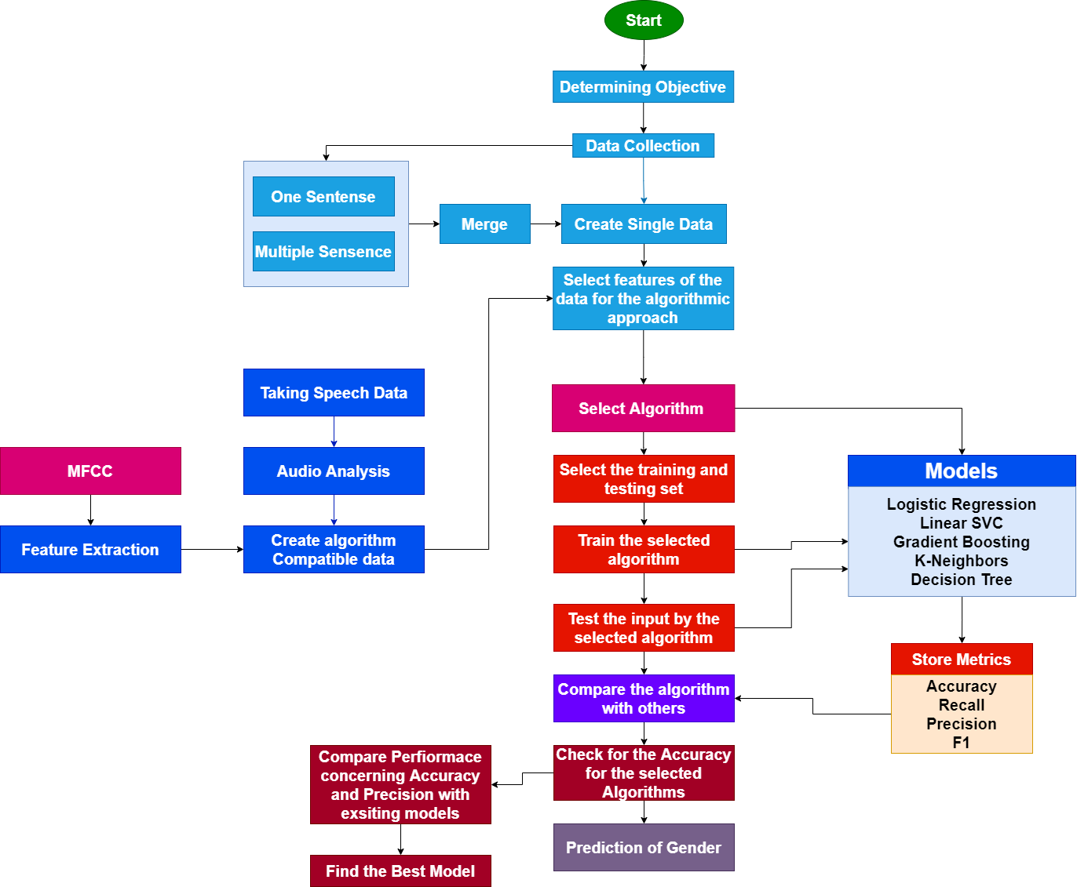
Figure 1 Proposed Methodology

Data Selection
The database for gender detection has been selected from Kaggle. This database contains speech files in two segments, The first segment contains speeches with one sentence and the second segment contains speeches with multiple sentences (Oge, 2020). The snapshot of the data is shown below:
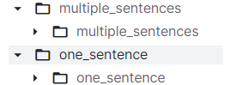
Figure 2 Speech Database
The selected database contains all speech files. However, the speech files are not labelled with the gender types. To identify the type of gender from the speech files, the metadata file has been provided in the dataset. The metadata has been stored in the name of BVC_Voice_Bio_Public.xlsx. The metadata file is shown below:
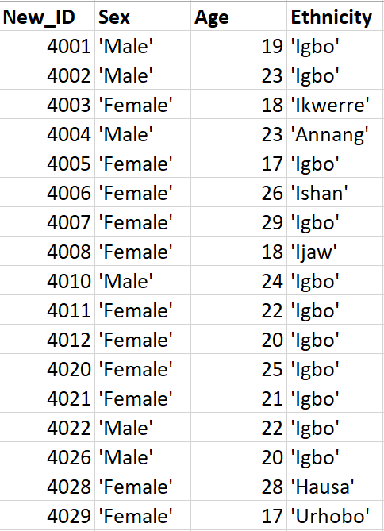
Figure 3 Speech Metadata
This data file contains the columns namely New_ID which defines the code of the speech file. The column sex defines the gender of the person of that speech file that contains the same code or New_ID. So, for example, if the speech file has been named with 'S_01_4001_VE.wav', It means the speech file belongs to a Male person as found in Metadata. The count of the speech files in the database is shown below:
- There are 671 speech files are stored with one sentence.
- There are 1778 speech files stored with multiple sentences

Tool Selection
Python has been considered a suitable programming language for this study due to its capability of carrying out gender detection via the interpretation of built-up machine-learning models. It is the most recognized programming language owning the facility of supporting multiple programming paradigms which are mostly object, aspect, and function oriented. It presents the benefit of legible and precise codes and it’s comparatively a more basic and easily interpretable computer programming. The Gender detection system via ML algorithms can be constructed easily via Python without notable errors in the developmental process with the provision for error-free app development (Python, 2022). Utilizing the language programmers can focus relatively on the upgradation of gender detection approaches without any worry about technological concerns. Python is a dynamically typed, easily interpretable high-level language with vast library support like NumPy for numerical calculation and Panda for data analytics. Thus, it proves to be an extremely suitable choice for Gender detection via ML it facilitates programmers with error-free software development owing to its simple and easy syntax of English alphabets rather than punctuations, unlike others (Ijitona & Soraghan, 2017). Its integrity supports the users with the provision of rapid and adjustable code generation and during processing, it monitors an exclusive data range indicating the confusing codes. It is easy to be acquainted and compatibility is another reason behind its choice. Above all, it is license-free, and open-source for the code developers owing to which the developers are expelled from paying any extra money for accessing Python (Daalache & Addou, 2017).

Technology for Research

Speech Analytics
Speech Analytics is considered the pathway involved in the assessment of voice recordings or live customer conversations over calls to contact centres enabled with the speech recognition software with the target of acquiring essential information and presenting with quality assurance. Speech Analytics usually proceeds via recognition of words spoken and examines the audio patterns for identifying emotions and stress in a speaker’s voice via the alterations noted in their vocal patterns. Speech Analytics can be suitably utilized for the purpose of speech processing and classification utilized for successful gender determination. (Speech Analytics (techtarget), 2022)

Machine Learning
For the purpose of structuring speech analytics, speech processing, and classification model, ML was chosen as an appropriate way. Machine learning has achieved significant recognition and is considered a subgroup of AI utilizing information and data for carrying out an exclusive variety of data patterns based on technology capable of duplicating the human experience (Sainath & Posonia, 2022). Machine learning technology enables users with the facility of subjecting their systems to data for analysis and then facilitating appreciable judgments based on the facts. It discovers correlations in information enabling experts with the ability to make decisions and execute certain operations. The above-mentioned study utilized Machine learning algorithms for both early prediction and detection of Gender as well. (Machine Learning, 2020). Machine learning processes usually proceed via the phases of a Decision process, an error function, a model optimization process, in which the decision process carries out the prediction and classification followed by the error function which estimates a model’s error generation and thus resulting in the accuracy assessment followed by the concluding step estimates the suitability of the model into the training set by weight adjustment and proceeds by minimizing the discrepancy between the known instance and model estimate (Hidayat & Bejo, 2018).

Selection of Algorithms for Research

Logistic Regression
Logistic regression is a method that is associated with statistical analysis and helps in the prediction process of a twofold outcome, such as yes/no, based on preceding observations that are found to be concerning the dataset. A model of logistic regression is found to be making predictions about a data variable which is dependent on the association analysis among one or more of the independent variables that prevail (Burns & Lawton, 2022).

Linear Support Vector Classifier
This linear support vector classifier class is providing support to both the dense and sparse amount of input along with the multiclass support that gets handled on the basis of a one-vs-the-rest scheme. This mainly gets implemented for the liblinear rather than libsvm, so it intends to have more amount of flexibility in the penalty choice and functions’ loss that should get to scale better for large numbers of samples (Linear Support Vector Classification., 2022).

Gradient Boosting
Gradient Boosting is a kind of algorithm which is popular in boosting. In the field of gradient boosting, each of the predictors makes a correction of the error of its predecessors. Contrary to Adaboost, the training instances’ weights are not twisted, as a substitute, each of the predictors gets trained with the use of the predecessor’s residual errors as labels. (ML – Gradient Boosting, 2022)

K-Neighbors
K-Nearest Neighbor is a modest person who is based on algorithms through using all of the Machine Learning on the basis of techniques that are associated with Supervised Learning. Hence, assumptions are being made by the K-NN algorithm about the alikeness among the new case or data with the cases available that puts the new case into the same category which is very much similar to the available categories (K-Nearest Neighbor, 2022).

Decision Tree
A decision Tree seems to be a tool that is very powerful and popular as well in the fields of classification and prediction as well. Hence a Decision tree can be denoted as a flowchart-like structure of a tree, where each of the internal nodes symbolises an attribute test, where each of the branches represents a test outcome and each leaf node is the holder of a class label. (Decision Tree, 2022)

Process of Evaluation

Accuracy
Accuracy gives out the measurement for how often correct prediction is made by the classifier. Hence it is able to define accuracy as the ratio of the number of correct predictions to the total number of predictions made. (Agrawal, 2021)

Recall
Recall explains the cases with actual positives that are capable of correct prediction with the model. It is a metric useful where a False Negative is higher than a False Positive (Agrawal, 2021).

Precision
Precision is the explanation of the number of correctly predicted cases that are actually positive. Hence, Precision seems useful where False Positive is higher than False Negatives (Agrawal, 2021).

F1-Score
This is the combined idea about the metrics associated with Precision and Recall. It gives out the maximum answer when Precision is equal to Recall. Hence, the F1 Score is the vocal mean of precision and recall. (Agrawal, 2021)

Analysis and Result
The speech database has been read, analysed, and prepared to detect gender. The detection of gender has been done using speech analytics and machine learning. The process of analytics and data preparation will be presented in this chapter along with the result of gender detection.

Reading Database

Load Speech Database
The database has two directories namely one sentence and multiple sentences. Both of the speech databases have been read. After reading the database, the pattern of speech file names has been checked and shown below:
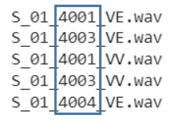
Figure 4 Speech File Name Structure
From the pattern of the speech file names, it can be identified that the file includes the code or ID of the speech files. For example, the first speech file contains ID 4001.

Detecting the Number of Files
After reading the databases, the counts of speech files have been checked. It has been found that the One Sentence directory contains 671 files, and the Multiple Sentence directory contains 1778 files.
Table 2 Number of Files in the Directory
Directory | Number of Speeches
One Sentence | 671
Multiple Sentence | 1778

Reading Metadata
The database also contains metadata which includes the details of the gender and age of the person from whom the speeches have been recorded. The identifier of the speech files and the metadata is the ID as shown below:
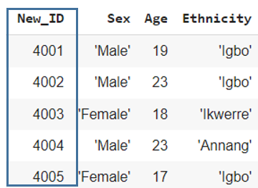
Figure 5 Metadata

Creating Data with ID and Gender
Now, the data has been subsetted with the ID and Gender so that the ID of the metadata can be matched with the speech files and the speech data can be prepsred. The subsetted data is shown below:
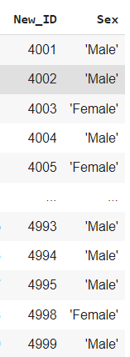
Figure 6 Data with ID and Gender

Data Formulation
The data will be formulated with the speech file name and the corresponding gender. To create this data, the following steps have been applied:
- The ID part of the speech files has been extracted from each of the speech files and stored in a list.
- The list has been iterated and each of the IDs has been matched with the ID mentioned in the dataset (Figure 6).
- After each matching iteration, the corresponding gender has been taken from that data and stored in another list.
- Finally, the speech file list (step 1) and the corresponding gender list (step 3) have been put into a data frame and the gender speech data has been created.

Preparing Gender Dataset
The gender dataset that has been prepared from the One Sentence directory is shown below:
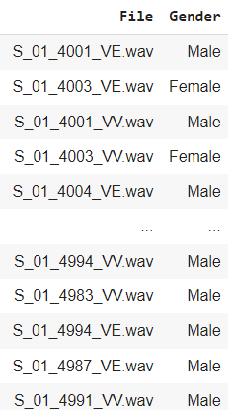
Figure 7 Gender Dataset for One Sentence
Next, the gender dataset that has been prepared from the Multiple Sentence directory is shown below:

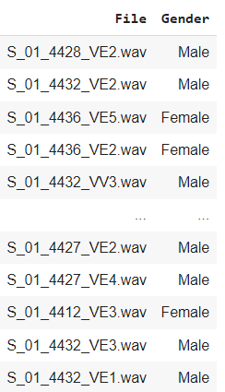
Figure 8 Gender Dataset for Multiple Sentence

Merging and Preparing Final Data
Finally, the two data frames have been merged to create the complete dataset. This dataset will be used to extract features and to prepare the feature-extracted dataset. The merged data is shown below:
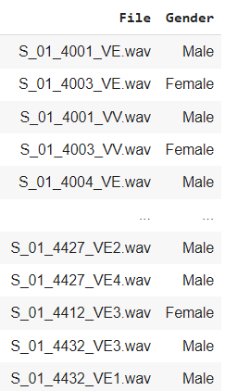
Figure 9 Final Merge Data

Speech Feature Extraction

Process of Feature Extraction
Speech files are not compatible with machine learning algorithms and dos, the direct processing cannot be done to detect gender. So, the features have been extracted from the speech file to prepare the numerical data which is compatible with machine learning. While extracting features, the following steps have been applied:
- Iterate the speech data and the speech file names
- Load the speech file using Librosa in each loop for each of the file names taken from the dataset
- While reading or loading the file, the sample rate has been maintained at 16K Hz and resample type has been set to Kaiser Fast to process the speech file comparatively faster.
- After loading the file, the sampling has been done using Librosa MFCC.
- The extracted features have been stored in a list for each iteration.
- The list has been assigned to the rows of a data frame
- Finally, the feature-extracted data frame has been prepared.

Feature-Extracted Data
The feature-extracted data frame is shown below where each row contains a list of features which have been extracted from the speech files in each of the data frame iterations:
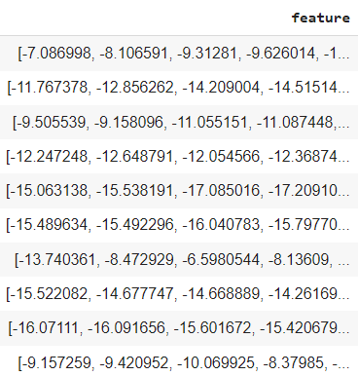
Figure 10 Speech Feature Data

Preparing Speech Dataset

Creating Speech Data
In Figure 10, the feature-extracted data has been prepared where each row contains a list. This data is not compatible to be processed in a machine learning classifier. The classifier expects data attributes where each row of each attribute contains a single data. So, the values from the list have been put into each column of a new data frame and the speech data has been prepared as follows:
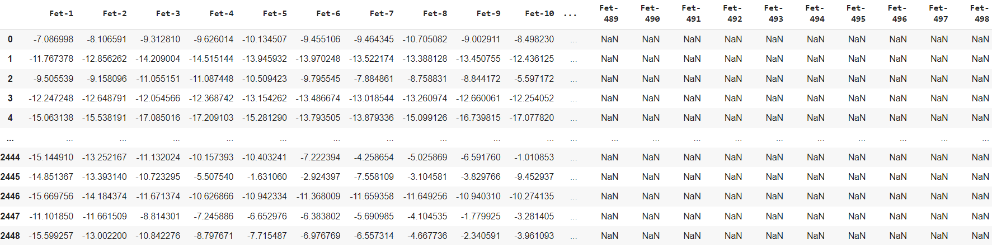
Figure 11 Speech Dataset

Data Cleaning
It has been observed that the data prepared in Figure 11 contains missing values. So, the missing values have been filled with the average values and the data has been made clear as follows:
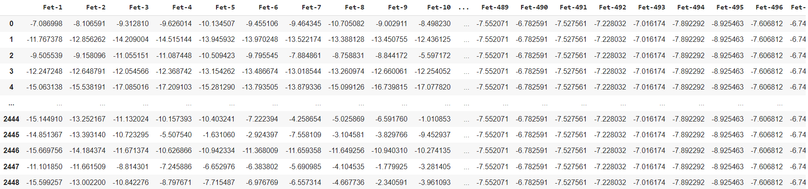
Figure 12 Cleaned Data

Class Distribution
The class distribution of the data has been checked and it has been observed that the Female class contains 1238 observations, and the Male class contains 1211 observations as follows:
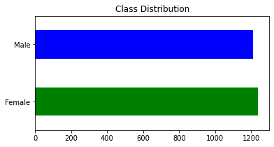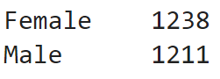
Figure 13 Class Distribution

Removing Data Outliers
In the prepared data, it has been observed that each of the extracted features is negative which means the speech files have higher power concentration and frequency values (Springer, 2020). It reflects the fact that the data may contain higher spectral values and outliers. To check the incident, the data outlier has been checked using Principal Component Analysis with PCA values 2 and 8. In both cases, it has been observed that the first components contain outliers as shown below:
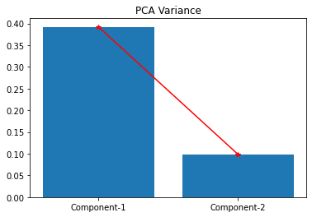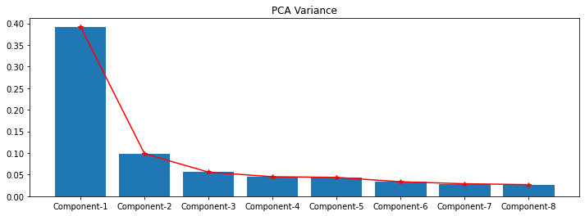
(a) With PCA=2 (b) With PCA=8
Figure 14 Checking Data Outliers
As data outliers have been found, the data has been normalised and prepared. The normalized data is shown below:
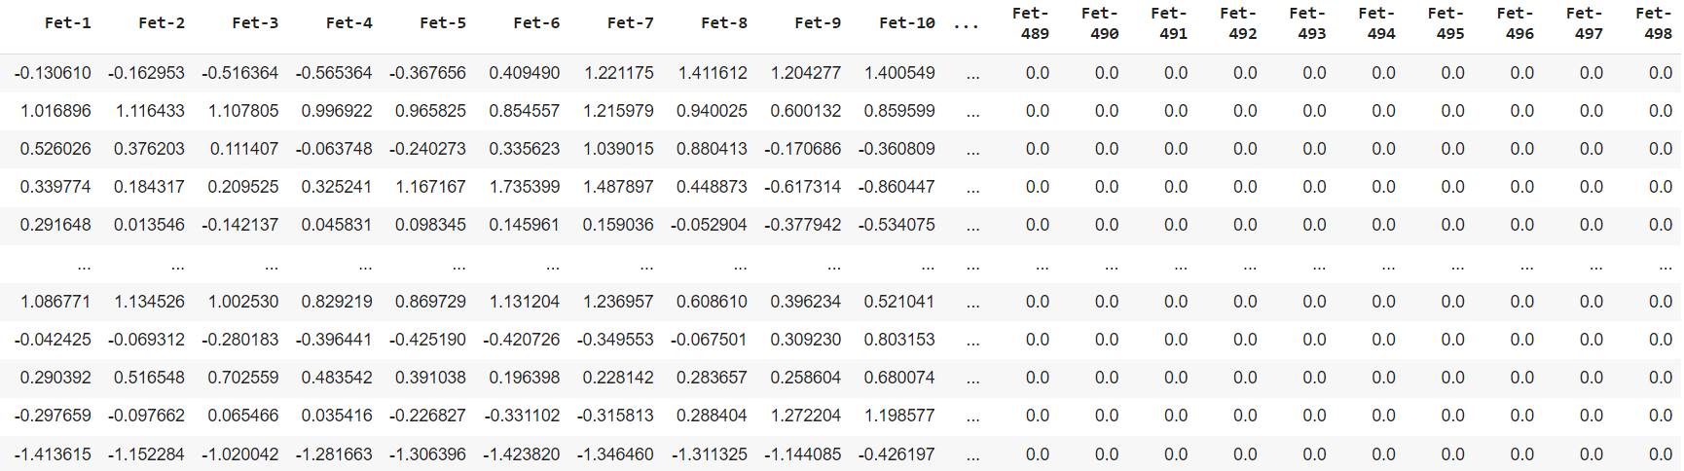
Figure 15 Normalized Data

Data Upscaling
The instances of data os moderate or low. So, the data resolution has been increased by applying data resampling or upscaling. After upscaling the data 10 times, the class distribution obtained as follows:
Table 3 Class Distribution of Upscaled Data
Class | Distribution
Female | 12415
Male | 12075

Preparing Train and Test Sets
The research and artefact have now two data frames. The first one if the actual data as collected and the second one is the upscaled version. Both of the data have been segregated to prepare the train and test set with an 80:20 ratio for train and est. The test support for both data is shown below:
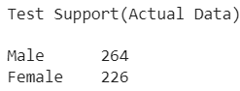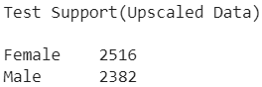
Figure 16 Test Supports

Gender Detection and Result
Finally, the classifiers have been applied to both data to detect gender from the speech database. The result of the classification will be presented in this section.

Gender Detection using Linear SVC
The confusion matrix for Linear SVC for both two data to detect gender are shown below:
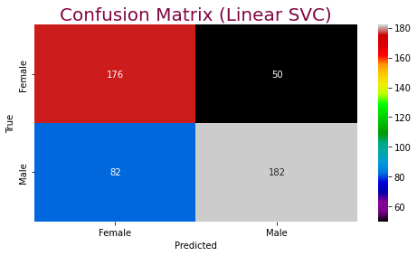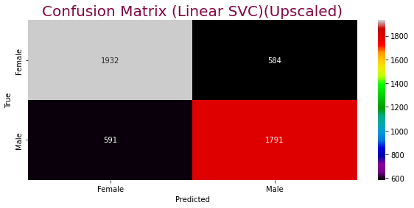
(a) Actual Data (b) Upscaled Data
Figure 17 Linear SVC Results
It can be observed that with the application of data upscaling, the detection rate has been increased for Linear SVC. The classification metrics for both two detections are shown below:

Table 4 Result Metrics for Linear SVC
Linear SVC | Actual Data | Upscaled Data
Accuracy | 73.0612 | 76.0106
Precision | 73.73 | 76.01
Recall | 73.06 | 76.01
F1-Score | 73.08 | 76.01

Gender Detection using K-Neighbors
The confusion matrix for KNN for both two data to detect gender are shown below:
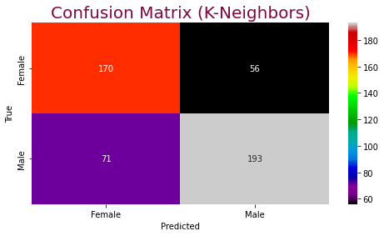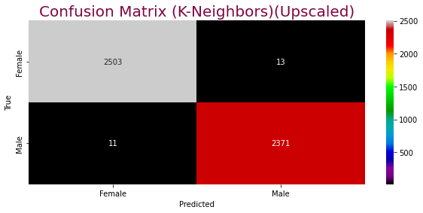
(a) Actual Data (b) Upscaled Data
Figure 18 K-Neighbors Results
It can be observed that with the application of data upscaling, the detection accuracy has been increased for KNN. The classification metrics for both two detections are shown below:
Table 5 Result Metrics for KNN
K-Neighbors | Actual Data | Upscaled Data
Accuracy | 74.0816 | 99.51
Precision | 74.3 | 99.51
Recall | 74.08 | 99.51
F1-Score | 74.12 | 99.51

Gender Detection using Logistic Regression
The confusion matrix for Logistic Regression for both two data to detect gender are shown below:
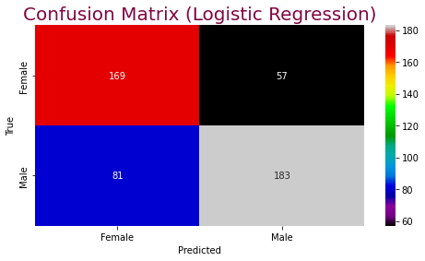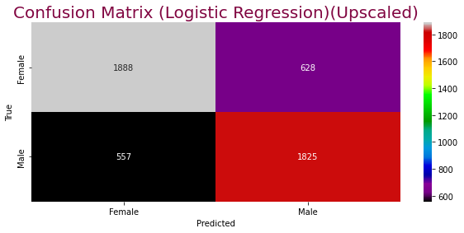
(a) Actual Data (b) Upscaled Data
Figure 19 Logistic Regression Results
It can be observed that with the application of data upscaling, the detection rate has been increased for Logistic Regression. The classification metrics for both two detections are shown below:
Table 6 Result Metrics for Logistic Regression
Logistic Regression | Actual Data | Upscaled Data
Accuracy | 71.8367 | 75.8065
Precision | 72.26 | 75.85
Recall | 71.84 | 75.81
F1-Score | 71.88 | 75.81

Gender Detection using Gradient Boosting
The confusion matrix for Gradient Boosting for both two data to detect gender are shown below:
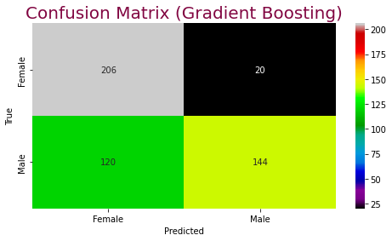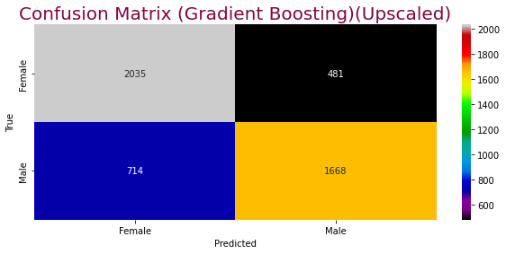
(a) Actual Data (b) Upscaled Data
Figure 20 Gradient Boosting Results
It can be observed that with the application of data upscaling, the detection rate has been increased for Gradient Boosting. The classification metrics for both two detections are shown below:
Table 7 Result Metrics for Gradient Boosting
Gradient Boosting | Actual Data | Upscaled Data
Accuracy | 71.4286 | 75.6023
Precision | 76.45 | 75.77
Recall | 71.43 | 75.6
F1-Score | 70.68 | 75.51

Gender Detection using Decision Tree
The confusion matrix for the Decision Tree for both two data to detect gender are shown below:
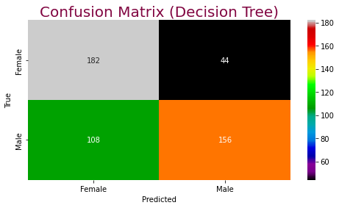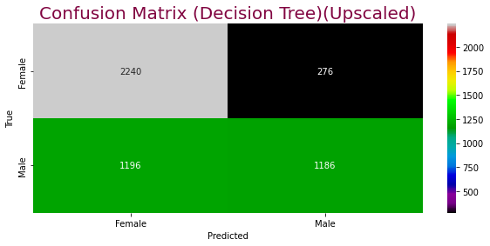
(a) Actual Data (b) Upscaled Data
Figure 21 Decision Tree Results
It can be observed that with the application of data upscaling, the detection rate has been increased for Decision Tree. The classification metrics for both two detections are shown below:
Table 8 Result Metrics for Decision Tree
Decision Tree | Actual Data | Upscaled Data
Accuracy | 68.9796 | 69.9469
Precision | 70.97 | 72.94
Recall | 68.98 | 69.95
F1-Score | 68.76 | 68.67

Discussion and Conclusion

Evaluation of Research

Performance Evaluation of Gender Detection
The results of gender detection using machine learning have been presented in section 5.5 concerning all applied models and both two data. The comparison of performances of all models has been done and will be presented here to determine the most efficient model for gender detection.
Comparison of Performances for Actual Data
The performance comparison for all applied models on the actual data is shown below:
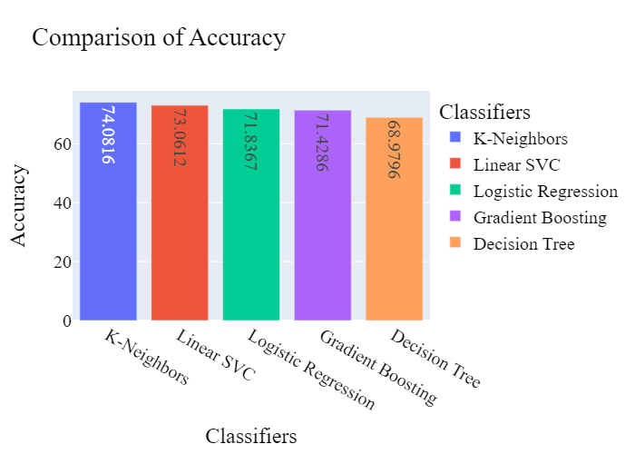
Figure 22 Comparison of Performances for Actual Data
From the comparison, it can be seen that KNN has attained the highest accuracy to detect gender from the actual speech database. However, the accuracy has been seen to be lower for which the upscaling has been done.
Comparison of Performances for Upscaled Data
The performance comparison for all applied models on the upscaled data is shown below:
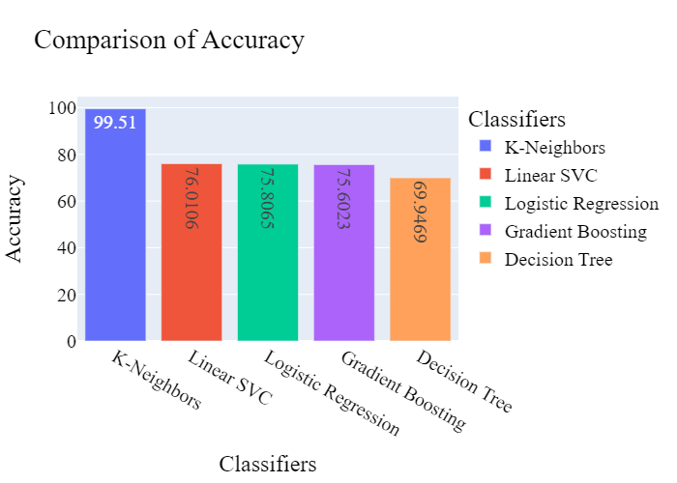
Figure 23 Comparison of Performances for Upscaled Data
From the result of the comparison for upscaled data, it can be observed that the accuracy for all models has increased when those have been applied to upscaled data. Additionally, the accuracy of KNN has reached 99.51% which is higher compared to the rest models. So, it can be stated that KNN is the most efficient model to detect gender from speech data with an accuracy rate of 99.51%.

Research Improvements
A review of the existing research has been done and the comparison of the method and accuracies has been done in Table 1. Now, by commencing the complete research to detect gender from speech data, the accuracy has been compared with the existing models. The comparison is shown below:
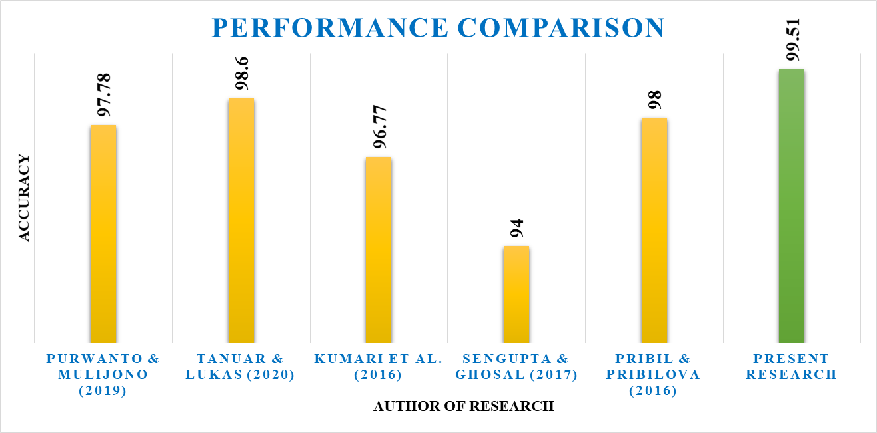
Figure 24 Improvement in Research with Highest Accuracy
By comparing the present research to all existing approaches, it is evident that the current research has achieved a higher level of accuracy. Based on the results of this study, it can be conclusively stated that the current method detects gender from speeches more effectively than existing approaches.

Discussion

Challenges Faced and Overcome
In this research, three main challenges have been faced during executing the artefact to detect gender. Those are stated below along with the process that has been undertaken to overcome these:
- The speech data (audio files) have been selected but the files were not labelled. So, the determination of the type of gender was hard at that time by checking the file name and type. To overcome the problem, the metadata has been taken into the context where the file ID and the corresponding gender have been mentioned. So, the data labels concerning the gender of the speeches have been prepared by extracting the ID from the speech files and matching them with the metadata.
- After extracting the features from the speech files, the data has been prepared. In that data, the features have been stored in the form of a list which is not eligible to be processed by machine learning. So, the problem has been overcome by placing the list values of features into individual columns to prepare the feature dataset.
- The last challenge occurs when the detection has been done using the actual data as the accuracies have been seen to be lower. The problem has been mitigated by upscaling the data where the KNN has acquired 99.51% accuracy to detect gender.

Research Questions Addressing

Discussion on RQ-1
The speech database has been selected for the detection of gender. However, the speech files cannot be processed directly by the algorithms to detect gender. So, the features from the speech files have been extracted using MFCC through which the feature data has been produced. That data has been seen to have numerical values (spectral values) which are compatible with machine learning. So, using that data, the detection of gender has been done with the application of classifiers of machine learning. So, it can be stated that the extraction of features helps detect gender through speech processing and analytics.

Discussion on RQ-2
To detect gender from speech data, five classifiers from five different families have been selected and applied to the speech data to detect gender. After the applications, the performances have been compared and it has been found that KNN detected gender from speech data with 99.51% accuracy which is the highest compared to other models applied. Additionally, this accuracy has been seen to be the highest among the previous approaches which reflect the improvement and achievement of the present research.

Conclusion
The present research has been conducted to detect by analysing speech data and by applying machine learning. The speech database has been collected from Kaggle and contains all the files with wav extension. The data has been prepared by taking the metadata into the scenario. This implication has been done because the speech data was unlabelled, and the detection will be done using the supervised learning method. So, the database needs to be labelled. After labelling the data, the features have been extracted from the speech files using the MFCC method and the outliers have been checked using PCA. In this checking, the outlier in the data has been found which has been solved by normalizing the data and increasing the data resolution by upscaling. Finally, with the application of machine learning classifiers, the detection of gender has been done with 99.51% accuracy using the KNN classifier. So, the research has been conducted successfully and the desired outputs have been achieved. The limitation of the research and possible future aspects have been stated below.

Research Limitations
The research has certain limitations and those are as follows:
- The number of instances in the speech database is few.
- The duration of the speech files is very less.
- Only the MFCC process has been applied to extract features.
- One sample rate has been applied to extract features.
- The train and test data have been prepared with a split ratio and no other ratio have been trained.

Future Aspects
The possible future aspects of the research are stated below:
- Deep learning models such as Recurrent Neural Networks can be applied to detect gender by analysing speech files.
- Different sample rates can be applied with the MFCC.
- Different split Ratios can be applied to prepare train and test data with different sizes.

References
Agrawal, S. K., 2021. Metrics to evaluate your classification model to take the right decisions. [Online]
Available at: https://www.analyticsvidhya.com/blog/2021/07/metrics-to-evaluate-your-classification-model-to-take-the-right-decisions/
[Accessed 20 July 2021].
Alharbi, Y. F. & Alotaibi, Y. A., 2021. The Correlate of Emotion and Gender Classification Using EEG Signals. 2021 IEEE 6th International Conference on Signal and Image Processing (ICSIP), pp. 790-794.
Alim, S. A., 2018. Speech Feature Extraction. [Online]
Available at: https://www.intechopen.com/chapters/63970
Backstrom, T., 2022. Fundamental frequency. [Online]
Available at: https://wiki.aalto.fi/pages/viewpage.action?pageId=149890776
Backstrom, T., 2022. Mel-frequency Cepstrum Coefficient. [Online]
Available at: https://wiki.aalto.fi/display/ITSP/Cepstrum+and+MFCC
Backstrom, T., 2022. Speech Autocorrelation. [Online]
Available at: https://wiki.aalto.fi/display/ITSP/Autocorrelation+and+autocovariance
Backstrom, T., 2022. Speech Energy(Aalto University). [Online]
Available at: https://wiki.aalto.fi/display/ITSP/Signal+energy%2C+loudness+and+decibel
Backstrom, T., 2022. Speech Spectogram STFT. [Online]
Available at: https://wiki.aalto.fi/display/ITSP/Spectrogram+and+the+STFT
Backstrom, T., 2022. Speech Waveform (Aalto University). [Online]
Available at: https://wiki.aalto.fi/display/ITSP/Waveform
Backstrom, T., 2022. Speech Windowing (Aalto Windowing). [Online]
Available at: https://wiki.aalto.fi/display/ITSP/Windowing
Backstrom, T., 2022. Strengths of MFCC. [Online]
Available at: https://wiki.aalto.fi/display/ITSP/Cepstrum+and+MFCC
Backstrom, T., 2022. Weakness of MFCC. [Online]
Available at: https://wiki.aalto.fi/display/ITSP/Cepstrum+and+MFCC
Baghel, S. & Prasanna, S., 2021. Effect of High-Energy Voiced Speech Segments and Speaker Gender on Shouted Speech Detection. 2021 National Conference on Communications (NCC), pp. 1-6.
Biscobing, J., 2022. speech analytics. [Online]
Available at: https://www.techtarget.com/searchcustomerexperience/definition/speech-analytics
[Accessed 2022].
Boril, H. & Horn, S., 2022. GAN-Based Augmentation for Gender Classification from Speech Spectrograms. 2022 International Conference on Electrical, Computer and Energy Technologies (ICECET), pp. 1-6.
Bunny Studio (Male Speech), 2022. Bunny Studio (Male Speech). [Online]
Available at: https://bunnystudio.com/blog/the-male-voice-whats-that-about-man/
Burns, E. & Lawton, G., 2022. logistic regression. [Online]
Available at: https://www.techtarget.com/searchbusinessanalytics/definition/logistic-regression
[Accessed 2022].
Chadha, A. N. & Zaveri, M. A., 2016. Optimal feature extraction and selection techniques for speech processing: A review,. 2016 International Conference on Communication and Signal Processing (ICCSP),, pp. 1669-1673.
Chai, L. & Du, J., 2021. A Cross-Entropy-Guided Measure (CEGM) for Assessing Speech Recognition Performance and Optimizing DNN-Based Speech Enhancement. IEEE/ACM Transactions on Audio, Speech, and Language Processing, vol. 29, pp. 106-117.
Daalache, M. & Addou, D., 2017. An efficient distributed speech processing in noisy mobile communications. 2017 International Conference on Wireless Technologies, Embedded and Intelligent Systems (WITS),, pp. 1-4.
Decision Tree, 2022. Decision Tree. [Online]
Available at: https://www.geeksforgeeks.org/decision-tree/
[Accessed 03 October 2022].
Do, C.-T. & Pastor, D., 2010. On the Recognition of Cochlear Implant-Like Spectrally Reduced Speech With MFCC and HMM-Based ASR,. IEEE Transactions on Audio, Speech, and Language Processing, vol. 18, pp. 1065-1068,.
Girish, K. V. V., 2019. tds (Speech Analytics). [Online]
Available at: https://towardsdatascience.com/beginners-guide-to-speech-analysis-4690ca7a7c05
Hidayat, R. & Bejo, A., 2018. Denoising Speech for MFCC Feature Extraction Using Wavelet Transformation in Speech Recognition System,. 2018 10th International Conference on Information Technology and Electrical Engineering (ICITEE), pp. 280-284,.
Ijitona, T. B. & Soraghan, J. J., 2017. Automatic detection of speech disorder in dysarthria using extended speech feature extraction and neural networks classification. IET 3rd International Conference on ​​Intelligent Signal Processing (ISP 2017), pp. 1-6,.
Ingleby, M. & Li, D., 1990. Intermediate level speech processing as an aim of low level signal analysis. IEE Colloquium on Techniques for Speech Processing.
Jhawar, G. & Nagraj, P., 2016. Speech disorder recognition using MFCC,. 2016 International Conference on Communication and Signal Processing (ICCSP),, pp. 0246-0250,.
Kaur, A. & Singh, A., 2016. Optimizing feature extraction techniques constituting phone based modelling on connected words for Punjabi automatic speech recognition. 2016 International Conference on Advances in Computing, Communications and Informatics (ICACCI), pp. 2104-2108.
K-Nearest Neighbor, 2022. K-Nearest Neighbor(KNN) Algorithm for Machine Learning. [Online]
Available at: https://www.javatpoint.com/k-nearest-neighbor-algorithm-for-machine-learning
[Accessed 2022].
Kumari, M. & Ali, I., 2016. A new gender detection algorithm considering the non-stationarity of speech signal. 2016 2nd International Conference on Communication Control and Intelligent Systems (CCIS), pp. 141-146.
Kumari, M., Talukdar, N. & Ali, I., 2016. A new gender detection algorithm considering the non-stationarity of speech signal. 2016 2nd International Conference on Communication Control and Intelligent Systems (CCIS), pp. 141-146.
Likitha, M. & Gupta, S. R. R., 2017. Speech based human emotion recognition using MFCC,. 2017 International Conference on Wireless Communications, Signal Processing and Networking (WiSPNET), pp. 2257-2260.
Li, L. & Wang, D., 2018. Deep Factorization for Speech Signal,. 2018 IEEE International Conference on Acoustics, Speech and Signal Processing (ICASSP),, pp. 5094-5098.
Linear Support Vector Classification., 2022. Linear Support Vector Classification.. [Online]
Available at: https://scikit-learn.org/stable/modules/generated/sklearn.svm.LinearSVC.html
[Accessed 2022].
Machine Learning, 2020. Machine Learning. [Online]
Available at: https://www.ibm.com/cloud/learn/machine-learning
Machine Learning, 2022. Machine Learning. [Online]
Available at: https://www.geeksforgeeks.org/machine-learning/
[Accessed 02 June 2022].
Mel Frequency Cepstral Coefficients, 2022. Mel Frequency Cepstral Coefficients. [Online]
Available at: https://en.wikipedia.org/wiki/Mel-frequency_cepstrum
ML – Gradient Boosting, 2022. ML – Gradient Boosting. [Online]
Available at: https://www.geeksforgeeks.org/ml-gradient-boosting/
[Accessed 2022].
Nitisara, G. R. & Suyanto, S., 2020. Speech Age-Gender Classification Using Long Short-Term Memory. 2020 3rd International Conference on Information and Communications Technology (ICOIACT), pp. 358-361.
Oge, 2020. Gender Age Classification from voice data. [Online]
Available at: https://www.kaggle.com/datasets/ogechukwu/voice?select=one_sentence
Pfeifenberger, L. & Schrank, R., 2015. Multi-channel speech processing architectures for noise robust speech recognition: 3rd CHiME challenge results. 2015 IEEE Workshop on Automatic Speech Recognition and Understanding (ASRU), pp. 452-459.
Pribil, J. & Pribilova, A., 2016. GMM-based speaker gender and age classification after voice conversion. 2016 First International Workshop on Sensing, Processing and Learning for Intelligent Machines (SPLINE), pp. 1-5.
Purwanto & Mulijono, 2019. Javanese Gender Speech Recognition Using Deep Learning And Singular Value Decomposition. 2019 International Seminar on Application for Technology of Information and Communication (iSemantic), pp. 251-254.
Python, 2022. Python. [Online].
Qaisar, S. M. & Hammad, N., 2019. A Speech to Machine Interface Based on Perceptual Linear Prediction and Classification. 2019 Advances in Science and Engineering Technology International Conferences (ASET), pp. 1-4.
Qing, Z., Zhong, W. & Peng, W., 2020. Research on Speech Emotion Recognition Technology Based on Machine Learning. 2020 7th International Conference on Information Science and Control Engineering (ICISCE), pp. 1220-1223.
Rehman, R. & Hazarika, G. C., 2016. Feature extraction and analysis of MISING speech vowels,. 2016 International Conference on Signal Processing, Communication, Power and Embedded System (SCOPES),, pp. 261-265,.
Sainath, N. & Posonia, A. M., 2022. Speech Emotion Recognition using Machine Learning. 2022 6th International Conference on Computing Methodologies and Communication (ICCMC), pp. 1014-1018.
Sengupta, S. & Ghosal, A., 2017. Classification of male and female speech using perceptual features. 2017 8th International Conference on Computing, Communication and Networking Technologies (ICCCNT), pp. 1-7.
Shen, J., Lederman, O. & Cao, J., 2018. GINA: Group Gender Identification Using Privacy-Sensitive Audio Data. 2018 IEEE International Conference on Data Mining (ICDM), pp. 457-466.
Sidorova, J. & Badia, T., 2008. ESEDA: A Tool for Enhanced Speech Emotion Detection and Analysis. 2008 International Conference on Automated Solutions for Cross Media Content and Multi-Channel Distribution, pp. 257-260.
Speech Analysis, 2022. Speech Analysis. [Online]
Available at: https://www.voicesignals.com/post/what-is-speech-analysis#:~:text=Speech%20analysis%20is%20the%20process,is%20recorded%20and%20then%20transcribed
Speech Analytics (techtarget), 2022. Speech Analytics (techtarget). [Online]
Available at: https://www.techtarget.com/searchcustomerexperience/definition/speech-analytics
Springer, 2020. MFCC Features. [Online]
Available at: https://link.springer.com/content/pdf/bbm:978-3-319-03116-3/1.pdf
Subramanian, A. S. & Wang, X., 2019. Speech Enhancement Using End-to-End Speech Recognition Objectives,. 2019 IEEE Workshop on Applications of Signal Processing to Audio and Acoustics (WASPAA, pp. 234-238.
Subramanian, A. S. & Weng, C., 2020. Far-Field Location Guided Target Speech Extraction Using End-to-End Speech Recognition Objectives," ICASSP 2020. 2020 IEEE International Conference on Acoustics, Speech and Signal Processing (ICASSP),, pp. 7299-7303.
Swedia, E. R. & Mutiara, A. B., 2018. Deep Learning Long-Short Term Memory (LSTM) for Indonesian Speech Digit Recognition using LPC and MFCC Feature,. 2018 Third International Conference on Informatics and Computing (ICIC), pp. 1-5.
Tanuar, E. & Lukas, 2020. Analysis of Gender Identification in Bahasa Indonesia using Supervised Machine Learning Algorithm. 2020 3rd International Conference on Information and Communications Technology (ICOIACT), pp. 421-424.
Tate, L., 2022. The Difference Between Speech and Voice Recognition. [Online]
Available at: https://www.kardome.com/blog-posts/difference-speech-and-voice-recognition
[Accessed 2022].
Wang, G.-Y. & Zhang, Y.-M., 2016. Speech signal feature parameters extraction algorithm based on PCNN for isolated word recognition. 2016 International Conference on Audio, Language and Image Processing (ICALIP),, pp. 679-682.
Watson, S., 2019. ASHAWIRE (Female Speech). [Online]
Available at: https://leader.pubs.asha.org/doi/10.1044/leader.FTR1.24022019.44#:~:text=In%20general%2C%20women%20speak%20at,cords%20to%20elongate%20and%20thicken
Winursito, A. & Hidayat, R., 2018. Improvement of MFCC feature extraction accuracy using PCA in Indonesian speech recognition. 2018 International Conference on Information and Communications Technology (ICOIACT),, pp. 379-383.

Appendix
import numpy
import random
from matplotlib import pyplot
from matplotlib.pyplot import specgram
import pandas
import os
import IPython.display as ipd
from plotly import express
import plotly.graph_objects as go
import random
from sklearn import utils
import seaborn
from scipy.io.wavfile import write

import librosa
import librosa.display
from scipy.io.wavfile import read
import scipy.io.wavfile as wav

import sklearn
from sklearn import metrics
from sklearn import model_selection
from sklearn.utils import resample

from sklearn import pipeline
from sklearn import preprocessing
from sklearn import decomposition

from sklearn import tree
from sklearn import svm
from sklearn import ensemble
from sklearn import linear_model
from sklearn import neighbors

mlalgo=[
linear_model.LogisticRegression(),
pipeline.make_pipeline(preprocessing.StandardScaler(),svm.LinearSVC()),
ensemble.GradientBoostingClassifier(learning_rate=0.001, n_estimators=100),
neighbors.KNeighborsClassifier(),
tree.DecisionTreeClassifier(min_weight_fraction_leaf=0.2)
]
mlnms=[
"Logistic Regression",
"Linear SVC",
"Gradient Boosting",
"K-Neighbors",
"Decision Tree"
]

from google.colab import drive
drive.mount('/content/drive')
GenDR = '/content/drive/MyDrive/Gender'
spdir1=os.path.join(GenDR,'one_sentence')
spdir2=os.path.join(GenDR,'multiple_sentences')
print(spdir1)
print(spdir2)

onesp=os.listdir(spdir1)
print("Total Available Files: {}".format(len(onesp)))
print(*onesp[:5],sep="\n")

twosp=os.listdir(spdir2)
print("Total Available Files: {}".format(len(twosp)))
print(twosp[:10])

meta=pandas.read_excel("BVC_Voice_Bio_Public.xlsx",sheet_name="voice_bio_data")
meta.head()

spidsone=[]
spnmsone=[]
for s in onesp:
spidsone.append(int(s[5:9]))
spnmsone.append(s)
print(spidsone[:5])
print(spnmsone[:5])

spidstwo=[]
spnmstwo=[]
for s in twosp:
spidstwo.append(int(s[5:9]))
spnmstwo.append(s)
print(spidstwo[:5])
print(spnmstwo[:5])

meta=meta.iloc[:,:2]
meta

meta.info()

metaid=meta.New_ID.tolist()
metagen=meta.Sex.tolist()

spgenone=[]
for ids in spidsone:
idx=metaid.index(ids)
spgenone.append(metagen[idx].strip("'"))

spgentwo=[]
for ids in spidstwo:
idx=metaid.index(ids)
spgentwo.append(metagen[idx].strip("'"))

spgendfone=pandas.DataFrame({"File":spnmsone,"Gender":spgenone})
spgendfone

spgendftwo=pandas.DataFrame({"File":spnmstwo,"Gender":spgentwo})
spgendftwo

spgendf=pandas.concat([spgendfone,spgendftwo])
spgendf=spgendf.reset_index(drop=True)
spgendf

df = pandas.DataFrame(columns=['feature'])
idsx=0
counter=0
for path in spgendf.File.tolist():
if idsx<len(spgendfone):
drpth=spdir1
else:
drpth=spdir2
X, sample_rate = librosa.load(os.path.join(drpth,path), res_type='kaiser_fast',sr=16000)
sample_rate = numpy.array(sample_rate)s
fet_extract = numpy.mean(librosa.feature.mfcc(y=X, sr=sample_rate, n_mfcc=20),axis=0)
df.loc[counter] = [fet_extract] # fet_extract will store features of every audio file
counter=counter+1
idsx+=1
df.head(10)

try:
fetdf = pandas.DataFrame(df['feature'].values.tolist()) # putting the values from the list into separate columns
filedf = fetdf.reset_index() # resetting index of the dataframe
filedf = filedf.drop(columns = 'index') # dropping the previous index value which will be replaced by dropped index
df = pandas.concat([filedf,fetdf],axis=1)
except:
pass
colnew=["Fet-{}".format(i+1) for i in range(len(df.columns))]
print(colnew[:5])
df.columns=colnew
df

df=df.fillna(df.mean())
df

try:
df.insert(0,"Gender",spgendf.Gender.tolist())
except:
pass
df

df.to_csv("Feature_Data.csv")

print("Insnstances Present in Class Lables:\n")
print(df['Gender'].value_counts())
df['Gender'].value_counts().plot(kind='barh',title="Class Distribution",figsize=(6,3),color=["g","b"])

datarray=numpy.array(df.iloc[:,1:])
pca = decomposition.PCA(n_components=2)
pca.fit(datarray)
print(pca.explained_variance_ratio_)
compn=["Component-{}".format(i+1) for i in range(len(pca.explained_variance_ratio_.tolist()))]
pyplot.figure(figsize=(6,4))
pyplot.title("PCA Variance")
pyplot.bar(compn,pca.explained_variance_ratio_.tolist())
pyplot.plot(pca.explained_variance_ratio_.tolist(),marker="*",color="r")
pyplot.show()

X=df.drop(["Gender"],axis=1) # X-> Predictor
y=df.Gender # y-> target
X_train, X_test, y_train, y_test = model_selection.train_test_split(X, y,test_size=0.2,shuffle=True,random_state=32)
datcols=X_train.columns
scaler = preprocessing.StandardScaler()
X_train=scaler.fit_transform(X_train)
X_test=scaler.transform(X_test)

X_train=pandas.DataFrame(X_train,columns=datcols)
X_test=pandas.DataFrame(X_test,columns=datcols)

X_train=X_train.fillna(0).reset_index()
X_test=X_test.fillna(0).reset_index()

X_train=X_train.drop('index',axis=1)
X_test=X_test.drop('index',axis=1)

print("Test Support(Actual Data): \n")
print(y_test.value_counts())

X_test

GenDetectRes=[[],[],[],[]]
for i in range(len(mlalgo)):
GenItr=[[],[],[],[]]
cms=[]
clfr=[]
for l in range(10):
mlalgo[i].fit(X_train,y_train)
gender_pred=mlalgo[i].predict(X_test)
score=metrics.accuracy_score(y_test,gender_pred)
GenItr[1].append(round(metrics.precision_score(y_test, gender_pred, average='weighted'),4)*100)
GenItr[2].append(round(metrics.recall_score(y_test, gender_pred, average='weighted'),4)*100)
GenItr[3].append(round(metrics.f1_score(y_test, gender_pred, average='weighted'),4)*100)
GenItr[0].append(round(score*100,4))
cm=pandas.crosstab(y_test, gender_pred, rownames=['True'], colnames=['Predicted'], margins=True)
cms.append(cm.iloc[:2,:2])
clfr.append(metrics.classification_report(y_test, gender_pred))
idx=GenItr[0].index(max(GenItr[0]))

GenDetectRes[1].append(GenItr[1][idx])
GenDetectRes[2].append(GenItr[2][idx])
GenDetectRes[3].append(GenItr[3][idx])
GenDetectRes[0].append(GenItr[0][idx])
pyplot.figure(figsize=(8,4))
pyplot.title("Confusion Matrix ({})".format(mlnms[i]), fontsize=20,color="#810541")
seaborn.heatmap(cms[idx],fmt="d",annot=True,cmap="nipy_spectral")
pyplot.show()
print("\nAccuracy: {}%\n".format(GenItr[0][idx]))
print("\nClassification Report for {} \n\n{}".format(mlnms[i],clfr[idx]))

GenDetectDF=pandas.DataFrame({
"Classifiers":mlnms,
"Accuracy":GenDetectRes[0],
"Precision":GenDetectRes[1],
"Recall":GenDetectRes[2],
"F1-Score":GenDetectRes[3],

})

for i in GenDetectDF.columns.tolist()[1:]:
GenDetectDF=GenDetectDF.sort_values(by=i,ascending=False)
fig = express.bar(GenDetectDF, y=i, x="Classifiers",text=i,color="Classifiers",
title="Comparison of {}".format(i),height=500,width=700)
fig.show()

df1=resample(df, replace = True, n_samples = len(df)*10, random_state = 0)
#df1.to_csv("Resampled_Gender.csv")
print(df1['Gender'].value_counts())
print(len(df1))

Xres=df1.drop(["Gender"],axis=1)
yres=df1.Gender
X_trainres, X_testres, y_trainres, y_testres = model_selection.train_test_split(Xres, yres,test_size=0.2,shuffle=True,random_state=32)
datcols=X_trainres.columns
scaler = preprocessing.StandardScaler()
X_trainres=scaler.fit_transform(X_trainres)
X_testres=scaler.transform(X_testres)

X_trainres=pandas.DataFrame(X_trainres,columns=datcols)
X_testres=pandas.DataFrame(X_testres,columns=datcols)

X_trainres=X_trainres.fillna(0).reset_index()
X_testres=X_testres.fillna(0).reset_index()

X_trainres=X_trainres.drop('index',axis=1)
X_testres=X_testres.drop('index',axis=1)

print("Test Support(Upscaled Data): \n")
print(y_testres.value_counts())

GenDetectResUP=[[],[],[],[]]
for i in range(len(mlalgo)):
GenItrUP=[[],[],[],[]]
cms=[]
clfr=[]
for l in range(10):
mlalgo[i].fit(X_trainres,y_trainres)
gender_predUP=mlalgo[i].predict(X_testres)
score=metrics.accuracy_score(y_testres,gender_predUP)
GenItrUP[1].append(round(metrics.precision_score(y_testres, gender_predUP, average='weighted'),4)*100)
GenItrUP[2].append(round(metrics.recall_score(y_testres, gender_predUP, average='weighted'),4)*100)
GenItrUP[3].append(round(metrics.f1_score(y_testres, gender_predUP, average='weighted'),4)*100)
GenItrUP[0].append(round(score*100,4))
cm=pandas.crosstab(y_testres, gender_predUP, rownames=['True'], colnames=['Predicted'], margins=True)
cms.append(cm.iloc[:2,:2])
clfr.append(metrics.classification_report(y_testres, gender_predUP))
idx=GenItrUP[0].index(max(GenItrUP[0]))

GenDetectResUP[1].append(GenItrUP[1][idx])
GenDetectResUP[2].append(GenItrUP[2][idx])
GenDetectResUP[3].append(GenItrUP[3][idx])
GenDetectResUP[0].append(GenItrUP[0][idx])
pyplot.figure(figsize=(10,4))
pyplot.title("Confusion Matrix ({})(Upscaled)".format(mlnms[i]), fontsize=20,color="#810541")
seaborn.heatmap(cms[idx],fmt="d",annot=True,cmap="nipy_spectral")
pyplot.show()
print("\nAccuracy: {}%\n".format(GenItrUP[0][idx]))
print("\nClassification Report for {} \n\n{}".format(mlnms[i],clfr[idx]))

GenDetectDFUP=pandas.DataFrame({
"Classifiers":mlnms,
"Accuracy":GenDetectResUP[0],
"Precision":GenDetectResUP[1],
"Recall":GenDetectResUP[2],
"F1-Score":GenDetectResUP[3],

})

for i in GenDetectDFUP.columns.tolist()[1:]:
GenDetectDFUP=GenDetectDFUP.sort_values(by=i,ascending=False)
fig = express.bar(GenDetectDFUP, y=i, x="Classifiers",text=i,color="Classifiers",
title="Comparison of {}".format(i),height=500,width=700)
fig.show()

