Logistics Performance Analysis
Advanced data analysis and visualization using a simulated shipment dataset
Week 3 analytical report | January-December 2025 | 1,200 hypothetical shipments

Executive summary
The simulated network contains 1,200 shipments across four regions and three transport modes. The late-delivery rate is 13.8%; mean shipment cost is $1,012.71; median transit is 2.41 days (mean 2.60). Cost is positively associated with distance (Pearson r=0.83) and weight (r=0.03). The charts identify useful questions about route cost, seasonal demand, and region-mode service performance. These are synthetic results for an analytical exercise, not actual operating outcomes.

Dataset and method
A fixed random seed creates 1,200 shipment-level records for 2025. Fields include date, region, mode, carrier, weight, volume, distance, actual and promised transit, cost, and a binary late indicator. In the scenario, cost is generated from distance, weight, mode, month, and region; transit and lateness depend on mode and regional context. Python uses NumPy and pandas for data generation and EDA, Pillow for portable chart rendering, and python-docx for the report. The generated CSV is included alongside this report.
Field | Description | Type
ship_date | Dispatch date in 2025 | Date
region, mode, carrier | Operating segments | Category
weight_kg, volume_m3 | Shipment load measures | Numeric
distance_km | Route length | Numeric
transit_days, promised_days | Actual and target service duration | Numeric
transport_cost_usd | Simulated transport cost | Numeric
late_delivery | 1 = late; 0 = on time | Binary

Exploratory findings
Metric | Mean | Median | Std. dev. | Min | Max
weight_kg | 182.91 | 146.55 | 137.48 | 19.20 | 1401.30
distance_km | 666.15 | 582.00 | 360.97 | 109.00 | 2200.00
transit_days | 2.60 | 2.41 | 1.03 | 0.35 | 8.96
promised_days | 2.00 | 1.81 | 0.70 | 1.08 | 6.50
transport_cost_usd | 1012.71 | 867.02 | 599.36 | 144.43 | 5946.34
Transit mean (2.60 days) exceeds its median (2.41), showing a right tail in which a smaller number of longer deliveries lift the average. The on-time share is 86.2%. Mean normalized cost is $12.92 per tonne-kilometre; comparisons still need to account for service level and shipment mix.
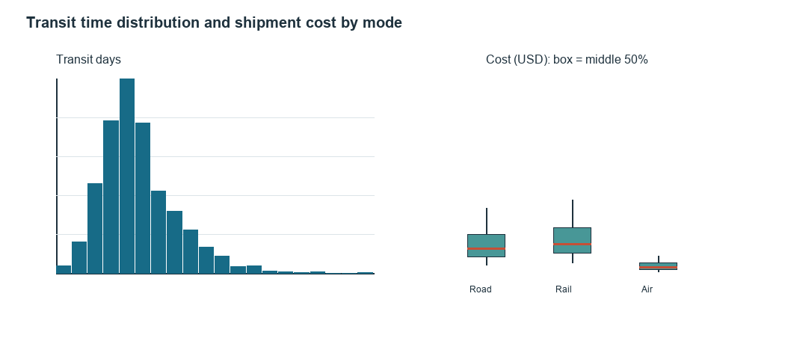
Figure 1. Histogram and mode cost distributions. The histogram shows spread; boxplots compare medians, middle quartiles, and range.

Trends and seasonality
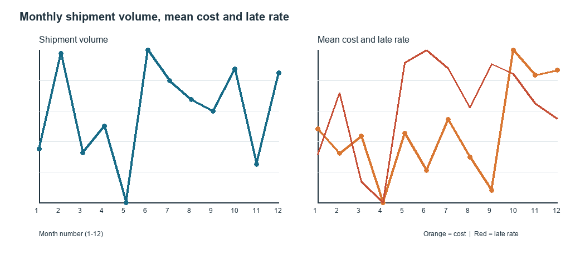
Figure 2. Monthly shipment volume, mean cost, and late rate. Month order exposes recurring peaks and co-movement.
Volume peaks in month 6 (116 shipments); mean cost peaks in month 10 ($1,166.80). Monthly observations can be noisy; compare with a rolling average and multiple years before capacity or pricing decisions.

Cost drivers and segment performance
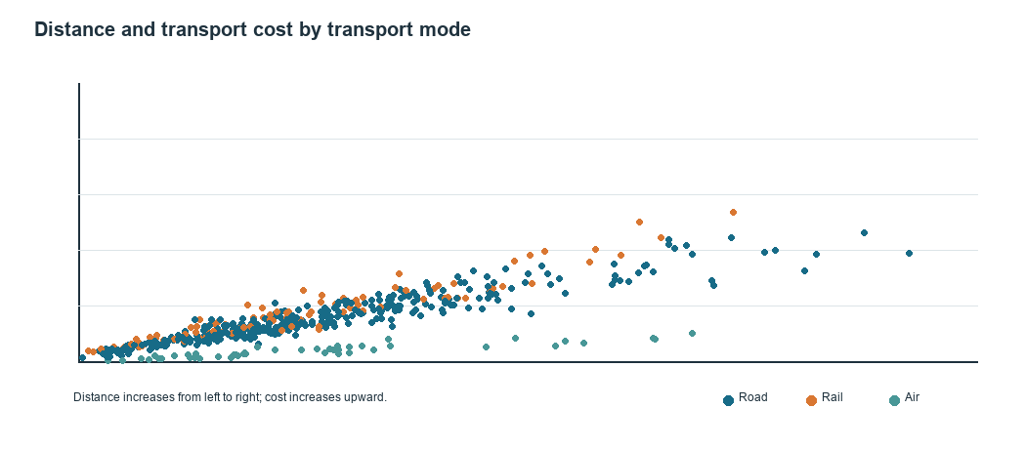
Figure 3. Distance-cost scatterplot colored by mode. The view reveals overall association and mode clusters.
Cost correlates with distance at r=0.83 and weight at r=0.03. These relationships are expected because the simulation uses both variables to generate cost; correlation does not prove causal impact. Compare normalized cost or use a multivariable model before assessing carrier efficiency.
Mode | Shipments | Mean cost | Mean transit | Late rate | Mean distance
Road | 786 | $1,052.01 | 2.53 d | 14.4% | 669 km
Rail | 281 | $1,207.65 | 3.20 d | 16.4% | 650 km
Air | 133 | $368.52 | 1.68 d | 5.3% | 684 km
Air has the lowest simulated late rate (5.3%); Rail has the highest (16.4%). Mode comparisons should account for route length, shipment mix, promised service, and cost.
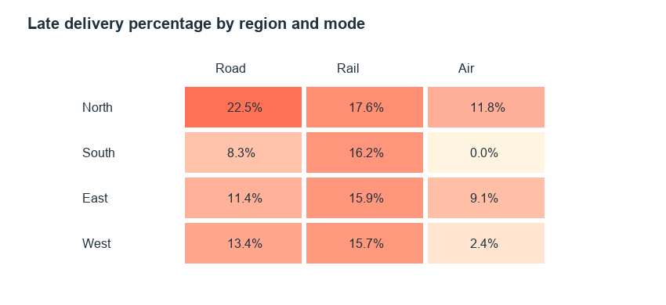
Figure 4. Heatmap of late-delivery rate by region and mode. The color pattern helps locate segment-level service exceptions.
North has the highest sampled regional late rate (20.4%). Treat this as a lead to investigate routes, handoffs, and carrier assignments, not as evidence that region itself caused delay.

Relationships and interpretation
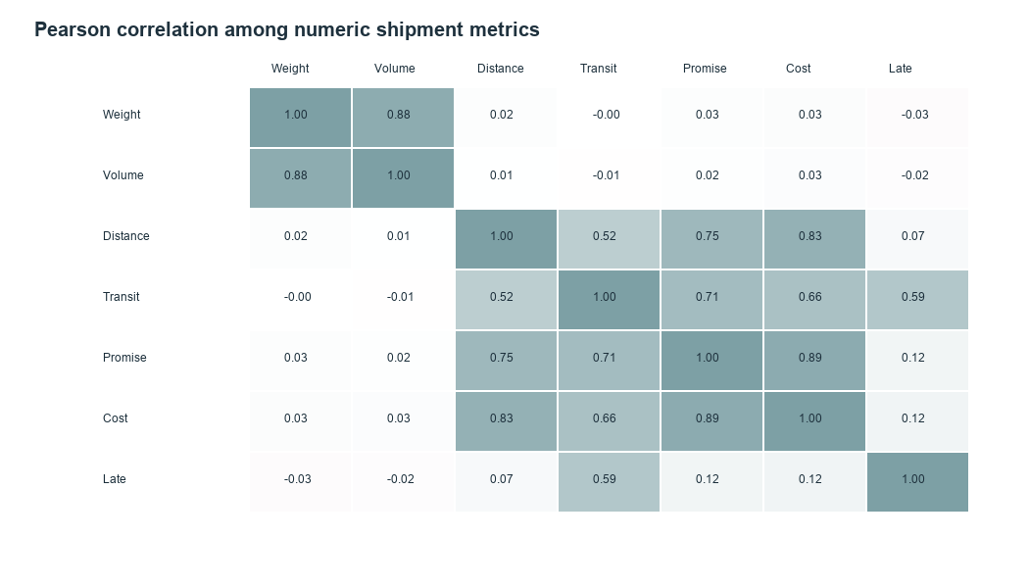
Figure 5. Pearson correlation matrix. Values summarize pairwise linear association and can reflect confounding or outliers.

Recommendations
- Track cost per shipment and cost per tonne-kilometre by lane, mode, and carrier, with distance and load visible. Investigate high-cost lanes after controlling for shipment mix.
- Review region-mode service exceptions against route, carrier, handoff, and promised transit details before changing service commitments.
- Compare peak-month volume and late rates with staffing, capacity, utilization, and spot rates; validate seasonality across multiple years.
- For real data, validate timestamps, late threshold, charge inclusions, shipment units, missing values, duplicates, and cancellations before analysis.
- Evaluate operational changes with matched lanes or controlled before-after comparisons; this synthetic example cannot establish savings or causal effects.

Visualization choices
View | Why it fits | Logistics question
Histogram and boxplot | Shows distribution and robust segment differences | How wide is transit spread? How do mode costs differ?
Monthly line chart | Preserves time order and exposes movement | When do volume, cost, or lateness rise?
Scatterplot | Shows numeric relationship and segment clusters | How does distance relate to cost by mode?
Heatmap | Encodes two categories in color | Which region-mode cells have high lateness?
Correlation matrix | Compact pairwise association scan | Which numeric measures merit follow-up modeling?

Reproducibility and code
Run the companion Python script to recreate the dataset, CSV, five figures, and report. Dependencies: numpy, pandas, Pillow, and python-docx. The seed is fixed at 42 for repeatable results with compatible library versions.
# Core EDA calculations
df["cost_per_tonne_km"] = df.transport_cost_usd / (df.weight_kg / 1000 * df.distance_km)
summary = df[["transit_days", "transport_cost_usd", "distance_km", "weight_kg"]].describe()
by_mode = df.groupby("mode").agg(
mean_cost=("transport_cost_usd", "mean"),
late_rate=("late_delivery", "mean"),
mean_transit=("transit_days", "mean"),
)
correlations = df[["distance_km", "weight_kg", "transit_days", "transport_cost_usd"]].corr()

Limitations
All records are hypothetical, and the simulation builds known relationships into the data. The analysis demonstrates methods but cannot forecast actual performance. Pairwise correlations do not isolate confounders or nonlinear relationships. Real decisions need validated operational data, uncertainty estimates, and clear cost definitions including applicable accessorial charges.

