Assessment Parameters
- Solution Completeness (all requirements addressed) – 20 %
- Working solution for each requirement – 40 %
- Comments – 20%
- Coding standards – 20 %
_______________________________________________________________________

Section 1 – Programming Foundation With Pseudocode [Marks 10]
Ask the user to enter room code and number of days they want to stay. Identify the room type and room price based on the table given below:

Code | Type | Price (B$)
D | Deluxe | 200.00
T | Twin Sharing | 170.00
S | Single | 120.00

The Code ,Type ,Price are entered through keyboard .write a Pseudo code and calculate the amount to be paid for the respective type of rooms.
Marks Distribution:

Subroutine Logic | 6
Best practices usage | 2
Exception Handling | 2

Section 2 – HTML and JavaScript [Marks 25]

Design a form to accept the details of the Members and their books . Use CSS (cascading style sheet) to design the web page. Perform the following validations.

a) Do the following:
1. All fields are mandatory
2. name should not be less than 5 characters
3. Mobile number should be 10 digits
4. Email Id should be valid.
5. Depart people dropdown should be autopopulated with the values :- 1 to 10.
6. Depart room dropdown should be autopopulated with the values :- with AC,Without AC.

b. When the customer clicks on the submit button, if all the data entered by the Member are valid, then display details such as Member name,Category and payable Amount in an alertbox.

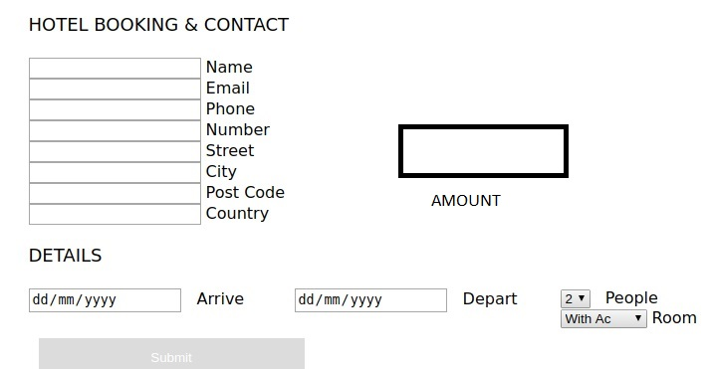

Marks Distribution:

HTML5 and CSS3 functionality
Displaying the form correctly | 6
Validating the form using HTML 5 attributes | 4
CSS Usage | 5
Javascript functionality
Calculating Payable amount | 5
Displaying the data in a new window | 5

Section 3 – Oracle [Marks 25]

Consider the following tables for the below questions.

Drop table Employee cascade constraints;
Drop table Department cascade constraints;

CREATE TABLE Department(Dno PRIMARY KEY, Dname VARCHAR2(20),Location VARCHAR2(20));

insert into Department values(10,’Research’,’Ney York’);
insert into Department values(20,’Accounts’,’Dallas’);
insert into Department values(30,’Sales’,’Chicago’);
insert into Department values(40,’Operations’,’Boston’);

CREATE TABLE Employee(Eid VARCHAR(6) PRIMARY KEY, Ename VARCHAR2(20), Salary NUMBER(7,2) , Mgr VARCHAR(6) references Employee(Eid), Dno Number(4) references Department(Dno));

INSERT INTO Employees values(‘EMP001’,’Smith’,2800,NULL,10);
INSERT INTO Employees values(‘EMP002’,’Allen’,1200,EMP001,20);
INSERT INTO Employees values(‘EMP003’,’Martin’,3000,EMP001,10);
INSERT INTO Employees values(‘EMP004’,’Turner’,1500,EMP003,30);
INSERT INTO Employees values(‘EMP005’,’Ramesh’,1000,EMP002,20);
INSERT INTO Employees values(‘EMP006’,’Suresh’,1600,EMP004,10);

Note: Question 1 and 3 are compulsory

- Write a stored procedure to accept the Department name and display department_number along with employee_ID,Employee_name and his salary in the following format. [Marks 12]

Dname | Eid | Ename | Salary

Note: If entered Dname doesn’t exist’s in the table, then throw exception with message “Department with name : <<Dname>> doesn’t exists”. Write a PL/SQL block to call this procedure.

Handling Customer NotFound exception | 2
Processing cursor | 5
Handling in /out parameters | 1
Coding conventions | 2
Pl/SQL block to call procedure | 2

- Solve any 2 out of 3. [Marks 5 each]
  - Write a Query to display Employee name along with his manager name.
  - Write a query to display employee name if he is working in the same department where an employee Allen is working and salary is greater than Miller’s salary.
  - Write a query to display department name of a department, if the department has at least 3 employees working in it and its average salary should be greater than average salary of all the employees..

- Write a SQL query to update the salary of an employee with a hike of 20% to the current salary only if the employee is acting as reporting manager to 2 employees. [Marks 3]

Section 4 – XML [Marks 5 each]

- Write XML document based on the Patients table given in section 3.
- Write Schema file and apply appropriate restrictions and validate the above created XML file.
For schema definition ensure that following restriction should be there.
a) Gender should be M or F only.
b) Ailment Type should only be "ENT", "Ortho", "Surgeon" or "Derma".

