You can install multiple versions of JDK. There is no problem with that. But please remember, only one JDK will be used at one time.
- Different Projects -> Different JDK
- API Automation -> JDK 21
- Selenium -> JDK 24

What is this Package?
- Folder Special Folder - Java recognise.
- Why Package -> We want to keep the proper structure Java programs.
Push the code to Github.
- Make sure you have a FREE account created on the ﻿github.com/
- Email, Password. ready.
- Create a Project in the IntelliJ - Create New Java -. Give a Name, LearningJavaATB15xProgram
- src -> Package ->(folder name) ->
  - ex_01_Java_Basics
    - Lab001_HelloWorld.java file
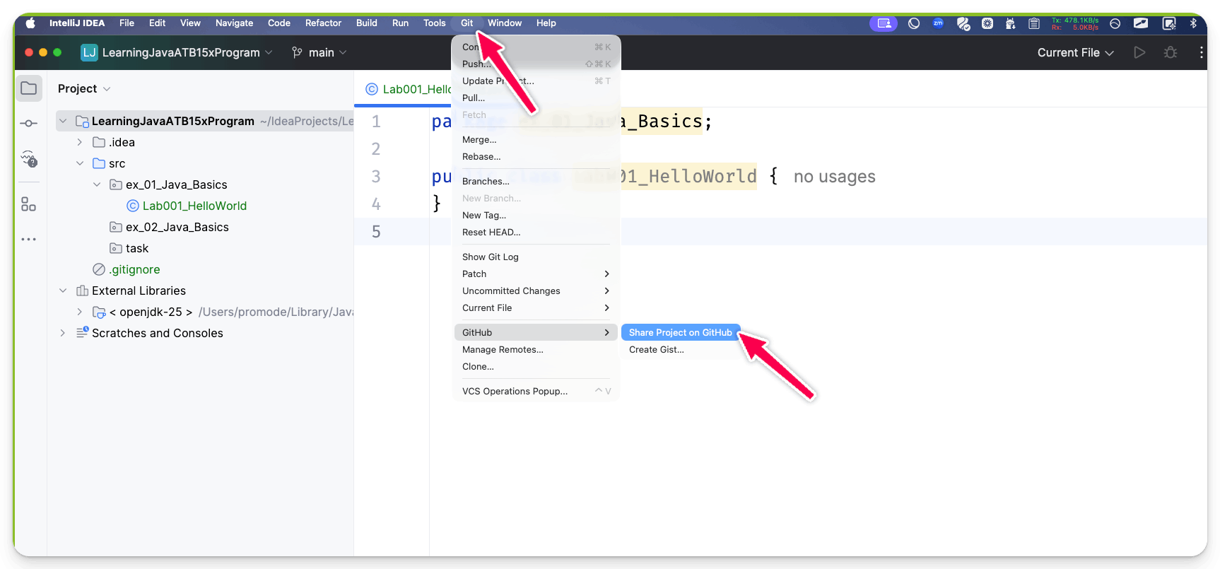
From the top menu, GIT / VCS -> GITHUB - Share Project on Github
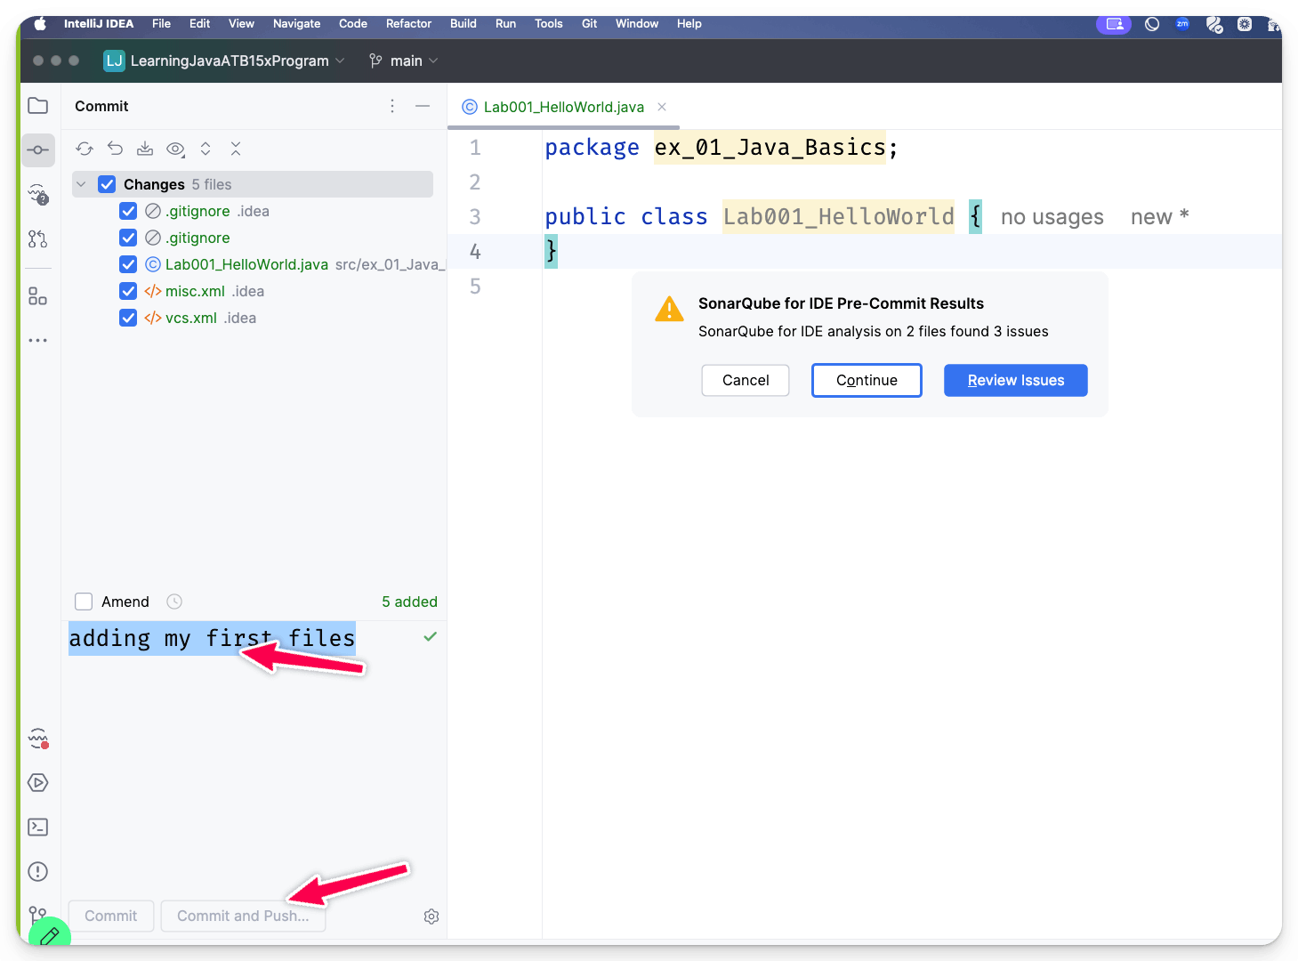
Uncheck the Private []. and click submit.
Option Intial Comment Yes or No, Yes and click on commit.
Click Top Git -> Commit -> (Add a message) Commit and Push Button.
﻿github.com/PramodDutta/LearningJavaATB15xProgram/blob/main/src/ex_01_Java_Basics/Lab001_HelloWorld.java

12th Dec 2025
⚠️ Flow Of Java PROGRAM
- Source Code ( Normal Code Editor NOTEPAD, intelliJ, eclipse , NotePad++)
- Javac ( Byte Code) ->
- JVM(JAVA) (I)( Line execution. )
- > Machine Code.
- Every java program has a source code file with .java extension
- .java -> .class -> .exe, .sh ..machine file (010101)
What is SRC folder?
- Folder which will contain all the Java files that we are working.
What is out? (Bytecode)
- Compiled Code Bytes Codes are presents
Why we are using Folder Structure?
- Learning purpose.
- Organised - Date What are topics which are covered.
How to run a Java program?
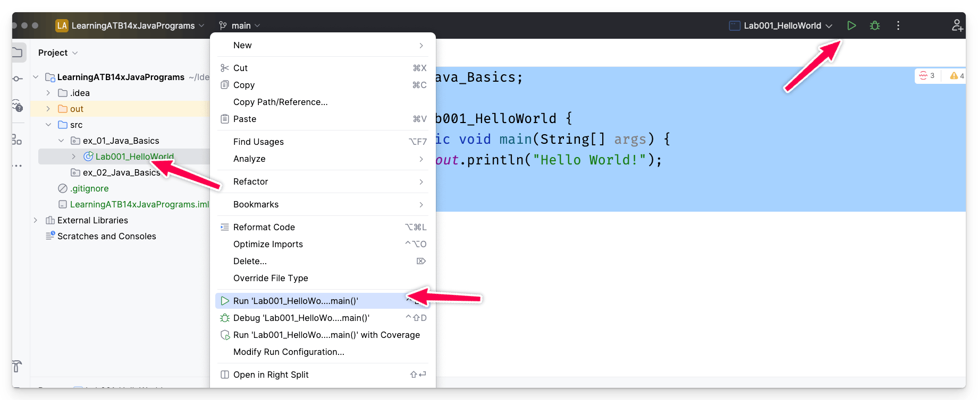
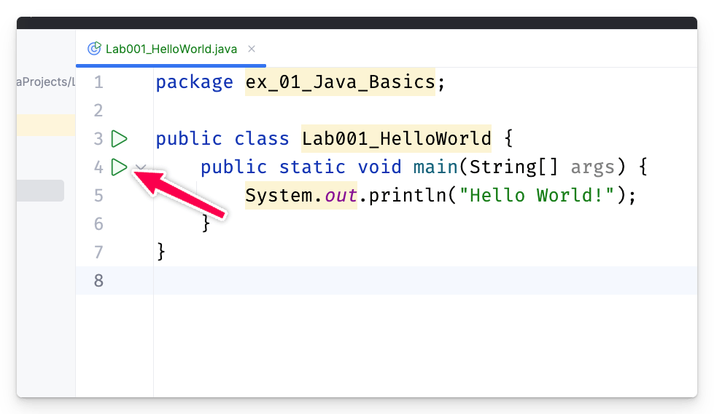
Shortcuts for the intelliJ
﻿resources.jetbrains.com/storage/products/intellij-idea/docs/IntelliJIDEA_ReferenceCard.pdf
﻿www.jetbrains.com/help/idea/reference-keymap-mac-default.html#basic_editing
psvm - main
main -> main
sout -> print -

⚠️ How Java program works? ( Source Code. file). Lab001.java
- Package
  - package ex_01_Java_Basics;
  - Basically tells the compiler that I am using a folder and this is the name of the folder, and when it is done, it adds a semicolon.
  - Class ( blueprint in Java)
    - public class Lab001_HelloWorld {
      - Method (main method, which is entry point to java program)
        - public static void main(String[] args) {
          - Statements ( That you want to do, always end with the ; (semi colon)
            - System.out.println();
            - misc code..
public -> avaible to everyone.
package -> This is nothing but a special folder in.
class -> blueprint, every java program starts with the class
main -> Main entry point is here.
statement -> println -> Print something into the console with new line.
System, out, static, void , String[] , args
package ex_01_Java_Basics;

public class Lab001_HelloWorld {
public static void main(String[] args) {
System.out.println("Hello World");
}
}
Dev / Tester / Automation Eng - Writes a Code in the Source Code.(Java)
Source Code. java. -> Lab001.java
Run > Green icon -> ByteCode -> Lab001.class (out)

- Main Method - main - JVM ( java virtual machine)
- Lab001.class -> Output in the console. ( JVM)
- JVM is looking for the signature.
  - public static void main(String[]
- Read the statement one by one and execute them.
- System.out.println("Hello World!");
How to write a Java program using Notepad? (Super Hard Way)
- Install the JDK Externally (Difficult Way)
- You need to check if JDK is installed on my machine or not. (cmd)
- javac --version
- java --version
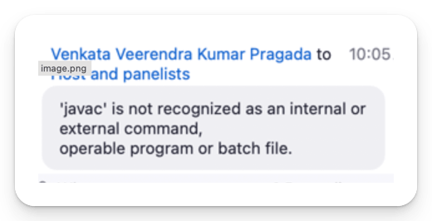
﻿www.openlogic.com/openjdk-downloads
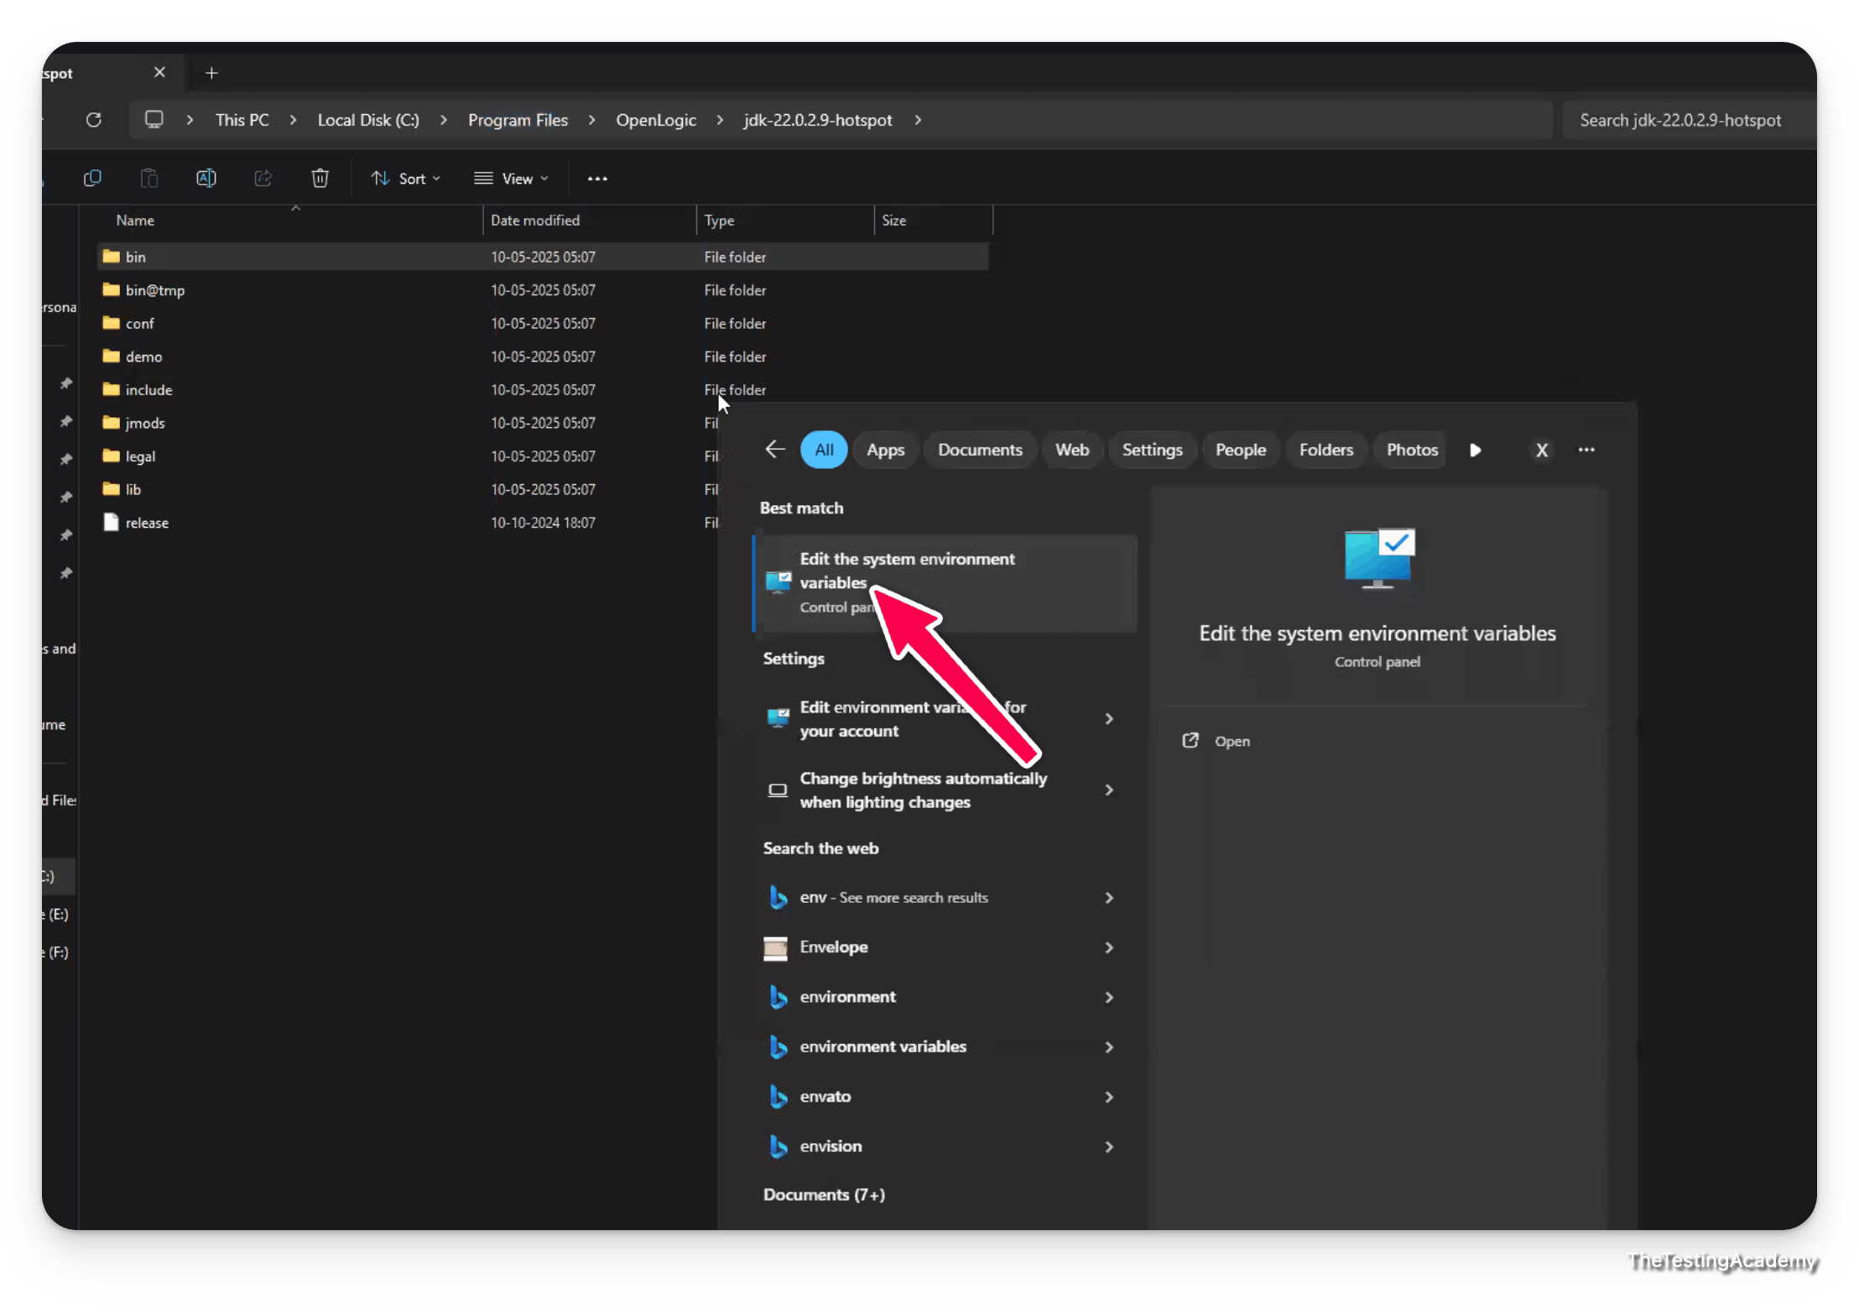
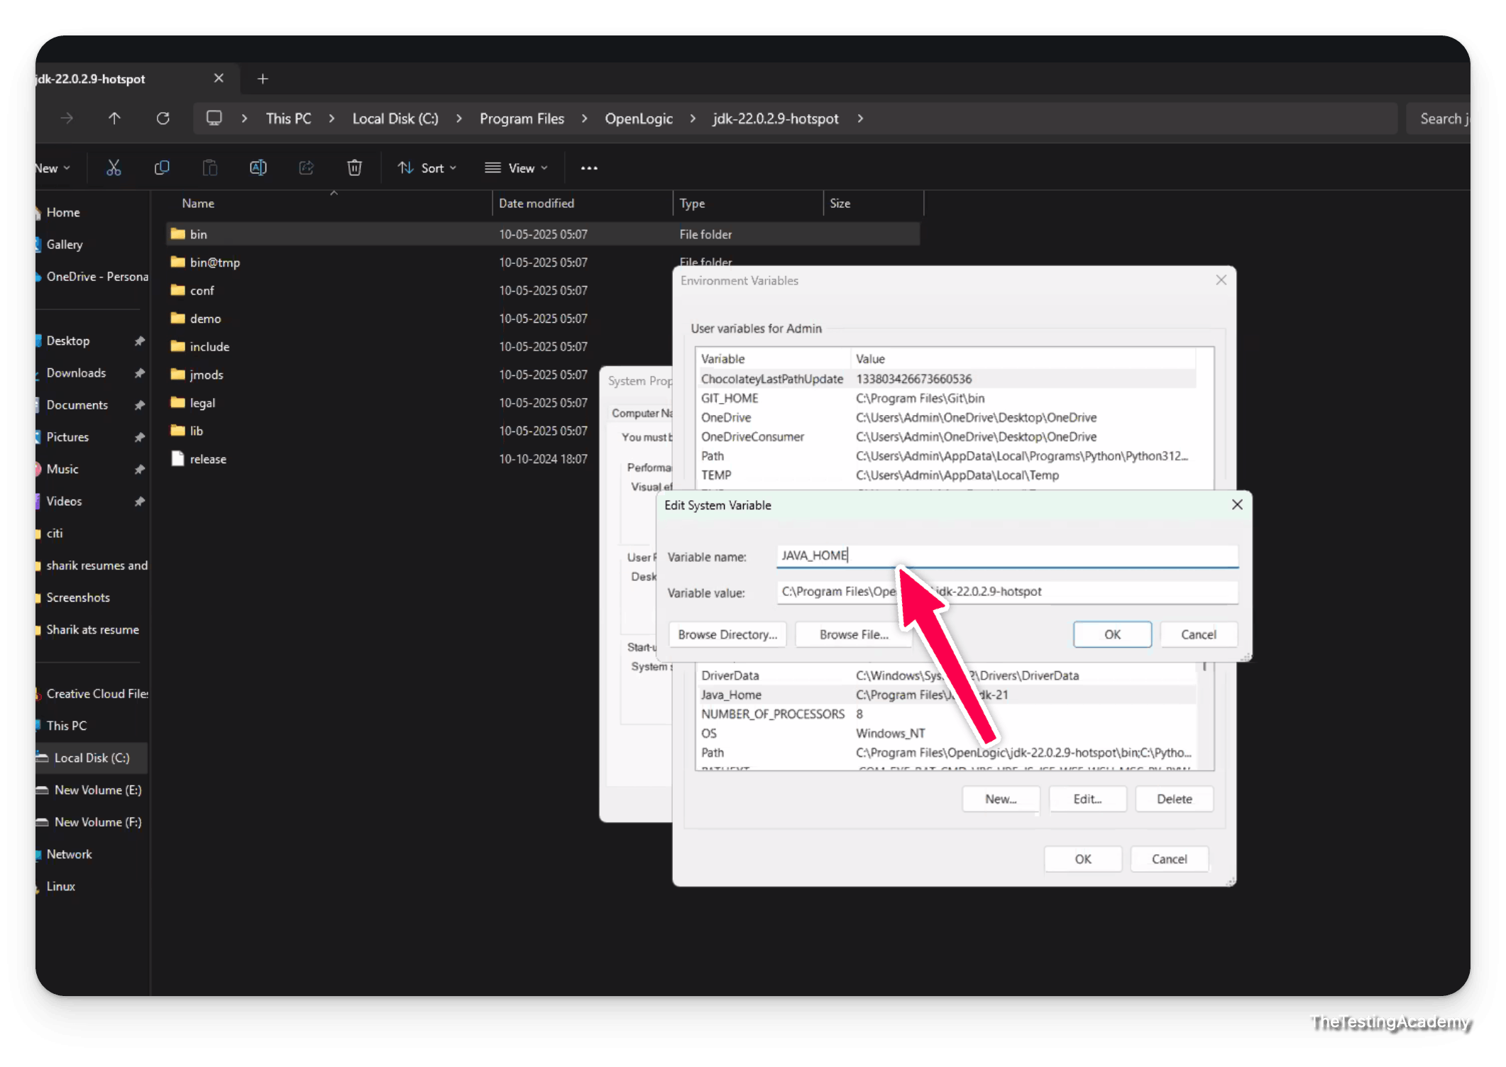
How to Set JAVA_HOME path in Windows
Set the JAVA_HOME Variable
﻿https://www.oracle.com/java/technologies/javase/jdk21-archive-downloads.html
﻿https://www.openlogic.com/openjdk-downloads
To set the JRE_HOME or JAVA_HOME variable:
- Locate your Java installation directory If you didn't change the path during installation, it'll be something like
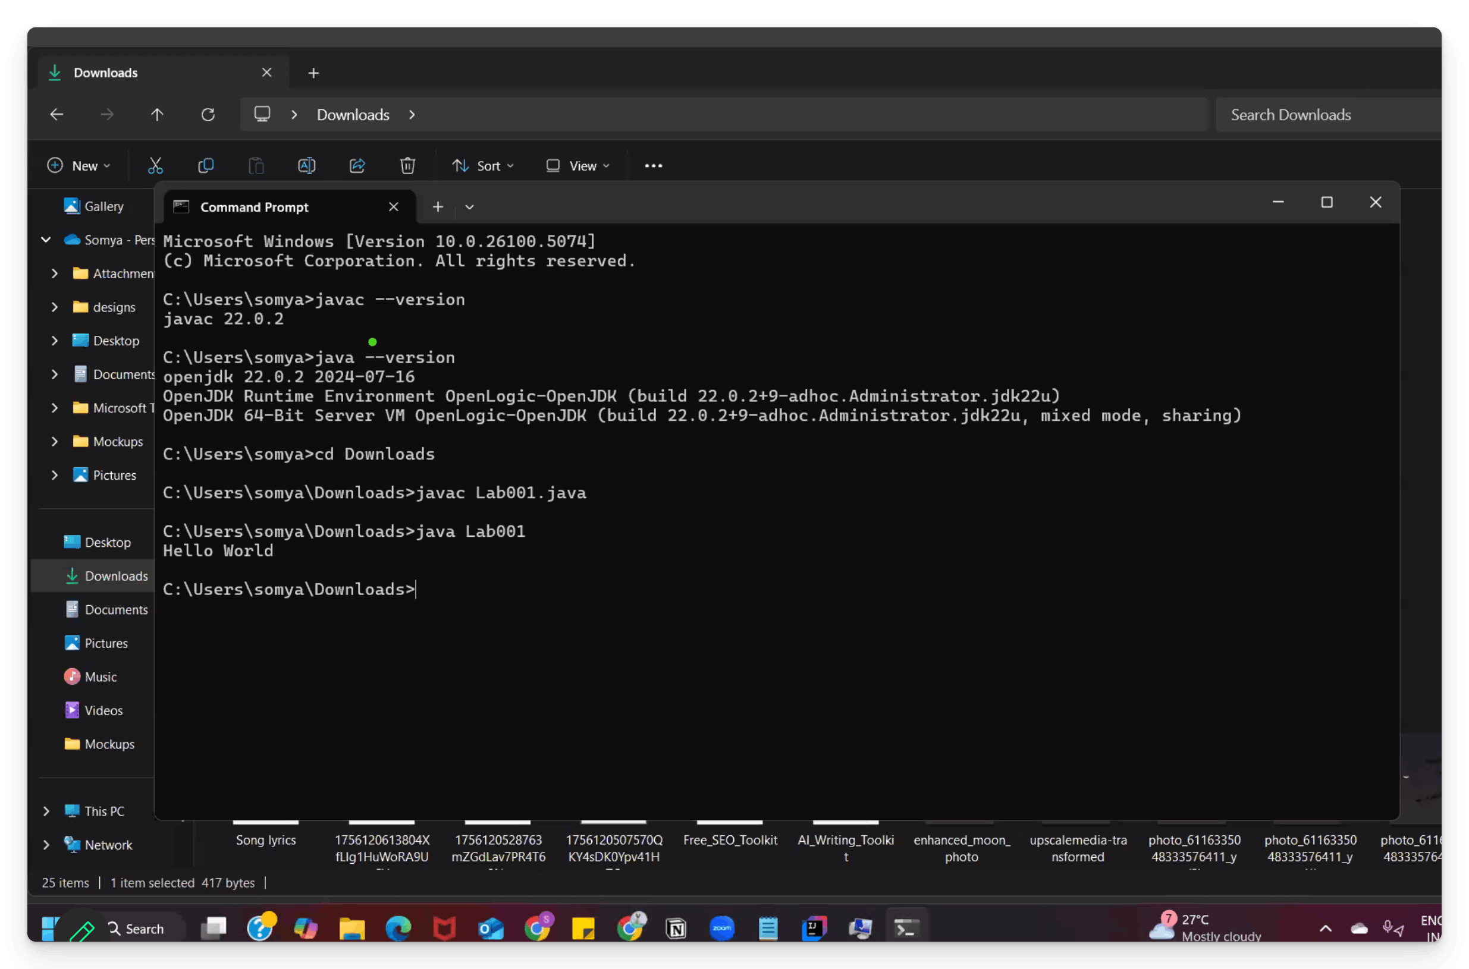
To install the OpenJDK into the Mac.
brew install openjdk
So that brew is installed. If it is not installed, you can use this command to install brew.
/bin/bash -c "$(curl -fsSL https://raw.githubusercontent.com/Homebrew/install/HEAD/install.sh)"
To type the command or type the program in the text edit, sublime text, Notepad++. So I save it as a Java and run it via the same( Terminal).
Run the Program in NotePad
- Pre Req -> JDK needs to run externally
- Make sure that you have saved the file in the same folder, where you are running the Commands
Lab002.java
public class Lab002 {
public static void main(String[] args){
System.out.println("Hi, Pramod");
}
}
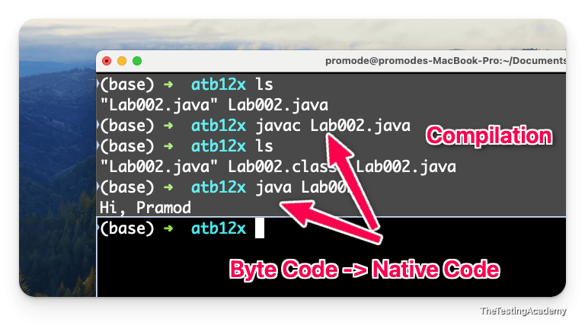
ls,cd, ... dir, pwd.. commands
linux Commands, Windows Works
Please watch this - ﻿courses.thetestingacademy.com/courses/sdet-club-masterclasses-1337/contents/647a955eb0a1c
How to write a Java program using Java Online Compiler? (Medium)
- ﻿www.programiz.com/java-programming/online-compiler/
- ﻿www.onlinegdb.com/online_java_compiler
Java is a case-sensitive language.
Windows Commands here ->
- If you find the cd, mkdir, dir command strange or not related
﻿www.perplexity.ai/search/winfows-commands-list-all-with-SwQeT79uRi2mKHiHY44eRg

- git.exe is not
- init failed.....blah

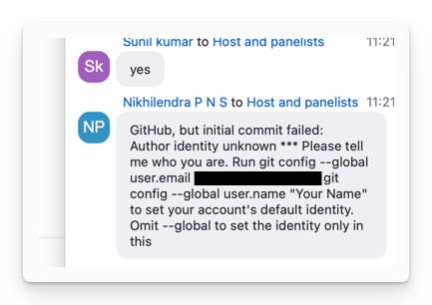
Any kind of Git related issue, just download this URL and install it and restart your IntelliJ.
﻿git-scm.com/downloads/win

- Create your Github account
- Push the code of first program
- IntelliJ
- Run the code on the Notepad after JDK Install
- Explore the online Java compiler also.
- Linux Commands
- Monday 8 PM - IST ( Doubt session GIT, JDK, NOTEPAD) - https://sdet.live/clubclass

⚠️ Monday 8 PM - IST ( Doubt session GIT, JDK, NOTEPAD, Github) - ﻿https://sdet.live/clubclass , 8 PM IST
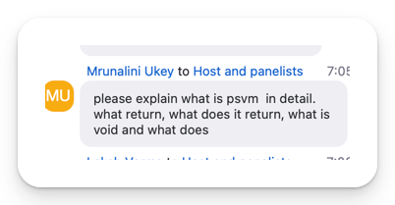
Main method - Functions clear)
Java | Comments in Java
Java comments are non-executable statements used to provide explanations, annotations, or documentation within the code.
- Single Line -> //
- Multiple Line -> /** **/
Shortcut ->
Comment / uncomment with line comment Ctrl + /. ( cmd+/)
Comment / uncomment with block comment Ctrl + Shift + /
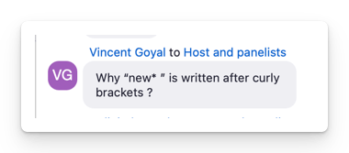

Exit Code
in Java, whenever you run a program, the program will also give you some kind of output or it will say that if your program is compiled successfully, yes or no. So it will give you a status for you. That status is generally in the form of integers.
exit code 0 - Program is successful
Normal Termination - Exit Code 0
Abnormal Termination - Exit Code: non-zero (1, 2, 255, etc.)
﻿www.ditig.com/linux-exit-status-codes

✅ Keywords & Identifiers
Keywords
- Simple English words which are having predefined meaning in Java Programming Language.
- Keywords are also called Reserved Words.
- All the keywords are defined in Lower Case.
- We can’t use keywords as names for variables, methods, classes, or as any other identifiers.
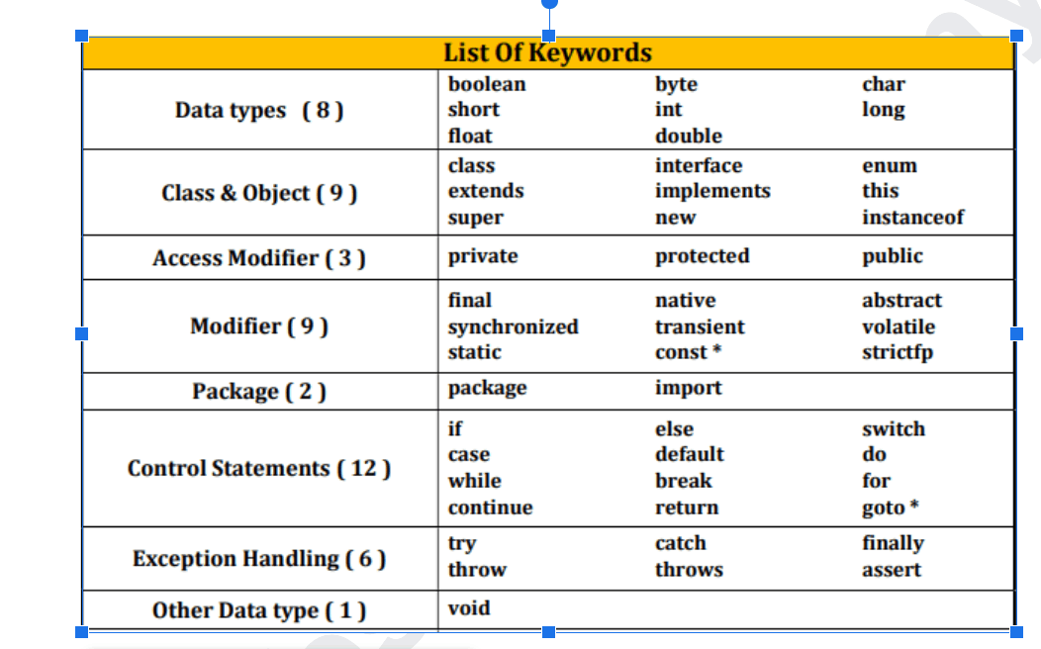
// package, public, class, static, void
package ex_02_Java_Basics;

public class Lab009_Keywords_Identifiers {
public static void main(String[] args) {
System.out.println("Keywords!");
}
}

// package, public, class, static, void

How many keywords are present in the Java JDK 24?
Java JDK 24 contains 54 reserved keywords. (54 RW)
Contextual Keywords (Introduced in Modern Java) ( 17-3) - Total - 68 Keywords
﻿www.perplexity.ai/search/how-many-keywords-are-present-PTjtMEIERoqsHLjLTyZPHQ#0

Identifiers
names those will be used to identify the programming elements like classes, methods, variables, etc uniquely.
Rules to follow when you define an Identifier:
- Identifier can contain Alphabets, Digits, and two special symbol i.e. Dollar ($), _,.
- Underscore (_).
- First character of an identifier must be an Alphabet(a-z,A-Z) or Dollar ($) or Underscore (_).
- Keywords or Reserved words can't be used as Identifiers.
// name convention - first letter capital and other letter capital also - CamelCase
// ex_02_Java_Basics ->. SnaKEcaSE
package ex_02_Java_Basics;

public class Lab014_Main_Method {
// public static void main(String[] args) {
//
// }
//
// public static void main(String[] args) {
//
// }
public static void main(String[] args) {

}

public static void main(String args) {

}
public static void Main(String[] args) {

}
}
can you have a multiple main function in a single program ?
Yes we can have multiple function looklike, But only 1 will run. ( public static void main(String[])
No, If you want to know, there is only one main method

println() vs print()
println -> new line in the console
print -> will not add a newline
Functions == Methods(class) in Java
// Block of code
⚠️ What are the differences between keywords and identifiers in Java?
Keywords are predefined, reserved words in Java that have special meanings and functions within the language. They are used to define the structure and behavior of Java programs.
Keywords:
- int, class, public, static, void, if, else, while, for
Identifiers:
- score, highestScore, convertToString, number1

People who are using Eclipse. ﻿sdet.live/git
commandline
How to push the Code to github.com?
Make sure that first time you have done the step - git -> github -> share the repo.
Git - commit ->push
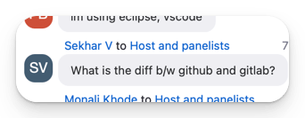
GIT - protocol to manage your source code with manage source.
Gitbash ( commandline utility to work with git)
Github -> MS -> Platform where you can store your source with git history.
Gitlab - Seperate -> Dev Ops + Git. (github ++, Security))

Watch these 4 tutorials - small vidoes, git add, git commit, git reset, git merge, git push
﻿sdet.live/git

- Make sure that you have already shared the project to ﻿github.com (Share with github.com)
- Git -> Commit (add a message) ->. git push -> then done
Delete the File
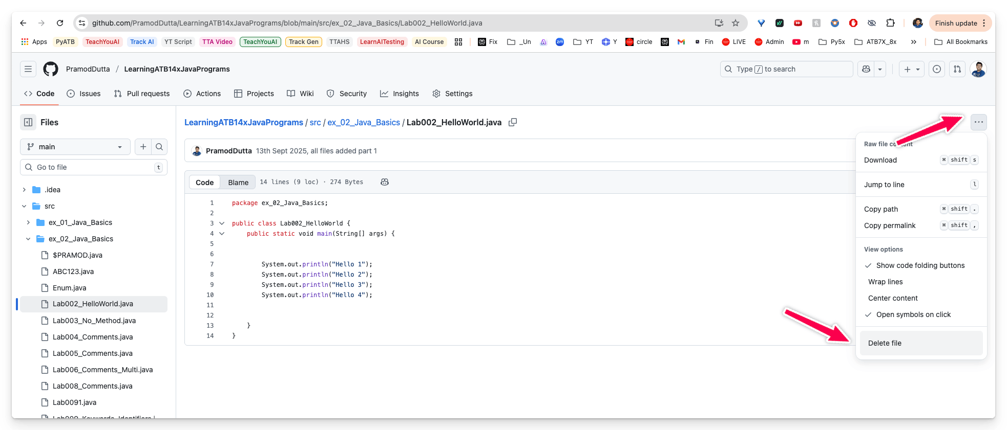
What is GIT?
Git is a version control system that is used for tracking changes to files.
It does this through a series of snapshots of your project.
It works with those snapshots to version and manage your source code, and it does this in a simple way.
Git -> protocol -> Rules -> Which can track your source code.
Git -> Version Control System - track our files.
Why Use Git?
- Can work offline.
- Collaborating with others is easy!
- Branching is easy!
- Branching is fast!
- Merging is easy!
- Git is fast.
- Git is flexible.

Variables and Data Type
What is Variable?
- Store the value (which can be changed in the program).
- Each variable should be given a unique name (identifier).
- Memory will be allocated for the variable while executing the program.
- Value of the variable can be changed any number of times during the program execution.
How to create Variable? (Declaration Syntax)
data_type variable_name = variable_value
variable_name -> identifier variable_value -> literal data_type -> int, short, byte, long, float, ....
Variable Name (identifier) | Rules to follow when you define an Identifier:
- Identifier can contain Alphabets, Digits, and two special symbol i.e. Dollar ($).
- Underscore (_).
- First character of an identifier must be an Alphabet or Dollar ($) or Underscore (_).
- Keywords or Reserved words can't be used as Identifiers.
Data Types
Value they can store, Size(Range) -
- Primitive Types
- Non Primitive Types , (Reference Type)
Primitive Types
- Boolean Type
- Numeric Type
  - Intergral -> ( whole numbers) , no decimal)
    - byte
    - short
    - char
    - int
    - long
  - Floating ->. with decimal)
    - float

    - double
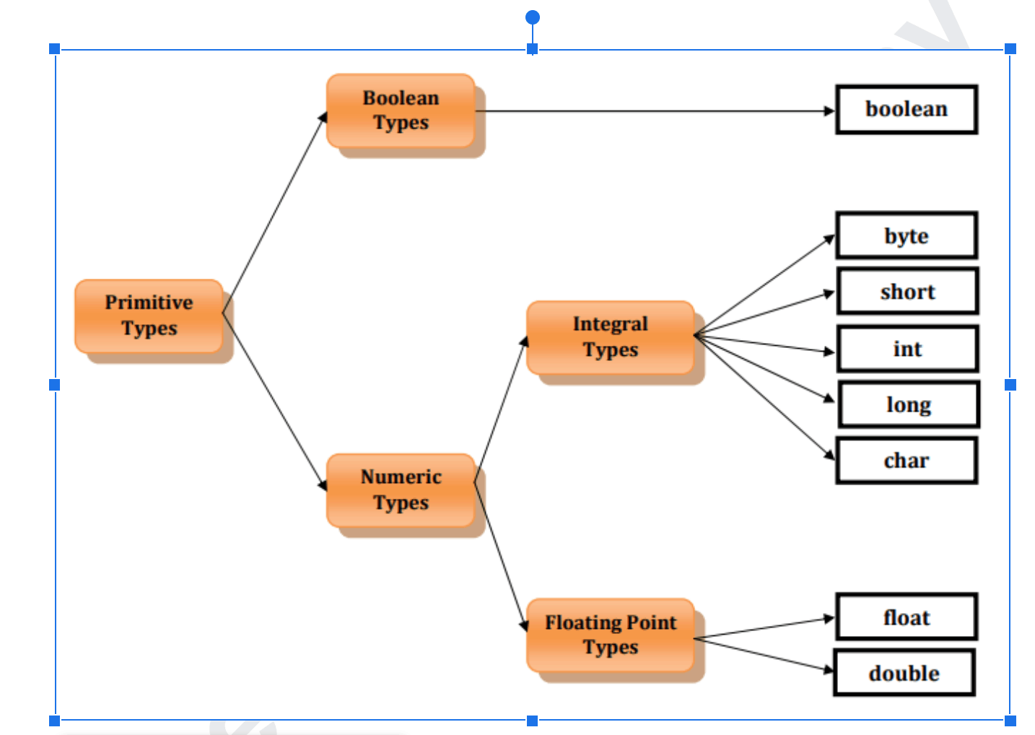
Non Primitive (Reference Data Types)
- String - PRAMOD -> p,r,a,m,o,d
- Arrays
- Enums
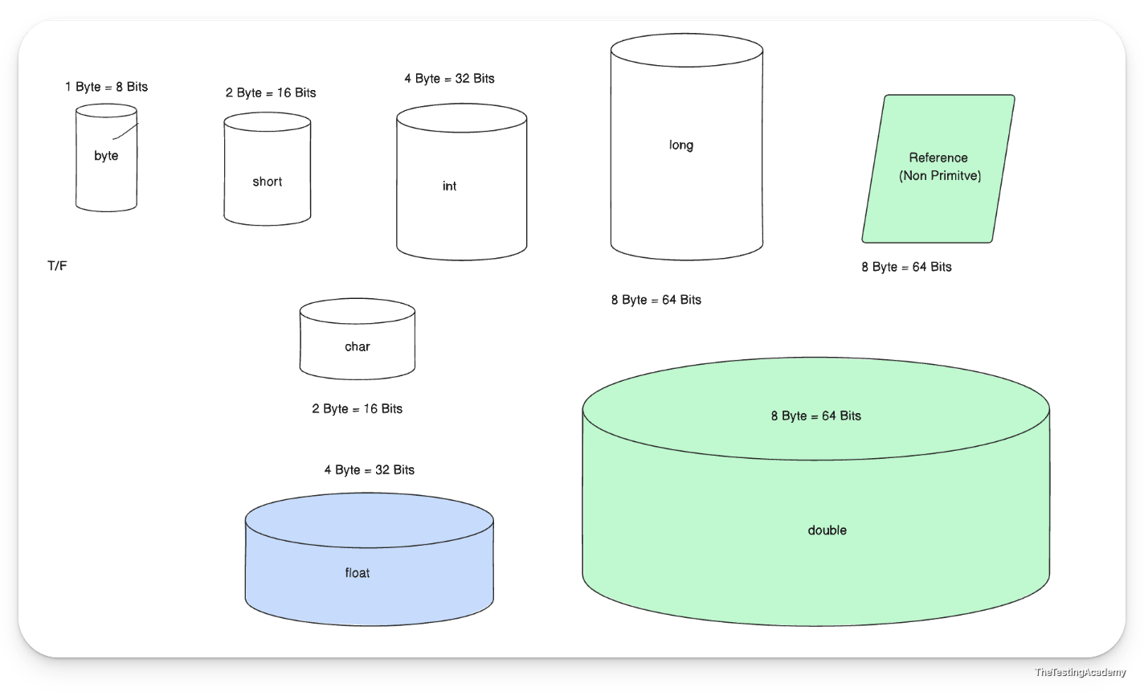
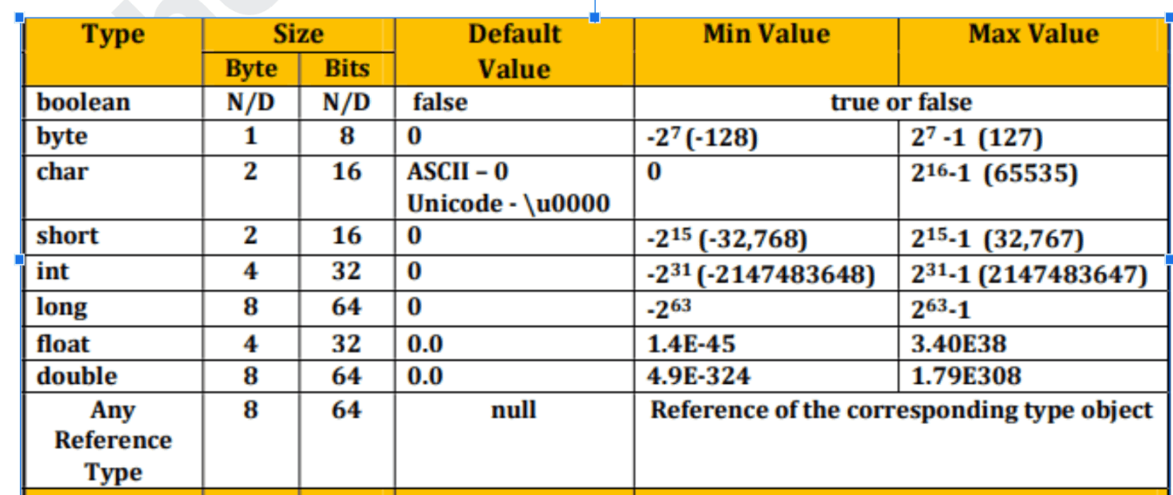
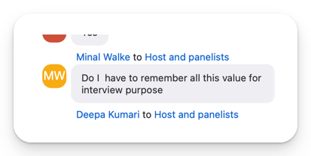
Byte, Bits
Variables in Java are strongly typed; thus they all must have a data type declared with their identifier.

Constants , Literals, Operators
int a = 10;
Constants
- Special variable whose value can't be modified during the program execution.
- One created and SET THE VALUE , we will not able to modify.
- PI - 3.14 , this value should be change during the execution of the program.
- Constant is also called as final variable.
Why it required?
- Constants - they should be final in nature.
If you try to change the value - java: cannot assign a value to final variable PI
Local Variable -> We have to initialize if you want to use it.
Variables Types ( Scope)
- Local Variables - within {}
- Static Variable - ?
- Instance Variable -?
Last 2,3 will come in OOPs concepts

How to Define Constants
- Use the final keyword.
- Commonly declared as public static final for global usage.
- Naming convention: UPPERCASE_WITH_UNDERSCORES
- Improves readability and maintainability.
final int MAX_USERS = 100;

✅ Literals
A literal is a fixed value directly written in the source code.
A literal is a fixed value directly written in the source code.
int a = 10;
- Literals are the actual values assigned
- Literals can be Numeric and Non Numeric.
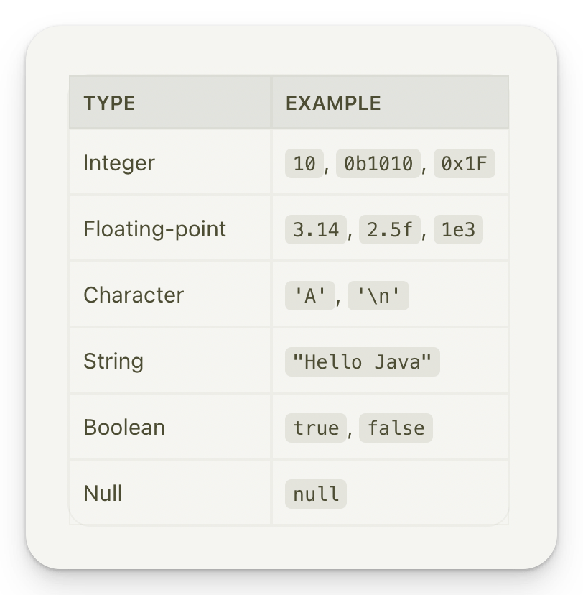
﻿www.rapidtables.com/convert/number/binary-to-decimal.html?x=1010
Types of Literals
- Boolean Literals - true, false
- Character Literals
- String Literals
- Integral Literals
- Floating Literals
- null Literal , Scientific Literals
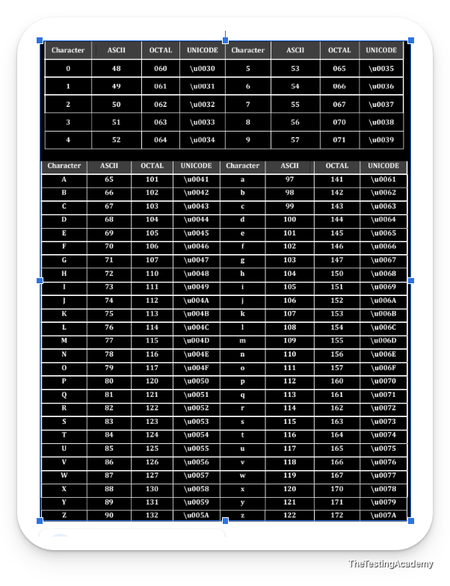
// 0 to 67535
A-Z, !@#$%^&*() - ( 65 to 3500)
象, ₹
ASCII -
UniCode - \u03203

I earn 1 lakh rupees per month(2-5L) without any issue through my job, through sharing the content on LinkedIn, sharing my thoughts and giving and contributing to my company. I do this without compromising my family time, without compromising my time with my husband or wife or my children or my mother and father or sister. I love sharing all this. I love contributing all this. I am a money magnet. I have a very healthy relationship with my parents, family and more.
minimum - 3 months > (30 early wake) - 6:15 - 6.45
Daily listen to this 1.5x -> https://www.youtube.com/watch?v=l1gXZu1i8TM&t=148s
Operators
- An operator is a special symbol.
- Tells the compiler to perform specific mathematical or logical operations on operands.
- Operators are used to perform operations by using operands.(variable names) -> age.
There are three types of operator depending on the number of operands required
- Unary Operator
- Binary Operator
- Ternary Operator

Assignment Operator ( =)
int a = 10;// = -> assignment operator// RHV to the LH
Arithmetic Operators -> Used for basic mathematical operations.
- + (Addition)
- - (Subtraction)
- * (Multiplication)
- / (Division)
- % (Modulus)
Relational Operators (Used to compare two values.)
- < (Less than)
- <= (Less than or equal to)
- > (Greater than)
- >= (Greater than or equal to)
- == (Equal to)
- != (Not equal to) !=
Logical Operators -> (Digital Electronics)
- && (AND)
- || (OR)
- ! (NOT) - REVERSE
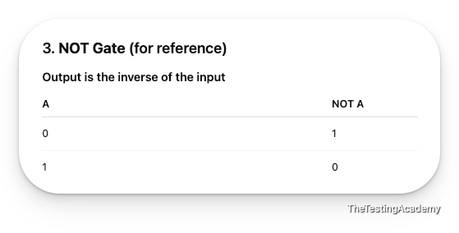
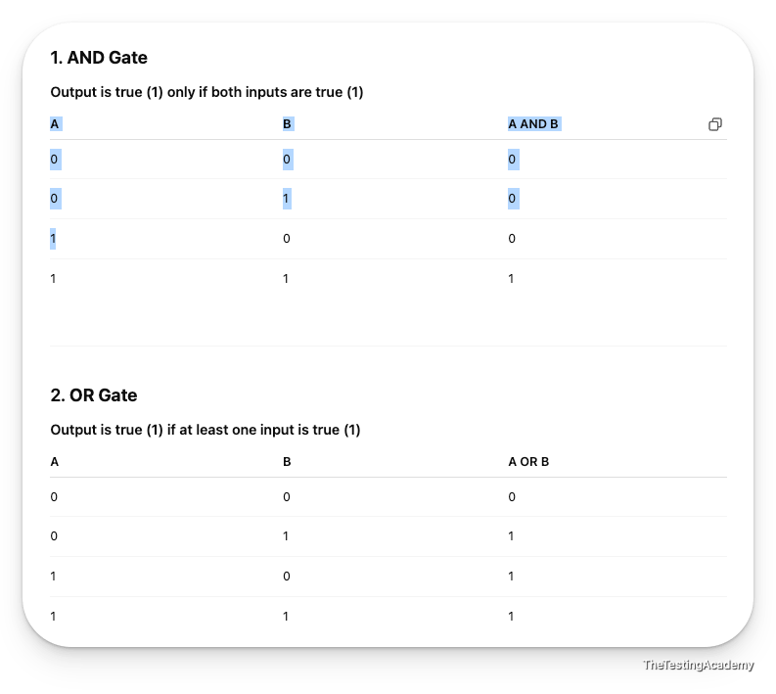
Compound Assignment Operators
- +=
- -=
- /= / =
- *=
New operator
String s1 = new String("Pramod");
Instance of operator
instanceof
Increment and Decrement (++,--)

BODMAS is an acronym that helps people remember the order of mathematical operations
- B: Brackets
- O: Order (powers, indices, or roots)
- D: Division
- M: Multiplication
- A: Addition
- S: Subtraction

= -> Assignment Operator (rhv == lv)
== -> Compare Value operator which return the boolean (compare)
Brackets Orders (powers, roots) Division Multiplication Addition Subtraction However, Multiplication and Division have the same precedence. When both appear together (without brackets),most programming languages evaluates them from left to right.

Daily Routine Example (QA/AT/ SDET)
- Start the day with daily stand-ups (Agile & Scrum framework). - ﻿sdet.live/agile
  - Discuss what was done yesterday.
  - Share today’s tasks.
  - Highlight any blockers to the team.
- Pick automation backlog items and work on automating them.
- Handle regression, stability, and maintenance issues in automation.
- Manage hotfix activities:
  - Plan hotfix execution.
  - Run Jenkins pipelines with correct parameters.
  - Execute on staging, QA, or production environments.
- Participate in Scrum ceremonies:
  - Sprint planning.
  - Sprint review.
  - Retrospective.
- Collaborate with developers:
  - Gain knowledge of new features.
  - Align automation tasks with development updates.
- Report daily to the manager:
  - Share completed tasks.
  - Flag blockers or issues.
- Perform manual testing tasks:
  - Test case creation.
  - Test planning.
  - Test execution for new features.
- Mentoring the junior QA if required.

24th Dec 2026
Type Casting
- Type Casting = converting one data type into another.
- There are two main types of type casting:
  - widening -> Explicit, Implicit
  - narrowing -> Explicit, Implicit
Widening Casting
Widening casting, also known as implicit casting, occurs when converting a smaller data type to a larger one.
This type of casting is performed automatically by the Java compiler and is considered safe because there's no risk of data loss.
- Smaller → Larger data type
- Done automatically by Java
- No data loss
byte → short → int → long → float → double

Narrowing (Explicit) Casting
- Larger → Smaller data type
- Must be done manually
- Possible data loss
double x = 10.75;
int y = (int) x; // 10 (decimal lost)

Object Type Casting (Upcasting & Downcasting)
Class and Objects - This is concept again used.

Ternary Operator
// result = condition ? expression1 : expression2;
Ternary Operator Concept
- The conditional operator, commonly known as the ternary operator in Java.
- evaluate a condition and return one of two values based on the result.
- Very similar - if-else statement.
Syntax
- result = condition ? expression1 : expression2;
- condition: This is a boolean expression that is evaluated.
- expression1: This expression is executed if the condition is true.
- expression2: This expression is executed if the condition is false.
Nested Ternary
result = condition1 ? expression1 : (condition2 ? expression2 : expression3);

Input from users (in java)
- CLI Command line. (Args)
- Scanner class.
- Buffer Reader class
- Files as input.

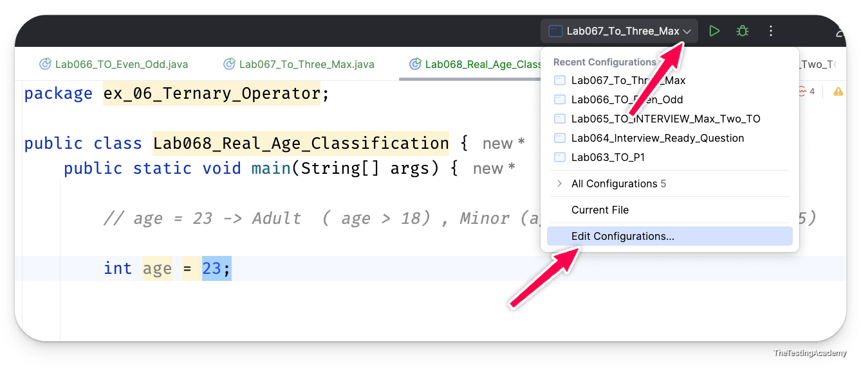
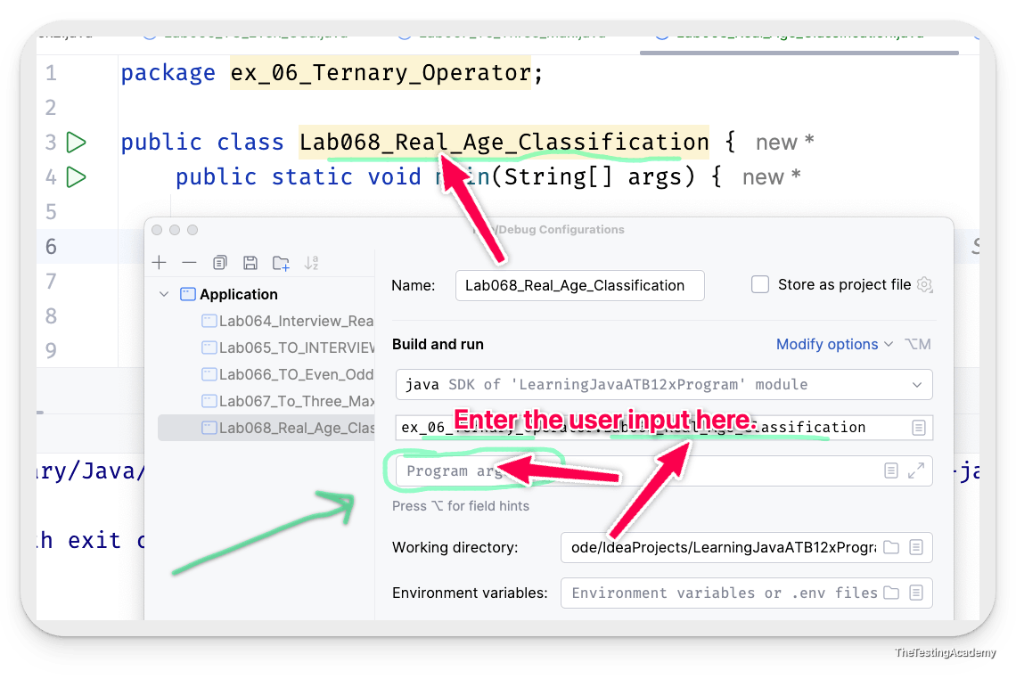
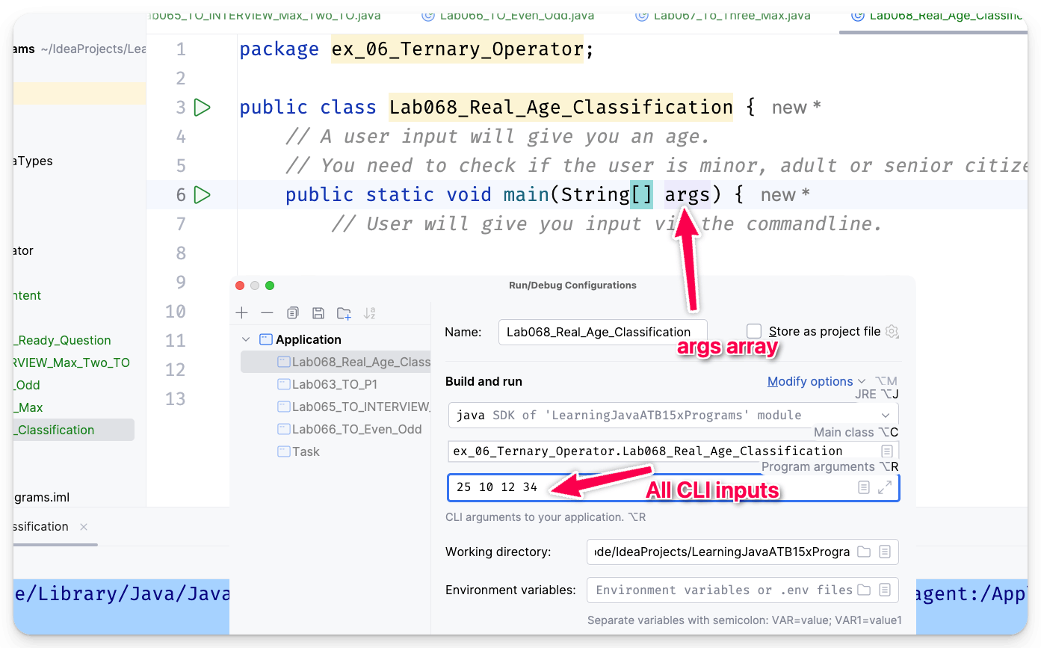

26th Dec 2025
Increment & Decrement Operator
They are unary operators used to increase or decrease a variable’s value by 1.
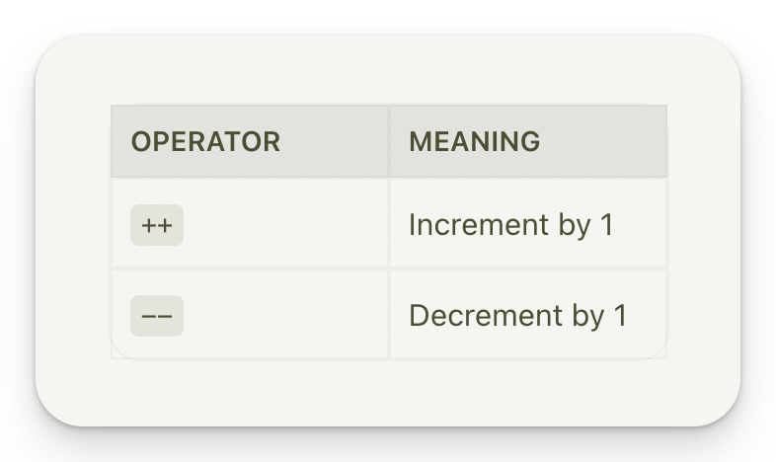
Increment Operator (++)
- Prefix Increment: ++variable
- Postfix Increment: variable++
Decrement Operator (--)
- Pre Decrement: --variable
- Post Decrement: variable--
int a = 10;
Pre - increment -> ++a , operand.
- value is incremented first and then stored in the result.
Post a++
- print first and then increase the value.
Expression and Result Table ( ERT) || Line no | a | Result (b) ||

Debug a Program in Java
- Step by Step execution to see the results.
- To find the issues(we can run the program line by line).
- Rule -> Add breaking point (red) by clicking on the number -> condition.
- ﻿www.jetbrains.com/help/idea/using-breakpoints.html?keymap=Windows
Run ->
Complete run in One Go.
Interviews (If Else)
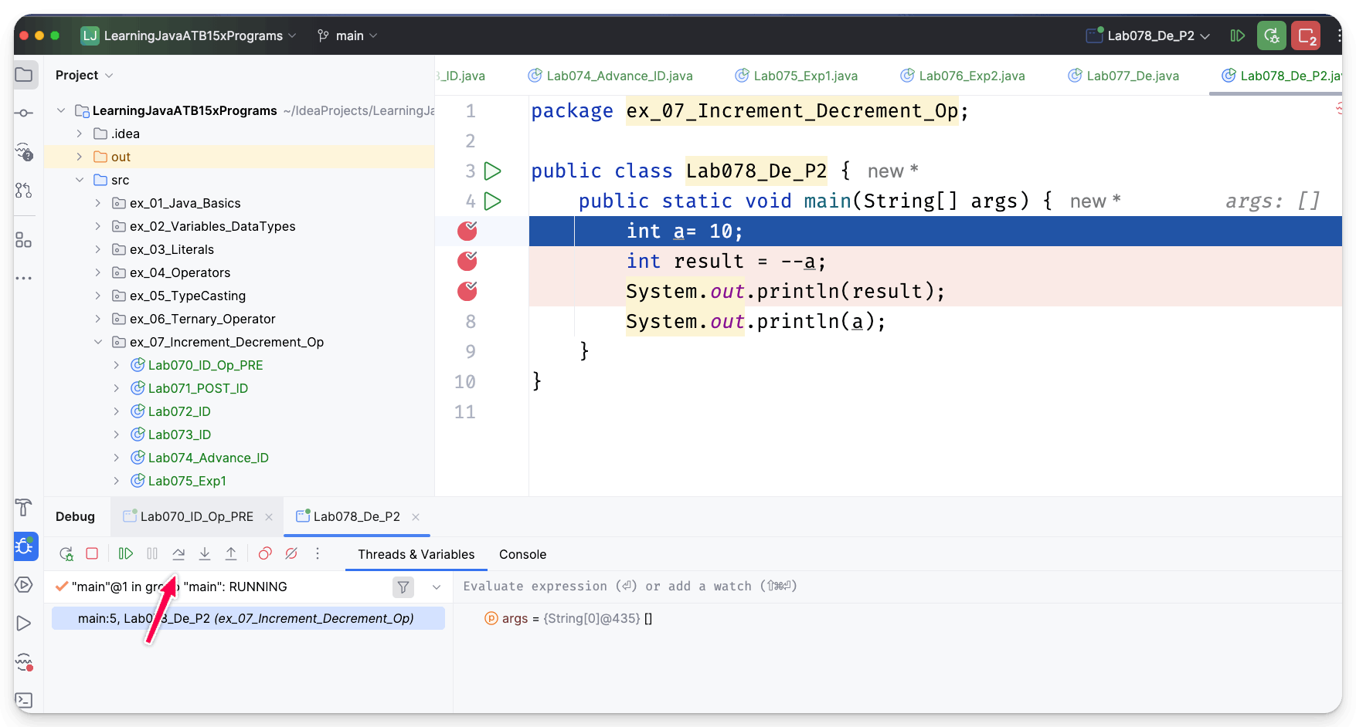

✅ Triangle Classifier:
Write a program that classifies a triangle based on its side lengths. Given three input values representing the lengths of the sides, determine if the triangle is equilateral (all sides are equal), isosceles (exactly two sides are equal), or scalene (no sides are equal). Use an if-else statement to classify the triangle.
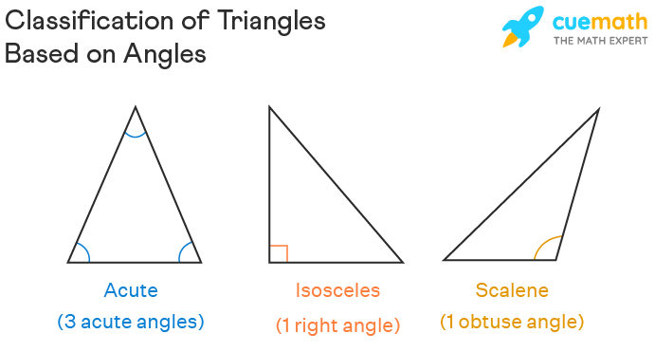
Conditions and Loops
If Conditional (statement)
Decision-making in programming.
- Only If condition
- If - else
- If with elseIf, else
Basic syntax
condition -> o/p. should be bolean
condition -> it will result in either true or false. -> Result dataytpe -> (boolean)

if (condition) {
// code to be executed if the condition is true
}
else {
// do this
}

1. If we have multiple condition - if else - complex.
2. Break and Continue keywords - can't be used with the if and else.

NesteD if, Switch, For, For Each... ..dasda

#### Basic syntax

asdasd

+  +  + | + | +
+
+

Scanner class
- Final Class, it has a inbuilt method like nextInt, , next, nextFloat.
- These inbuilt methods can be used to basically get an input from a user and assign directly into their respective data types.
- You can use the Scanner class; it's an inbuilt class provided by Java. You have to create the object by using the new operator. The moment you use it, you can directly use their functions to get input from a user.

