**CS 5710**

**Machine Learning (Assignment # ICP1)**

E-mail: [mxk74830@ucmo.edu](mailto:mxk74830@ucmo.edu)

Name: Madhu Kumar Komarapuri

Course: CS 5710

Assignment: Assignment 1

Video Demo: https://drive.google.com/file/d/1ctgXs1jD2D53WlL7NC4Kjw27khazo_vx/view?usp=sharing

**Question 1**

The following is a list of 10 students ages:

ages = [19, 22, 19, 24, 20, 25, 26, 24, 25, 24]

• Sort the list and find the min and max age

• Add the min age and the max age again to the list

• Find the median age (one middle item or two middle items divided by two)

• Find the average age (sum of all items divided by their number)

• Find the range of the ages (max minus min)

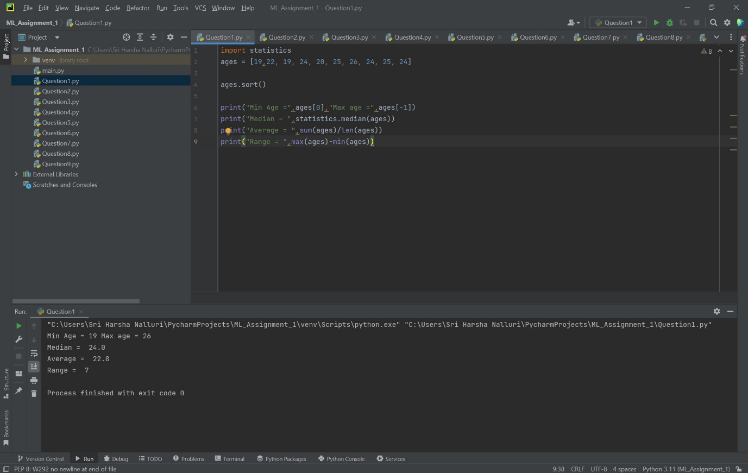

Sorted the list and done the min and max age, again added min and max age to the list. Now identified the median, average and range of the ages.

**Question 2**

• Create an empty dictionary called dog

• Add name, color, breed, legs, age to the dog dictionary

• Create a student dictionary and add first_name, last_name, gender, age, marital status,

skills, country, city and address as keys for the dictionary

• Get the length of the student dictionary

• Get the value of skills and check the data type, it should be a list

• Modify the skills values by adding one or two skills

• Get the dictionary keys as a list

• Get the dictionary values as a list

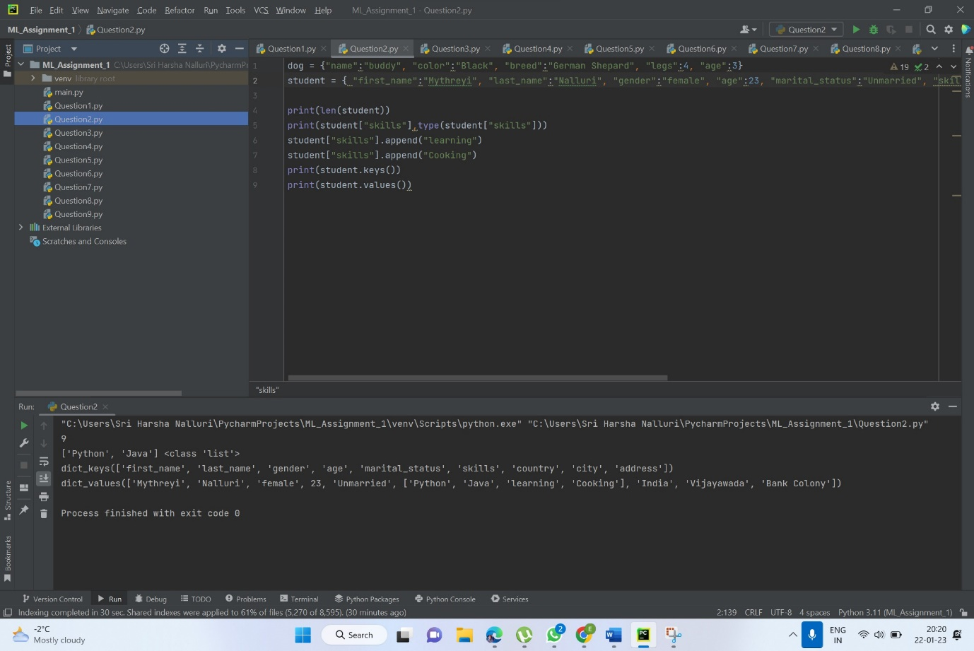

Created dog, which is empty dictionary and added name, color, breed, legs, age to the dog dictionary. Created student dictionary and add first_name, last_name, gender, age, marital status, skills, country, city and address as keys for the dictionary. Identified the key values and length of the student dictionary.

**Question 3**

• Create a tuple containing names of your sisters and your brothers (imaginary siblings are

fine)

• Join brothers and sisters tuples and assign it to siblings

• How many siblings do you have?• Modify the siblings tuple and add the name of your father and mother and assign it to

family_members

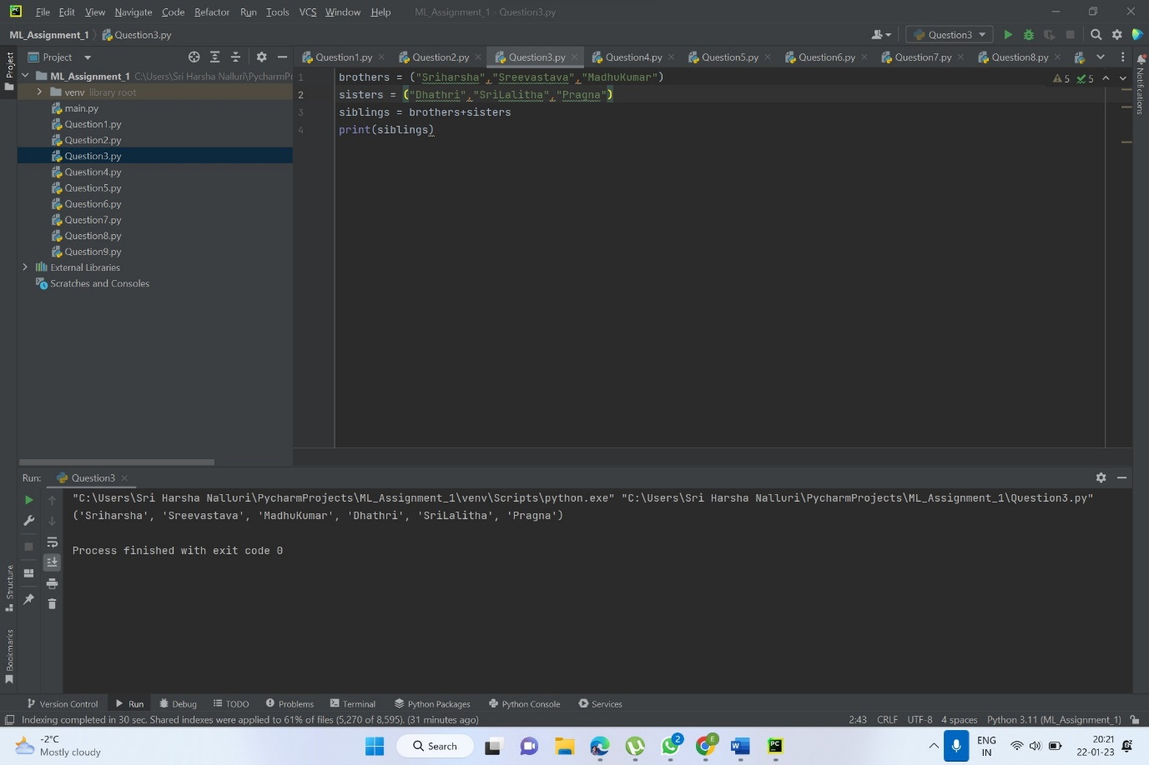

Created tuple containing names of sisters and brothers and Joined brothers and sisters tuples and assigned it to siblings and modified the siblings tuple and added the name of father and mother and assigned to family_members

**Question 4**

it_companies = {'Facebook', 'Google', 'Microsoft', 'Apple', 'IBM', 'Oracle', 'Amazon'}

A = {19, 22, 24, 20, 25, 26}

B = {19, 22, 20, 25, 26, 24, 28, 27}

age = [22, 19, 24, 25, 26, 24, 25, 24]

• Find the length of the set it_companies

• Add 'Twitter' to it_companies

• Insert multiple IT companies at once to the set it_companies

• Remove one of the companies from the set it_companies

• What is the difference between remove and discard

• Join A and B

• Find A intersection B

• Is A subset of B

• Are A and B disjoint sets

• Join A with B and B with A

• What is the symmetric difference between A and B

• Delete the sets completely

• Convert the ages to a set and compare the length of the list and the set.

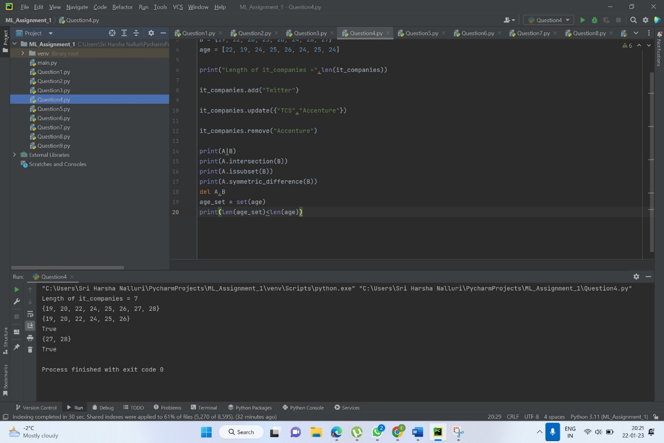

Identified the length of the set it_companies added twitter and inserted multiple companies to the set it_companies and joined A and B done the below details and at the end found symmetric difference between A and B and deleted the sets completely and converted the ages to a set and compared the length of the list and the set.

**Question 5**

The radius of a circle is 30 meters.

• Calculate the area of a circle and assign the value to a variable name of _area_of_circle_

• Calculate the circumference of a circle and assign the value to a variable name of

_circum_of_circle_

• Take radius as user input and calculate the area.

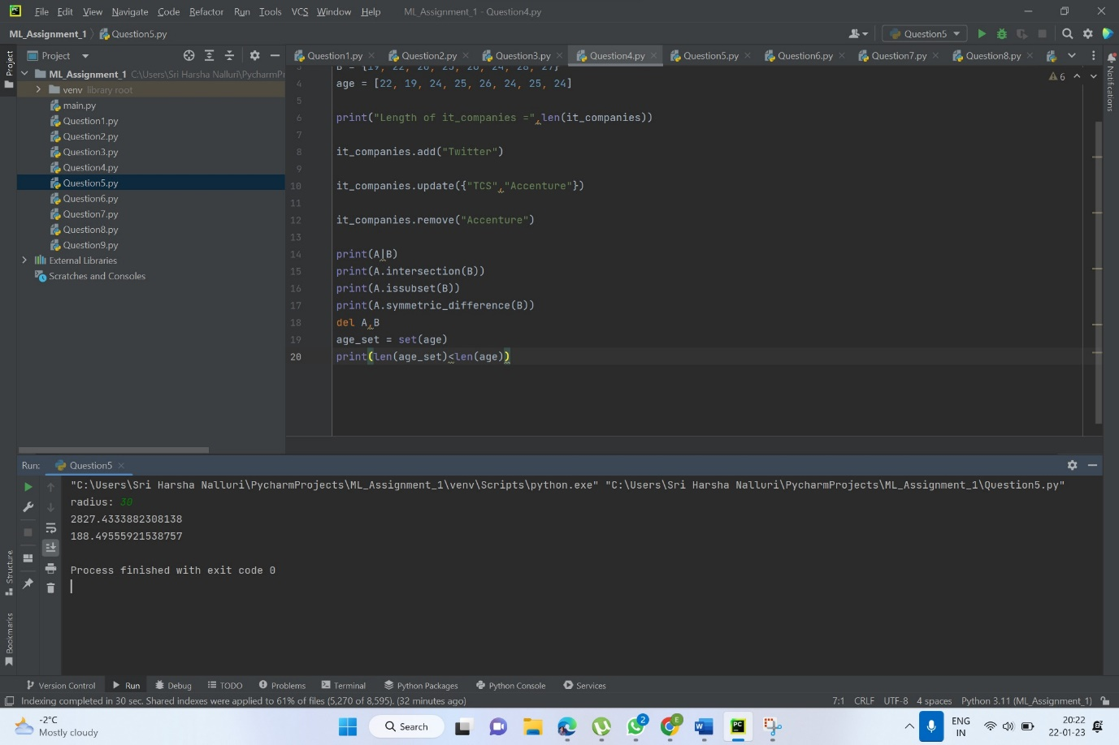

Given radius of a circle is 30 meters. And calculated the area of a circle and assigned the value to a variable name of _area_of_circle_

**Question 6**

“I am a teacher and I love to inspire and teach people”

• How many unique words have been used in the sentence? Use the split methods and set

to get the unique words.

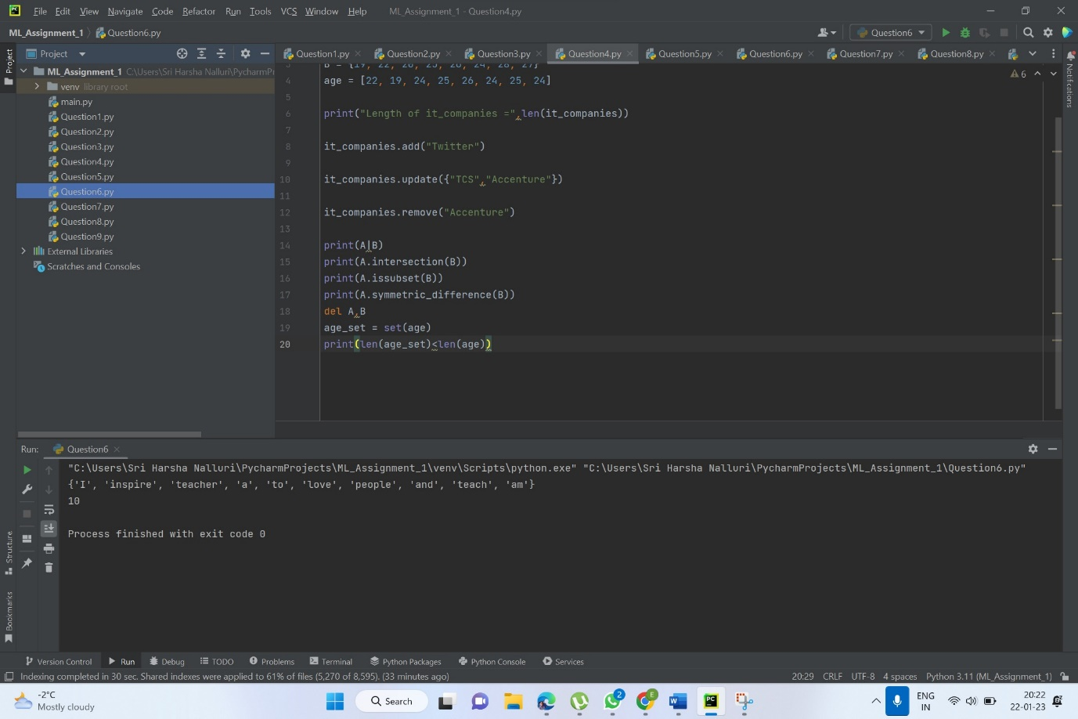

I am a teacher and I love to inspire and teach people” This is the given sentence. Used the split methods and set to get the unique words.

**Question 7**

Use a tab escape sequence to get the following lines.

**Name Age Country City**

**Asabeneh 250 Finland Helsinki**

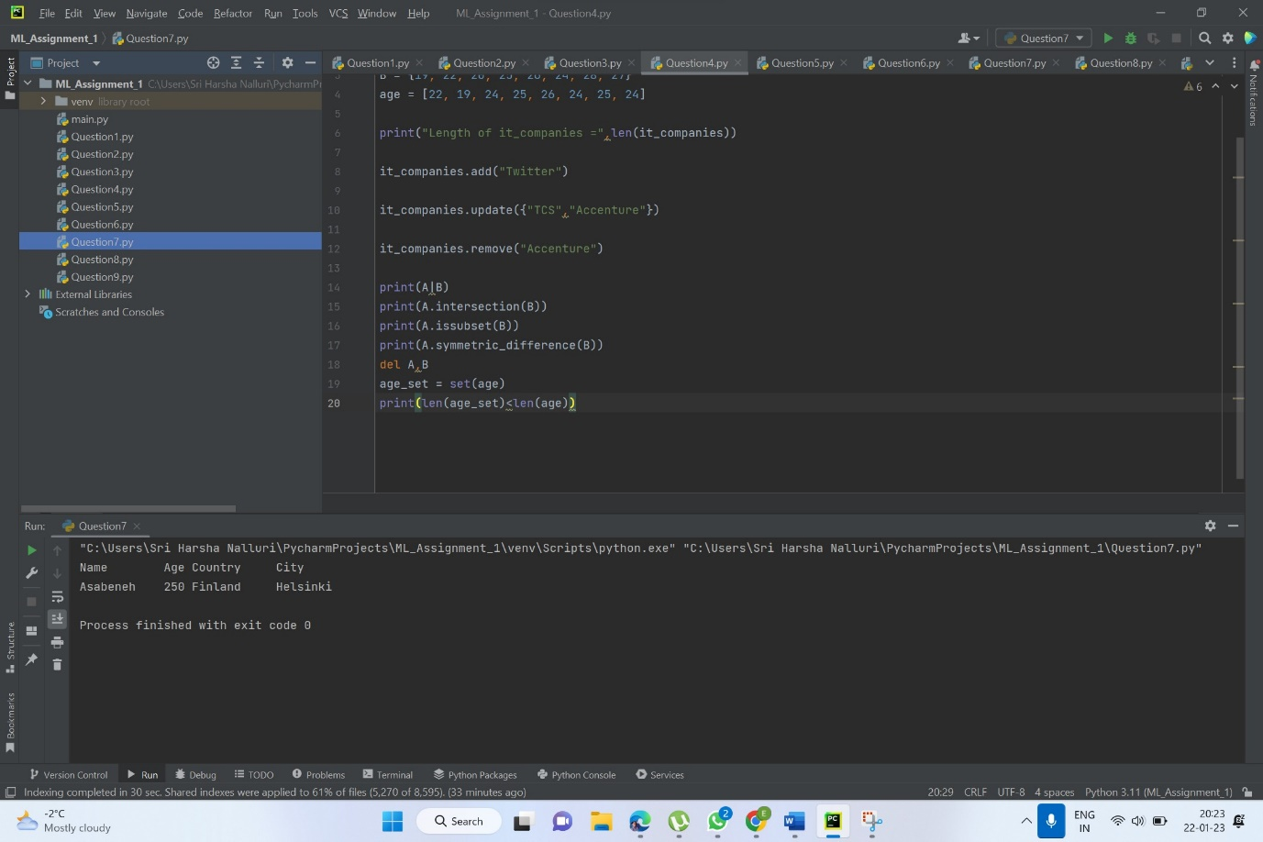

Used a tab escape sequence to get the following output.

**Question 8**

Use the string formatting method to display the following:

radius = 10

area = 3.14 * radius ** 2

“The area of a circle with radius 10 is 314 meters square.”

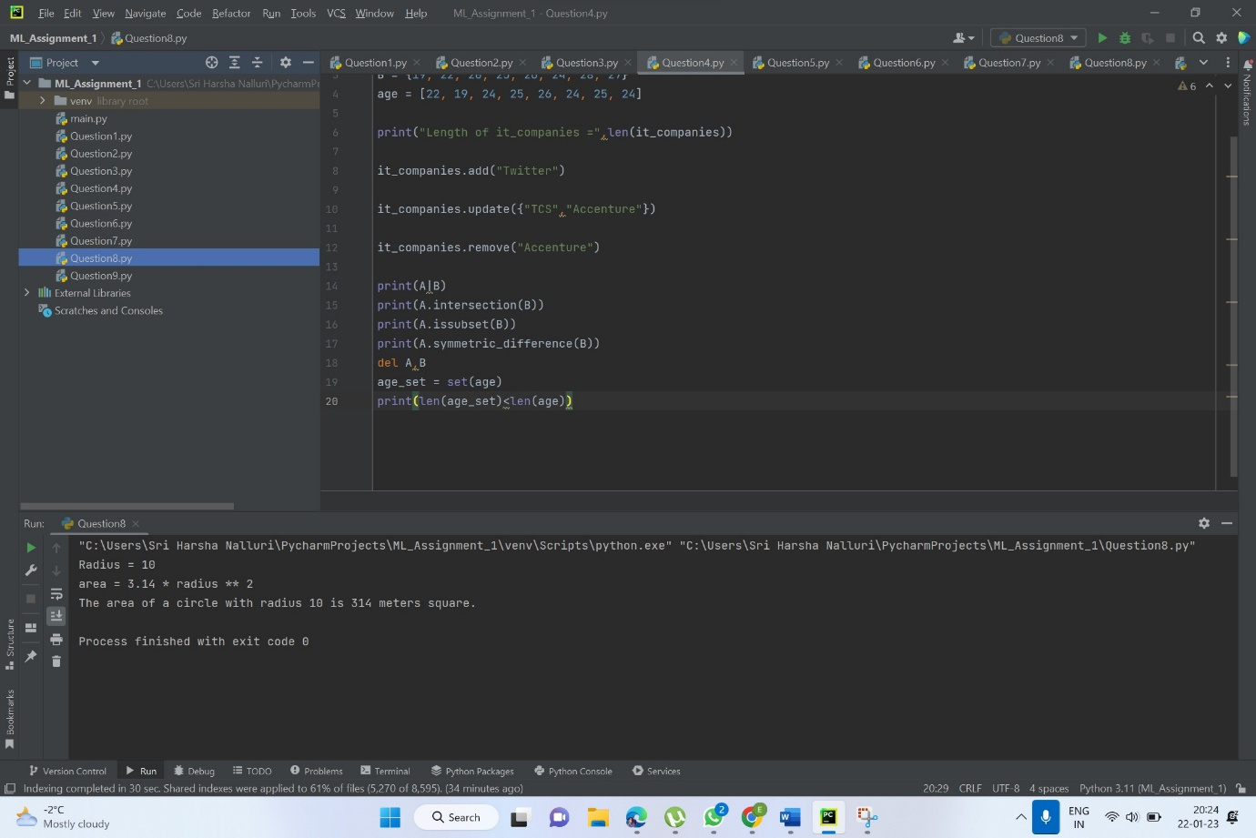

**\***Using the string formatting method I have displayed the following: radius = 10 area = 3.14 * radius ** 2 and given the area of a circle with radius 10 is 314 meters square.

**Question 9**

Write a program, which reads weights (lbs.) of N students into a list and convert these weights to

kilograms in a separate list using Loop. N: No of students (Read input from user)

Ex: L1: [150, 155, 145, 148]

Output: [68.03, 70.3, 65.77, 67.13]

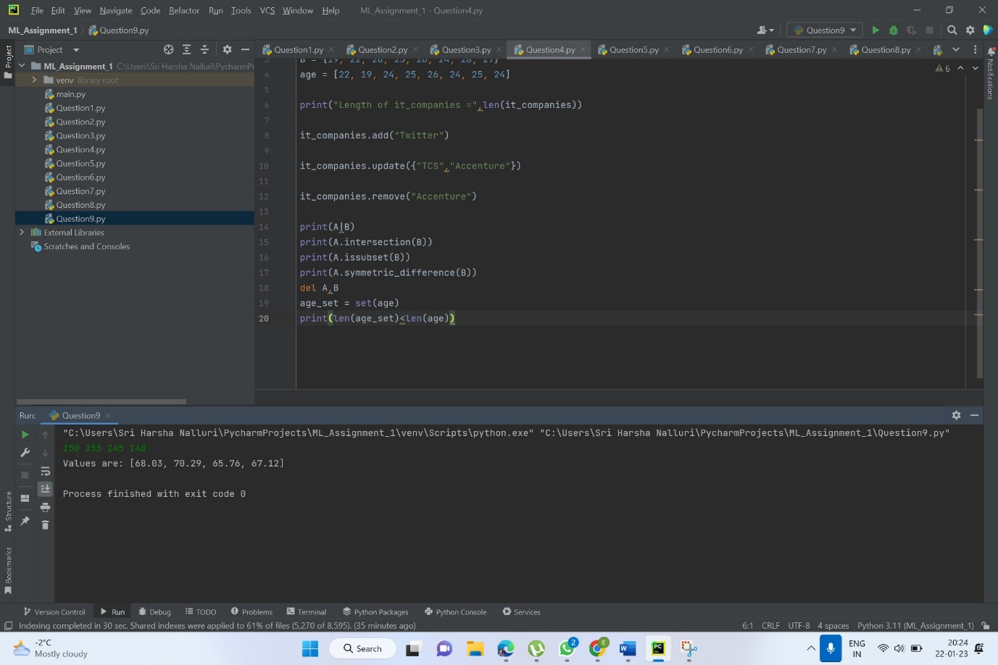

Executed the program, which reads weights (lbs.) of N students into a list and convert these weights to kilograms in a separate list using Loop. N: No of students (Read input from user)