Create a react app for Student Management Portal named scorecalculatorapp and create a function component named “CalculateScore” which will accept Name, School, Total and goal in order to calculate the average score of a student and display the same.

1. Create a React project named “scorecalculatorapp” type the following command in terminal of Visual studio:



1. Create a new folder under Src folder with the name “Components”. Add a new file named “CalculateScore.js”
2. Type the following code in CalculateScore.js

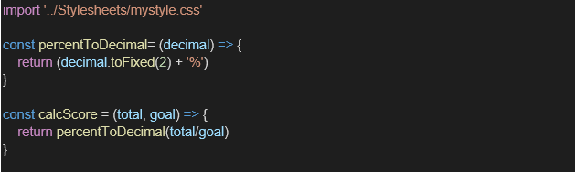

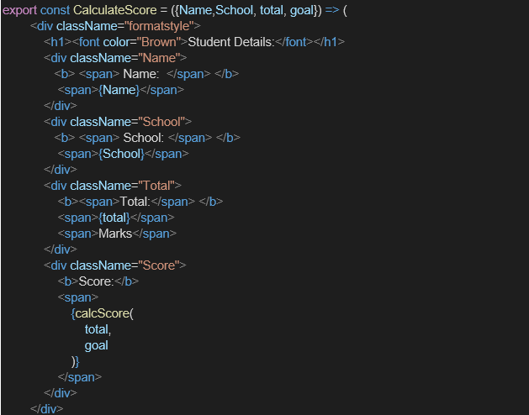

1. Create a Folder named Stylesheets and add a file named “mystyle.css” in order to add some styles to the components:

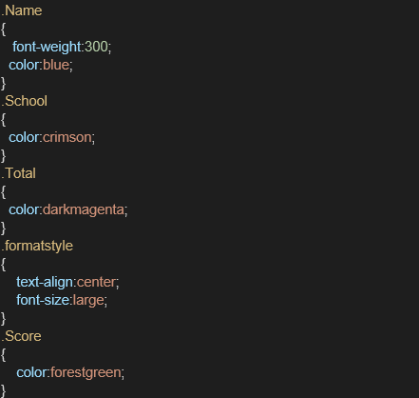

1. Edit the App.js to invoke the CalculateScore functional component as follows:

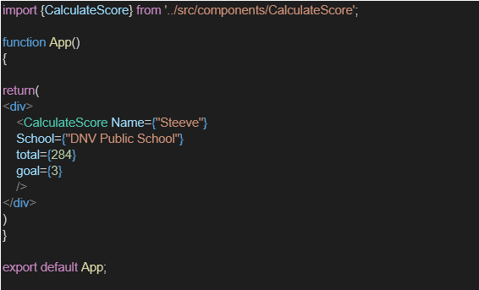

1. In command Prompt, navigate into scorecalculatorapp and execute the code by typing the following command:



1. Open browser and type “localhost:3000” in the address bar:

**CODES:**

**Src/components/calculateScore.js**

import '../Stylesheets/mystyle.css'

const percentToDecimal = (decimal) => {

return (decimal.toFixed(2) + '%')

}

const calcScore = (total, goal) => {

return percentToDecimal(total / goal)

}

export const CalculateScore = ({ Name, School, total, goal }) => (

<div className="formatstyle">

<h1><font color="Brown">Student Details:</font></h1>

<div className="Name">

<b> <span> Name: </span> </b>

<span>{Name}</span>

</div>

<div className="School">

<b> <span> School: </span> </b>

<span>{School}</span>

</div>

<div className="Total">

<b><span>Total:</span> </b>

<span>{total}</span>

<span>Marks</span>

</div>

<div className="Score">

<b>Score:</b>

<span>

{calcScore(

total,

goal

)}

</span>

</div>

</div>

)

**src/Stylesheets/mystyle.css**

.Name {

font-weight: 300;

color: blue;

}

.School {

color: crimson;

}

.Total {

color: darkmagenta;

}

.formatstyle {

text-align: center;

font-size: large;

}

.Score {

color: forestgreen;

}

**Src/app.js**

import { CalculateScore } from './Components/CalculateScore';

function App() {

return (

<div>

<CalculateScore

Name={"Steeve"}

School={"DNV Public School"}

total={284}

goal={3}

/>

</div>

)

}

export default App;

**OUTPUTS:**

