**Objectives**

* **Define JSX**
* **Explain about ECMA Script**
* **Explain React.createElement()**
* **Explain how to create React nodes with JSX**
* **Define how to render JSX to DOM**
* **Explain how to use JavaScript expressions in JSX**
* **Explain how to use inline CSS in JSX**

**In this hands-on lab, you will learn how to:**

* **Use JSX syntax in React applications**
* **Use inline CSS in JSX**

**Prerequisites**

**The following is required to complete this hands-on lab:**

* **Node.js**
* **NPM**
* **Visual Studio Code**

**Notes**

**Estimated time to complete this lab: 60 minutes.**

**Create a React Application named “officespacerentalapp” which uses React JSX to create elements, attributes and renders DOM to display the page.**

**Create an element to display the heading of the page.**

**Attribute to display the image of the office space**

**Create an object of office to display the details like Name, Rent and Address.**

**Create a list of Object and loop through the office space item to display more data.**

**To apply Css, Display the color of the Rent in Red if it’s below 60000 and in Green if it’s above 60000.**

**Output:**

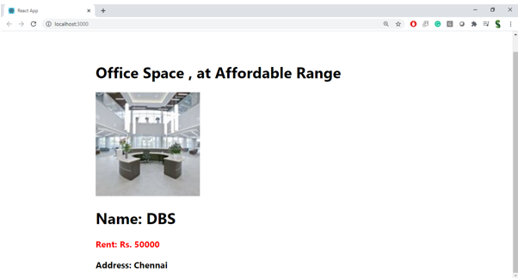

**Hint:**

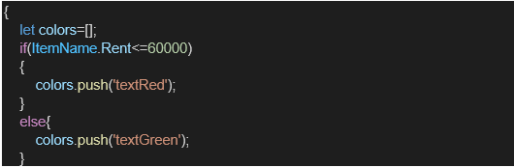

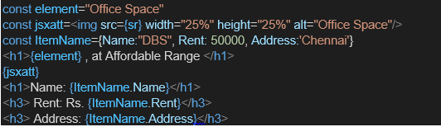

**CODES:**

**Src/components/OfficeList.js**

import React from 'react';

const OfficeList = () => {

  const heading = <h1>Office Space Rental Portal</h1>;

  const officeImage = "https://images.pexels.com/photos/221537/pexels-photo-221537.jpeg?auto=compress&cs=tinysrgb&w=1200";

  const officeObj = {

    name: "Innovate Hub",

    rent: 55000,

    address: "123 Startup Lane, Bengaluru"

  };

  const officeSpaces = [

    { name: "TechZone", rent: 50000, address: "IT Park, Hyderabad" },

    { name: "WorkNest", rent: 65000, address: "MG Road, Pune" },

    { name: "StartupBay", rent: 45000, address: "Sector 21, Gurgaon" },

    { name: "GrowthHub", rent: 70000, address: "Whitefield, Bengaluru" }

  ];

  const getRentStyle = (rent) => ({

    color: rent > 60000 ? "green" : "red",

    fontWeight: "bold"

  });

  return (

    <div>

      {heading}

      <img src={officeImage} alt="Office Space" width="600" style={{ margin: '20px 0' }} />

      <h2>Featured Office</h2>

      <p><strong>Name:</strong> {officeObj.name}</p>

      <p style={getRentStyle(officeObj.rent)}><strong>Rent:</strong> ₹{officeObj.rent}</p>

      <p><strong>Address:</strong> {officeObj.address}</p>

      <h2>Available Office Listings</h2>

      <ul>

        {officeSpaces.map((office, index) => (

          <li key={index} style={{ marginBottom: "10px" }}>

            <p><strong>Name:</strong> {office.name}</p>

            <p style={getRentStyle(office.rent)}><strong>Rent:</strong> ₹{office.rent}</p>

            <p><strong>Address:</strong> {office.address}</p>

          </li>

        ))}

      </ul>

    </div>

  );

};

export default OfficeList;

**app.js**

// src/App.js

import React from 'react';

import './App.css';

import OfficeList from './components/OfficeList';

function App() {

  return (

    <div className="App">

      <OfficeList />

    </div>

  );

}

export default App;

**OUTPUTS:**

