**Objectives**

* **Explain React events**
* **Explain about event handlers**
* **Define Synthetic event**
* **Identify React event naming convention**

**In this hands-on lab, you will learn how to:**

* **Implement Event handling concept in React applications**
* **Use this keyword**
* **Use synthetic event**

**Prerequisites**

**The following is required to complete this hands-on lab:**

* **Node.js**
* **NPM**
* **Visual Studio Code**

**Notes**

**Estimated time to complete this lab: 90 minutes.**

**Create a React Application “eventexamplesapp” to handle various events of the form elements in HTML.**

1. **Create “Increment” button to increase the value of the counter and “Decrement” button to decrease the value of the counter. The “Increase” button should invoke multiple methods.** 
   1. **To increment the value**
   2. **Say Hello followed by a static message.**

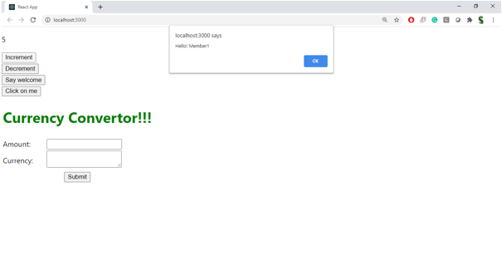

1. **Create a button “Say Welcome” which invokes the function which takes “welcome” as an argument.**

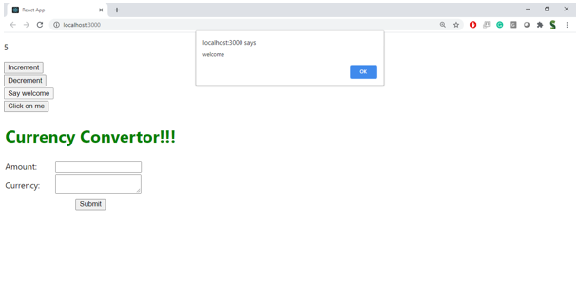

1. **Create a button which invokes synthetic event “OnPress” which display “I was clicked”**

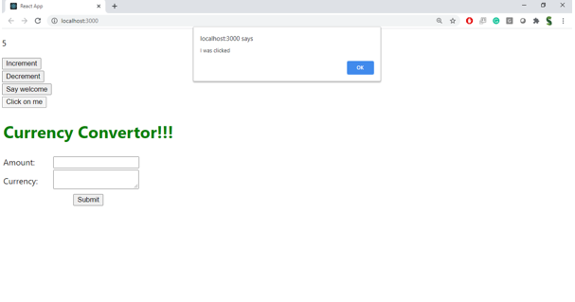

**Create a “CurrencyConvertor” component which will convert the Indian Rupees to Euro when the Convert button is clicked.**

**Handle the Click event of the button to invoke the handleSubmit event and handle the conversion of the euro to rupees.**

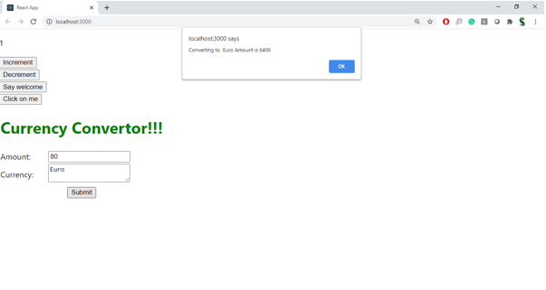

**CODES:**

**Src/components/Counter.js**

import React, { Component } from 'react';

class Counter extends Component {

  constructor() {

    super();

    this.state = {

      count: 0

    };

  }

  increment = () => {

    this.setState({ count: this.state.count + 1 });

    this.sayHello();

    this.sayMessage();

    alert(`Counter incremented to ${this.state.count + 1}`);

  };

  decrement = () => {

    this.setState({ count: this.state.count - 1 });

  };

  sayHello = () => {

    console.log("Hello!");

  };

  sayMessage = () => {

    console.log("This is a static message.");

  };

  render() {

    return (

      <div>

        <h2>Counter: {this.state.count}</h2>

        <button onClick={this.increment}>Increment</button>

        <button onClick={this.decrement}>Decrement</button>

      </div>

    );

  }

}

export default Counter;

**src/components/CurrencyConvertor.js**

import React, { useState } from 'react';

const CurrencyConvertor = () => {

  const [rupees, setRupees] = useState('');

  const [euros, setEuros] = useState(null);

  const handleSubmit = (e) => {

    e.preventDefault();

    const euroValue = (parseFloat(rupees) / 90).toFixed(2);

    setEuros(euroValue);

    alert(`₹${rupees} converted to €${euroValue}`);

  };

  return (

    <div>

      <h3>Currency Converter (INR ➡ Euro)</h3>

      <form onSubmit={handleSubmit}>

        <input

          type="number"

          value={rupees}

          onChange={(e) => setRupees(e.target.value)}

          placeholder="Enter amount in ₹"

        />

        <button type="submit">Convert</button>

      </form>

      {euros !== null && <p>Converted: €{euros}</p>}

    </div>

  );

};

export default CurrencyConvertor;

**src/components/SyntheticEventButton.js**

import React from 'react';

const SyntheticEventButton = () => {

  const handleClick = (e) => {

    e.preventDefault();

    alert("I was clicked");

  };

  return (

    <div>

      <button onClick={handleClick}>OnPress</button>

    </div>

  );

};

export default SyntheticEventButton;

**src/components/WelcomeButton.js**

import React from 'react';

const WelcomeButton = () => {

  const sayWelcome = (msg) => {

    alert(`Say ${msg}`);

  };

  return (

    <div>

      <button onClick={() => sayWelcome("Welcome")}>Say Welcome</button>

    </div>

  );

};

export default WelcomeButton;

**App.js**

import React from 'react';

import './App.css';

import Counter from './components/Counter';

import WelcomeButton from './components/WelcomeButton';

import SyntheticEventButton from './components/SyntheticEventButton';

import CurrencyConvertor from './components/CurrencyConvertor';

function App() {

  return (

    <div className="App">

      <h1>React Event Examples</h1>

      <Counter />

      <hr />

      <WelcomeButton />

      <hr />

      <SyntheticEventButton />

      <hr />

      <CurrencyConvertor />

    </div>

  );

}

export default App;

**OUTPUTS:**

