**Objectives**

* **Explain various ways of conditional rendering**
* **Explain how to render multiple components**
* **Define list component**
* **Explain about keys in React applications**
* **Explain how to extract components with keys**
* **Explain React Map, map() function**

**In this hands-on lab, you will learn how to:**

* **Implement conditional rendering in React applications**

**Prerequisites**

**The following is required to complete this hands-on lab:**

* **Node.js**
* **NPM**
* **Visual Studio Code**

**Notes**

**Estimated time to complete this lab: 60 minutes.**

**Create a React App named “bloggerapp” in with 3 components.**

1. **Book Details**
2. **Blog Details**
3. **Course Details**

**Implement this with as many ways possible of Conditional Rendering.**

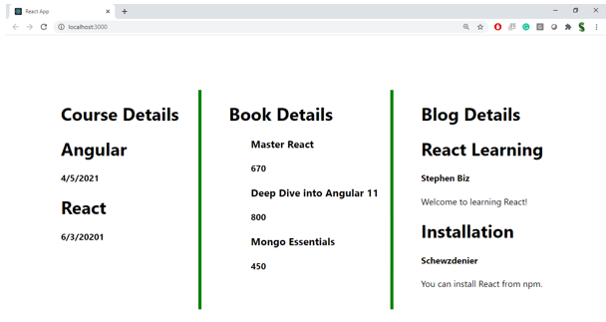

**Hint:**

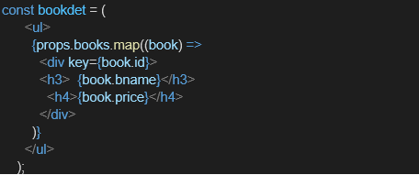

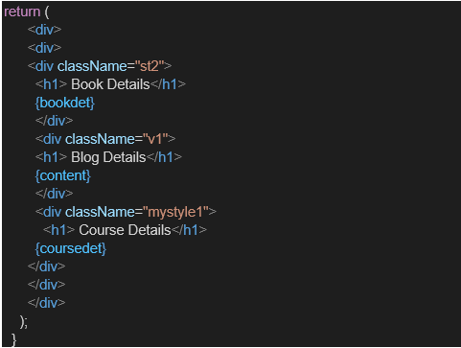

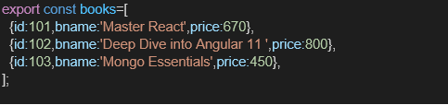

**CODES:**

**Src/components/BlogDetails.js**

import React from 'react';

const blogs = [

  { id: 1, title: 'React Basics', author: 'Jane' },

  { id: 2, title: 'Hooks in Depth', author: 'John' },

  { id: 3, title: 'Advanced Props', author: 'Alice' }

];

const BlogDetails = () => {

  return (

    <div>

      <h3>Blog Details</h3>

      {blogs.length > 0 ? (

        blogs.map((blog) => (

          <div key={blog.id}>

            <p>

              <strong>{blog.title}</strong> - {blog.author}

            </p>

          </div>

        ))

      ) : (

        <p>No blogs available.</p>

      )}

    </div>

  );

};

export default BlogDetails;

**Src/components/BookDetails.js**

import React from 'react';

const books = [

  { id: 1, title: 'Atomic Habits', author: 'James Clear' },

  { id: 2, title: 'The Alchemist', author: 'Paulo Coelho' },

  { id: 3, title: 'Deep Work', author: 'Cal Newport' }

];

const BookDetails = () => {

  return (

    <div>

      <h3>Book Details</h3>

      <ul>

        {books.map((book) => (

          <li key={book.id}>

            <strong>{book.title}</strong> by {book.author}

          </li>

        ))}

      </ul>

    </div>

  );

};

export default BookDetails;

**Src/components/CourseDetails.js**

import React from 'react';

const courses = [

  { id: 1, name: 'ReactJS', duration: '6 Weeks' },

  { id: 2, name: 'NodeJS', duration: '5 Weeks' },

  { id: 3, name: 'MongoDB', duration: '4 Weeks' }

];

const CourseDetails = () => {

  return (

    <div>

      <h3>Course Details</h3>

      {courses.length === 0 && <p>No courses available.</p>}

      {courses.length > 0 && (

        <ul>

          {courses.map((course) => (

            <li key={course.id}>

              {course.name} - {course.duration}

            </li>

          ))}

        </ul>

      )}

    </div>

  );

};

export default CourseDetails;

**App.js**

// src/App.js

import React, { useState } from 'react';

import BookDetails from './components/BookDetails';

import BlogDetails from './components/BlogDetails';

import CourseDetails from './components/CourseDetails';

function App() {

  const [activeComponent, setActiveComponent] = useState("book");

  // Element Variable Method

  let content;

  if (activeComponent === "book") {

    content = <BookDetails />;

  } else if (activeComponent === "blog") {

    content = <BlogDetails />;

  } else if (activeComponent === "course") {

    content = <CourseDetails />;

  }

  return (

    <div style={{ padding: '20px', fontFamily: 'Arial' }}>

      <h1>Blogger App</h1>

      <div style={{ marginBottom: '10px' }}>

        <button onClick={() => setActiveComponent("book")}>Book Details</button>

        <button onClick={() => setActiveComponent("blog")}>Blog Details</button>

        <button onClick={() => setActiveComponent("course")}>Course Details</button>

      </div>

      <hr />

      {/* Render with variable */}

      {content}

      {/* Ternary Conditional Rendering Example */}

      {/* {activeComponent === "book" ? <BookDetails /> : null} */}

    </div>

  );

}

export default App;

**OUTPUT:**

