Create a React Application named “cricketapp” with the following components:

1. ListofPlayers

* Declare an array with 11 players and store details of their names and scores using the map feature of ES6

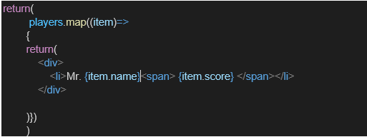

* Filter the players with scores below 70 using arrow functions of ES6.

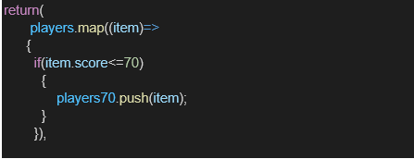

1. IndianPlayers
   1. Display the Odd Team Player and Even Team players using the Destructuring features of ES6

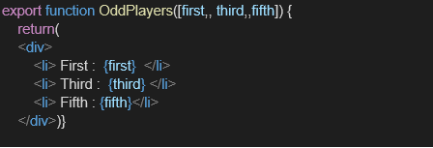

* 1. Declare two arrays T20players and RanjiTrophy players and merge the two arrays and display them using the Merge feature of ES6

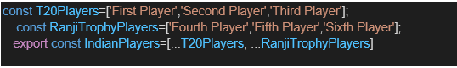

Display these two components in the same home page using a simple if else in the flag variable.

**Output:**

When Flag=true

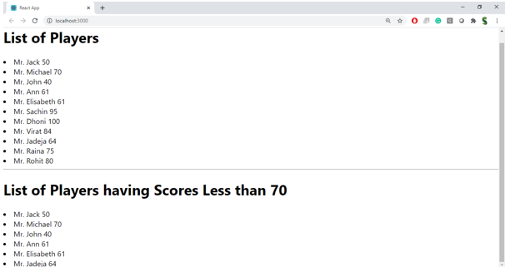

When Flag=false

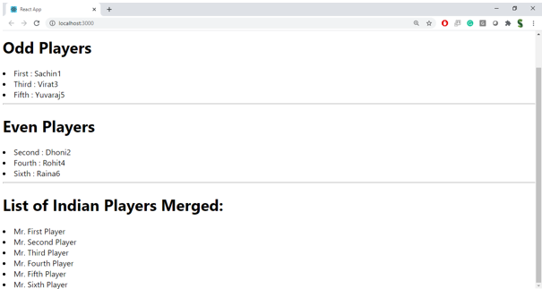

**Hint:**

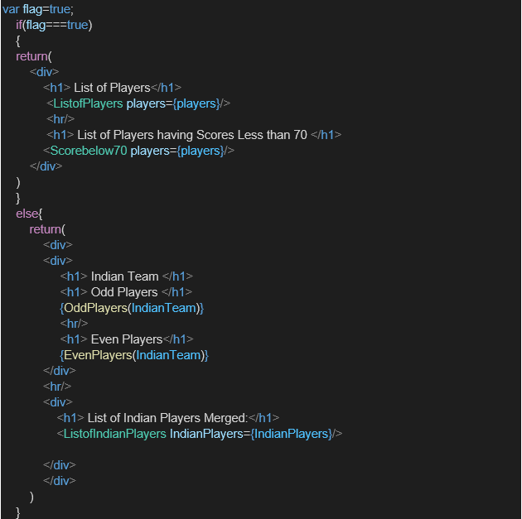

**CODES:**

**Src/components/ListofPlayers.js**

import React from 'react';

const ListofPlayers = () => {

const players = [

{ name: 'Virat Kohli', score: 85 },

{ name: 'Rohit Sharma', score: 45 },

{ name: 'KL Rahul', score: 70 },

{ name: 'Shubman Gill', score: 60 },

{ name: 'MS Dhoni', score: 95 },

{ name: 'Hardik Pandya', score: 65 },

{ name: 'Jadeja', score: 55 },

{ name: 'Bumrah', score: 40 },

{ name: 'Shami', score: 30 },

{ name: 'Kuldeep', score: 72 },

{ name: 'Siraj', score: 68 }

];

const lowScorers = players.filter(player => player.score < 70);

return (

<div>

<h2>All Players</h2>

<ul>

{players.map((player, index) => (

<li key={index}>{player.name} - {player.score}</li>

))}

</ul>

<h2>Players with score below 70</h2>

<ul>

{lowScorers.map((player, index) => (

<li key={index}>{player.name} - {player.score}</li>

))}

</ul>

</div>

);

};

export default ListofPlayers**;**

**src/Components/IndianPlayers.js**

import React from 'react';

const IndianPlayers = () => {

  const players = [

    'Player1', 'Player2', 'Player3', 'Player4',

    'Player5', 'Player6', 'Player7', 'Player8'

  ];

  const oddPlayers = [];

  const evenPlayers = [];

  players.forEach((player, index) => {

    if ((index + 1) % 2 === 0) {

      evenPlayers.push(player);

    } else {

      oddPlayers.push(player);

    }

  });

  const [first, second, ...rest] = players;

  const T20players = ['Virat', 'Rohit'];

  const RanjiTrophy = ['Rahane', 'Pujara'];

  const mergedPlayers = [...T20players, ...RanjiTrophy];

  return (

    <div>

      <h2>Odd Team Players</h2>

      <ul>

        {oddPlayers.map((player, index) => (

          <li key={index}>{player}</li>

        ))}

      </ul>

      <h2>Even Team Players</h2>

      <ul>

        {evenPlayers.map((player, index) => (

          <li key={index}>{player}</li>

        ))}

      </ul>

      <h2>Merged Players (T20 + Ranji)</h2>

      <ul>

        {mergedPlayers.map((player, index) => (

          <li key={index}>{player}</li>

        ))}

      </ul>

      <h4>Destructured Players</h4>

      <p>First: {first}, Second: {second}, Rest: {rest.join(', ')}</p>

    </div>

  );

};

export default IndianPlayers;

**App.js**

import React from 'react';

import './App.css';

import ListofPlayers from './Components/ListofPlayers.js';

import IndianPlayers from './Components/IndianPlayers.js';

function App() {

  const flag = true ; //Toggle to test

  return (

    <div className="App">

      <h1>Welcome to Cricket App</h1>

      {flag ? <ListofPlayers /> : <IndianPlayers />}

    </div>

  );

}

export default App;

**OUTPUT:**

