PROGRAM-1

# Deploy to GitHub via Git in Ubuntu #1

sudo – superuser privileges

apt-get – advanced package tools to install, update, upgrade and remove packages

sudo apt-get upgrade

ls – list all files

ls -a -list all hidden files

ls -l - list all files and directories

ls .git – to check all meta data in .git

touch courses.txt

touch keyword is used to create files

in this command, courses.txt was created

Vi command opens vi editor

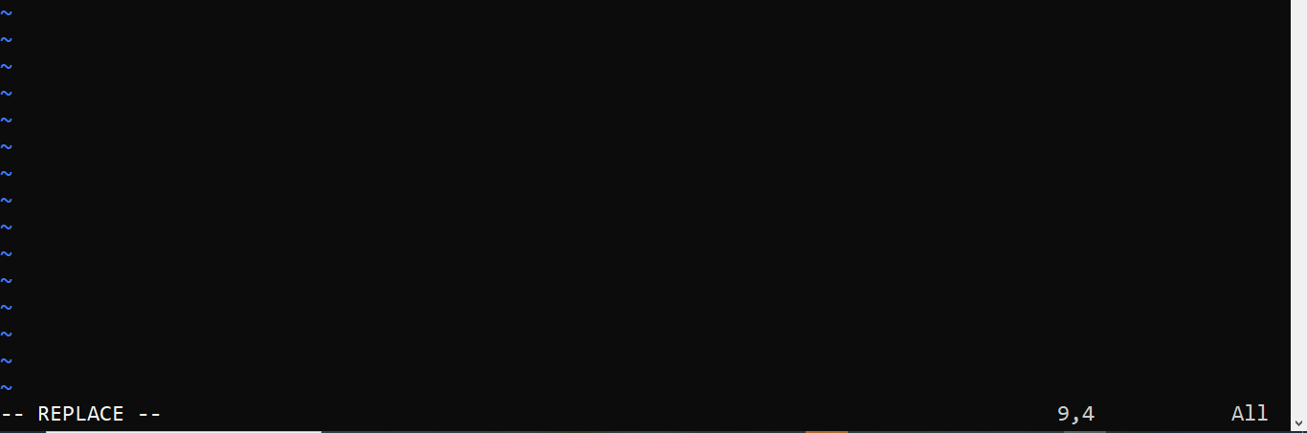

To enter text

In keyboard, enter insert command to write text

After writing text, enter esc button in keyboard and type :wq

git commit

we are ready to move from staged to commit for our repository

commit means keep track of our progress and changes as we work.

-m means adds a message.



Go to github.com and create new or use previous repository url to add



Refresh your github repository web page

You get visibility of files

**End of results and program**

**Note**

**Some times, during push command you will find more errors like this**

**Authentication failed errors**

**Follow steps to generate tokens**

Getting error likes this for my laptop hardware environment

For older github account getting error like this

Those who newly created account, you didn’t error

You will get results

For this error, the solution is to generate tokens

Click on symbol on the right side of github login page

Got to settings and click on developer settings

Select Personal access tokens and select Tokens(classic)

In Token (classic) select generate new token option to generate tokens and Generate new token(classic)

Give name as token1

Select expiration as 90 days

In select scope option

Select all check boxes

Select generate tokens

Save this token in notepad for future use

Every time if you want push files it will ask you enter token.