**Ex. No: 1 DATA DEFINITION LANGUAGE COMMANDS**

**AIM**

To study basic DDL commands.

**PROCEDURE**

1. **CREATE**

* It is used to create a new relation.
* *Syntax*: CREATE TABLE <Relation name>(<Attribute name1><Datatype1>, <Attribute name2><Datatype2>,…,<Attribute namen><Datatypen>,<integrity-constraint1>,<integrity-constraintk>)
* **CONSTRAINTS**:
  + **NOT NULL**: This constraint prohibits the insertion of a null value for an attribute.

*<Attribute name><Datatype> NOT NULL*

* + **UNIQUE**: No two tuples in a relation can be equal on a attribute or set of attributes which has been specified as unique.

*UNIQUE (<Attribute name1>, <Attribute name2>,…, <Attribute namen>)*

* + **CHECK**: It specifies a condition that must be satisfied by every tuple in the relation.

*CHECK (Predicate)*

* + **PRIMARY KEY**: It specifies that designated attributes form the primary key of the relation. It is *not null* and *unique*.

*PRIMARY KEY (<Attribute name1>, <Attribute name2>,…, <Attribute namen>)*

* + **FOREIGN KEY**: It specifies that it references a primary key of another relation.

*FOREIGN KEY (<Attribute name>) REFERENCES* <Related Relation name>

1. **ALTER**

* It is used to add a new attribute, add a new constraint, modify datatype and drop a new attribute to a relation.
* *Syntax*: ALTER TABLE <Relation name> ADD <Attribute name><Datatype>
* *Syntax*: ALTER TABLE <Relation name> ADD <constraint>
* *Syntax*: ALTER TABLE <Relation name> MODIFY <Attribute name><Datatype>
* *Syntax*: ALTER TABLE <Relation name> DROP COLUMN <Attribute name>

1. **DROP**

* It is used to remove a relation from the database.
* *Syntax*: DROP TABLE <Relation name>

1. **RENAME**

* It is used to rename one or more relations.
* *Syntax*: RENAME TABLE <Relation name> TO <New_Relation name>

1. **TRUNCATE**

* It empties a relation completely (delete all rows).
* *Syntax*: TRUNCATE TABLE <Relation name>

1. **DESC**

* It is neither a DDL nor DML command. It provides information about the attributes in a relation.
* *Syntax*: DESC <Relation name>

**Ex. No: 2 DATA MANIPULATION LANGUAGE COMMANDS**

**AIM**

To study basic DML commands.

**PROCEDURE**

1. **INSERT**

* It is used to insert new tuple into a relation.
* *Syntax*: INSERT INTO <Relation name>

VALUES (<value1>, <value2>,…, <valuen>)

1. **SELECT**

* It is a query statement used to retrieve data from relations or views.
* *Syntax*: SELECT (<Attribute name1>,<Attribute name2>,…,<Attribute namen>)

FROM <Relation name1>, <Relation name2>,…, <Relation namen>

WHERE <Condition>

1. **UPDATE**

* It is used to change values in a tuple or tuples of the relation.
* *Syntax*: UPDATE <Relation name>

SET <Attribute name> = <value>

WHERE <Condition>

1. **DELETE**

* It is used to delete tuple or tuples from the relation.
* *Syntax*: DELETE FROM <Relation name>

WHERE <Condition>

**EXECUTION OF DDL & DML COMMANDS**

* **CREATE RELATION**

SQL> **create table student (regno int, name varchar(20), cgpa number(4,2), deptID int);**

Table created.

* **ALTER RELATION**

SQL> **alter table student add primary key(regno);**

Table altered.

SQL> **alter table student add dob date;**

Table altered.

SQL> **alter table student modify deptID varchar2(3);**

Table altered.

* **DESCRIBE STRUCTURE OF RELATION**

SQL> **desc student;**

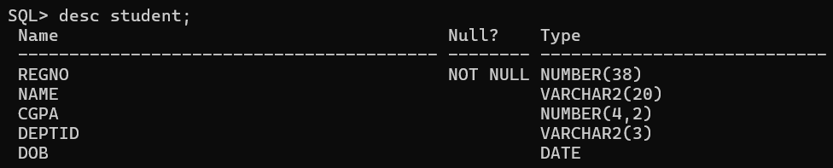

* **INSERTING ROWS**

SQL> **insert into student values(1001, 'Rohith Sharma',9.6,'CC',date '1987-04-30');**

1 row created.

SQL> **insert into student values(1001, 'Virat Kohli',9.84,'CC', TO_DATE('05-11-1989','dd-mm-yyyy'));**

insert into student values(1001, 'Virat Kohli',9.84,'CC', TO_DATE('05-11-1989','dd-mm-yyyy'))

*

ERROR at line 1:

ORA-00001: unique constraint (SYSTEM.SYS_C008314) violated

SQL> **insert into student values(1002, 'Virat Kohli',9.84,'CC', TO_DATE('05-11-1989','dd-mm-yyyy'));**

1 row created.

* **RETRIEVING DATA USING SELECT**

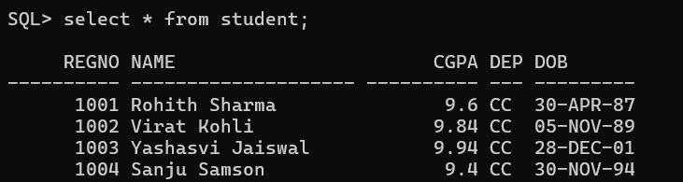

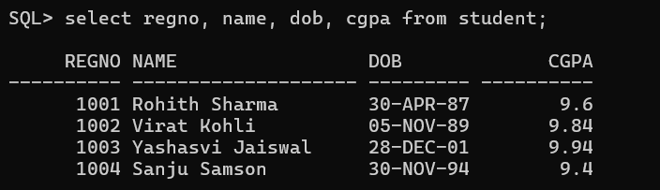

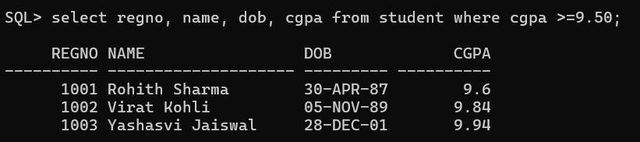

* **UPDATE**

SQL> **update student set dob = date '1988-11-05' where regno = 1002;**

1 row updated.

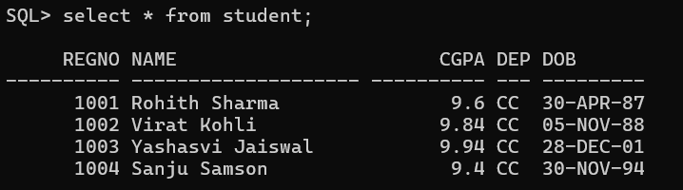

SQL> **update student set deptID = 'CSE';**

4 rows updated.

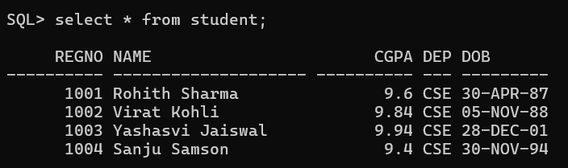

* **DELETE**

SQL> **delete from student where regno = 1004;**

1 row deleted.

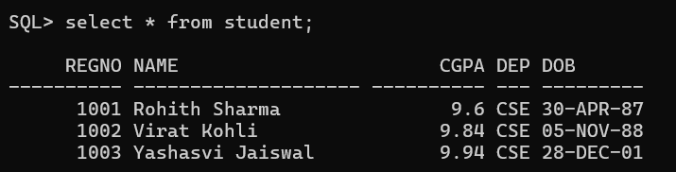

**SQL> delete from student;**

3 rows deleted.

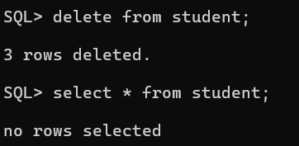

* **RENAME RELATION**

SQL> **rename student to ugstudent;**

Table renamed.

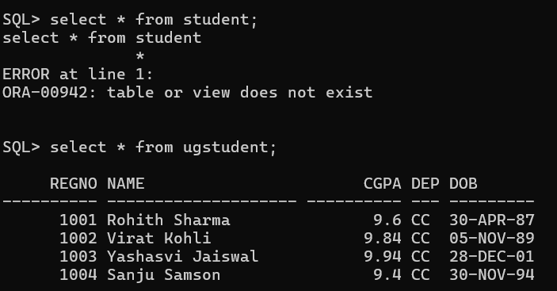

* **ALTER RELATION – DROP COLUMN**

SQL> **alter table ugstudent drop column deptID;**

Table altered.

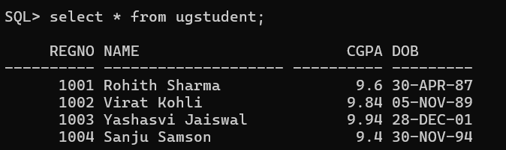

* **TRUNCATE**

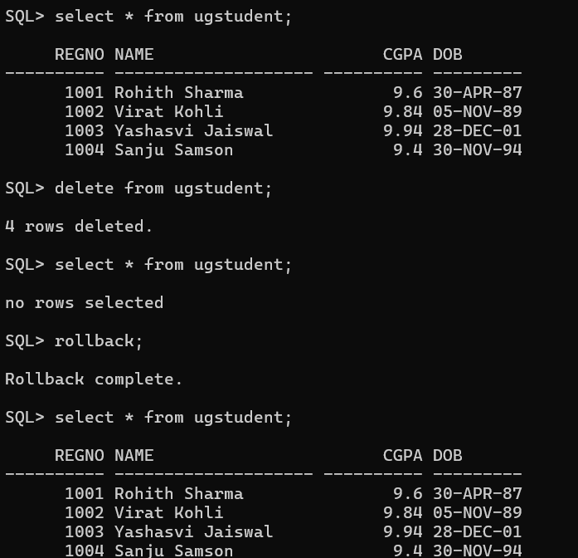

**SQL> truncate table ugstudent;**

Table truncated.

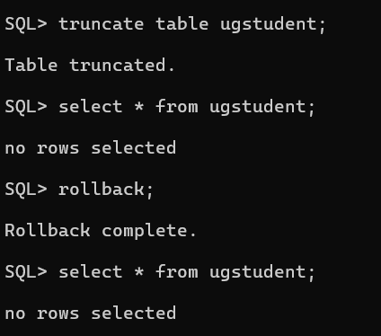

* **DROP**

SQL> **drop table ugstudent;**

Table dropped.

