**To connect to SQL PLUS through Command Prompt**

C:\Users\hp>**SQLPLUS/NOLOG**

SQL> **CONNECT <<username>>**

SQL> **CONNECT SYSTEM;**

Enter password:

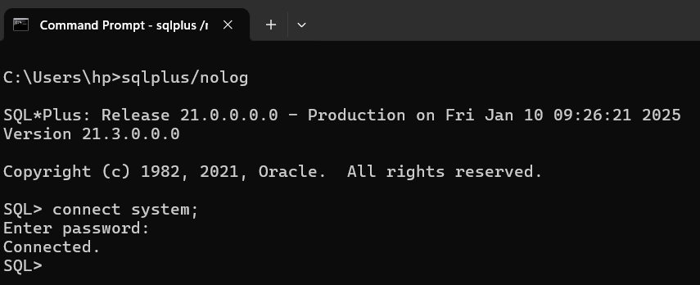

**To exit from SQL PLUS**

SQL> **EXIT;**

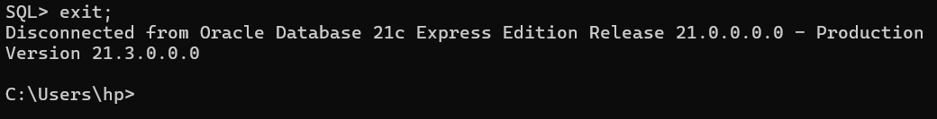

**To open SQL PLUS Application Directly**

**Option-1: Open using Run dialog box**

* Press **Windows key + R** opens the Run dialog box in Windows.
* Then, type **sqlplus** in the dialog box.

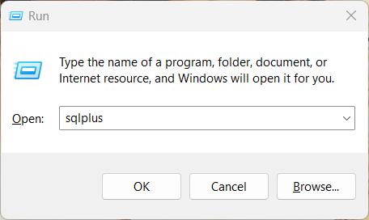

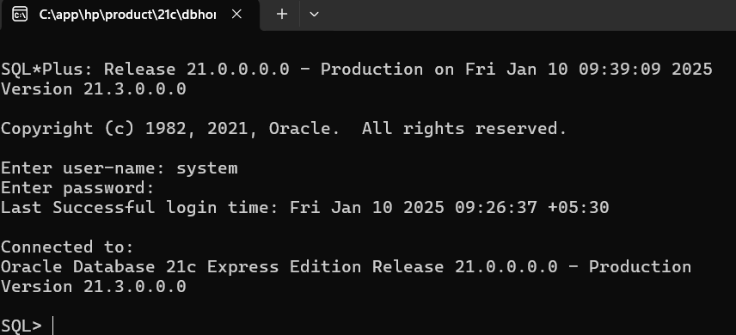

**Option-2: Open using Windows Search**

* Type **sqlplus** in the Windows

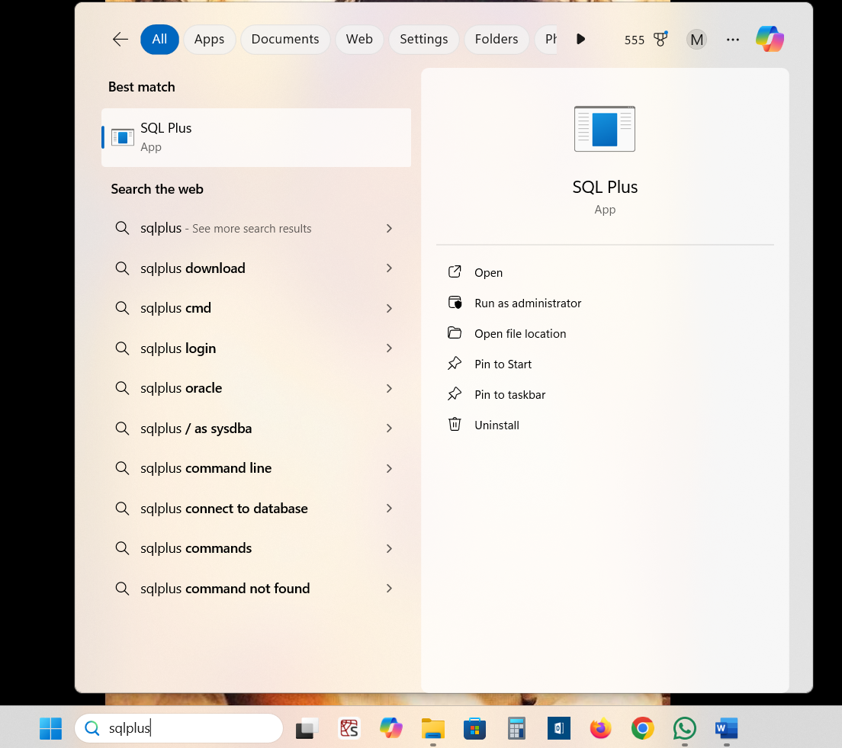

**ANSI SQL Data Types**

|  |  |
| --- | --- |
| **ANSI SQL Data Type** | **Equivalent Oracle Data Type** |
| CHARACTER(n) | CHAR(n) | CHAR(n) |
| CHARACTER VARYING(n) or VARCHAR(n) | VARCHAR2(n) |
| NUMERIC[(p,s)] | DECIMAL[(p,s)] | NUMBER(p,s) |
| INTEGER | INT | SMALLINT | NUMBER(38) |
| FLOAT | DOUBLE PRECISION | FLOAT(126) |
| REAL | FLOAT(63) |

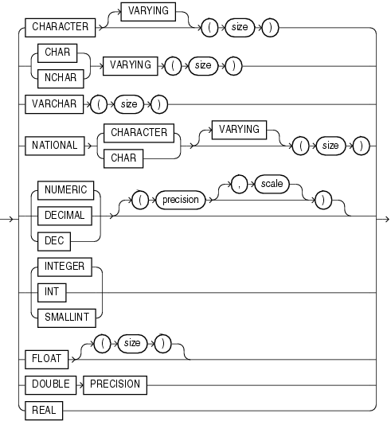

**Oracle Built-in Data Types**

**Source:** <https://docs.oracle.com/en/database/oracle/oracle-database/19/sqlrf/Data-Types.html>

|  |  |  |
| --- | --- | --- |
| **Data Types** | **Description** | **Examples** |
| VARCHAR2(size [BYTE | CHAR]) | Variable-length character string having maximum length size bytes or characters. You must specify size for VARCHAR2.  The maximum length of a VARCHAR2 column is 32,767 bytes if MAX_STRING_SIZE = EXTENDED, or 4,000 bytes if MAX_STRING_SIZE = STANDARD. | *‘RAHUL DRAVID’*  VARCHAR2(20) |
| NUMBER(p,s) | p is the precision, or the maximum number of significant decimal digits  s is the scale, or the number of digits from the decimal point to the least significant digit.  Specify an integer  Specify a floating-point number | *123.89*  NUMBER(5,2) 123.89  NUMBER(3,2) exceeds precision  NUMBER(6,1) 123.9  NUMBER(6,-2) 100  NUMBER(p)  NUMBER |

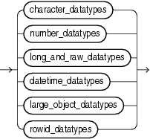

**Fig: Oracle Builtin Data Types Categories**

**Representing DATE**

**ISO 8601:** <https://www.iso.org/iso-8601-date-and-time-format.html> [Date and time format]

Standard Format: **YYYY-MM-DD** (Date)

**year, month, day, hour, minutes, seconds, and milliseconds.** (Date and Time)

Example**: September 27, 2022 at 6 p.m.** is represented as **2022-09-27 18:00:00.000.**

**Using Date Literals/Values in SQL Queries**

**ANSI Standard (Uses ISO 8601):**

Date Literal: **date '2018-01-25'**

Timestamp Literal: **timestamp '2018-01-25 01:23:45'**

**Oracle:**

**TO_DATE** converts char to a value of DATE data type.

TO_DATE('11-01-1973','dd-mm-yyyy')

TO_DATE('01-11-1973','mm-dd-yyyy')

Refer: <https://docs.oracle.com/en/database/oracle/oracle-database/21/sqlrf/TO_DATE.html>

* NLS_DATE_FORMAT specifies the default date format to use with the TO_CHAR and TO_DATE functions. The default value of this parameter is determined by NLS_TERRITORY.

SQL> **SELECT * FROM V$NLS_PARAMETERS;**

NLS_TERRITORY: AMERICA

NLS_DATE_FORMAT: DD-MON-RR

* In Oracle Database, the NLS (National Language Support) parameters determine the locale-specific behaviour on both the client and the server.

**BLOB and CLOB**

* Binary Large Object (BLOB) standard data type to enable SQL to store, manage, and deliver audio, photo, and video content.
* The Character Large Object (CLOB) was also introduced to include XML and other large character requirements.

**SQL Comments**

* Single Line Comment

-- Select all the columns from the student table;

SELECT * FROM student;

* Multi Line Comment

/* Select all the columns

from the student table */

SELECT * FROM student;

**Clear Screen**

**SQL> CLEAR SCREEN | CL SCR;**

It refers to the command to clear the screen within the SQL*Plus command line interface, essentially wiping out the displayed output on the console while still remaining logged into the Oracle database.

**Note:** SQL commands are case insensitive unlike programming languages like C, C++, Java.

Current SQL Standard: [SQL:2023, ISO/IEC 9075-16:2023 - 9th edition](https://www.iso.org/standard/79473.html)