UNIT V
Trees: Introduction to Trees, Binary Search Tree Insertion, Deletion & Traversal
Hashing: Brief introduction to hashing and hash functions, Collision resolution techniques:
chaining and open addressing, Hash tables: basic implementation and operations, Applications of hashing in unique identifier generation, caching, etc.

UNIT V TREES

1.1 Introduction to Trees:
A tree is a nonlinear hierarchical data structure that consists of nodes connected by edges.
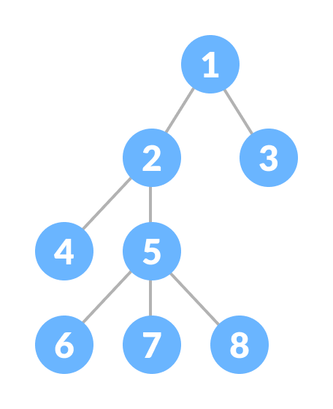

1.2 Why Tree Data Structure?
Other data structures such as arrays, linked list, stack, and queue are linear data structures that store data sequentially. In order to perform any operation in a linear data structure, the time complexity increases with the increase in the data size. But, it is not acceptable in today's computational world.

Different tree data structures allow quicker and easier access to the data as it is a non-linear data structure.
1.3 Tree Terminologies
Node:
A node is an entity that contains a key or value and pointers to its child nodes.
The last nodes of each path are called leaf nodes or external nodes that do not contain a link/pointer to child nodes.
The node having at least a child node is called an internal node.
Edge:
It is the link between any two nodes.
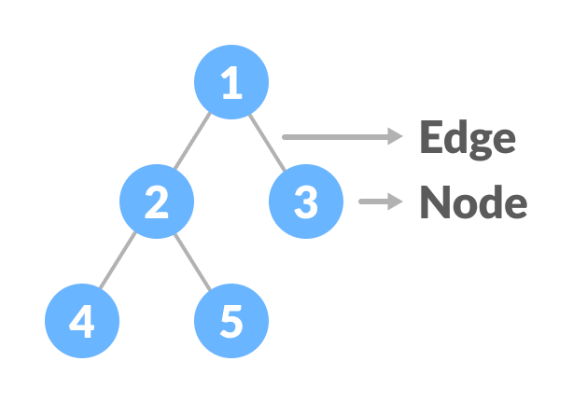
Root
It is the topmost node of a tree.
Height of a Node
The height of a node is the number of edges from the node to the deepest leaf (ie. the longest path from the node to a leaf node).
Depth of a Node
The depth of a node is the number of edges from the root to the node.
Height of a Tree
The height of a Tree is the height of the root node or the depth of the deepest node.
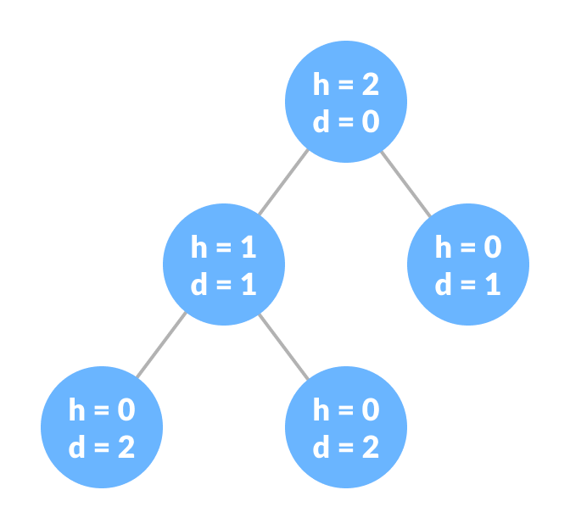
Degree of a Node
The degree of a node is the total number of branches of that node.
Forest
A collection of disjoint trees is called a forest.
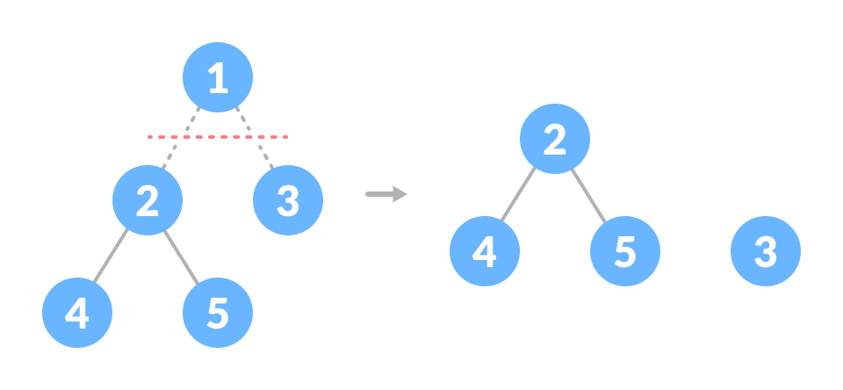
Types of Tree
- Binary Tree
- Binary Search Tree
- AVL Tree
- B-Tree

Tree Traversal
In order to perform any operation on a tree, you need to reach to the specific node. The tree traversal algorithm helps in visiting a required node in the tree.
1.4 Tree Traversal - inorder, preorder and postorder
Traversal is a process to visit all the nodes of a tree and may print their values too. Because, all nodes are connected via edges (links) we always start from the root (head) node. That is, we cannot randomly access a node in a tree. There are three ways which we use to traverse a tree −
- In-order Traversal
- Pre-order Traversal
- Post-order Traversal

Generally, we traverse a tree to search or locate a given item or key in the tree or to print all the values it contains.

In-order Traversal
In this traversal method, the left subtree is visited first, then the root and later the right sub-tree. We should always remember that every node may represent a subtree itself.

If a binary tree is traversed in-order, the output will produce sorted key values in an ascending order.
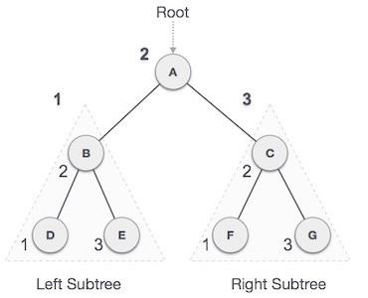
We start from A, and following in-order traversal, we move to its left subtree B.B is also traversed in-order. The process goes on until all the nodes are visited. The output of in-order traversal of this tree will be −
D → B → E → A → F → C → G

Algorithm
Until all nodes are traversed −
Step 1 − Recursively traverse left subtree.
Step 2 − Visit root node.
Step 3 − Recursively traverse right subtree.

Pre-order Traversal
In this traversal method, the root node is visited first, then the left subtree and finally the right subtree.
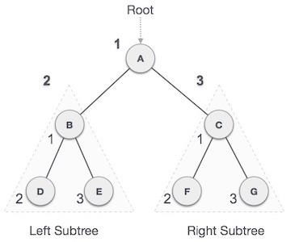

We start from A, and following pre-order traversal, we first visit A itself and then move to its left subtree B. B is also traversed pre-order. The process goes on until all the nodes are visited. The output of pre-order traversal of this tree will be −
A → B → D → E → C → F → G
Algorithm
Until all nodes are traversed −
Step 1 − Visit root node.
Step 2 − Recursively traverse left subtree.
Step 3 − Recursively traverse right subtree.

Post-order Traversal
In this traversal method, the root node is visited last, hence the name. First we traverse the left subtree, then the right subtree and finally the root node.

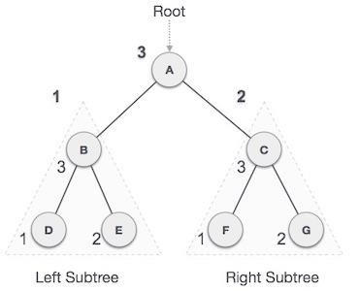

We start from A, and following pre-order traversal, we first visit the left subtree B. B is also traversed post-order. The process goes on until all the nodes are visited. The output of post-order traversal of this tree will be −
D → E → B → F → G → C → A

Algorithm

Until all nodes are traversed −

Step 1 − Recursively traverse left subtree.
Step 2 − Recursively traverse right subtree.
Step 3 − Visit root node.

Implementation
#include <stdio.h>
#include <stdlib.h>
struct node {
int data;
struct node *leftChild;
struct node *rightChild;
};
struct node *root = NULL;
void insert(int data){
struct node *tempNode = (struct node*) malloc(sizeof(struct node));
struct node *current;
struct node *parent;
tempNode->data = data;
tempNode->leftChild = NULL;
tempNode->rightChild = NULL;

//if tree is empty
if(root == NULL) {
root = tempNode;
} else {
current = root;
parent = NULL;
while(1) {
parent = current;

//go to left of the tree
if(data < parent->data) {
current = current->leftChild;

//insert to the left
if(current == NULL) {
parent->leftChild = tempNode;
return;
}
}//go to right of the tree
else {
current = current->rightChild;

//insert to the right
if(current == NULL) {
parent->rightChild = tempNode;
return;
}
}
}
}
}
void pre_order_traversal(struct node* root){
if(root != NULL) {
printf("%d ",root->data);
pre_order_traversal(root->leftChild);
pre_order_traversal(root->rightChild);
}
}
void inorder_traversal(struct node* root){
if(root != NULL) {
inorder_traversal(root->leftChild);
printf("%d ",root->data);
inorder_traversal(root->rightChild);
}
}
void post_order_traversal(struct node* root){
if(root != NULL) {
post_order_traversal(root->leftChild);
post_order_traversal(root->rightChild);
printf("%d ", root->data);
}
}
int main(){
int i;
int array[7] = { 27, 14, 35, 10, 19, 31, 42 };
for(i = 0; i < 7; i++)
insert(array[i]);
printf("Preorder traversal: ");
pre_order_traversal(root);
printf("\nInorder traversal: ");
inorder_traversal(root);
printf("\nPost order traversal: ");
post_order_traversal(root);
return 0;
}
Output
Preorder traversal: 27 14 10 19 35 31 42
Inorder traversal: 10 14 19 27 31 35 42
Post order traversal: 10 19 14 31 42 35 27

1.4 Binary Search Tree
Binary search tree is a binary tree with following properties:
Left sub tree of a node always contains lesser key
Right subtree of a node always contains greater key
Equal valued keys are not allowed

Sometime it is also referred as Ordered binary tree or Sorted binary tree.
With the aforementioned constraints, Searching gets faster. In best case searching takes Θ(logn), although the worst case leads to Ο(n) when the structure of the tree gets skewed. For eliminating the skewed based structure, further balanced binary search tree comes into the picture. Apart from searching, there are other advantages also such as in traversing, binary search tree is preferred.
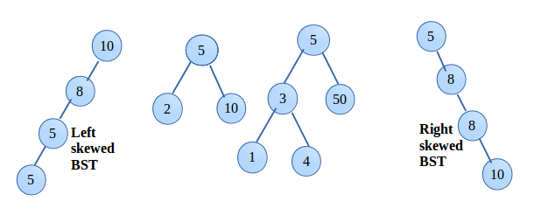

In the above shown binary search tree, first and last one are skewed BST.
Insertion and deletion in worst case takes O(n).

Operation on BST:
1. Insertion
Say we have to build a BST of the keys, 50, 80, 30, 20, 100, 40. It can be clearly seen below, for inserting, first the key is compared is compared with the root, if smaller then goto Left subtree else Right subtree. The same step is repeated until all the keys are inserted.

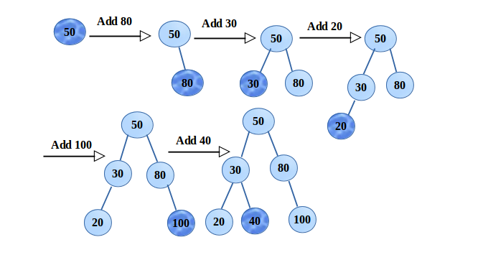

2. Deletion
Deletion of a node is performed as follows,
- Deleting node has no child, therefore just delete the node(made to point NULL)
- Deleting node has 1 child, swap the key with the child and delete the child.
- Deleting node has 2 children, in this case swap the key with inorder successor of the deleting node. It should be noted, inorder successor will be the minimum key in the right subtree (of the deleting node).
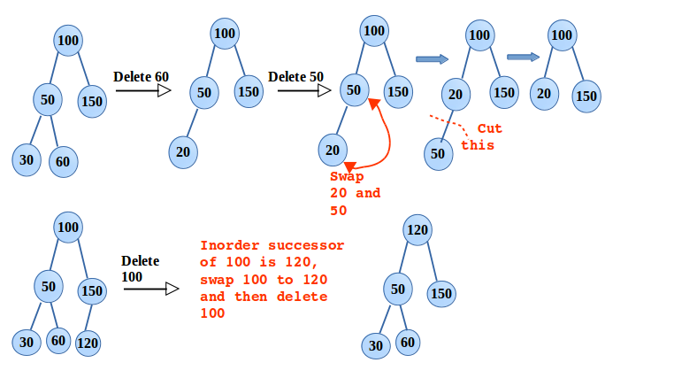

3. Searching
The steps follow in the insertion, are same followed here. Only difference is in comparison, if the key is not matched, repeat the steps till reached NULL. That says, desired key is not available in the BST.

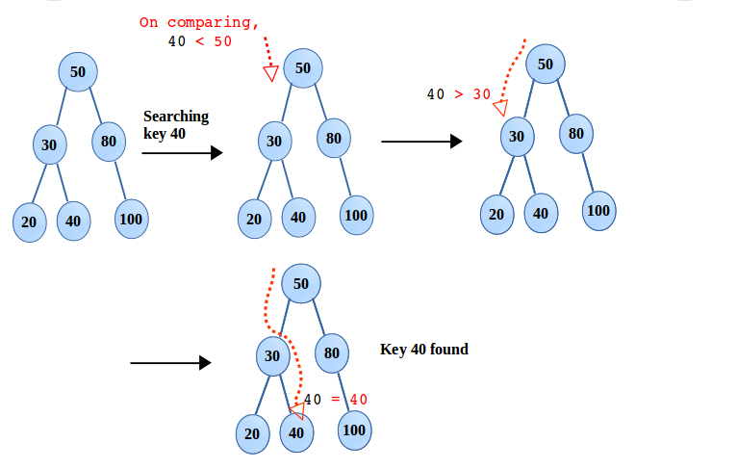
4. Traversal
Interestingly, inorder traversal of any binary search tree outputs keys in non-decreasing order. This makes BST more useful in many implementations. The code mentioned below, inorder traversal is done by calling the function traverseInorder(root).

#include<stdio.h>
#include<stdlib.h>

typedef struct node{
int key;
struct node *left;
struct node *right;
}Node;

/*for creating new node */
Node * newNode(int key){

Node *temp = (Node *)malloc(sizeof(Node));

temp->key = key;
temp->left = NULL;
temp->right = NULL;

return temp;
}

/*for inserting the key, newNode is the node needed to be inserted */
Node * insert(Node *p, Node *nwNode){

if(!p){
printf("Key %d\tinserted\n", nwNode->key);
return nwNode;
}
if(nwNode->key > p->key){

insert(p->right, nwNode);
if(!(p->right))
p->right = nwNode;
}
else{
insert(p->left, nwNode);
if(!(p->left))
p->left = nwNode;
}
return p;
}

/* for searching the key */
void search(Node *p, int searchKey){

if(!p){
printf("No key found for value - %d.\n", searchKey);
return ;
}

if(p->key == searchKey){
printf("Key %d\tfound\n", searchKey);
}

else if(p->key < searchKey)
search(p->right, searchKey);
else
search(p->left, searchKey);

}

/* inorder successor in BST will be the minimum key in right subtree */
Node * getInSuccessor(Node *p){

while(p->left != NULL)
p = p->left; //this will give the minimum key

return p;
}

Node * deletion(Node *p, int delKey){

struct node *temp;

if(!p){
printf("Unable to delete. No such key exists.\n");
return p;
}

else if(delKey > p->key)
p->right = deletion(p->right, delKey);
else if(delKey < p->key)
p->left = deletion(p->left, delKey);

/* executing else means get the key */
else{
/* node has one child or no child */
if(p->left == NULL){
temp = p->right;
free(p);
return temp;
}
else if(p->right == NULL){
temp = p->left;
free(p);
return temp;
}

/* node with two children, interchange with inorder successor */
temp = getInSuccessor(p->right);
p->key = temp->key;
p->right = deletion(p->right, temp->key); // Delete the inorder successor
}
return p;
}

/* Preorder traversal that outputs key in non-decreasing order*/
void traversePreorder(Node *p){

if(!p)
return ;

printf("%d ", p->key);
traversePreorder(p->left);
traversePreorder(p->right);
}

/* Inorder traversal that outputs key in non-decreasing order*/
void traverseInorder(Node *p){

if(!p)
return ;

traverseInorder(p->left);
printf("%d ", p->key);
traverseInorder(p->right);
}

/* Postorder traversal that outputs key in non-decreasing order*/
void traversePostorder(Node *p){

if(!p)
return ;

traversePostorder(p->left);
traversePostorder(p->right);
printf("%d ", p->key);
}

int main(void){

Node *root = NULL;

root = insert(root, newNode(50));
insert(root, newNode(80));
insert(root, newNode(30));
insert(root, newNode(40));
insert(root, newNode(20));
insert(root, newNode(100));

search(root, 50);
search(root, 10);

Node *newRoot = deletion(root, 50);
if(newRoot){
printf("Successfully deleted node. Now tree root node is - %d.\n", newRoot->key);
}
search(root, 50);

printf("Preorder Traversal: ");
traversePreorder(root);
printf("\nInorder Traversal: ");
traverseInorder(root);
printf("\nPostorder Traversal: ");
traversePostorder(root);

return 0;
}

2 What is Hashing in Data Structure?
Hashing is a technique used in data structures to store and retrieve data efficiently. It involves using a hash function to map data items to a fixed-size array which is called a hash table.
Hash Table
A hash table is also known as a hash map. It is a data structure that stores key-value pairs. It uses a hash function to map keys to a fixed-size array, called a hash table. This allows in faster search, insertion, and deletion operations.
Hash Function
The hash function is a function that takes a key and returns an index into the hash table. The goal of a hash function is to distribute keys evenly across the hash table, minimizing collisions (when two keys map to the same index).
Common hash functions include:
- Division Method: Key % Hash Table Size
- Multiplication Method: (Key * Constant) % Hash Table Size
- Universal Hashing: A family of hash functions designed to minimize collisions

2.1 How does Hashing in Data Structures Work?
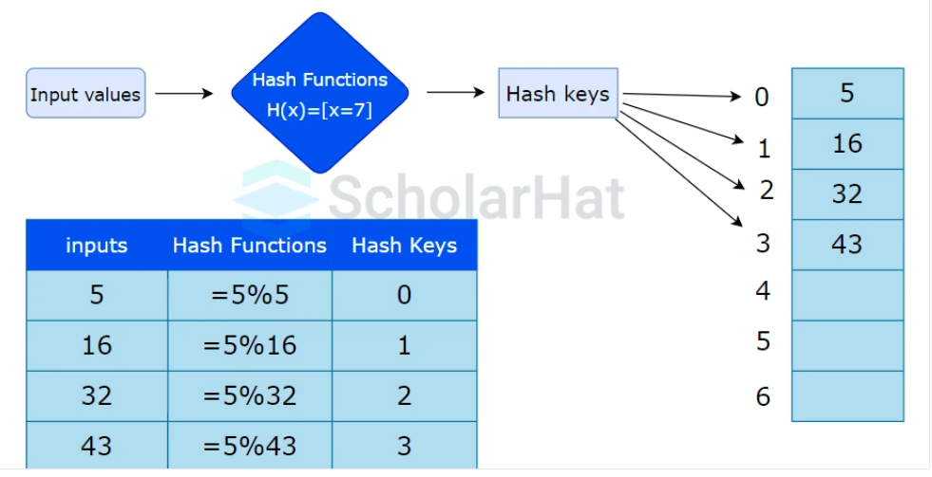

- Hash key: It is the data you want to be hashed in the hash table. The hashing algorithm translates the key to the hash value. This identifier can be a string or an integer. There are some types of hash keys:
  - Public key - It is an open key used solely for data encryption.
  - Private key - It is known as a symmetric key used for both purposes, encryption and decryption.
  - SSH public key - SSH is a set of both public and private keys.
- Hash Function: It performs the mathematical operation of accepting the key value as input and producing the hash code or hash value as the output. Some of the characteristics of an ideal hash function are as follows:
- It must produce the same hash value for the same hash key to be deterministic.
- Every input has a unique hash code. This feature is known as the hash property.
- It must be collision-friendly.
- A little bit of change leads to a drastic change in the output.
- The calculation must be quick
- Hash Table: It is a type of data structure that stores data in an array format. The table maps keys to values using a hash function.

2.2 Types of Hash Functions
The primary types of hash functions are:
- Division Method.
- Mid Square Method.
- Folding Method.
- Multiplication Method.
- Division Method
The easiest and quickest way to create a hash value is through division. The k-value is divided by M in this hash function, and the result is used.
Formula:
h(K) = k mod M
(where k = key value and M = the size of the hash table)
Advantages:
- This method is effective for all values of M.
- The division strategy only requires one operation, thus it is quite quick.
Disadvantages:
- Since the hash table maps consecutive keys to successive hash values, this could result in poor performance.
- There are times when exercising extra caution while selecting M's value is necessary.
Example of Division Method
k = 1987
M = 13h(1987) = 1987 mod 13
h(1987) = 4

- Mid Square Method
The following steps are required to calculate this hash method:
- k*k, or square the value of k
- Using the middle r digits, calculate the hash value.
Formula:
h(K) = h(k x k)
(where k = key value)
Advantages:
- This technique works well because most or all of the digits in the key value affect the result. All of the necessary digits participate in a process that results in the middle digits of the squared result.
- The result is not dominated by the top or bottom digits of the initial key value.
Disadvantages:
- The size of the key is one of the limitations of this system; if the key is large, its square will contain twice as many digits.
- Probability of collisions occurring repeatedly.
Example of Mid Square Method
k = 60Therefore,k = k x k
k = 60 x 60
k = 3600Thus,
h(60) = 60
- Folding Method
The process involves two steps:
- except for the last component, which may have fewer digits than the other parts, the key-value k should be divided into a predetermined number of pieces, such as k1, k2, k3,..., kn, each having the same amount of digits.
- Add each element individually. The hash value is calculated without taking into account the final carry, if any.
Formula:
k = k1, k2, k3, k4, ….., kn
s = k1+ k2 + k3 + k4 +….+ kn
h(K)= s
(Where, s = addition of the parts of key k)
Advantages:
- Creates a simple hash value by precisely splitting the key value into equal-sized segments.
- Without regard to distribution in a hash table.
Disadvantages:
- When there are too many collisions, efficiency can occasionally suffer.
Example of Folding Method
k = 12345
k1 = 67; k2 = 89; k3 = 12Therefore,s = k1 + k2 + k3
s = 67 + 89 + 12
s = 168
- Multiplication Method
- Determine a constant value. A, where (0, A, 1)
- Add A to the key value and multiply.
- Consider kA's fractional portion.
- Multiply the outcome of the preceding step by M, the hash table's size.
Formula:
h(K) = floor (M (kA mod 1))
(Where, M = size of the hash table, k = key value and A = constant value)
Advantages:
- Any number between 0 and 1 can be applied to it, however, some values seem to yield better outcomes than others.
Disadvantages:
- The multiplication method is often appropriate when the table size is a power of two since multiplication hashing makes it possible to quickly compute the index by key.
Example of Multiplication Method
k = 5678
A = 0.6829
M = 200
Now, calculating the new value of h(5678):h(5678) = floor[200(5678 x 0.6829 mod 1)]
h(5678) = floor[200(3881.5702 mod 1)]
h(5678) = floor[200(0.5702)]
h(5678) = floor[114.04]
h(5678) = 114
So, with the updated values, h(5678) is 114.

2.3 What is a Hash Collision?
A hash collision occurs when two different keys map to the same index in a hash table. This can happen even with a good hash function, especially if the hash table is full or the keys are similar.
Causes of Hash Collisions:
- Poor Hash Function: A hash function that does not distribute keys evenly across the hash table can lead to more collisions.
- High Load Factor: A high load factor (ratio of keys to hash table size) increases the probability of collisions.
- Similar Keys: Keys that are similar in value or structure are more likely to collide.

2.4 Collision Resolution Techniques
There are two types of collision resolution techniques:
- Open Addressing:
  - Linear Probing: Search for an empty slot sequentially
  - Quadratic Probing: Search for an empty slot using a quadratic function
- Closed Addressing:
  - Chaining: Store colliding keys in a linked list or binary search tree at each index
  - Cuckoo Hashing: Use multiple hash functions to distribute keys

2.4.1 Separate Chaining:
The idea behind separate chaining is to implement the array as a linked list called a chain. Separate chaining is one of the most popular and commonly used techniques in order to handle collisions.

The linked list data structure is used to implement this technique. So what happens is, when multiple elements are hashed into the same slot index, then these elements are inserted into a singly-linked list which is known as a chain.

Here, all those elements that hash into the same slot index are inserted into a linked list. Now, we can use a key K to search in the linked list by just linearly traversing. If the intrinsic key for any entry is equal to K then it means that we have found our entry. If we have reached the end of the linked list and yet we haven’t found our entry then it means that the entry does not exist. Hence, the conclusion is that in separate chaining, if two different elements have the same hash value then we store both the elements in the same linked list one after the other.

Example: Let us consider a simple hash function as “key mod 7” and a sequence of keys as 50, 700, 76, 85, 92, 73, 101
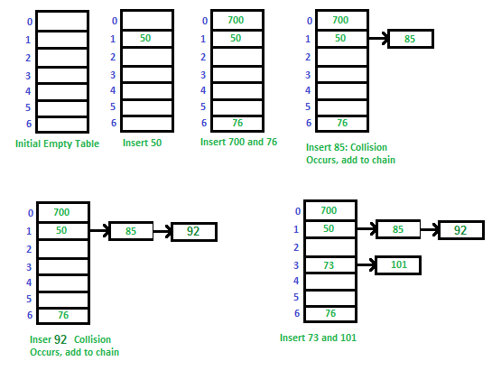

2.4.2 Open Addressing:

Like separate chaining, open addressing is a method for handling collisions. In Open Addressing, all elements are stored in the hash table itself. So at any point, the size of the table must be greater than or equal to the total number of keys (Note that we can increase table size by copying old data if needed). This approach is also known as closed hashing. This entire procedure is based upon probing. We will understand the types of probing ahead:

Insert(k): Keep probing until an empty slot is found. Once an empty slot is found, insert k.
Search(k): Keep probing until the slot’s key doesn’t become equal to k or an empty slot is reached.
Delete(k): Delete operation is interesting. If we simply delete a key, then the search may fail. So slots of deleted keys are marked specially as “deleted”.
The insert can insert an item in a deleted slot, but the search doesn’t stop at a deleted slot.

Different ways of Open Addressing:

1. Linear Probing:
In linear probing, the hash table is searched sequentially that starts from the original location of the hash. If in case the location that we get is already occupied, then we check for the next location.

The function used for rehashing is as follows: rehash(key) = (n+1)%table-size.

For example, The typical gap between two probes is 1 as seen in the example below:

Let hash(x) be the slot index computed using a hash function and S be the table size
If slot hash(x) % S is full, then we try (hash(x) + 1) % S
If (hash(x) + 1) % S is also full, then we try (hash(x) + 2) % S
If (hash(x) + 2) % S is also full, then we try (hash(x) + 3) % S
…………………………………………..
…………………………………………..
Let us consider a simple hash function as “key mod 7” and a sequence of keys as 50, 700, 76, 85, 92, 73, 101,
which means hash(key)= key% S, here S=size of the table =7,indexed from 0 to 6.We can define the hash function as per our choice if we want to create a hash table,although it is fixed internally with a pre-defined formula.

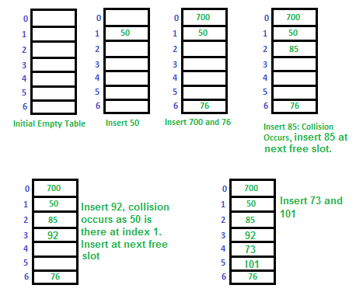

Example: Let us consider a simple hash function as “key mod 5” and a sequence of keys that are to be inserted are 50, 70, 76, 93.
- Step1: First draw the empty hash table which will have a possible range of hash values from 0 to 4 according to the hash function provided.

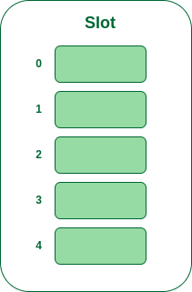
- Step 2: Now insert all the keys in the hash table one by one. The first key is 50. It will map to slot number 0 because 50%5=0. So insert it into slot number 0.

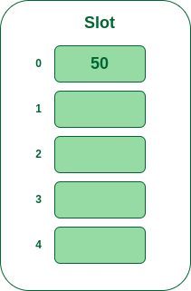
Insert 50 into hash table

- Step 3: The next key is 70. It will map to slot number 0 because 70%5=0 but 50 is already at slot number 0 so, search for the next empty slot and insert it.

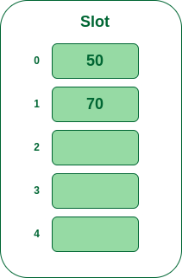
Insert 70 into hash table

- Step 4: The next key is 76. It will map to slot number 1 because 76%5=1 but 70 is already at slot number 1 so, search for the next empty slot and insert it.
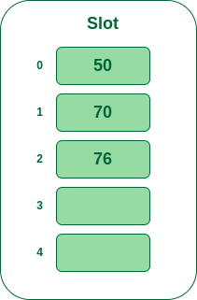
Insert 76 into hash table

- Step 5: The next key is 93 It will map to slot number 3 because 93%5=3, So insert it into slot number 3.
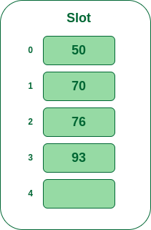
Insert 93 into hash table

2. Quadratic Probing
If you observe carefully, then you will understand that the interval between probes will increase proportionally to the hash value. Quadratic probing is a method with the help of which we can solve the problem of clustering that was discussed above. This method is also known as the mid-square method. In this method, we look for the i²‘th slot in the i^{th} iteration. We always start from the original hash location. If only the location is occupied then we check the other slots.
let hash(x) be the slot index computed using hash function.
If slot hash(x) % S is full, then we try (hash(x) + 1*1) % S
If (hash(x) + 1*1) % S is also full, then we try (hash(x) + 2*2) % S
If (hash(x) + 2*2) % S is also full, then we try (hash(x) + 3*3) % S
…………………………………………..
…………………………………………..

Example: Let us consider table Size = 7, hash function as Hash(x) = x % 7 and collision resolution strategy to be f(i) = i² . Insert = 22, 30, and 50.

- Step 1: Create a table of size 7.

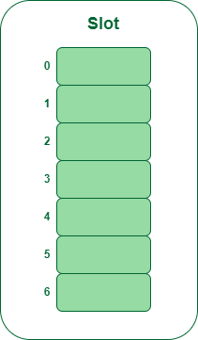
Hash table
- Step 2 – Insert 22 and 30
  - Hash(22) = 22 % 7 = 1, Since the cell at index 1 is empty, we can easily insert 22 at slot 1.
  - Hash(30) = 30 % 7 = 2, Since the cell at index 2 is empty, we can easily insert 30 at slot 2.

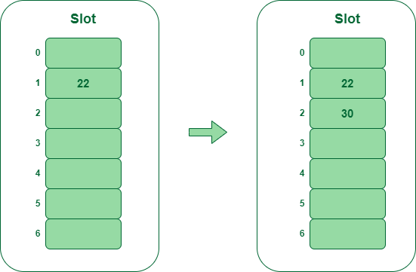

Insert keys 22 and 30 in the hash table

- Step 3: Inserting 50
  - Hash(50) = 50 % 7 = 1
  - In our hash table slot 1 is already occupied. So, we will search for slot 1+1², i.e. 1+1 = 2,
  - Again slot 2 is found occupied, so we will search for cell 1+2², i.e.1+4 = 5,
  - Now, cell 5 is not occupied so we will place 50 in slot 5.

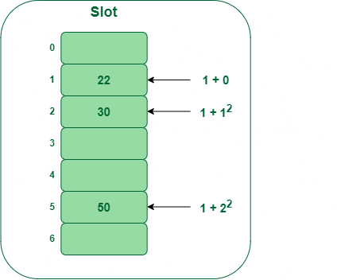
Insert key 50 in the hash table

2.4.2 Separate Chaining:
The idea behind separate chaining is to implement the array as a linked list called a chain. Separate chaining is one of the most popular and commonly used techniques in order to handle collisions.

The linked list data structure is used to implement this technique. So what happens is, when multiple elements are hashed into the same slot index, then these elements are inserted into a singly-linked list which is known as a chain.

Here, all those elements that hash into the same slot index are inserted into a linked list. Now, we can use a key K to search in the linked list by just linearly traversing. If the intrinsic key for any entry is equal to K then it means that we have found our entry. If we have reached the end of the linked list and yet we haven’t found our entry then it means that the entry does not exist. Hence, the conclusion is that in separate chaining, if two different elements have the same hash value then we store both the elements in the same linked list one after the other.

Example: Let us consider a simple hash function as “key mod 7” and a sequence of keys as 50, 700, 76, 85, 92, 73, 101


2.5 Applications of Hashing

- Database indexing: Hashing is used to index and retrieve data efficiently in databases and other data storage systems.
- Password storage: Hashing is used to store passwords securely by applying a hash function to the password and storing the hashed result, rather than the plain text password.
- Data compression: Hashing is used in data compression algorithms, such as the Huffman coding algorithm, to encode data efficiently.
- Search algorithms: Hashing is used to implement search algorithms, such as hash tables and bloom filters, for fast lookups and queries.
- Cryptography: Hashing is used in cryptography to generate digital signatures, message authentication codes (MACs), and key derivation functions.
- Load balancing: Hashing is used in load-balancing algorithms, such as consistent hashing, to distribute requests to servers in a network.
- Blockchain: Hashing is used in blockchain technology, such as the proof-of-work algorithm, to secure the integrity and consensus of the blockchain.
- Image processing: Hashing is used in image processing applications, such as perceptual hashing, to detect and prevent image duplicates and modifications.
- File comparison: Hashing is used in file comparison algorithms, such as the MD5 and SHA-1 hash functions, to compare and verify the integrity of files.
- Fraud detection: Hashing is used in fraud detection and cybersecurity applications, such as intrusion detection and antivirus software, to detect and prevent malicious activities.

