step 1:
=====

-->create private repo in nexus
select the Repository --> go to --> create repository.
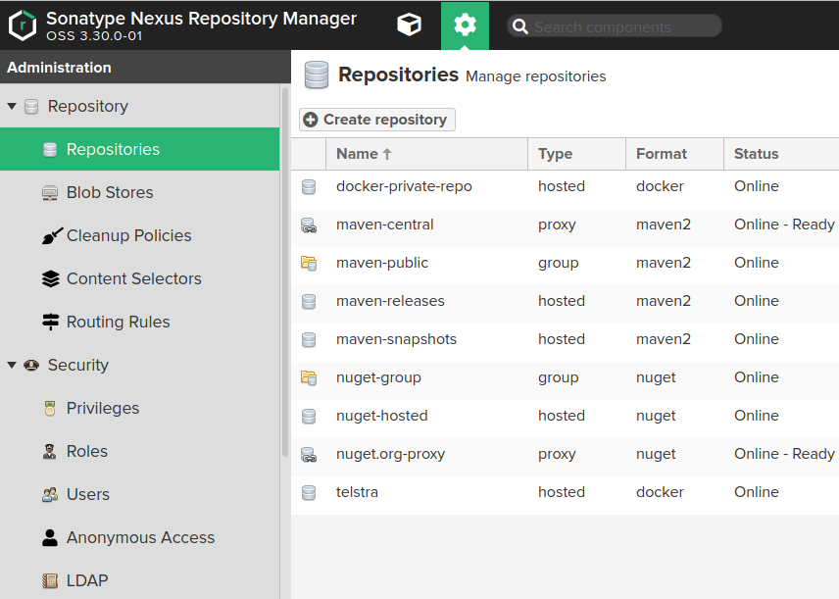
-->click the create repo option --> select the docker(hosted)

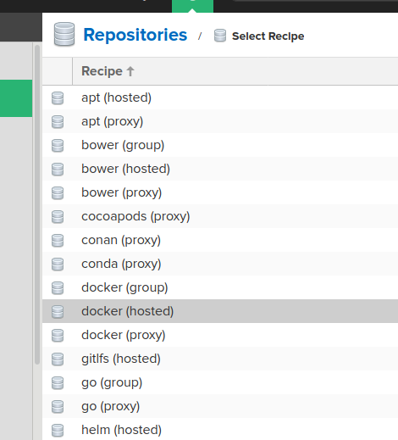

-->Enter the details of repo.
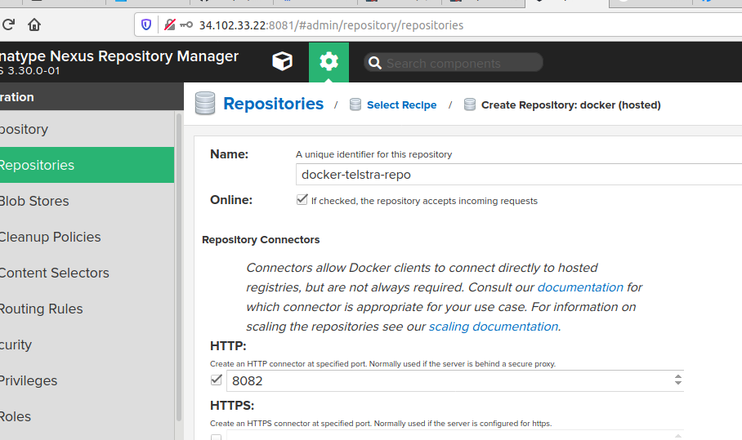

Step 2:

--> Install docker on your instanse or node.
On centos 7:
sudo yum check-update
curl -fsSL https://get.docker.com/ | sh
sudo systemctl start docker
sudo systemctl status docker
sudo systemctl enable docker

If you need to add a user to the docker group that you’re not logged in as, declare that username explicitly using:
sudo usermod -aG docker username.

After installation docker.
--> go to vi /ect/docker/ deamon.json.
If file is not there create deamon.json file.

Wite the below mentioned into deamon.json file
{“insecure-registries”:[“nexsuip:repository-port”] }

then

--> restart docker.
Systemctl restart docker or service docker restart

-->check --> docker info

--> create direcorty name as busybox.
mkdir busybox

--> cd busybox
create one dockerfile in this busybox directory.

FROM busybox
RUN touch a b c

--> build the docker file.
$ docker build . -t busybox:1.0

--> check the image create or not. With name busybox tag 1.0
* docker images

--> tag the docker image.
-> docker tag busybox:1.0 nexusip:repoport/imagename:1.0 ( here image name is busybox)

Login to docker:

docker login -u admin -p admin@123 nexusip:repoport

--> push the docker image to nexus repo.

Docker push image:1.0

