R Workshop Notebook

Madhu Vasudevan

June 18, 2019

Table of Contents

[Workshop url](https://ariel.rbind.io/workshop/rmarkdown/)

This is an [R Markdown](http://rmarkdown.rstudio.com) Notebook. When you execute code within the notebook, the results appear beneath the code.

Try executing this chunk by clicking the *Run* button within the chunk or by placing your cursor inside it and pressing *Ctrl+Shift+Enter*.

plot(cars)

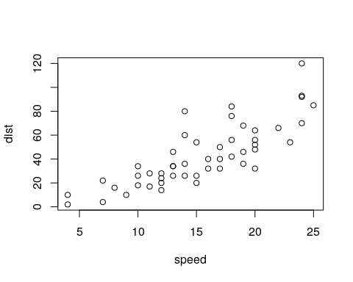

Add a new chunk by clicking the *Insert Chunk* button on the toolbar or by pressing *Ctrl+Alt+I*.

When you save the notebook, an HTML file containing the code and output will be saved alongside it (click the *Preview* button or press *Ctrl+Shift+K* to preview the HTML file).

The preview shows you a rendered HTML copy of the contents of the editor. Consequently, unlike *Knit*, *Preview* does not run any R code chunks. Instead, the output of the chunk when it was last run in the editor is displayed.

# Introduction to Markdown

## Headers

The [RStudio cheatsheet](https://www.rstudio.com/wp-content/uploads/2015/02/rmarkdown-cheatsheet.pdf) is a good resource, as is RStudio’s [Markdown Basics page](http://rmarkdown.rstudio.com/authoring_basics.html).

**Bold text** looks like **this**.

*Italic* text looks like *this*.

## Nested Bullet List

* First bullet
* Second bullet
  + Secondary bullet

Do you see the nested bullet list above?

## Nested Numbered Lists

1. Item 1
2. Item 2
   1. Item 2a
   2. Item 2b
3. Item 3

## Block quotes

Here is how to write a block quote as a single block of text even if it is written on multiple lines

Here is the first block quote  
Here is the second  
end each above line with two or more spaces.

Here is the first block quote.

Here is the second after a line break.

## Images



RStudio-logo

## Inline R code

There were 32 rows in the dataset.

## Plain code blocks

## Plain code blocks  
Write in *italics* with single asterisks.

## Equations

### Inline equations

Look up symbols at Math-Linux.com [website](https://math-linux.com/latex-26/faq/latex-faq/article/how-to-write-latex-derivatives-limits-sums-products-and-integrals)

Also: Getting Started with LaTeX By David R. Wilkins 2nd Edition Copyright David R. Wilkins 1995 [online](https://www.maths.tcd.ie/~dwilkins/LaTeXPrimer/)

Also: LaTex [wiki](https://oeis.org/wiki/List_of_LaTeX_mathematical_symbols)

Let’s talk about $σ^{2}$ within a sentence, using the Greek letter.

And $\int_{a}^{b}{f}(x)dx$

### Display equation

Here is how we sum everything together:

$$\sum_{i=1}^{n}{X_{i}}$$

And

$$\int_{a}^{b}{f}(x) dx.$$

## Page breaks

Force new pages by putting three or more dashes or asterisks on a line. ****

# Miscellaneous

## Superscripts

y2

## Subscripts

H2O

## Strikethroughs

~~Strike this out~~

# YAML header

Refer:  
[RStudio HTML R Markdown page](http://rmarkdown.rstudio.com/html_document_format.html#overview)  
[PDF R Markdown page](http://rmarkdown.rstudio.com/pdf_document_format.html#overview)

---  
title: "Practice Notebook"  
date: May 16, 2018  
output: html_notebook  
---

# Code Chunks

library(ggplot2)

## Registered S3 methods overwritten by 'ggplot2':  
## method from   
## [.quosures rlang  
## c.quosures rlang  
## print.quosures rlang

library(dplyr)

##   
## Attaching package: 'dplyr'

## The following objects are masked from 'package:stats':  
##   
## filter, lag

## The following objects are masked from 'package:base':  
##   
## intersect, setdiff, setequal, union

detach("package:dplyr", unload = TRUE)  
detach("package:ggplot2", unload = TRUE)

## Knitr Options

Author [Yihui Xie](https://yihui.name/knitr/options/)

## Making a setup chunk

code it as follows within a code chunk delimiters - three back-ticks (`):

{r setup, echo = FALSE}  
library(knitr)  
opts_chunk$set(root.dir = “filepath”, fig.height = 10, fig.width = 5)

## Suppressing messages and warnings

library(ggplot2)  
library(dplyr)

## Suppressing code output

mtcars %>%  
group_by(cyl) %>%  
summarise(mdisp = mean(disp) )

## Suppressing code

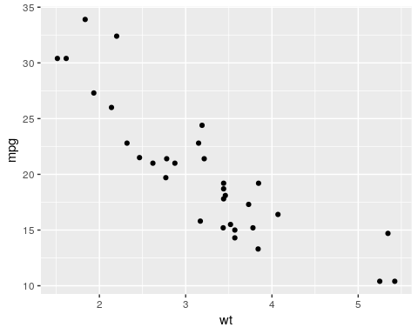

plot(cars)

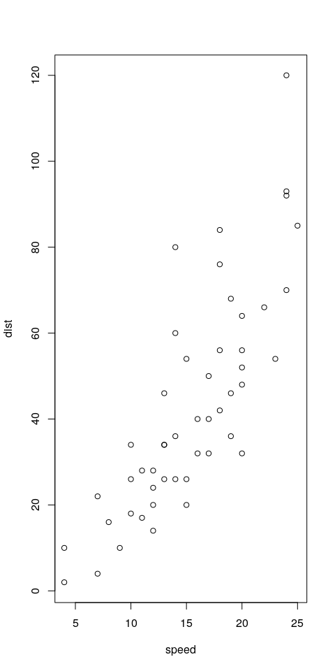

## Default working directory

For R Notebooks and all other R Markdown documents, default working directory is the directory where the Rmd file is stored.

dat = read.csv("./Data/test.csv")  
dat

## Diffmeans Lower.CI Upper.CI plantdate stocktype  
## 1 -0.27 -0.63 0.09 Jan2 cont  
## 2 0.11 -0.25 0.47 Jan28 cont  
## 3 -0.15 -0.51 0.21 Jan28 bare  
## 4 -1.27 -1.63 -0.91 Feb25 cont  
## 5 -1.18 -1.54 -0.82 Feb25 bare

## Separating single code chunks into multiples

qplot(disp, mpg, data = mtcars)

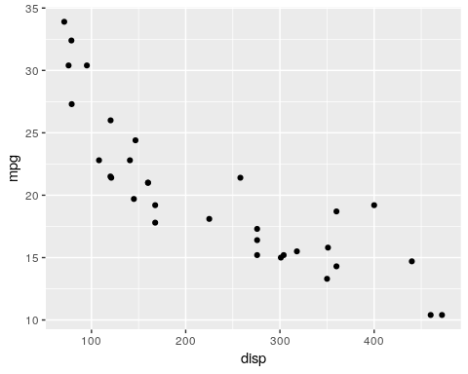

qplot(wt, mpg, data = mtcars)



qplot(disp, mpg, data = mtcars)



qplot(wt, mpg, data = mtcars)



## Embedding interactive graphics

library(dygraphs)  
dygraph(nhtemp) %>%  
dyRangeSelector( dateWindow = c("1920-01-01", "1960-01-01") )

## Registered S3 method overwritten by 'xts':  
## method from  
## as.zoo.xts zoo

## Change how static images are added

For pinning down figure location in pdf documents.



## Holding figures to end of chunk with fig.show

Does NOT work with notebooks.

plot(cars)



plot(pressure)

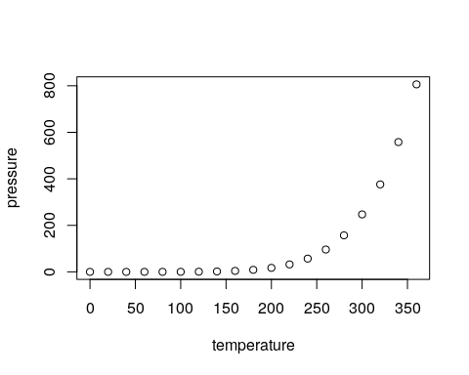

plot(cars)  
plot(pressure)



—- End of Document