R Markdown Workshop

Madhu V

6/18/2019

Table of Contents

## R Markdown

This is an R Markdown document. Markdown is a simple formatting syntax for authoring HTML, PDF, and MS Word documents. For more details on using R Markdown see <http://rmarkdown.rstudio.com>.

When you click the **Knit** button a document will be generated that includes both content as well as the output of any embedded R code chunks within the document. You can embed an R code chunk like this:

summary(cars)

speed dist   
 Min. : 4.0 Min. : 2.00   
 1st Qu.:12.0 1st Qu.: 26.00   
 Median :15.0 Median : 36.00   
 Mean :15.4 Mean : 42.98   
 3rd Qu.:19.0 3rd Qu.: 56.00   
 Max. :25.0 Max. :120.00

## Including Plots

You can also embed plots, for example:

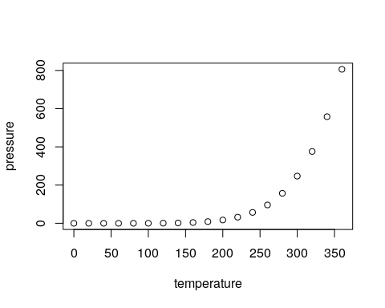

Note that the echo = FALSE parameter was added to the code chunk to prevent printing of the R code that generated the plot.

## Removing pound signs from code output via setup chunk

Include comment = NA in the setup chunk to get rid of these.

## Add table of contents

With toc: TRUE in YAML header.

##Change the document margins via geometry: setting in the YAML header,  
setting the margins overall or just some of the margins

## Make URL links visible

change the url color using the urlcolor: option in the YAML header

## Using eval and echo

library(dplyr)

mtcars %>%  
group_by(cyl) %>%  
summarise(mdisp = mean(disp) )

|  |  |
| --- | --- |
| cyl | mdisp |
| 4 | 105.1364 |
| 6 | 183.3143 |
| 8 | 353.1000 |

## Holding figures to end of chunk with fig.show

plot(cars)

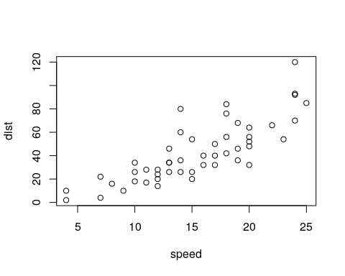

plot(pressure)



plot(cars)  
plot(pressure)

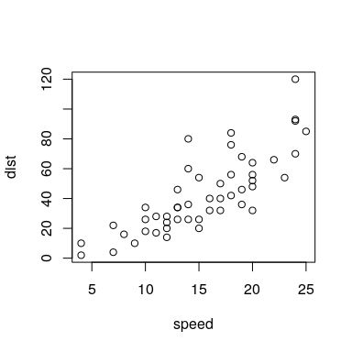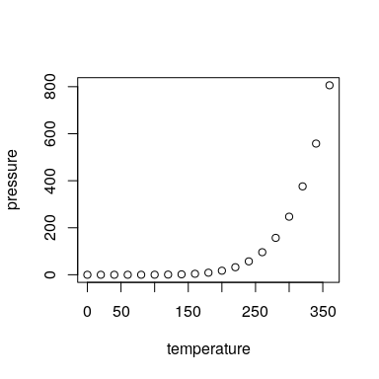

# Informational links

## Package tinytex

<https://yihui.name/tinytex/>

## RStudio cheatsheet

<https://www.rstudio.com/wp-content/uploads/2015/02/rmarkdown-cheatsheet.pdf>

## Markdown basics

<http://rmarkdown.rstudio.com/authoring_basics.html>

## LaTeX mathematical symbols

<https://oeis.org/wiki/List_of_LaTeX_mathematical_symbols>

## Formatting HTML documents

<http://rmarkdown.rstudio.com/html_document_format.html#overview>

—- End of Document