**Mandotory HandsOn**

**1. Create a new React Application with the name “myfirstreact”,**

**App.js**

import React from 'react';

function App() {

  return (

    <div>

      <center><h1>Welcome to the first session of React</h1> </center>

    </div>

  );

}

export default App;

**Output:**

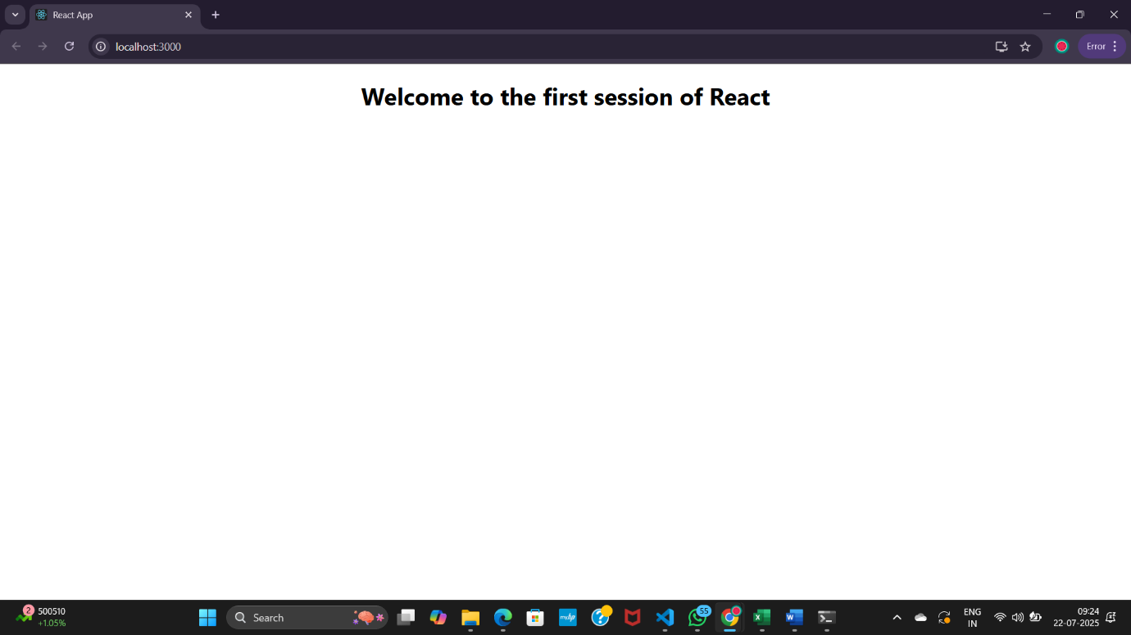

**2. Create a React project named “StudentApp”**

**Components**

**Home.js**

import React, { Component } from 'react';

class Home extends Component {

  render() {

    return (

      <div>

        <h2>Welcome to the Home page of Student Management Portal</h2>

      </div>

    );

  }

}

export default Home;

**About.js**

import React, { Component } from 'react';

class About extends Component {

  render() {

    return (

      <div>

        <h2>Welcome to the About page of the Student Management Portal</h2>

      </div>

    );

  }

}

export default About;

**Contact.js**

import React, { Component } from 'react';

class Contact extends Component {

  render() {

    return (

      <div>

        <h2>Welcome to the Contact page of the Student Management Portal</h2>

      </div>

    );

  }

}

export default Contact;

**App.js**

import React from 'react';

import './App.css';

import Home from './Components/Home';

import About from './Components/About';

import Contact from './Components/Contact';

function App() {

  return (

    <div className="App">

      <h1>Student Management Portal</h1>

      <Home />

      <About />

      <Contact />

    </div>

  );

}

export default App;

**Output:**

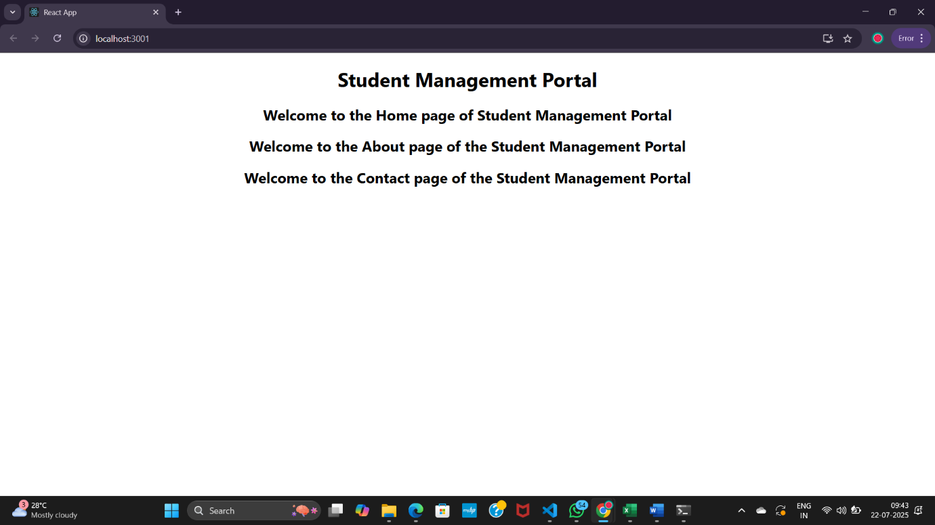

**3. Create a react app for Student Management Portal named scorecalculatorapp**

**Compnents**

**CalculateScore.js**

import React, { useState } from 'react';

import '../Stylesheets/mystyle.css';

function CalculateScore() {

  const [name, setName] = useState('');

  const [school, setSchool] = useState('');

  const [total, setTotal] = useState('');

  const [goal, setGoal] = useState('');

  const [average, setAverage] = useState(null);

  const handleCalculate = () => {

    const totalScore = parseFloat(total);

    const goalScore = parseFloat(goal);

    if (!isNaN(totalScore) && !isNaN(goalScore) && goalScore !== 0) {

      const avg = totalScore / goalScore;

      setAverage(avg.toFixed(2));

    } else {

      setAverage('Invalid input');

    }

  };

  return (

    <div className="score-container">

      <h2>Student Score Calculator</h2>

      <input type="text" placeholder="Enter Name" onChange={(e) => setName(e.target.value)} />

      <input type="text" placeholder="Enter School" onChange={(e) => setSchool(e.target.value)} />

      <input type="number" placeholder="Enter Total Score" onChange={(e) => setTotal(e.target.value)} />

      <input type="number" placeholder="Enter Goal" onChange={(e) => setGoal(e.target.value)} />

      <button onClick={handleCalculate}>Calculate Average</button>

      {average !== null && (

        <div className="result">

          <p><strong>Name:</strong> {name}</p>

          <p><strong>School:</strong> {school}</p>

          <p><strong>Average Score:</strong> {average}</p>

        </div>

      )}

    </div>

  );

}

export default CalculateScore;

**mystyle.css**

.score-container {

  width: 400px;

  margin: 30px auto;

  padding: 20px;

  border: 2px solid #4CAF50;

  border-radius: 10px;

  background-color: #f9f9f9;

  box-shadow: 2px 2px 12px rgba(0,0,0,0.1);

}

.score-container h2 {

  text-align: center;

  color: #4CAF50;

}

.score-container input {

  display: block;

  width: 100%;

  padding: 8px;

  margin: 10px 0;

  border: 1px solid #ccc;

  border-radius: 5px;

}

.score-container button {

  width: 100%;

  padding: 10px;

  background-color: #4CAF50;

  border: none;

  color: white;

  font-size: 16px;

  border-radius: 5px;

  cursor: pointer;

}

.score-container button:hover {

  background-color: #45a049;

}

.result {

  margin-top: 15px;

  padding: 10px;

  background-color: #e7f3e7;

  border: 1px solid #4CAF50;

  border-radius: 5px;

}

**App.js**

import React from 'react';

import './App.css';

import CalculateScore from './Components/CalculateScore';

function App() {

  return (

    <div className="App">

      <CalculateScore />

    </div>

  );

}

export default App;

**Output:**

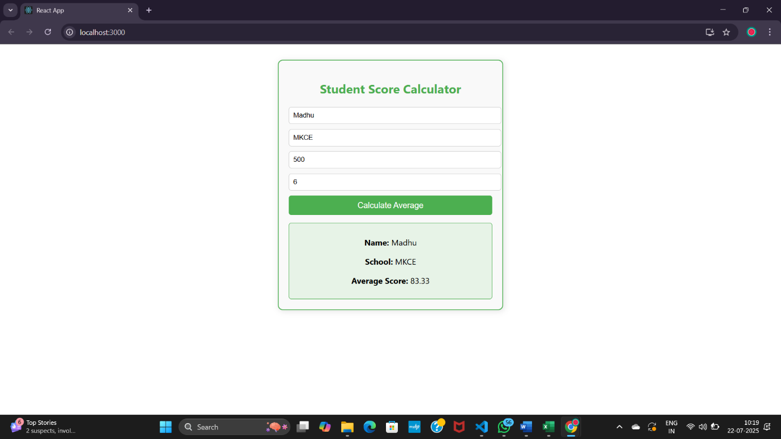

**4.BlogApp**

**Post.js**

class Post {

  constructor(id, title, body) {

    this.id = id;

    this.title = title;

    this.body = body;

  }

}

export default Post;

**Posts.js**

import React, { Component } from 'react';

import Post from './Post'; // Importing the Post class

class Posts extends Component {

  constructor(props) {

    super(props);

    this.state = {

      posts: [],

      hasError: false,

      error: null

    };

  }

  // Function to fetch posts

  loadPosts = async () => {

    try {

      const response = await fetch('https://jsonplaceholder.typicode.com/posts');

      const data = await response.json();

      const posts = data.slice(0, 10).map(

        p => new Post(p.id, p.title, p.body)

      ); // Only take first 10 posts

      this.setState({ posts });

    } catch (error) {

      console.error("Fetch Error:", error);

    }

  }

  // Lifecycle hook to fetch posts after component mounts

  componentDidMount() {

    this.loadPosts();

  }

  // Lifecycle hook to catch errors

  componentDidCatch(error, info) {

    this.setState({ hasError: true, error });

    alert("An error occurred: " + error.message);

  }

  // Render method to display posts

  render() {

    const { posts, hasError, error } = this.state;

    if (hasError) {

      return <h3>Error loading posts: {error?.message}</h3>;

    }

    return (

      <div style={{ padding: '20px' }}>

        <h1>Blog Posts</h1>

        {posts.map(post => (

          <div key={post.id} style={{ marginBottom: '20px', borderBottom: '1px solid #ccc' }}>

            <h2>{post.title}</h2>

            <p>{post.body}</p>

          </div>

        ))}

      </div>

    );

  }

}

export default Posts;

**App.js**

import React from 'react';

import './App.css';

import Posts from './Posts';

function App() {

  return (

    <div className="App">

      <Posts />

    </div>

  );

}

export default App;

**OutPut:**

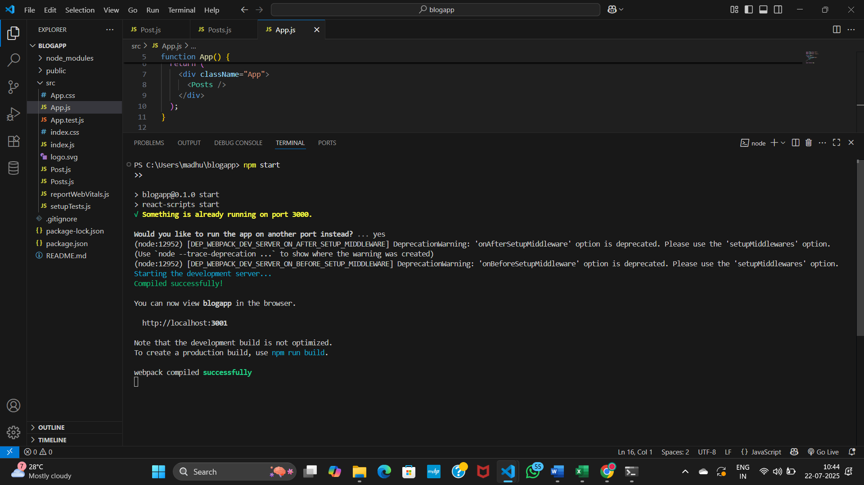

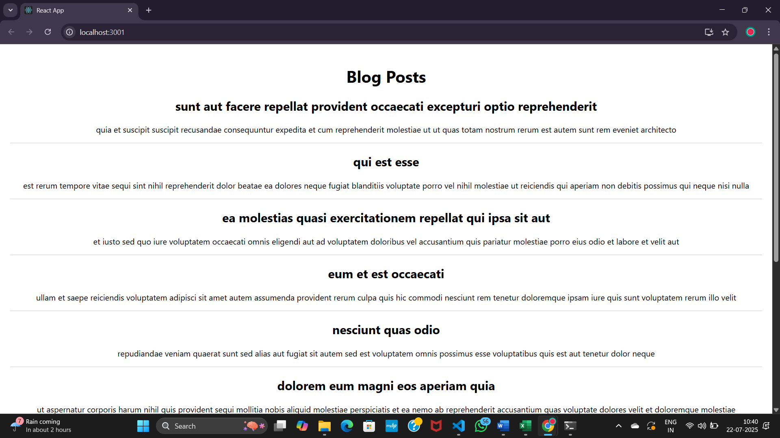

**5.To create a dashboard**

**App.js**

import React from 'react';

import './App.css';

import CohortDetails from './CohortDetails';

function App() {

  return (

    <div className="App">

      <h2>My Academy Dashboard</h2>

      <CohortDetails

        name="React Cohort"

        status="ongoing"

        startDate="2024-01-10"

        endDate="2024-04-10"

      />

      <CohortDetails

        name="Java Cohort"

        status="completed"

        startDate="2023-10-01"

        endDate="2023-12-31"

      />

    </div>

  );

}

export default App;

**CohortDetails.js**

import React from 'react';

import styles from './CohortDetails.module.css';

function CohortDetails(props) {

  return (

    <div className={styles.box}>

      <h3 style={{ color: props.status === 'ongoing' ? 'green' : 'blue' }}>

        {props.name}

      </h3>

      <dl>

        <dt>Status</dt>

        <dd>{props.status}</dd>

        <dt>Start Date</dt>

        <dd>{props.startDate}</dd>

        <dt>End Date</dt>

        <dd>{props.endDate}</dd>

      </dl>

    </div>

  );

}

export default CohortDetails;

**CohortDetails.modules.css**

.box {

  width: 300px;

  display: inline-block;

  margin: 10px;

  padding: 10px 20px;

  border: 1px solid black;

  border-radius: 10px;

}

dt {

  font-weight: 500;

}

**Output:**

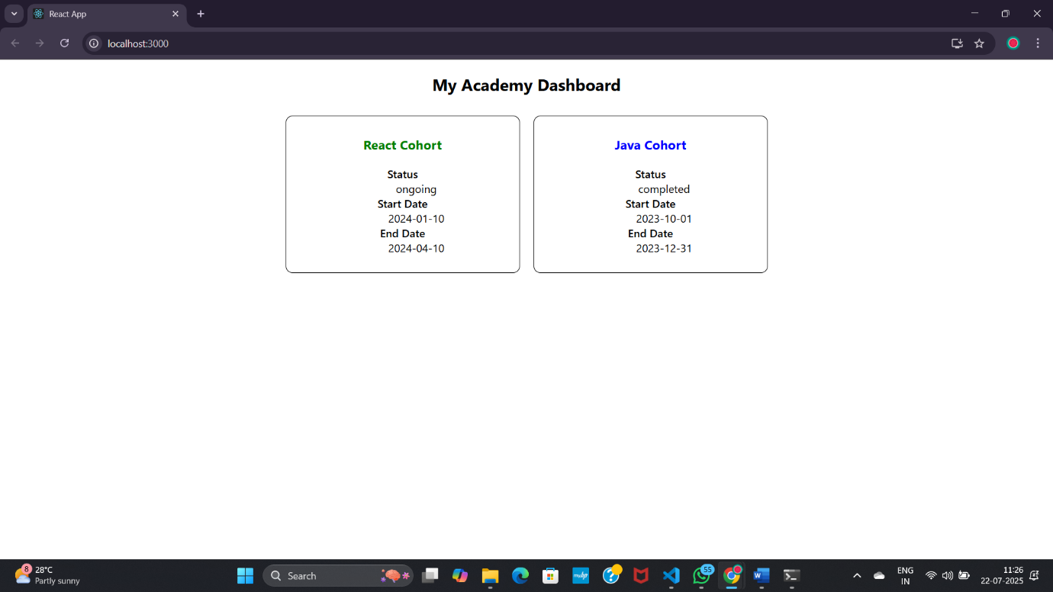

**Additional Mandotory HandsOn**

**6.TrainersApp**

**App.js**

import React from 'react';

import { BrowserRouter as Router, Routes, Route, Link } from 'react-router-dom';

import Home from './Home';

import TrainersList from './TrainersList';

import TrainerDetail from './TrainerDetails';

import trainers from './TrainersMock';

function App() {

  return (

    <Router>

      <div>

        <nav style={{ padding: "10px", borderBottom: "1px solid #ccc" }}>

          <Link to="/" style={{ marginRight: "15px" }}>Home</Link>

          <Link to="/trainers">Trainers</Link>

        </nav>

        <div style={{ padding: "20px" }}>

          <Routes>

            <Route path="/" element={<Home />} />

            <Route path="/trainers" element={<TrainersList data={trainers} />} />

            <Route path="/trainer/:id" element={<TrainerDetail />} />

          </Routes>

        </div>

      </div>

    </Router>

  );

}

export default App;

**Home.js**

import React from 'react';

function Home() {

  return (

    <div>

      <h2>Welcome to Cognizant Academy Trainer Portal</h2>

      <p>Select a section from the navigation menu.</p>

    </div>

  );

}

export default Home;

**Trainer.js**

class Trainer {

  constructor(trainerId, name, email, phone, technology, skills) {

    this.trainerId = trainerId;

    this.name = name;

    this.email = email;

    this.phone = phone;

    this.technology = technology;

    this.skills = skills;

  }

}

export default Trainer;

**TrainerDetails.js**

import React from 'react';

import { useParams } from 'react-router-dom';

import trainers from './TrainersMock';

function TrainerDetail() {

  const { id } = useParams();

  const trainer = trainers.find(t => t.trainerId === parseInt(id));

  if (!trainer) return <p>Trainer not found!</p>;

  return (

    <div>

      <h2>{trainer.name}'s Details</h2>

      <p><strong>Email:</strong> {trainer.email}</p>

      <p><strong>Phone:</strong> {trainer.phone}</p>

      <p><strong>Technology:</strong> {trainer.technology}</p>

      <p><strong>Skills:</strong> {trainer.skills.join(', ')}</p>

    </div>

  );

}

export default TrainerDetail;

**TrainersList.js**

import React from 'react';

import { Link } from 'react-router-dom';

function TrainersList({ data }) {

  return (

    <div>

      <h2>Trainers List</h2>

      <ul>

        {data.map((trainer) => (

          <li key={trainer.trainerId}>

            <Link to={`/trainer/${trainer.trainerId}`}>{trainer.name}</Link>

          </li>

        ))}

      </ul>

    </div>

  );

}

export default TrainersList;

**TrainersMock.js**

import Trainer from './Trainer';

const trainers = [

  new Trainer(1, "Arun Kumar", "arun@example.com", "1234567890", "React", ["JS", "Hooks", "Routing"]),

  new Trainer(2, "Priya R", "priya@example.com", "9876543210", "Java", ["Spring", "JPA"]),

  new Trainer(3, "Karan M", "karan@example.com", "4561237890", "Python", ["Django", "Flask"])

];

export default trainers;

**Output:**

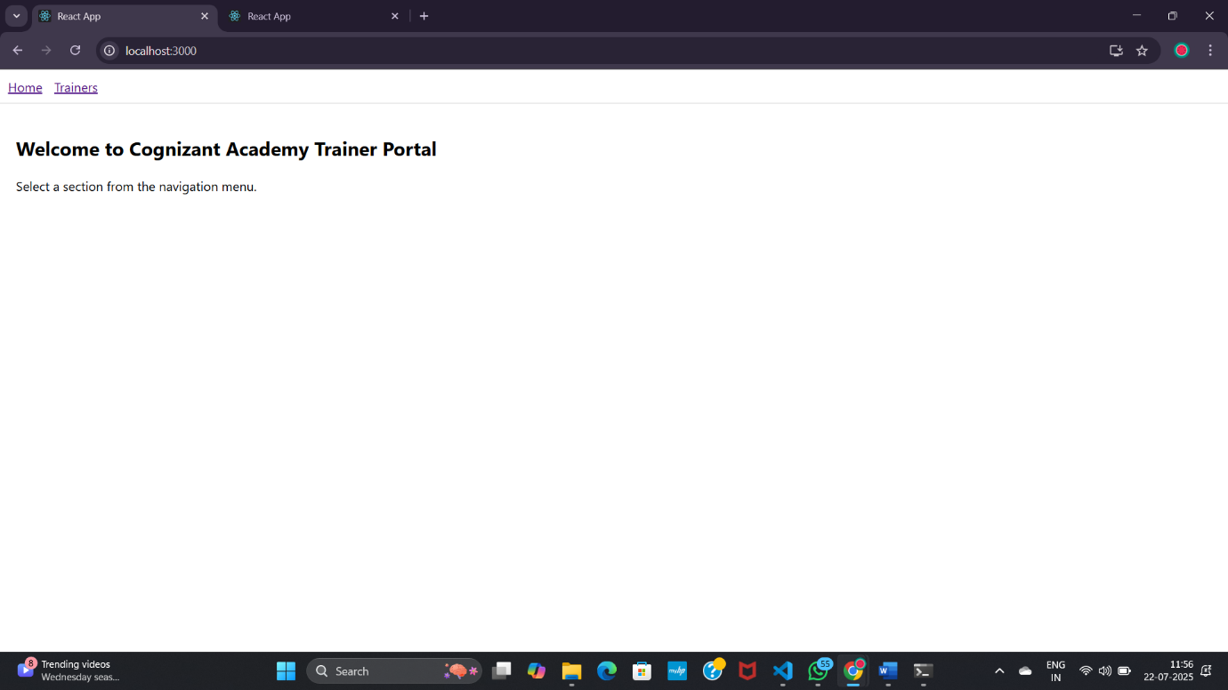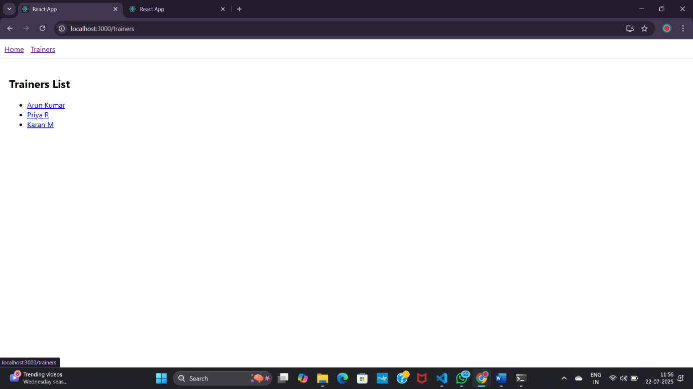

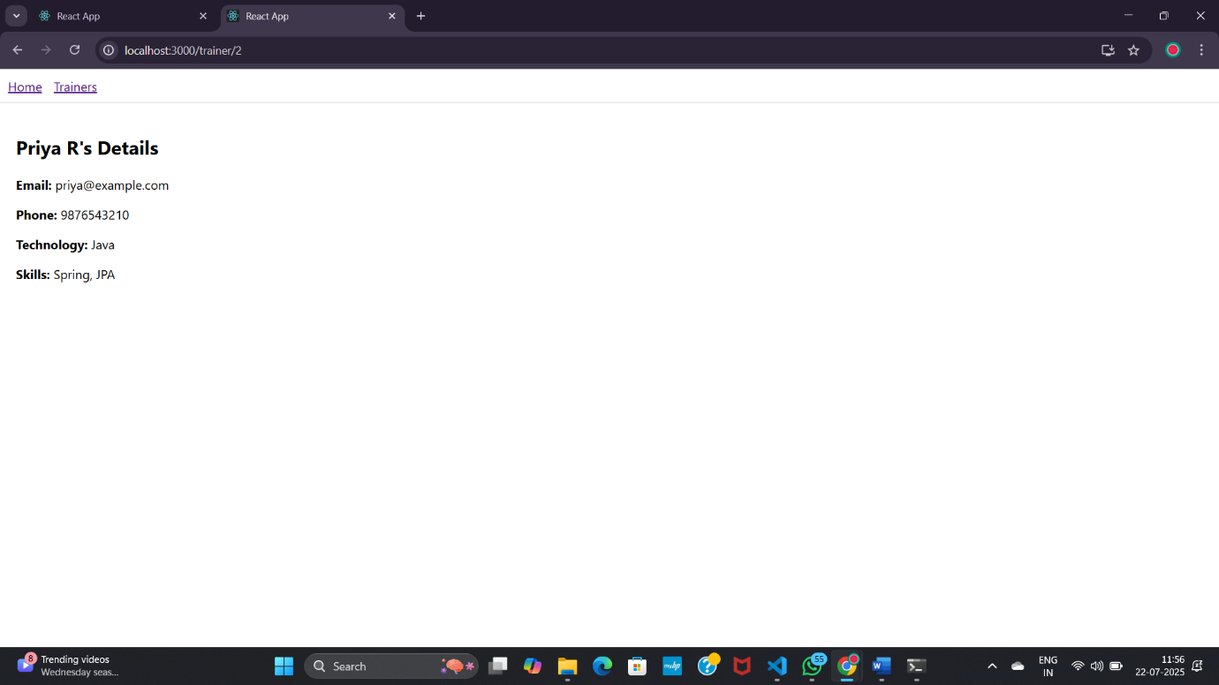

**7. Create a React Application named shoppingapp**

**Cart.js**

import React from 'react';

class Cart extends React.Component {

  render() {

    return (

      <div style={{ border: '1px solid gray', padding: '10px', marginBottom: '10px' }}>

        <h2>Item: {this.props.itemname}</h2>

        <p>Price: ₹{this.props.price}</p>

      </div>

    );

  }

}

export default Cart;

**index.js**

import React from 'react';

import ReactDOM from 'react-dom/client';

import OnlineShopping from './OnlineShopping';

const root = ReactDOM.createRoot(document.getElementById('root'));

root.render(<OnlineShopping />);

**OnlineShopping.js**

import React from 'react';

import Cart from './Cart';

class OnlineShopping extends React.Component {

  render() {

    const items = [

      { itemname: 'Laptop', price: 50000 },

      { itemname: 'Mobile', price: 20000 },

      { itemname: 'Headphones', price: 3000 },

      { itemname: 'Smartwatch', price: 7000 },

      { itemname: 'Keyboard', price: 1500 },

    ];

    return (

      <div>

        <h1>Online Shopping Items</h1>

        {items.map((item, index) => (

          <Cart key={index} itemname={item.itemname} price={item.price} />

        ))}

      </div>

    );

  }

}

export default OnlineShopping;

**App.js**

import React, { Component } from 'react';

import Cart from './Cart';

class OnlineShopping extends Component {

  render() {

    const items = [

      { itemname: "Mobile", price: 15000 },

      { itemname: "Laptop", price: 45000 },

      { itemname: "Headphones", price: 2000 },

      { itemname: "Watch", price: 3000 },

      { itemname: "Shoes", price: 2500 },

    ];

    return (

      <div>

        <h1>Online Shopping Cart</h1>

        {items.map((item, index) => (

          <Cart key={index} itemname={item.itemname} price={item.price} />

        ))}

      </div>

    );

  }

}

export default OnlineShopping;

**Output:**

