**Mandatory handson**

**9.Cricketapp**

**IndianPalyers.jsx**

// src/IndianPlayers.jsx

import React from 'react';

const IndianPlayers = () => {

  const oddTeam = ["Rohit", "Kohli", "Bumrah", "Jadeja", "Ashwin"];

  const evenTeam = ["Gill", "Rahul", "Pandya", "Siraj", "Suryakumar"];

// Destructuring

  const [p1, p2, p3, p4, p5] = oddTeam;

  const [q1, q2, q3, q4, q5] = evenTeam;

const T20players = ["Rohit", "Kohli", "Gill"];

  const RanjiPlayers = ["Rahane", "Pujara", "Saha"];

const allPlayers = [...T20players, ...RanjiPlayers]; // ES6 Spread to merge

return (

    <div>

      <h2>Odd Team Players</h2>

      <ul>

        <li>{p1}</li><li>{p2}</li><li>{p3}</li><li>{p4}</li><li>{p5}</li>

      </ul>

<h2>Even Team Players</h2>

      <ul>

        <li>{q1}</li><li>{q2}</li><li>{q3}</li><li>{q4}</li><li>{q5}</li>

      </ul>

<h2>Merged Players (T20 + Ranji)</h2>

      <ul>

        {allPlayers.map((player, idx) => <li key={idx}>{player}</li>)}

      </ul>

    </div>

  );

};

export default IndianPlayers;

**ListofPlayers.jsx**

// src/ListofPlayers.jsx

import React from 'react';

const ListofPlayers = () => {

  const players = [

    { name: "Virat Kohli", score: 95 },

    { name: "Rohit Sharma", score: 88 },

    { name: "Jasprit Bumrah", score: 60 },

    { name: "Ravindra Jadeja", score: 45 },

    { name: "KL Rahul", score: 78 },

    { name: "Shubman Gill", score: 90 },

    { name: "Suryakumar Yadav", score: 50 },

    { name: "R Ashwin", score: 72 },

    { name: "Ishan Kishan", score: 35 },

    { name: "Hardik Pandya", score: 85 },

    { name: "Mohammed Siraj", score: 65 },

  ];

  const below70 = players.filter(player => player.score < 70); // Arrow function

  return (

    <div>

      <h2>All Players</h2>

      <ul>

        {players.map((player, index) => (

          <li key={index}>{player.name} - {player.score}</li>

        ))}

      </ul>

      <h2>Players Scoring Below 70</h2>

      <ul>

        {below70.map((player, index) => (

          <li key={index}>{player.name} - {player.score}</li>

        ))}

      </ul>

    </div>

  );

};

export default ListofPlayers;

**App.js**

// src/App.js

import React from 'react';

import ListofPlayers from './components/ListofPlayers';

import IndianPlayers from './components/IndianPlayers';

function App() {

  const flag = true; // change to false to toggle component

return (

    <div className="App">

      <h1>🏏 Welcome to Cricket App</h1>

      {flag ? <ListofPlayers /> : <IndianPlayers />}

    </div>

  );

}

export default App;

**output:**

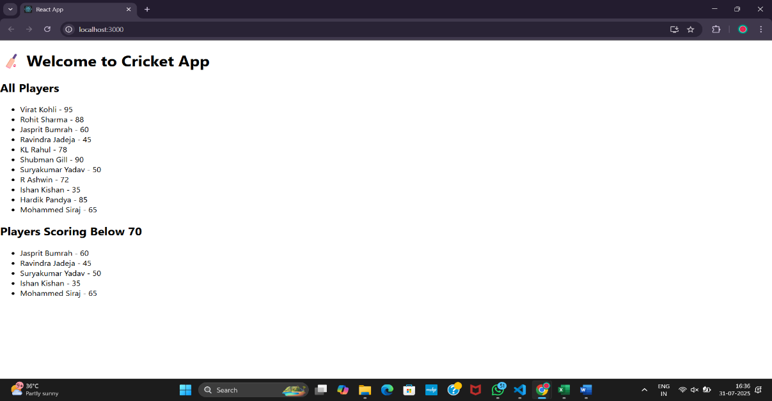

**10. officespacerentalapp**

**url:** [**http://localhost:3000**](http://localhost:3000)

**App.js**

// src/App.js

import React from 'react';

import officeImageFile from './images/off.jpeg';

function App() {

  const heading = <h1>Office Space Rental App</h1>;

 const officeImage = (

  <img

    src={officeImageFile}

    alt="Office Space"

    style={{ width: "400px", borderRadius: "10px", marginBottom: "20px" }}

  />

);

  const singleOffice = {

    name: "Prestige Tech Park",

    rent: 75000,

    address: "Whitefield, Bangalore"

  };

  const offices = [

    { name: "Prestige Tech Park", rent: 75000, address: "Whitefield" },

    { name: "MindSpace", rent: 58000, address: "Hyderabad" },

    { name: "Cyber Tower", rent: 61000, address: "Chennai" },

    { name: "DLF IT Park", rent: 95000, address: "Gurgaon" },

    { name: "Tidel Park", rent: 40000, address: "Coimbatore" }

  ];

  const officeList = offices.map((office, index) => {

    const rentStyle = {

      color: office.rent < 60000 ? 'red' : 'green',

      fontWeight: 'bold'

    };

    return (

      <div key={index} style={{ border: "1px solid #ccc", padding: "10px", margin: "10px 0", borderRadius: "8px" }}>

        <h3>{office.name}</h3>

        <p>Address: {office.address}</p>

        <p style={rentStyle}>Rent: ₹{office.rent}</p>

      </div>

    );

  });

  return (

    <div style={{ padding: "20px", fontFamily: "Arial" }}>

      {heading}

      {officeImage}

<h2>Featured Office:</h2>

      <div style={{ marginBottom: "20px" }}>

        <p><strong>Name:</strong> {singleOffice.name}</p>

        <p><strong>Address:</strong> {singleOffice.address}</p>

        <p><strong>Rent:</strong> ₹{singleOffice.rent}</p>

      </div>

      <h2>All Office Spaces:</h2>

      {officeList}

    </div>

  );

}

export default App;

**Output:**

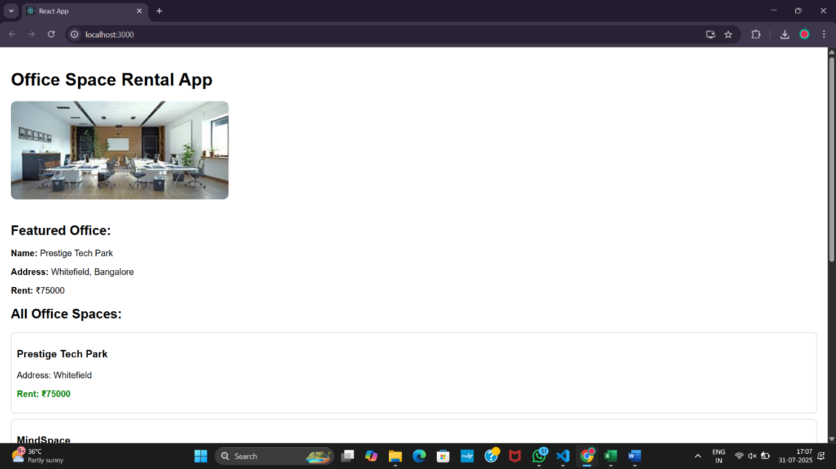

**11. eventexamplesapp**

**CurrencyConvertor.jsx**

// src/CurrencyConvertor.jsx

import React, { useState } from 'react';

function CurrencyConvertor() {

  const [rupees, setRupees] = useState('');

  const [euro, setEuro] = useState(null);

  const handleChange = (e) => {

    setRupees(e.target.value);

  };

  const handleSubmit = (e) => {

    e.preventDefault(); // synthetic event

    const converted = (parseFloat(rupees) / 90).toFixed(2); // 1 euro = ~90 INR

    setEuro(converted);

  };

  return (

    <div style={{ marginTop: '30px' }}>

      <h2>Currency Convertor</h2>

      <form onSubmit={handleSubmit}>

        <input

          type="number"

          value={rupees}

          onChange={handleChange}

          placeholder="Enter amount in INR"

        />

        <button type="submit">Convert</button>

      </form>

      {euro !== null && <p>Euro: €{euro}</p>}

    </div>

  );

}

export default CurrencyConvertor;

**App.js**

// src/App.js

import React, { Component } from 'react';

import CurrencyConvertor from './components/CurrencyConvertor';

class App extends Component {

  constructor(props) {

    super(props);

    this.state = {

      counter: 0

    };

  }

  increment = () => {

    this.setState((prev) => ({ counter: prev.counter + 1 }));

  };

  sayHello = () => {

    console.log("Hello! This is a static message.");

  };

  handleIncrease = () => {

    this.increment();

    this.sayHello();

  };

  decrement = () => {

    this.setState((prev) => ({ counter: prev.counter - 1 }));

  };

  sayMessage = (msg) => {

    alert(msg);

  };

  handleClick = (event) => {

    console.log("Synthetic event triggered:", event);

    alert("I was clicked");

  };

  render() {

    return (

      <div style={{ textAlign: 'center', padding: '30px' }}>

        <h1>React Event Examples</h1>

        <h2>Counter: {this.state.counter}</h2>

        <button onClick={this.handleIncrease}>Increase</button>{" "}

        <button onClick={this.decrement}>Decrease</button>

        <div style={{ marginTop: '20px' }}>

          <button onClick={() => this.sayMessage("Welcome!")}>Say Welcome</button>

        </div>

        <div style={{ marginTop: '20px' }}>

          <button onClick={this.handleClick}>OnPress</button>

        </div>

        {/* Currency Convertor */}

        <CurrencyConvertor />

      </div>

    );}

export default App;

**Output:**

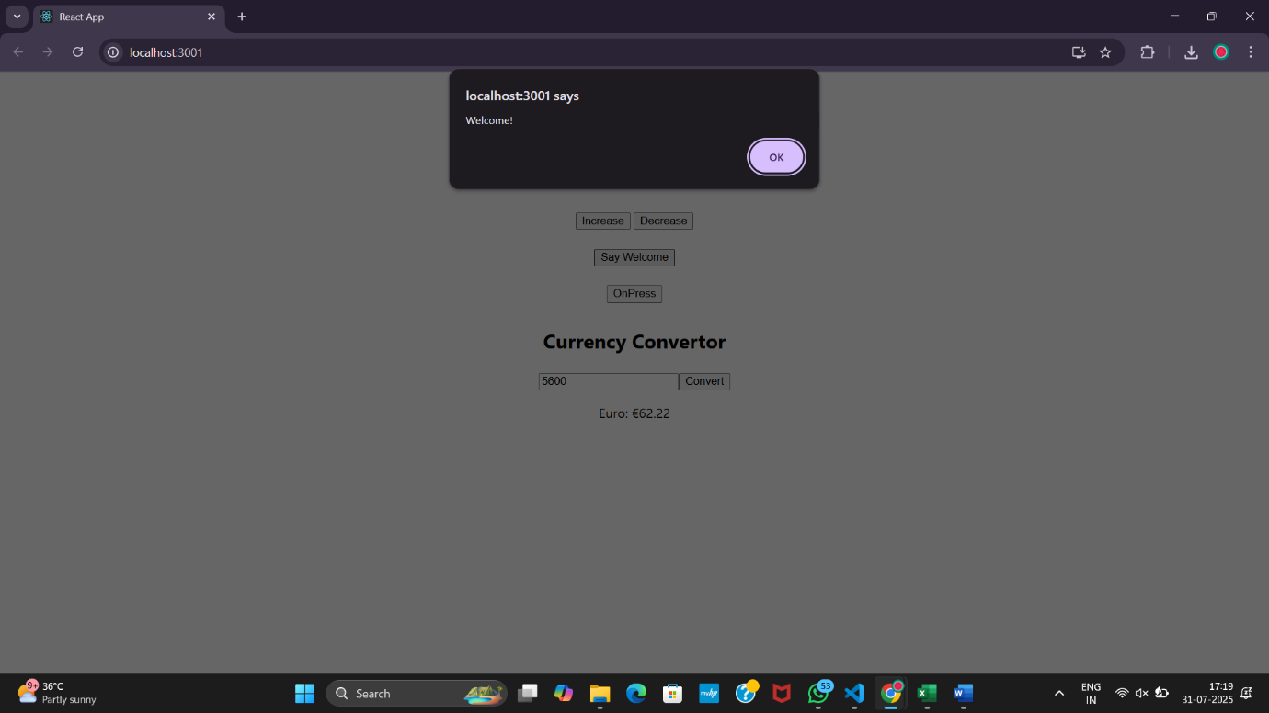

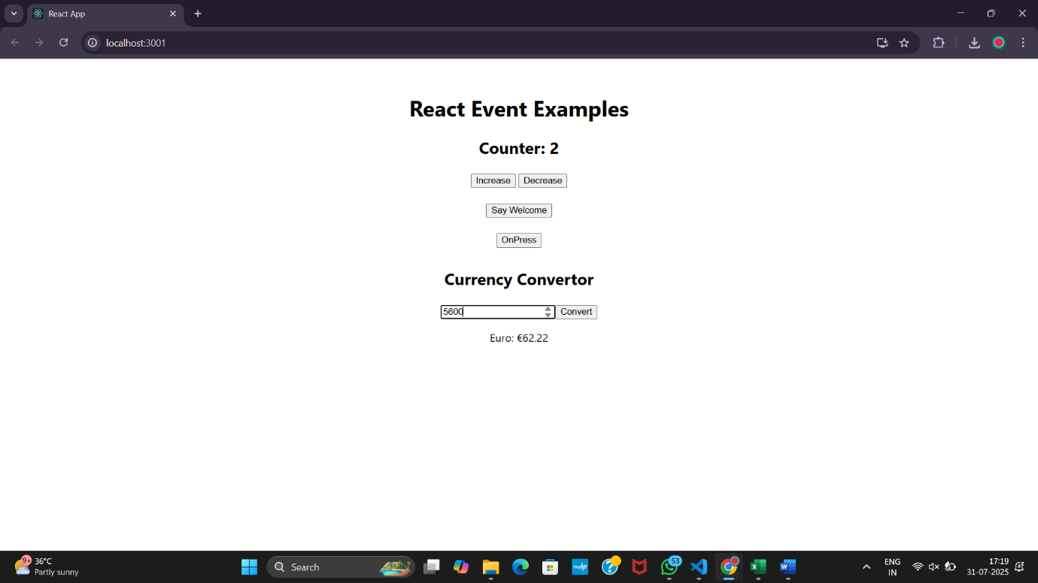

**12.ticketbookingapp**

**LoginControl.js**

import React, { useState } from 'react';

import GuestPage from './GuestPage';

import UserPage from './UserPage';

function LoginControl() {

  const [isLoggedIn, setIsLoggedIn] = useState(false);

  const handleLoginClick = () => setIsLoggedIn(true);

  const handleLogoutClick = () => setIsLoggedIn(false);

  let button;

  let page;

  if (isLoggedIn) {

    button = <button onClick={handleLogoutClick}>Logout</button>;

    page = <UserPage />;

  } else {

    button = <button onClick={handleLoginClick}>Login</button>;

    page = <GuestPage />;

  }

  return (

    <div>

      {button}

      {page}

    </div>

  );

}

export default LoginControl;

**GuestPage.js**

import React from 'react';

function GuestPage() {

  return (

    <div>

      <h2>Welcome, Guest!</h2>

      <p>Please log in to book your flight tickets.</p>

      <p>Available Flights:</p>

      <ul>

        <li>✈ Chennai → Mumbai - 7:00 AM</li>

        <li>✈ Delhi → Bangalore - 9:30 AM</li>

      </ul>

    </div>

  );

}

export default GuestPage;

**UserPage.js**

import React from 'react';

function UserPage() {

  return (

    <div>

      <h2>Welcome, User!</h2>

      <p>You are logged in and can now book flight tickets.</p>

      <button>Book Chennai → Mumbai</button>

      <button>Book Delhi → Bangalore</button>

    </div>

  );

}

export default UserPage;

**Output:**

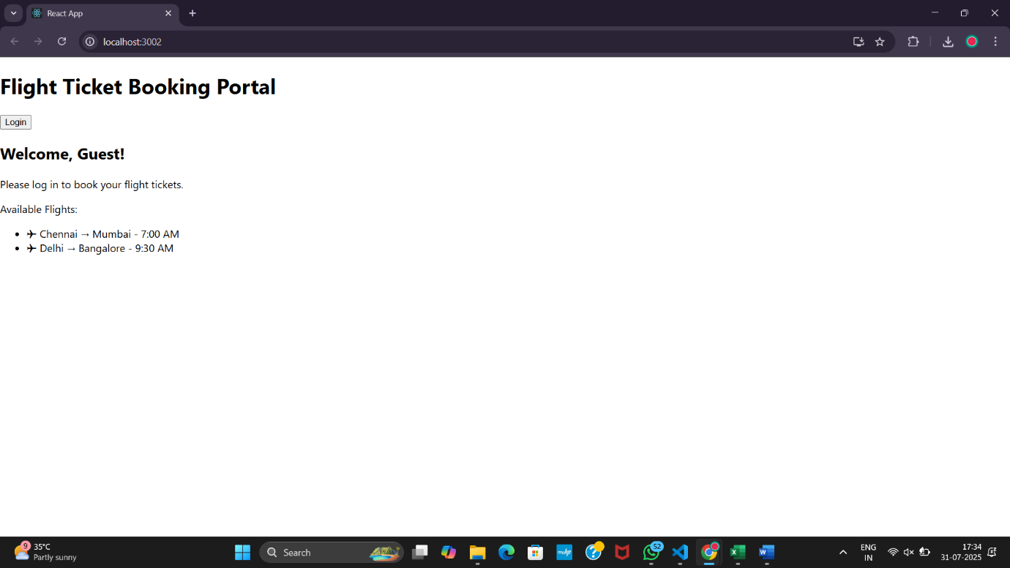

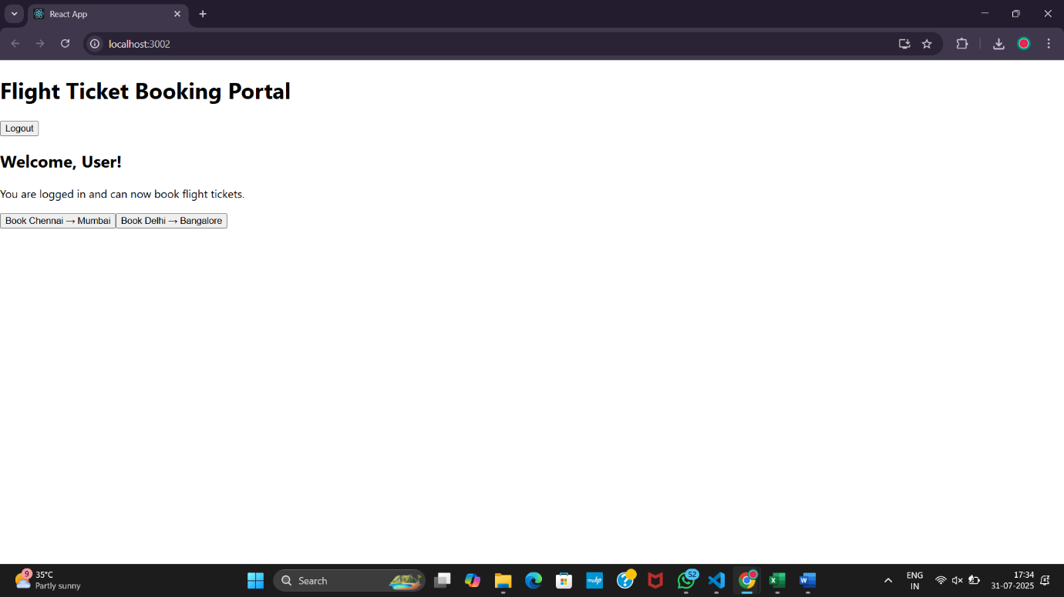

**13.bloggerapp**

**BlogDetails.js**

import React from 'react';

function BlogDetails() {

  const blogs = [

    { title: "React Learning", author: "Stephen Biz", content: "Welcome to learning React!" },

    { title: "Installation", author: "Schwezdenier", content: "You can install React from npm." }

  ];

  return (

    <div className="column">

      <h2>Blog Details</h2>

      {blogs.map((blog, index) => (

        <div key={index}>

          <strong>{blog.title}</strong><br />

          <em>{blog.author}</em><br />

          {blog.content}

        </div>

      ))}

    </div>

  );

}

export default BlogDetails;

**Bookdetails.js**

import React from 'react';

function BookDetails() {

  const books = [

    { title: "Master React", price: 670 },

    { title: "Deep Dive into Angular 11", price: 800 },

    { title: "Mongo Essentials", price: 450 }

  ];

  return (

    <div className="column">

      <h2>Book Details</h2>

      {books.map((book, index) => (

        <div key={index}>

          <strong>{book.title}</strong><br />

          {book.price}

        </div>

      ))}

    </div>

  );

}

export default BookDetails;

**CourseDetails.js**

import React from 'react';

function CourseDetails() {

  const courses = [

    { name: "Angular", date: "4/5/2021" },

    { name: "React", date: "6/3/20201" }

  ];

  return (

    <div className="column">

      <h2>Course Details</h2>

      {courses.map((course, index) => (

        <div key={index}>

          <strong>{course.name}</strong><br />

          {course.date}

        </div>

      ))}

    </div>

  );

}

export default CourseDetails;

**App.js**

import React from 'react';

import './App.css';

import CourseDetails from './components/CourseDetails';

import BookDetails from './components/BookDetails';

import BlogDetails from './components/BlogDetails';

function App() {

  return (

    <div className="container">

      <CourseDetails />

      <BookDetails />

      <BlogDetails />

    </div>

  );

}

export default App;

**App.css**

.container {

  display: flex;

  justify-content: center;

  align-items: flex-start;

  padding: 50px;

  text-align: left;

  font-family: sans-serif;

}

.column {

  margin: 0 40px;

  padding: 20px;

  border-right: 4px solid green;

}

.column:last-child {

  border-right: none;

}

**Output:**

