**MANDATORY HANDSON**

**1.GIT COMMANDS**

madhu@Madhuuu MINGW64 ~ (main)

**$ git config --global user.name "MadhuVarshini03"**

madhu@Madhuuu MINGW64 ~ (main)

**$ git config --global user.email "varshinimadhu0305@gmail.com"**

madhu@Madhuuu MINGW64 ~ (main)

$ git config --list

diff.astextplain.textconv=astextplain

filter.lfs.clean=git-lfs clean -- %f

filter.lfs.smudge=git-lfs smudge -- %f

filter.lfs.process=git-lfs filter-process

filter.lfs.required=true

http.sslbackend=schannel

core.autocrlf=true

core.fscache=true

core.symlinks=false

pull.rebase=false

credential.helper=manager

credential.https://dev.azure.com.usehttppath=true

init.defaultbranch=master

filter.lfs.process=git-lfs filter-process

filter.lfs.required=true

filter.lfs.clean=git-lfs clean -- %f

filter.lfs.smudge=git-lfs smudge -- %f

user.name=MadhuVarshini03

user.email=varshinimadhu0305@gmail.com

core.editor=notepad++ -multiInst -notabbar -nosession -noPlugin

core.repositoryformatversion=0

core.filemode=false

core.bare=false

core.logallrefupdates=true

core.symlinks=false

core.ignorecase=true

remote.origin.url=https://github.com/MadhuVarshini03/927622BCS057.git

remote.origin.fetch=+refs/heads/*:refs/remotes/origin/*

madhu@Madhuuu MINGW64 ~ (main)

**$ git config --global core.editor "notepad++ -multiInst -notabbar -nosession -noPlugin"**

madhu@Madhuuu MINGW64 ~ (main)

**$ git config --global -e**

madhu@Madhuuu MINGW64 ~ (main)

$ mkdir GitDemo

madhu@Madhuuu MINGW64 ~ (main)

$ cd GitDemo

madhu@Madhuuu MINGW64 ~/GitDemo (main)

$ git init

Initialized empty Git repository in C:/Users/madhu/GitDemo/.git/

madhu@Madhuuu MINGW64 ~/GitDemo (master)

$ ls -a

**.**/ **..**/ **.git**/

madhu@Madhuuu MINGW64 ~/GitDemo (master)

$ echo "Welcome to git hands-on lab">welcom.txt

madhu@Madhuuu MINGW64 ~/GitDemo (master)

$ ls

welcom.txt

madhu@Madhuuu MINGW64 ~/GitDemo (master)

$ cat welcom.txt

Welcome to git hands-on lab

madhu@Madhuuu MINGW64 ~/GitDemo (master)

$ git commit -m "Initial commit: Added welcom.txt"

[master (root-commit) c396ecc] Initial commit: Added welcom.txt

1 file changed, 1 insertion(+)

create mode 100644 welcom.txt

madhu@Madhuuu MINGW64 ~/GitDemo (master)

$ git status

On branch master

nothing to commit, working tree clean

madhu@Madhuuu MINGW64 ~/GitDemo (master)

$ git add welcom.txt

madhu@Madhuuu MINGW64 ~/GitDemo (master)

$ git log --oneline

c396ecc (**HEAD** -> **master**) Initial commit: Added welcom.txt

madhu@Madhuuu MINGW64 ~/GitDemo (master)

$ git commit -m "Initial commit: Added welcom.txt"

On branch master

nothing to commit, working tree clean

madhu@Madhuuu MINGW64 ~/GitDemo (master)

$ git remote add origin https://gitlab.com/madhuvarshini03-group/gitdemo.git

madhu@Madhuuu MINGW64 ~/GitDemo (master)

$ git push -u origin master

madhu@Madhuuu MINGW64 ~/GitDemo (master)

$ git push -u origin master

info: please complete authentication in your browser...

Enumerating objects: 3, done.

Counting objects: 100% (3/3), done.

Writing objects: 100% (3/3), 264 bytes | 132.00 KiB/s, done.

Total 3 (delta 0), reused 0 (delta 0), pack-reused 0 (from 0)

remote:

remote: To create a merge request for master, visit:

remote: https://gitlab.com/madhuvarshini03-group/gitdemo/-/merge_requests/new?merge_request%5Bsource_branch%5D=master

remote:

To https://gitlab.com/madhuvarshini03-group/gitdemo.git

* [new branch] master -> master

branch 'master' set up to track 'origin/master'.

madhu@Madhuuu MINGW64 ~/GitDemo (master)

$ echo "This is a second line" >> welcome.txt

madhu@Madhuuu MINGW64 ~/GitDemo (master)

$ git add welcome.txt

warning: in the working copy of 'welcome.txt', LF will be replaced by CRLF the next time Git touches it

madhu@Madhuuu MINGW64 ~/GitDemo (master)

$ git commit -m "Added a second line to welcome.txt"

[master de11f69] Added a second line to welcome.txt

2 files changed, 2 insertions(+)

create mode 100644 welcome.txt

madhu@Madhuuu MINGW64 ~/GitDemo (master)

$ git push

Enumerating objects: 4, done.

Counting objects: 100% (4/4), done.

Delta compression using up to 12 threads

Compressing objects: 100% (2/2), done.

Writing objects: 100% (3/3), 335 bytes | 167.00 KiB/s, done.

Total 3 (delta 0), reused 0 (delta 0), pack-reused 0 (from 0)

remote:

remote: To create a merge request for master, visit:

remote: https://gitlab.com/madhuvarshini03-group/gitdemo/-/merge_requests/new?merge_request%5Bsource_branch%5D=master

remote:

To https://gitlab.com/madhuvarshini03-group/gitdemo.git

de11f69..3289071 master -> master

**OUTPUT:**

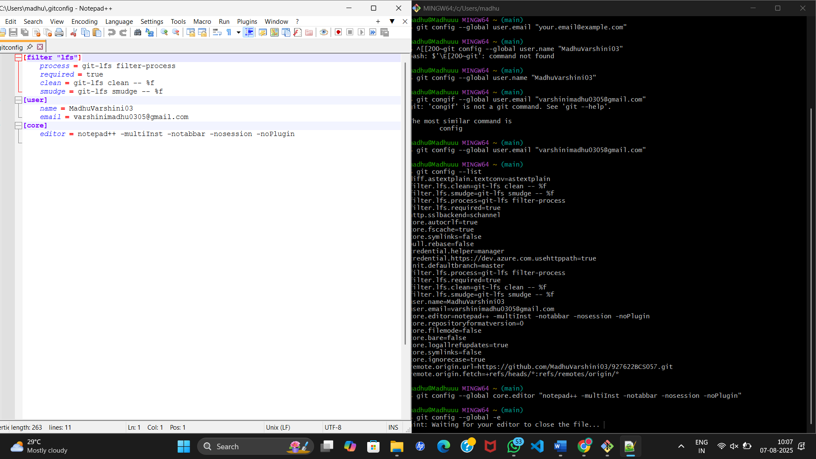

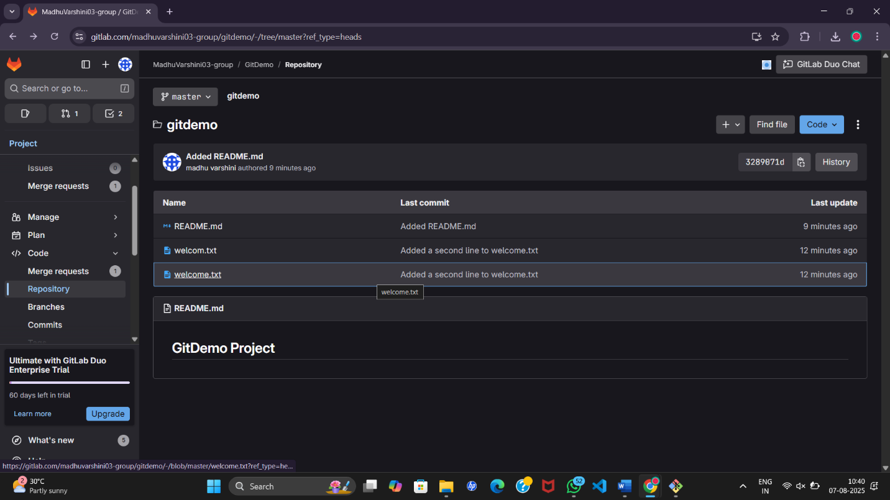

**2.**

madhu@Madhuuu MINGW64 ~ (main)

$ cd /c/Users/YourName/Path/To/gitdemo

bash: cd: /c/Users/YourName/Path/To/gitdemo: No such file or directory

madhu@Madhuuu MINGW64 ~ (main)

$ echo "This is a log file" > error.log

madhu@Madhuuu MINGW64 ~ (main)

$ mkdir log

madhu@Madhuuu MINGW64 ~ (main)

$ echo "This is another log file" > log/output.log

madhu@Madhuuu MINGW64 ~ (main)

**$ touch .gitignore**

madhu@Madhuuu MINGW64 ~ (main)

$ cd ~/gitdemo

madhu@Madhuuu MINGW64 ~/gitdemo (master)

**$ echo "Log content" > error.log**

madhu@Madhuuu MINGW64 ~/gitdemo (master)

$ mkdir log

madhu@Madhuuu MINGW64 ~/gitdemo (master)

**$ echo "Inside log folder" > log/sample.log**

madhu@Madhuuu MINGW64 ~/gitdemo (master)

$ ls

README.md error.log log/ welcom.txt welcome.txt

madhu@Madhuuu MINGW64 ~/gitdemo (master)

$ ls log

sample.log

**OUTPUT:**

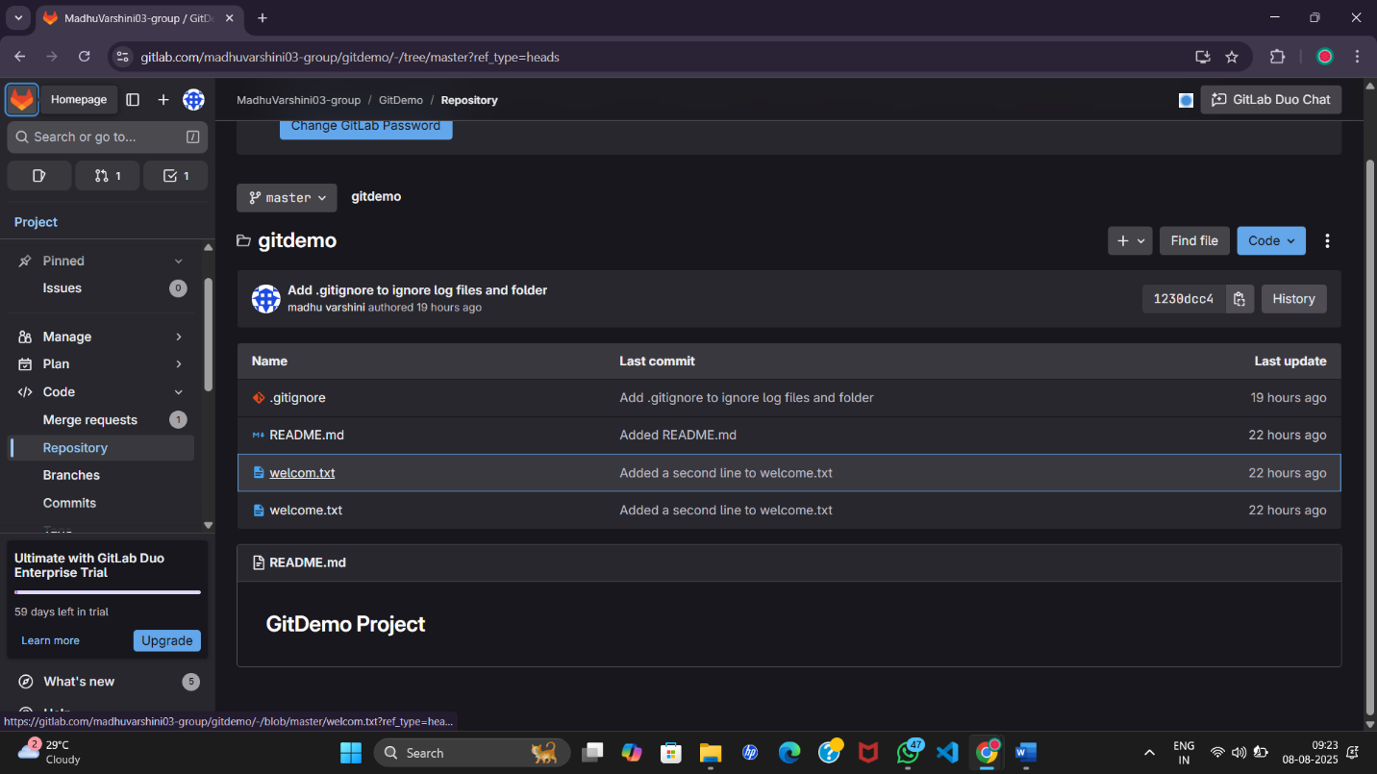

**3.**

madhu@Madhuuu MINGW64 ~ (GitNewBranch)

**$ git checkout GitNewBranch**

Already on 'GitNewBranch'

madhu@Madhuuu MINGW64 ~ (GitNewBranch)

**$ git commit -m "Added newbranchfile.txt to GitNewBranch"**

warning: could not open directory 'AppData/Local/Application Data/': Permission denied

warning: could not open directory 'Application Data/': Permission denied

warning: could not open directory 'Cookies/': Permission denied

warning: could not open directory 'Local Settings/': Permission denied

warning: could not open directory 'My Documents/': Permission denied

warning: could not open directory 'NetHood/': Permission denied

warning: could not open directory 'PrintHood/': Permission denied

warning: could not open directory 'Recent/': Permission denied

warning: could not open directory 'SendTo/': Permission denied

warning: could not open directory 'Start Menu/': Permission denied

warning: could not open directory 'Templates/': Permission denied

On branch GitNewBranch

Untracked files:

(use "git add <file>..." to include in what will be committed)

.bash_history

.config/

.eclipse/

.gitconfig

.gitignore

.gradle/

.idlerc/

.jdks/

.lesshst

.m2/

.matplotlib/

.node_repl_history

.p2/

.python_history

.vscode/

AppData/

Contacts/

Desktop/

Documents/

Downloads/

Favorites/

GitDemo/

IdeaProjects/

LEARNING-REPO/

Links/

NTUSER.DAT

NTUSER.DAT{8e54c3a5-162f-11f0-adb3-94bb43aff790}.TM.blf

NTUSER.DAT{8e54c3a5-162f-11f0-adb3-94bb43aff790}.TMContainer00000000000000000001.regtrans-ms

NTUSER.DAT{8e54c3a5-162f-11f0-adb3-94bb43aff790}.TMContainer00000000000000000002.regtrans-ms

OneDrive/

Oracle/

Pictures/

Saved Games/

Searches/

Videos/

blogapp/

cohortdashboard/

eclipse-workspace/

eclipse/

error.log

index.html

log/

my-app/

myapp/

myfirstreact/

ntuser.dat.LOG1

ntuser.dat.LOG2

ntuser.ini

scorecalculatorapp/

shoppingapp/

studentapp/

trainersapp/

nothing added to commit but untracked files present (use "git add" to track)

madhu@Madhuuu MINGW64 ~ (GitNewBranch)

$ git log --oneline

17a925f (**HEAD** -> **GitNewBranch**) Added newbranchfile.txt in GitNewBranch

madhu@Madhuuu MINGW64 ~ (GitNewBranch)

$ cd ~/gitdemo

madhu@Madhuuu MINGW64 ~/gitdemo (master)

$ ls

README.md error.log **log**/ welcom.txt welcome.txt

madhu@Madhuuu MINGW64 ~/gitdemo (master)

**$ git checkout -b GitNewBranch**

Switched to a new branch 'GitNewBranch'

madhu@Madhuuu MINGW64 ~/gitdemo (GitNewBranch)

$ git branch

* GitNewBranch

master

madhu@Madhuuu MINGW64 ~/gitdemo (GitNewBranch)

$ echo "This is from GitNewBranch" > newbranchfile.txt

madhu@Madhuuu MINGW64 ~/gitdemo (GitNewBranch)

$ git add newbranchfile.txt

warning: in the working copy of 'newbranchfile.txt', LF will be replaced by CRLF the next time Git touches it

madhu@Madhuuu MINGW64 ~/gitdemo (GitNewBranch)

$ git commit -m "Added newbranchfile.txt in GitNewBranch"

[GitNewBranch 64272f0] Added newbranchfile.txt in GitNewBranch

1 file changed, 1 insertion(+)

create mode 100644 newbranchfile.txt

madhu@Madhuuu MINGW64 ~/gitdemo (GitNewBranch)

$ git status

On branch GitNewBranch

nothing to commit, working tree clean

madhu@Madhuuu MINGW64 ~/gitdemo (GitNewBranch)

**$ git checkout master**

**Switched to branch 'master'**

Your branch is up to date with 'origin/master'.

madhu@Madhuuu MINGW64 ~/gitdemo (master)

$ git diff master GitNewBranch

**diff --git a/newbranchfile.txt b/newbranchfile.txt**

**new file mode 100644**

**index 0000000..bd667bc**

**--- /dev/null**

**+++ b/newbranchfile.txt**

@@ -0,0 +1 @@

+This is from GitNewBranch

madhu@Madhuuu MINGW64 ~/gitdemo (master)

**$ git mergetool**

This message is displayed because 'merge.tool' is not configured.

See 'git mergetool --tool-help' or 'git help config' for more details.

'git mergetool' will now attempt to use one of the following tools:

opendiff kdiff3 tkdiff xxdiff meld tortoisemerge gvimdiff diffuse diffmerge ecmerge p4merge araxis bc codecompare smerge emerge vimdiff nvimdiff

No files need merging

madhu@Madhuuu MINGW64 ~/gitdemo (master)

**$ git config --global merge.tool p4merge**

madhu@Madhuuu MINGW64 ~/gitdemo (master)

$ git config --global merge.tool p4merge

git config --global mergetool.p4merge.cmd '"C:/Program Files/Perforce/p4merge.exe" "$BASE" "$LOCAL" "$REMOTE" "$MERGED"'

madhu@Madhuuu MINGW64 ~/gitdemo (master)

$ git merge GitNewBranch

Updating 1230dcc..64272f0

Fast-forward

newbranchfile.txt | 1 +

1 file changed, 1 insertion(+)

create mode 100644 newbranchfile.txt

madhu@Madhuuu MINGW64 ~/gitdemo (master)

$ git log --oneline --graph --decorate

* 64272f0 (**HEAD** -> **master**, **GitNewBranch**) Added newbranchfile.txt in GitNewBranch

* 1230dcc (**origin/master**) Add .gitignore to ignore log files and folder

* 3289071 Added README.md

* de11f69 Added a second line to welcome.txt

* c396ecc Initial commit: Added welcom.txt

madhu@Madhuuu MINGW64 ~/gitdemo (master)

$ git branch -d GitNewBranch

Deleted branch GitNewBranch (was 64272f0).

madhu@Madhuuu MINGW64 ~/gitdemo (master)

**$ git status**

**On branch master**

**Your branch is ahead of 'origin/master' by 1 commit.**

**(use "git push" to publish your local commits)**

**nothing to commit, working tree clean**

**OUTPUT:**

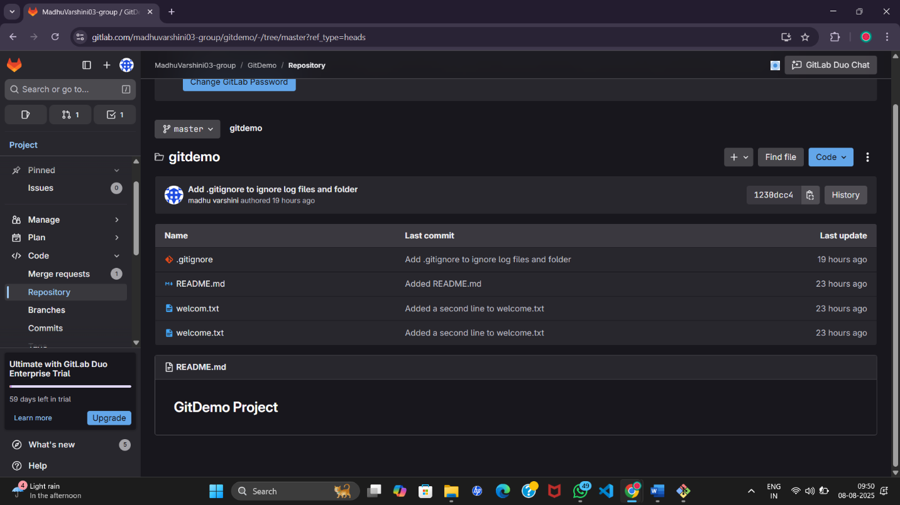

**4. conflict resolution**

1. master is in clean state

**git status**

2.branch GitWork

**git checkout -b GitWork**

3.hello.xml

**echo "<message>Hello from GitWork</message>" > hello.xml**

4.update xml

**echo "<author>Madhu</author>" >> hello.xml**

git status

5.commit changes

**git add hello.xml**

**git commit -m "Added hello.xml in GitWork branch"**

6.switch to master

**git checkout master**

7. Add a file “hello.xml” to master with different content

**echo "<message>Hello from Master</message>" > hello.xml**

8. Commit the changes to the master

**git add hello.xml**

**git commit -m "Added hello.xml in master branch"**

9.log in graph view

**git log --oneline --graph --decorate –all**

10.diff btw master and GitWork

**git diff GitWork hello.xml**

11.p4mergetool

**git difftool GitWork hello.xml**

12. Merge GitWork into master

**git merge GitWork**

13.merge result

**git add hello.xml**

**git commit -m "Resolved merge conflict in hello.xml"**

14.check git status

**git status**

15.add backup files

**echo "hello.xml.orig" >> .gitignore**

16.commit to gitignore

git add .gitignore

**git commit -m "Added backup file to .gitignore"**

17.delete

**git branch -d GitWork**

18.log graph

**git log --oneline --graph --decorate**

**OUTPUT:**

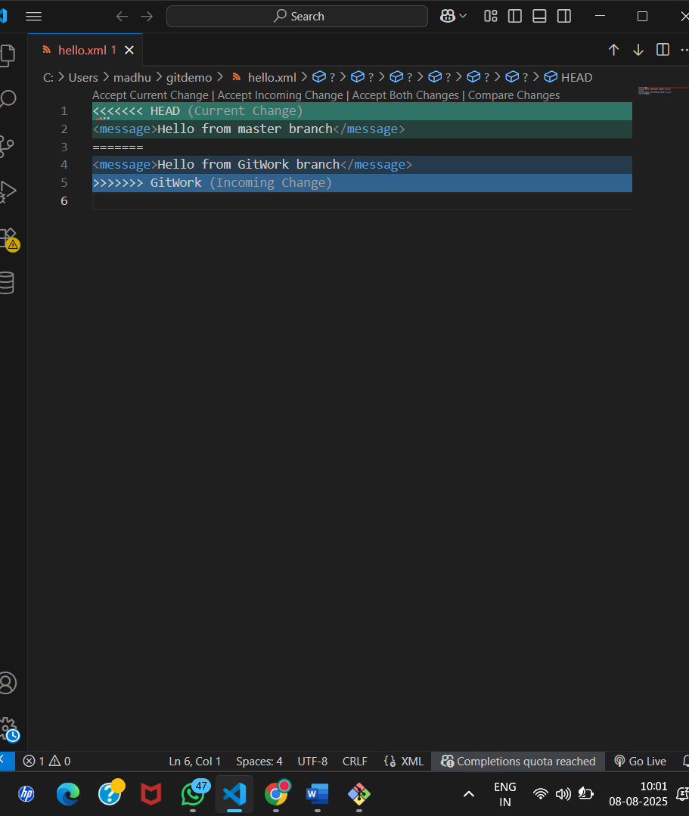

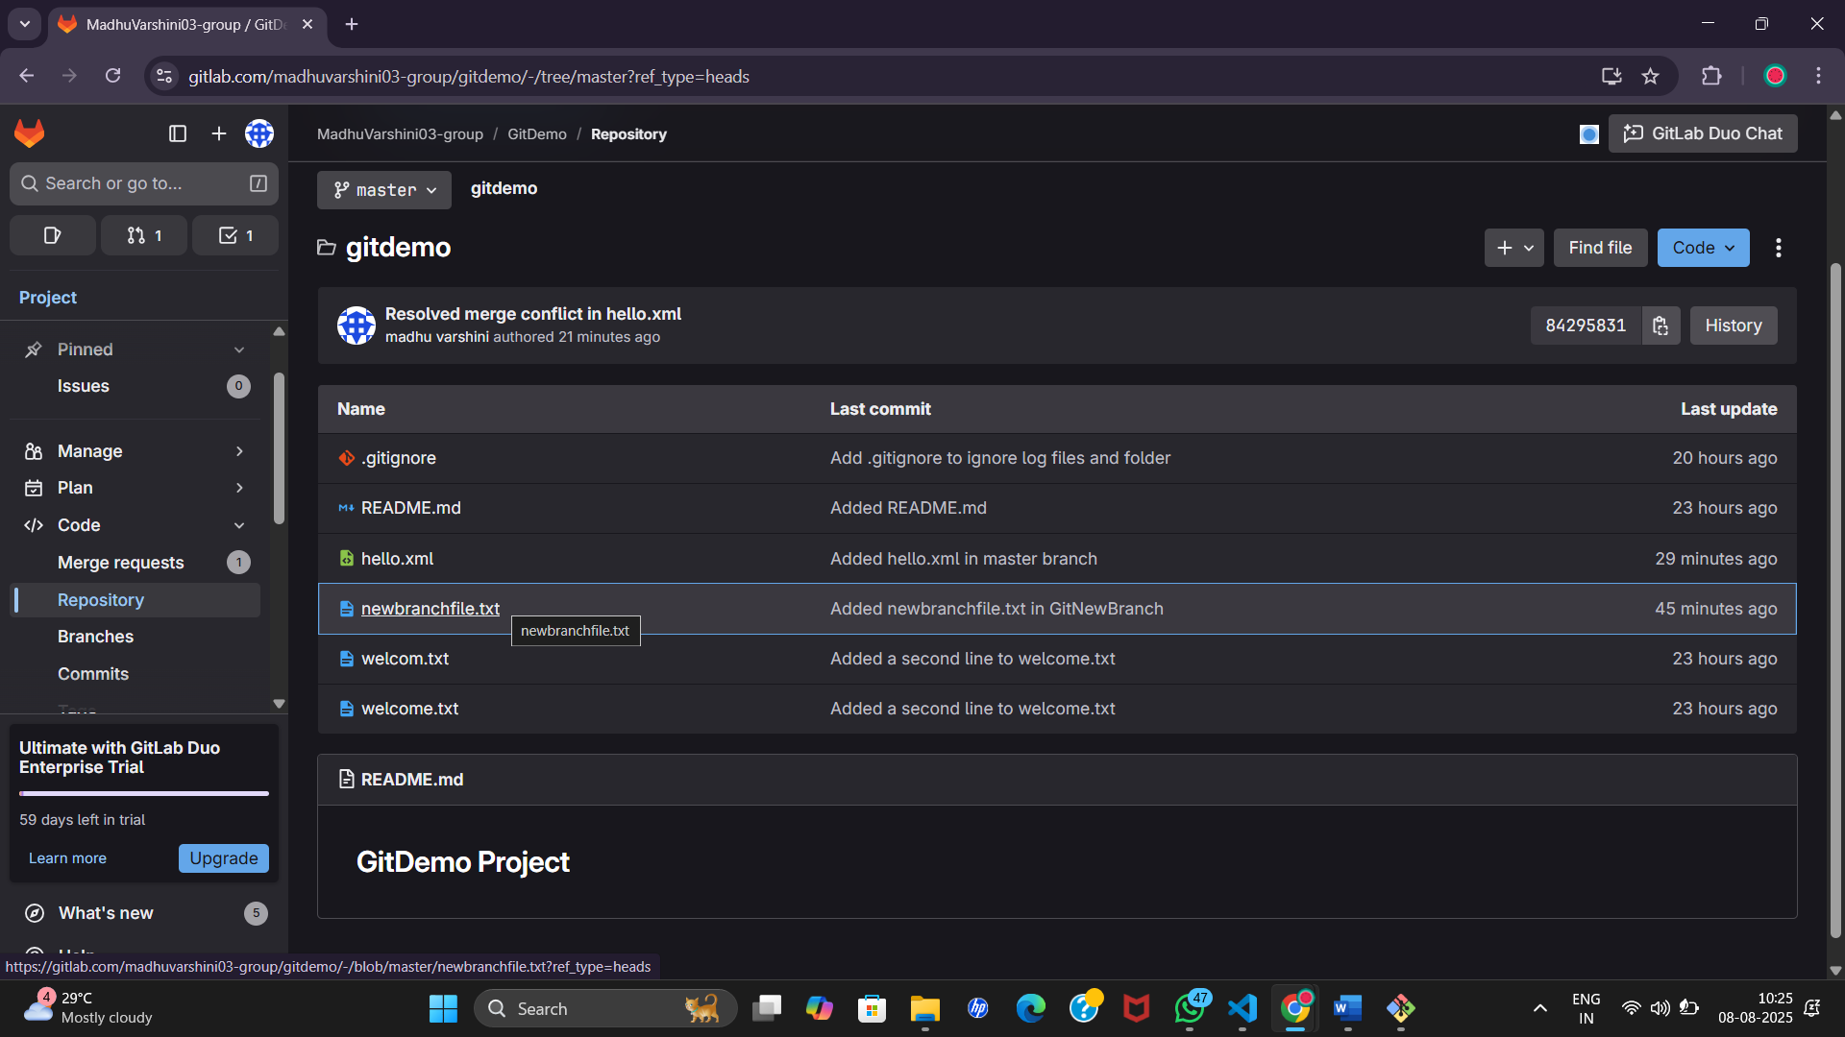

**5.** **Git-T03-HOL_002**

madhu@Madhuuu MINGW64 ~/gitdemo (master)

$ git status

On branch master

Your branch is ahead of 'origin/master' by 1 commit.

(use "git push" to publish your local commits)

nothing to commit, working tree clean

madhu@Madhuuu MINGW64 ~/gitdemo (master)

$ git branch -a

* master

remotes/origin/master

madhu@Madhuuu MINGW64 ~/gitdemo (master)

**$ git pull origin master**

From https://gitlab.com/madhuvarshini03-group/gitdemo

* branch master -> FETCH_HEAD

Already up to date.

**OUTPUT:**

