**ASSIGNMENT-2:**

**Assignment 27: Advanced Plotting with ggplot2**

**Scenario: Use ggplot2 to create a bar chart for categorical data representing the count of each**

**category.**

**Parameters:**

**Use the ggplot() function with geom_bar().**

**Questions:**

**1. Write the code to generate a bar chart using ggplot2.**

**2. How can you customize the appearance of the bar chart (e.g., colors, labels)?**

**Output:**

**1. Write the code to generate a bar chart using ggplot2.**

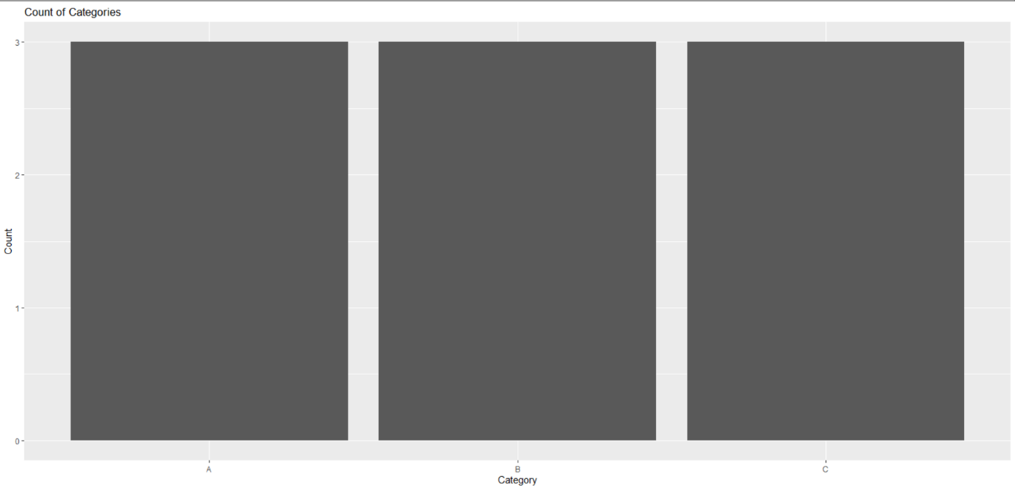

**2. How can you customize the appearance of the bar chart (e.g., colors, labels)?**

