1. Write a R program to create an array, passing in a vector of values and a vector of dimensions. Also

provide names for each dimension.

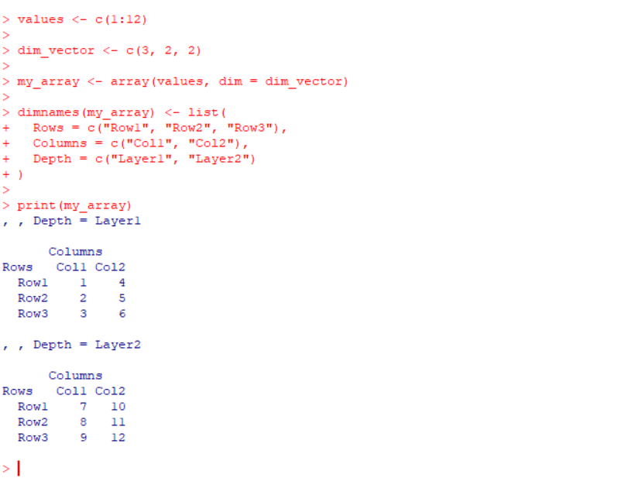

2.Write a R program to create an array with three columns, three rows, and two "tables", taking two

vectors as input to the array. Print the array.

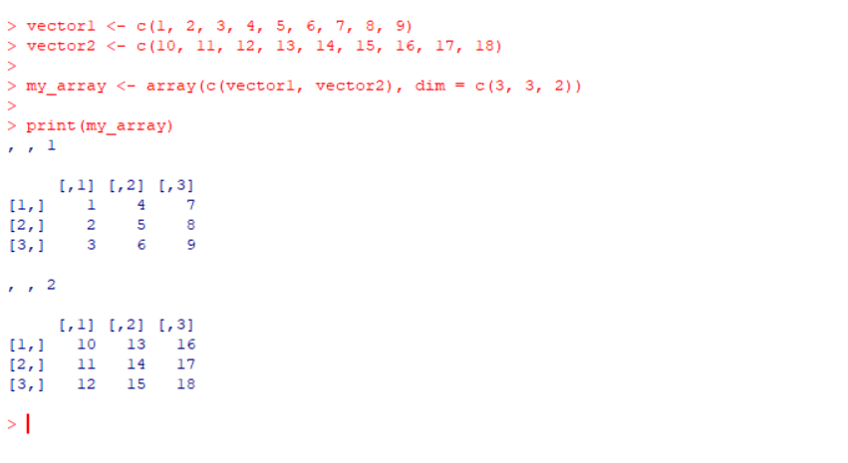

3. Write a R program to draw an empty plot and an empty plot specify the axes limits of the graphic.

**Input:**

**plot.new()**

**plot(1, type = "n", xlim = c(0, 10), ylim = c(0, 10), xlab = "X-Axis", ylab = "Y-Axis", main = "Empty Plot with Axis Limits")**

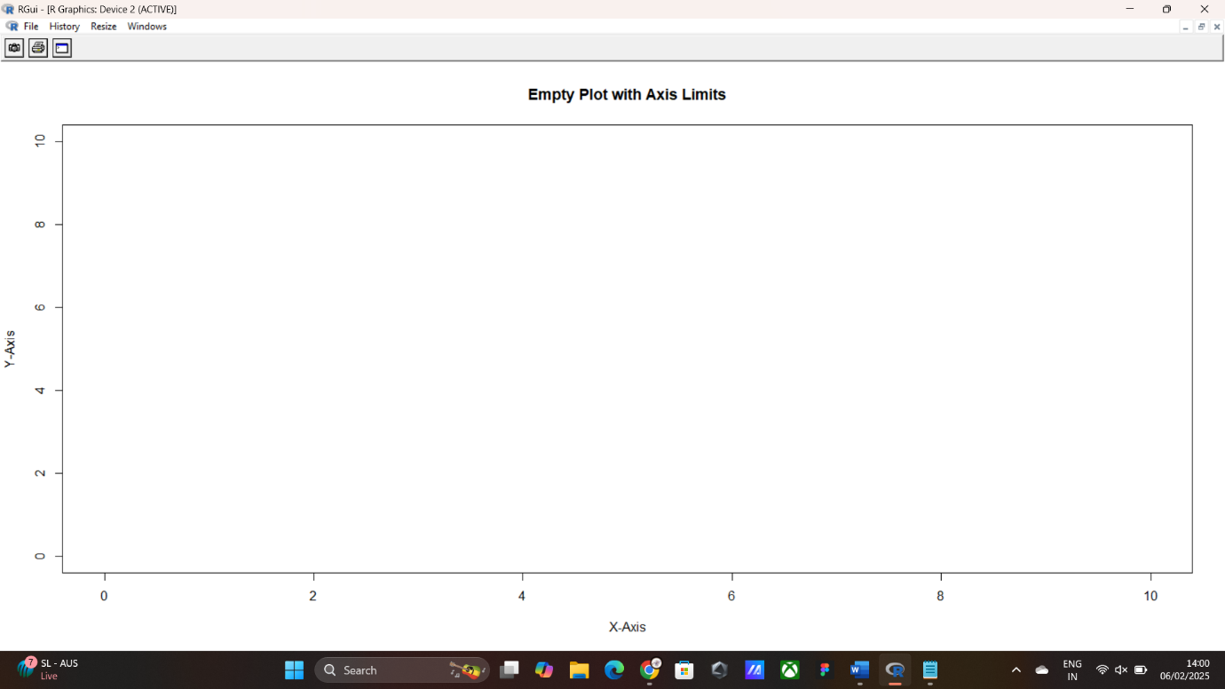

**4. Write a R program to combine three arrays so that the first row of the first array is followed by the**

**first row of the second array and then first row of the third array.**

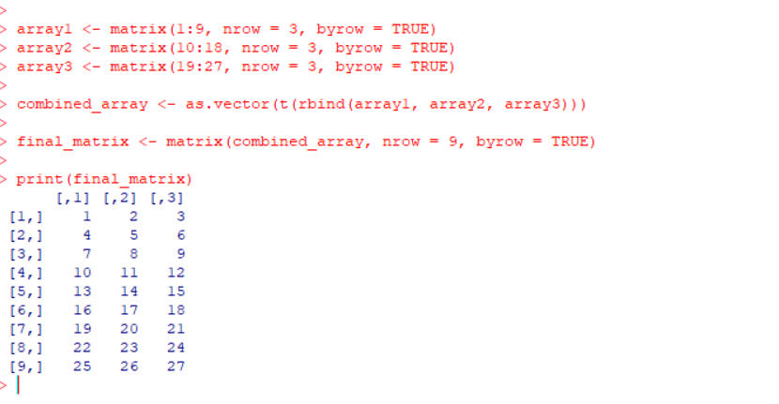

**5. Write a R program to create an array using four given columns, three given rows, and two given**

**tables and display the content of the array.**

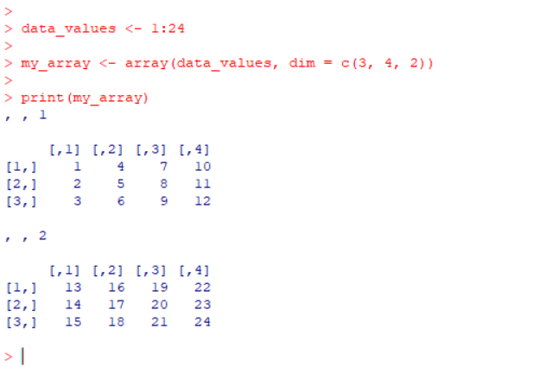

**6. Write a R program to create a two-dimensional 5x3 array of sequence of even integers greater than**

**50.**

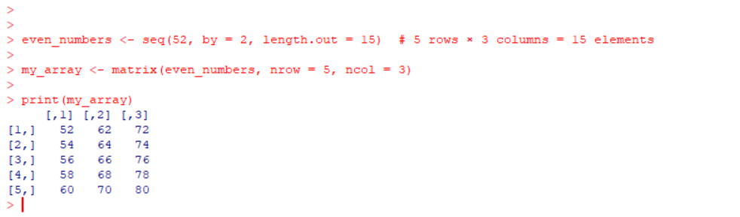

**7. Write a R program to call the (built-in) dataset airquality. Check whether it is a data frame or not?**

**Order the entire data frame by the first and second column. remove the variables 'Solar.R' and 'Wind'**

**and display the data frame.**

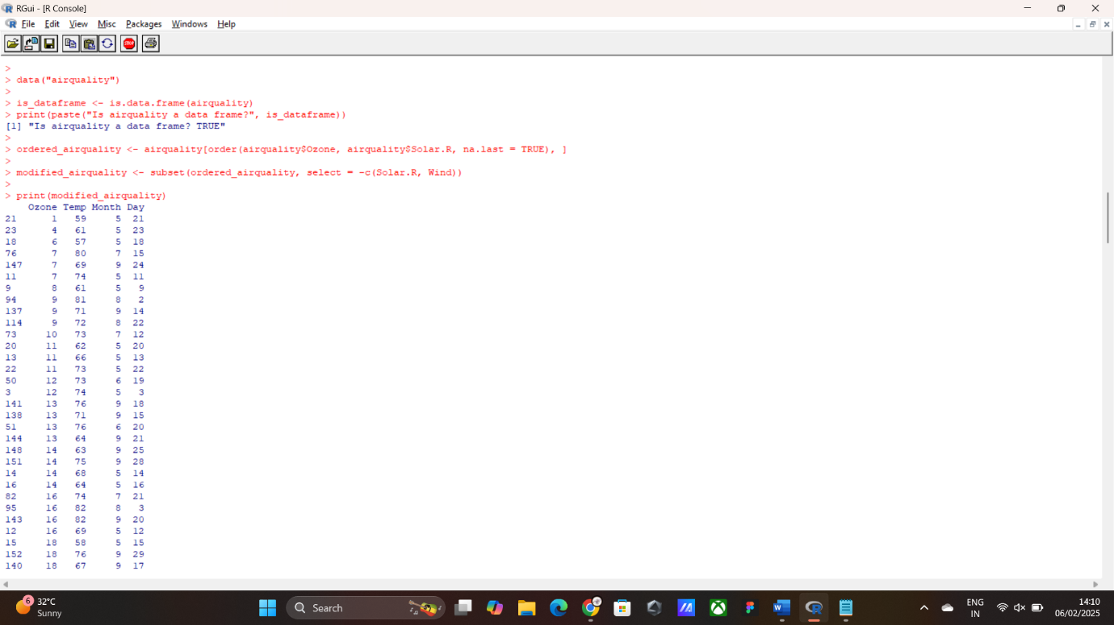

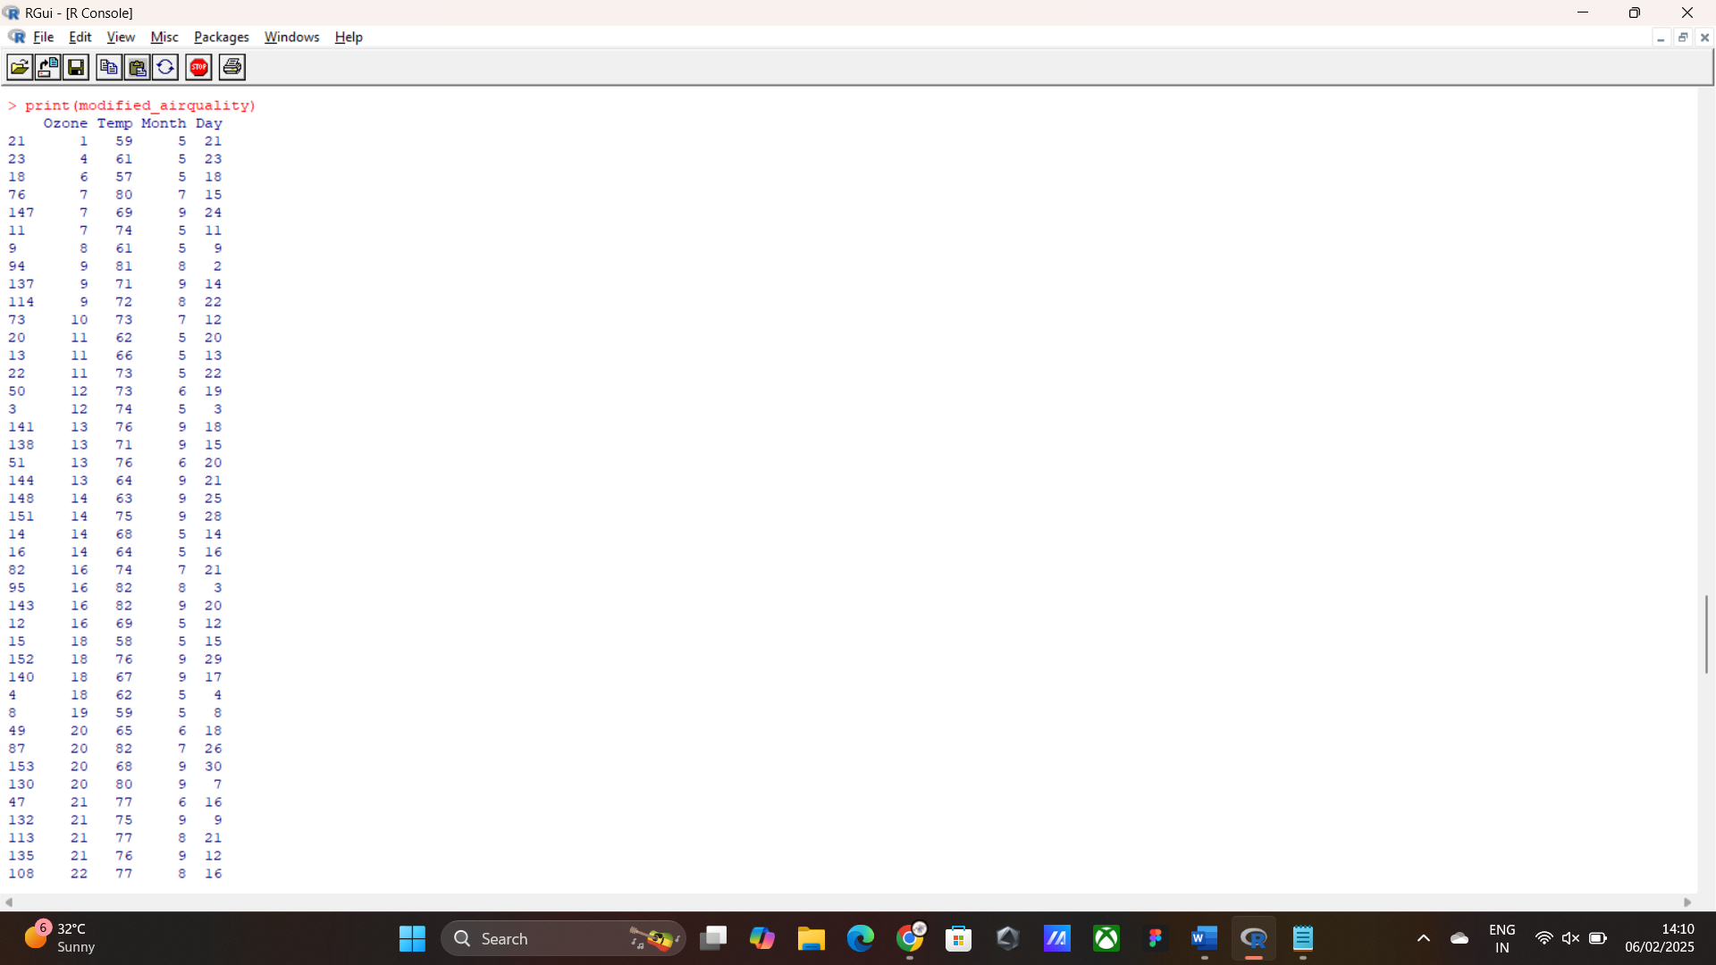

**8. Write a R program to create a factor corresponding to height of women data set , which inbuild in**

**R, contains height and weights for a sample of women.**

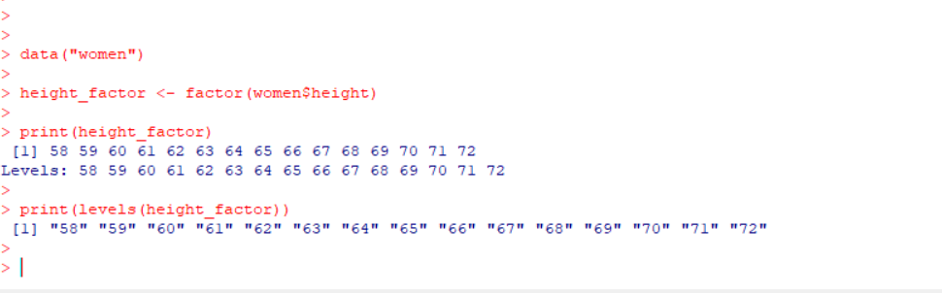

**9. Explore the airquality dataset. It contains daily air quality measurements from New York during a**

**period of five months: • Ozone: mean ozone concentration (ppb), • Solar.R: solar radiation (Langley),**

**• Wind: average wind speed (mph), • Temp: maximum daily temperature in degrees Fahrenheit,**

**• Month: numeric month (May=5, June=6, and so on),• Day: numeric day of the month (1 31).**

**i. compute the mean temperature(don’t use build in function) ii.Extract the first five rows from**

**airquality.**

**iii.Extract all columns from airquality except Temp and Wind iv.Which was the coldest day during the**

**period? v.How many days was the wind speed greater than 17 mph?**

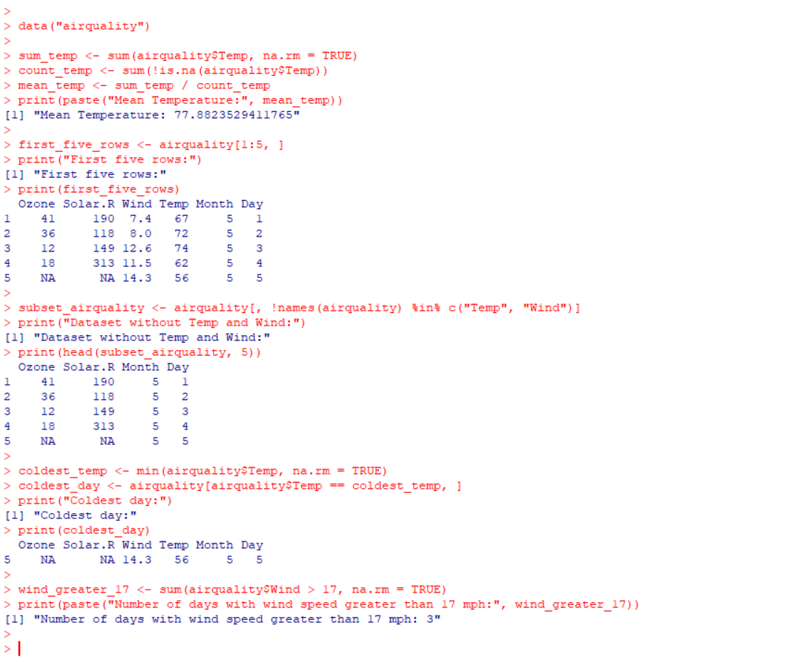

**10. (i)Get the Summary Statistics of air quality dataset (ii)Melt airquality data set and display as a long**

**– format data? (iii)Melt airquality data and specify month and day to be “ID variables”? (iv)Cast the**

**molten airquality data set with respect to month and date features (v) Use cast function appropriately**

**and compute the average of Ozone, Solar.R , Wind and temperature per month?**

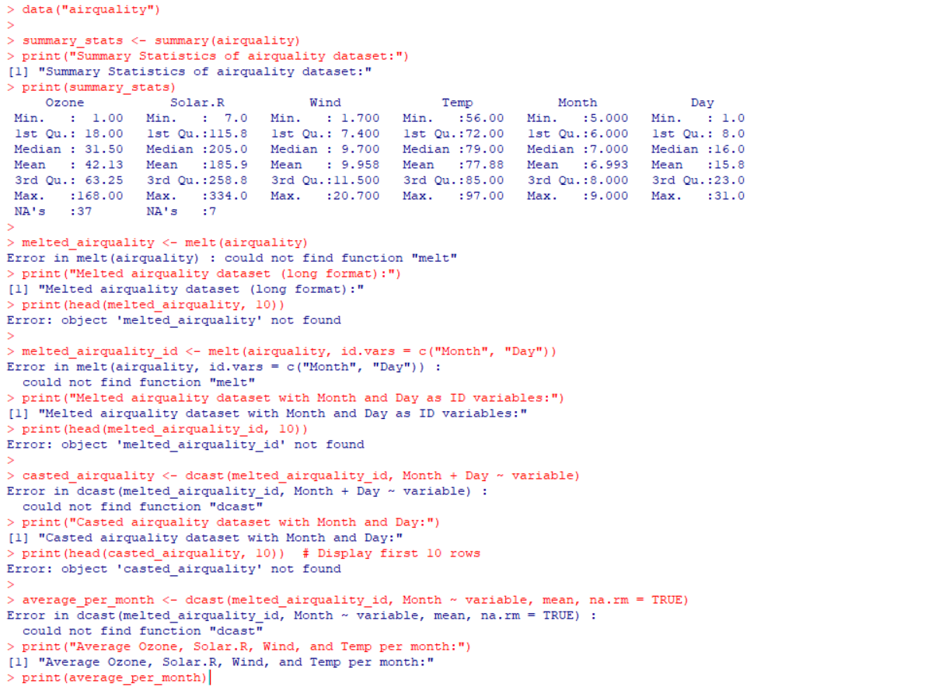

**11. consider air quality dataset**

**(i) Find any missing values(na) in features and drop the missing values if its less than 10% else replace**

**that with mean of that feature.**

**(ii) Apply a linear regression algorithm using Least Squares Method on “Ozone” and “Solar.R” (iii)Plot**

**Scatter plot between Ozone and Solar and add regression line created by above model**

