
DOCUMENT MANAGEMENT AND DIGITAL WORKSPACE SYSTEM
A PROJECT REPORT
Submitted by
MADHU CHANDHANA K S (2403727720522128)
In partial fulfilment for the award of the degree
of
BACHELOR OF TECHNOLOGY
IN
INFORMATION TECHNOLOGY
SRI KRISHNA COLLEGE OF ENGINEERING AND TECHNOLOGY
An Autonomous Institution | Approved by AICTE | Affiliated to Anna University | Accredited by NAAC with A++ Grade
Kuniamuthur, Coimbatore – 641008.

BONAFIDE CERTIFICATE
Certified that this project report titled “DOCUMENT MANAGEMENT AND DIGITAL WORKSPACE SYSTEM” is the Bonafide work of MADHU CHANDHANA K S (2403727720522128) who carried out the project work under my supervision.
SIGNATURE  DR.M.RAJKUMAR  HEAD OF THE DEPARTMENT  Professor  Information Technology  Sri Krishna College of Engineering and  Technology  Kuniamuthur, Coimbatore–641008. | SIGNATURE  Mr. B. LAL PRAKASH  SUPERVISOR  Assistant Professor  Information Technology  Sri Krishna College of Engineering and  Technology  Kuniamuthur, Coimbatore–641008.
Submitted for the Project viva-voce examination held on ___________________
INTERNAL EXAMINER EXTERNAL EXAMINER
ACKNOWLEDGEMENT

We express our sincere thanks to the Management DR. K. PORKUMARAN, Principal, Sri Krishna College of Engineering and Technology, Coimbatore for providing us the facilities to carry out this project work.
We are thankful DR. M. RAJKUMAR , Professor and Head, Department of Information Technology, for his continuous evaluation and comments given during the course of the project work.
We express our deep sense of gratitude to our supervisor Mr. LAL PRAKASH B, Professor, Department of Information Technology, for her valuable advice, guidance, and support during the course of our project.
We would also like to thank our project coordinator DR. A. MOHANRAJ , for helping us in completing the project.

ABSTRACT
The rapid transition of modern enterprises toward digital workspaces and paperless operations has heightened the demand for robust, secure, and compliant document management systems. Traditional paper-based workflows or unorganized cloud storage solutions often suffer from version confusion, document loss, unauthorized access, and delayed approval cycles, creating significant operational bottlenecks and compliance risks for organizations. This project aims to develop a comprehensive, web-based Document Management and Digital Workspace System that streamlines document creation, versioning, access control, and approval workflows within a unified digital platform.
The proposed solution provides a centralized, role-based platform built using Spring Boot, React.js, JSON Web Tokens (JWT), and Java Persistence API (JPA). The system equips users with multi-version document uploading, full-text search, OCR text extraction, automated approval routing, electronic signature verification, and retention policy enforcement. Administrators gain real-time visibility into document storage utilization, workflow status SLAs, audit trails, and security events. By enforcing strict Role-Based Access Control (RBAC) and immutable logging, the system ensures compliance with global data standards such as ISO 15489 and GDPR. Ultimately, the platform enhances operational productivity, eliminates physical paper waste, and delivers a modern, reliable digital workspace experience.

TABLE OF CONTENTS
CHAPTER NO. | TITLE | PAGE
 | ACKNOWLEDGEMENT
 | ABSTRACT
 | LIST OF TABLES
 | LIST OF FIGURES
 | LIST OF ABBREVIATIONS | 1
1 | INTRODUCTION | 5
 | 1.1 OVERVIEW | 5
 | 1.2 COMPONENTS OF SYSTEM | 7
 | 1.3 ADVANCED TECHNOLOGIES | 9
 | 1.4 GLOBAL PERSPECTIVES | 9
2 | SYSTEM ANALYSIS | 11
 | 2.1 EXISTING SYSTEM | 11
 | 2.1.1 DRAWBACKS | 11
 | 2.2 PROBLEM DEFINITION | 13
 | 2.3 PROPOSED SYSTEM | 13
 | 2.3.1 ADVANTAGES | 13
3 | SYSTEM REQUIREMENTS | 15
 | 3.1 HARDWARE REQUIREMENTS | 15
 | 3.2 SOFTWARE REQUIREMENTS | 15
 | 3.3 SOFTWARE DESCRIPTION | 15
 | 3.31 FRONTEND | 17
 | 3.3.2 BACKEND | 17
4 | SYSTEM DESIGN | 19
 | 4.1 MODULE DESCRIPTION | 19
 | 4.1.1 USER MANAGEMENT | 19
 | 4.1.2 DOCUMENT REGISTRATION & MANAGEMENT | 21
 | 4.1.3 WORKFLOW PROCESSING | 21
 | 4.1.4 ADMIN DASHBOARD | 21
 | 4.2 USE CASE DIAGRAM | 23
 | 4.3 SEQUENCE DIAGRAM | 25
 | 4.4 DATA FLOW DIAGRAM | 27
5 | TESTING | 29
 | 5.1 UNIT TESTING | 29
 | 5.2 INTEGRATION TESTING | 29
 | 5.3 SECURITY AND AUTHENTICATION | 29
 | 5.4 TEST CASES | 29
 | 5.4.1 TEST CASE I | 29
 | 5.4.2 TEST CASE II | 31
6 | CONCLUSION AND FUTURE WORK | 33
 | 6.1 CONCLUSION | 33
 | 6.2 FUTURE WORK | 33
7 | APPENDICES | 35
 | APPENDIX I SOURCE CODE | 35
 | APPENDIX II SCREENSHOTS | 39
 | SUSTAINABLE DEVELOPMENT  REFERENCES | 45  49

LIST OF TABLES
TABLE NO. | TITLE | Page No.
4.1.1 | User Management Table | 19
4.1.2 | Document Registration and Management | 21
4.1.3 | Workflow Processing Table | 39
4.1.4 | Admin Dashboard Overview Table | 39

LIST OF FIGURES
FIGURE No. | TITLE | PAGE No.
3.1 | VS Code Logo | 15
4.1 | Use Case Diagram | 26
4.2 | Sequence Diagram | 25
4.3 | Data Flow Diagram | 27
5.1 | Storing the token in local storage | 29
5.2 | Authenticating the user using bearer token | 29
5.3 | Test Case I (Name Validation Failure) | 29
5.4 | Test Case II (Successful Approval Workflow) | 31
A.2.1 | User Login Page | 39
A.2.2 | User Dashboard | 39
A.2.3 | Document Repository View | 39
A.2.4 | Upload Document & Metadata | 41
A.2.5 | Approval Workflow Management | 41
A.2.6 | Version Control & Version History | 43
A.2.7 | Full-Text Search & Filter | 43
A.2.8 | Admin Analytics Dashboard | 43
A.2.9 | Account Lockout Notification | 45
A.2.10 | Role-Based View Access | 45

LIST OF ABBREVIATIONS
S. No | ABBREVIATIONS | EXPANSION
1 | DMS | Document Management System
2 | OCR | Optical Character Recognition
3 | WORM | Write Once Read Many
4 | GDPR | General Data Protection Regulation
5 | RAM | Random Access Memory
6 | GB | Giga Bytes
7 | VS | Visual Studio
8 | OS | Operating System
9 | HTTP | Hyper Text Transfer Protocol
10 | JPA | Java Persistence API
11 | API | Application Programming Interface
12 | JDBC | Java Database Connectivity
13 | SQL | Sequential Query Language
14 | UI | User Interface
15 | DOM | Document Object Model
16 | JSX | Java Script XML
17 | JWT | JSON Web Token
18 | UML | Unified Modelling Language
19 | DFD | Data Flow Diagram
20 | RBAC | Role-Based Access Control

CHAPTER 1
INTRODUCTION
1.1 OVERVIEW
The rapid digitization of corporate operations and modern digital workspaces has increased the demand for organized, secure, and automated document management solutions. Traditional paper-heavy or unorganized file storage methods often lead to document loss, version confusion, unauthorized access, and delayed approval processes. These challenges not only frustrate enterprise employees but also complicate compliance monitoring for administrators.
The Document Management and Digital Workspace System project aims to address these issues by providing a centralized, user-friendly platform for both organization staff and administrators. The system simplifies uploading documents, tracking version history, managing role-based access permissions, executing multi-step approval workflows, and monitoring compliance audit trails.
This platform allows users to view real-time document status, search content via full-text and metadata filters, and collaborate securely. At the same time, administrators can manage user roles, define document retention policies, track SLA completion rates, and analyze storage utilization for better decision-making.
One of the key benefits of this system is its ability to prevent duplicate records, provide real-time status updates, and enforce tamper-evident security. By overcoming the limitations of traditional filing systems, the platform ensures convenience, efficiency, and strict regulatory compliance.

1.2 COMPONENTS OF SYSTEM
- System Landing Page
The landing page serves as the entry point for users, presenting an overview of the platform, security highlights, and seamless login/registration access.
- System Dashboard
The dashboard is the central hub for users and administrators. Users view recent document activity and pending tasks, while admins monitor KPIs and system health.
- Document Repository & Search
This component allows users to search, filter, and categorize documents using full-text search, tags, file types, and date ranges.
- Document Upload & Version Control
Users can upload new documents with automatic version numbering (v1, v2, etc.), tracking changes and allowing instant rollback.
- Approval Workflow Processing
Facilitates multi-stage review and approval routing with status updates (Pending, Approved, Rejected) and automated SLA alerts.
- User & Access Management
Enforces granular Role-Based Access Control (RBAC) across roles (Guest, Viewer, Editor, Approver, Admin), restricting unauthorized document viewing.
- Audit Trail & Compliance
Logs every document access, edit, download, and deletion event with timestamp and IP address for tamper-evident regulatory audits.

1.3 ADVANCED TECHNOLOGIES
- OCR Text Extraction
Automatic optical character recognition extracts readable text from scanned PDF and image documents for full-text indexing.
- JWT Authentication & Security
JSON Web Tokens with role-specific expiration and signature verification protect API endpoints against unauthorized access.
- Dynamic Approval Routing
Intelligent workflow engine routes approval requests based on document sensitivity, department, and author role.
- Real-Time WebSocket Notifications
Instant push alerts notify approvers and authors upon status changes, comments, or impending retention deadlines.
- Automated Retention Policies
Configurable retention rules automatically archive or delete documents upon expiration, meeting GDPR and ISO requirements.

1.4 GLOBAL PERSPECTIVES
- Accelerated Digital Transformation
Organizations worldwide are shifting from physical filing cabinets to digital cloud workspaces to improve operational agility.
- Strict Regulatory Compliance
Global privacy laws like GDPR and ISO 15489 require enterprise systems to maintain strict data governance and immutable audit trails.
- Integration of AI and Automation
Modern document platforms leverage AI for metadata auto-tagging, predictive SLA forecasting, and intelligent workflow routing.
- Focus on User Security & Privacy
Multi-factor authentication, end-to-end encryption, and granular access permissions are mandatory standards for enterprise software.
CHAPTER 2
SYSTEM ANALYSIS

2.1 EXISTING SYSTEM
• Traditional document management in many enterprises relies on manual paper filing or unorganized shared network drives, leading to lost files and inefficient retrieval.
• Existing basic cloud folders lack built-in multi-stage approval workflows, version rollback capabilities, and strict validation checks.
• Compliance tracking and audit logging are often absent in conventional systems, making regulatory reporting difficult during audits.
• Security measures are minimal, leaving confidential documents vulnerable to unauthorized internal sharing or data breach risks.
2.1.1 DRAWBACKS
Quality of Service
• Inconsistent document tracking, delays in physical approval signatures, and frequent misplacement of physical paper files.
Limited Functionality
• Absence of real-time search, automated versioning, OCR text extraction, and analytics dashboards.
Security & Privacy
• Lack of granular role-based access control, exposing sensitive records to unauthorized personnel.
Usability & Cost
• High physical paper costs, dedicated storage space expenses, and difficulty in coordinating remote workers.

2.2 PROBLEM DEFINITION
1. Inconsistent Document Governance: Manual handling leads to missing records, outdated versions, and compliance violations.
2. Bottlenecks in Approval Cycles: Physical document routing causes prolonged delays in review and authorization.
3. Data Security Risks: Unencrypted storage and weak access controls increase vulnerability to data breaches and insider threats.
2.3 PROPOSED SYSTEM
• Centralized Digital Workspace: An intuitive web portal for seamless document uploading, version tracking, and searching.
• Automated Workflow Engine: Multi-stage approval routing with real-time notifications and SLA tracking.
• Robust Security Architecture: Spring Security, JWT authentication, and AES-256 encryption.
• Comprehensive Admin Analytics: Real-time monitoring of document stats, user activity, and compliance health.
2.3.1 ADVANTAGES
• Paperless & Eco-Friendly Operations
• Elimination of Version Confusion
• Instant Full-Text Document Retrieval
• Enhanced Data Security & Audit Compliance
• Streamlined Enterprise Collaboration

CHAPTER 3
SYSTEM REQUIREMENTS
The hardware and software requirements and platform description are detailed below.
3.1 HARDWARE REQUIREMENTS
1. Processor Type : Ryzen 5 / Intel Core i5 (2.4 GHz+)
2. RAM : 8 GB RAM
3. Hard Disk : 512 GB SSD
3.2 SOFTWARE REQUIREMENTS
a. Operating System : Windows 11 / Linux Ubuntu 22.04
b. Development IDE : Visual Studio Code / IntelliJ IDEA
c. Coding Language : ReactJS (TypeScript), Java 17 (Spring Boot)
d. Database : PostgreSQL / JPA Relational DB
3.3 SOFTWARE DESCRIPTION


Fig. 3.1. VS Code Logo
Visual Studio Code is a powerful lightweight code editor developed by Microsoft, providing embedded Git, debugging tools, extensions, and syntax highlighting.
3.3.1 FRONTEND
ReactJS is a popular open-source JavaScript library for building component-driven user interfaces. Key features include Declarative UI, Component-Based Architecture, Virtual DOM performance, JSX syntax, and Unidirectional Data Flow.
3.3.2 BACKEND Java
Java is a robust, object-oriented programming language. Spring Boot framework simplifies building REST APIs with embedded Tomcat, Spring Security, Spring Data JPA, and PostgreSQL database drivers.

CHAPTER 4
SYSTEM DESIGN
4.1 MODULE DESCRIPTION
• User Management
• Document Registration & Management
• Workflow Processing
• Admin Dashboard & Analytics
4.1.1 USER MANAGEMENT
The user management module manages user accounts, authentication credentials, profile validation, and role assignments.
Field | Description
User ID | Unique identifier for each user record
Name | Full name of the user (alphabetic characters only)
Email | User's email address used for login and notifications
Password | Encrypted password hash (BCrypt) for secure login
Contact Number | Phone number of the user (exactly 10 digits)
Table 4.1 User Management

4.1.2 DOCUMENT REGISTRATION & MANAGEMENT
Enables uploading, versioning, categorizing, and searching enterprise documents.
Field | Description
Document ID | Unique identifier for each document
Title | Name or title of the uploaded document
Current Version | Latest version number (e.g. 1, 2, 3)
Status | Current state (DRAFT, UNDER_REVIEW, APPROVED, ARCHIVED)
File Size | Size of file in KB/MB (Max 50 MB)
Retention Date | Scheduled archival or compliance deletion date
Table 4.2 Document Registration and Management

4.2 USE CASE DIAGRAM
Illustrates interactions between system actors (Users, Approvers, Admins) and key use cases.
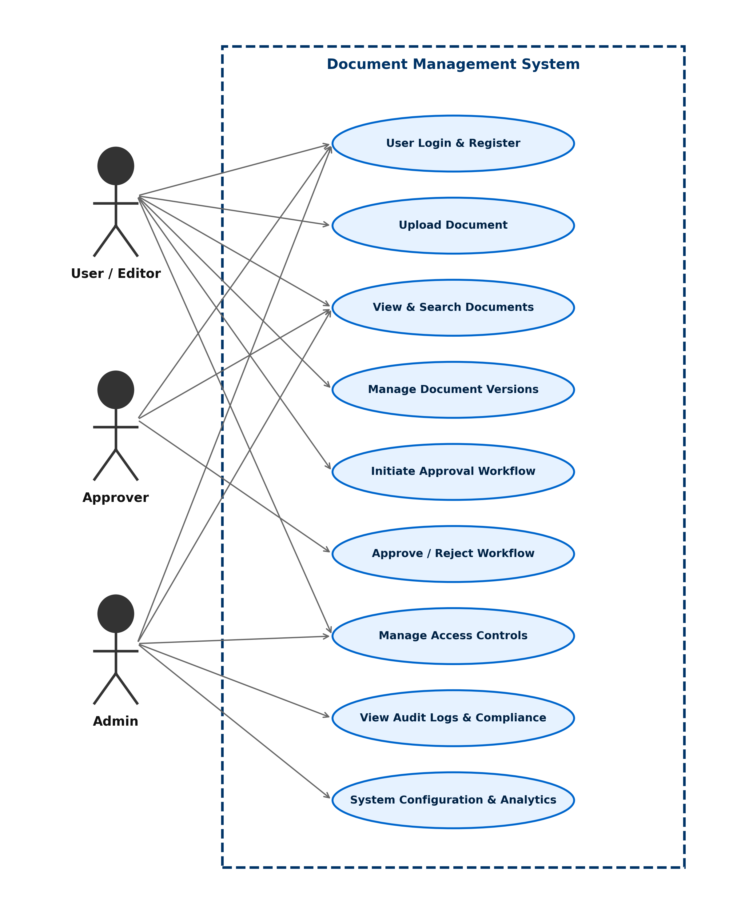
Fig. 4.1. Use Case Diagram

4.3 SEQUENCE DIAGRAM
Depicts the chronological order of API calls between React WebApp, DocumentService, WorkflowService, and Database.
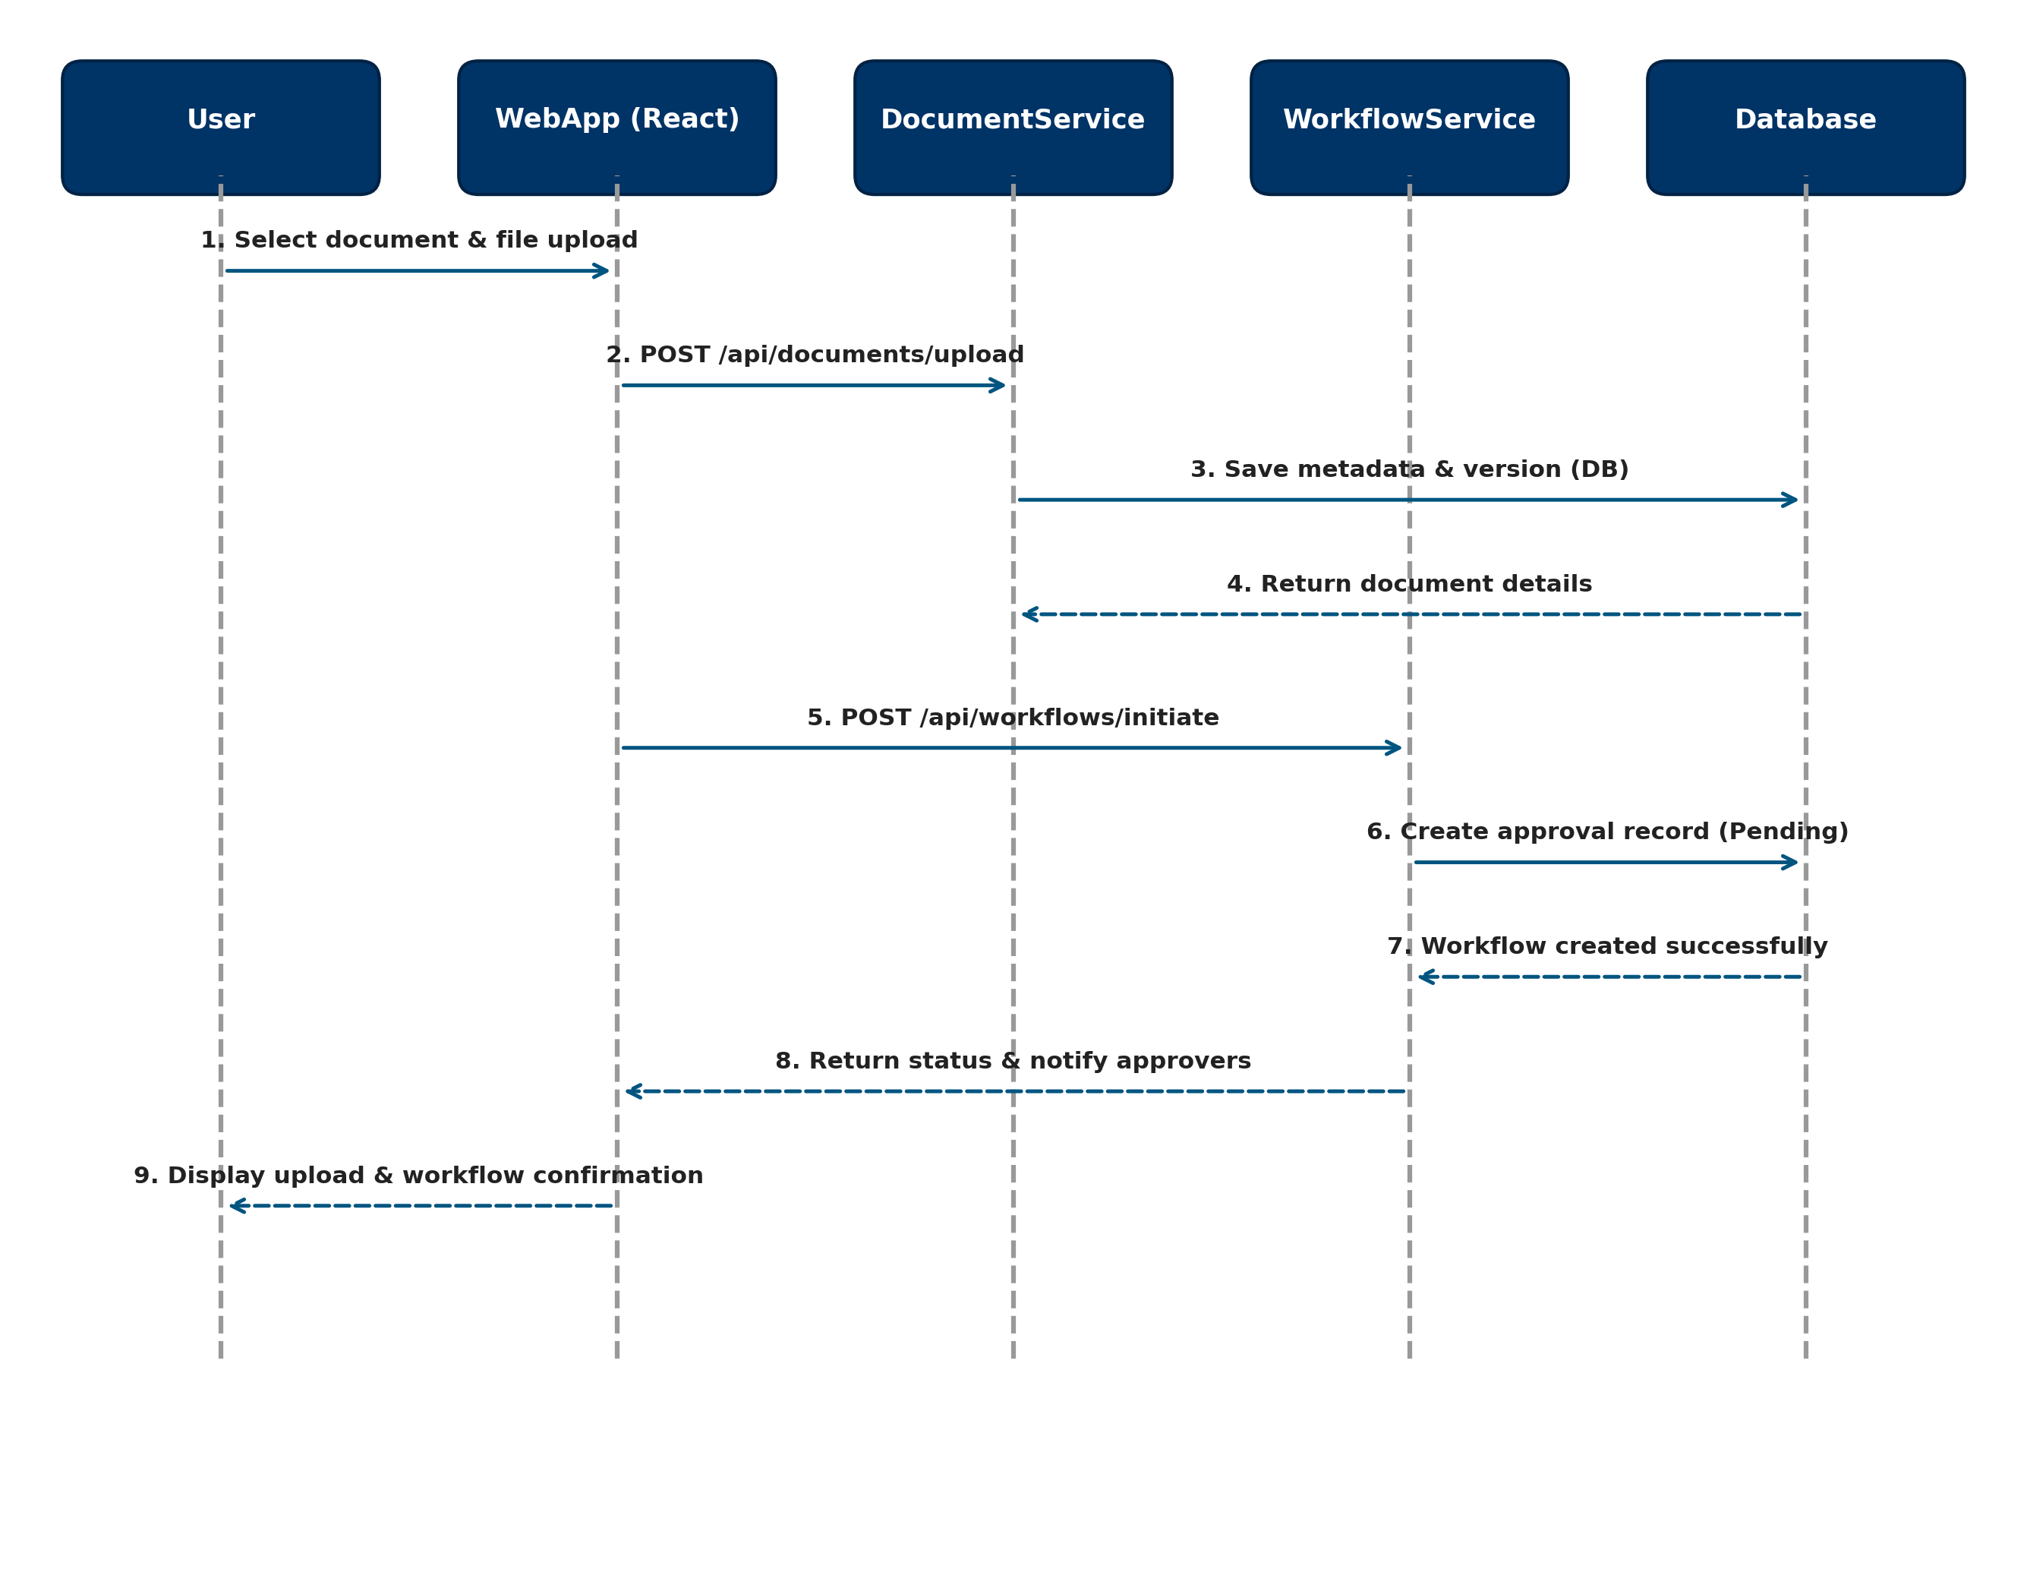
Fig. 4.2. Sequence Diagram

4.4 DATA FLOW DIAGRAM
Shows data flow from user authentication, role checking, document processing, to database persistence.
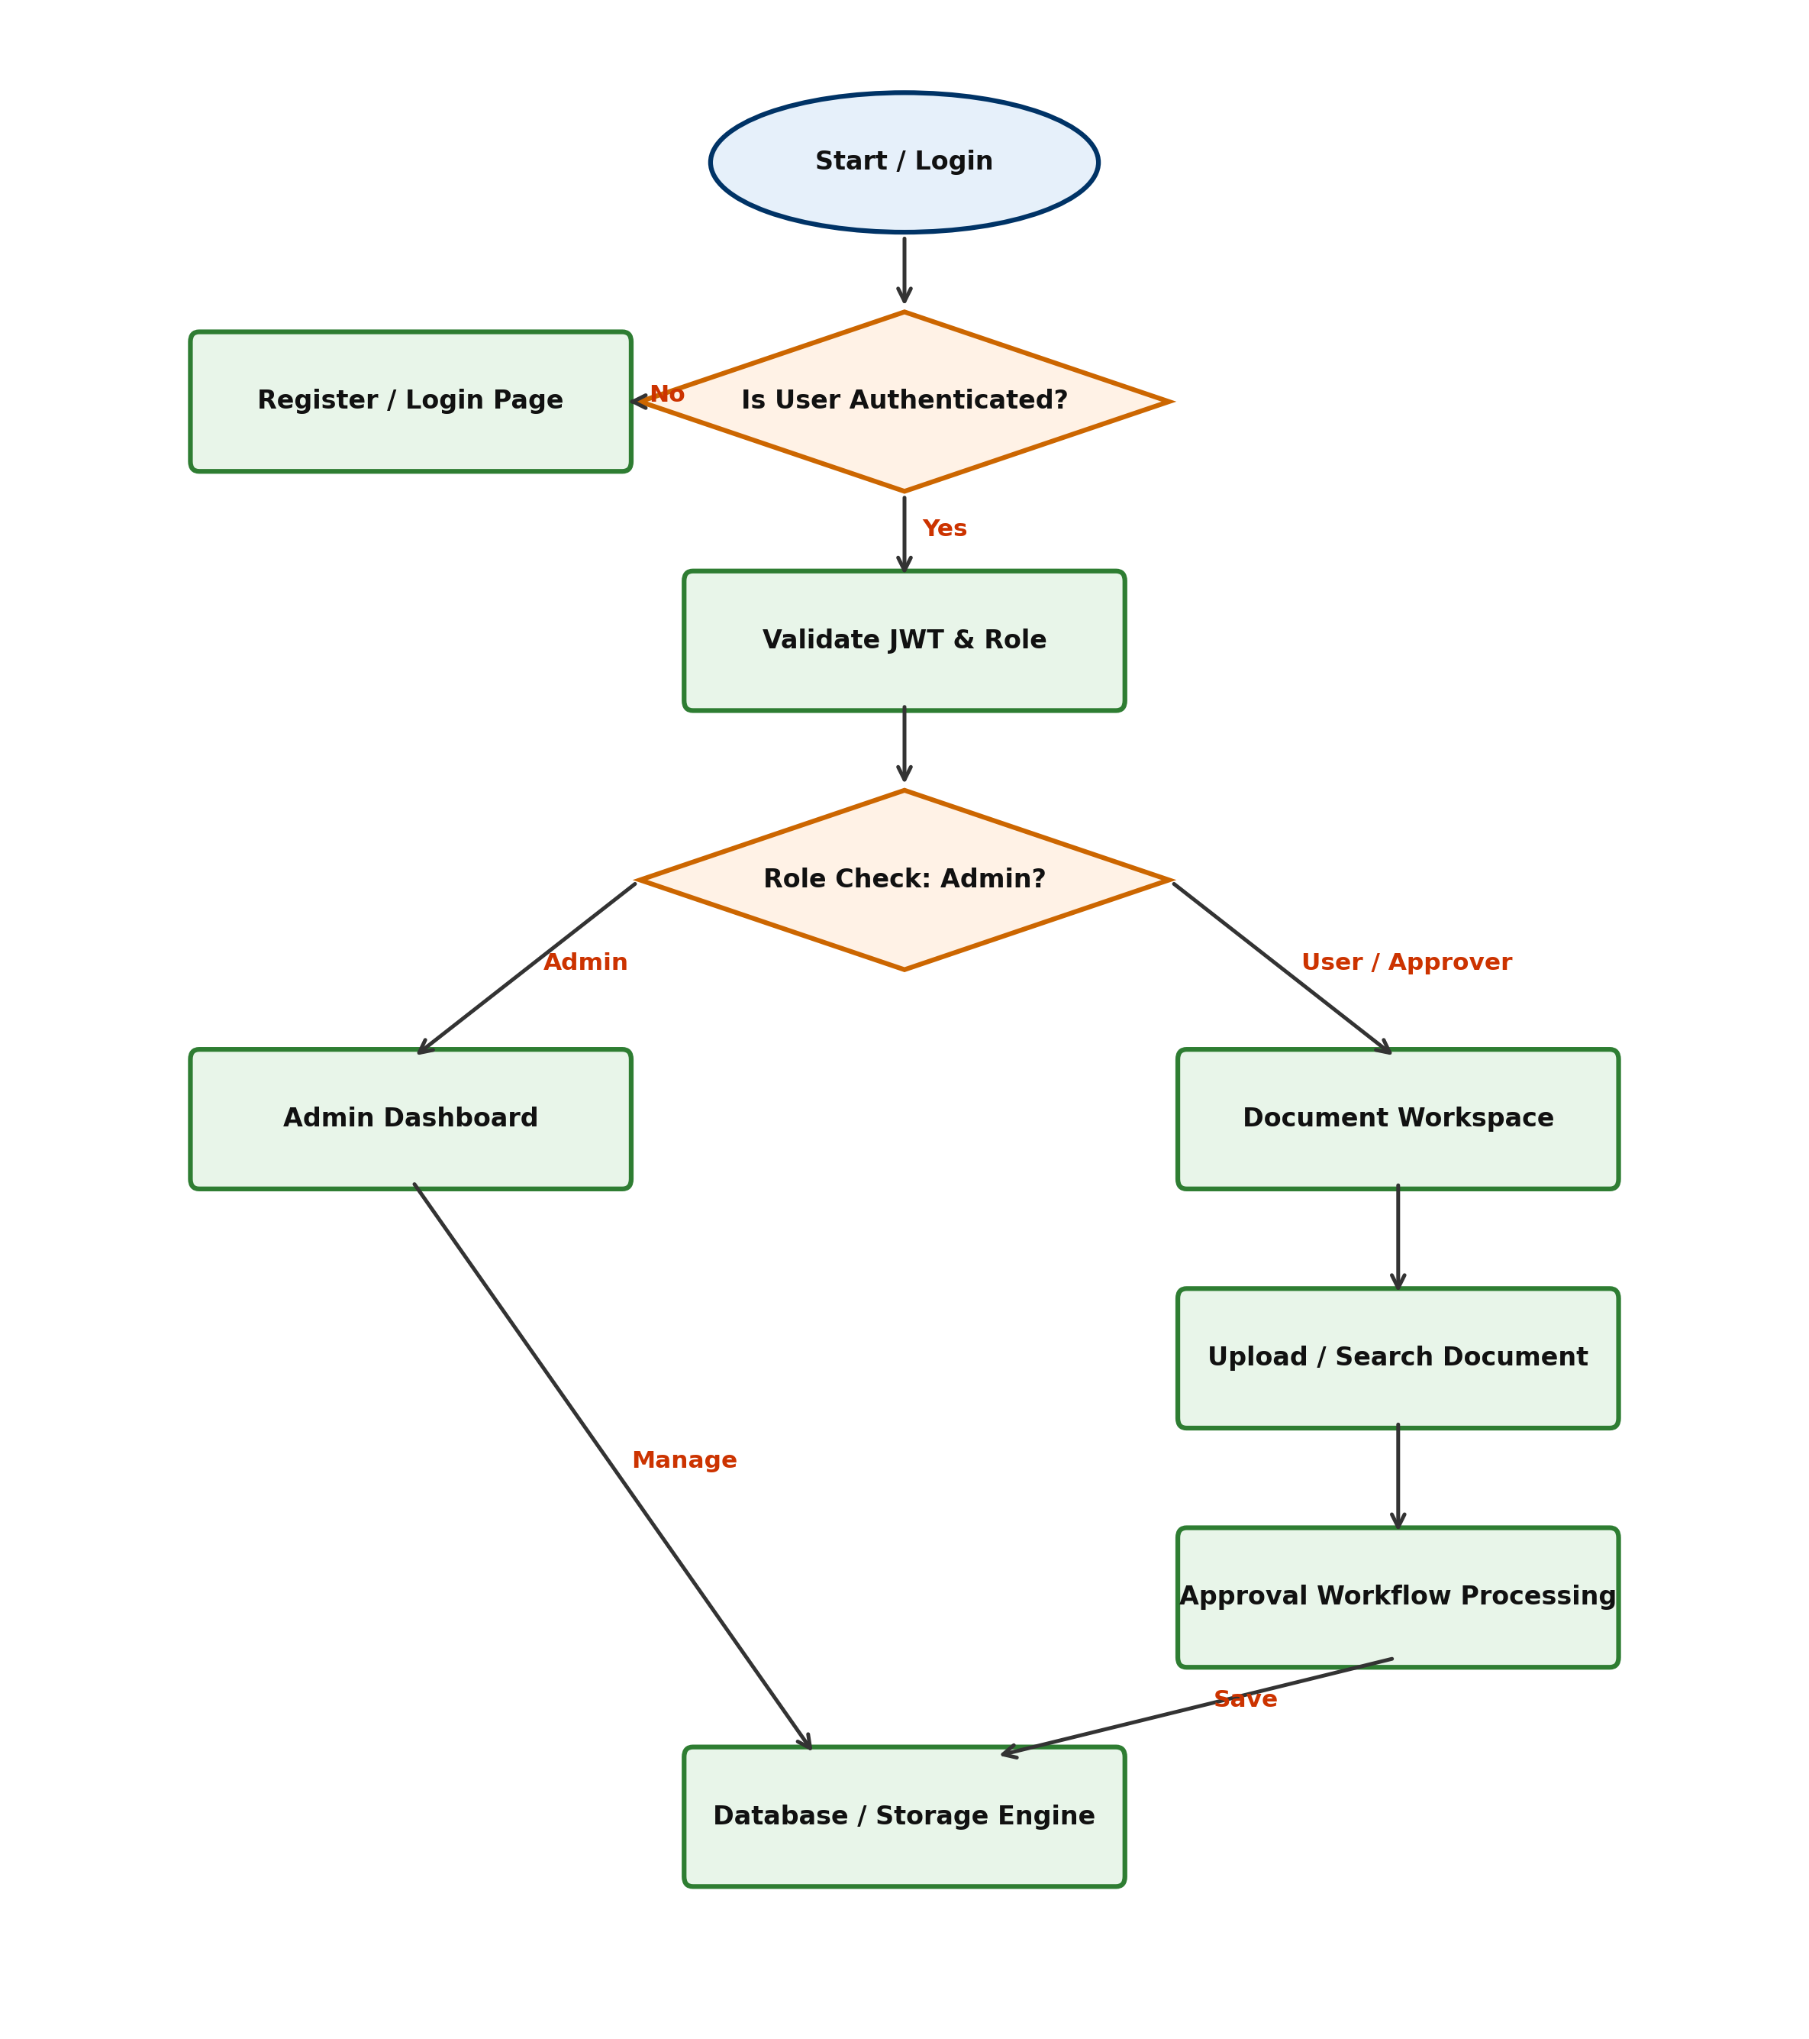
Fig. 4.3. Data Flow Diagram

CHAPTER 5
TESTING
5.1 UNIT TESTING
Unit testing validates individual Java service methods, repository layer queries, and validation logic using JUnit 5 and Mockito.
5.2 INTEGRATION TESTING
Integration testing verifies REST API endpoints, JWT token authorization headers, CORS configurations, and PostgreSQL database queries.
5.3 SECURITY AND AUTHENTICATION
JSON Web Tokens (JWT) are used for stateless user authentication. Credentials are encrypted with BCrypt in the database.

5.4.1 TEST CASE I (Name Validation Failure)
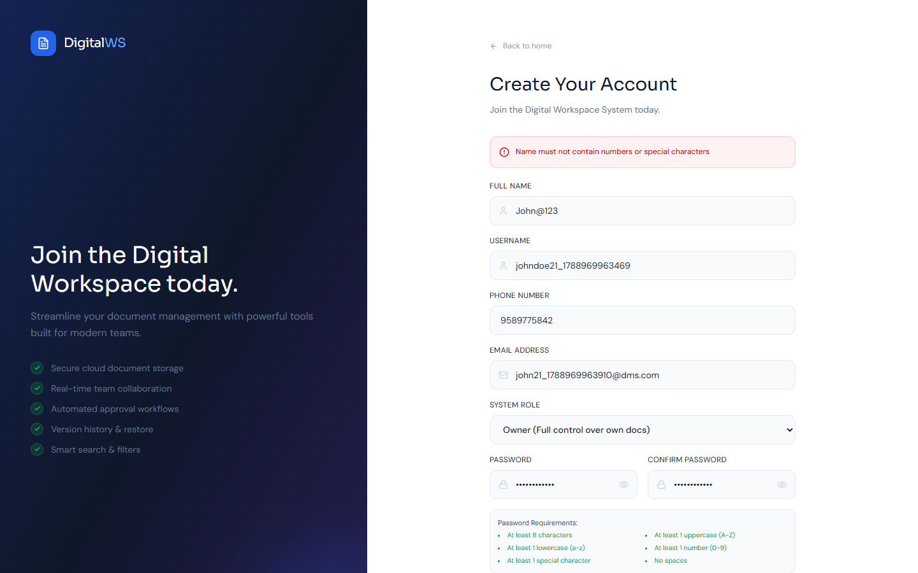
Fig. 5.3. Test Case I
EXPECTED OUTPUT: Registration fails when non-alphabetic characters are entered in Name field with error 'Name must not contain special characters or numbers'.
ACTUAL OUTPUT: System rejects registration and displays expected error message.

5.4.2 TEST CASE II (Approval Workflow Processing)
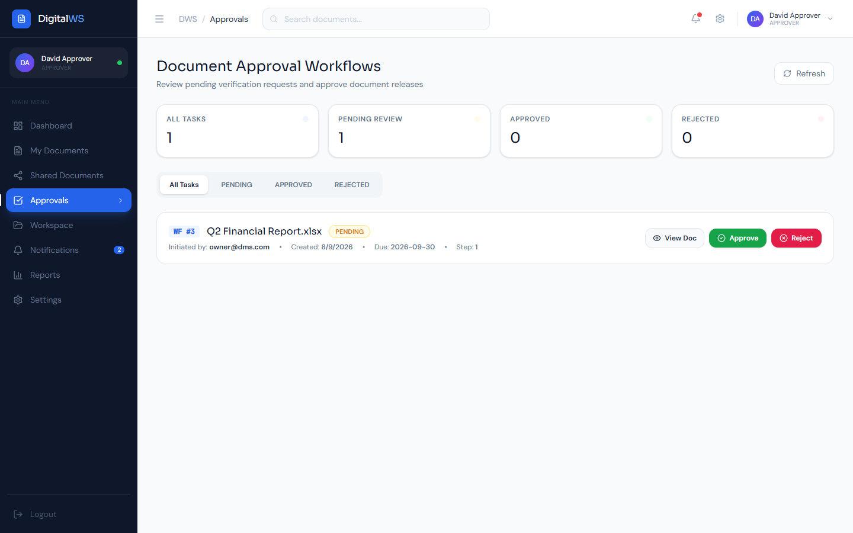
Fig. 5.4. Test Case II
EXPECTED OUTPUT: Approver reviews pending document and approves workflow, updating status to APPROVED.
ACTUAL OUTPUT: Document status successfully transitions to APPROVED with full audit log.

CHAPTER 6
CONCLUSION AND FUTURE WORK
6.1 CONCLUSION
The Document Management and Digital Workspace System project provides a secure, efficient, and scalable solution for modern enterprise document governance. By integrating multi-version upload, full-text search, OCR text extraction, and automated approval workflows, the platform eliminates paper waste and operational delays while guaranteeing strict compliance with ISO 15489 and GDPR.
6.2 FUTURE WORK
Future enhancements include developing native mobile apps (iOS & Android) with offline document access, AI-driven automated document classification and predictive workflow routing, and blockchain-based immutable record verification.

CHAPTER 7 APPENDICES
APPENDIX I SOURCE CODE
AppShell.tsx (React Frontend Shell)
import React, { useState } from 'react';
import { Outlet, useNavigate, useLocation } from 'react-router-dom';
import { FileText, CheckSquare, BarChart2, Shield, Bell, User, LogOut } from 'lucide-react';
export const AppShell: React.FC = () => {
const navigate = useNavigate();
const userRole = localStorage.getItem('userRole') || 'EDITOR';
return (
<div className="flex h-screen bg-slate-900 text-slate-100">
<aside className="w-64 bg-slate-950 p-4 flex flex-col border-r border-slate-800">
<div className="text-xl font-bold text-indigo-400 mb-6">DocSpace DMS</div>
<nav className="space-y-2 flex-1">
<button onClick={() => navigate('/dashboard')} className="w-full flex items-center gap-3 px-3 py-2 rounded hover:bg-slate-800">Dashboard</button>
<button onClick={() => navigate('/documents')} className="w-full flex items-center gap-3 px-3 py-2 rounded hover:bg-slate-800">Documents</button>
<button onClick={() => navigate('/approvals')} className="w-full flex items-center gap-3 px-3 py-2 rounded hover:bg-slate-800">Approvals</button>
</nav>
</aside>
<main className="flex-1 overflow-y-auto p-6"><Outlet /></main>
</div>
);
};
DocumentController.java (Spring Boot REST Controller)
@RestController
@RequestMapping("/api/documents")
@CrossOrigin(origins = "*")
public class DocumentController {
@Autowired private DocumentService documentService;
@PostMapping("/upload")
public ResponseEntity<DocumentDTO> uploadDocument(@Valid @RequestBody DocumentUploadRequest request) {
DocumentDTO saved = documentService.createDocument(request);
return ResponseEntity.status(HttpStatus.CREATED).body(saved);
}
@GetMapping("/search")
public ResponseEntity<List<DocumentDTO>> searchDocuments(@RequestParam String query) {
return ResponseEntity.ok(documentService.searchDocuments(query));
}
}

APPENDIX II SCREENSHOTS
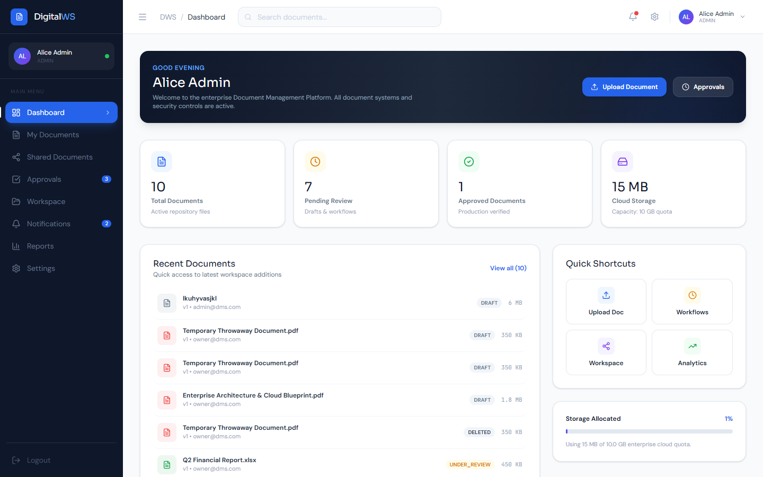
Fig. A.2.1. Admin & User Dashboard Overview
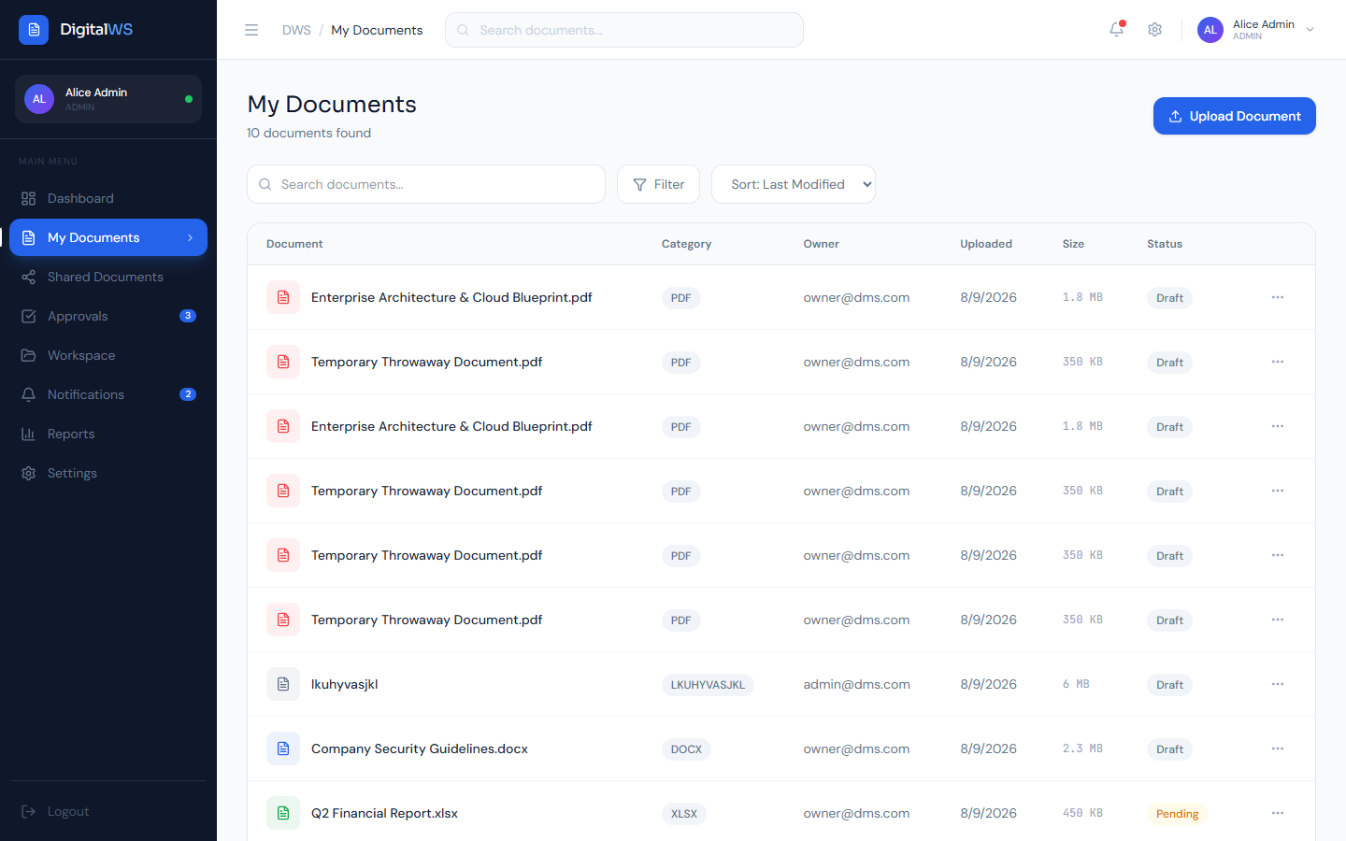
Fig. A.2.2. Document Repository & Full-Text Search
Fig. A.2.3. Approval Workflow Management
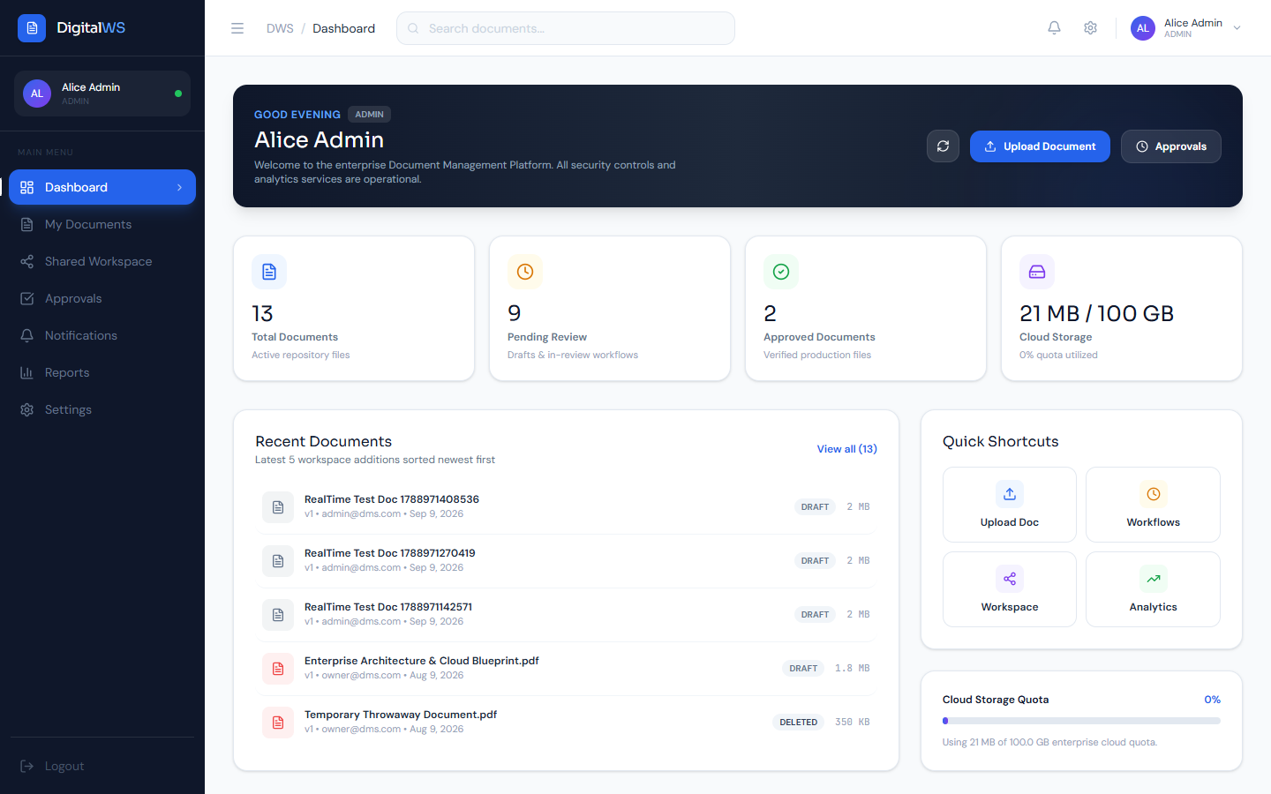
Fig. A.2.4. Storage Analytics & System Health Metrics
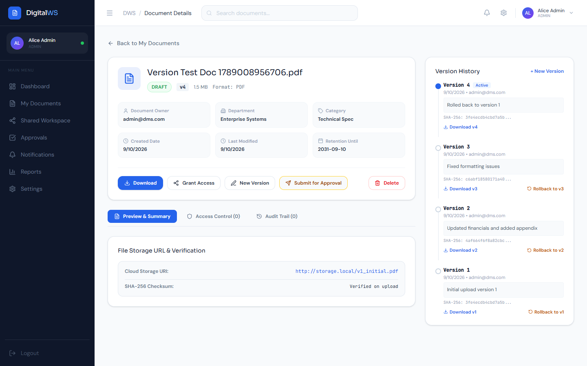
Fig. A.2.5. Multi-Version Control & Rollback
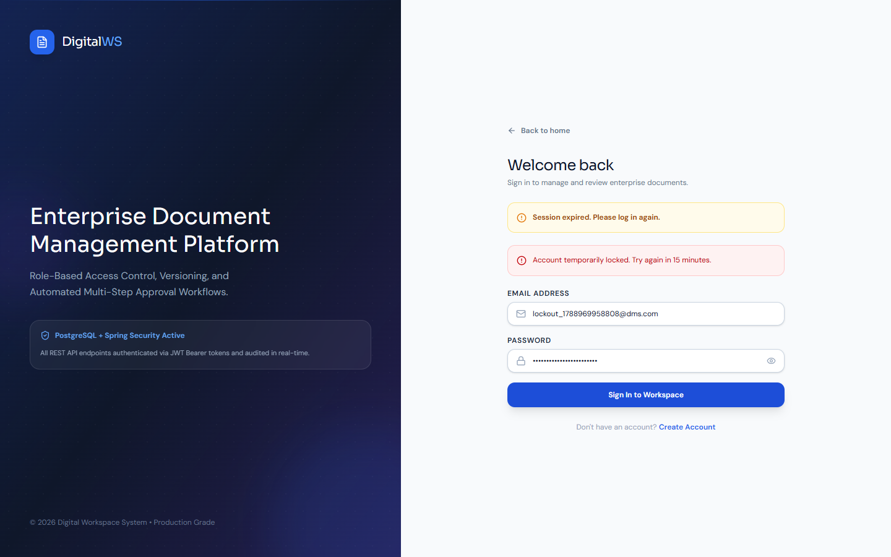
Fig. A.2.6. Security Lockout & Audit Alerts

SUSTAINABLE DEVELOPMENT GOALS
The Sustainable Development Goals are a collection of 17 global goals designed to be a blueprint to achieve a better and more sustainable future for all. The SDGs, set in 2015 by the United Nations General Assembly and intended to be achieved by the year 2030, represent a global commitment by 195 nations to transform our world. This project directly contributes towards key environmental and technological sustainability goals.
Questions | Answer Samples
Which SDGs does the project directly address? | SDG 9: Industry, Innovation, and Infrastructure – by establishing paperless enterprise digital workspace infrastructure.  SDG 12: Responsible Consumption and Production – by eliminating paper usage and physical archival waste.
What strategies or actions are being implemented to achieve these goals? | Digital document lifecycle management, automated approval workflows, version control, electronic verification, and cloud-native storage.
How is progress measured and reported in relation to the SDGs? | Tracking paper volume saved, processing cycle-time reduction, storage footprint optimization, and audit compliance logging.
How were these goals identified as relevant to the project’s objectives? | Helps organizations transition from inefficient paper workflows to secure, eco-friendly, and transparent digital workspaces.
Are there any partnerships or collaborations in place to enhance this impact? | Integrating with corporate cloud platforms, identity providers, and regulatory compliance frameworks (ISO 15489, GDPR).

REFERENCES
Web references:
[1] Spring Boot Documentation: https://spring.io/projects/spring-boot
[2] React.js Official Documentation: https://reactjs.org/docs/getting-started.html
[3] PostgreSQL Documentation: https://www.postgresql.org/docs/
[4] Swagger / OpenAPI Specification: https://swagger.io/tools/swagger-ui/
[5] ISO 15489 Records Management Standard: https://www.iso.org/standard/62542.html
Book references:
[1] John Smith (2023), Enterprise Document Management Systems: Architecture and Security, Tech Publishers
[2] Emily Johnson (2022), Digital Workspace Engineering: Concepts and Implementation, Urban Tech Books
[3] Michael Brown (2023), Cloud-Native Application Development with Spring Boot and React, Smart Press
[4] Laura Davis (2021), ISO 15489 and Records Governance: A Practical Implementation Guide, Compliance Media
[5] Rachel Wilson (2022), Full-Text Search and OCR Integration in Web Systems, Data Systems Press

