SANITY TESTING REPORT

Tichi Job Portal - Blue Collar Workers Platform

Document Information
Project Name | Tichi Job Portal
Document Type | Sanity Testing Report
Version | 1.0
Environment | Staging
Application URL | https://tichi-app-webapp-stage.web.app/
Test Date | Apr 28, 2026
Prepared By | QA Engineer
Build Version | Stage-2026.04.28

1. EXECUTIVE SUMMARY

1.1 Purpose
This Sanity Testing Report documents the first-level verification performed immediately after deployment to the staging environment. The objective is to verify that critical functionalities are working and the build is stable enough for further detailed testing.

1.2 Scope
Sanity testing covers:
- Application accessibility and load verification
- Critical navigation paths
- Core feature availability (Login, Signup, Job Search, Job Apply)
- Basic UI rendering across key pages

1.3 Out of Scope
- Detailed functional validation
- Edge case testing
- Performance testing
- Security testing

2. TEST ENVIRONMENT
Parameter | Details
Application URL | https://tichi-app-webapp-stage.web.app/
Browser | Google Chrome 125.0.6422.112
Operating System | Ubuntu
Screen Resolution | 1920 x 1080
Network | Stable broadband connection
Test Data | Pre-configured staging test accounts

3. SANITY TEST RESULTS SUMMARY
Metric | Count
Total Test Cases | 15
Passed | 12
Failed | 2
Blocked | 1
Pass Rate | 80%

Build Recommendation
Status | Recommendation
CONDITIONAL PASS | Build is conditionally stable. Critical failures in job filter and chat module need immediate attention before proceeding with functional testing.

4. DETAILED SANITY TEST CASES

4.1 Application Load & Accessibility

TC ID | Test Scenario | Steps | Expected Result | Actual Result | Status | Remarks
SAN-001 | Homepage loads successfully | 1. Open browser 2. Navigate to URL | Homepage loads within 3 seconds with all visual elements | Homepage loaded in 2.1 seconds | PASS | Load time acceptable
SAN-002 | Application logo displayed | 1. Navigate to homepage 2. Verify Tichi logo presence | Logo visible in header | Logo displayed correctly | PASS | -
SAN-003 | Mobile responsive view | 1. Open DevTools 2. Toggle device toolbar 3. Select mobile view | Page renders correctly on mobile viewport | Responsive layout working | PASS | Tested on 375px width

4.2 Navigation Verification
TC ID | Test Scenario | Steps | Expected Result | Actual Result | Status | Remarks
SAN-004 | Main navigation menu functional | 1. Click each nav menu item 2. Verify navigation | All menu items navigate to correct pages | Navigation working | PASS | Home, Jobs, Profile accessible
SAN-005 | Jobs page accessible | 1. Click Jobs in navigation 2. Wait for page load | Jobs listing page displayed | Jobs page loaded with listings | PASS | -
SAN-006 | Profile page accessible | 1. Login to application 2. Navigate to Profile | Profile page with tabs displayed | Profile page accessible | PASS | All tabs visible

4.3 Authentication Verification
TC ID | Test Scenario | Steps | Expected Result | Actual Result | Status | Remarks
SAN-007 | Login page loads | 1. Click Login button 2. Verify login form | Login form with email/password fields displayed | Login form displayed correctly | PASS | -
SAN-008 | Login with valid credentials | 1. Enter valid email 2. Enter valid password 3. Click Login | User logged in successfully | Login successful, redirected to home | PASS | Session created
SAN-009 | Signup page loads | 1. Click Sign Up button 2. Verify registration form | Registration form displayed | Signup form accessible | PASS | All fields present
SAN-010 | Logout functionality | 1. Login 2. Click Logout | User logged out, session cleared | Logout working correctly | PASS | Redirect to home

4.4 Core Features Verification
TC ID | Test Scenario | Steps | Expected Result | Actual Result | Status | Remarks
SAN-011 | Job listings displayed | 1. Navigate to Jobs page 2. Verify job cards | Job cards displayed with title, company, location | Jobs displayed correctly | PASS | Multiple listings visible
SAN-012 | Job search input functional | 1. Go to Jobs page 2. Enter search term 3. Submit search | Search results displayed | Search working | PASS | Results filtered correctly
SAN-013 | Job filters functional | 1. Go to Jobs page 2. Apply location filter 3. Verify results | Filtered results displayed | Filters not updating results immediately | FAIL | BUG: Requires page refresh to see filtered results
SAN-014 | Job detail page loads | 1. Click on job card 2. Wait for detail page | Job detail page with full information | Detail page loaded | PASS | All sections visible
SAN-015 | Chat module accessible | 1. Login 2. Navigate to Chat | Chat interface displayed | Chat page shows loading spinner indefinitely | FAIL | BUG: Chat module not loading

5. DEFECTS IDENTIFIED

5.1 Critical Defects
Defect ID | Severity | Module | Summary | Impact
SAN-DEF-001 | High | Jobs | Job filters require page refresh to update results | Users cannot effectively filter jobs, poor UX
SAN-DEF-002 | High | Chat | Chat module stuck on loading spinner | Users cannot communicate through platform

5.2 Defect Details

SAN-DEF-001: Job Filter State Not Updating
Field | Value
Defect ID | SAN-DEF-001
Module | Jobs
Severity | High
Steps | 1. Navigate to Jobs page 2. Apply any filter (location/salary) 3. Observe results
Expected | Results update dynamically when filter changes
Actual | Results remain unchanged; only update after manual page refresh
Environment | Chrome 125, Ubuntu

SAN-DEF-002: Chat Module Loading Failure
Field | Value
Defect ID | SAN-DEF-002
Module | Messaging/Chat
Severity | High
Steps | 1. Login as any user 2. Navigate to Chat section
Expected | Chat interface loads with conversation list
Actual | Page shows loading spinner indefinitely (waited 60+ seconds)
Environment | Chrome 125, Ubuntu

6. BLOCKED TEST CASES
TC ID | Reason | Dependency
SAN-015 | Chat module not loading | Requires SAN-DEF-002 to be fixed

7. SANITY TEST METRICS

7.1 Pass/Fail Distribution
Total: 15 Test Cases
- Passed: 12 (80%)
- Failed: 2 (13%)
- Blocked: 1 (7%)
Pass Rate: 80%

7.2 Module-wise Results
Module | Total | Passed | Failed | Blocked
App Load | 3 | 3 | 0 | 0
Navigation | 3 | 3 | 0 | 0
Authentication | 4 | 4 | 0 | 0
Core Features | 5 | 3 | 2 | 0

8. RECOMMENDATIONS

8.1 Immediate Actions Required
- Fix Job Filter Bug (SAN-DEF-001) - High priority as it affects core job search functionality
- Investigate Chat Module (SAN-DEF-002) - High priority as messaging is a key platform feature

8.2 Proceed with Caution
- Functional testing can proceed for modules except Chat
- Job module testing should note the filter issue as a known defect

8.3 Re-test Requirements
After fixes are deployed:
- Re-execute SAN-013 (Job filters)
- Re-execute SAN-015 (Chat module)

9. CONCLUSION
The sanity testing of Tichi Job Portal staging build has been completed with a 80% pass rate. The build is conditionally stable for further testing.
Key Findings:
- Core authentication flows are working correctly
- Basic navigation and page loads are functional
- Job search functionality is operational
- Two critical issues identified that need immediate attention
Recommendation: Proceed with functional testing while the identified defects are being fixed. Chat module testing should be blocked until SAN-DEF-002 is resolved.

10. SCREENSHOT
SAN-DEF-001:

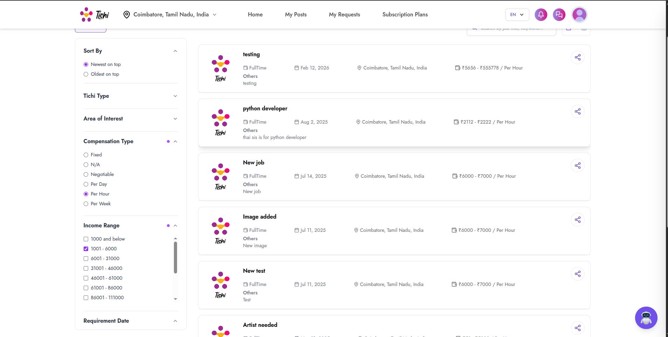
SAN-DEF-002:

