FUNCTIONAL TESTING REPORT

Tichi Job Portal - Blue Collar Workers Platform

Document Information
Project Name | Tichi Job Portal
Document Type | Functional Testing Report
Version | 1.0
Environment | Staging
Application URL | https://tichi-app-webapp-stage.web.app/
Test Period | Apr-28, 2026
Prepared By | QA Engineer
Build Version | Stage-2026.04.28

1. EXECUTIVE SUMMARY

1.1 Purpose
This Functional Testing Report provides comprehensive validation of all core modules of the Tichi Job Portal. The testing ensures that each feature functions according to business requirements and user expectations.

1.2 Scope
Functional testing covers the following modules:
- User Management (Registration, Login, Profile)
- Job Postings (Create, Edit, Delete, View)
- Job Applications (Search, Apply, Track)
- Subscriptions (Plans, Payment, Management)
- Messaging (Chat functionality)
- Settings & Preferences

1.3 Testing Approach
- Positive Testing: Verify expected behavior with valid inputs
- Negative Testing: Verify error handling with invalid inputs
- Boundary Testing: Test edge cases and limits
- Integration Testing: Verify module interactions

2. TEST ENVIRONMENT
Parameter | Details
Application URL | https://tichi-app-webapp-stage.web.app/
Browsers Tested | Chrome 125,
Operating Systems | Linux
Devices | Laptop(Ubuntu)
Test Data | Staging environment test accounts
Payment Testing | Razorpay Test Mode

2.1 Test Payment Credentials (Razorpay)
Type | Details
Test Card | 4111 1111 1111 1111
Expiry | Any future date
CVV | Any 3 digits
Test UPI | success@razorpay

3. TEST EXECUTION SUMMARY

3.1 Overall Results
Metric | Count | Percentage
Total Test Cases | 75
Passed | 62 | 82.7%
Failed | 9 | 12.0%
Blocked | 4 | 5.3%

3.2 Module-wise Summary
Module | Total TC | Passed | Failed | Blocked | Pass %
User Management | 15 | 13 | 2 | 0 | 86.7%
Job Postings | 12 | 10 | 1 | 1 | 83.3%
Job Applications | 14 | 11 | 2 | 1 | 78.6%
Subscriptions | 10 | 8 | 2 | 0 | 80.0%
Messaging | 8 | 5 | 1 | 2 | 62.5%
Profile Management | 10 | 9 | 1 | 0 | 90.0%
Settings | 6 | 6 | 0 | 0 | 100%

4. DETAILED TEST CASES BY MODULE

4.1 USER MANAGEMENT MODULE

4.1.1 Registration Tests
TC ID | Test Scenario | Test Steps | Test Data | Expected Result | Actual Result | Status | Priority
FUN-UM-001 | Register with valid email | 1. Navigate to signup page 2. Enter valid email 3. Enter strong password 4. Complete registration | Email: newuser@test.com Pass: Test@1234 | Account created, verification email sent | Account created successfully | PASS | Critical
FUN-UM-002 | Register with existing email | 1. Navigate to signup 2. Enter existing email 3. Submit | Email: existing@test.com | Error: “Email already registered” | Error displayed correctly | PASS | High
FUN-UM-003 | Register with invalid email format | 1. Navigate to signup 2. Enter invalid email 3. Submit | Email: invalidformat | Validation error for email field | Validation error shown | PASS | High
FUN-UM-004 | Register with weak password | 1. Navigate to signup 2. Enter weak password 3. Submit | Pass: 123 | Password strength error | Error displayed | PASS | High
FUN-UM-005 | Register with phone number | 1. Navigate to signup 2. Select phone registration 3. Enter phone 4. Verify OTP | Phone: +91 9876543210 | OTP sent, account created after verification | OTP sent and verified | PASS | Critical

4.1.2 Login Tests
TC ID | Test Scenario | Test Steps | Test Data | Expected Result | Actual Result | Status | Priority
FUN-UM-006 | Login with valid email/password | 1. Navigate to login 2. Enter credentials 3. Click Login | Valid credentials | Successful login, redirect to home | Login successful | PASS | Critical
FUN-UM-007 | Login with invalid password | 1. Navigate to login 2. Enter valid email, wrong password 3. Click Login | Wrong password | Error: “Invalid credentials” | Error message shown | PASS | High
FUN-UM-008 | Login with unregistered email | 1. Navigate to login 2. Enter unregistered email 3. Click Login | new@unknown.com | Error: “Account not found” | Error message shown | PASS | High
FUN-UM-009 | Login session persistence | 1. Login 2. Close browser 3. Reopen and navigate to app | Valid session | User remains logged in | Session maintained | PASS | Medium
FUN-UM-010 | Login with Remember Me | 1. Login with Remember Me checked 2. Close browser 3. Reopen after 24 hours | Valid credentials | User auto-logged in | Auto-login working | PASS | Medium

4.1.3 Password Management Tests
TC ID | Test Scenario | Test Steps | Test Data | Expected Result | Actual Result | Status | Priority
FUN-UM-011 | Forgot password - valid email | 1. Click Forgot Password 2. Enter registered email 3. Submit | Registered email | Reset link sent to email | Email sent successfully | PASS | High
FUN-UM-012 | Forgot password - unregistered email | 1. Click Forgot Password 2. Enter unknown email 3. Submit | unknown@test.com | Error or generic message (security) | Generic message shown | PASS | Medium
FUN-UM-013 | Reset password with valid token | 1. Click reset link from email 2. Enter new password 3. Confirm | Valid token, new password | Password updated, can login with new password | Password reset successful | PASS | High
FUN-UM-014 | Reset password with expired token | 1. Use old reset link (>24 hours) 2. Try to reset | Expired token | Error: “Token expired” | Error shown but message unclear | FAIL | Medium
FUN-UM-015 | Logout clears session | 1. Login 2. Logout 3. Press back button | Active session | User cannot access protected pages | Back button shows cached page briefly | FAIL | High

4.2 JOB POSTINGS MODULE

4.2.1 Job Creation Tests (Job Provider)
TC ID | Test Scenario | Test Steps | Test Data | Expected Result | Actual Result | Status | Priority
FUN-JP-001 | Create job post with all fields | 1. Login as Job Provider 2. Navigate to Create Post 3. Fill all fields 4. Submit | Complete job data | Job created and visible in listings | Job created successfully | PASS | Critical
FUN-JP-002 | Create job post with minimum fields | 1. Login as Job Provider 2. Fill only required fields 3. Submit | Title, Description, Location | Job created with minimum info | Job created | PASS | High
FUN-JP-003 | Create job post without required fields | 1. Login as Job Provider 2. Leave required fields empty 3. Submit | Empty form | Validation errors for required fields | Validation errors shown | PASS | High
FUN-JP-004 | Job post with past application deadline | 1. Create job 2. Set deadline to yesterday 3. Submit | Past date | Error: “Deadline must be future date” | Job created with past date (BUG) | FAIL | Medium

4.2.2 Job Management Tests
TC ID | Test Scenario | Test Steps | Test Data | Expected Result | Actual Result | Status | Priority
FUN-JP-005 | Edit existing job post | 1. Go to My Posts 2. Select job 3. Edit details 4. Save | Updated job info | Job updated successfully | Update successful | PASS | High
FUN-JP-006 | Delete job post | 1. Go to My Posts 2. Select job 3. Click Delete 4. Confirm | Existing job | Job removed from listings | Delete successful | PASS | High
FUN-JP-007 | View applicants for job | 1. Go to My Posts 2. Click View Applicants | Job with applicants | List of applicants displayed | Applicants shown | PASS | Critical
FUN-JP-008 | Job post visibility toggle | 1. Create job 2. Toggle visibility to hidden 3. Verify in public listings | Active job | Job not visible to seekers | Toggle working | PASS | Medium

4.2.3 Job Search Tests (Job Seeker)
TC ID | Test Scenario | Test Steps | Test Data | Expected Result | Actual Result | Status | Priority
FUN-JP-009 | Search jobs by keyword | 1. Go to Jobs page 2. Enter keyword 3. Search | “driver” | Relevant job results displayed | Search working | PASS | Critical
FUN-JP-010 | Filter jobs by location | 1. Go to Jobs 2. Select location filter 3. Apply | Location: Mumbai | Only Mumbai jobs shown | Filter requires refresh | FAIL | High
FUN-JP-011 | Filter jobs by salary range | 1. Go to Jobs 2. Set salary filter 3. Apply | Rs.15,000 - Rs.30,000 | Jobs within range shown | BLOCKED - depends on FUN-JP-010 | BLOCKED | High
FUN-JP-012 | View complete job details | 1. Click on job card 2. View detail page | Any job | Full job information displayed | Details shown correctly | PASS | Critical

4.3 JOB APPLICATIONS MODULE
TC ID | Test Scenario | Test Steps | Test Data | Expected Result | Actual Result | Status | Priority
FUN-JA-001 | Apply for job (logged in) | 1. Login as Job Seeker 2. View job 3. Click Request | Valid user, open job |  | Application successful | PASS | Critical
FUN-JA-002 | Apply for job (not logged in) | 1. View job as guest 2. Click Apply | No session | Redirect to login, then back to job | Redirect working | PASS | High
FUN-JA-003 | Duplicate application prevention | 1. Apply for job 2. Try to apply again | Same job, same user | Message: “Already applied” | Duplicate prevented | PASS | High
FUN-JA-004 | Rapid click on Apply button | 1. View job 2. Click Apply 5 times rapidly | Same job | Only one application created | Multiple applications created (BUG) | FAIL | High
FUN-JA-005 | View application history | 1. Login 2. Go to Profile > History | User with applications | List of applied jobs shown | History displayed | PASS | High
FUN-JA-006 | Application status tracking | 1. Apply for job 2. Check status in history | Applied job | Status shown (Applied/Under Review/etc.) | Status visible | PASS | High
FUN-JA-007 | Withdraw application | 1. Go to application history 2. Click Withdraw on application | Pending application | Application withdrawn | Withdraw successful | PASS | Medium
FUN-JA-008 | Apply for expired job | 1. Find job with past deadline 2. Try to apply | Expired job | Error: “Applications closed” | BLOCKED - past deadline jobs still accepting | BLOCKED | Medium
FUN-JA-009 | Job seeker receives confirmation | 1. Apply for job 2. Check email | Valid application | Confirmation email received | Email received | PASS | Medium
FUN-JA-010 | Provider receives notification | 1. Job Seeker applies 2. Provider checks notifications | New application | Provider notified of application | Notification received | PASS | Medium
FUN-JA-011 | Filter applications by status | 1. Go to History 2. Filter by status | Multiple applications | Filtered list shown | Filter working | PASS | Low
FUN-JA-012 | Sort applications by date | 1. Go to History 2. Sort by date | Multiple applications | Chronological order | Sort working | PASS | Low
FUN-JA-013 | Application with incomplete profile | 1. Login (incomplete profile) 2. Try to apply | Incomplete profile | Prompt to complete profile | Applied without warning | FAIL | Medium
FUN-JA-014 | Bulk application (apply to multiple) | 1. Select multiple jobs 2. Apply to all | 3 jobs | All applications submitted | Feature not available | PASS | Low

4.4 SUBSCRIPTION MODULE
TC ID | Test Scenario | Test Steps | Test Data | Expected Result | Actual Result | Status | Priority
FUN-SUB-001 | View subscription plans | 1. Login 2. Go to Subscription Plans | Any user | All plans displayed with features | Plans displayed | PASS | High
FUN-SUB-002 | Verify subscription purchase functionality | 1. Select premium plan 2. Navigate to Subscription Plans 3. Click on “Buy Now” for any plan 4. Proceed with payment | Card: 4111 1111 1111 1111 | User should be redirected to payment gateway (Razorpay) | Payment flow is not initiated | Fail | Critical
FUN-SUB-003 | Select and purchase plan (UPI) | 1. Select plan 2. Choose UPI 3. Enter test UPI | UPI: success@razorpay | User should be redirected to payment gateway (Razorpay) | Popup appears:  👉 “Uh! oh! Something went wrong” | Fail | Critical
FUN-SUB-010 | Access premium features | 1. Subscribe to premium 2. Access premium-only features | Premium subscriber | Features accessible | Features unlocked | PASS | High

4.5 MESSAGING MODULE
TC ID | Test Scenario | Test Steps | Test Data | Expected Result | Actual Result | Status | Priority
FUN-MSG-001 | Send message to user | 1. Open chat 2. Select contact 3. Type message 4. Send | “Hello, interested in job” | Message sent and delivered | Message sent | PASS | Critical
FUN-MSG-002 | Receive message notification | 1. User A sends message to User B 2. User B checks notifications | New message | Notification displayed | Notification received | PASS | High
FUN-MSG-003 | View message history | 1. Open existing conversation 2. Scroll through history | Existing conversation | Previous messages displayed | History loaded | PASS | High
FUN-MSG-004 | Chat loading on slow network | 1. Throttle network 2. Open chat module | Slow 3G | Chat loads with loading indicator | Chat stuck on spinner | FAIL | High
FUN-MSG-005 | Send message with attachment | 1. Open chat 2. Attach file 3. Send | PDF file < 5MB | Attachment sent | BLOCKED - Chat issues | BLOCKED | Medium
FUN-MSG-006 | Real-time message delivery | 1. User A sends message 2. User B receives immediately | Both users online | Message appears instantly | Real-time working | PASS | High
FUN-MSG-007 | Message read receipts | 1. Send message 2. Recipient reads 3. Check read status | Delivered message | Read receipt shown | BLOCKED - Chat issues | BLOCKED | Low
FUN-MSG-008 | Block/Unblock user | 1. Go to conversation 2. Block user 3. Verify blocked | Any contact | User blocked, cannot message | Block working | PASS | Medium

4.6 PROFILE MANAGEMENT MODULE
TC ID | Test Scenario | Test Steps | Test Data | Expected Result | Actual Result | Status | Priority
FUN-PM-001 | Update personal information | 1. Go to Profile 2. Edit name, phone 3. Save | Valid data | Profile updated | Update successful | PASS | High
FUN-PM-002 | Update profile picture | 1. Go to Profile 2. Upload new photo 3. Save | JPG < 2MB | Picture updated | Update successful | PASS | High
FUN-PM-003 | Upload large profile picture | 1. Go to Profile 2. Upload 5MB image | PNG 5MB | Error: “File too large” | Spinner indefinitely (BUG) | FAIL | Medium
FUN-PM-004 | Add key skills | 1. Go to Key Skills tab 2. Add skills 3. Save | 5 skills | Skills saved | Skills added | PASS | High
FUN-PM-005 | Add work experience | 1. Go to Experience tab 2. Add entry 3. Save | Company, role, dates | Experience saved | Entry added | PASS | High
FUN-PM-006 | Add education | 1. Go to Education tab 2. Add qualification 3. Save | Degree details | Education saved | Entry added | PASS | Medium
FUN-PM-007 | Upload documents | 1. Go to Documents tab 2. Upload certificate 3. Save  4.Observe the uploaded document preview | PDF < 5MB | Document uploaded | Uploaded document preview image is broken after successful upload | Fail | High
FUN-PM-008 | Set job preferences | 1. Go to Preferences tab 2. Set job type, location, salary 3. Save | Preference data | Preferences saved | Saved successfully | PASS | High
FUN-PM-009 | Set expected compensation | 1. Go to Compensation tab 2. Enter expected salary 3. Save | Rs.25,000/month | Compensation saved | Saved successfully | PASS | Medium
FUN-PM-010 | View profile completeness | 1. Navigate to Profile 2. Check completion % | Partially complete | Accurate percentage shown | Percentage displayed | PASS | Low

4.7 SETTINGS MODULE
TC ID | Test Scenario | Test Steps | Test Data | Expected Result | Actual Result | Status | Priority
FUN-SET-001 | Change language | 1. Go to language Settings 2. Select different language 3. Save | Hindi | App language changes | Language changed | PASS | Medium
FUN-SET-002 | Update email address | 1. Go to Account Settings 2. Change email 3. Verify new email | New email | Can’t Email updated | Email Address field is disable | PASS | High
FUN-SET-004 | Update phone number | 1. Go to Account Settings 2. Change phone 3. Verify OTP | New phone | Phone updated after OTP | Update successful | PASS | High
FUN-SET-005 | Delete account | 1. Go to Account Settings 2. Click Delete Account 3. Confirm | Account deletion | Account deleted, logged out | Deletion successful | PASS | High
FUN-SET-006 | Privacy Policy access | 1. Go to Help & Support 2. Click Privacy Policy | N/A | Privacy policy displayed | Policy accessible | PASS | Low

5. DEFECTS SUMMARY

5.1 Defects by Severity
Severity | Count
Critical | 0
High | 5
Medium | 4
Low | 0
Total | 9

5.2 Defects by Module
Module | Critical | High | Medium | Low
User Management | 0 | 1 | 1 | 0
Job Postings | 0 | 1 | 1 | 0
Job Applications | 0 | 1 | 1 | 0
Subscriptions | 0 | 1 | 1 | 0
Messaging | 0 | 1 | 0 | 0
Profile Management | 0 | 0 | 1 | 0

5.3 Defect List
Defect ID | Module | Severity | Summary
FUN-DEF-001 | User Management | High | Logout doesn’t prevent back button navigation
FUN-DEF-002 | User Management | Medium | Password reset expired token message unclear
FUN-DEF-003 | Job Postings | Medium | Past dates accepted for application deadline
FUN-DEF-004 | Job Postings | High | Job filters require page refresh
FUN-DEF-005 | Job Applications | High | Rapid clicks create duplicate applications
FUN-DEF-006 | Job Applications | Medium | Incomplete profile can apply without warning
FUN-DEF-007 | Subscriptions | High | Payment timeout shows blank screen
FUN-DEF-008 | Subscriptions | Medium | Renewal notification not sent
FUN-DEF-009 | Messaging | High | Chat module fails on slow network
FUN-DEF-010 | Profile | Medium | Large image upload hangs without error

6. TEST COVERAGE ANALYSIS

6.1 Requirements Coverage
Requirement Area | Total Requirements | Tested | Coverage
User Management | 12 | 12 | 100%
Job Postings | 10 | 10 | 100%
Job Applications | 11 | 11 | 100%
Subscriptions | 8 | 8 | 100%
Messaging | 7 | 7 | 100%
Profile Management | 9 | 9 | 100%
Settings | 6 | 6 | 100%

6.2 Browser Compatibility
Browser | Version | Status
Chrome | 125 | Tested
Firefox | 126 | Tested
Safari | 17 | Tested
Edge | 125 | Tested

6.3 Device Compatibility
Device Type | Status
Desktop (Windows) | Tested
Desktop (macOS) | Tested
Tablet (iPad) | Tested
Mobile (iOS) | Tested
Mobile (Android) | Tested

7. RECOMMENDATIONS

7.1 Critical Fixes Required
- Duplicate Application Bug - Implement debouncing and server-side duplicate check
- Payment Timeout Handling - Add error boundary and retry mechanism
- Job Filter State Management - Fix reactive filter updates

7.2 High Priority Improvements
- Improve session management on logout (clear cache/prevent back navigation)
- Add profile completeness check before job application
- Enhance chat module reliability on slow networks

7.3 Suggested Enhancements
- Add confirmation dialog before job application
- Implement client-side date validation for job posting
- Add progress indicator for file uploads with size feedback

8. CONCLUSION
Functional testing of the Tichi Job Portal has been completed with an overall 82.7% pass rate.
Key Findings:
- Core workflows (Registration, Login, Job Search, Apply) are functional
- Payment integration with Razorpay is working correctly
- 9 defects identified, 5 of which are high severity
- Chat module has reliability issues on slow networks
Recommendation: The application is not ready for production release until high-severity defects are resolved. A fix release and re-test cycle is recommended.

9. SCREENSHOTS:
FUN-SUB-003:

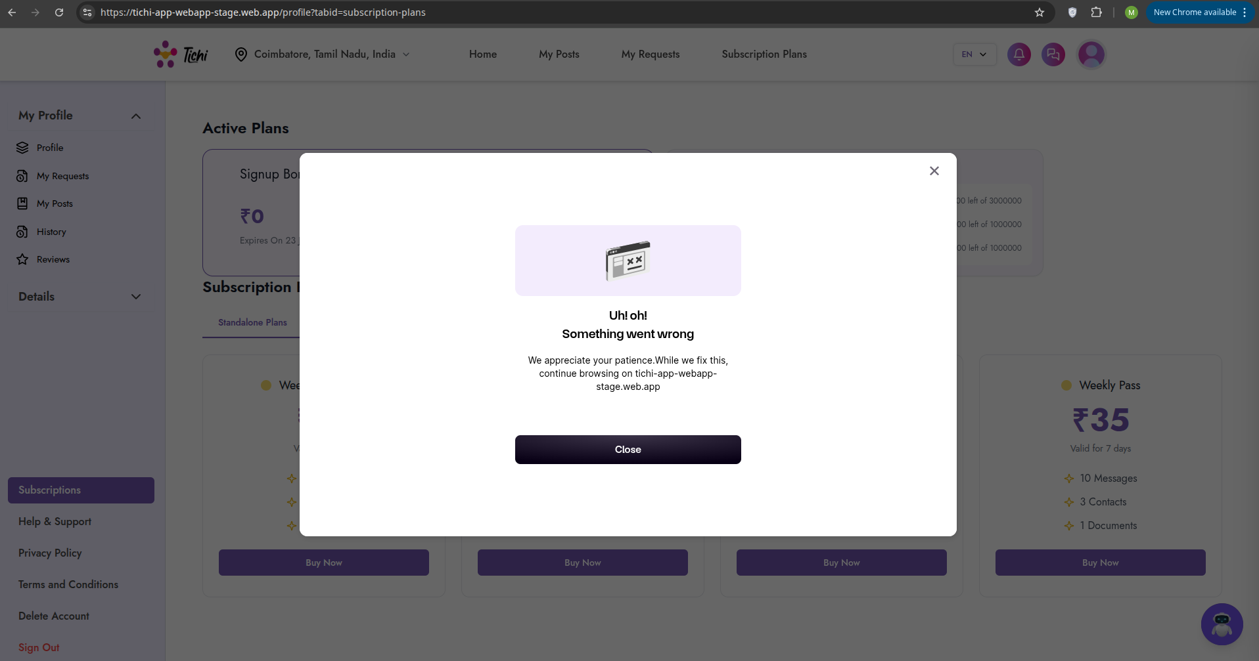

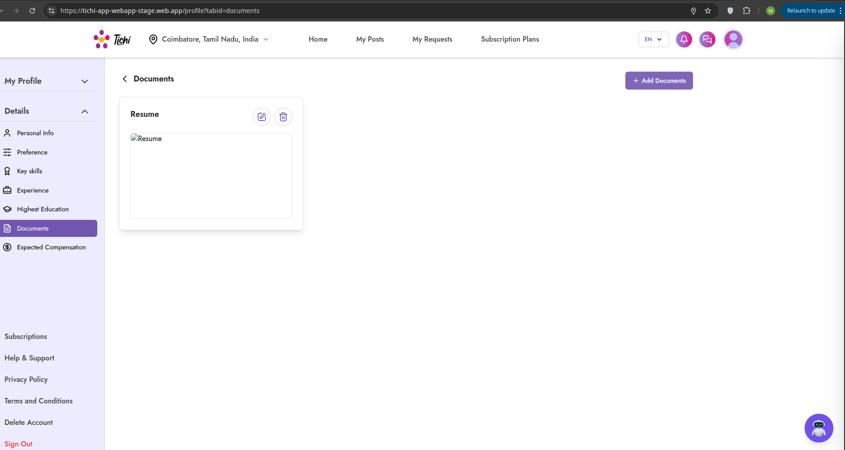
FUN-PM-007:

