Tichi Application - Overall Bug Report
Application: Tichi - Job Portal Web Application URL: https://tichi-app-webapp-stage.web.app Testing Period: April 27, 2026 - May 6, 2026 Tester: QA Team Report Date: May 7, 2026

Executive Summary
This report documents all bugs identified during manual and exploratory testing of the Tichi web application. A total of 20 bugs have been identified across various modules including Authentication, Profile Management, Job Posting, Subscription Plans, Chat System, and AI Features.

Bug Summary by Severity
Severity | Count | Percentage
Critical | 4 | 20%
High | 6 | 30%
Medium | 7 | 35%
Low | 3 | 15%
Total | 20 | 100%

Bug Summary by Module
Module | Count
Authentication & OTP | 3
Profile Management | 2
Job Posting | 3
Subscription Plans | 3
Chat System | 4
AI Features | 2
API/Network | 2
UI/UX | 1

Detailed Bug Reports

BUG-001: Blank Page on Application Load
Bug ID: BUG-001 Severity: Critical Priority: P1 Module: Application Core Status: Open Reported Date: April 27, 2026
Description: Application shows a completely blank page (about:blank) when attempting to load, indicating a critical failure in the application initialization.
Steps to Reproduce: 1. Open browser 2. Navigate to Tichi application URL 3. Observe blank page
Expected Result: Application should load with the home page or login screen.
Actual Result: Browser displays “about:blank” with no content loaded.
Screenshot: 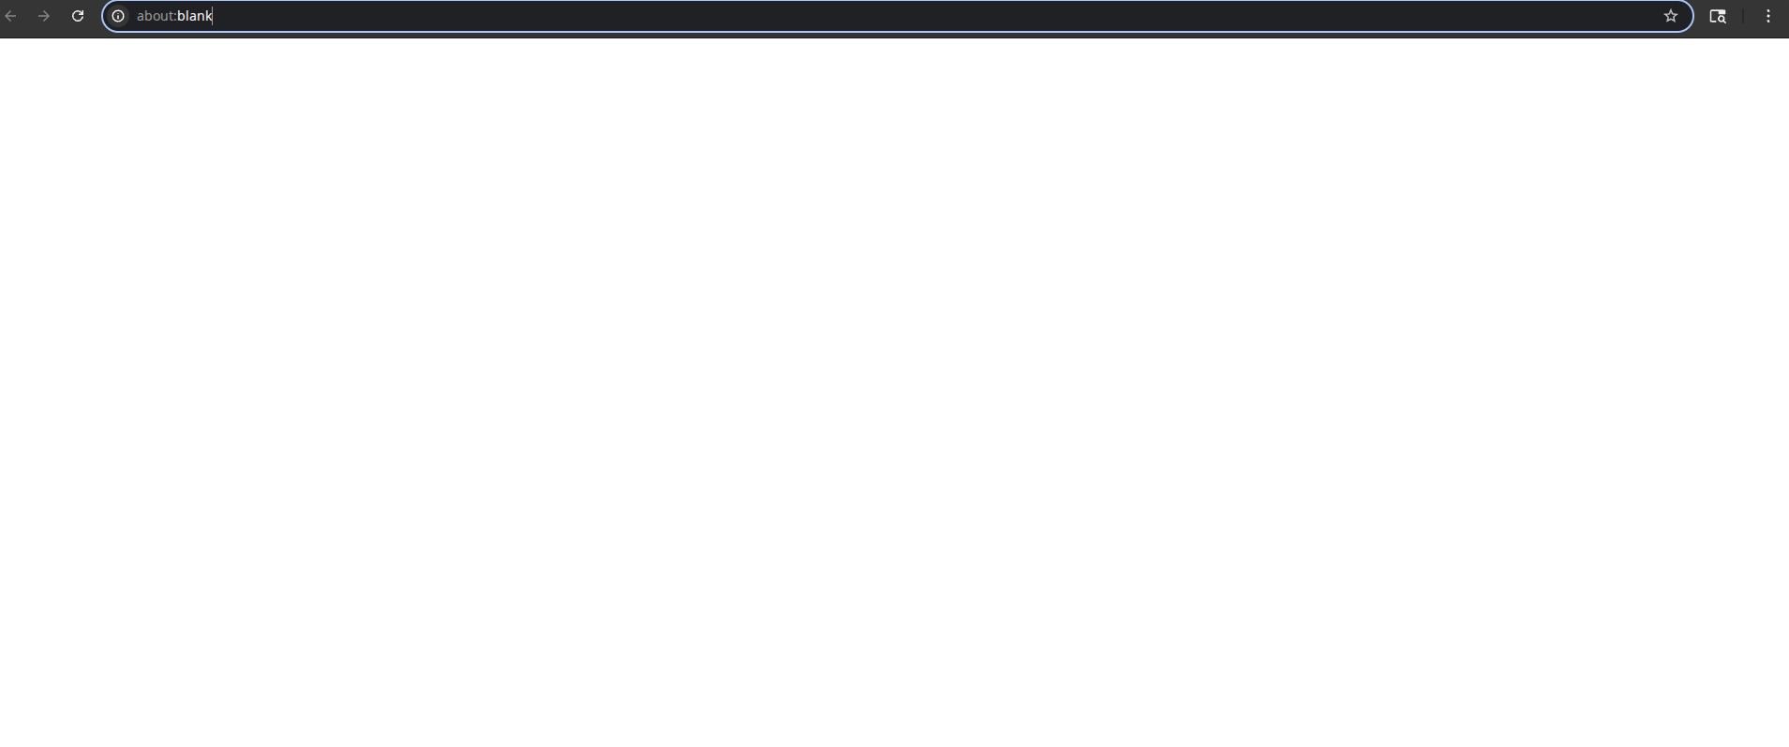
Impact: Users cannot access the application at all, resulting in complete service unavailability.

BUG-002: OTP Verification API Failure (401 Error)
Bug ID: BUG-002 Severity: Critical Priority: P1 Module: Authentication Status: Open Reported Date: April 29, 2026
Description: The send-otp API endpoint returns a 401 Unauthorized error during mobile number verification process, preventing users from completing profile verification.
Steps to Reproduce: 1. Login to Tichi application 2. Navigate to Profile settings 3. Attempt to verify mobile number 4. Enter mobile number and request OTP 5. Observe network tab for API response
Expected Result: OTP should be sent successfully to the provided mobile number.
Actual Result: API returns 401 error status. Network request to https://o0guf45zb8.execute-api.ap-south-1.amazonaws.com/qa/users/send-otp fails.
Screenshot: 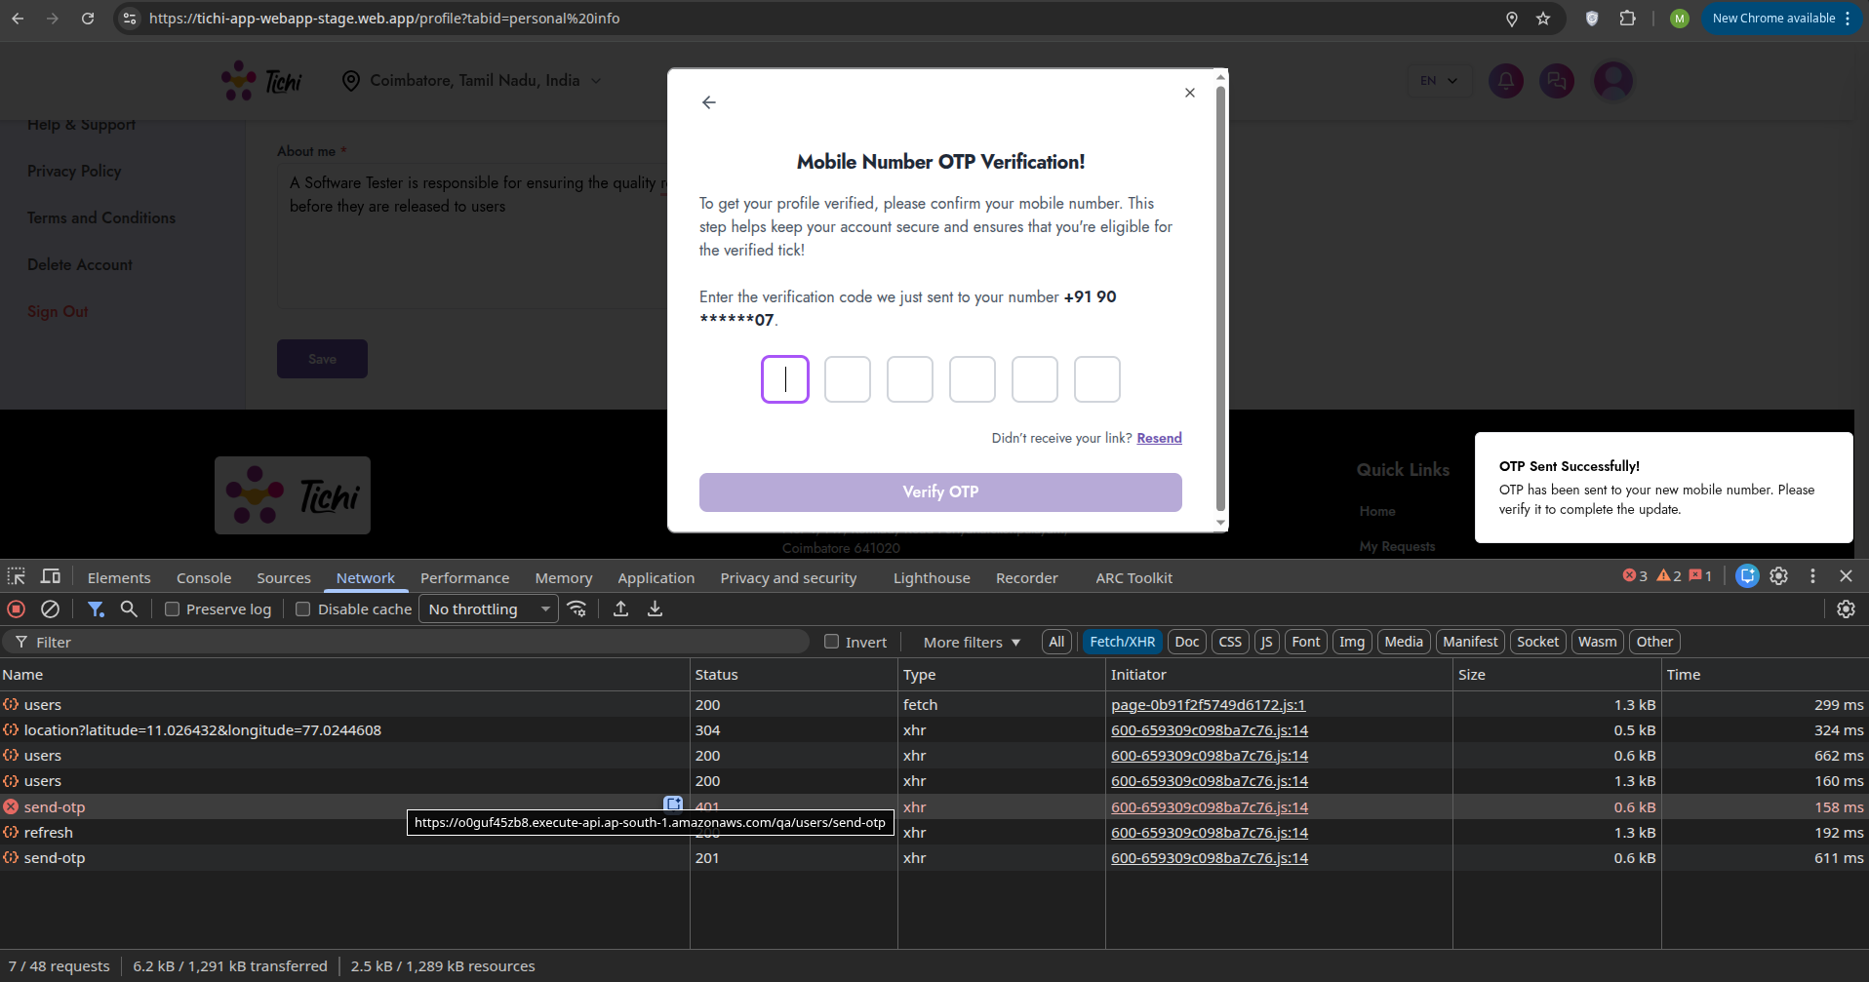
Technical Details: - Endpoint: /qa/users/send-otp - Status Code: 401 - Response Type: XHR
Impact: Users cannot verify their mobile numbers, blocking access to verified profile features.

BUG-003: Verify OTP API Returning 401 Error
Bug ID: BUG-003 Severity: Critical Priority: P1 Module: Authentication Status: Open Reported Date: April 29, 2026
Description: The verify-otp API endpoint returns 401 Unauthorized error when attempting to verify the OTP code.
Steps to Reproduce: 1. Request OTP for mobile verification 2. Enter the received OTP code 3. Click “Verify OTP” button 4. Observe network response
Expected Result: OTP should be verified and profile should be marked as verified.
Actual Result: API returns 401 error, verification fails.
Screenshot: 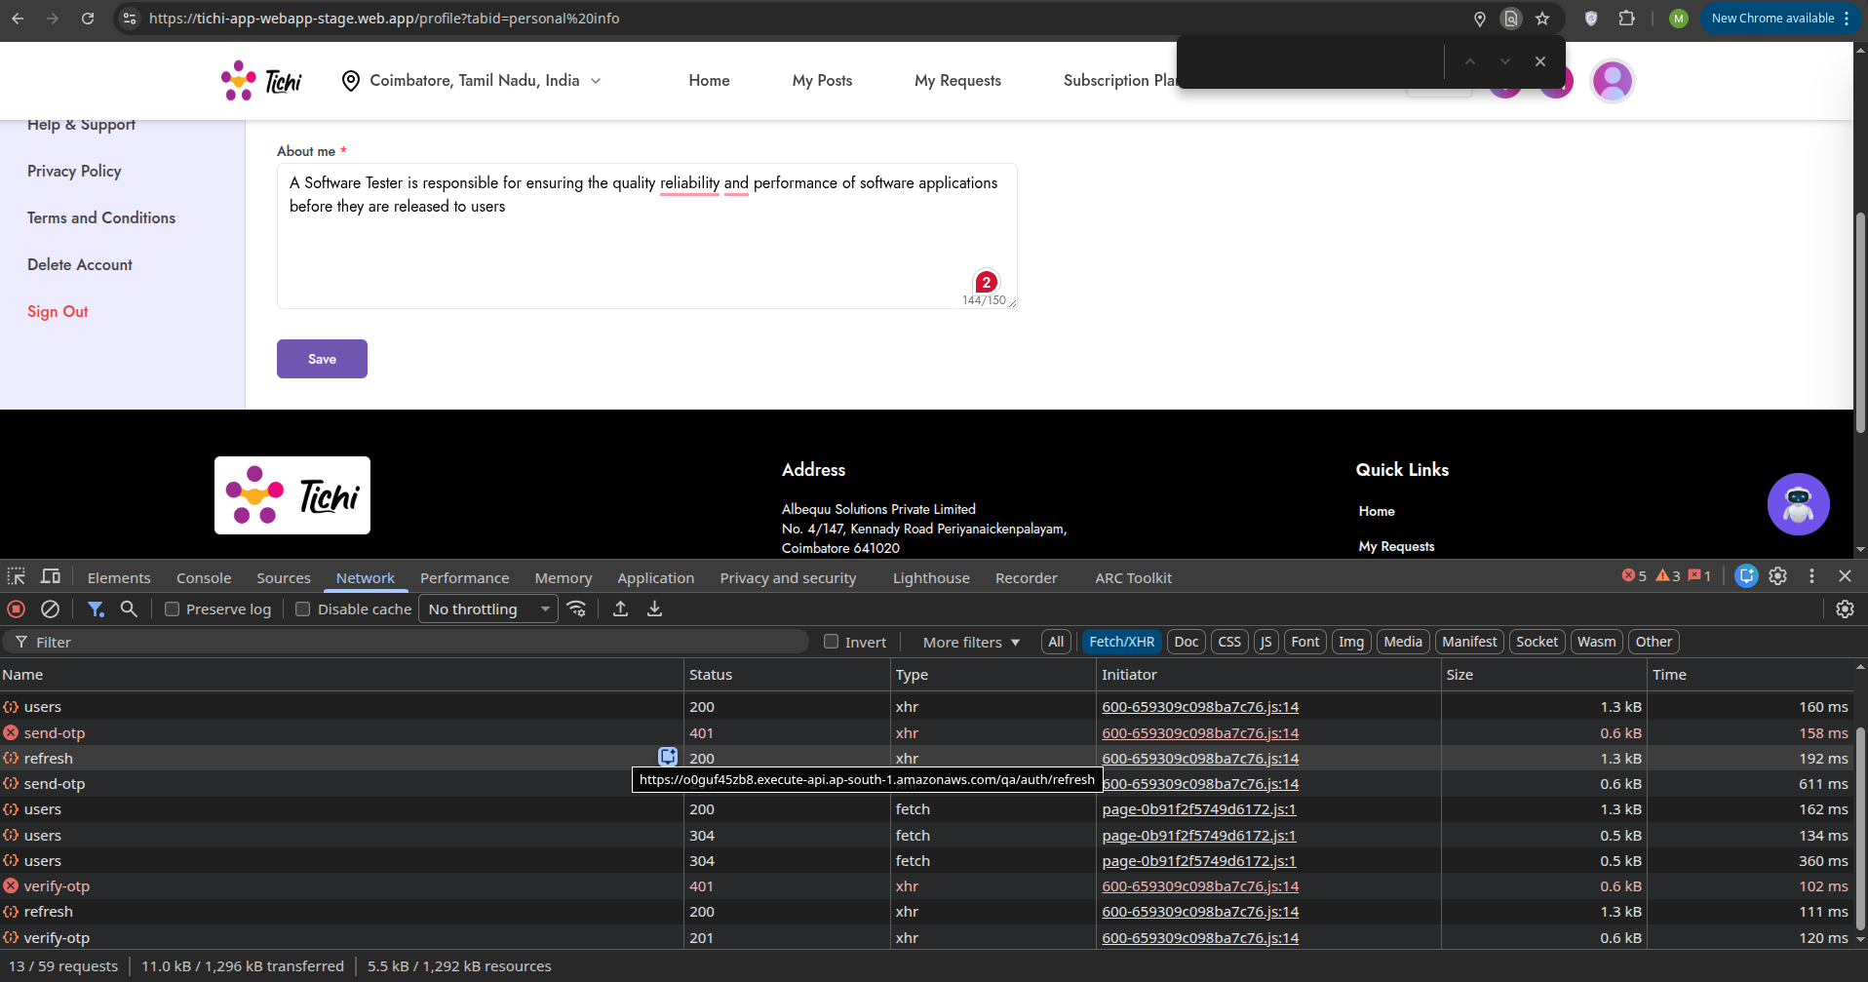
Impact: Users cannot complete the verification process even if they receive the OTP.

BUG-004: AI Generation Service Unavailable
Bug ID: BUG-004 Severity: High Priority: P2 Module: AI Features Status: Open Reported Date: April 29, 2026
Description: The AI Generate feature on the Create New Post page shows “AI Generation Failed - AI service is temporarily unavailable. Please try again later.”
Steps to Reproduce: 1. Login to Tichi application 2. Navigate to Create New Post page 3. Fill in basic job details (Title, Description) 4. Click “AI Generate” button 5. Observe error message
Expected Result: AI should generate job description content based on the input.
Actual Result: Error toast appears: “AI Generation Failed - AI service is temporarily unavailable. Please try again later.”
Screenshot: 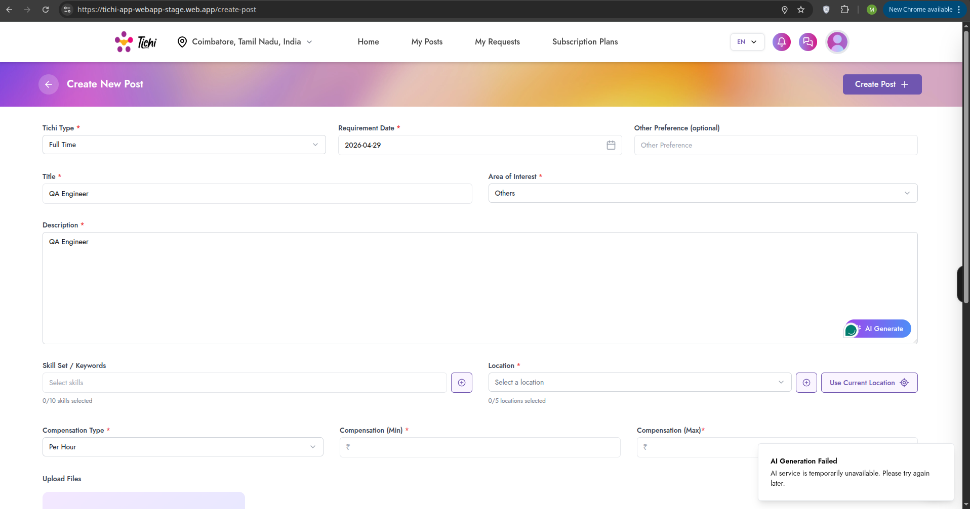
Impact: Users cannot utilize the AI-powered content generation feature, reducing the platform’s value proposition.

BUG-005: Description Field Validation Without AI
Bug ID: BUG-005 Severity: Medium Priority: P3 Module: Job Posting Status: Open Reported Date: April 29, 2026
Description: When AI generation fails, the Description field shows validation error “Please fill out this field” but the placeholder text provides misleading guidance about using AI Generate.
Steps to Reproduce: 1. Navigate to Create New Post 2. Leave Description empty 3. Attempt to submit 4. Observe validation message
Expected Result: Clear validation message without AI dependency.
Actual Result: Confusing user experience with AI reference when AI is unavailable.
Screenshot: 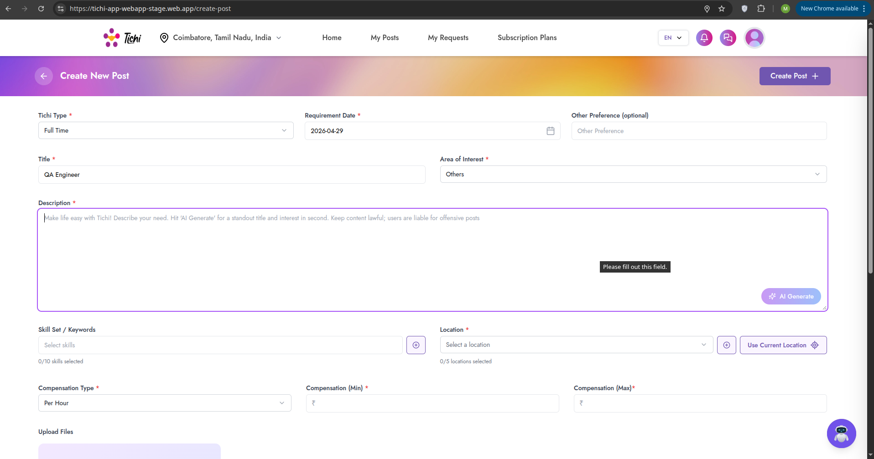
Impact: Poor user experience when AI features are unavailable.

BUG-006: Subscription Plans - “Something Went Wrong” Error
Bug ID: BUG-006 Severity: High Priority: P2 Module: Subscription Plans Status: Open Reported Date: April 29, 2026
Description: When attempting to purchase or interact with subscription plans, a generic error modal appears: “Uh! oh! Something went wrong - We appreciate your patience. While we fix this, continue browsing on tichi-app-webapp-stage.web.app”
Steps to Reproduce: 1. Login to Tichi application 2. Navigate to Subscription Plans page 3. Click on any “Buy Now” button 4. Observe error modal
Expected Result: Payment/subscription flow should proceed normally.
Actual Result: Generic error modal appears blocking the transaction.
Screenshot: 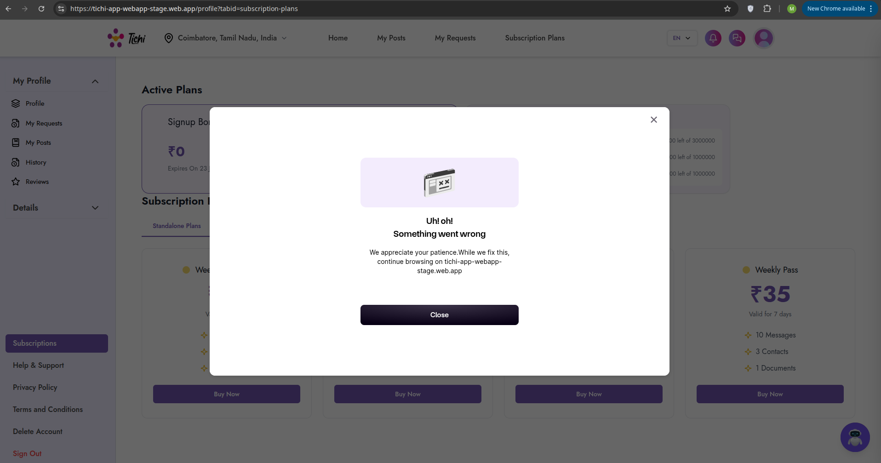
Impact: Users cannot purchase subscription plans, directly affecting revenue.

BUG-007: Subscription Plans Error (Repeated)
Bug ID: BUG-007 Severity: High Priority: P2 Module: Subscription Plans Status: Open Reported Date: May 3, 2026
Description: Same “Something went wrong” error persists on subscription plans page with payment failure message visible.
Steps to Reproduce: 1. Navigate to Subscription Plans 2. Attempt any subscription action 3. Observe error
Expected Result: Subscription functionality should work properly.
Actual Result: Error modal with “Payment Failed - Order amount less than minimum amount allowed” message visible.
Screenshot: 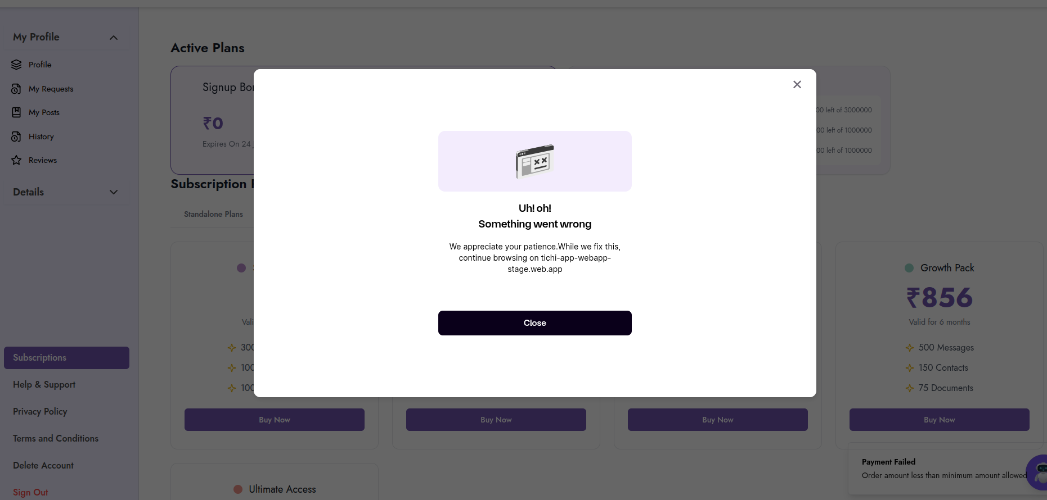
Impact: Continued revenue loss due to broken subscription flow.

BUG-008: Profile Page - Incomplete User Information Display
Bug ID: BUG-008 Severity: Low Priority: P4 Module: Profile Management Status: Open Reported Date: May 3, 2026
Description: Profile page displays user information but the “About me” description appears truncated and the “Get Verified” prompt is always visible regardless of verification status.
Steps to Reproduce: 1. Login to Tichi 2. Navigate to Profile page 3. Observe profile information display
Expected Result: Complete profile information displayed with proper verification status.
Actual Result: Truncated about section and persistent verification prompt.
Screenshot: 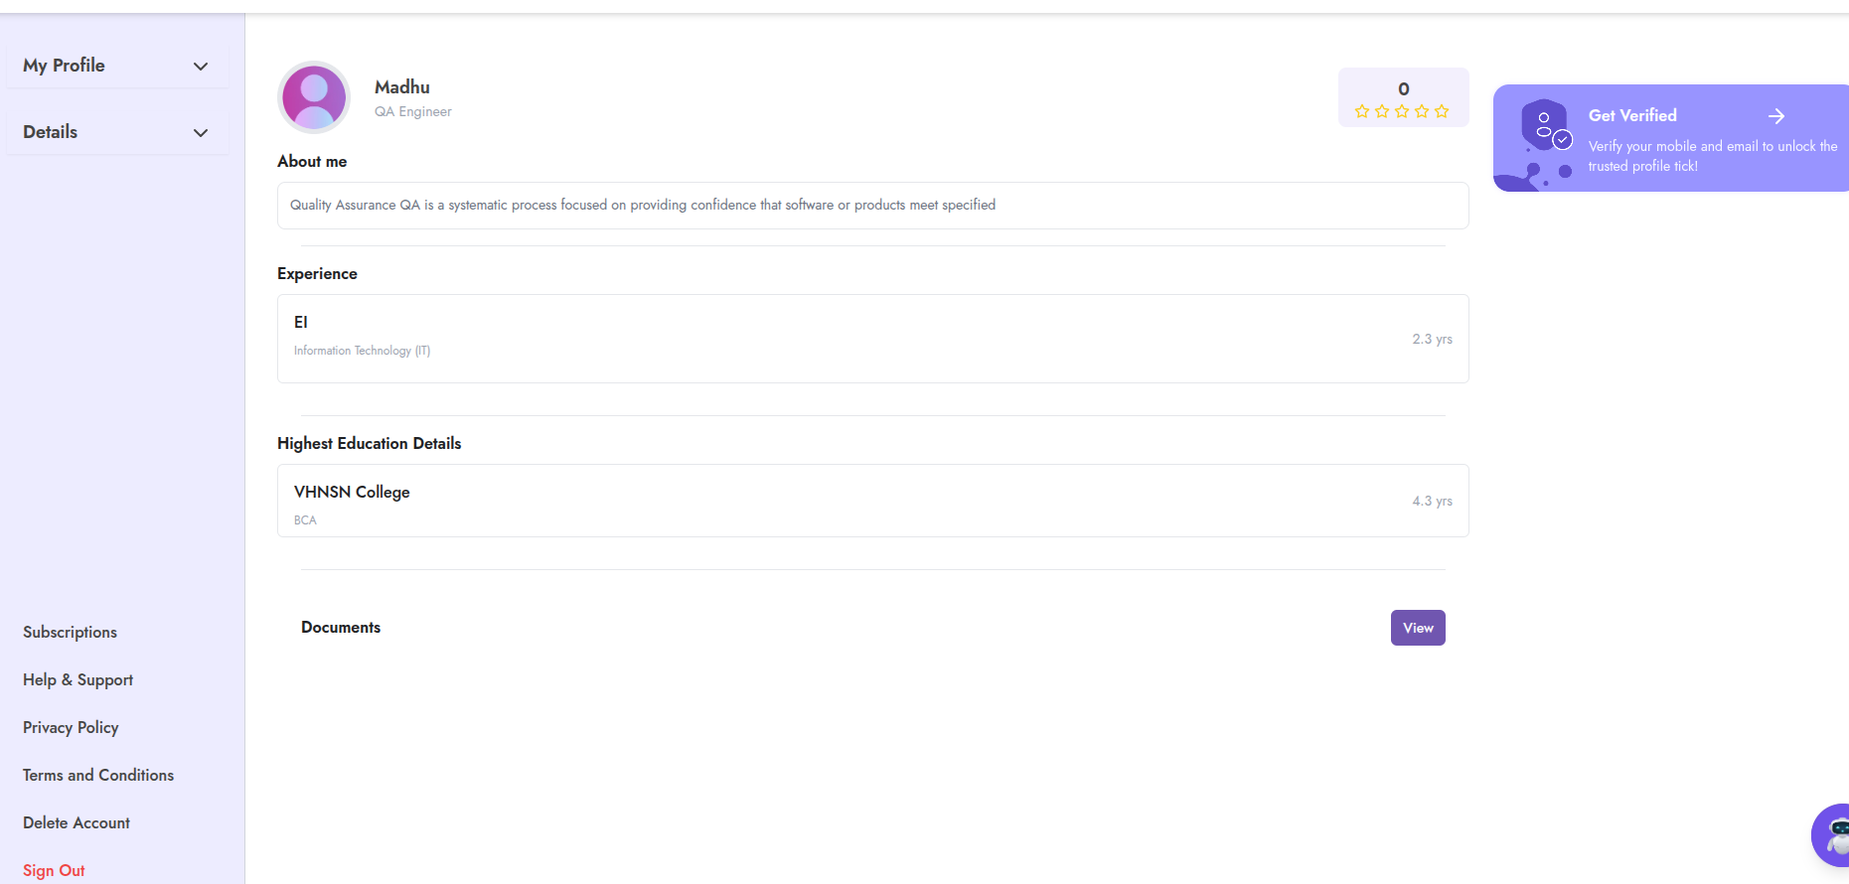
Impact: Minor UX issue affecting profile presentation.

BUG-009: SSL Certificate Information Exposure in Dev Tools
Bug ID: BUG-009 Severity: Low Priority: P4 Module: Security Status: Open Reported Date: May 4, 2026
Description: Certificate viewer shows detailed SSL certificate information which may expose unnecessary technical details.
Steps to Reproduce: 1. Open Tichi application 2. Open browser dev tools 3. View Security tab or certificate details 4. Observe certificate hierarchy information
Expected Result: Standard certificate information only.
Actual Result: Detailed certificate fields visible including Certificate Key Usage, Extended Key Usage, etc.
Screenshot: 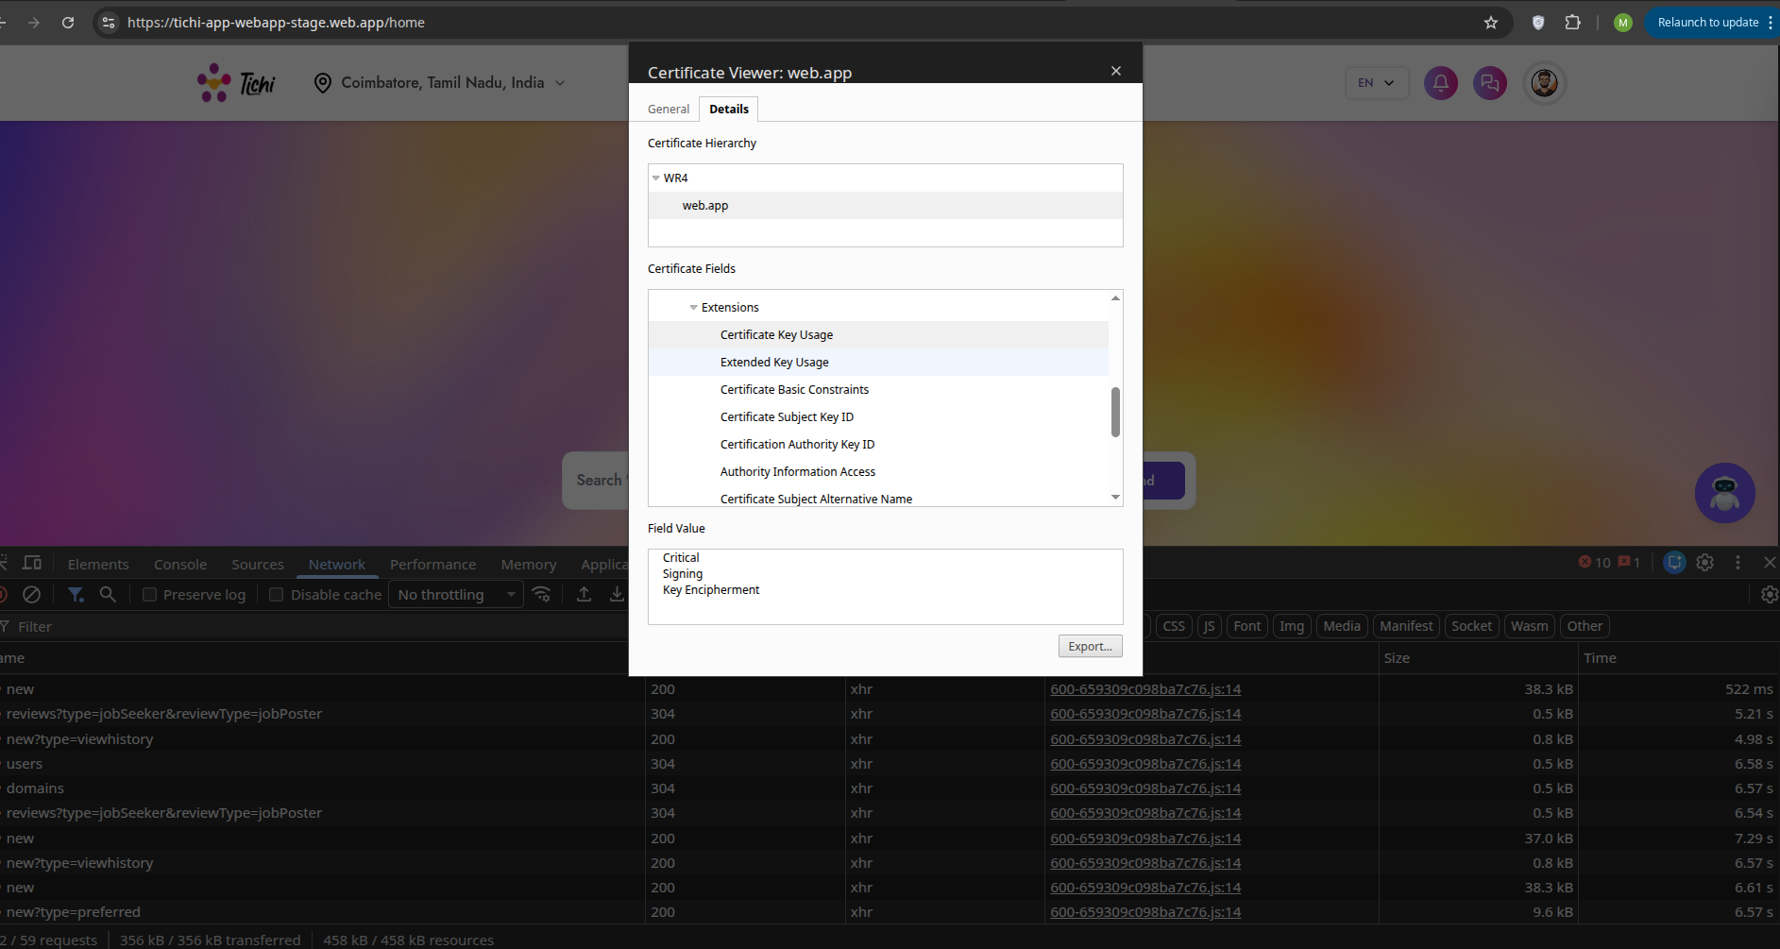
Impact: Minor security information exposure (informational).

BUG-010: Sign Out Confirmation Modal UX Issue
Bug ID: BUG-010 Severity: Low Priority: P4 Module: UI/UX Status: Open Reported Date: May 4, 2026
Description: Sign out confirmation modal appears but the design could be improved for better user experience.
Steps to Reproduce: 1. Login to Tichi 2. Click “Sign Out” option 3. Observe confirmation modal
Expected Result: Clean, intuitive sign out confirmation.
Actual Result: Modal functions but design could be improved.
Screenshot: 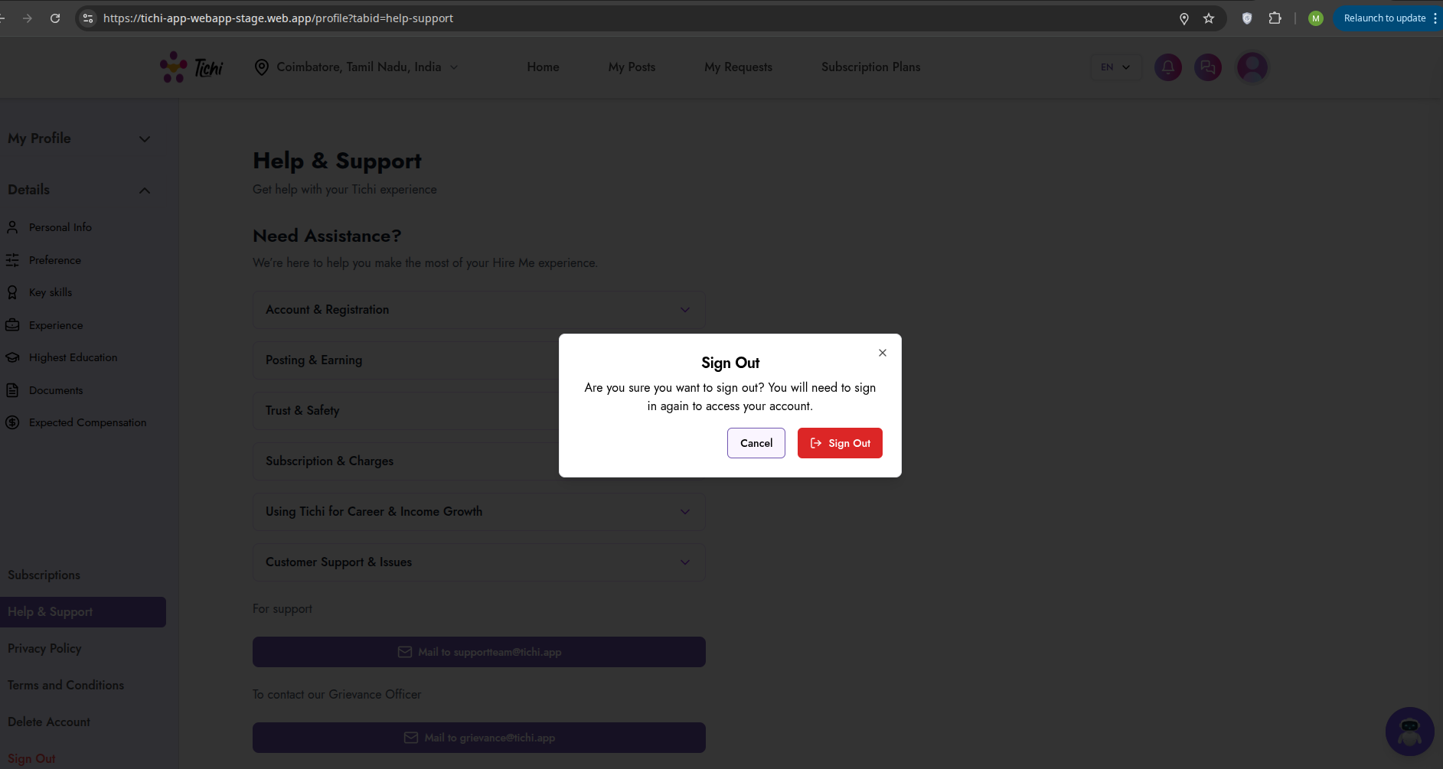
Impact: Minor UX improvement opportunity.

BUG-011: Documents Section - Broken Image Display
Bug ID: BUG-011 Severity: Medium Priority: P3 Module: Profile Management Status: Open Reported Date: May 4, 2026
Description: In the Documents section, uploaded resume shows as broken image placeholder “:Resume” instead of proper document preview or icon.
Steps to Reproduce: 1. Login to Tichi 2. Navigate to Profile > Documents 3. Observe uploaded documents display
Expected Result: Documents should display with proper icons or previews.
Actual Result: Broken image placeholder with “:Resume” text visible.
Screenshot: 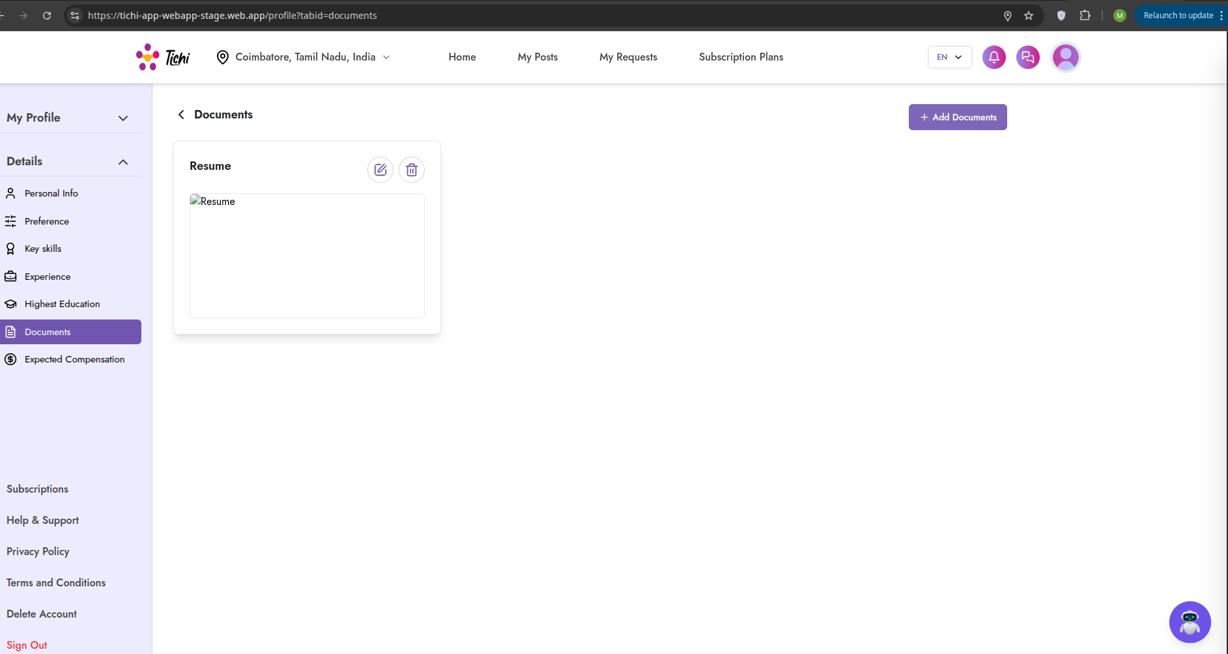
Impact: Users cannot preview their uploaded documents properly.

BUG-012: Tichi Bot - Network Error
Bug ID: BUG-012 Severity: High Priority: P2 Module: Chat System Status: Open Reported Date: May 4, 2026
Description: The Tichi Bot chatbot shows “Network Error” when attempting to interact with it.
Steps to Reproduce: 1. Login to Tichi 2. Click on Chat or Tichi Bot icon 3. Type a message (e.g., “Can you Explain me about this job”) 4. Observe Network Error response
Expected Result: Bot should respond with helpful information.
Actual Result: “Network Error” message appears in chat.
Screenshot: 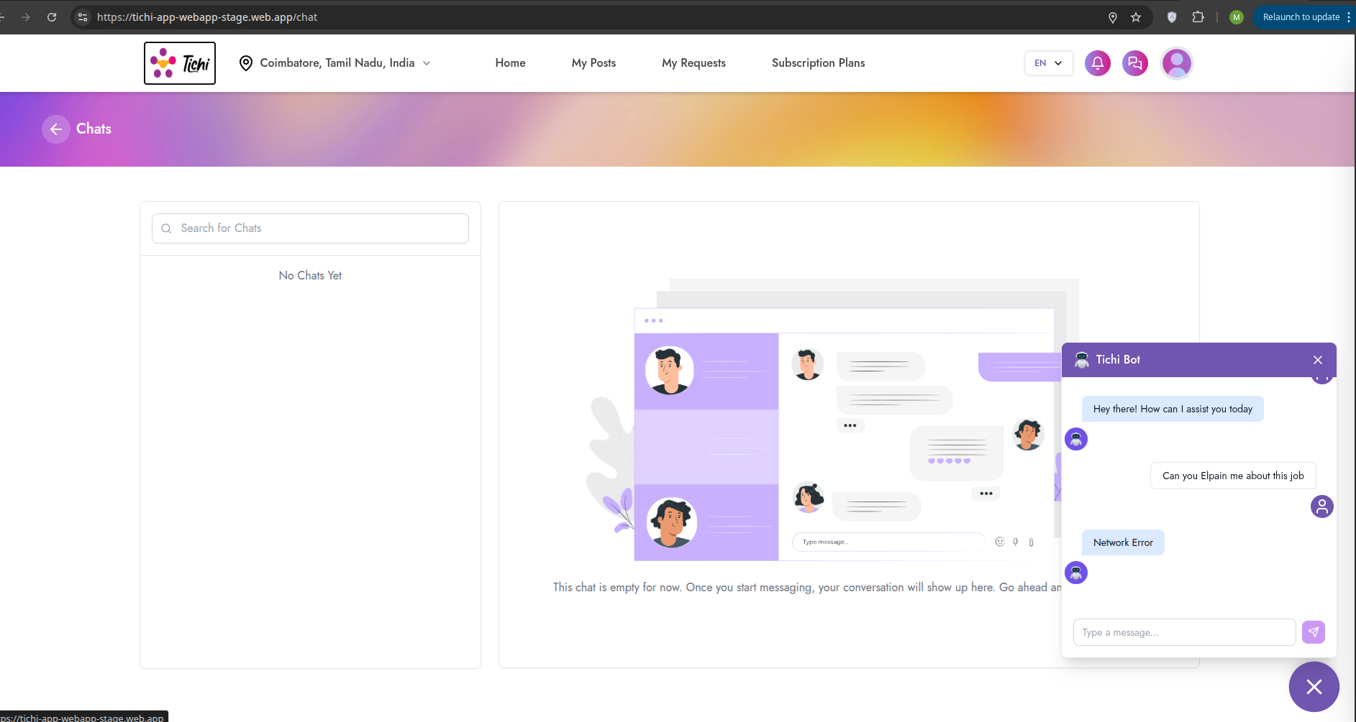
Impact: AI assistant feature completely non-functional.

BUG-013: Login Page - “Something Went Wrong” Error
Bug ID: BUG-013 Severity: Critical Priority: P1 Module: Authentication Status: Open Reported Date: May 4, 2026
Description: Login page displays “Something went wrong. Please try again.” error message with console showing ERR_FAILED network errors.
Steps to Reproduce: 1. Navigate to Tichi login page 2. Enter email address 3. Click Continue 4. Observe error message
Expected Result: Login flow should proceed to OTP/password entry.
Actual Result: Error message displayed, network requests failing with ERR_FAILED.
Screenshot: 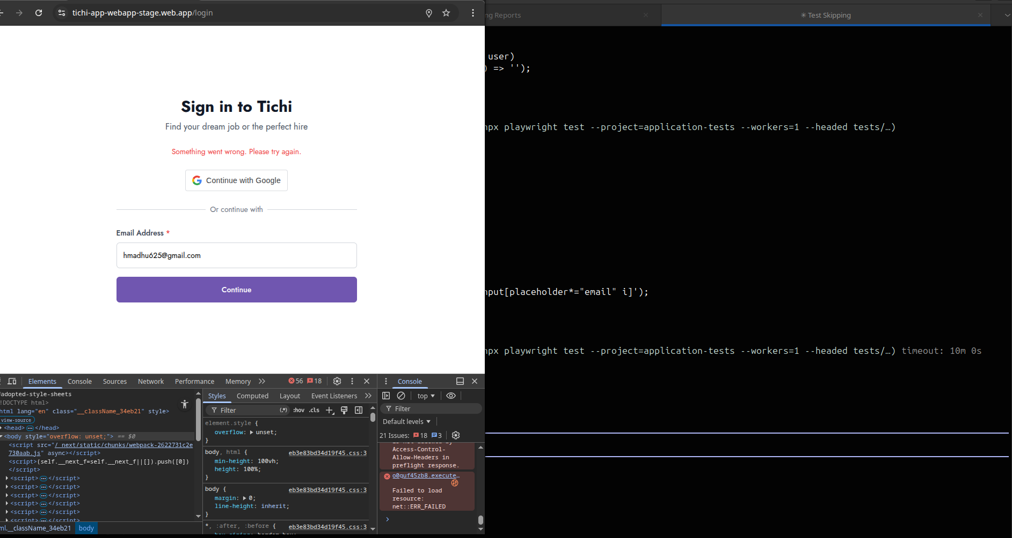
Technical Details: - Console shows: net::ERR_FAILED - Multiple API calls failing - CORS policy errors visible
Impact: Users cannot login to the application.

BUG-014: Job Post - Title Field Accepts Excessive Gibberish Text
Bug ID: BUG-014 Severity: Medium Priority: P3 Module: Job Posting Status: Open Reported Date: May 5, 2026
Description: Job posting allows creation with nonsensical/gibberish titles without proper validation, resulting in spam-like content visible to all users.
Steps to Reproduce: 1. Login to Tichi 2. Create a new job post 3. Enter random characters as title (e.g., “adfadfafadfadfafa…”) 4. Submit the post 5. View the published post
Expected Result: Validation should prevent meaningless content or flag for review.
Actual Result: Post created with gibberish title displayed publicly.
Screenshot: 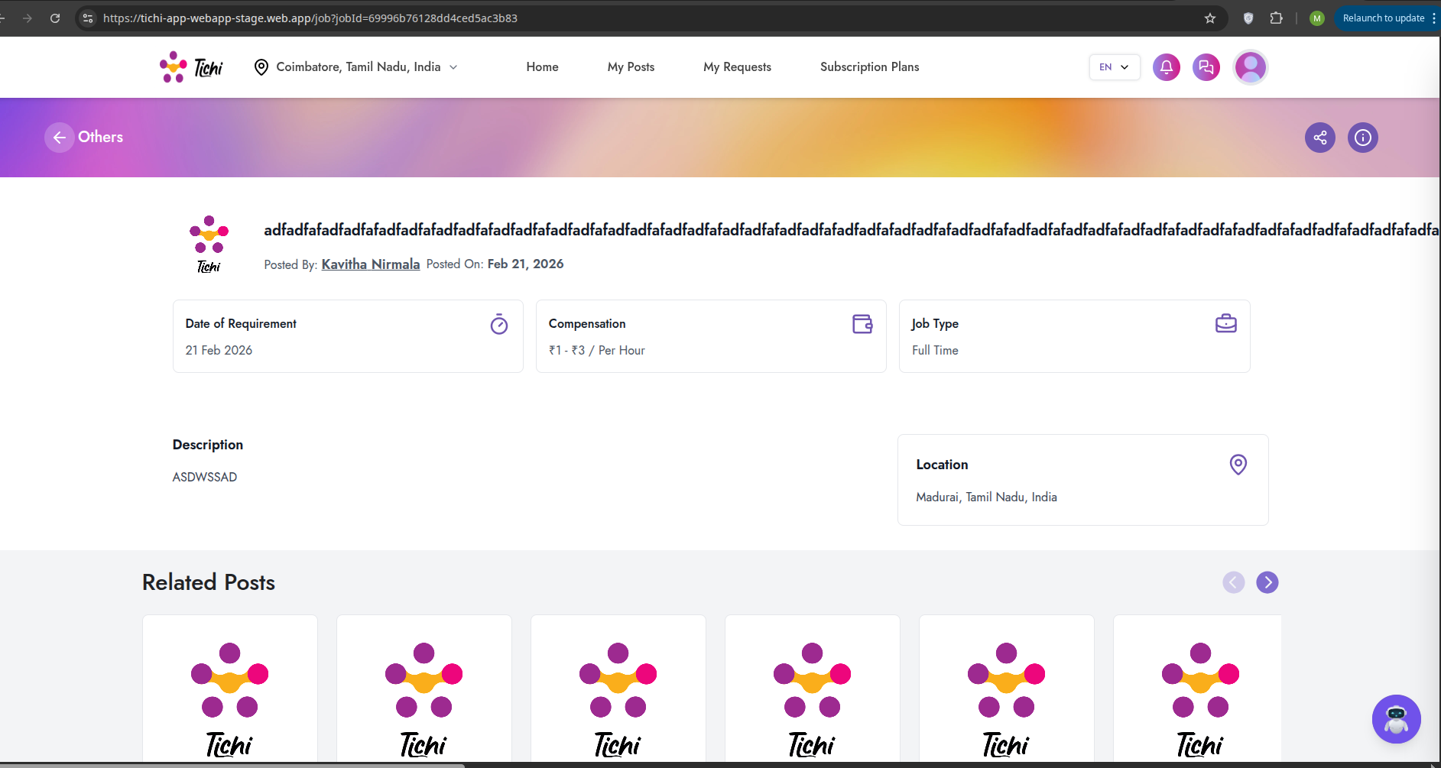
Impact: Poor content quality, potential for spam, degrades platform credibility.

BUG-015: Job Listing - Inconsistent Date Formats
Bug ID: BUG-015 Severity: Medium Priority: P3 Module: Job Posting Status: Open Reported Date: May 5, 2026
Description: Job listings show dates in different formats (some show “Feb 12, 2026” while others show different formats), creating inconsistent user experience.
Steps to Reproduce: 1. Navigate to Job listings page 2. Compare date formats across different listings 3. Observe inconsistencies
Expected Result: All dates should follow consistent format.
Actual Result: Mixed date formats across listings.
Screenshot: 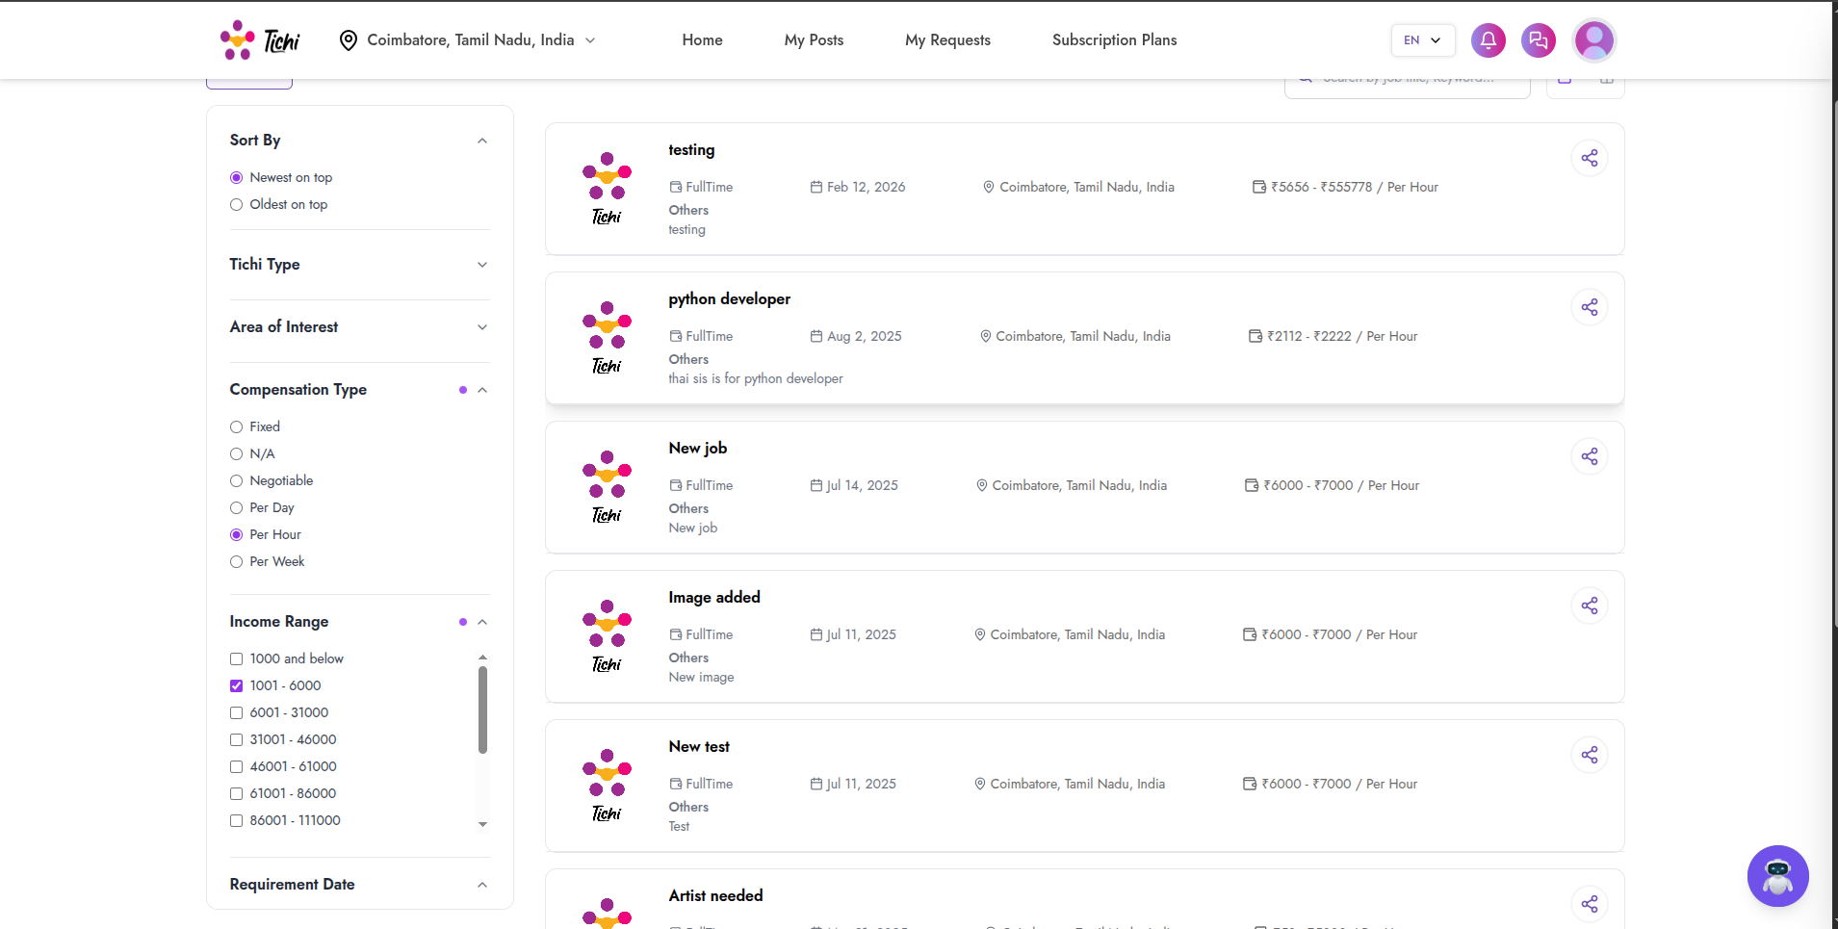
Impact: Minor UX issue but affects professional appearance.

BUG-016: Create Post - Date Picker Format Issue
Bug ID: BUG-016 Severity: Medium Priority: P3 Module: Job Posting Status: Open Reported Date: May 5, 2026
Description: Date picker on Create New Post shows placeholder “dd-mm-yyyy” format but actual selected date shows different format (2026-05-05).
Steps to Reproduce: 1. Navigate to Create New Post 2. Click on Requirement Date field 3. Select a date 4. Observe format mismatch
Expected Result: Consistent date format throughout.
Actual Result: Placeholder shows “dd-mm-yyyy” but selected value shows “yyyy-mm-dd”.
Screenshots: 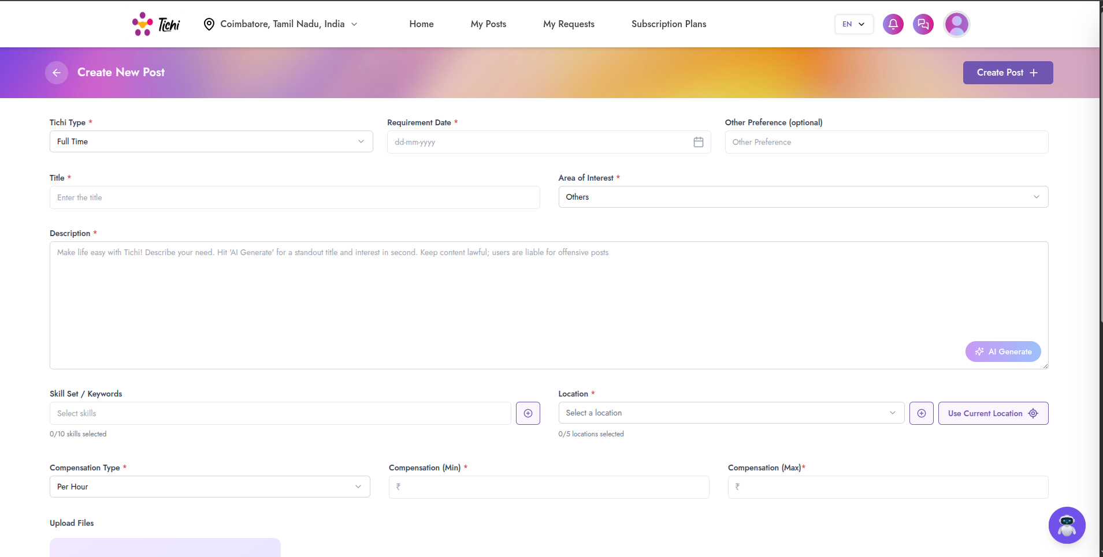 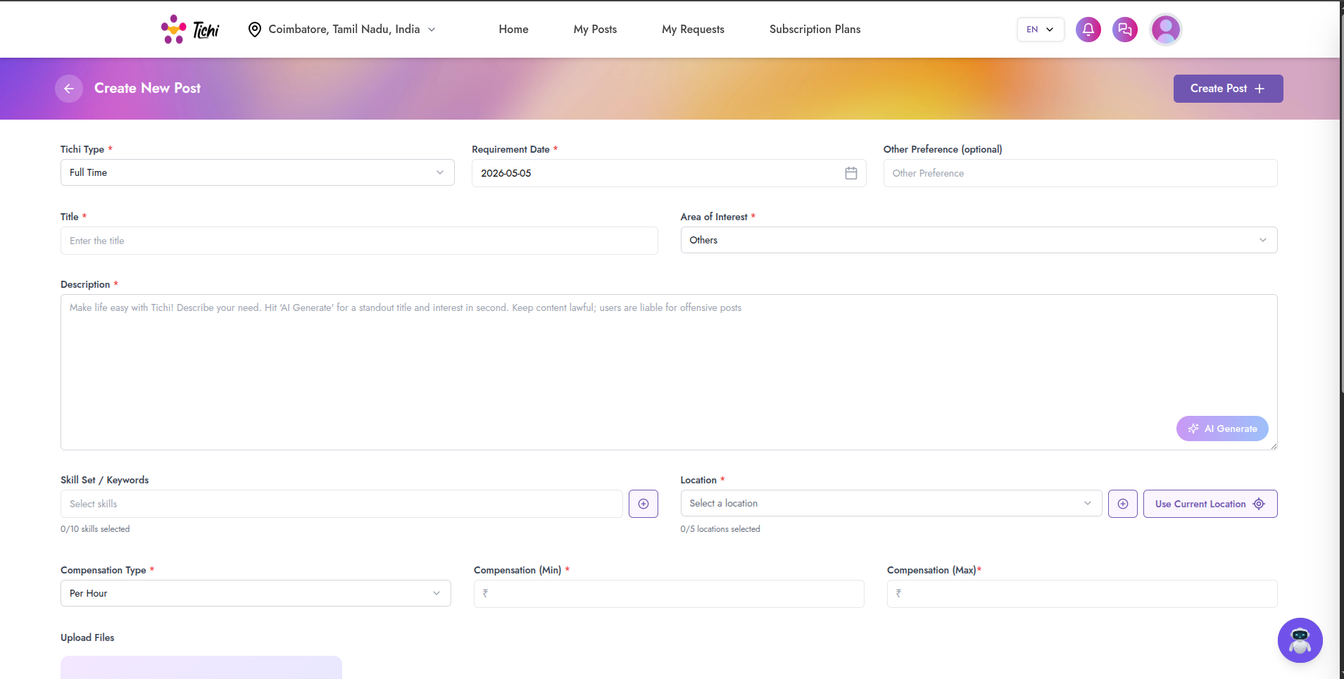
Impact: User confusion about expected date format.

BUG-017: Chat Connection Error - Failed to Connect to Chat Server
Bug ID: BUG-017 Severity: High Priority: P2 Module: Chat System Status: Open Reported Date: May 6, 2026
Description: Chat feature shows “Connection Error - Failed to connect to chat server. Please check your internet connection and try again.” even with stable internet connection.
Steps to Reproduce: 1. Login to Tichi 2. Navigate to Chats section 3. Select a contact (e.g., “Allwin Martin”) 4. Observe connection error
Expected Result: Chat should connect and allow messaging.
Actual Result: Connection Error popup appears, chat shows “Connecting…” status indefinitely.
Screenshots: 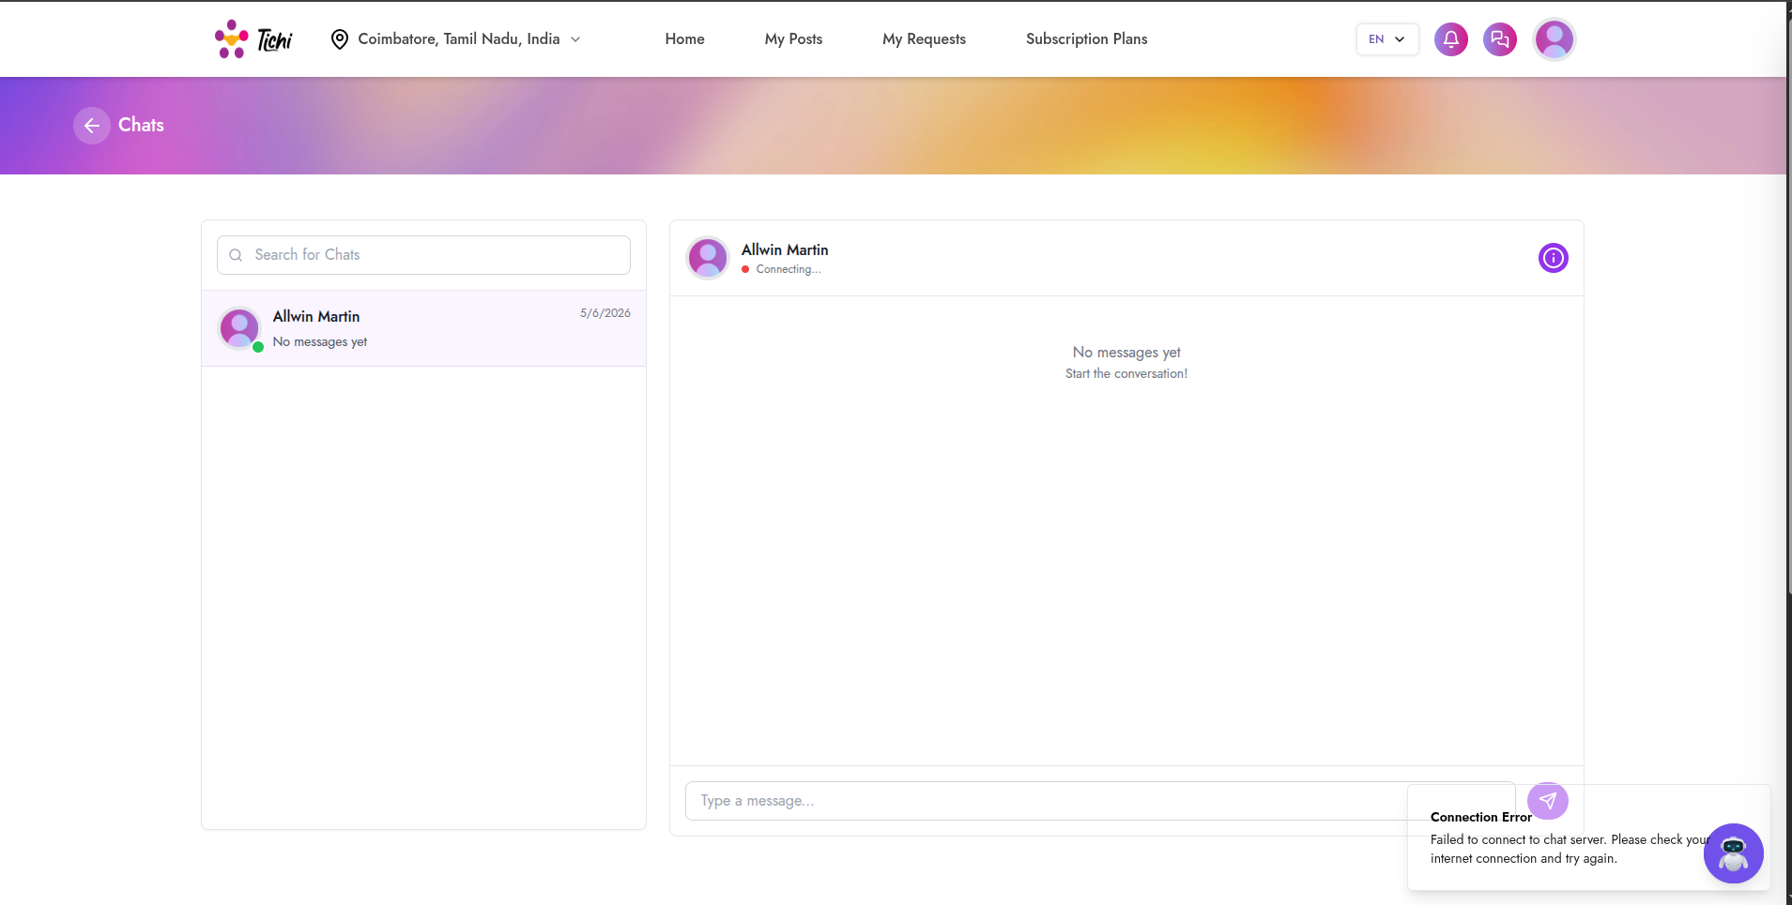 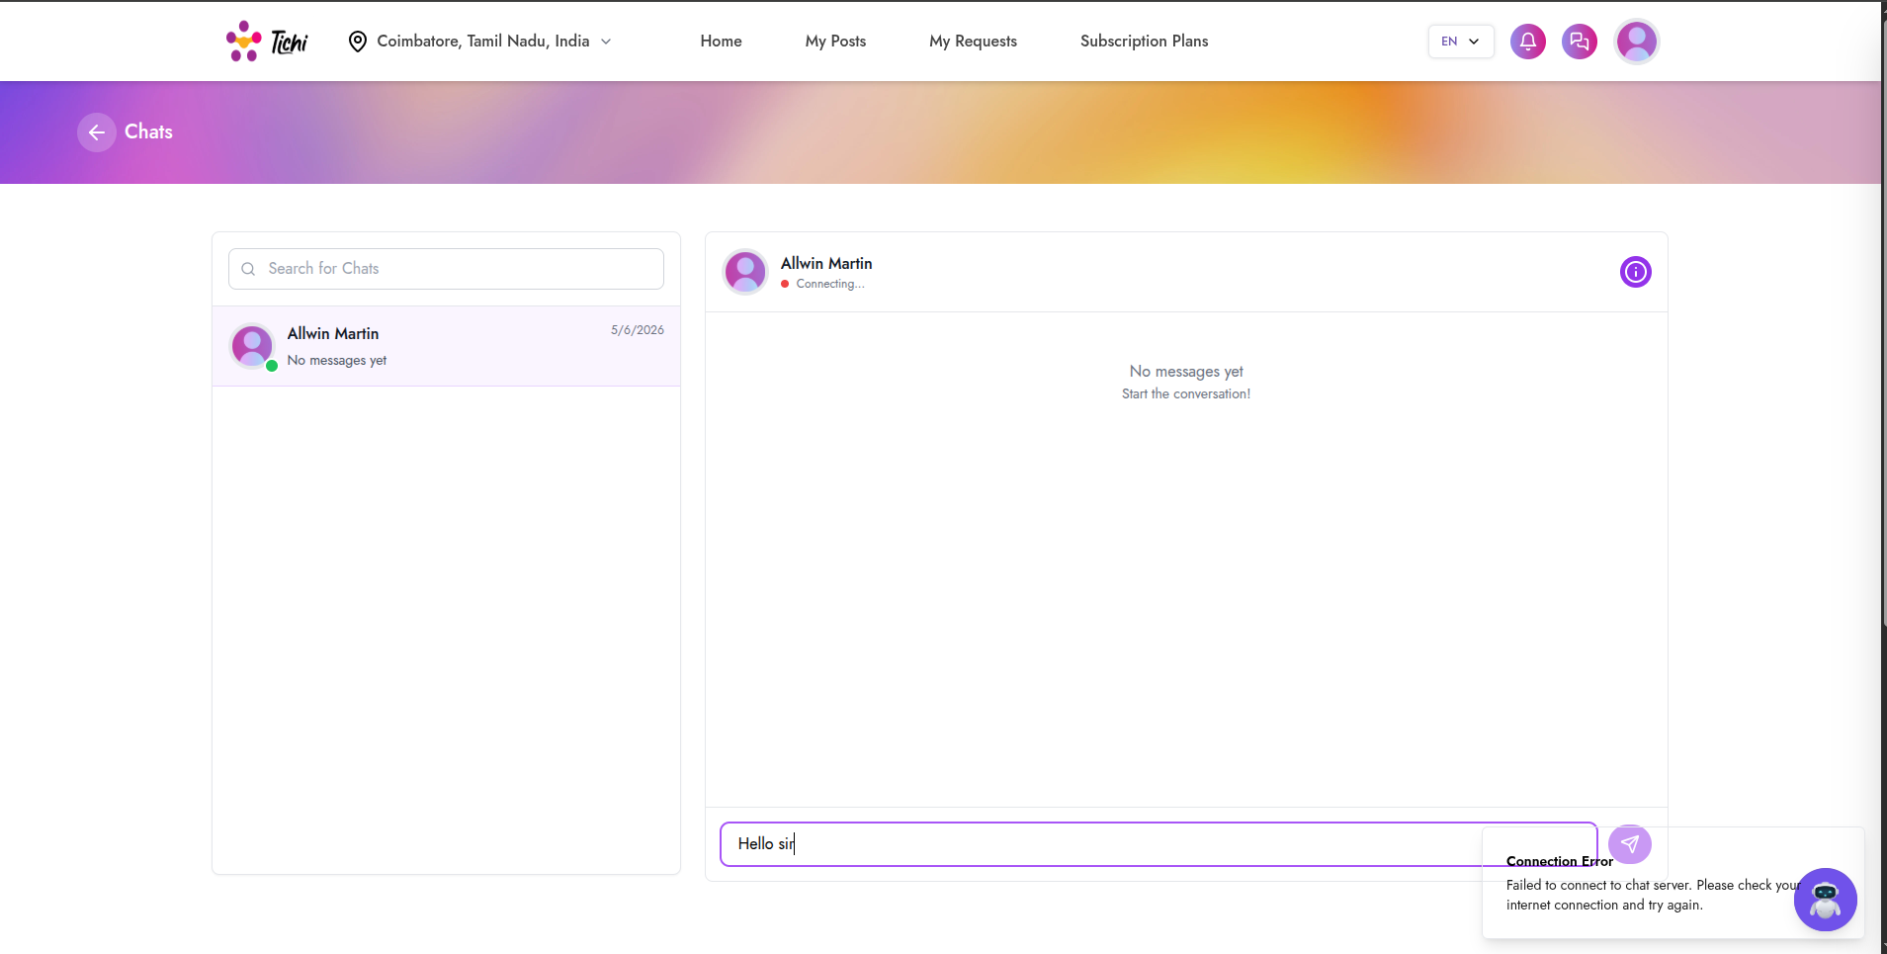
Impact: Users cannot communicate through the platform’s chat feature.

BUG-018: My Requests - CORS Policy Error & No Posts Found
Bug ID: BUG-018 Severity: High Priority: P2 Module: API/Network Status: Open Reported Date: May 6, 2026
Description: My Requests page shows “No posts found” with multiple CORS policy errors in console. The API requests are being blocked due to missing Access-Control-Allow-Headers.
Steps to Reproduce: 1. Login to Tichi 2. Navigate to My Requests 3. Open browser console 4. Observe CORS errors
Expected Result: User’s requests should be displayed properly.
Actual Result: “No posts found” message with CORS errors: - Access-Control-Allow-Headers in preflight response - net::ERR_FAILED errors
Screenshot: 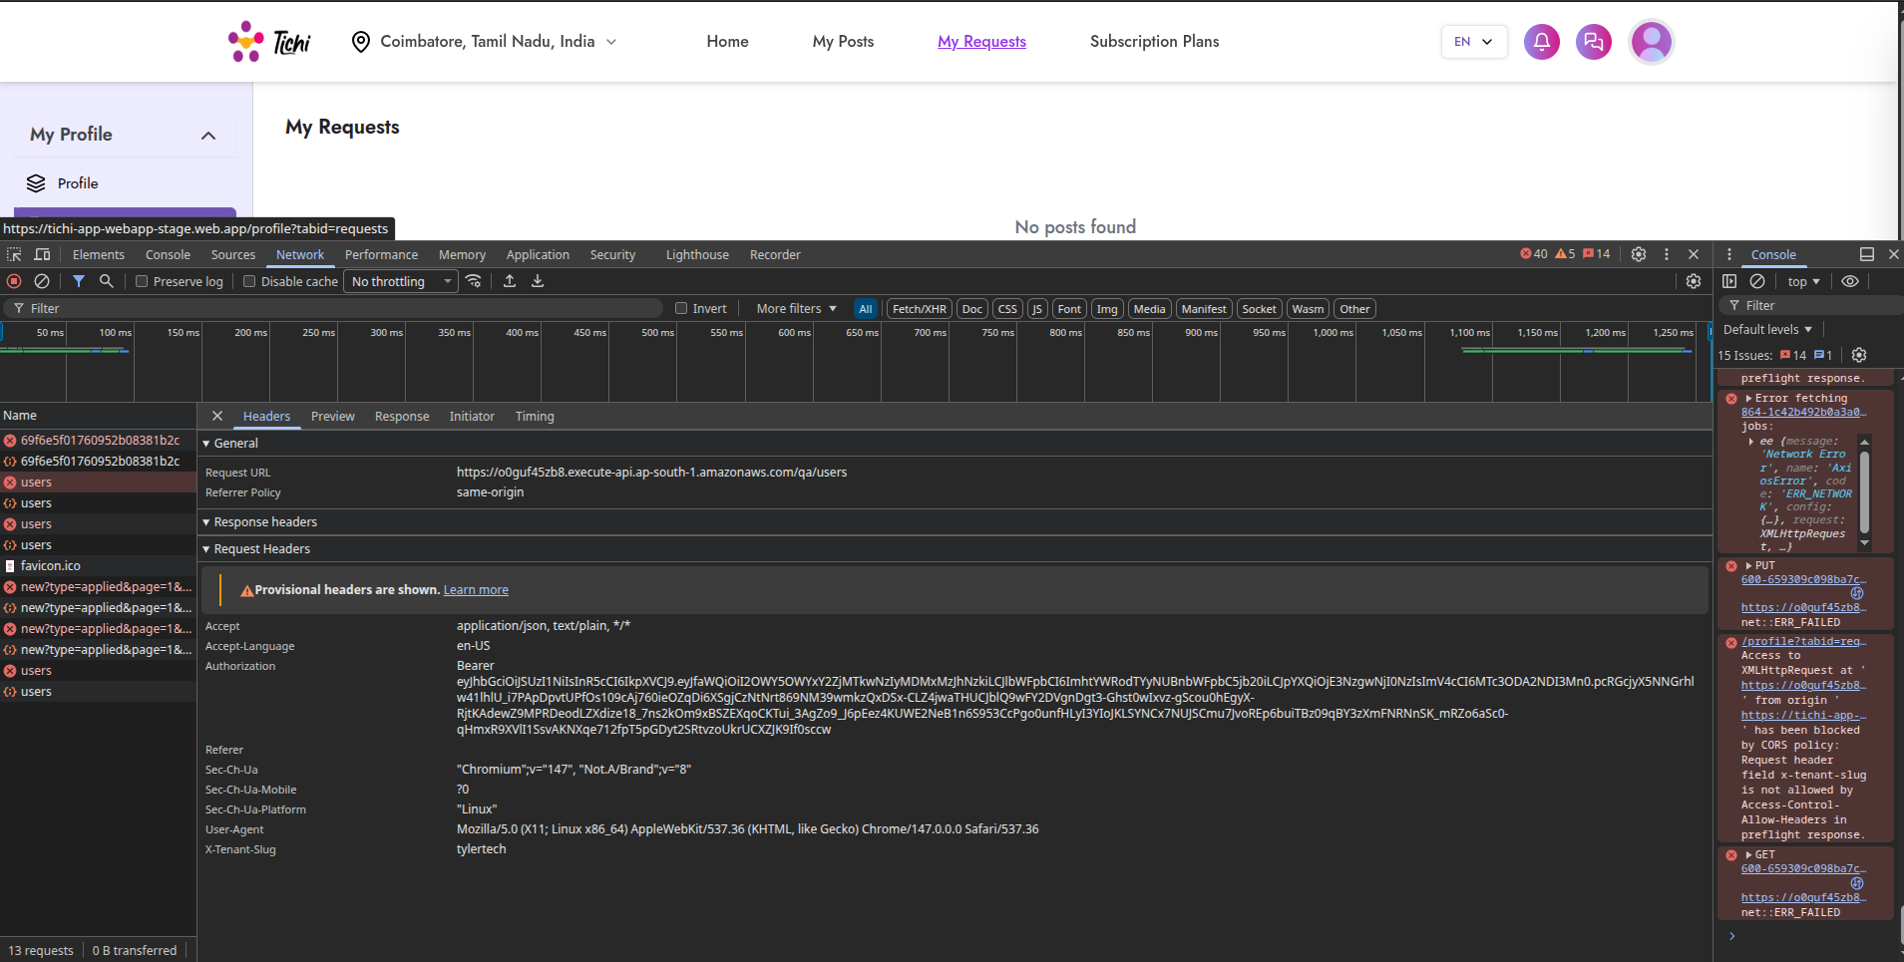
Technical Details: - Request header x-tenant-slug is not allowed by Access-Control-Allow-Headers in preflight response - Multiple API endpoints affected
Impact: Critical functionality broken, users cannot view their requests.

BUG-019: Chat Connection Error (Different User)
Bug ID: BUG-019 Severity: High Priority: P2 Module: Chat System Status: Open Reported Date: May 6, 2026
Description: Chat connection error persists when trying to chat with different users (Paramesh), indicating a systemic issue with the chat service.
Steps to Reproduce: 1. Navigate to Chats 2. Select different user “Paramesh” 3. Try to send message “hi” 4. Observe connection error
Expected Result: Chat should connect successfully.
Actual Result: Same “Connection Error - Failed to connect to chat server” message appears.
Screenshot: 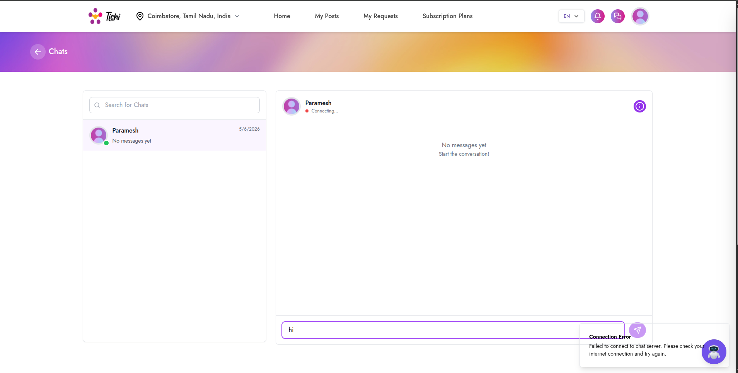
Impact: Complete chat functionality failure across all users.

BUG-020: Profile Incomplete Notification Overlaps UI
Bug ID: BUG-020 Severity: Medium Priority: P3 Module: UI/UX Status: Open Reported Date: April 29, 2026
Description: The “Profile Incomplete” notification popup overlaps with other UI elements and the chat bot icon, creating visual clutter.
Steps to Reproduce: 1. Login with incomplete profile 2. Navigate to any page 3. Observe notification popup position
Expected Result: Notification should be positioned without overlapping other elements.
Actual Result: Notification overlaps with chat bot icon.
Screenshot: 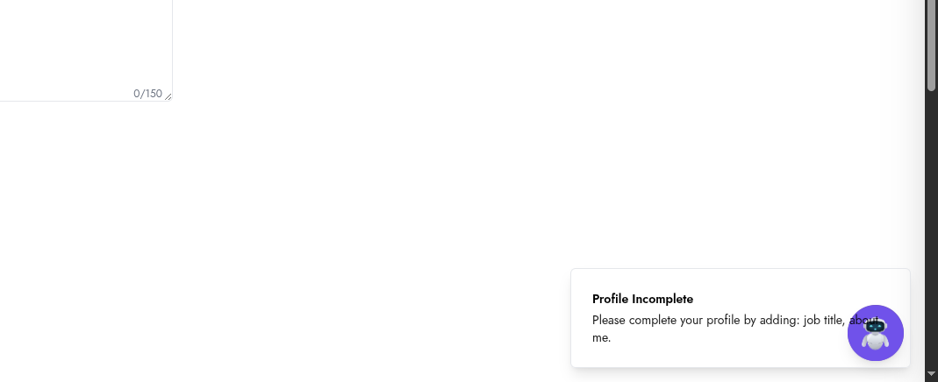
Impact: Minor UI/UX issue affecting visual presentation.

Bug Distribution Analysis

By Priority
P1 (Critical): ████████████████ 4 bugs (20%)
P2 (High): ████████████████████████ 6 bugs (30%)
P3 (Medium): ████████████████████████████ 7 bugs (35%)
P4 (Low): ████████████ 3 bugs (15%)

By Status
Status | Count
Open | 20
In Progress | 0
Resolved | 0
Closed | 0

Recommendations

Immediate Actions (P1 - Critical)
- Fix Authentication APIs - OTP send/verify endpoints returning 401 errors
- Resolve Login Issues - Network errors blocking user access
- Fix Application Load - Blank page on initial load

Short-term Actions (P2 - High)
- Fix Chat Server Connection - WebSocket/Socket connection issues
- Resolve CORS Configuration - Add missing headers to API responses
- Fix AI Service - Restore AI generation functionality
- Fix Subscription Flow - Payment integration issues

Medium-term Actions (P3 - Medium)
- Input Validation - Add proper content validation for job posts
- Date Format Standardization - Consistent date formats across the application
- Document Preview - Fix broken image displays
- UI Polish - Fix overlapping elements

Long-term Actions (P4 - Low)
- UX Improvements - Modal designs, notifications
- Security Hardening - Certificate information exposure

Test Environment
Parameter | Value
Browser | Chrome 147.0.0.0
OS | Linux
Application URL | https://tichi-app-webapp-stage.web.app
Environment | Staging (QA)
API Endpoint | https://o0guf45zb8.execute-api.ap-south-1.amazonaws.com/qa

Appendix: Screenshot Reference
Bug ID | Screenshot File
BUG-001 | BUG_2026_04_27_10_43_35.png
BUG-002 | BUG_2026_04_29_16_13_31.png
BUG-003 | BUG_2026_04_29_16_14_18.png
BUG-004 | BUG_2026_04_29_16_42_17.png
BUG-005 | BUG_2026_04_29_16_42_53.png
BUG-006 | BUG_2026_04_29_18_18_18.png
BUG-007 | BUG_2026_05_03_18_01_14.png
BUG-008 | BUG_2026_05_03_18_06_27.png
BUG-009 | BUG_2026_05_04_10_58_25.png
BUG-010 | BUG_2026_05_04_11_54_16.png
BUG-011 | BUG_2026_05_04_12_00_59.png
BUG-012 | BUG_2026_05_04_12_10_46.png
BUG-013 | BUG_2026_05_04_17_47_29.png
BUG-014 | BUG_2026_05_05_12_24_44.png
BUG-015 | BUG_2026_05_05_12_52_44.png
BUG-016 | BUG_2026_05_05_17_49_59.png, BUG_2026_05_05_17_50_18.png
BUG-017 | BUG_2026_05_06_14_11_49.png, BUG_2026_05_06_14_12_07.png
BUG-018 | BUG_2026_05_06_16_16_53.png
BUG-019 | BUG_2026_05_06_17_49_52.png
BUG-020 | BUG_2026_04_29_14_25_38.png

Report Prepared By: QA Team Report Version: 1.0 Last Updated: May 7, 2026

