**Day- 12**

**Madhu Kalyani Gadi (16-12-2023)**

**Map Function:**

map() function in Python is a built-in function that applies a specified function to all the items in an iterable and returns an iterator that produces the results.

Syntax:

map(function, iterable, ...)

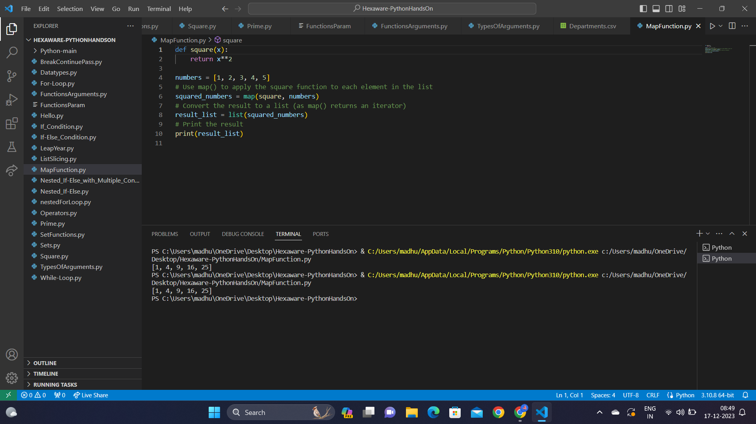

**String functions:**

String functions allow you to manipulate and work with strings.

- Capitalize: Converts the first letter of the string to uppercase and the rest to lowercase. In this example, it transforms "mY name is YUVRAJ" to "My name is yuvraj".

- Count: Counts the number of occurrences of 'G' in the string. In this case, it returns 3 as there are three 'G' characters in the string.

- Find: Returns the index of the first occurrence of 'is' in the string. In this example, it returns 7 because 'is' starts at index 7 in the string.

- Lower: Converts all uppercase characters to lowercase. It transforms the entire string to lowercase: "hexaforhexa is a computer science portal".

- Upper: Converts all lowercase characters to uppercase. It transforms the entire string to uppercase: "HEXAFORHEXA IS A COMPUTER SCIENCE PORTAL".

- Replace: Replaces all occurrences of 's' with 't' in the string. In this example, it becomes "tubway turfer".

- Join: Joins elements of a list with a space between each element. It creates a single string: "Anshul is my only friend", where each element is separated by a space.

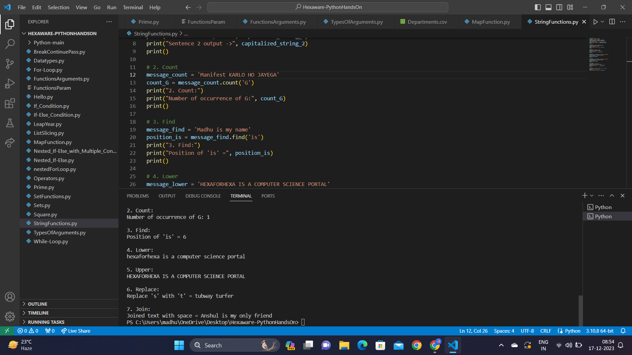

**Time modules and functions:**

- time.time(): Gives the current time in seconds since the beginning of time (January 1, 1970). Useful for measuring how much time something takes.

- time.ctime(): Provides the current time in a way that's easy for humans to understand, like "Fri Dec 17 14:30:00 2023".

- time.sleep(seconds): Pauses the program for a specified number of seconds. It's like telling your program to take a little break.

- time.localtime(): Shows the current time and date in a structured way, breaking it down into details like the year, month, day, and so on.

- time.strftime(format, time): Turns the structured time (like that from localtime()) into a nicely formatted string. For example, "2023-12-17 14:30:00".

- time.gmtime(): Similar to localtime(), but it gives you the current time in Coordinated Universal Time (UTC) rather than your local time.

- time.mktime(t): Converts the structured time back into a format that represents the number of seconds since the beginning of time. It's like turning a date and time into a single number.

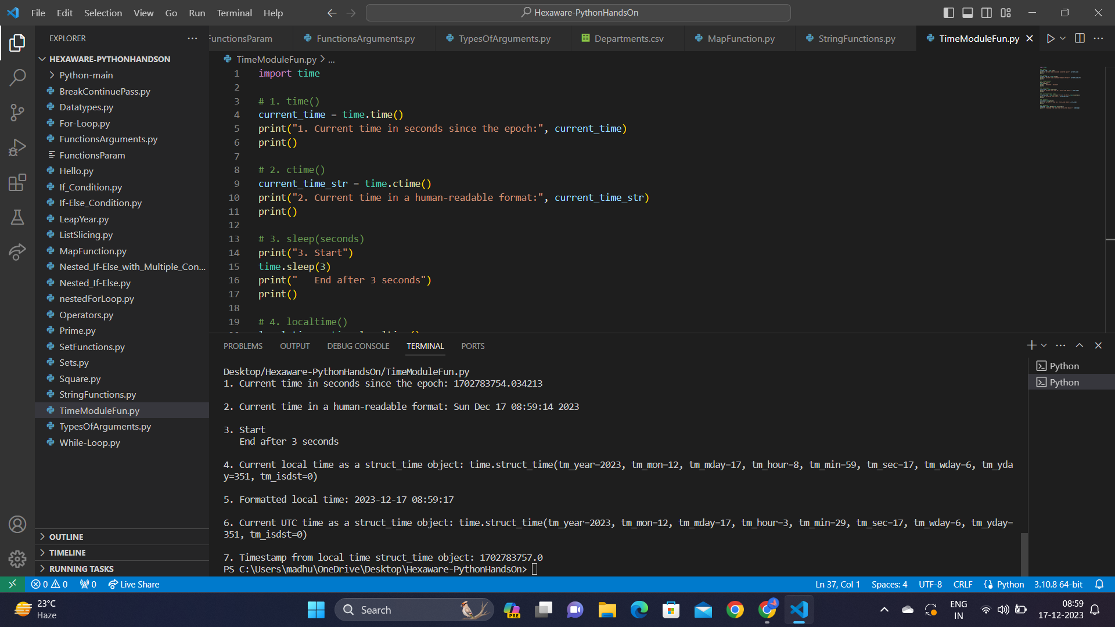

**Lambda Functions:**

Lambda functions are quick, nameless functions in Python made with the lambda keyword. They're like mini-functions for short tasks.

- A basic use of a lambda function is defining a quick function to square a number and then applying it to the value 5, resulting in the output 25.

- The lambda function is used with the map() function to create a new list containing the squares of each number in the original list [1, 2, 3, 4, 5].

- The lambda functions with the filter() function to create a list containing only the even numbers from the original list [1, 2, 3, 4, 5, 6, 7, 8, 9, 10].

- The lambda functions as a key function with the sorted() function to sort a list of words based on their lengths.

