**Day- 13**

**Madhu Kalyani Gadi (18-12-2023)**

**Oops Concepts in python**

**Python class**

A class in Python is a blueprint for creating objects, containing attributes (variables) and methods that define the object's behaviour.

Objects are instances of a class; you create them using the class as a template, and each object can have its own unique attributes while sharing the class's methods.

**Encapsulation**

Encapsulation is like putting data and the methods that operate on the data into a single box (class), and can control how others interact with what's inside (public or private).

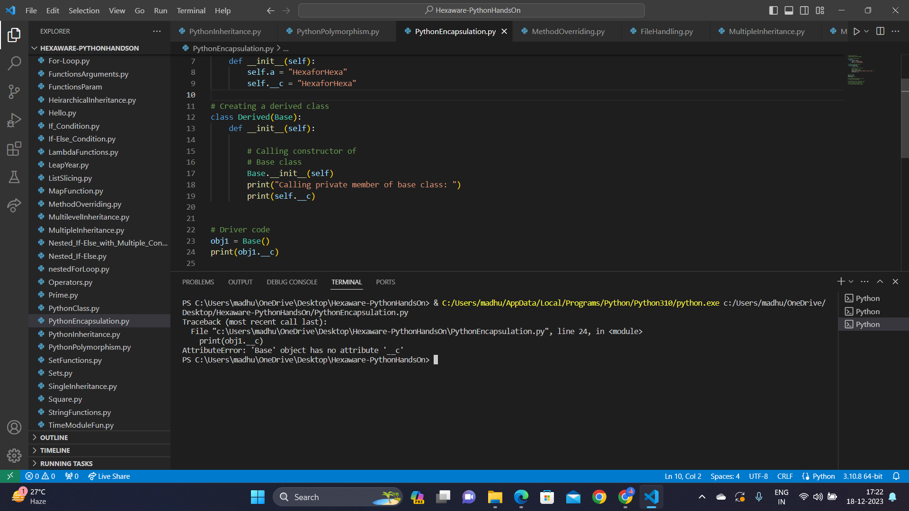

The above code defines a Base class with a private member __c and attempts to directly access obj1.__c outside the class result in an AttributeError. The Derived class showcases encapsulation by accessing the private member within the class through the base class constructor.

**Polymorphism**

Polymorphism is like using a single interface (e.g., a method name) for different types of objects, allowing them to be used interchangeably based on their common behavior.

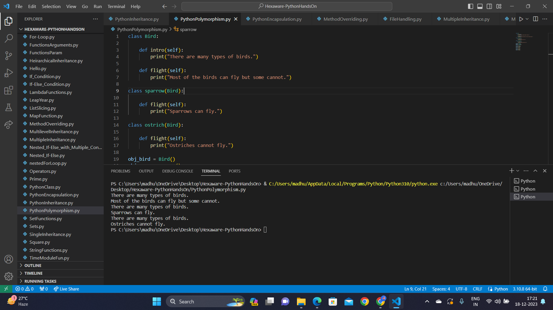

**Inheritance**

Inheritance is like passing down traits from a parent to a child, so we can reuse code and build on existing functionality.

Single Inheritance:

Single inheritance in Python is like passing down features from a parent to a child. You create a base class (parent) with certain qualities, and then a derived class (child) inherits those qualities.

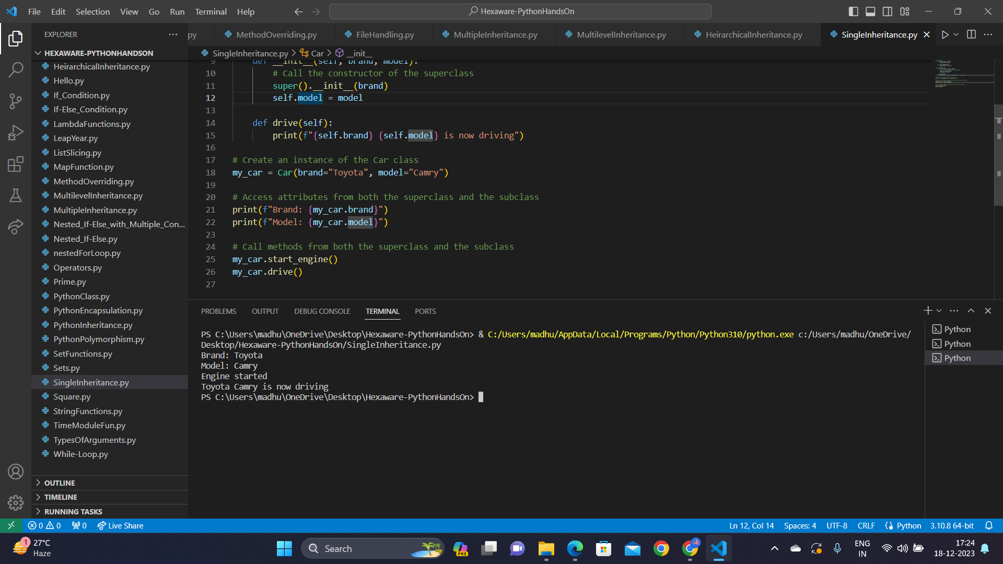

Multiple Inheritance:

Multiple inheritance involves a class inheriting attributes and methods from more than one base class.

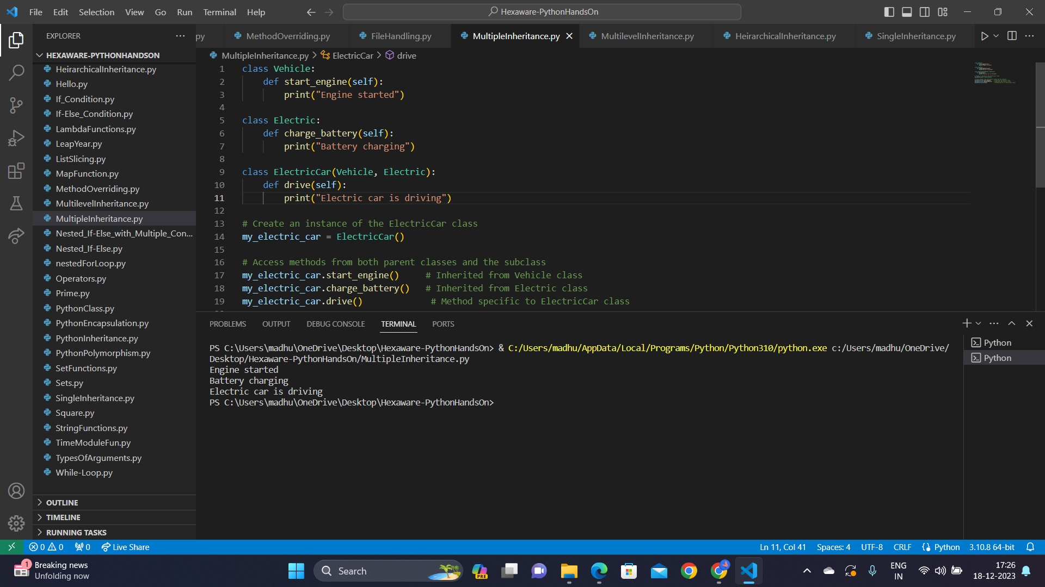

Multi-level Inheritance:

Multi-level inheritance occurs when a class is derived from a class, which is further derived from another class.

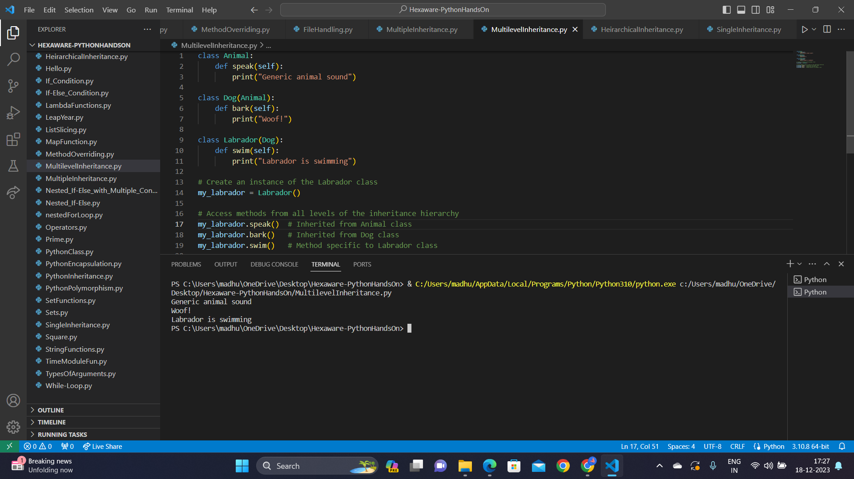

Hierarchical Inheritance:

Hierarchical inheritance in involves multiple classes being derived from a single base class.

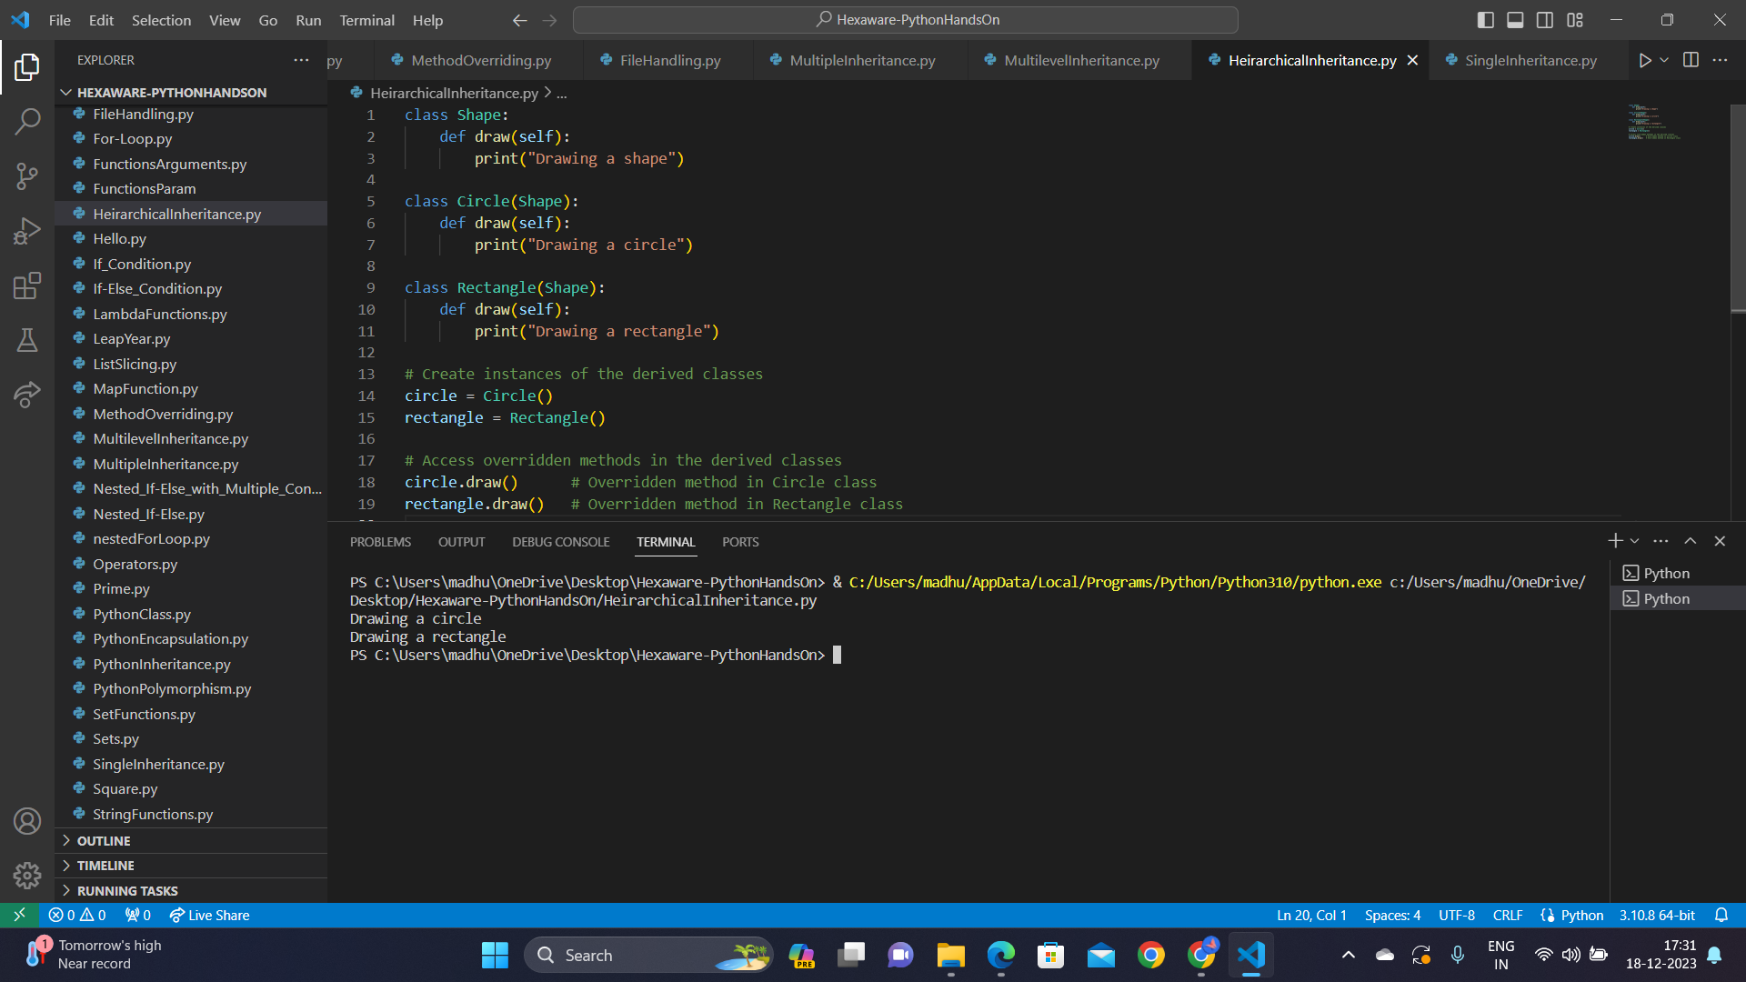

**Method Overriding:**

Method overriding allows a subclass to redefine a method inherited from its superclass, giving the subclass the flexibility to customise or extend the behaviour of that method while keeping the same method name and structure.

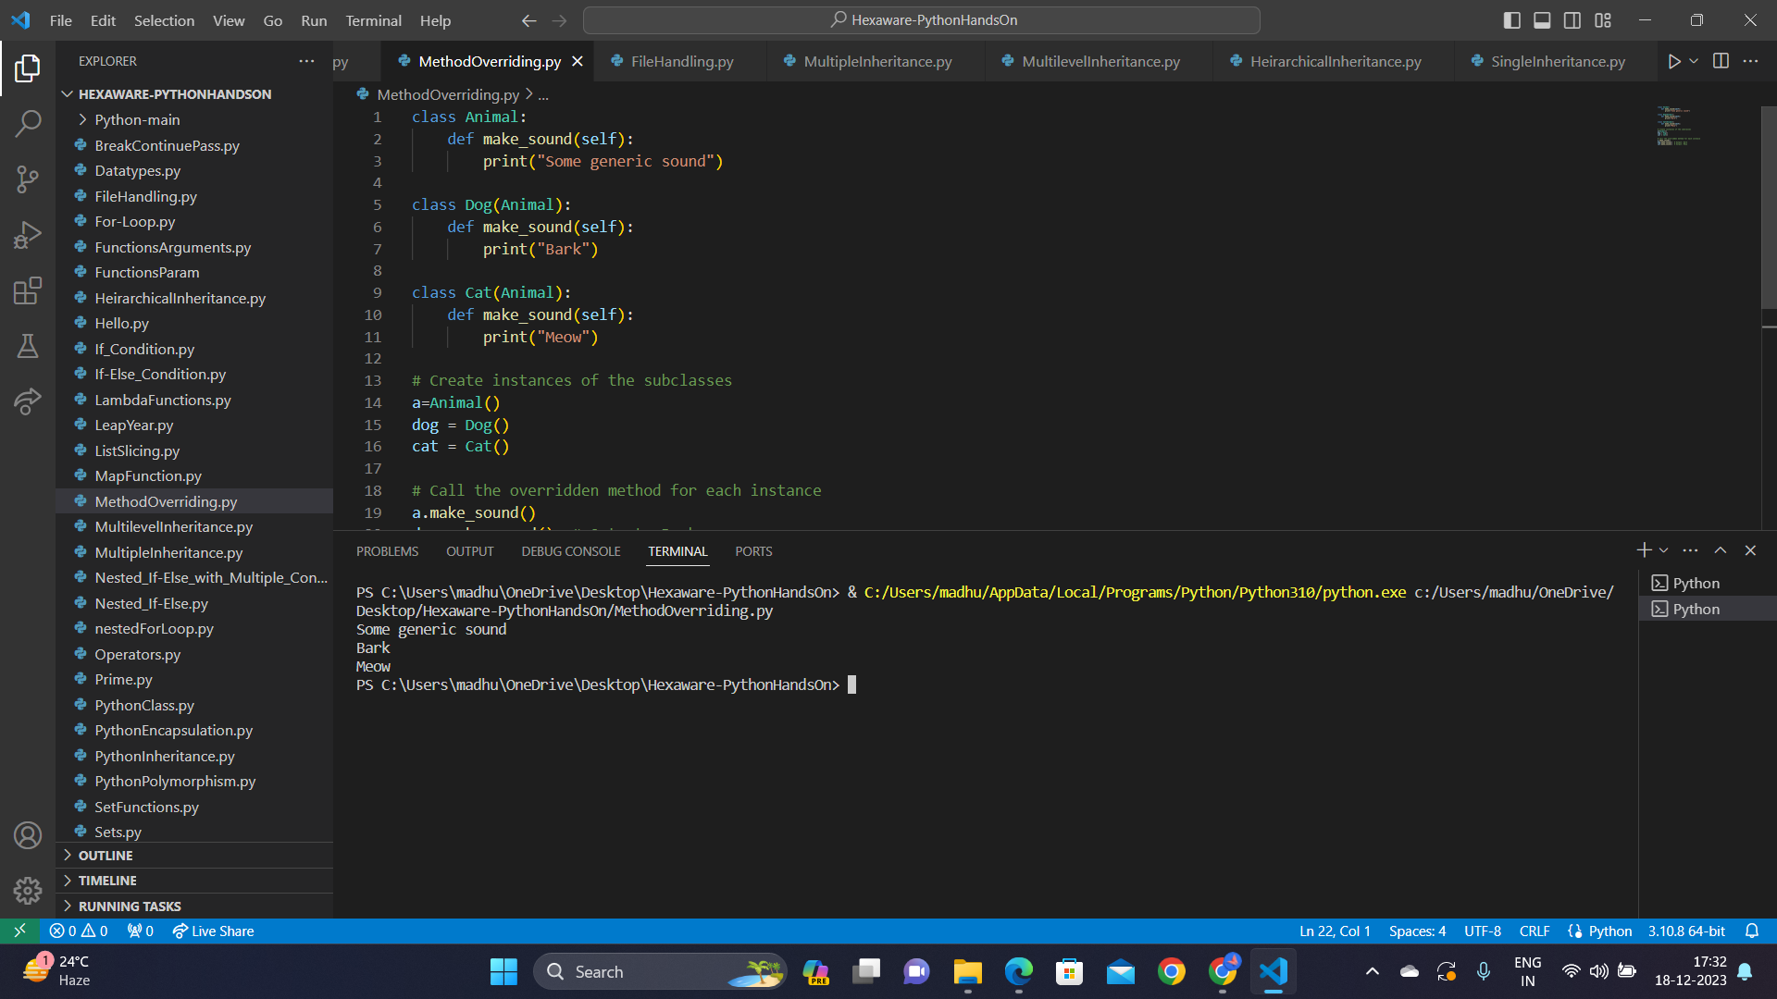

**File Handling in python**

File handling involves operations related to reading from and writing to files.

Open a file with open("example.txt", "r") specifying the file path and mode ("r" for read, "w" for write, "a" for append).

Read content from the file using methods like read(), readline(), or readlines().

Open a file in write mode ("w") with open("example.txt", "w") and use write("text") to add or overwrite content.

The with statement for automatic file closure and streamlined file handling, enhancing readability and maintenance.

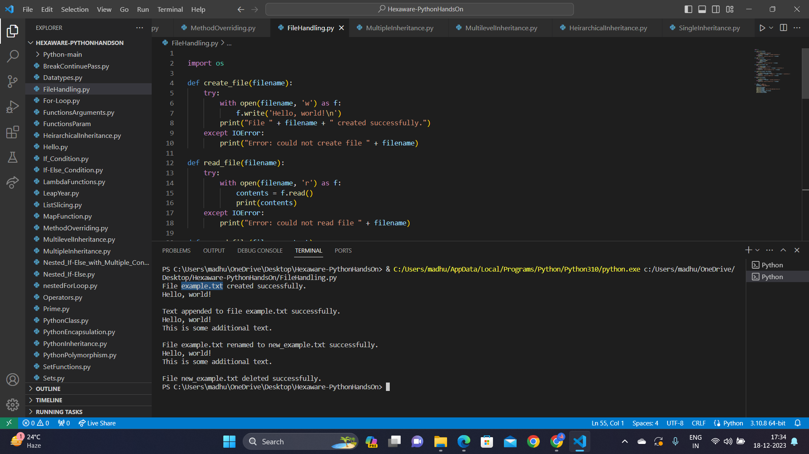

**Python Modules**

Modules are reusable pieces of code that can be imported into other programs. You import a module using import module_name.  
  
Math Module

The math module in Python provides mathematical functions. Import it with import math and then use functions.

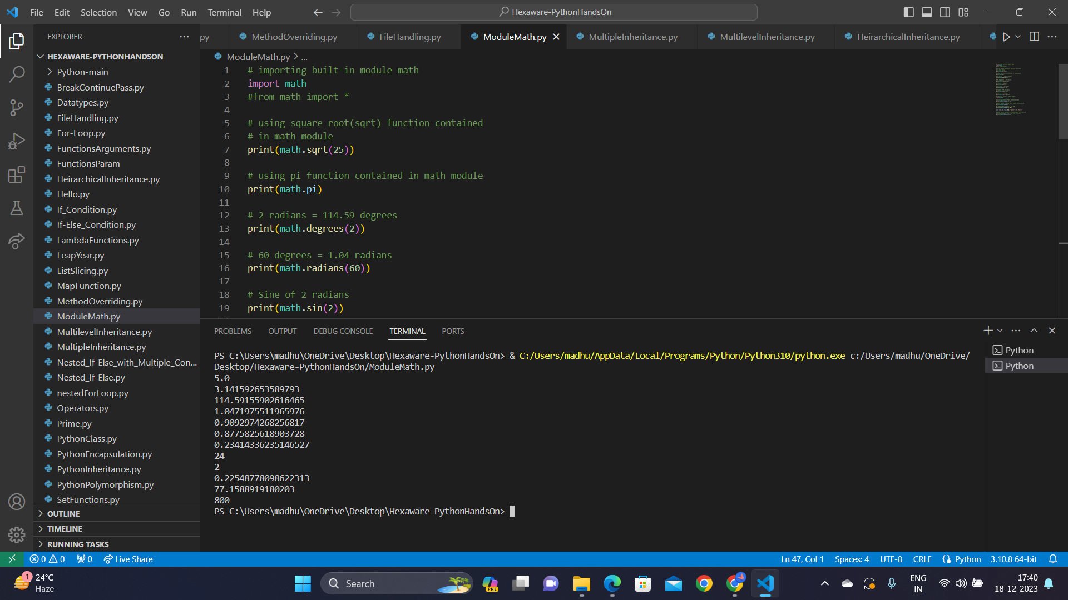

Datetime Module

The datetime module provides classes for working with dates and times.

