**Day- 9**

**Madhu Kalyani Gadi (13-12-2023)**

**If Condition:**

Here, if condition is used to check if the variable x is not equal to zero and prints "x is a non-zero number" if the condition is true, indicating that the value of x is not zero.

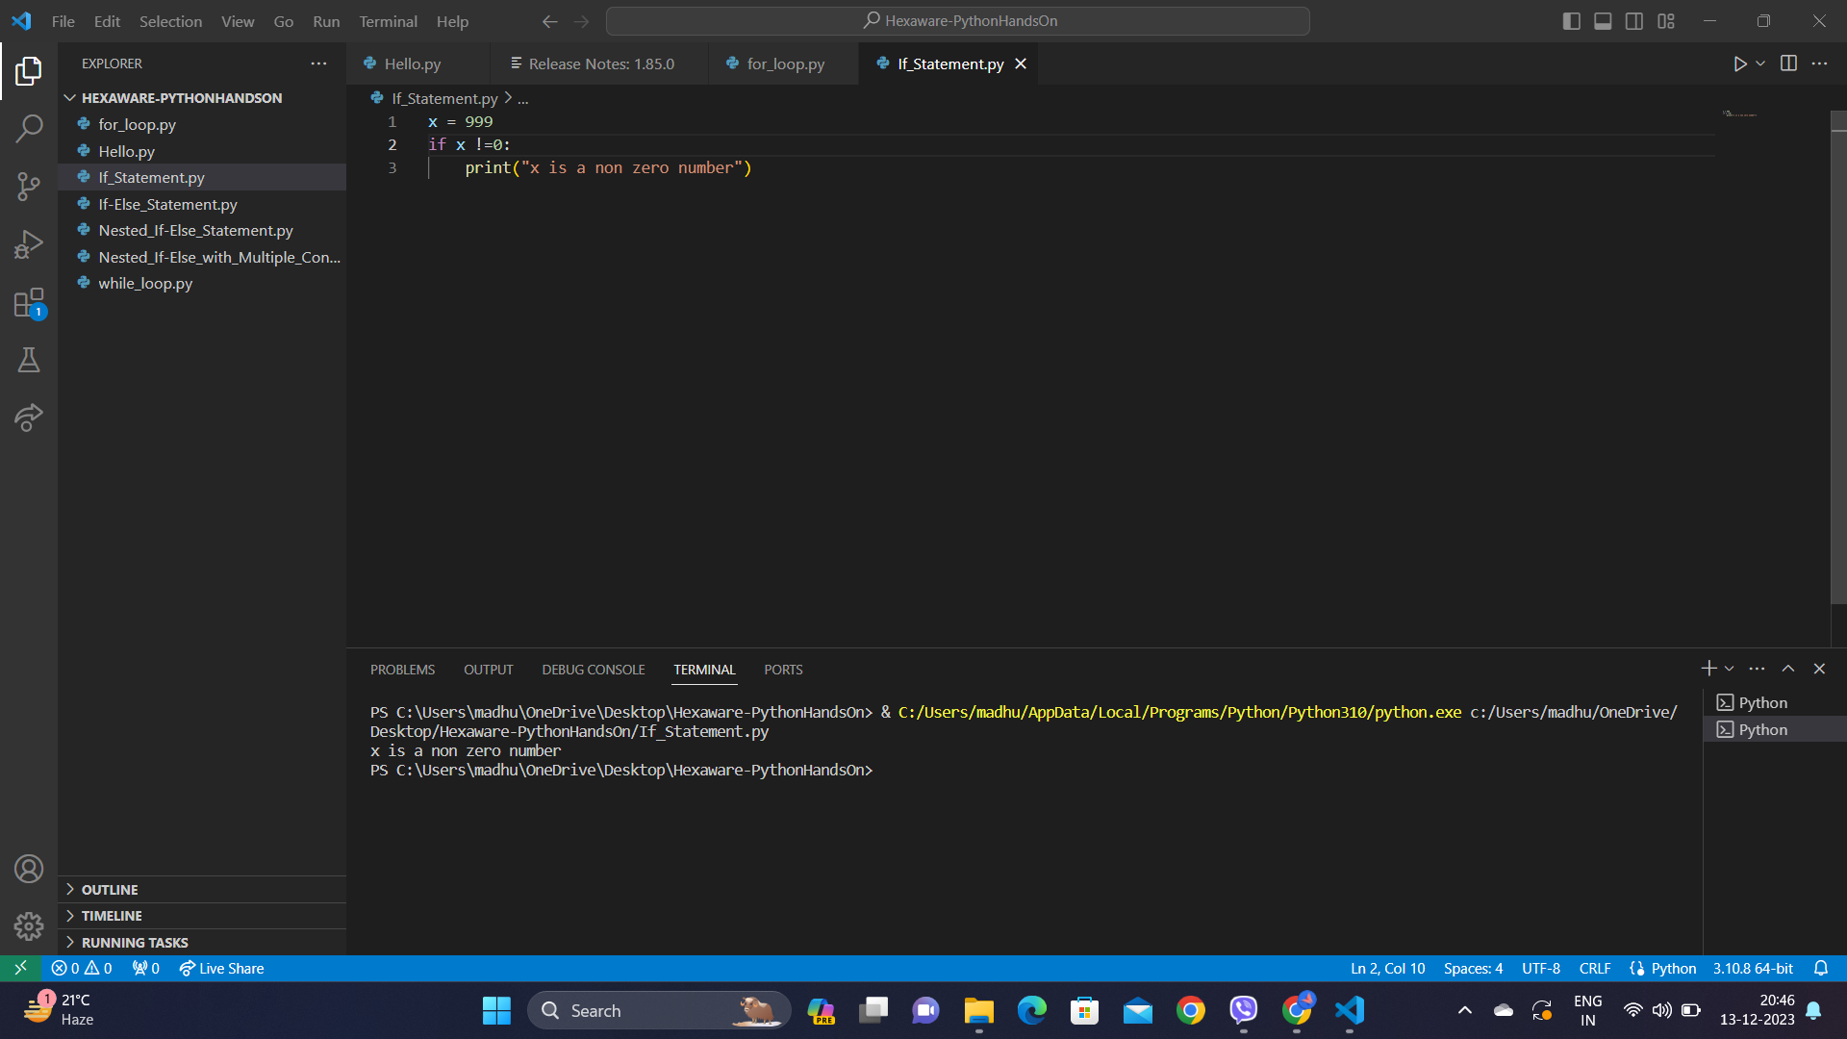

**If else statement:**

If-else is used here to check if the variable x is equal to zero and prints "x is zero" if true; otherwise, it prints "x is a non-zero number," indicating whether the value of x is zero or not.

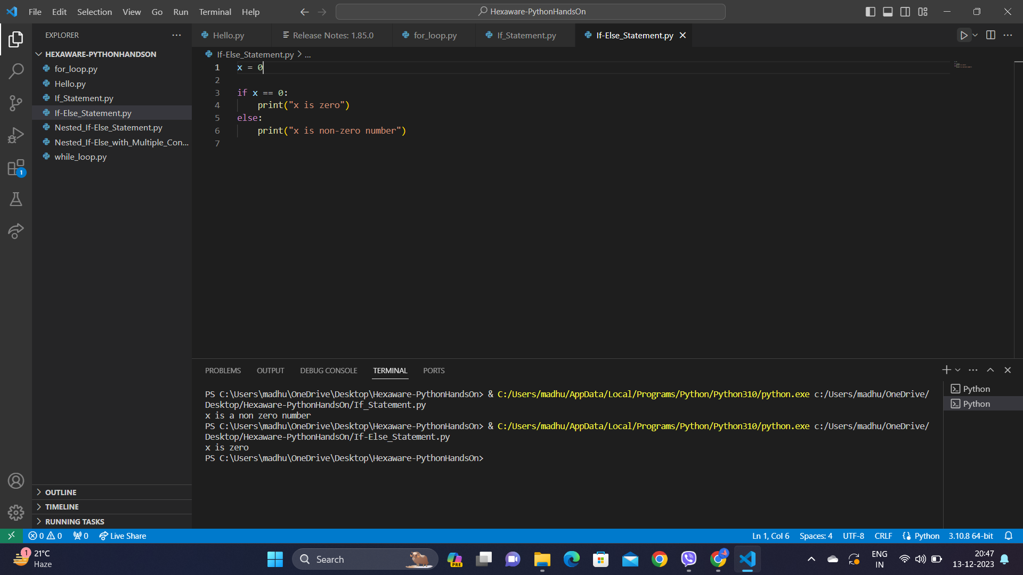

**Nested If else Statement:**

Nested if-else statements are used to check the value of variable x and prints "x is positive" if x is greater than 0, "x is zero" if x is equal to 0, and "x is negative" if x is less than 0, providing a classification of x based on its sign.

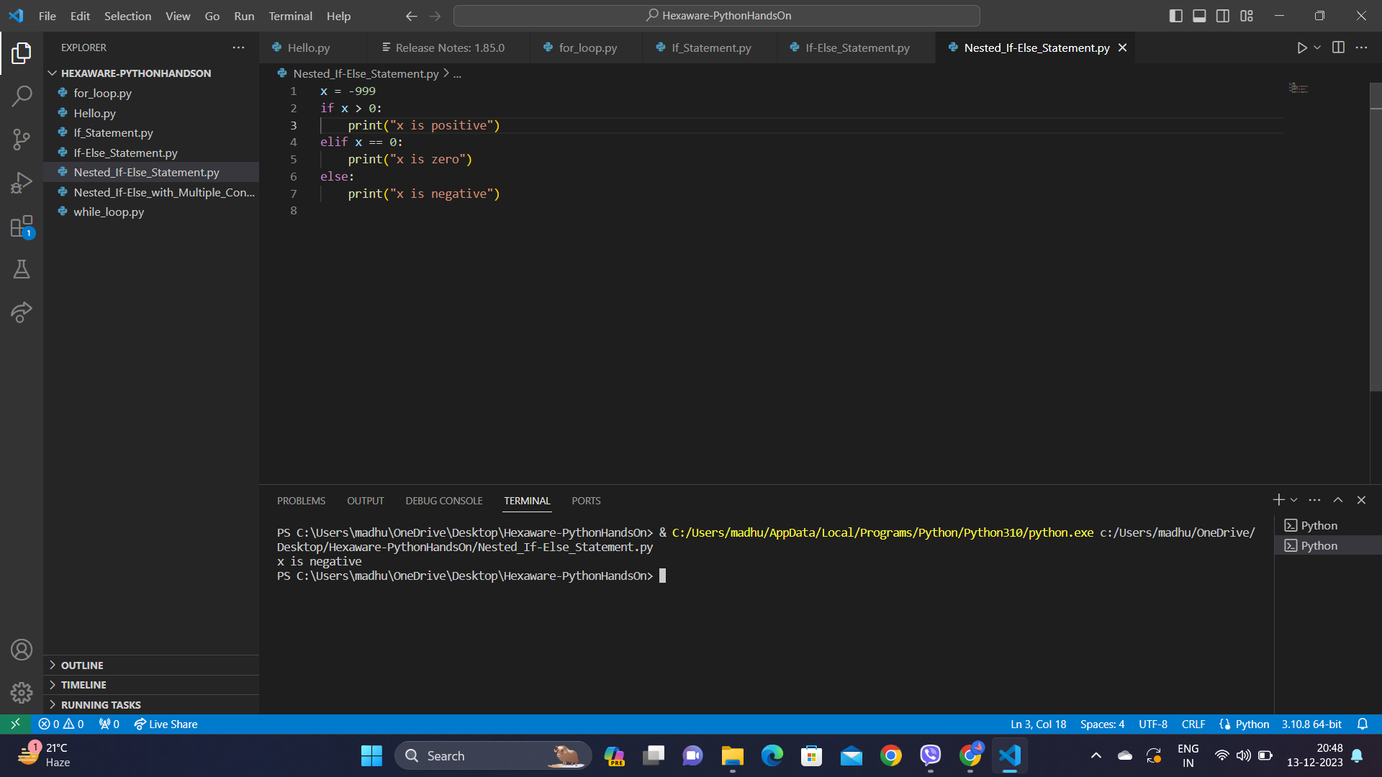

**Nested if else with multiple conditions:**

Here, nested if-else is used in multiple conditions to compare the values of variables x and y and prints "x is greater than y" if x is greater, "x is less than y" if x is smaller, and "x and y are equal" if they are equal, providing a concise representation of their relationship.

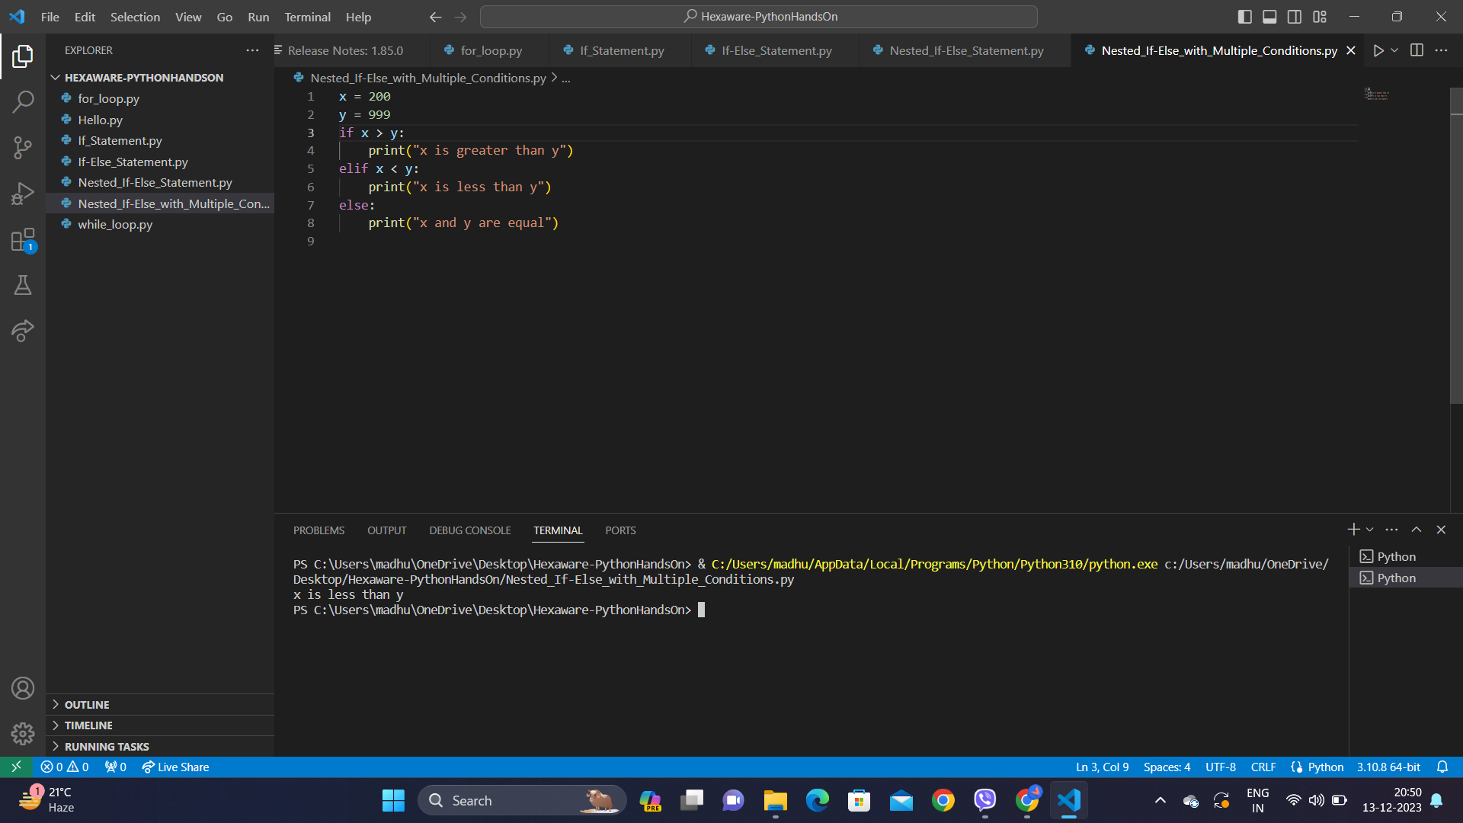

**For loop:**

For loop is used here to calculate the sum of numbers in the range from 0 to 9 using a for loop and prints the result. The final sum is displayed as "The sum of numbers is: 45".

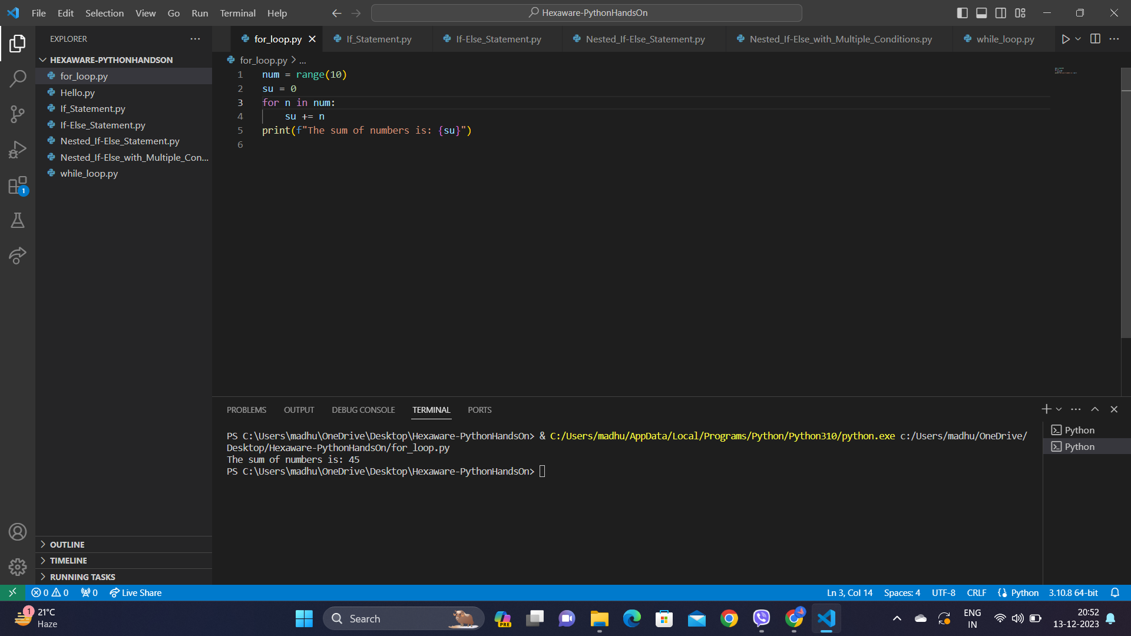

**While Loop:**

While loop is used to calculate the sum of elements in the list c and prints the result. The sum of elements is displayed as "Sum of the elements in the list: 15".

