**Day 3   
Madhu kalyani Gadi (06-12-2023)**

**MySQL Server Hands-On**A table named "Customers" was created and after inserting values, with the **SELECT** command, we displayed the table contents.

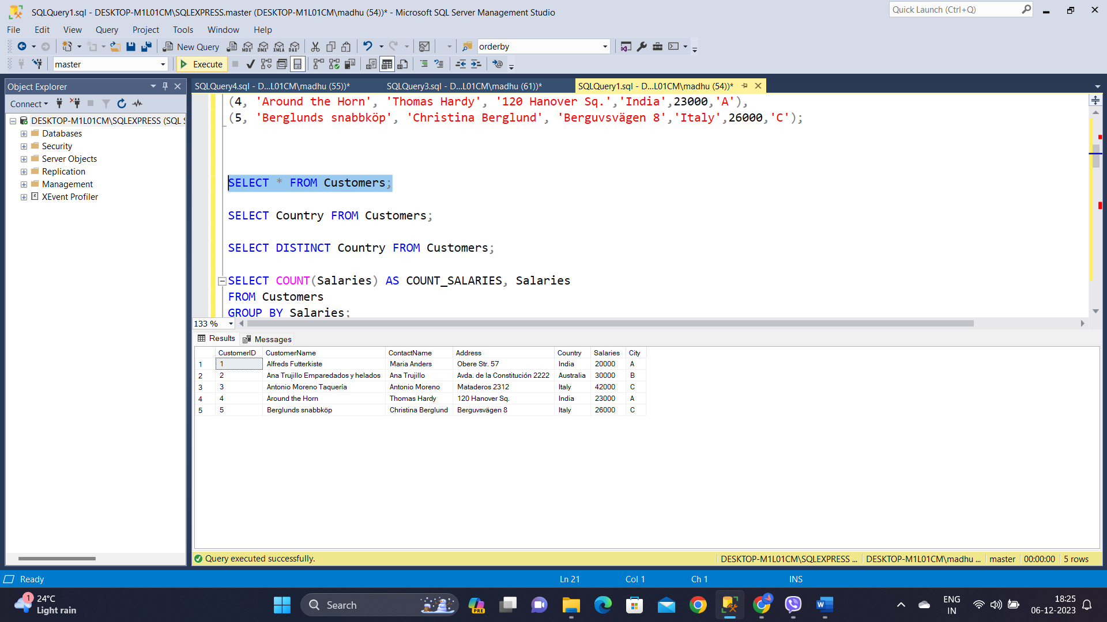

The **DISTINCT** command is used to showcase unique countries.

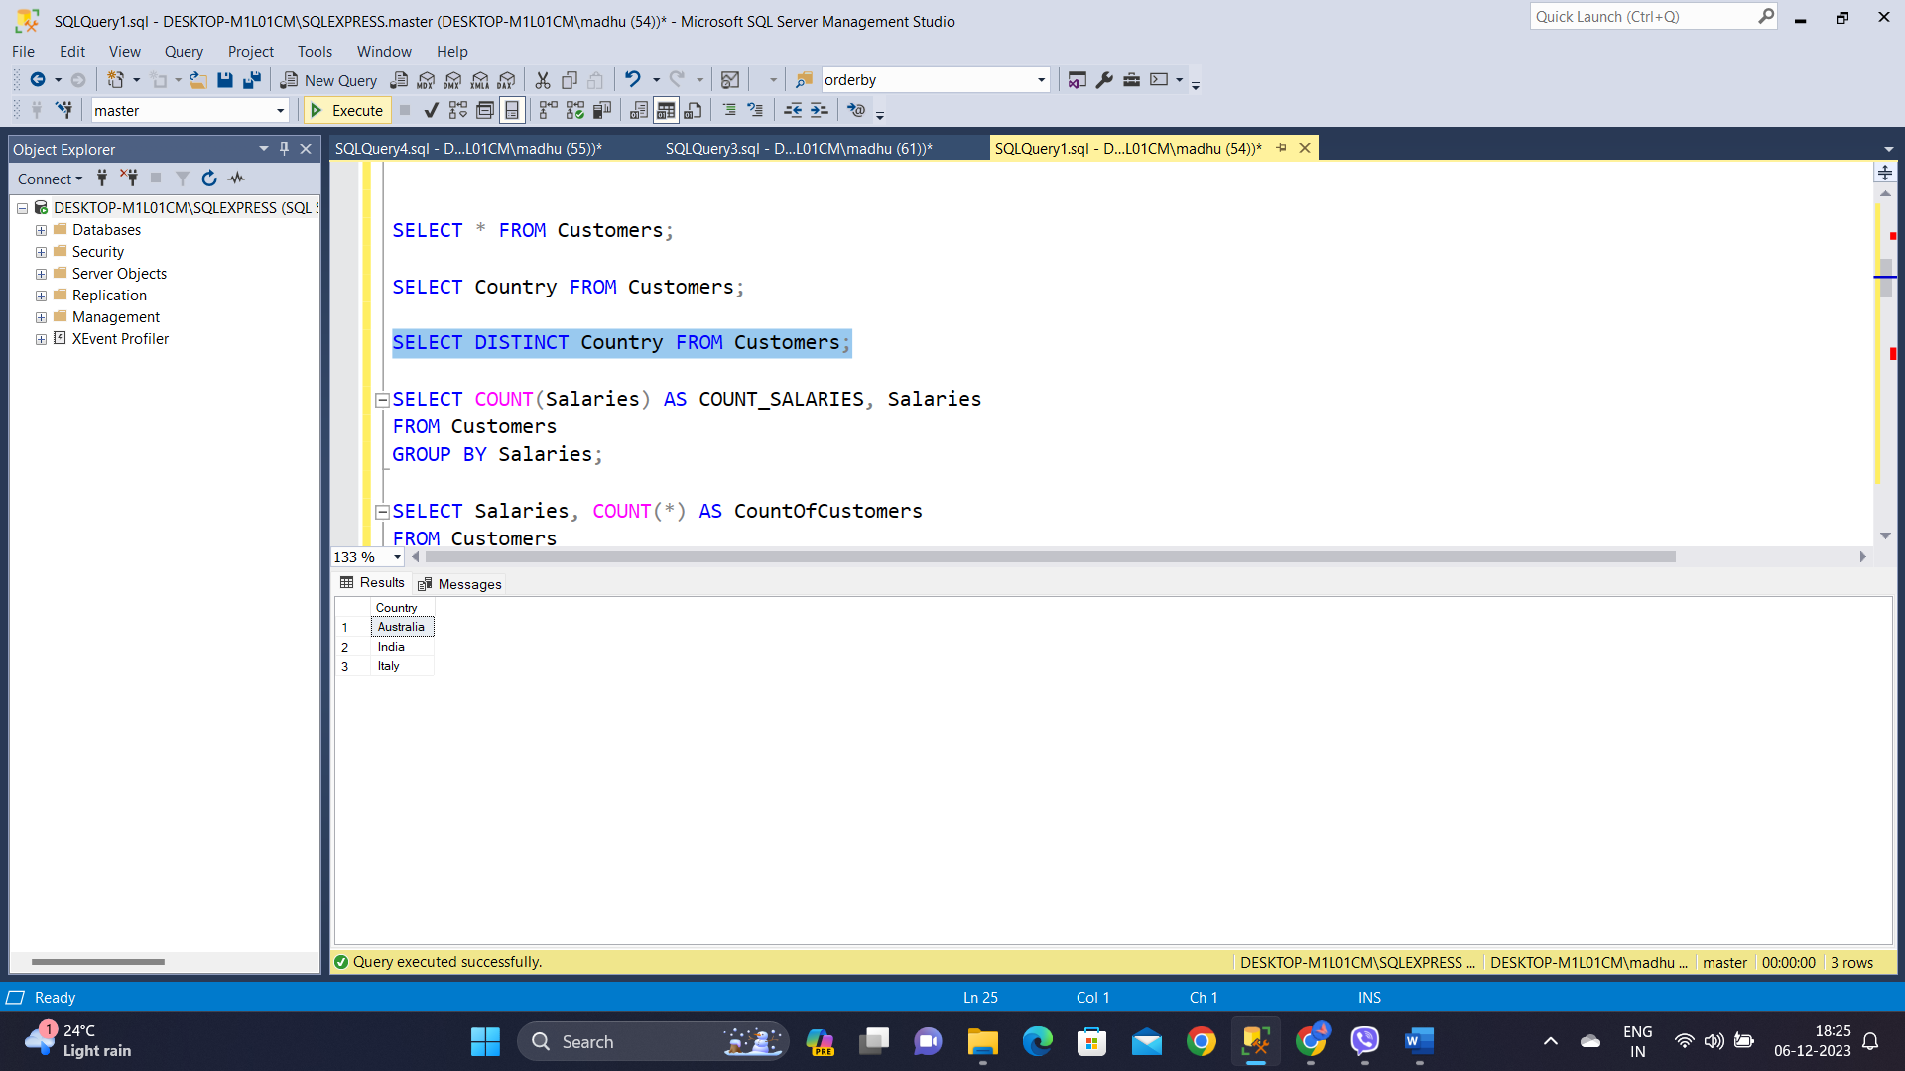

**GROUP BY & HAVING:**

Here, it selects salary values and the count of customers for each unique salary in the "Customers" table, filtering results to display only salaries with a single customer by using GROUP BY and HAVING clauses.

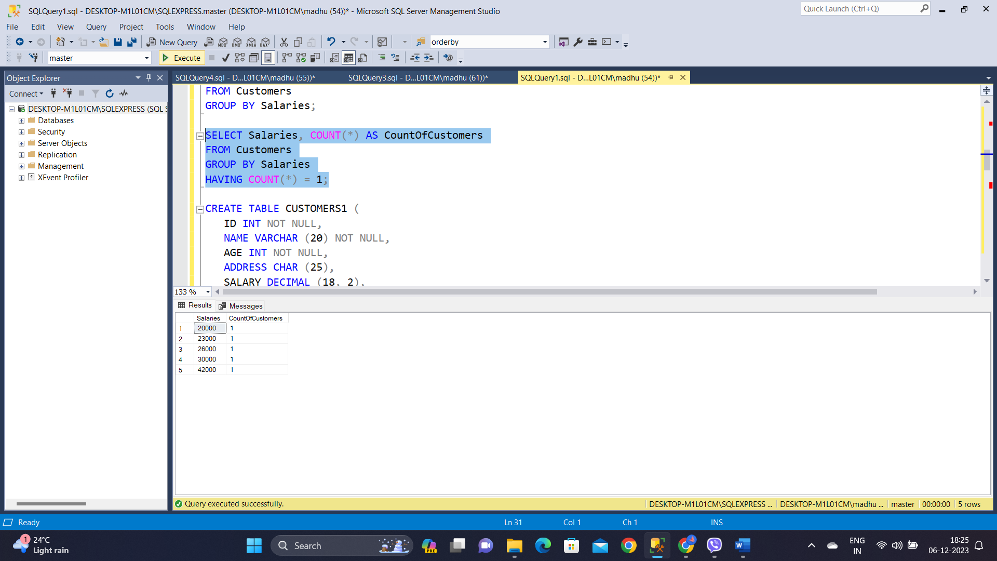

**TCL COMMANDS**

**COMMIT:**A table named "CUSTOMERS1" is created for executing transaction control commands. Following the insertion of values, a delete operation is performed, and the transaction is committed using the COMMIT command. After committing the table is as follows:

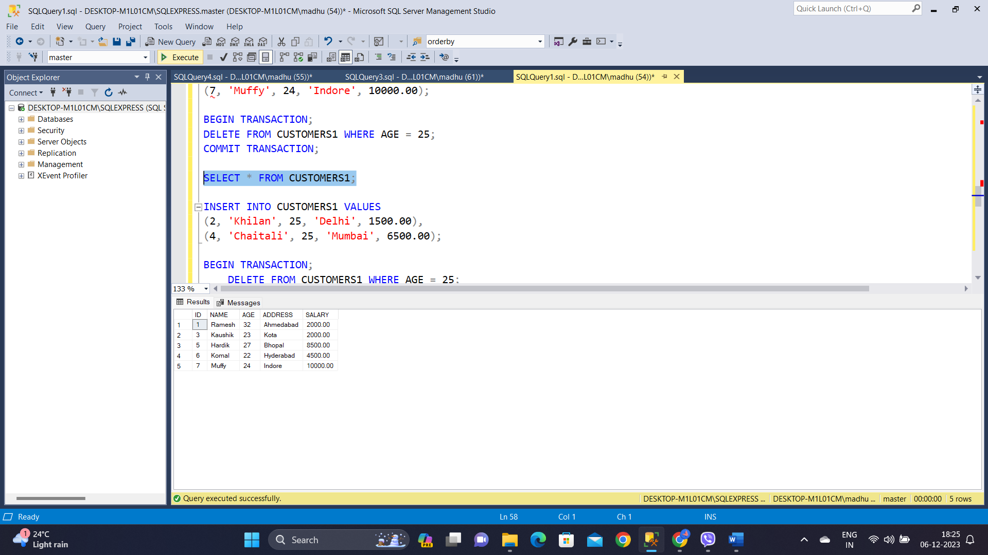

**ROLLBACK:**

To revert to the previous state after committing a transaction, the ROLLBACK command can be employed.

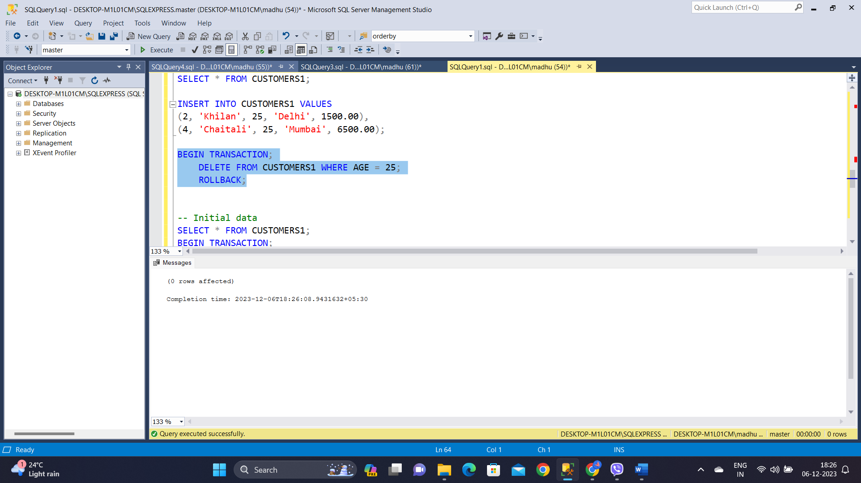

**SAVE POINT:**

This transaction saves points (SP1, SP2, SP3) for rollbacks, performs deletions on records with IDs 1, 2, and 3 and displays the resulting state of the "CUSTOMERS1" table before and after the operations.

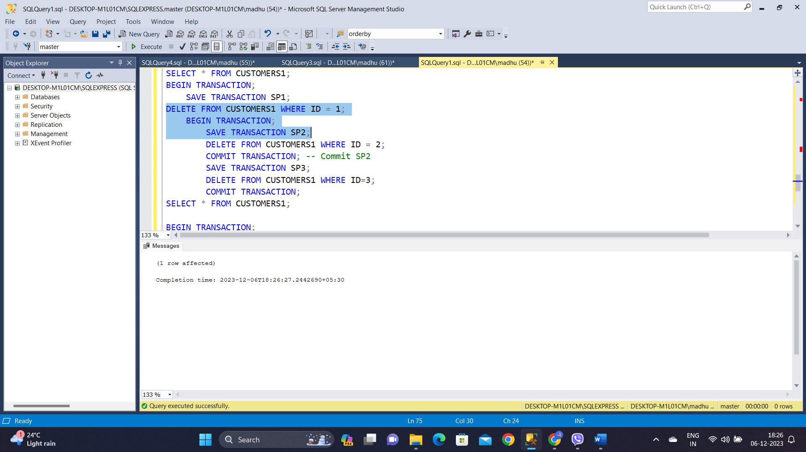

The final table after doing multiple transactions is displayed by using the SELECTcommand.

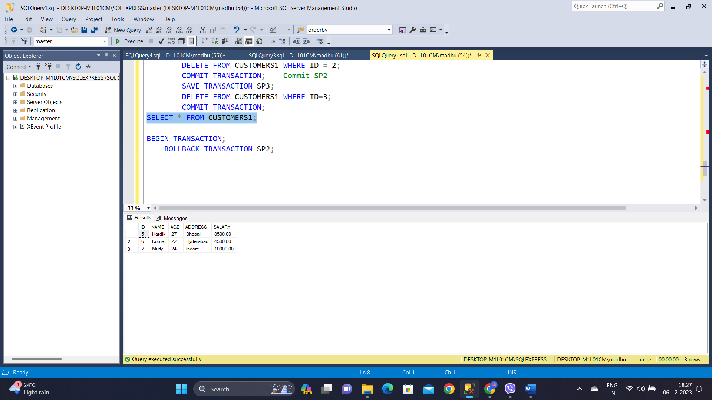

**DATA INTEGRITY**

Created a table named "Departments" with columns for "DepartmentID" and "DepartmentName," establishing "DepartmentID" as the **primary key**.

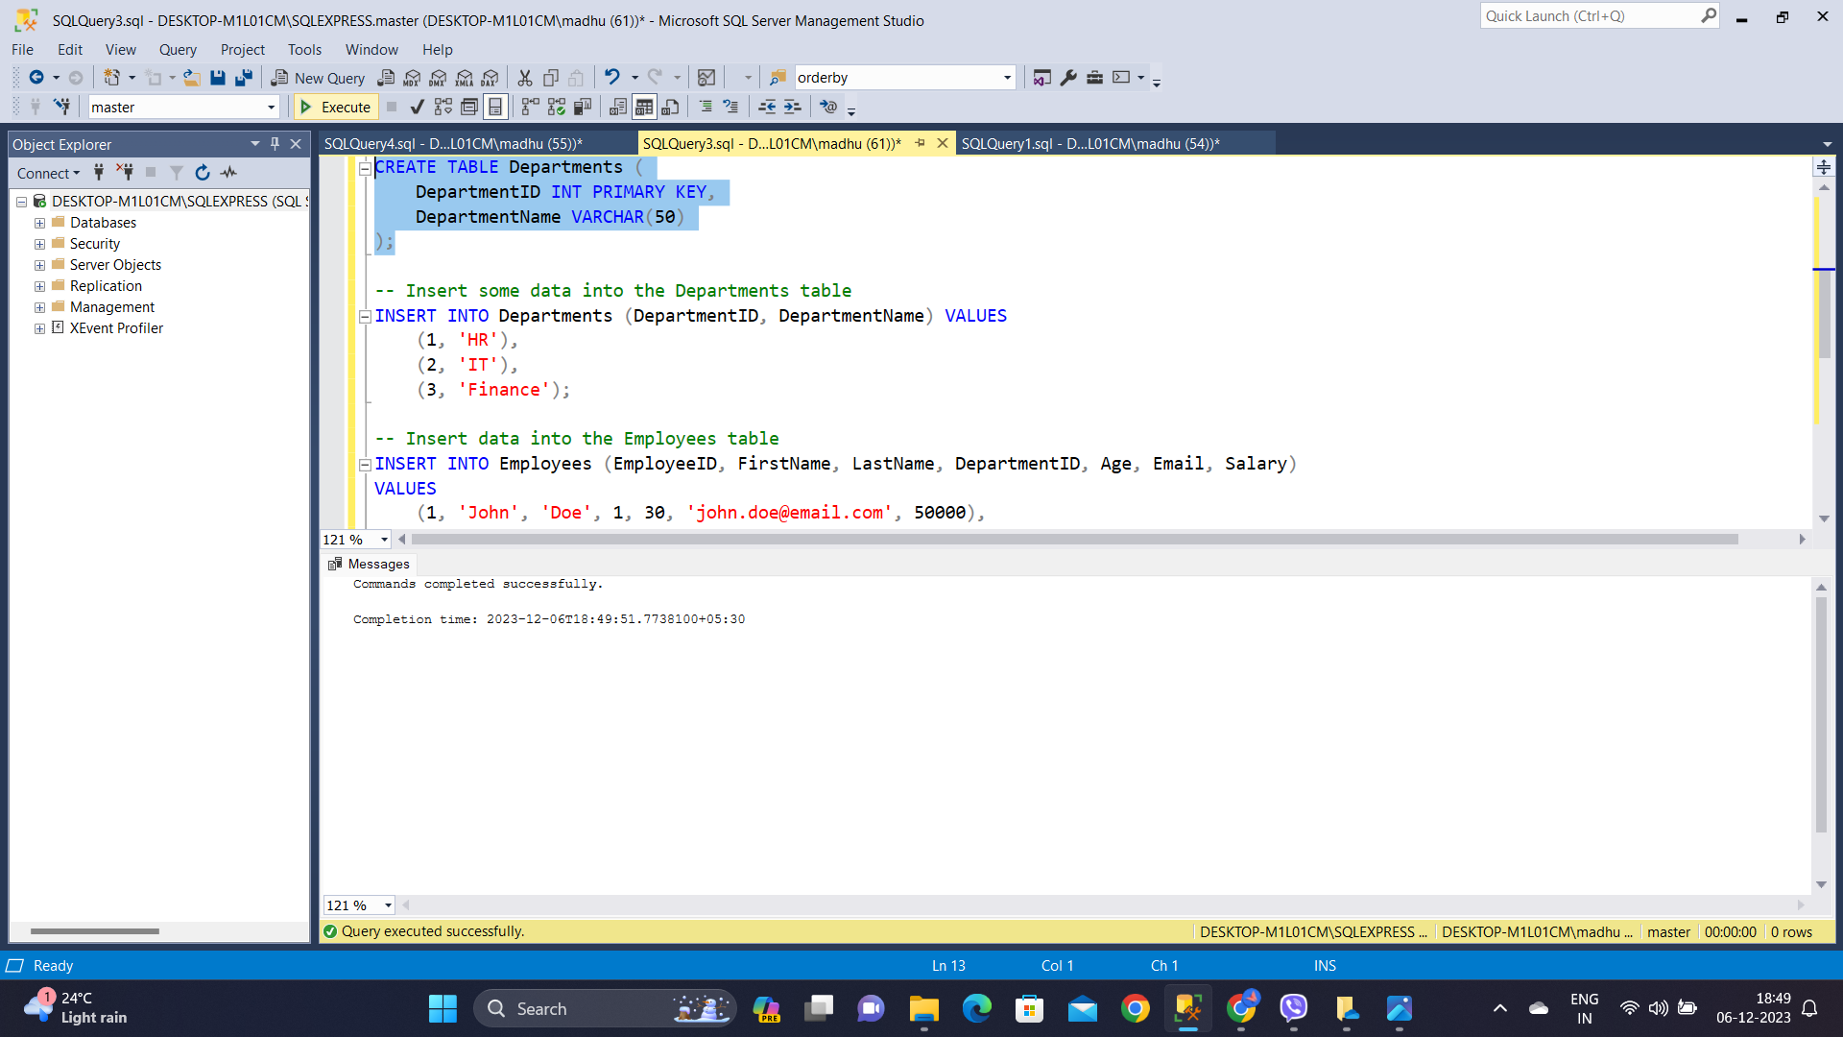

Here, a table named "Employees" is created with integrity constraints. There is a **primary key** on "EmployeeID," a **check** constraint on "Age", a **unique** constraint on "Email", and a **check** constraint on "Salary" to prevent negative values. The composite check constraint CHK_EmployeeName is used so that both "FirstName" and "LastName" are **not null**, contributing to data integrity. Also by using **foreign key** constraints we have established a relation between the Employees and Departments table.

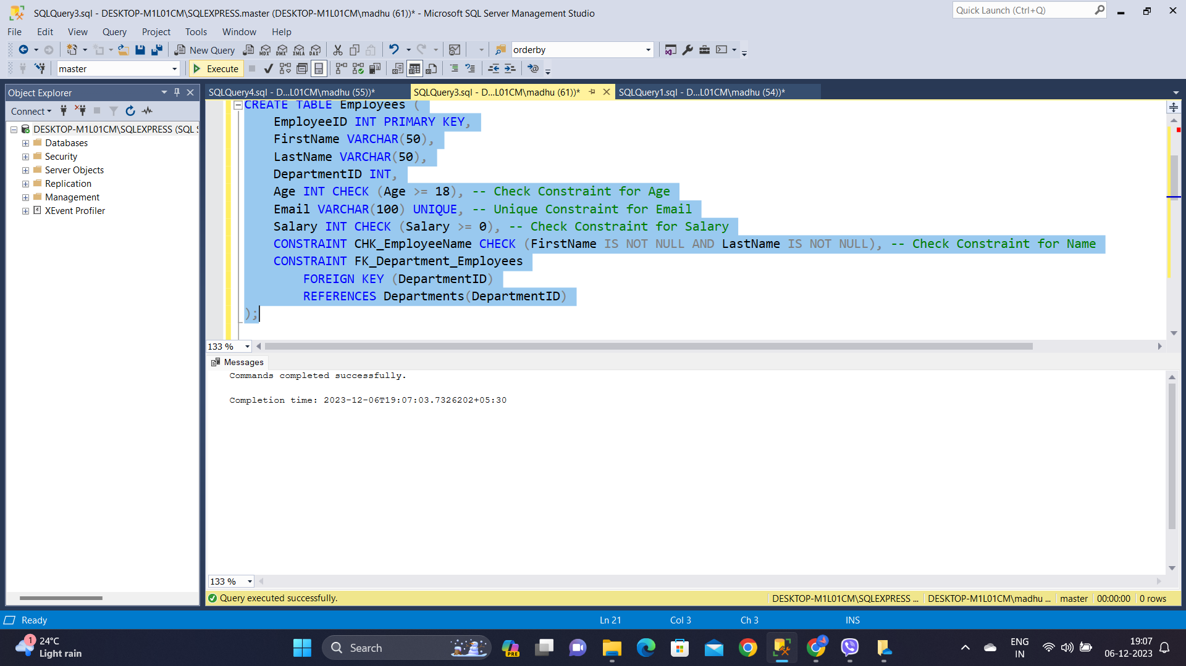

Now, we attempt to insert a record into the "Employees" table with the values for a new employee, including a duplicate email ('[john.doe@email.com](mailto:john.doe@email.com)') which will throw an error.

