**Day-5**

**Madhu Kalyani Gadi (08-12-2023)**

**Special Operators**

Special operators in subqueries, such as ANY, ALL, and EXISTS, enhance SQL queries by providing better ways to compare results within subquery expressions.

**EXISTS**

This query retrieves students who have at least one entry in the grades table. It uses the EXISTS operator to check the existence of related records in the grades table for each student in the students table.

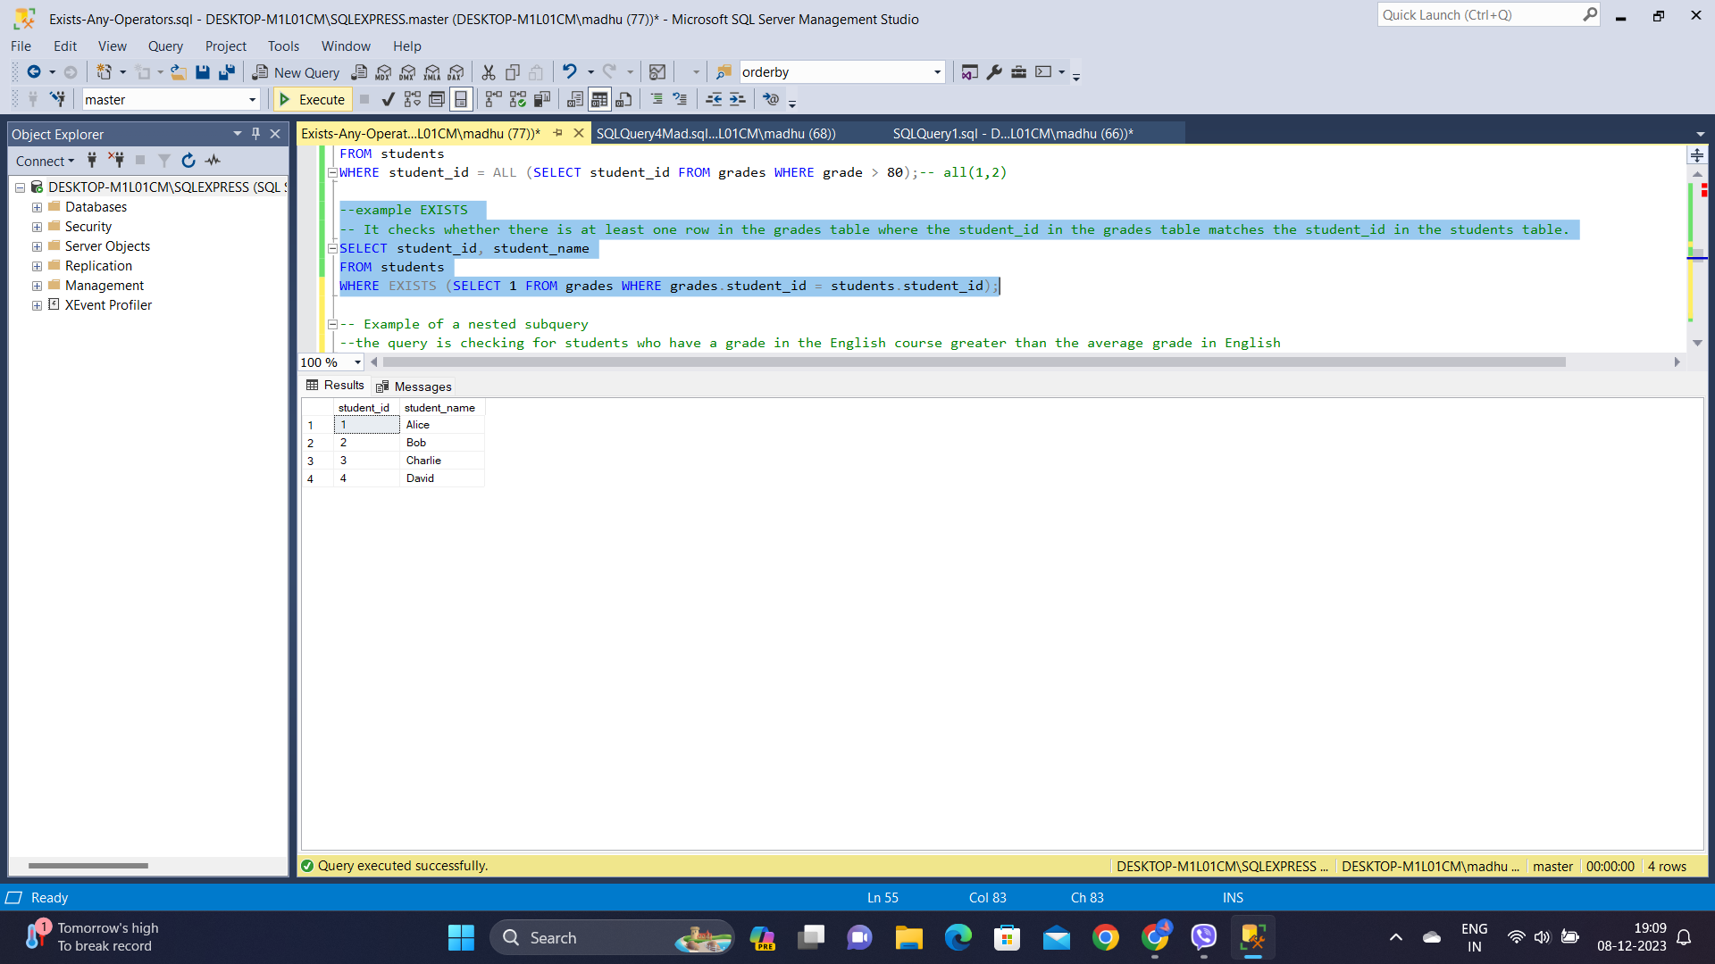

**ANY**

The query uses the ANY operator to check if the student_id matches any student_id in the grades table where the grade is greater than 90. If a match is found, the student is included in the result.

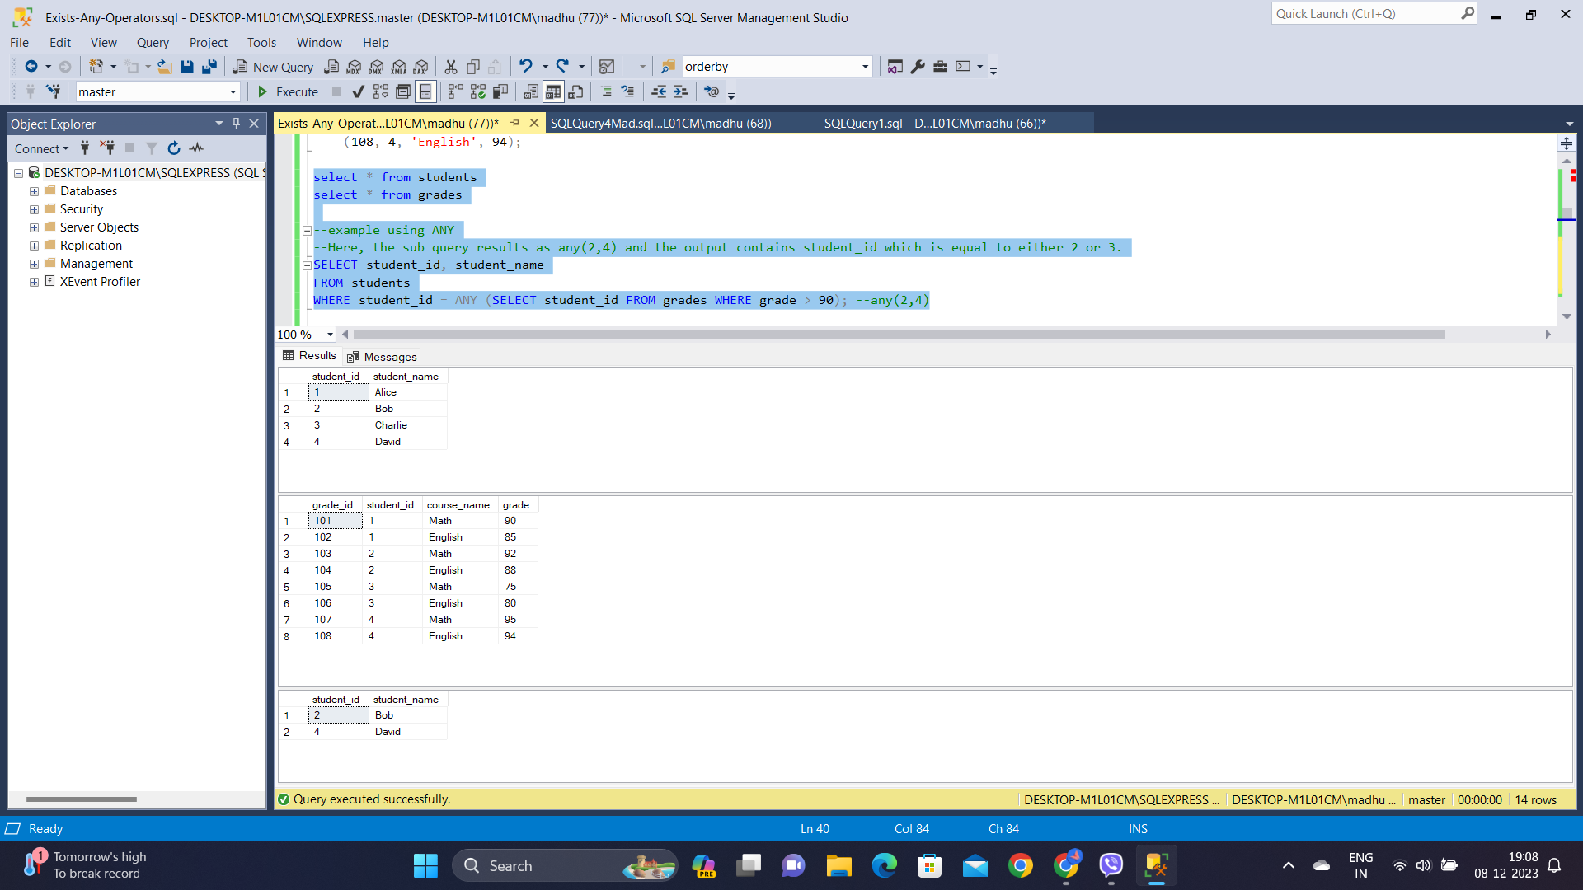

**ALL**

The query uses the ALL operator to check if the specified condition (grade > 80) holds true for all rows with the same student_id in the grades table. If all grades are greater than 80, the student is included in the result.

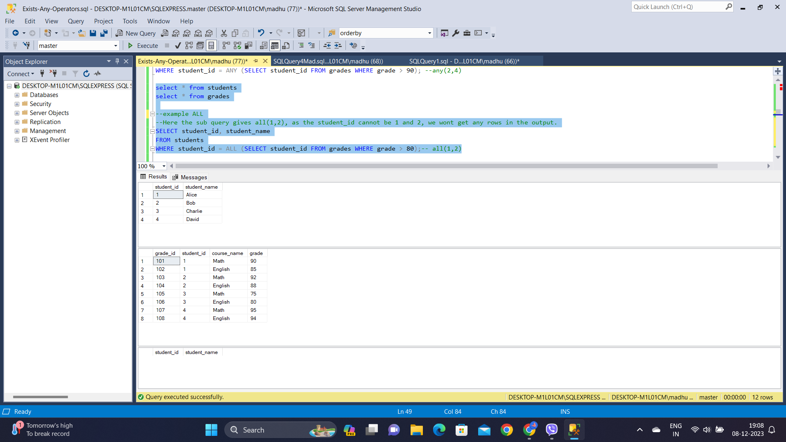

**NESTED SUBQUERIES**

Nested subqueries in SQL involve placing one query inside another, enabling the inner query to reference values from the outer query.

- The below query is checking for students who have a grade in the English course greater than the average grade in English.

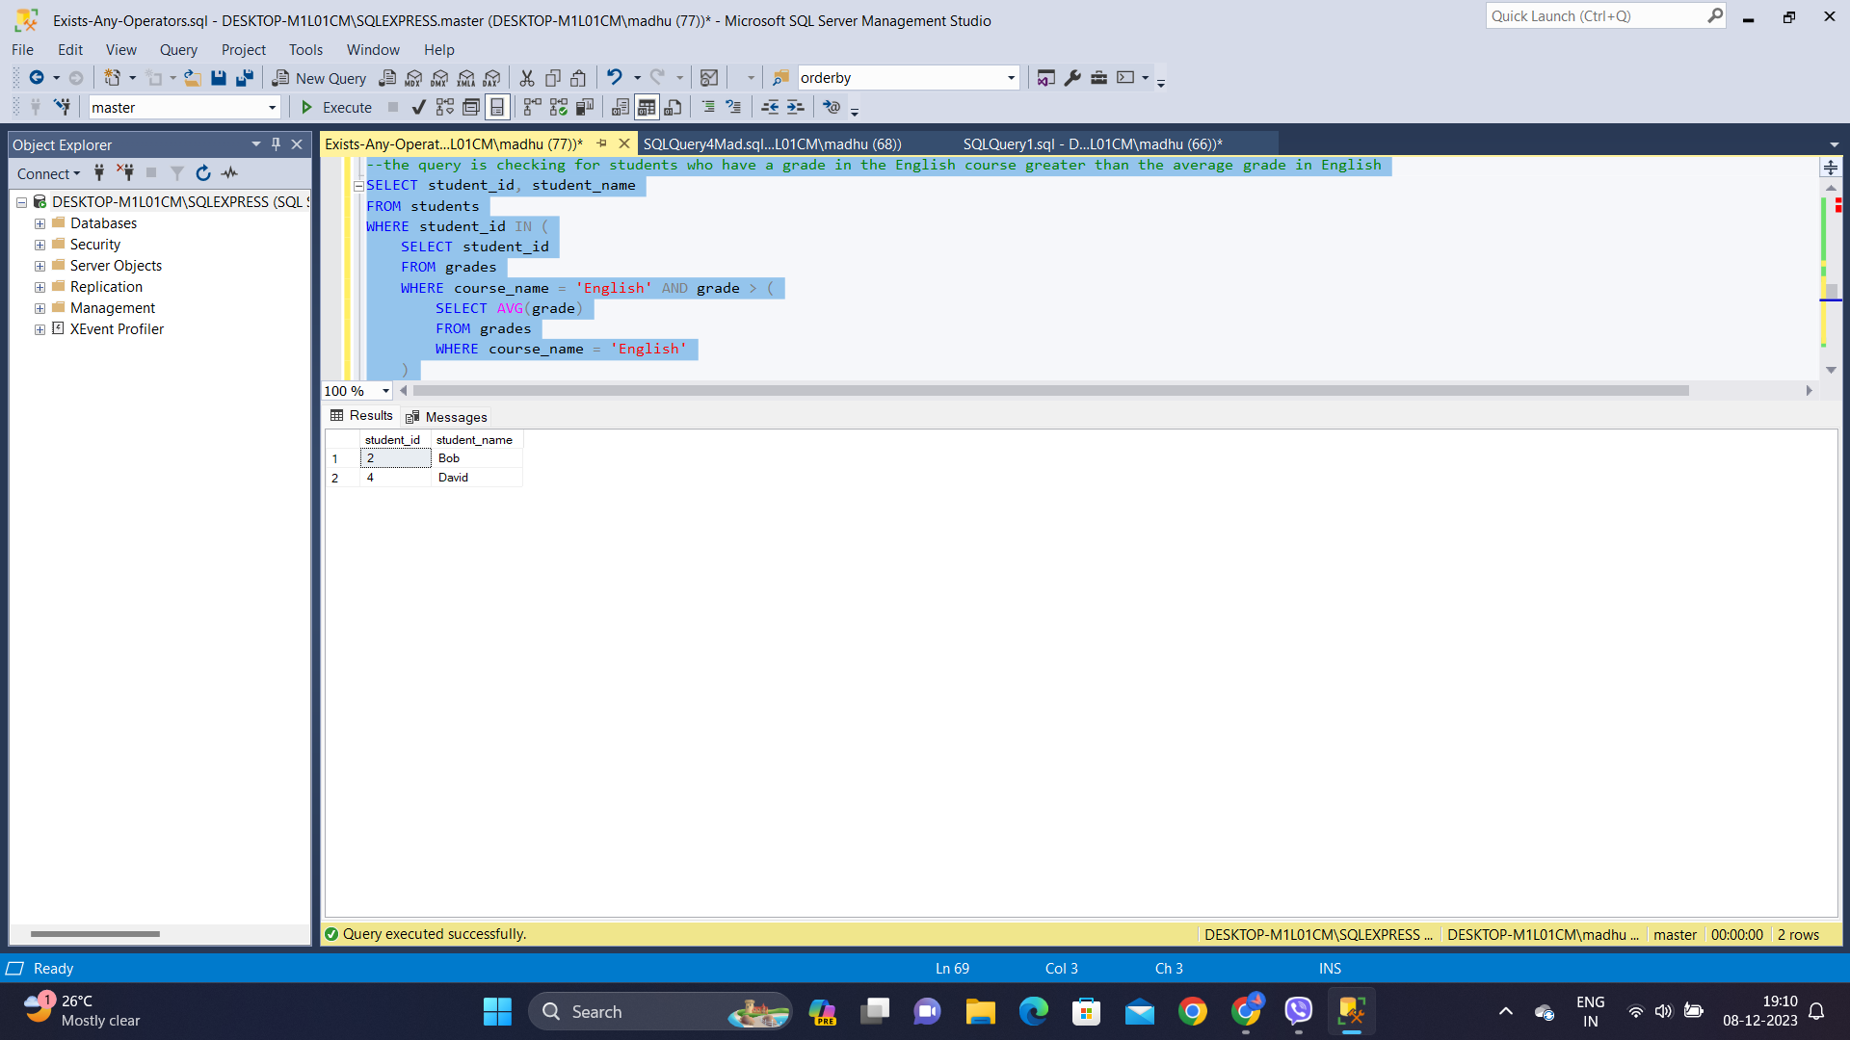

- This query finds students who have grades higher than the average grades in both Math and English.

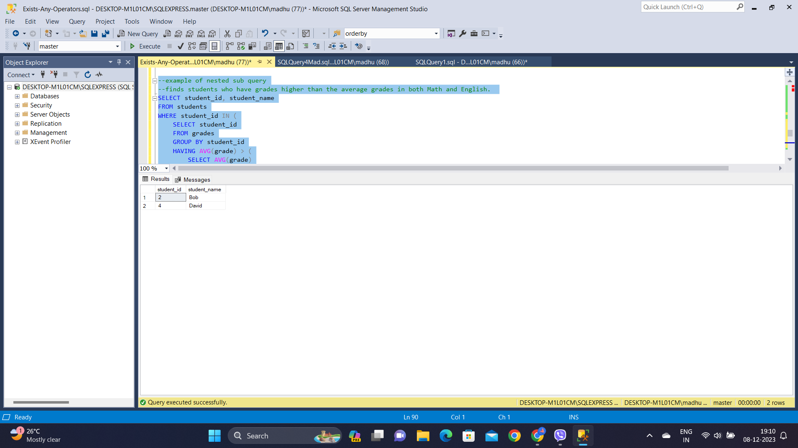

**SET OPERATIONS**

**UNION**

The UNION operator is used to combine the result sets of two or more SELECT statements. It removes duplicate rows from the combined result set.

**UNION ALL**

The UNION ALL operator is similar to UNION, but it includes all rows, including duplicates, from the combined result sets.

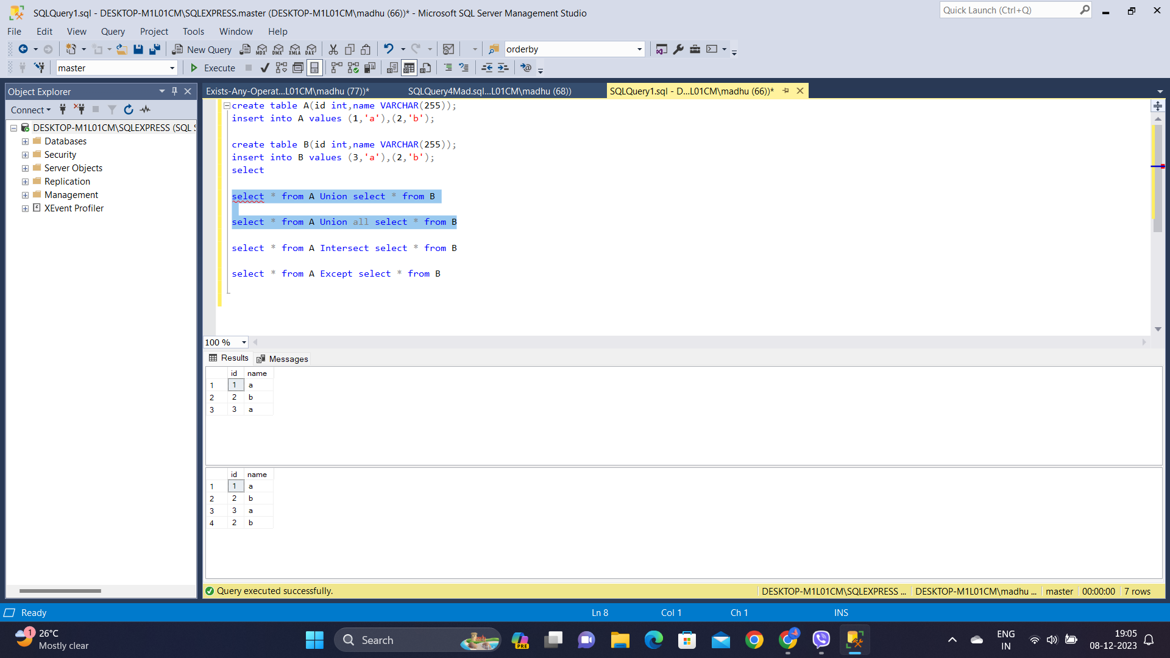

**INTERSECT**

The INTERSECT operator returns the common rows that appear in the result sets of two SELECT statements.

**EXCEPT**

The EXCEPT operator returns the rows that are unique to the first SELECT statement and not present in the result set of the second SELECT statement.

