**Day-6  
Madhu Kalyani Gadi (09-12-2023)**

**SQL Stored Procedures**

The below is a Stored procedure created to display all the records of the SalesList table.

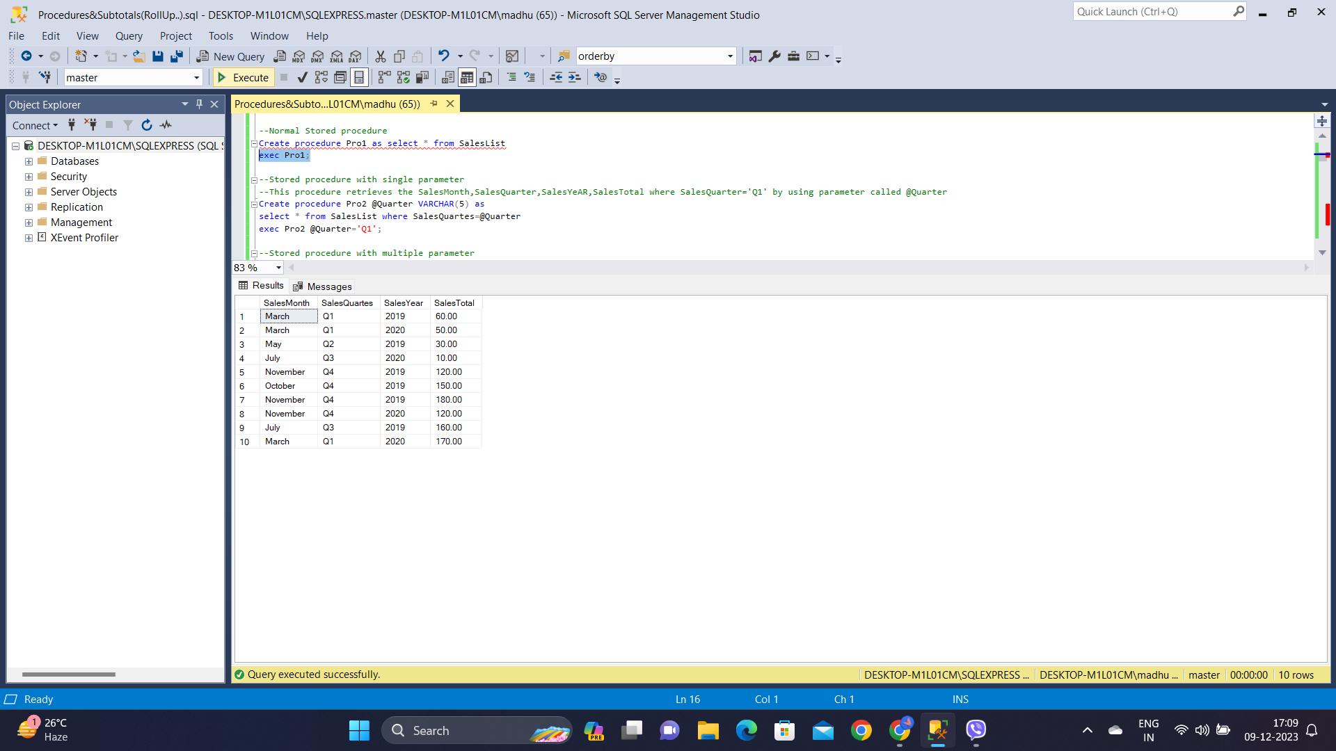

**Stored procedure using Single parameter:**

This procedure retrieves the SalesMonth,SalesQuarter,SalesYeAR,SalesTotal where SalesQuarter='Q1' by using a parameter called @Quarter.

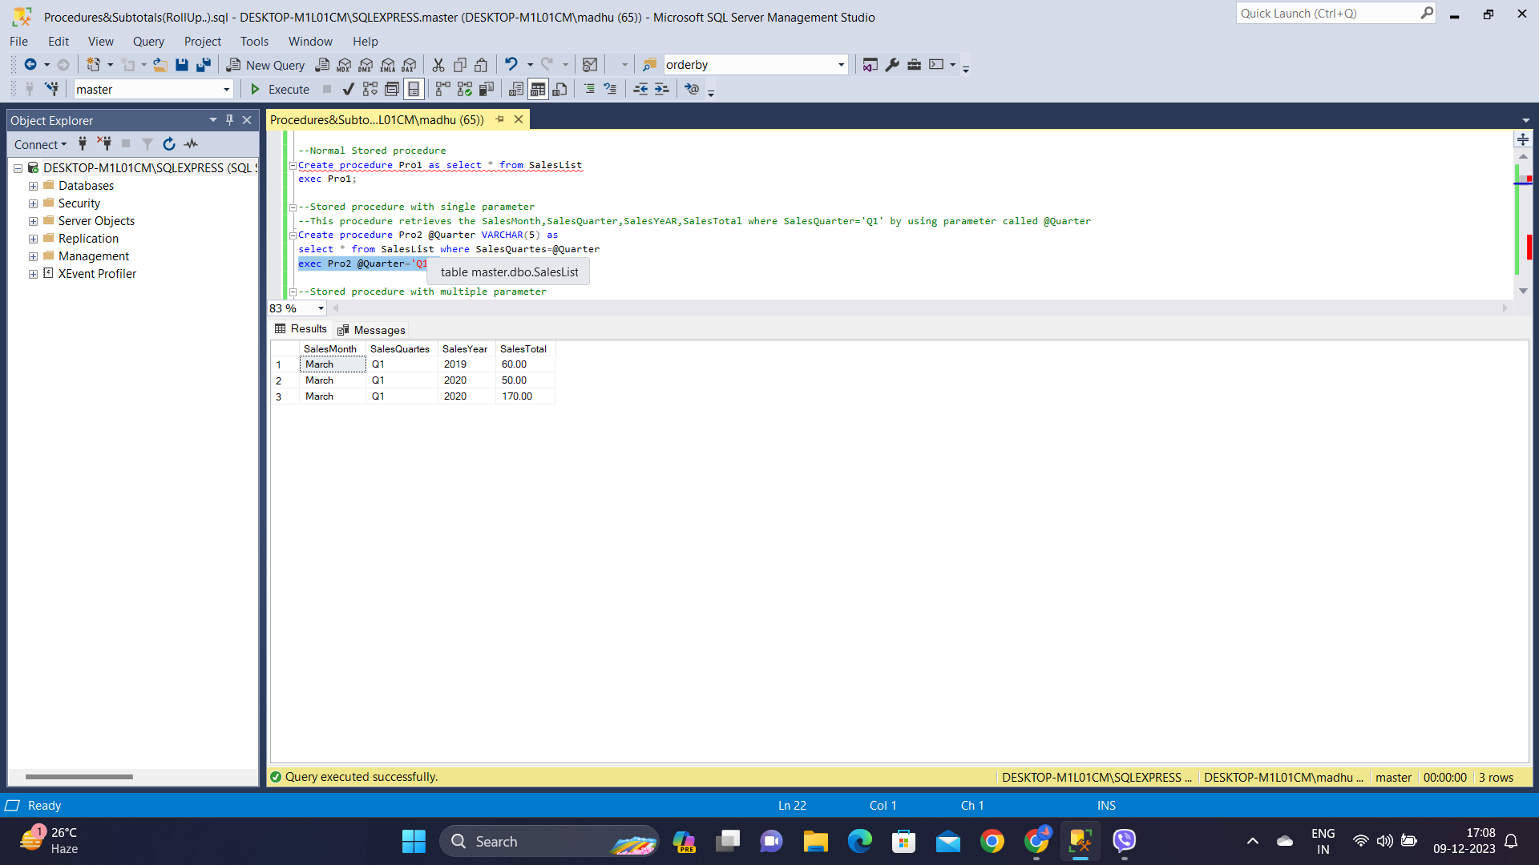

**Stored procedure with multiple parameters:**

This procedure retrieves the SalesMonth,SalesQuarter,SalesYeAR,SalesTotal where SalesQuarter='Q1' and SalesYear=2020 by using parameters called @Quarter and @year.

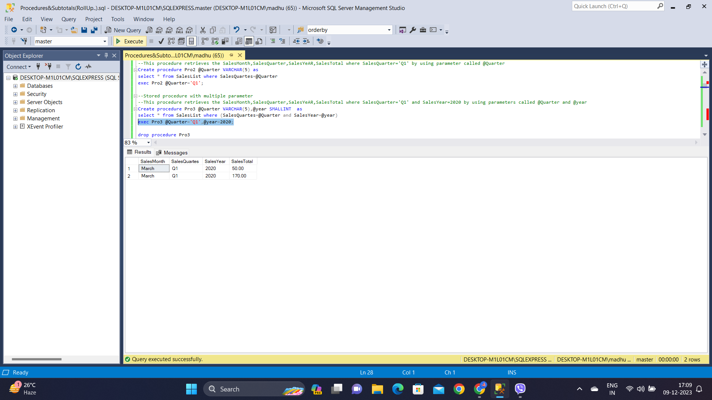

**Subtotals in SQL Queries**

Subtotals in SQL queries can be achieved using aggregate functions along with the GROUP BY clause along with ROLL UP.

**ROLL UP**

In the below query, ROLL UP is done based on SalesYear so the subtotals for 2019,2020 are displayed followed by the grand total.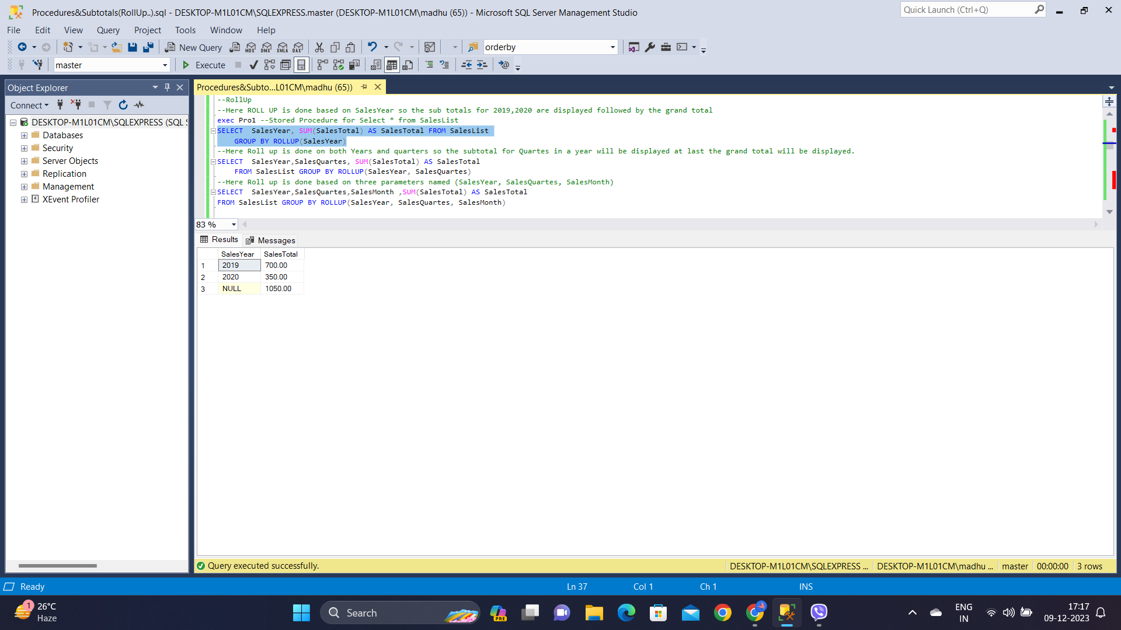

Below ROLL UP is done on both Years and quarters so the subtotal for Quartes in a year will be displayed at last the grand total will be displayed.

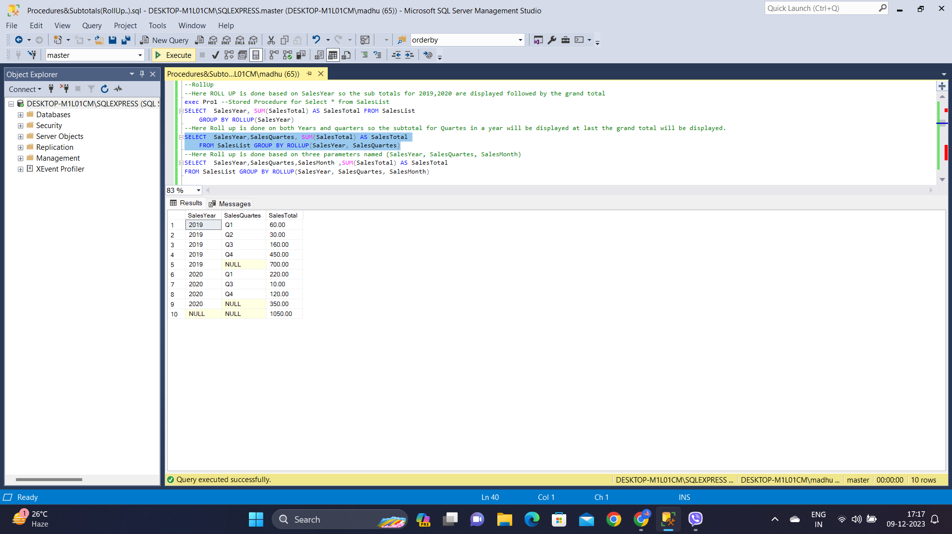

The query below is Roll up, done based on three parameters named (SalesYear, SalesQuartes, SalesMonth)

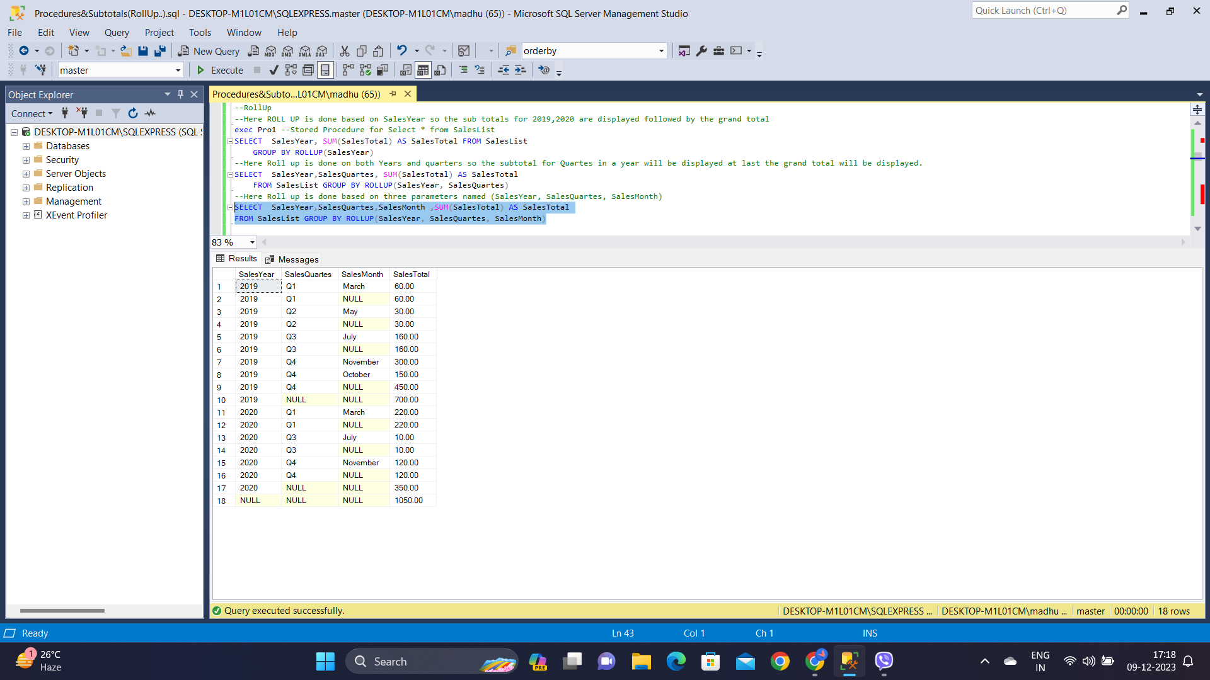

**GROUPING Function**

This function is used to determine whether a column in the result set is part of a grouping set by representing them as 0 or 1.

If the row is grouped then 1 else 0.

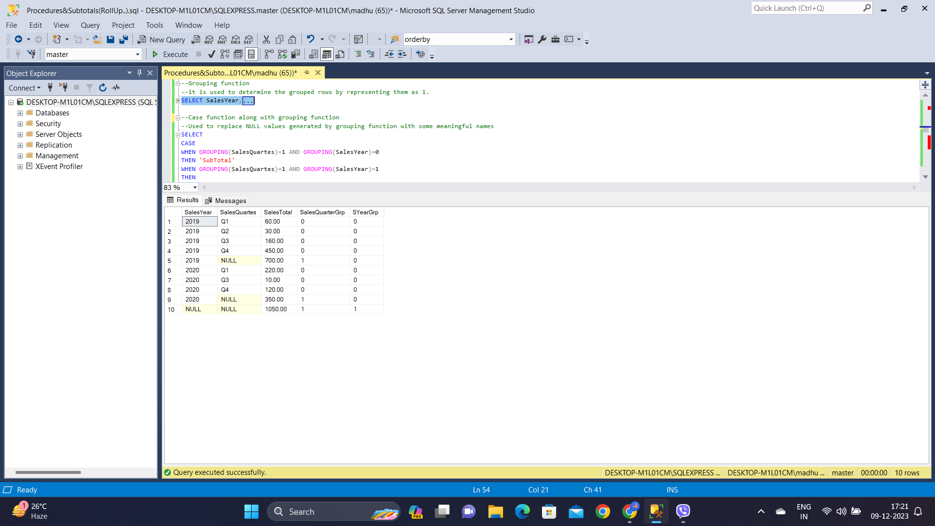

**CASE Function with GROUPING to name the Grouped row as ‘subtotal’**

The below query is used to replace NULL values generated by grouping function with some meaningful names as ‘subtotal’ and ‘grandtotal’.

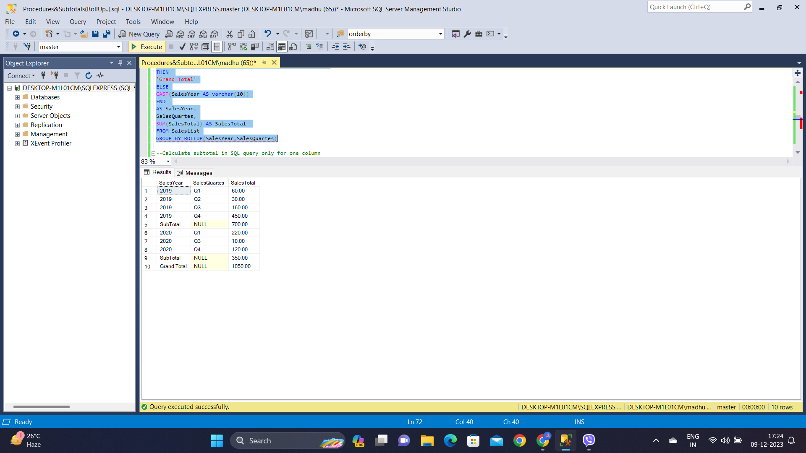

**Calculate subtotal in SQL query only for one column**

For some cases, we may require to add a subtotal in SQL query for only one column. In this situation, we can use the ROW_NUMBER() and NEWID() function together as below.

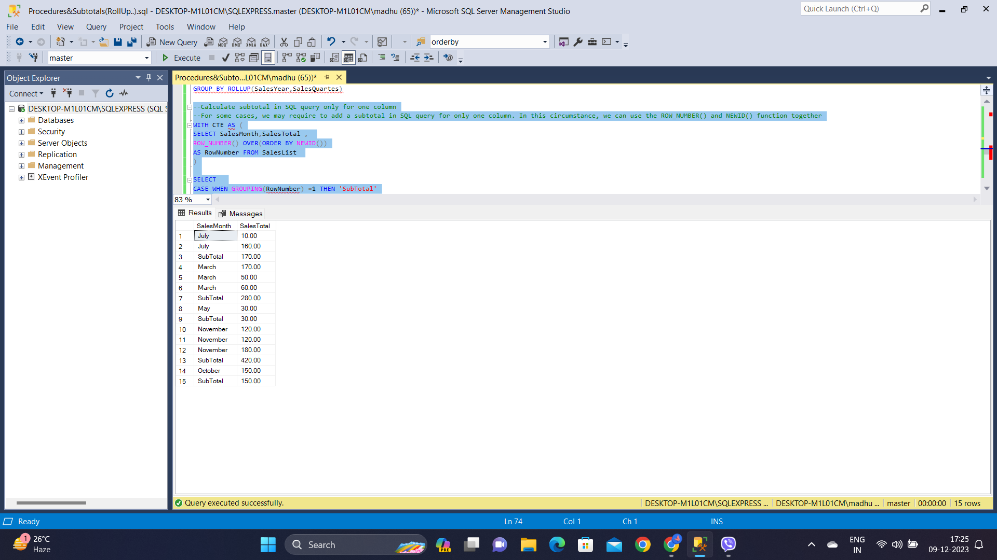

**GROUPING SETS**

In the below query we used the ROLLUP and GROUPING SETS extensions to calculate subtotals in SQL queries.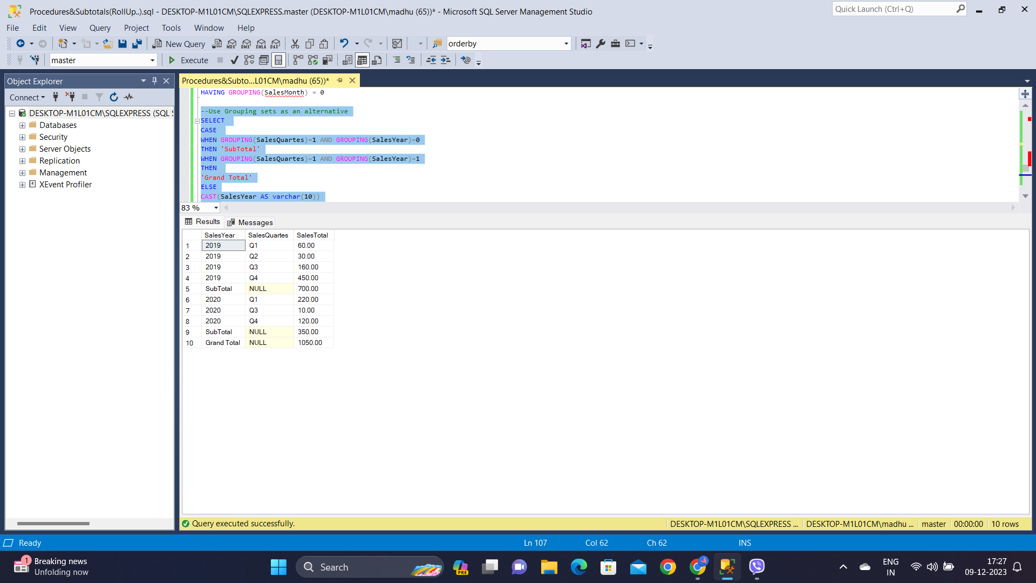

I have also learnt about Database, database schema and its types, its designs.  
  
To summarise-

* A database schema is a logical representation of a database, illustrating how data is organised and related.
* It encompasses attributes, tables, fields, and relationships, providing instructions on data organisation and association.
* It doesn't store data but defines its structure, promoting consistent formatting and unique keys.
* The schema includes logical, physical, and view schemas.
  + The logical schema specifies constraints and relationships, aided by tools like ER modelling.
  + Physical schema details the physical storage on disk, involving files and indices.
  + The view schema outlines end-user interactions. Key differences lie in attributes, key types, and included elements.
* Creating a schema involves SQL statements tailored to the specific database system.
* Schemas and instances differ; the former is a static plan, while the latter is a dynamic snapshot.
* Schema designs, such as flat, hierarchical, network, relational, star, and snowflake, cater to various data organisation needs, emphasising efficiency and scalability in database management.