1. Checking the graph for the below values:

If the learning rate is high all the input is coming closer

Vocabulary size: 2000

Learning rate: 0.7

Num of steps: 20

Embedded size: 200

Window size: 150

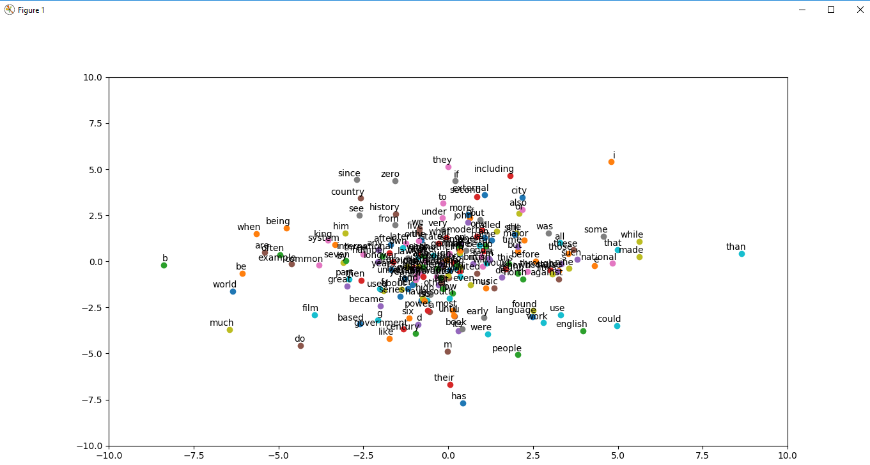

1. Changed learned rate value to 0.03 from the values in 1

If the learning rate is less the values are spread across the graph.

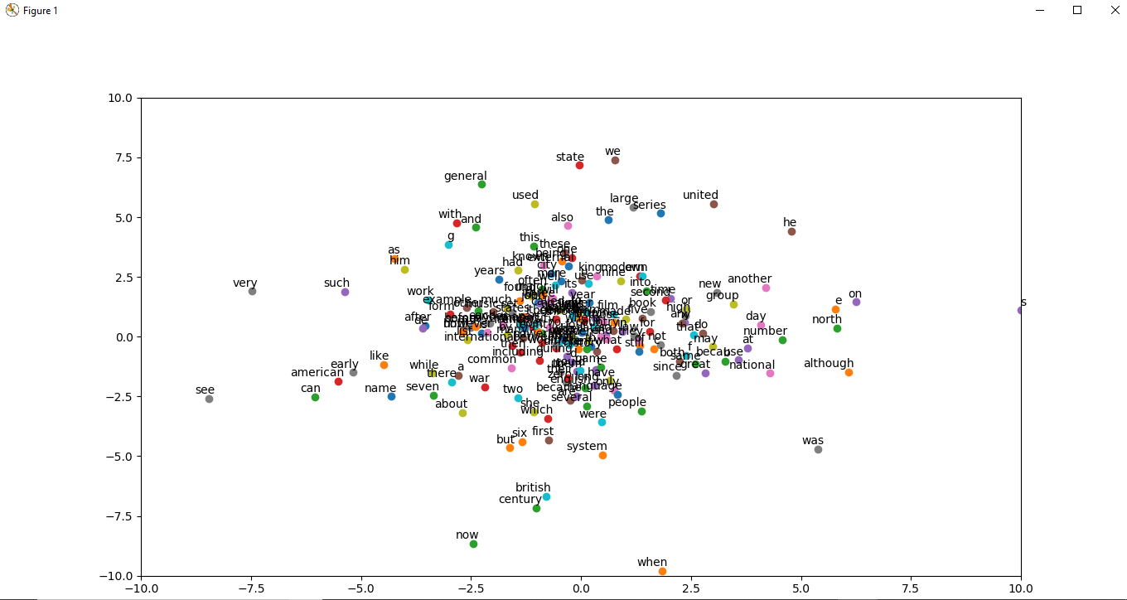

1. Changing window size to 100 from 1 and learning rate as 0.03

If the window size is less the data is overlapped

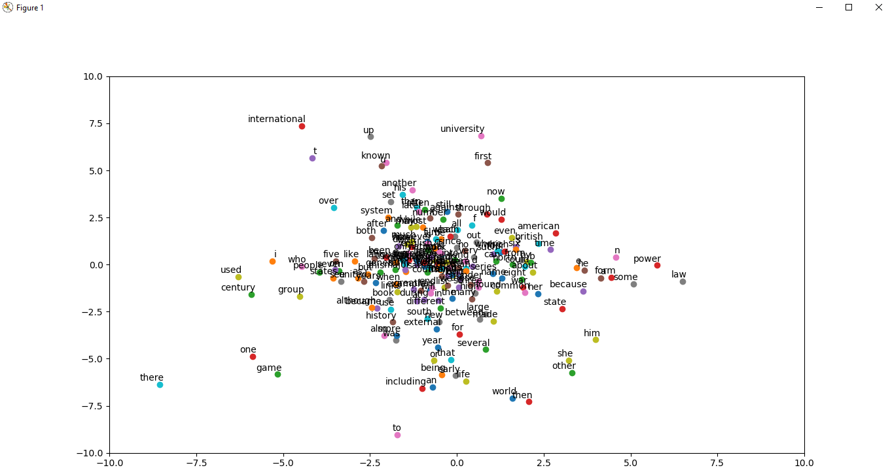

1. Changing the window size to 200

If window size is more the data is spread across the graph.

