Experiment 2 : GitHub Workflow with Branching, Merging, and Pull Request
Demonstrate to create a project in remote repository and apply fork, merge, diff, merge conflict, branch and pull request concepts on repository using GitHub.

Branching
- Clone a Github Repository that contains file demo1.txt
- Switch to main
Git switch main (Git branch -M main)
- Create a new branch:
git branch feature (Eg: git branch B1)
- Switch to the branch:
git switch feature (Eg: git switch B1)
- Or use single line command to create and switch:
git switch -c B1 [ (or) git checkout -b feature ]
- Modify any file (eg : demo1.txt)
- Add and file Commit file:
git add . (or) git add demo1.txt
git commit -m “message……”
- Push the branch to github
git push -u origin B1

The feature (B1) branch will now appear in GitHub.

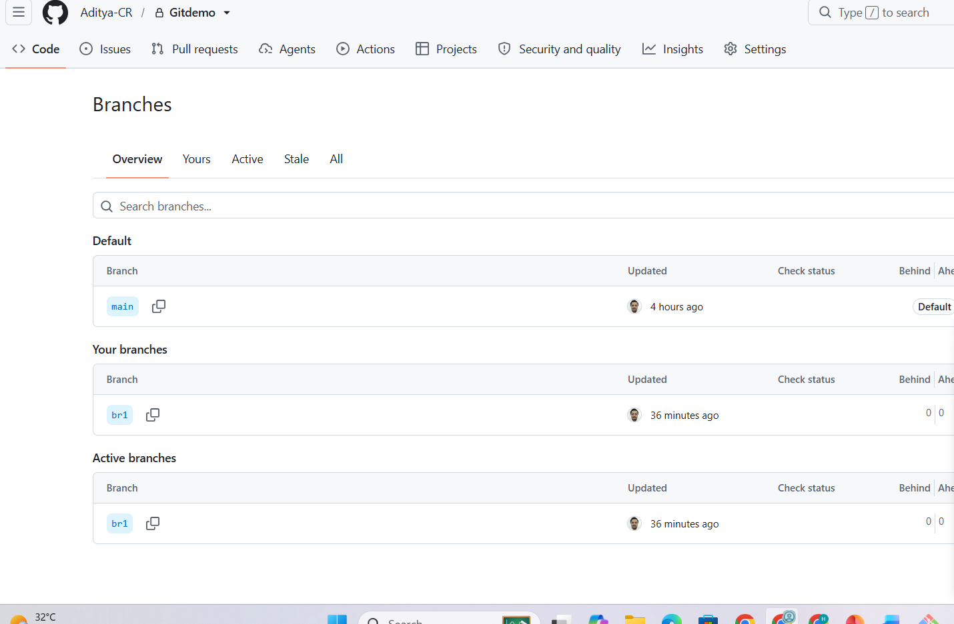
Note:
Some commands, like git checkout try to do too many things at once, which can lead to confusion, even for experienced developers. To address this, Git introduced in latest versions new commands like git switch and git restore, splitting the functionality of git checkout into more focused pieces.

Merge
- Clone a Github Repository that contains files demo1.txt, demo2.txt
- Switch to main
Git switch main (Git branch -M main)
- create a Branch and switch to it
git switch -c student-registration
- Create, Add and commit new file (Eg: demo2.txt)

- Now switch to main:
git switch main
- Check the main branch files
ls
- The demo2.txt will NOT be in the main branch's files. Since it is created and committed in branch student-registration

- Merge the student-registration branch to main
git merge student-registration
- Inspect the main branch
git status (or) ls
Now the demo2.txt is available in main because you have merged the branch.

Merge Conflict

- Clone a Github Repository that contains a file demo.txt
- Switch to main branch and pull latest version
- Create and Switch to a new branch
git switch -c branch_conflict
- Change the demo.txt file ( line 1 with different content)
- Add it and commit it
- Switch back to main branch
git switch main
- Change the demo.txt file ( line 1 with different content)
- Add it and commit it
- Now the demo.txt in main and branch_conflict branches are different (Line 1)
- Merge the branch_conflict with main
Git merge branch_conflict
- You will get merge conflict
warning: Cannot merge binary files: file.txt (HEAD vs. branch_conflict)
Auto-merging file.txt
CONFLICT (content): Merge conflict in file.txt
Automatic merge failed; fix conflicts and then commit the result.

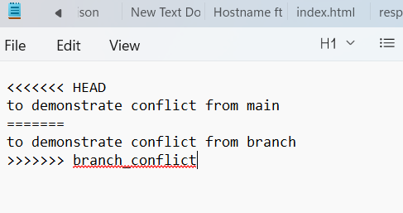

Manually you need to resolve the conflicts

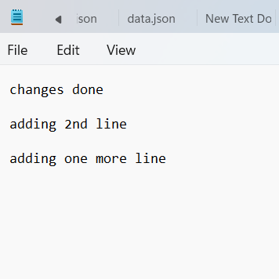

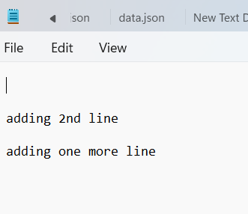

Fork vs Clone
a fork creates a copy of a repository on GitHub's servers under your own account, while a clone downloads a copy of a repository to your local computer

- We can fork the entire repo or only the main branch of the repo.
- If we want a local repository containing only that specific branch use clone
git clone --branch <branch_name> --single-branch <original_repository_URL>
--branch <branch_name> specifies the exact branch you want.
--single-branch tells Git to download only that specific branch, completely ignoring main all other branches.
Once cloned locally, you can create a brand new, empty repository on GitHub and push this single branch to it as your primary branch

Pull Request
A pull request (PR) on GitHub isa proposal to merge code changes from one branch into another. It is the primary tool for collaboration, allowing team members to review code, discuss changes, run automated tests, and fix bugs before the code goes live.

- Create a Repository “Pull-Request-Demo “ in Git Hub
https://github.com/Aditya-CR/Pull-Request-Demo.git
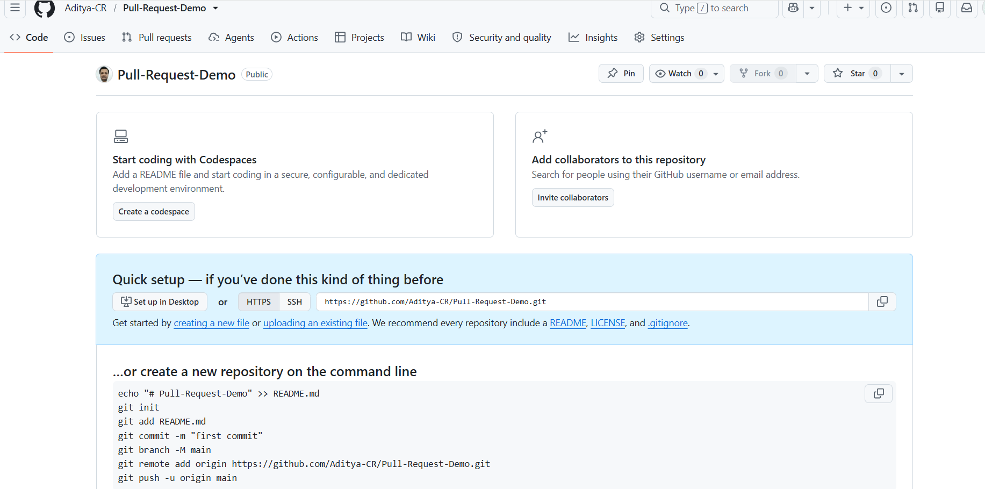

- Create a new file demo.txt
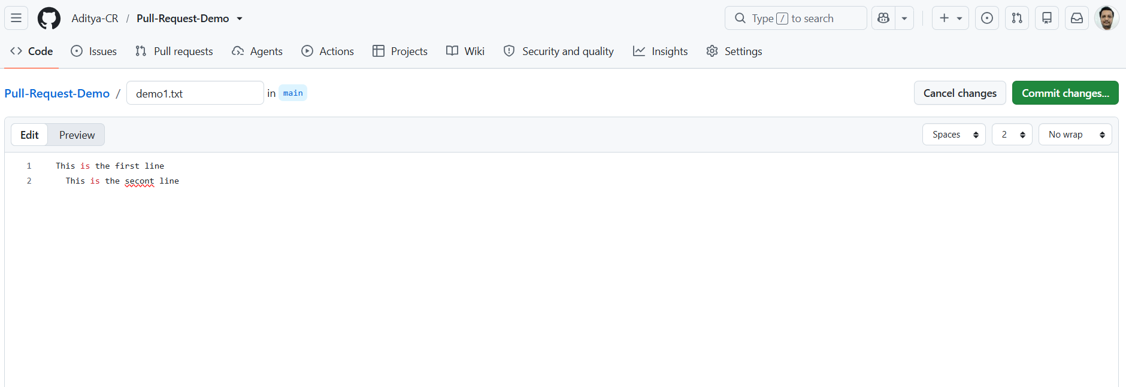

Commit changes
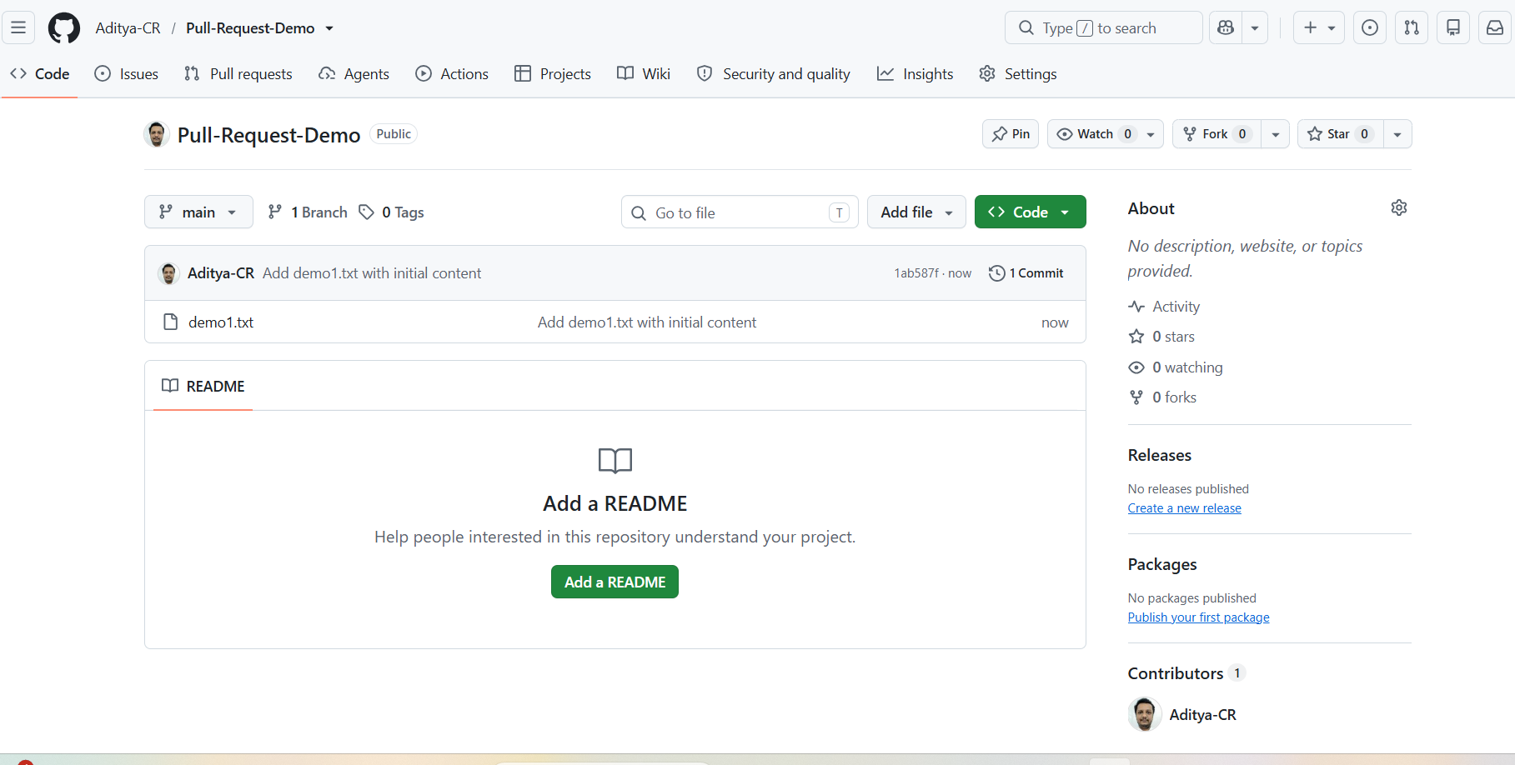

- Create a Branch in GitHub
Goto Branch New Branch Create a branch B1 in GitHub
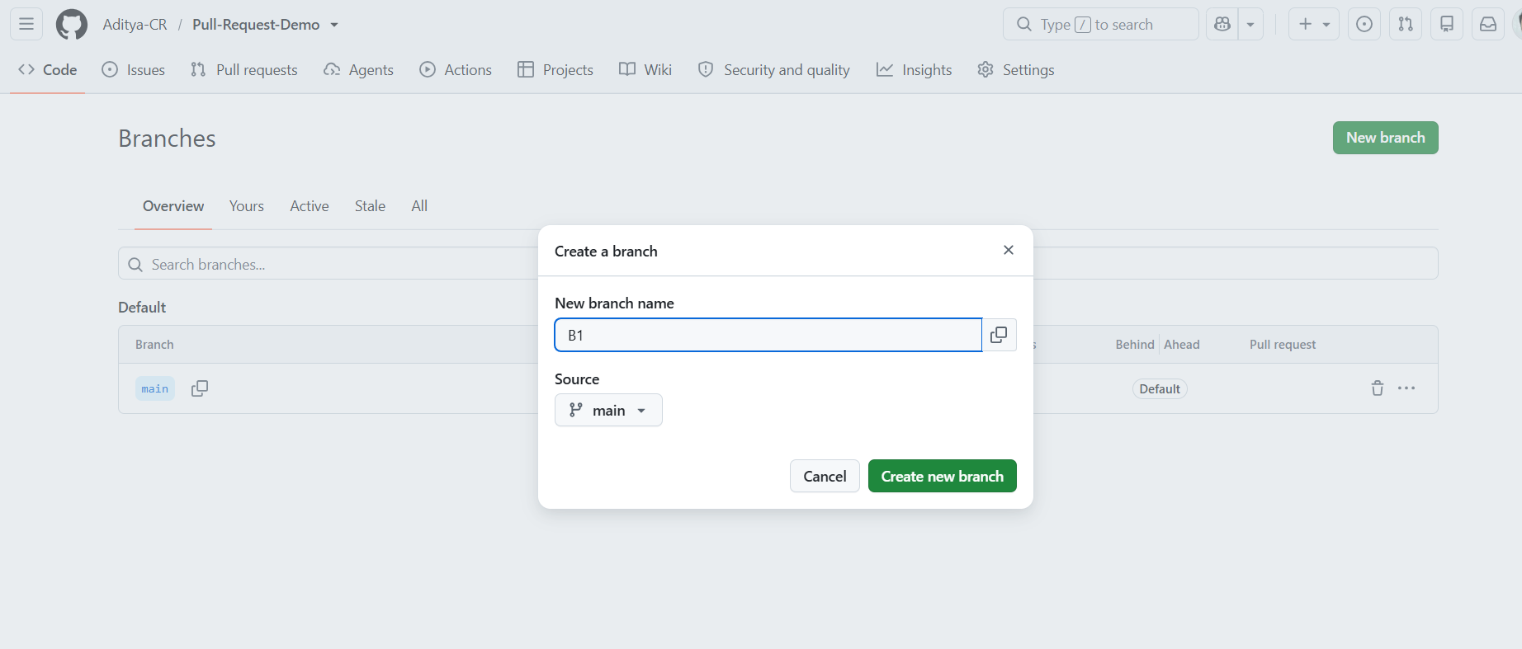
A new branch B1 is created . All files from Main branch are visible through B1
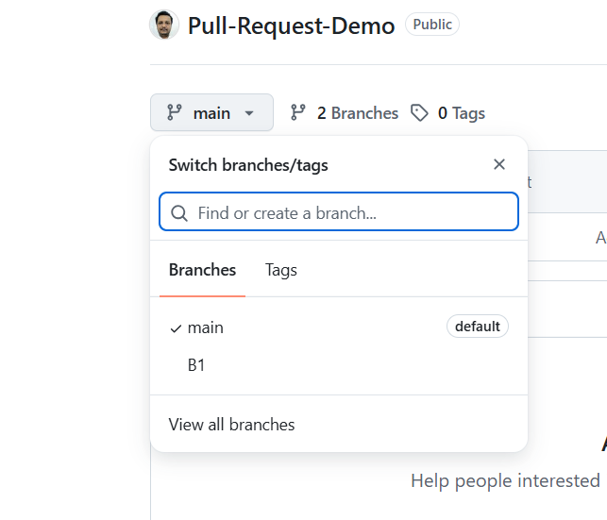
- Create one more Branch B2 in similar lines in github or through local Git Commands

- Clone the Git Hub Repository
git clone https://github.com/Aditya-CR/Pull-Request-Demo.git
- Change working directory to cloned repository
cd Pull-Request-Demo
- Switch to main (if needed, by default in cloned repo you will be in main branch)
Git switch main
- Create and switch to new branch B2
git switch -c B1
- Create a new file, add and commit in B2
echo "This is second file" > demo2.txt
git add .
git commit -m “created 2nd file”

- Push the branch B2 to github
Git push -u origin B2

- The new branch to be visible in github

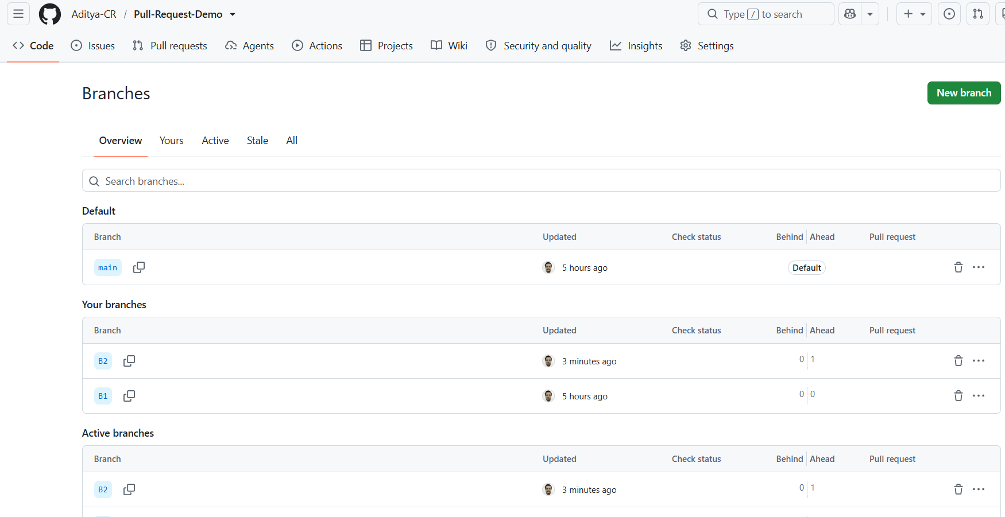

- In GitHub goto “Pull Requests”
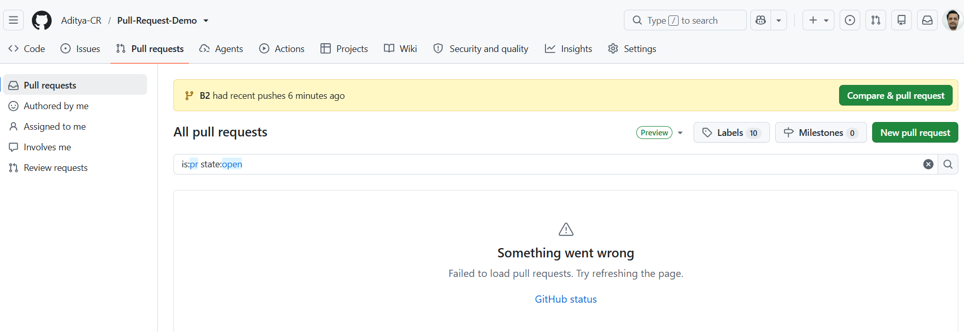
Since Branch B2 has a file demo2.txt which was not in main branch. “Compare & pull request” will be highlighted suggesting for merging changes from B2 to main.
Use “Compare & Pull request” or else “New pull request”
Select the branches to be merged (B2 to Main in this case)
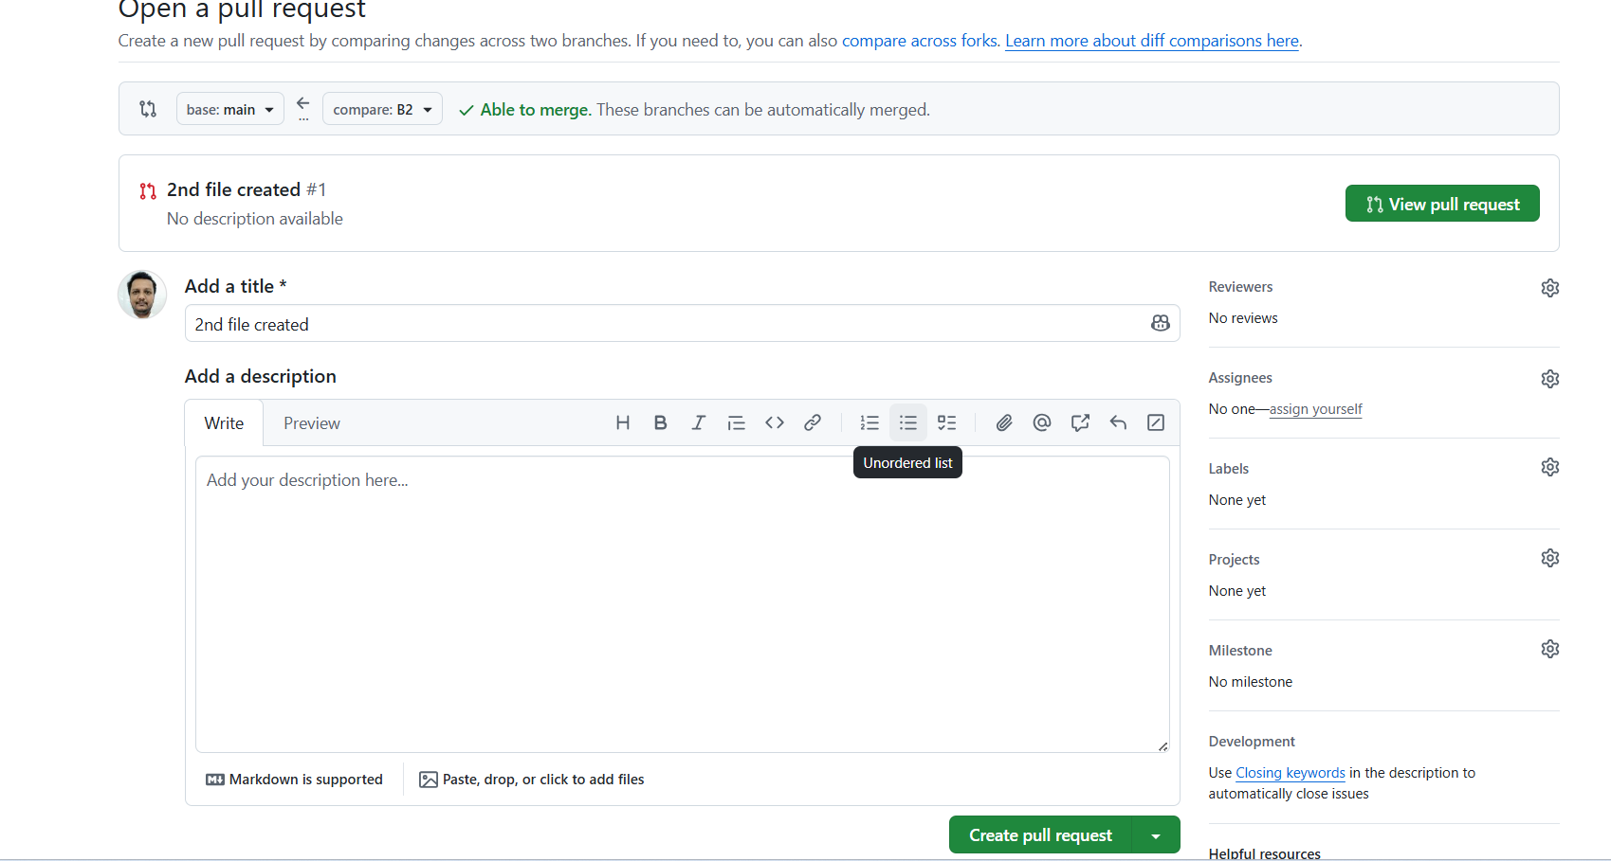

Then “Create pull request”
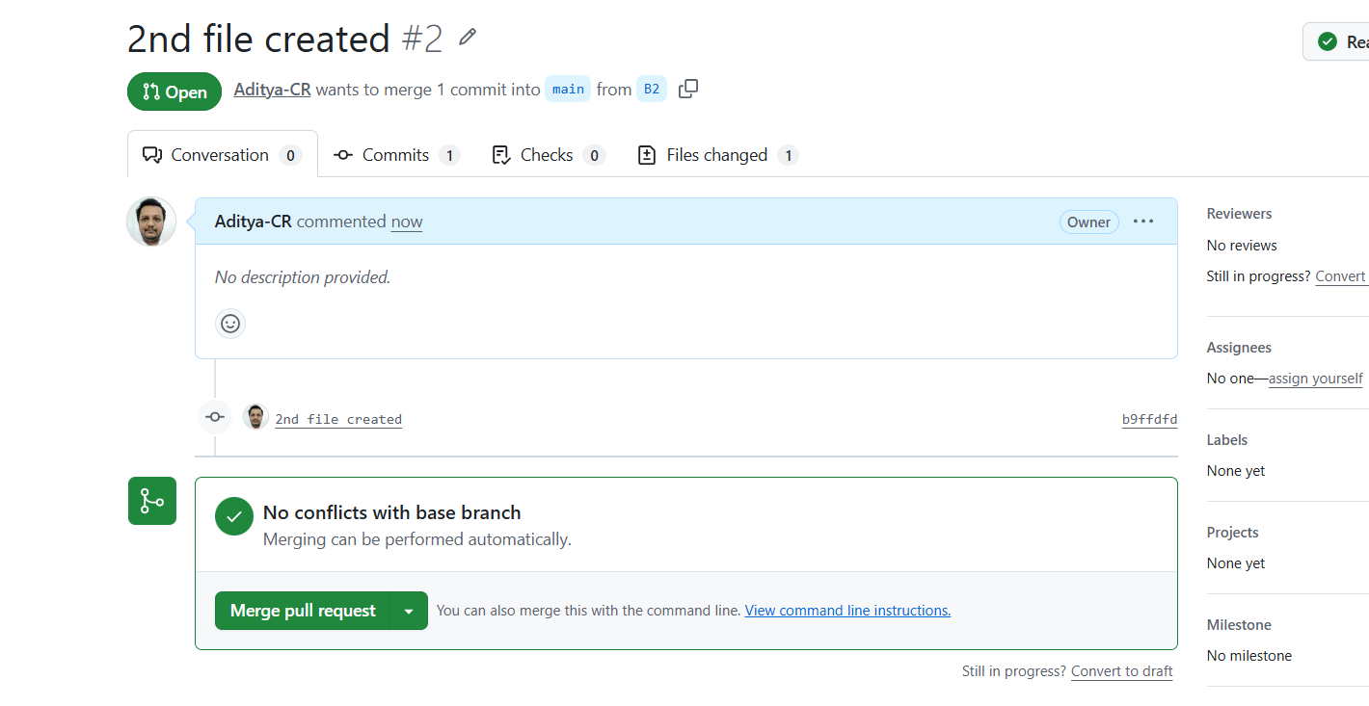
Github will check for conflicts. If no conflicts it will show for “Merge pull request”. Click on it and confirm merge.
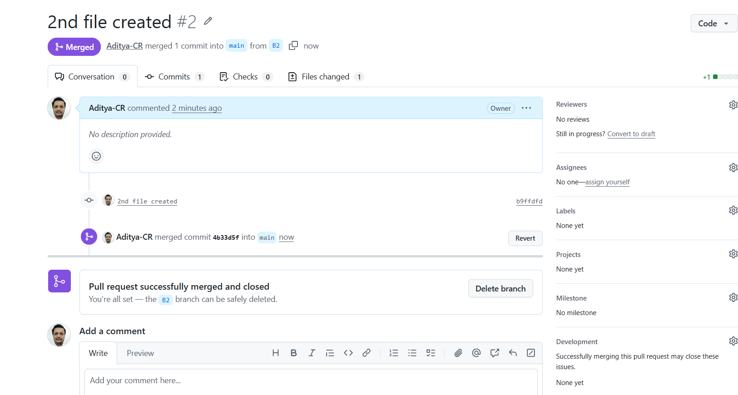

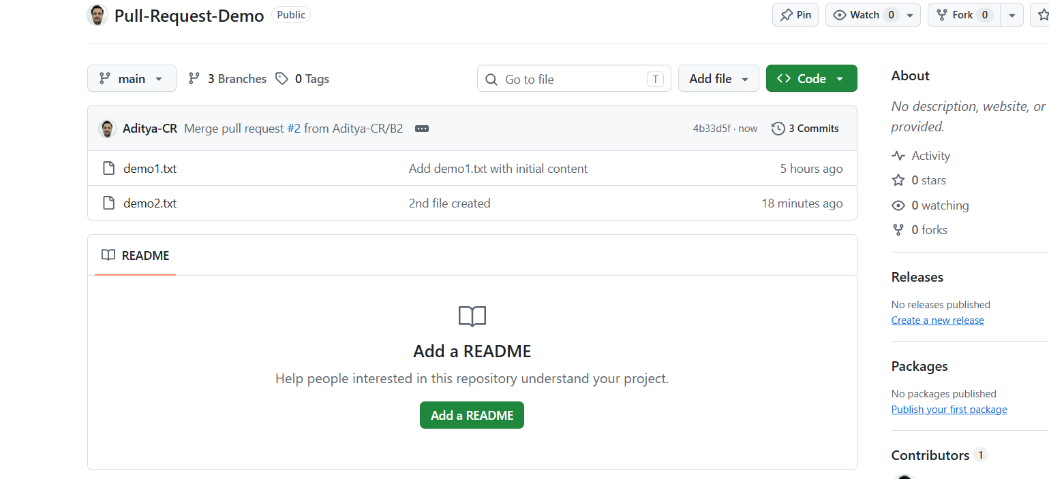
Demo2.txt is successfully merged to main branch

- To know merge conflict
Goto to B1 branch open demo1.txt edit the file commit changes
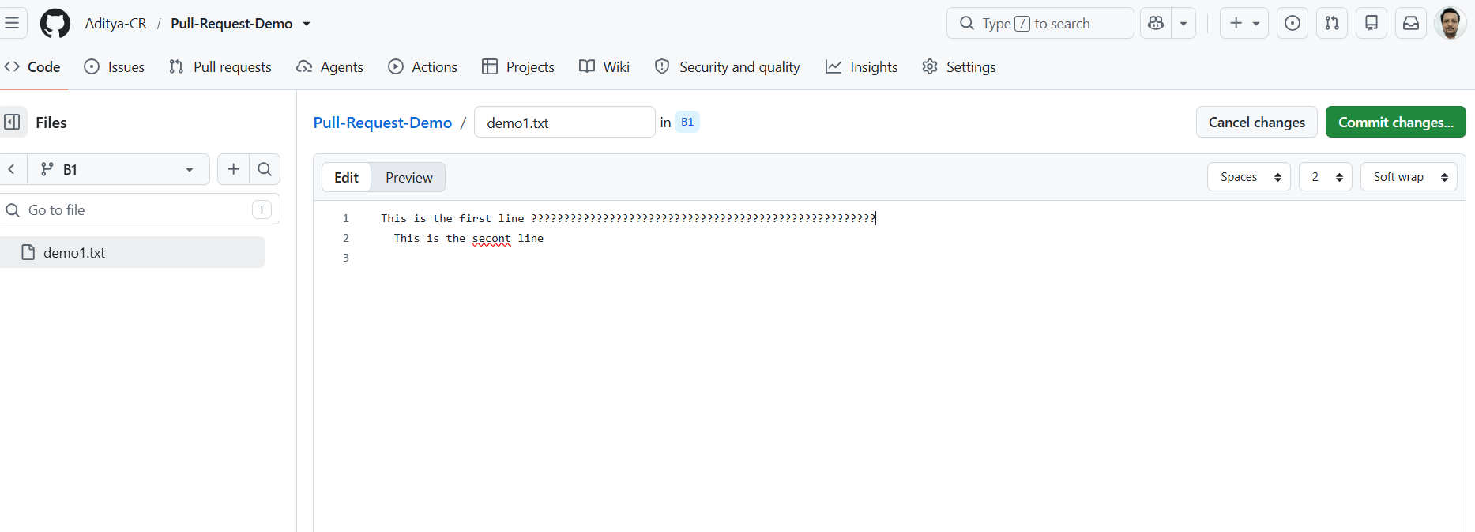

Goto to B2 branch open demo1.txt edit the file commit changes
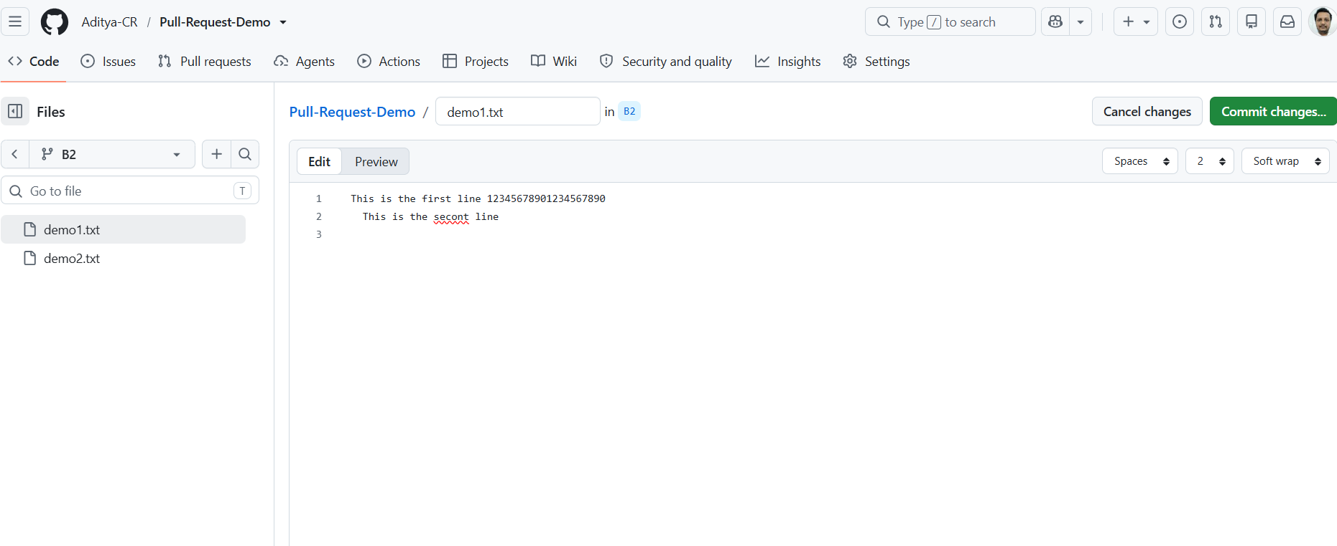

Now demo1.txt has been changed in B1 and B2
Create a pull request to merge the demo1.txt from B1 to main. There will be no conflict.
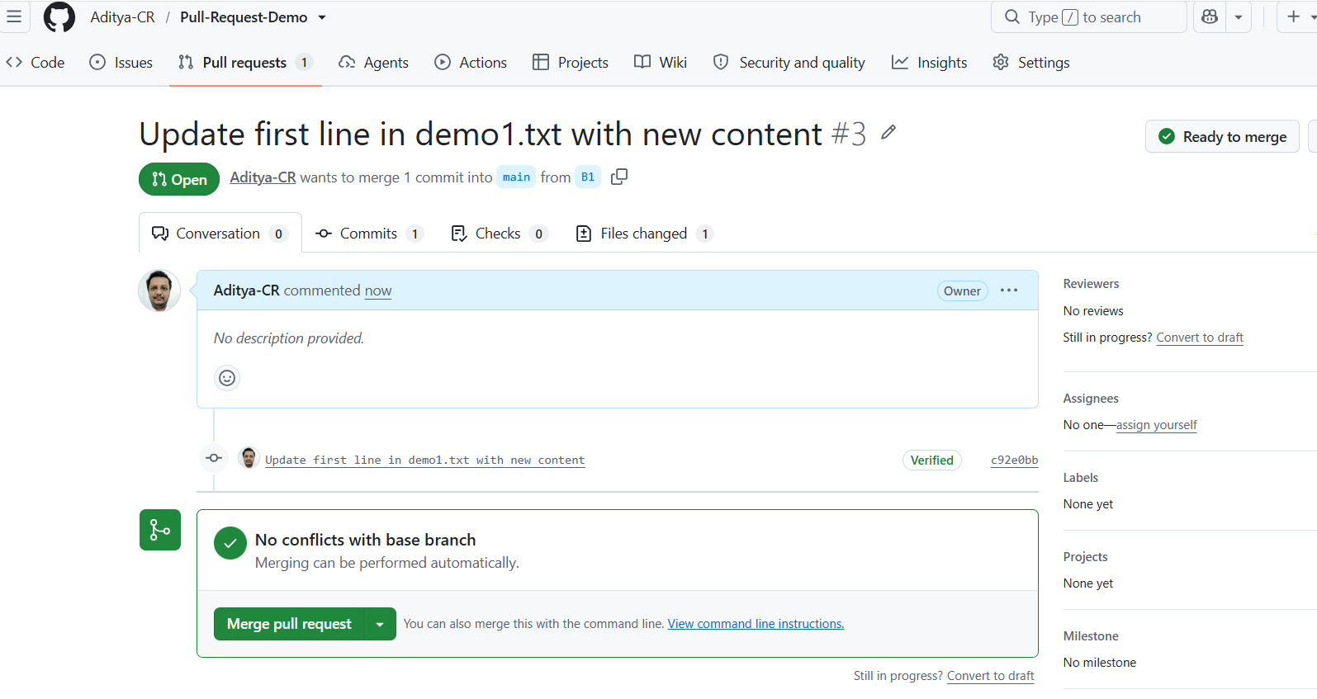
Confirm the merge. Now Main branch is updated with the contents from B1 (Verify the changes in contents)

Next try to create a pull request from B2 to main for demo1.txt. You will see a warning
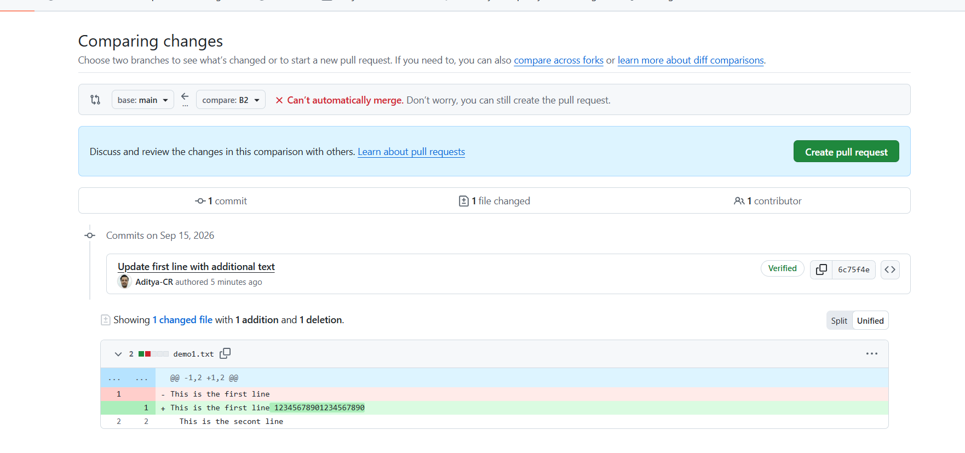
Still if you create a pull request, you will get merge conflict
Reason : The demo1.txt in main was changed by update from branch B1. Merging the same file from branch B2 will have conflict since same line has been changed in demo1.txt.
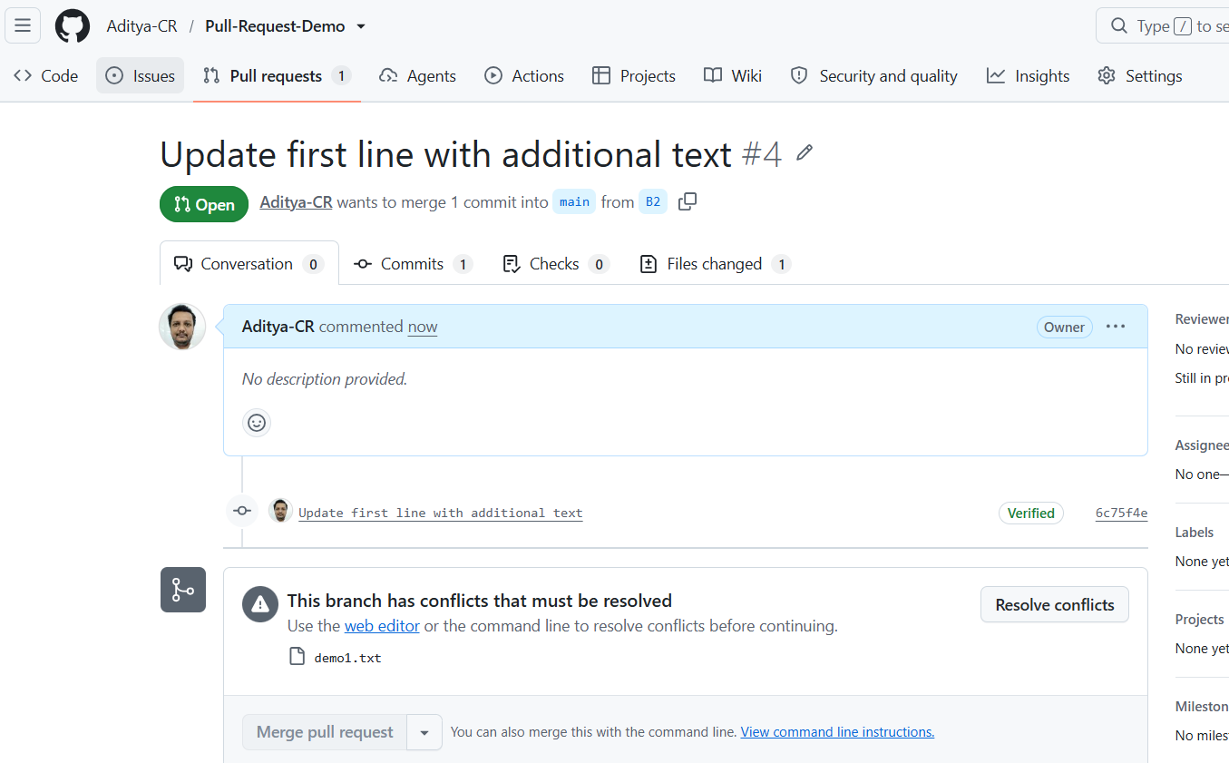

Select Resolve conflicts and manually resolve the conflict before merging
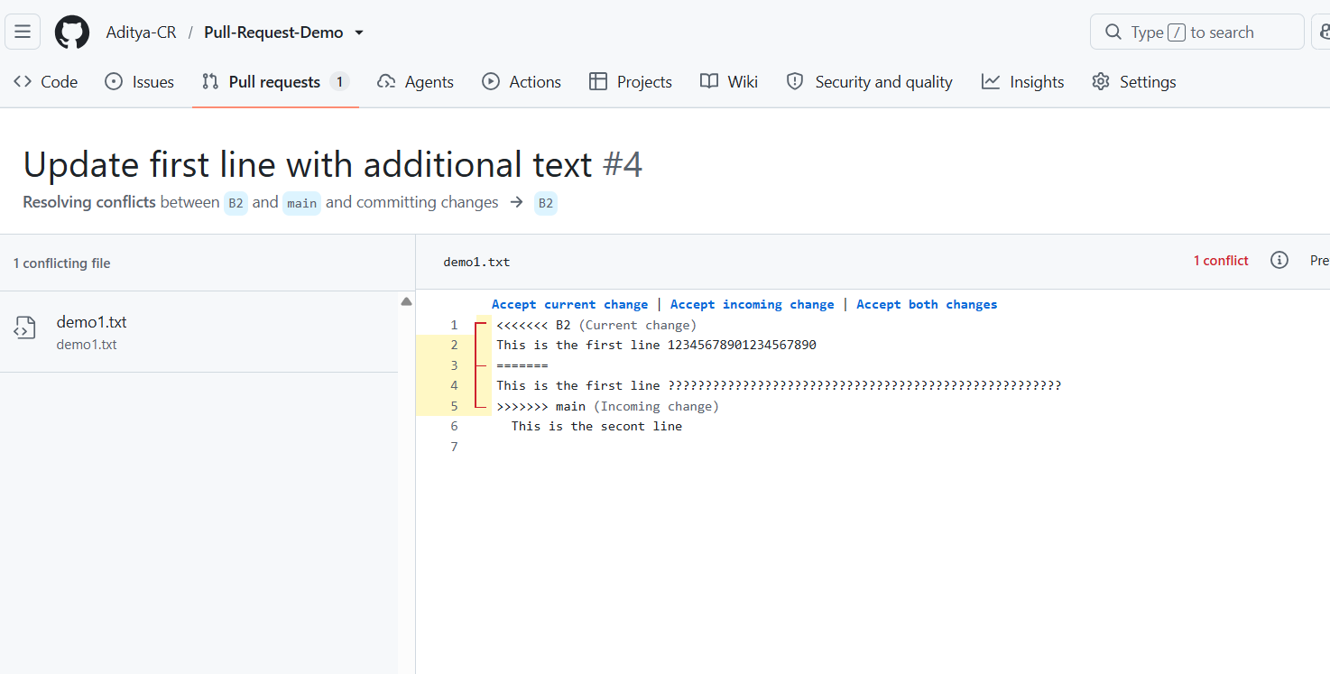

NOTE:
Suppose Person-A clones a repository of Person-B from github to local Git repository. makes changes, adds and commits. Then pushes the repo back to git hub using "push origin main" will the local repository be pushed to Person-A github or Person-B github ?
It depends on what origin points to.
Suppose:
- Person-B owns GitHub repository: https://github.com/Person-B/project.git
- Person-A clones it:
git clone https://github.com/Person-B/project.git
Git automatically creates a remote called origin.
So, in Person-A's local repository:
git remote -v
will show something like:
origin https://github.com/Person-B/project.git (fetch)
origin https://github.com/Person-B/project.git (push)
Therefore, when Person-A executes:
git push origin main
Git tries to push to Person-B's repository, NOT Person-A's repository.

But there is an important catch
Person-A must have permission to push to Person-B's repository.
If Person-B has not given Person-A write access, the push will generally be rejected.
For example:
remote: Permission to Person-B/project.git denied to Person-A

What if Person-A wants the code in Person-A's GitHub?
There are two common approaches.

Method 1: Fork
Person-A first forks Person-B's repository.
Then the structure becomes:
Person-B
│
│ fork
↓
Person-A/project
│
│ clone
↓
Person-A's Local Repository
Now:
git push origin main
will push to Person-A's fork, assuming origin points there.
This is the normal Fork → Clone → Modify → Commit → Push → Pull Request workflow.

Method 2: Change the origin
Person-A can also change where origin points:
git remote set-url origin https://github.com/Person-A/project.git
Then:
git push origin main
will push to Person-A's repository.

In short:
Situation | git push origin main goes to
A cloned B's repository | B's repository
A cloned A's fork | A's fork
A changed origin to A's repository | A's repository

Group Activity

Suppose I want to assign 2 subtaks to 2 programmers as a team lead and collaborate in github . how to do it?
To collaborate smoothly, your programmers must follow a structured Feature Branch Workflow. This prevents them from overwriting each other's code and allows you to review their work before it goes live.
Here is the exact step-by-step process your programmers should follow, including the terminal commands.
1. Set Up the Tasks (GitHub Issues)
Create individual tracking tickets for each subtask so your programmers have clear goals.
- Create a Main Issue: Write a parent issue that describes the overall goal or feature.
- Create Subtask Issues: Click New Issue for each subtask.
  - Title them clearly (eg, Subtask 1: Build Frontend Login Form).
  - Use the Assignees section on the right sidebar to assign each issue to the respective programmer.
  - Link them to the main issue by pasting their issue numbers (eg, Closes #12) in the description.
2. Organize the Workflow (GitHub Projects)
Use a Kanban board to visualize who is doing what and the current status of each task.
- Go to the Projects tab at the top of your repository and click New Project .
- Choose the Board template (this gives you Todo , In Progress , and Done columns).
- Click Add Item in the Todo column and link the subtask issues you just created.
3. The Collaboration Workflow (For the Programmers)
Instruct your programmers to follow this standard branch-and-merge workflow to avoid messing up the main codebase:
[Main Branch] ───┬───────────────────────────────────► [Merge & Deploy]
│ ▲
├──► [Branch 1] ──► [Pull Request] ──┤ (Code Review)
│ ▲
└──► [Branch 2] ──► [Pull Request] ──┘
- Clone & Branch: Each programmer pulls the latest code from the mainbranch and creates a new feature branch locally:
bash
git checkout -b feature/subtask-name
Use the code carefully.
- Commit Work: They write their code and commit it with clear messages.
- Push & Open a Pull Request (PR): They push their branch to GitHub and open a Pull Request (PR).
4. Review and Merge (Your Role as Team Lead)
Once a programmer submits a Pull Request, you play the role of the gatekeeper:
- Code Review: Go to the PR's Files changed tab. Leave comments on specific lines of code if changes are needed.
- Approve: Once the code looks good, click Review changes -> Approve .
- Merge: Click Merge pull request to officially add their subtask into the mainbranch.

Phase A: Getting Started & Creating a Branch
Before writing any code, each programmer must download the latest project files and create an isolated workbench (a branch) for their specific subtask.
1. Clone the repository (Only if they haven't already)
The programmer downloads the project to their local computer:
git clone https://github.com
cd YourRepository
2. Update the main branch
They must ensure they have the absolute latest updates from the team:
git checkout main (or) git switch main (Switch your current working environment to the main branch)
git pull origin main (Get the latest Changes from GitHub)
3. Create and switch to a new subtask branch
They create a unique branch named after their task. This isolates their code from the other programmer:
- Programmer 1: git checkout -b feature/login-form
- Programmer 2: git checkout -b feature/database-setup

Phase B: Writing & Saving Code
As the programmers work on their respective subtasks, they save snapshots of their progress locally.
4. Check modified files
To see which files they have changed or added, they run:
git status
5. Stage the changes
They select the files they want to save for this specific update:
# To stage a specific file:
git add src/login.js

# OR to stage all modified files at once:
git add .
6. Commit the changes
They save the staged snapshot locally with a clear, descriptive message explaining what they did:
git commit -m "Create layout and style inputs for the login form"
(They can repeat steps 4, 5, and 6 multiple times a day as they build the feature).

Phase C: Uploading & Requesting a Merge
Once the subtask is fully complete and tested locally, they upload it to GitHub so you can review it.
7. Push the branch to GitHub
They upload their local branch to the remote GitHub repository:
# For Programmer 1:
git push -u origin feature/login-form

# For Programmer 2:
git push -u origin feature/database-setup
(The -u flag is only needed the very first time they push a new branch).
8. Open a Pull Request (PR) on GitHub
The programmer must now transition from the terminal to the web browser:
- Go to your repository on GitHub.com.
- A yellow banner will automatically appear saying: “feature/login-form had recent pushes less than a minute ago.”
- Click the green Compare & pull request button next to it.
- In the description box, instruct them to link their assigned issue by typing:
Closes #12 - This adds the UI for the login form.
- Click Create pull request.

If both programmers happen to edit the exact same lines of code in the same file, GitHub will flag a Merge Conflict.

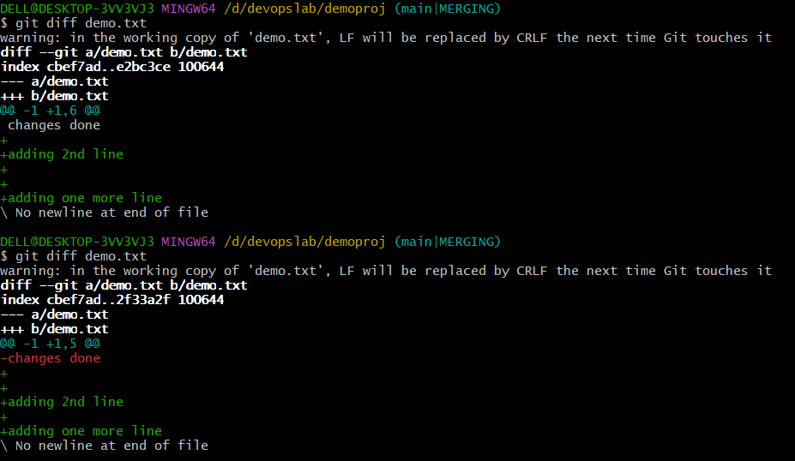
Demonstation of diff
git diff # unstaged changes
git diff --staged # staged changes
git diff HEAD # all changes since last commit
git diff main..feature # differences between two branches
git diff <commit1> <commit2>
git diff -- filename # changes to one file
git log
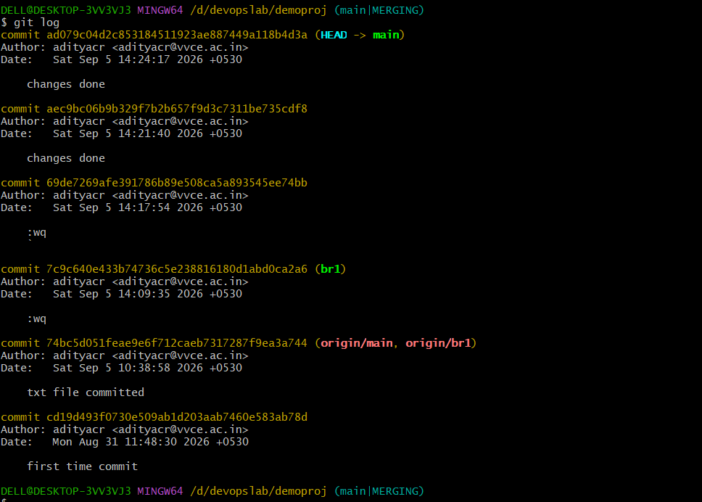

DELL@DESKTOP-3VV3VJ3 MINGW64 /d/devopslab/demoproj (main|MERGING)
$ git cd19d493f0730e509ab1d203aab7460e583ab78d 7c9c640e433b74736c5e238816180d1abd0ca2a6
git: 'cd19d493f0730e509ab1d203aab7460e583ab78d' is not a git command. See 'git --help'.

DELL@DESKTOP-3VV3VJ3 MINGW64 /d/devopslab/demoproj (main|MERGING)
$ git diff cd19d493f0730e509ab1d203aab7460e583ab78d 7c9c640e433b74736c5e238816180d1abd0ca2a6
diff --git a/demo.txt b/demo.txt
new file mode 100644
index 0000000..b1eb873
--- /dev/null
+++ b/demo.txt
@@ -0,0 +1 @@
+good morning
diff --git a/demo2.txt b/demo2.txt
new file mode 100644
index 0000000..f269e64
--- /dev/null
+++ b/demo2.txt
@@ -0,0 +1 @@
+changes done again

Snapshot 1
DELL@DESKTOP-3VV3VJ3 MINGW64 /d/devopslab/demoproj (student-registration)
$ echo "changes done again" > demo2.txt

DELL@DESKTOP-3VV3VJ3 MINGW64 /d/devopslab/demoproj (student-registration)
$ git add demo2.txt
warning: in the working copy of 'demo2.txt', LF will be replaced by CRLF the next time Git touches it

DELL@DESKTOP-3VV3VJ3 MINGW64 /d/devopslab/demoproj (student-registration)
$ git commit demo2.txt
warning: in the working copy of 'demo2.txt', LF will be replaced by CRLF the next time Git touches it
[br1 7c9c640] :wq
1 file changed, 1 insertion(+)
create mode 100644 demo2.txt

DELL@DESKTOP-3VV3VJ3 MINGW64 /d/devopslab/demoproj (student-registration)
$ ls
README.md demo.txt demo2.txt

DELL@DESKTOP-3VV3VJ3 MINGW64 /d/devopslab/demoproj (student-registration)
$ git switch main
M demo.txt
Switched to branch 'main'
Your branch is up to date with 'origin/main'.

DELL@DESKTOP-3VV3VJ3 MINGW64 /d/devopslab/demoproj (main)
$ ls
README.md demo.txt

DELL@DESKTOP-3VV3VJ3 MINGW64 /d/devopslab/demoproj (main)
$ git merge student-registration
Updating 74bc5d0..7c9c640
Fast-forward
demo2.txt | 1 +
1 file changed, 1 insertion(+)
create mode 100644 demo2.txt

DELL@DESKTOP-3VV3VJ3 MINGW64 /d/devopslab/demoproj (main)
$ ls
README.md demo.txt demo2.txt

Snapshot 2

DELL@DESKTOP-3VV3VJ3 MINGW64 /d/devopslab/demoproj (main)
$ git checkout conflictdemo.txt
Updated 0 paths from the index

DELL@DESKTOP-3VV3VJ3 MINGW64 /d/devopslab/demoproj (main)
$ git add conflictdemo.txt

DELL@DESKTOP-3VV3VJ3 MINGW64 /d/devopslab/demoproj (main)
$ git commit -m "changes done"
[main ad079c0] changes done
1 file changed, 1 insertion(+), 1 deletion(-)

DELL@DESKTOP-3VV3VJ3 MINGW64 /d/devopslab/demoproj (main)
$ git switch -c branch_conflict
fatal: a branch named 'branch_conflict' already exists

DELL@DESKTOP-3VV3VJ3 MINGW64 /d/devopslab/demoproj (main)
$ git switch branch_conflict
Switched to branch 'branch_conflict'

DELL@DESKTOP-3VV3VJ3 MINGW64 /d/devopslab/demoproj (branch_conflict)
$ git add conflictdemo.txt

DELL@DESKTOP-3VV3VJ3 MINGW64 /d/devopslab/demoproj (branch_conflict)
$ git commit -m "changes done"
[branch_conflict 2bad138] changes done
1 file changed, 1 insertion(+), 1 deletion(-)

DELL@DESKTOP-3VV3VJ3 MINGW64 /d/devopslab/demoproj (branch_conflict)
$ git switch main
Switched to branch 'main'
Your branch is ahead of 'origin/main' by 4 commits.
(use "git push" to publish your local commits)

DELL@DESKTOP-3VV3VJ3 MINGW64 /d/devopslab/demoproj (main)
$ git merge branch_conflict
Auto-merging conflictdemo.txt
CONFLICT (content): Merge conflict in conflictdemo.txt
Automatic merge failed; fix conflicts and then commit the result.

DELL@DESKTOP-3VV3VJ3 MINGW64 /d/devopslab/demoproj (main|MERGING)
$ cat conflictdemo.txt
<<<<<<< HEAD
to demonstrate conflict from main
=======
to demonstrate conflict from branch
>>>>>>> branch_conflict

