**SHIKSHA**

1. **Team Name** : SHIKSHA  
   **Team Leader’ name** : N.Lalitha Madhulika  
   Team **Leader’ Email ID : madhulikalalitha05@gmail.com**
2. **Solution Brief overview:**

Our idea is about, helping the students to learn easily in easier ways. Now a days most of the students find a difficulty in downloading the books, journals, articles, magazines, research papers, job notifications, and the complete data. Here we are providing solution by creating an app named as 'SHIKSHAN'.

In this app the student can ask whatever the books or articles or anything required for their studies. This app helps in downloading the student requirements in an easy way.

Mostly in the remote areas the people over there donot have a laptop or desktop. They mostly use the smart phones so this app makes them download their requirements easily without any cost.

1. **Working Model: https://youtu.be/7JBV-L3-oIU**
2. **Solution Description:**

For implementing this idea we use IBM tools like Watson Assistant, slack application are used to develop an application for the students. And also we have created a Chabot that helps or responds to the questions asked by the user. The Chabot answers to the questions asked by the user by providing the answers in a systematic procedure. So in this Chabot where the response is given according to the intends, entities and dialogues which are imported in the CHATBOT. so this is how the communication process goes on in the chat-bot. Firstly we log in to an IBM cloud then by creating a Watson assistant, imported intends i.e. input given by the user, entities nothing but outputs given to the Chabot and then go to the dialogue by adding nodes in that and the Chabot is ready.

As of now, there is no application like this so we have developed this application and this application is helpful to the students at any time and at any situations.

1. **Solution Architecture**:

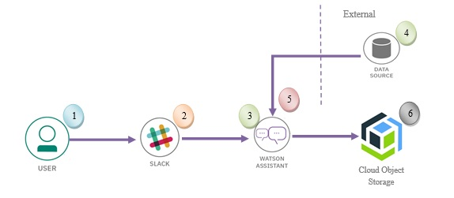

In the solution architecture, IBM services like Watson assistant, slack are used to develop a CHATBOT to help the students, the user visits a website with the SHIKSHA Chabot and asks a question.  
The Slack Integrated with Watson Assistant is hosted in IBM Cloud.

* + Watson Assistant uses natural language understanding and machine learning to extract entities and intents of the user question.
  + From the Watson assistant through the slack app the user will able to get the required data what they need.
  + Watson Assistant is also connected to the external data source so that the user will get the additional information from that external data sources.
  + If the user want to store any data then they can store in data in cloud object storage.

1. **IBM Cloud Services/Systems:**

The List of IBM Services used in this solution:

* + IBM Watson Assistant
  + Slack app
  + Cloud object storage