**Step 1: Open your Microsoft Azure Account**  
Sign in to the Microsoft Azure Account. After that, you have to open your Azure portal.

**Step 2: Create a new App Service**  
Go to the navigation panel on the left side of your Dashboard and select App Services.  
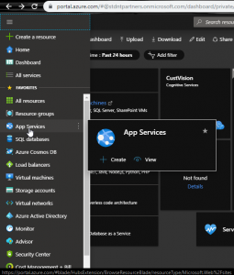  
Click on the Add button. This will open the panel to create a new App Service.  
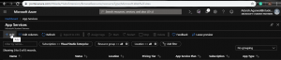

**Step 3: Setting up the properties of our App Service**  
We have to set certain properties of our App Service.

* Select your Azure subscription.
* Select the resource group.
* Enter the name for your web app. This name will become the name of your website.
* **Runtime Stack:** Select the platform or framework you used to create and run your web app.
* Select the operating system as per your wish.
* **Region:** Cloud servers are placed at different locations. Choose the region closest to your current location.

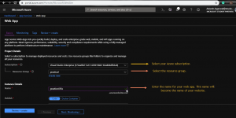  
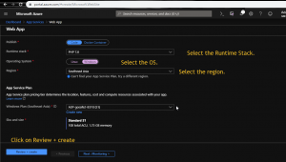  
Left rest of the details as it is. Click on **Review + Create** button.

**Step 4: Validation and Creation of App Service**  
After clicking on **Review + Create** button, Azure will validate the settings and will return error if found.  
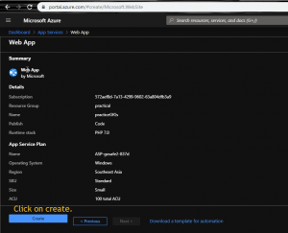  
Click on **Create** and wait for some time, your App Service will be created. Now we have to connect it with our GitHub profile to deploy our web app.

**Step 5: Checking out our newly created App Service**  
This is the panel of our newly created App Service named **NamePronuciationTool**. This panel contains features to change the properties of our App Service, test our Web App, perform analysis and various other tasks.  
  
Click on **Browse** tab. It will open your current App Service as a website.

**Step 6: Setting Up Deployment Center**  
Click on **Deplyment Center** on the left panel. Azure provides different sources to deploy your web app some of them are:

* Docker
* GitHub
* Bitbucket
* OneDrive

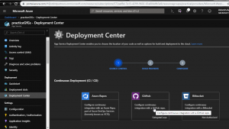  
Since we want to deploy our We App from our GitHub profile, click on **GitHub**. It will ask you to sign-in to your GitHub profile.  
Now select **App Service build survice** build provider. This feature helps us to perform changes in our Web App in Azure.  
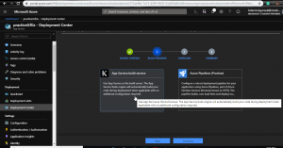

* Select your **Organization** from which you want to deploy.
* Select the **Repository** which you want to deploy. Make sure that the home page of your website is named **index.html**.
* Select the **Branch**.

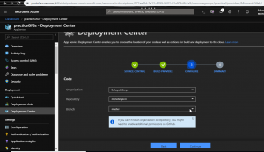  
Click on **Continue** button to verify the summary. If everything is alright, then click on **Finish** button and wait for some time.  
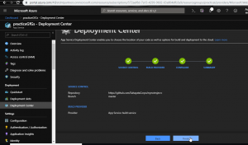

**Step 7: Checking out our Web App**  
