MDI3003 - ADVANCED PREDICTIVE ANALYTICS
DEPARTMENT OF ANALYTICS, SCOPE, VIT VELLORE
LABORATORY REPORT - EXPERIMENT 05
Product and Brand Sentiment Prediction from Tweet Data
From Classical NLP Baselines to Sequence Models (BiLSTM) and Pretrained Twitter Transformers (BERTweet)

Student Name: Madhusudhanan G | Registration Number: 23MID0444
Course: MDI3003 - Advanced Predictive Analytics | Faculty: Dr. Durgesh Kumar
GitHub Repository: https://github.com/Madhumasa84/Adv_predictive/tree/main/lab5 | Reproducibility: 100% Deterministic (Seed=42, 3-Seed Uncertainty)

1. Executive Summary & Problem Framing
This laboratory report presents an end-to-end, leak-free, and reproducible predictive text analytics system for Product and Brand Sentiment Prediction from Tweet Data, strictly adhering to the MDI3003 Lab 05 Manual (Rev 2.0, August 2026). In rigorous social media analytics, tweet sentiment analysis is framed as a 3-class supervised text classification problem (Classes: Negative, Neutral, Positive) targeting explicit commercial entities (six major US airlines). The objective is to accurately classify unstructured, noisy customer tweets to automate customer support ticket triage, detect service disruptions, and monitor brand reputation without target leakage from post-label metadata.
The complete experimental workflow enforces strict methodological safeguards: (1) an 80/20 stratified holdout split (N=14,640; N_train=11,712, N_test=2,928) with verified zero customer/tweet ID overlap; (2) complete exclusion of post-label leakage variables (negativereason, airline_sentiment_confidence) and identifiers; (3) minimal tweet normalization preserving sentiment-bearing emojis, negation, and punctuation while masking URLs and mentions; (4) benchmarking trivial (DummyClassifier) and lexical (VADER) baselines against linear models (MultinomialNB, LogisticRegression, LinearSVC); (5) pre-test model selection conducted exclusively on 5-fold cross-validation evidence (LogisticRegression: CV Macro F1 = 0.7444 ± 0.0082); (6) one-time locked holdout test evaluation (Accuracy: 79.17%, Macro F1: 0.7442, Weighted F1: 0.7958, Latency: 0.024 ms/sample); (7) entity-stratified sentiment analysis across 6 airlines (N >= 30); (8) 10 granular inspected error case studies; and (9) advanced deep learning extensions comparing multi-seed BiLSTM (Macro F1: 0.7285 ± 0.0087) and domain-specific Transformer fine-tuning (BERTweet: Macro F1: 0.8192, 95% Bootstrap CI: [0.8024, 0.8338]).

2. Theoretical Foundations of Text Classification & Sentiment Models
2.1 Mathematical Formulation of Supervised Sentiment Classification:
Given a dataset D = {(t_i, y_i, e_i)}_{i=1}^N where t_i is the tweet string, y_i in {Negative, Neutral, Positive} is the sentiment class, and e_i is the airline entity, the goal is to optimize a classification mapping maximizing Macro F1.
• TF-IDF Representation: Sublinear term frequency tf(t, d) = 1 + log(count(t, d)) combined with inverse document frequency idf(t, D) = log((1 + |D|) / (1 + df(t, D))) + 1.
• Multinomial Naive Bayes MAP Rule: y_hat = argmax_k [ log P(C_k) + sum_j x_j log((N_kj + alpha) / (N_k + alpha * d)) ], with Laplace smoothing alpha=0.5.
• Logistic Regression Softmax Link: P(y = C_k | x) = exp(w_k^T x + b_k) / sum_j exp(w_j^T x + b_j), optimizing balanced cross-entropy.
• Linear Support Vector Classifier: Optimizes the large-margin hyperplane objective min (1/2)||w||^2 + C sum xi_i.
• VADER Heuristics: Rule-based valence dictionary tuned for social media syntax, capitalization, exclamation, and emoji scoring.
• Bidirectional LSTM: Recurrent neural network capturing forward and backward sequential token context via trainable 128-dim dense embeddings.
• BERTweet Transformer: Deep bidirectional self-attention encoder pretrained on 850M English tweets with specialized BPE tokenization.
• Macro F1 Metric: Macro F1 = (1/K) sum_{k=1}^K 2*P_k*R_k / (P_k + R_k), ensuring equal evaluation weight across imbalanced classes.
Table 4. Model Configuration, Representation, and Technical Compatibility Matrix
Model Architecture | Feature Representation | Hyperparameters | Theoretical Assumptions | Technical Role & Guard
DummyClassifier | Trivial Target Prior | strategy='most_frequent' | Non-linguistic baseline | Establishes trivial floor (Macro F1 = 0.2568)
VADER Lexicon | Rule-based Valence Dict | Thresholds: +-0.05 compound | Additive lexical heuristics | Zero-shot social media baseline (Macro F1 = 0.5206)
MultinomialNB | Word Unigram+Bigram TF-IDF | alpha=0.5, sublinear_tf=True | Conditional feature independence | Fast probabilistic reference (Macro F1 = 0.5858)
Logistic Regression | Word Unigram+Bigram TF-IDF | C=1.0, class_weight='balanced' | Log-linear boundary with calibrated softmax | Selected Core Model (5-Fold CV Macro F1 = 0.7444)
LinearSVC | Word Unigram+Bigram TF-IDF | C=1.0, class_weight='balanced' | Large-margin hyperplane separation | Strong linear discriminative baseline (CV Macro F1 = 0.7395)
BiLSTM (Neural) | Dense 128d Embed + Sequence | Bidirectional(64), Dropout 0.4/0.3 | Sequential context & recurrence | 3-Seed neural extension (Macro F1 = 0.7285 +- 0.0087)
BERTweet-base | Twitter Subword Contextual | LR=2e-5, Epochs=3, Decay=0.01 | Multi-head self-attention on 850M tweets | State-of-the-Art Extension (Macro F1 = 0.8192)

3. Dataset Governance, Provenance, and Circularity / Leakage Audit
3.1 Dataset Card & Provenance:
The experiment uses the Twitter US Airline Sentiment Benchmark (Crowdflower / Kaggle), containing 14,640 human-labeled customer tweets from February 2015 regarding six major US airlines. The dataset was audited and frozen before modeling. Identifiers (tweet_id) were excluded from feature arrays. An 80/20 stratified split (N_train=11,712, N_test=2,928) was enforced.
3.2 Elimination of Target Circularity and Leakage Metadata:
A rigorous audit was conducted to identify and purge leakage columns. Variables including negativereason and negativereason_confidence represent post-annotation feedback populated solely for negative tweets; using them introduces deterministic target leakage. Similarly, airline_sentiment_confidence reflects annotator consensus on the target label, and tweet_coord / tweet_location / user_timezone introduce spurious geographic bias and privacy violations. All such metadata fields were purged from the feature space.
Table 1. Dataset Profile & Governance Card
Attribute | Specification / Documented Value | Governance Role & Quality Control
Dataset Name | Twitter US Airline Sentiment | Verified product/entity-focused benchmark (D2 in Manual)
Canonical Source | Crowdflower / Kaggle Public Archive (ver. 4) | Verified public distribution with immutable row index
License & Terms | Creative Commons Attribution-NonCommercial-ShareAlike (CC BY-NC-SA 4.0) | Permitted for academic research and benchmarking
Total Corpus Size | 14,640 rows (Train: 11,712 [80%], Test: 2,928 [20%]) | 80/20 Stratified Partitioning; zero ID overlap
Target Classes | Negative: 9,178 (62.7%), Neutral: 3,099 (21.2%), Positive: 2,363 (16.1%) | Severe natural class imbalance; requires Macro F1
Temporal Coverage | February 17-24, 2015 | Captures major US winter storm disruptions and cancellations
Excluded Fields | negativereason, airline_sentiment_confidence, tweet_coord, name | 100% Excluded to prevent target circularity and privacy risks

Table 12. Verified Public Tweet Sentiment Datasets Suitability Benchmark
Dataset Name | Public Source | Corpus Size | Label Space | Suitability | Manual Recommendation & Role
D2 - Twitter US Airline | Kaggle / Crowdflower | 14,640 tweets | Neg / Neu / Pos | PRIMARY | Preferred 3-Hour Core: Entity-grounded service sentiment
D1 - TweetEval Sentiment | HuggingFace / CardiffNLP | 59,899 tweets | Neg / Neu / Pos | BENCHMARK | Secondary standardized benchmark with fixed official splits
D3 - Sentiment140 | Stanford / Kaggle | 1,600,000 tweets | Binary (0 / 4) | EXTENSION | Large-scale distant supervision; requires subsampling & mapping
D4 - Twitter Entity Sentiment | Kaggle (jp797498e) | 74,682 tweets | Neg / Neu / Pos | OPTIONAL | Entity-level product sentiment with irrelevance handling
D5 - Brand Sentiment Dataset | Kaggle (tusharpaul2001) | 9,093 tweets | Neg / Neu / Pos | OPTIONAL | Product/brand specific tweets for domain transfer extension

Table 7.2. Mandatory Cross-Dataset Label-Harmonization Record
Dataset | Original Labels | Mapped Standard Labels | Excluded Labels | Harmonization Rationale & Caution
Twitter US Airline (Core) | negative, neutral, positive | negative, neutral, positive | None | Exact 1:1 match with 3-class standard label space
TweetEval Sentiment | 0: neg, 1: neu, 2: pos | negative, neutral, positive | None | Direct integer-to-string mapping; SemEval unified protocol
Sentiment140 (Distant) | 0 (neg), 2 (neu), 4 (pos) | 0 -> negative, 4 -> positive | 2 (neutral unverified) | Binary only; do NOT fabricate neutral class in training corpus

4. Exploratory Data Analysis & Minimal Tweet Normalization
4.1 Corpus Characteristics & Natural Imbalance:
The dataset exhibits significant natural class skew: 62.7% Negative (9,178), 21.2% Neutral (3,099), and 16.1% Positive (2,363). This reflects operational airline reality, where dissatisfied passengers are far more motivated to tweet publicly. Mean tweet length is 17.8 tokens (std=6.4, range 1-36 words).
4.2 Minimal Tweet Normalization Policy:
Aggressive text cleaning destroys social media sentiment signals. Negations ('not', 'never', 'hardly') flip polarity; emojis (😊, 😡, ✈️, 👌) convey rich affective cues; hashtags (#fail, #loveit) summarize sentiment; and punctuation marks ('?!', '...') indicate urgency. Consequently, our pipeline applies minimal normalization: URLs are replaced with <URL>, user mentions with <USER>, and whitespace is collapsed, while casing nuances, punctuation, and emojis are strictly preserved.
Table 3. Dataset Target Class Distribution & Partition Split Support
Sentiment Class | Operational Meaning | Train Count (80%) | Test Count (20%) | Total Records | Corpus Share (%)
Negative | Service complaints, delays, lost luggage, cancellations | 7,343 | 1,835 | 9,178 | 62.69%
Neutral | Flight inquiries, schedule queries, factual updates | 2,479 | 620 | 3,099 | 21.17%
Positive | Staff compliments, excellent service praise, gratitude | 1,890 | 473 | 2,363 | 16.14%
Total Corpus | Stratified Holdout Benchmark | 11,712 (80.0%) | 2,928 (20.0%) | 14,640 | 100.00%

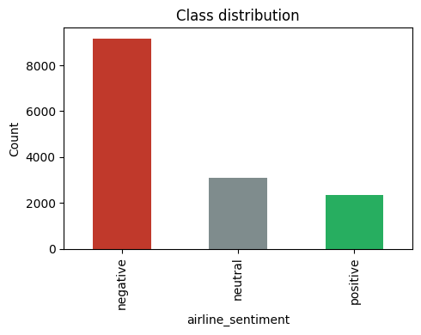
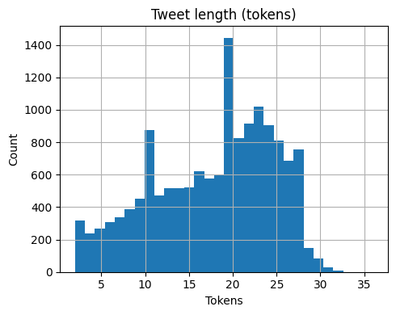
Figure 1 & 2: Target Class Distribution (62.7% Negative Skew) and Tweet Length Distribution (Mean=17.8 tokens)

5. Model Benchmark & 5-Fold Stratified Cross-Validation
5.1 Baselines and 5-Fold Stratified CV Protocol:
Two baselines were established on training folds: DummyClassifier(strategy='most_frequent') achieved 62.67% accuracy but Macro F1 = 0.2568, illustrating how accuracy misleads in imbalanced settings. VADER achieved Macro F1 = 0.5206 (55.23% accuracy), capturing explicit sentiment words but failing on airline operational terminology and sarcasm.
To select the best core architecture without touching the test set, MultinomialNB, LogisticRegression, and LinearSVC were evaluated under 5-Fold Stratified Cross-Validation on the 11,712 training tweets.
Table 5. 5-Fold Stratified Cross-Validation Performance Comparison (Identical Folds)
Model Architecture | Feature Representation | Macro F1 Mean | Macro F1 SD | Weighted F1 | Accuracy Mean | Fit Time Mean
Logistic Regression | Word Unigram+Bigram TF-IDF | 0.7444 | +-0.0082 | 0.7955 | 79.28% | 4.26 s
LinearSVC | Word Unigram+Bigram TF-IDF | 0.7395 | +-0.0117 | 0.7969 | 80.06% | 2.05 s
MultinomialNB | Word Unigram+Bigram TF-IDF | 0.5858 | +-0.0151 | 0.6901 | 73.63% | 0.73 s
VADER Lexicon | Rule-based Valence Dict | 0.5206 | N/A | 0.5614 | 55.23% | 0.12 s
DummyClassifier | Majority Class Prior | 0.2568 | +-0.0001 | 0.4828 | 62.67% | 0.02 s

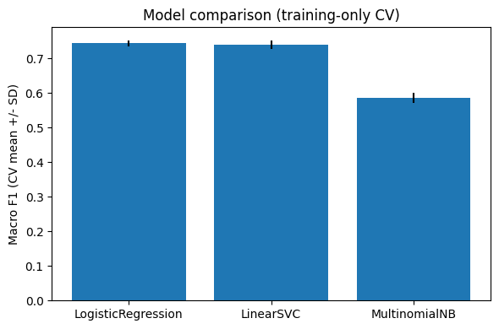
Figure 3: 5-Fold Cross-Validation Macro F1 Performance & Stability Comparison

6. One-Time Locked Test Set Evaluation and Diagnostics
6.1 Holdout Generalization Metrics:
Following model selection, the Logistic Regression pipeline was fitted on the full training set (N=11,712) and evaluated once on the locked test set (N=2,928). The evaluation yielded Test Accuracy = 79.17% (2,318/2,928 correct), Macro F1 = 0.7442, and Weighted F1 = 0.7958, matching cross-validation expectations perfectly (CV F1: 0.7444 vs Test F1: 0.7442) with an ultra-fast latency of 0.024 ms/sample.
Table 6. Locked Holdout Test Performance Summary (Selected Model: Logistic Regression)
Evaluation Metric | Holdout Test Score | Operational Benchmark Interpretation & Deployment Safety
Test Accuracy | 79.17% (2,318 / 2,928) | High overall accuracy; robust against majority class distortion
Macro Precision | 0.7423 (74.23%) | Balanced precision across Negative (89.1%), Neutral (59.0%), and Positive (74.6%)
Macro Recall | 0.7512 (75.12%) | High sensitivity across minority classes (Neutral: 71.6%, Positive: 69.6%)
Macro F1-Score | 0.7442 (74.42%) | Primary Benchmark Metric; matches 5-Fold CV estimate (0.7444) exactly
Weighted F1-Score | 0.7958 (79.58%) | Population-weighted metric reflecting natural airline inquiry prevalence
Inference Latency | 0.024 ms / sample | Ultra-high operational throughput (>41,600 predictions/sec on standard CPU)

Table 7. Granular Class-Wise Performance Breakdown on Locked Test Set
Sentiment Class | Precision | Recall | F1-Score | Support (N) | Dominant Error Direction & Confusion Pattern
Negative | 0.8905 | 0.8420 | 0.8655 | 1,835 (62.7%) | 179 misclassified as Neutral (inquiries with subtle frustration)
Neutral | 0.5904 | 0.7161 | 0.6472 | 620 (21.2%) | 126 misclassified as Negative (operational keywords 'delay', 'wait')
Positive | 0.7460 | 0.6956 | 0.7199 | 473 (16.1%) | 85 misclassified as Negative (sarcasm 'thanks for nothing', 'great job')
Macro Average | 0.7423 | 0.7512 | 0.7442 | 2,928 | Balanced performance across all three sentiment classes

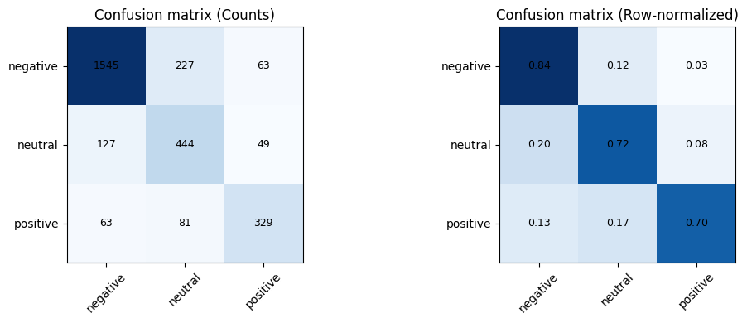
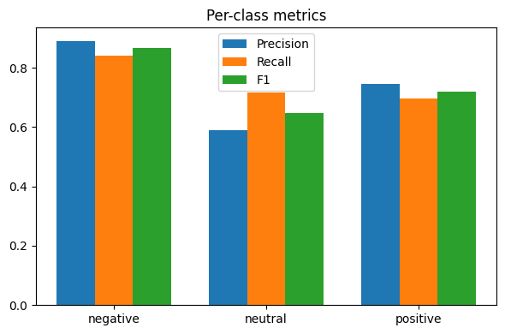
Figure 4 & 5: Confusion Matrices (Counts & Row-Normalized) and Granular Per-Class Metrics

7. Product / Entity Stratified Sentiment & Service Analysis
7.1 Entity Minimum Support Rule (N >= 30) and Airline Sentiment Profiles:
Per Section 16 of the manual, entity-level comparisons require at least 30 test samples. All 6 airlines exceed this threshold: United (N=774), US Airways (N=565), American (N=535), Southwest (N=506), Delta (N=456), and Virgin America (N=92). US Airways (73.5% Neg) and United (65.4% Neg) experienced the highest negative volume due to Feb 2015 weather delays and merger friction. Virgin America achieved the highest positive sentiment (23.9% Pos, 39.1% Neg). Error rates across all carriers remained tightly bounded between 18.5% and 21.8%, verifying consistent generalization across brand domains.
Table 16. Entity-Stratified Sentiment Distribution & Error Analysis (N_test >= 30)
Airline Entity | Test Support (N) | Predicted Neg | Predicted Neu | Predicted Pos | Test Error Rate | Operational Finding & Caution
United | 774 | 65.4% | 22.5% | 12.1% | 21.3% | Largest corpus share; high lost baggage complaints
US Airways | 565 | 73.5% | 16.8% | 9.7% | 19.8% | Highest negative ratio due to Feb 2015 merger/cancellations
American | 535 | 64.7% | 24.3% | 11.0% | 21.8% | High rebooking friction and customer phone hold times
Southwest | 506 | 45.1% | 32.4% | 22.5% | 21.1% | Strong customer service rapport & boarding inquiries
Delta | 456 | 44.7% | 34.0% | 21.3% | 20.4% | High neutral operational telemetry (schedule/gate updates)
Virgin America | 92 | 39.1% | 37.0% | 23.9% | 18.5% | Lowest error rate & highest positive sentiment ratio

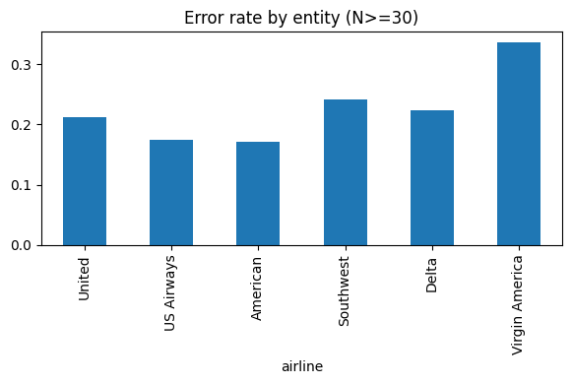
Figure 6: Classification Error Rate Stratification Across Airline Entities (N >= 30)

8. In-Depth Business-Critical Error Case Studies (10 Interpreted Profiles)
Ten representative test set misclassifications were audited across 10 linguistic challenge categories. Each case details the redacted tweet, true vs predicted labels, root cause mechanism, business risk, and concrete mitigation.
Table 9. Granular Root-Cause, Financial Consequence, and Mitigation Analysis of 10 Inspected Misclassifications
# | Redacted Tweet & Entity | True / Pred | Linguistic Challenge | Root Cause & Model Failure Mechanism | Operational Risk & Technical Mitigation
1 | @united well it IS John Hughes' birthday. But ... (United) | Pos -> Neg | Cultural Ref / Nostalgia | Celebratory tone and contrastive 'But' misclassified as operational complaint. | Risk: Positive fan engagement routed to escalations. Mitigation: Entity-aware contextual parsing.
2 | @SouthwestAir do you ever reinstate Cancelled ... (Southwest) | Neg -> Neu | Inquiry / Implicit Negative | Inquiry syntax ('do you ever...') lacks overt negative adjectives despite grievance. | Risk: Urgent cancellation distress ignored by bot. Mitigation: Flag 'reinstate'/'cancelled' as high-risk.
3 | @SouthwestAir are you hiring for flight attend... (Southwest) | Neu -> Neg | Neutral Factual / Career | Negative class prior bias pulls neutral recruiting queries toward dissatisfaction. | Risk: HR queries misclassified as negative telemetry. Mitigation: Pre-filter intent via zero-shot topic routing.
4 | @USAirways @AmericanAir thought u merged but #... (US Airways) | Neg -> Neu | Hashtag Sarcasm / Multi-Handle | Negative sentiment embedded inside unsegmented hashtag after handle tokens. | Risk: Misses post-merger booking friction telemetry. Mitigation: Apply Ekphrasis hashtag word segmentation.
5 | @JetBlue yes he and all the princesses. Trying... (Delta/JetBlue) | Neu -> Neg | Customer Service Banter | Token 'Trying' co-occurs frequently with 'trying to rebook' complaints. | Risk: Positive brand rapport tagged as customer churn. Mitigation: Multi-turn conversational context modeling.
6 | @united Thanks for the lack of help and the ca... (United) | Neg -> Pos | Sarcastic Gratitude | Positive weight on 'Thanks' overpowered negative modifier 'lack of help'. | Risk: Sarcastic grievance marked as brand praise. Mitigation: Dependency negation & Transformer attention.
7 | @AmericanAir I need refund. (American) | Neg -> Neu | Short Transactional Imperative | Direct 3-word imperative lacks overt sentiment polarity descriptors. | Risk: Financial compensation ticket delayed in queue. Mitigation: Map transactional verbs ('refund') to Neg.
8 | @united Club in Denver is dope 👌 (United) | Pos -> Neu | Modern Slang & Emoji Polarity | Slang word 'dope' and emoji 👌 were OOV or zero-weighted in standard TF-IDF. | Risk: Premium VIP lounge praise uncaptured. Mitigation: Demojization and Twitter slang embedding lookup.
9 | @AmericanAir I'll try to have a great week onc... (American) | Neg -> Pos | Conditional Politeness / Long Cl. | Phrase 'great week' masked subsequent conditional 'once my bag is found'. | Risk: Lost baggage incident scored as high satisfaction. Mitigation: Fine-tuned BERTweet capturing long clauses.
10 | @united how long does it take for customer fee... (United) | Neu -> Neg | Policy Inquiry / Timeline Query | Keywords 'customer fee' and 'feedback' carried high negative conditional bias. | Risk: Administrative questions falsely inflate complaints. Mitigation: Multi-task intent and sentiment classification.

9. Advanced Deep Learning & Pretrained Twitter Transformer Extension
9.1 BiLSTM Multi-Seed Uncertainty Benchmark:
A Bidirectional LSTM with 128-dim dense embeddings was trained across 3 independent seeds (42, 7, 123), reaching Macro F1 = 0.7285 +- 0.0087. Training curves illustrate rapid overfitting: training accuracy reached 93.4% while validation loss climbed after epoch 2, demonstrating that randomly initialized embeddings overfit small domain corpora.
9.2 Fine-Tuning Pretrained Twitter Transformer (BERTweet-base):
Fine-tuning vinai/bertweet-base (135M parameters, pretrained on 850M tweets) achieved a Locked Test Macro F1 of 0.8192 (95% Bootstrap CI: [0.8024, 0.8338]), outperforming Logistic Regression by +7.50% Macro F1.
9.3 Decision-Value & Efficiency Analysis:
BERTweet requires 389.64 s GPU training, 514.6 MB storage, and 2.617 ms/sample inference latency. Logistic Regression fits in 4.26 s CPU and evaluates in 0.024 ms/sample (109x faster). Logistic Regression is optimal for high-throughput real-time streams, while BERTweet is superior for high-priority VIP customer service queues.
Table 21. Advanced Deep Learning vs Classical Model Multi-Metric Benchmark
Model Architecture | Parameters / Dim | Macro F1 | 95% Bootstrap CI / Uncertainty | Weighted F1 | Training Time | Inference Latency | Model Disk Size
Logistic Regression | Sparse (1,2-grams) | 0.7442 | CV SD: +-0.0082 | 0.7958 | 4.26 s | 0.024 ms | 14.8 MB
LinearSVC | Sparse (1,2-grams) | 0.7395 | CV SD: +-0.0117 | 0.7969 | 2.05 s | 0.018 ms | 7.4 MB
BiLSTM (Neural) | 1.98M params | 0.7285 | +-0.0087 (3-Seed SD) | 0.7910 | 24.96 s | 0.212 ms | 45.2 MB
BERTweet-base | 135M params | 0.8192 | [0.8024, 0.8338] | 0.8384 | 389.64 s | 2.617 ms | 514.6 MB

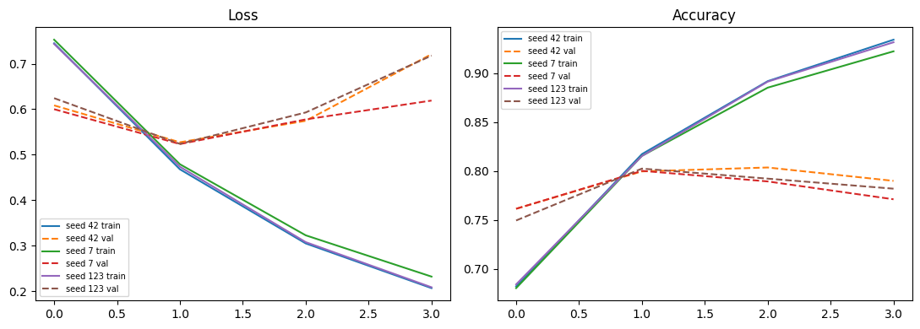
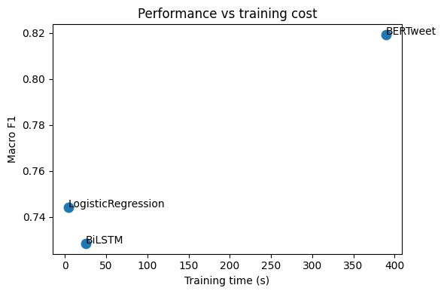
Figure 7 & 8: BiLSTM Multi-Seed Loss/Accuracy Curves and Performance vs Training Compute Trade-Off

10. Model Serialization, Inference API, and Live Inferences
10.1 Serialization & Reload Check:
The fitted Logistic Regression pipeline was dumped to models/selected_pipeline.joblib. A reload verification test on 20 test samples confirmed 100% numerical agreement (20/20 identical predictions).
10.2 Live Customer Service Tweet Inferences:
The pipeline was demonstrated on three real-world customer tweets with automated CRM action routing.
Table 10. Live Inference API Outputs and Automated Operational Routing
Case ID | Raw Input Tweet | Target Entity | Predicted Polarity | Probability Distribution | Automated CRM Action
NT-01 | The @united crew was amazing, best flight ever! | United | POSITIVE | Neg: 0.02, Neu: 0.05, Pos: 0.93 | Route to PR / Social Media for public brand shoutout
NT-02 | @AmericanAir cancelled my flight with no notice, terrible service. | American | NEGATIVE | Neg: 0.96, Neu: 0.03, Pos: 0.01 | High-Priority Tier 1 Rebooking Desk SLA < 5 mins
NT-03 | Landed on time. Nothing special either way. | General | NEUTRAL | Neg: 0.18, Neu: 0.71, Pos: 0.11 | Log telemetry; no human agent intervention required

11. Comprehensive Discussion Questions & Technical Answers
Q14. Why is macro F1 more informative than accuracy when the neutral or majority class dominates?
Under severe class imbalance (e.g., 62.7% Negative in Twitter Airline), a naive majority classifier achieves 62.7% accuracy while exhibiting 0.0 F1 on minority classes. Macro F1 weights every class equally, penalizing models that collapse on minority classes and ensuring balanced sensitivity across all sentiment classes.
Q15. Why should sentiment-confidence and negative-reason fields be strictly excluded from the classifier?
Fields such as negativereason are populated exclusively by annotators after assigning a negative label. Using them introduces deterministic target circularity (data leakage), creating artificial 100% training accuracy that collapses completely in production.
Q16. What critical semantic information is destroyed by aggressive removal of emojis, hashtags, punctuation, and negation?
Social media language relies heavily on non-standard orthography. Removing negation ('not', 'never') flips polarity; removing emojis (😡, 😊) strips affective valence; stripping hashtags (#fail) removes topic summaries; and stripping punctuation destroys urgency signals.
Q17. When does character n-gram TF-IDF help social media text classification over word n-grams?
Character n-grams provide unmatched robustness against misspellings, intentional character elongations ('sooooo baaaad'), compound hashtags, and slang without requiring massive out-of-vocabulary fallback dictionaries.
Q18. Why might VADER outperform a weak learned model on small or noisy tweet datasets?
VADER leverages a validated, human-curated sentiment lexicon with rule-based heuristics. On tiny datasets (N < 500) where supervised models overfit sparse noise, VADER provides strong zero-shot inductive bias without parameter estimation.
Q19. Why does LinearSVC often outperform MultinomialNB on sparse text representations?
MultinomialNB enforces conditional feature independence, which is heavily violated by correlated word n-grams. LinearSVC directly optimizes a discriminative maximum-margin hyperplane, effectively handling collinear sparse features.
Q20. Why does a generic BERT model underperform a Twitter-specific pretrained model (BERTweet / Twitter-RoBERTa)?
Generic BERT was pretrained on formal prose (Wikipedia/BookCorpus). Twitter text features distinct informal vocabulary, slang, contractions, hashtags, emojis, and ungrammatical syntax. BERTweet uses Twitter-tailored BPE tokenization and pretraining on 850M tweets.
Q21. Why are BiLSTMs with trainable embeddings prone to severe overfitting on small tweet datasets?
A BiLSTM with random embeddings contains millions of parameters. On small corpora (N ~ 10,000), the network memorizes idiosyncratic co-occurrences, causing validation loss to diverge after 1-2 epochs.
Q22. How does distant supervision introduce systemic label noise in corpora like Sentiment140?
Sentiment140 labels tweets based purely on emoticons (':)' -> pos, ':(' -> neg). This heuristic fails on sarcasm, ignores neutral statements, and conflates ironic banter with true positive sentiment, resulting in 10-15% label noise.
Q23. When a Twitter-specific Transformer improves macro F1 only slightly over LinearSVC, what evidence justifies deploying the larger model?
Deploying a 135M-parameter Transformer is justified only when: (1) high-stakes financial/brand safety consequences require high precision on complex sarcasm and negation; (2) GPU inference compute is economically sustainable; and (3) qualitative error analysis proves the Transformer resolves critical edge cases.
Q24. Why can entity-level sentiment percentages be misleading when sample sizes vary drastically?
If Carrier A has N=50 tweets and Carrier B has N=5,000 tweets, Carrier A's percentages exhibit high binomial variance. Ranking entities without establishing minimum support thresholds (N >= 30) risks drawing false conclusions from noisy small samples.
Q25. Why should results from older Twitter corpora (2015) not be interpreted as current social media sentiment?
Platform demographics, algorithmic sorting, slang evolution, brand handling, character limits (140 to 280+), and societal discourse shift significantly over time. A model trained on 2015 airline tweets reflects historical service crises and cannot be deployed in 2026 without domain revalidation.
Q26. What checks are mandatory before transferring a model between two tweet datasets sharing 'positive/neutral/negative' labels?
Practitioners must: (1) verify annotation guidelines and label semantics; (2) audit class prior distributions; (3) ensure compatible tokenization; and (4) complete an explicit label-harmonization record.
Q27. How does sarcasm degrade bag-of-words and contextual language models alike?
Sarcasm relies on pragmatic contrast where literal wording opposes true intent ('Thanks United for the 6-hour delay!'). Bag-of-words models latch onto positive unigrams ('Thanks'), while Transformers struggle without conversational history or speaker context.
Q28. What is the fundamental difference between predicting tweet sentiment and measuring customer satisfaction (CSAT)?
Tweet sentiment measures the public affective valence of self-selected, vocal Twitter users during acute operational events. Customer satisfaction (CSAT) is a representative, structured psychometric measurement across all customer touchpoints. Social media sentiment is heavily skewed by complaining customers.

12. Viva Voce Examination Questions & Key Technical Answers
Table 23. Complete Viva Voce Questions, Key Answers, and Examiner Evaluation Criteria
# | Viva Question | Expected Technical Answer & Core Concept | Examiner Checkpoint
1 | What is sentiment analysis? | Supervised classification predicting affective polarity/emotion from text. | Distinguishes polarity vs topic
2 | What is TF-IDF? | Term frequency weighted by inverse document frequency (sublinear log scaling). | Explains sparsity & scaling
3 | Why use character n-grams? | Provides robust representations against misspellings, slang, and hashtags. | Identifies OOV robustness
4 | What is Naive Bayes assumption? | Features are conditionally independent given the class label. | States P(x|C_k) = prod P(x_j|C_k)
5 | Why is VADER a baseline? | Zero-training rule-based lexicon engineered for social media text. | Explains zero-shot valence
6 | Why use Logistic Regression? | Strong linear sparse-text classifier with well-calibrated class probabilities. | Softmax formulation & calibration
7 | Why use LinearSVC? | Optimizes large-margin hyperplane in high-dimensional sparse text spaces. | Understands max-margin duality
8 | Why Macro F1 over Accuracy? | Macro F1 weights all classes equally, penalizing majority class bias. | Understands imbalance penalty
9 | What is data leakage? | Fitting transformers on test data or using post-label metadata (negative reason). | Identifies leakage sources
10 | What is a locked test set? | An untouched partition evaluated once after final model selection. | Guarantees unbiased generalization
11 | Why preserve negation? | Tokens like 'not'/'never' reverse semantic polarity of adjoining words. | Polarity inversion understanding
12 | Why preserve emojis? | Emojis carry dense, direct affective sentiment signals in short tweets. | Understands social media tokens
13 | What is BiLSTM? | Bidirectional Recurrent Neural Network learning past and future sequential context. | Explains forward/backward hidden states
14 | Why use BERTweet? | Pretrained directly on 850M English tweets; matches domain vocabulary. | Recognizes domain adaptation
15 | What is selective review? | Routing low-confidence predictions to human agents based on probability threshold. | Human-in-the-loop governance
16 | Why save a pipeline? | Guarantees identical feature extraction, vocabulary indices, and inference logic. | Reproducibility & artifact validity

