Week 3 – Advanced Data Analysis and Visualization
Exploratory Data Analysis and Business Insights
Student Project: Logistics Data Analyst Internship

1. Dataset Overview
The cleaned dataset contains 12,000 records covering January 2025 to September 2026. The analysis examines delivery performance across shipping modes, markets, product categories and time. The main analytical target is late delivery, defined as actual shipping days greater than scheduled shipping days.

2. Core Findings
Overall late-delivery rate is 36.0%. Among shipping modes, First Class has the highest observed late rate in this simulated dataset, while Standard Class has the lowest. Africa has the highest market-level late rate. These results are associations in the simulated data and should not be interpreted as causal evidence.
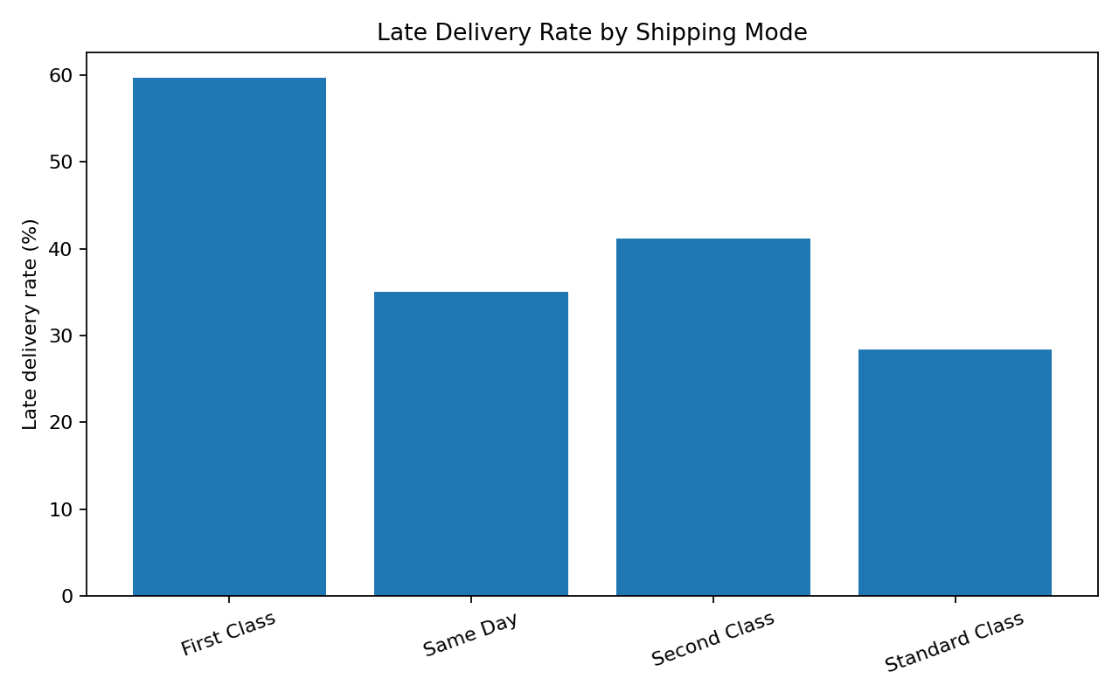
Figure 1. Late delivery rate by shipping mode.
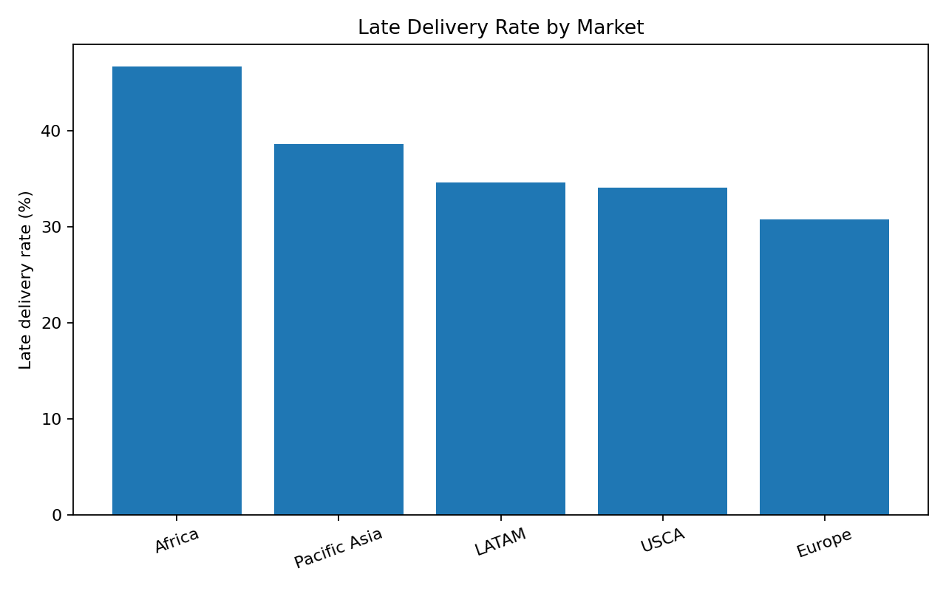
Figure 2. Late delivery rate by market.
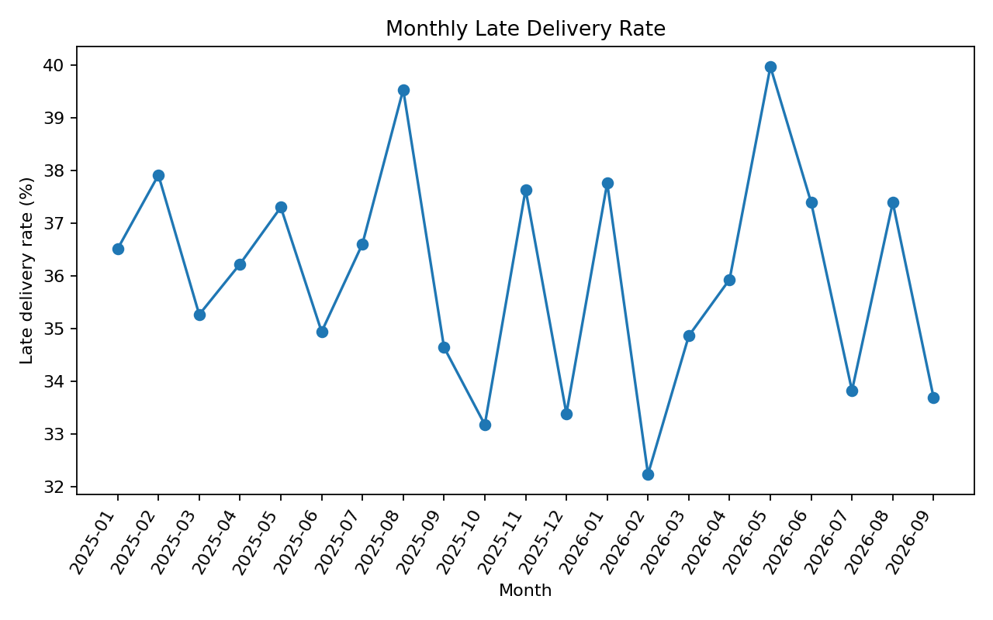
Figure 3. Monthly late delivery trend.

3. Sales and Category Analysis
The highest-sales category is Apparel, with approximately $1.56 million in simulated sales. Category-level analysis is useful because operational decisions should consider both delivery risk and commercial value.
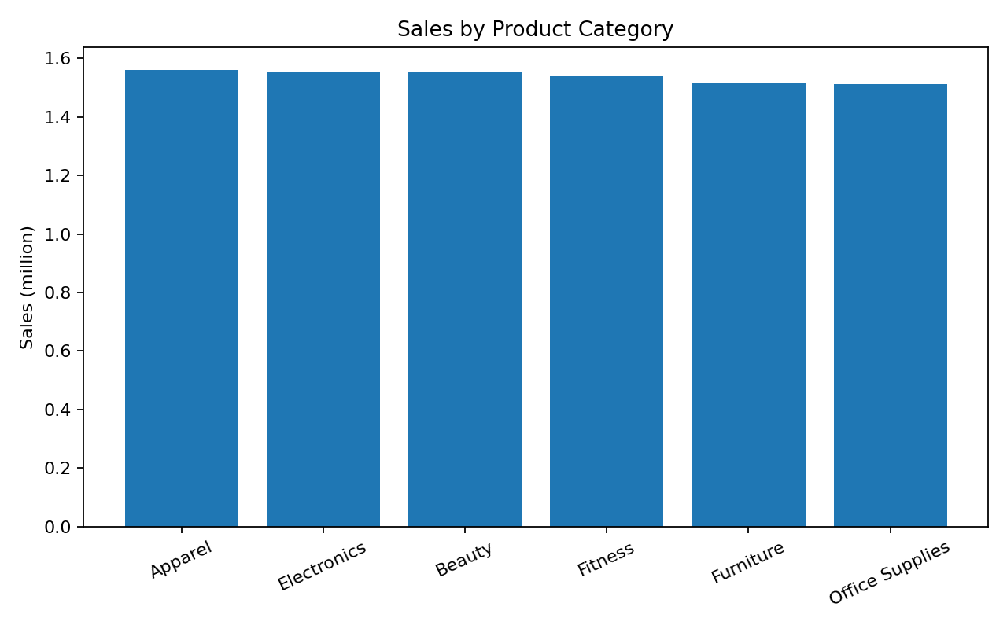
Figure 4. Sales by product category.

4. Correlation Analysis
The correlation matrix was used to identify relationships among numeric variables. Transport cost and actual shipping days show a positive relationship in the simulated data because the cost-generation logic increases with shipping duration. Correlation is used as an exploratory signal, not proof of causation.
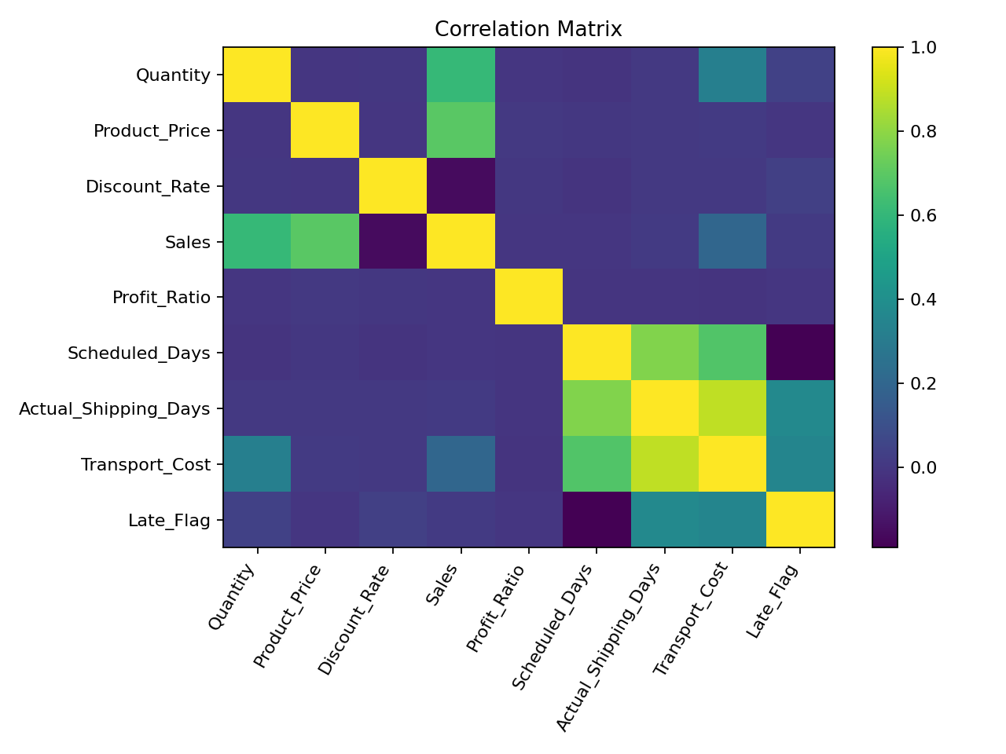
Figure 5. Correlation matrix.
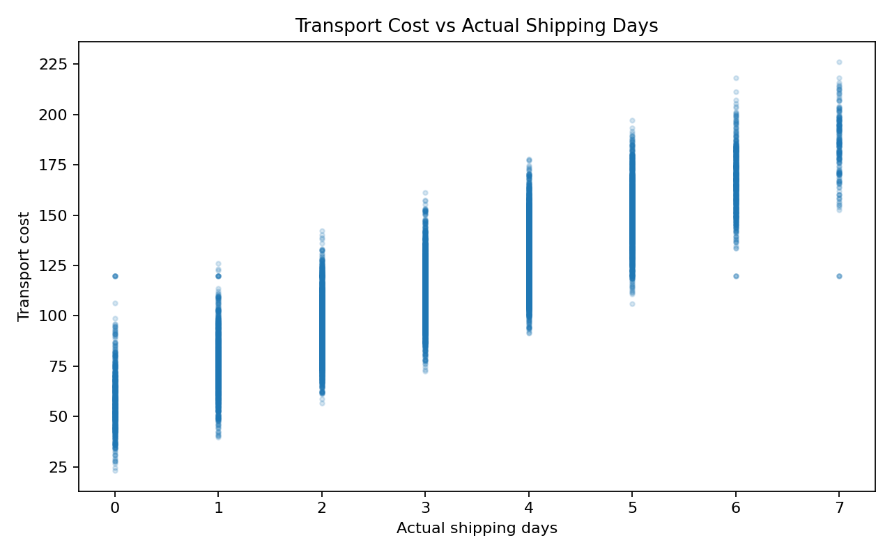
Figure 6. Transport cost versus actual shipping days.

5. Business Recommendations
- Monitor high-risk shipping modes with weekly SLA reviews.
- Prioritize high-value and high-risk orders for operational intervention.
- Track market-level late rates to identify where capacity or carrier planning needs improvement.
- Use monthly dashboards to detect persistent deterioration rather than reacting to individual late orders.
- Combine delivery risk with cost and sales impact before making operational decisions.

6. Visualization Rationale
Bar charts are used for category and shipping-mode comparisons, line charts for time trends, and correlation/scatter plots for relationships between numeric variables. The combination provides both management-level summaries and analytical detail.

