Week 4 – Predictive Modeling and Optimization
Late-Delivery Prediction and Operational Recommendations
Student Project: Logistics Data Analyst Internship

1. Problem Definition
The predictive objective is to estimate whether a shipment is likely to be late using information available when the order is planned. A second regression model estimates actual shipping days. Post-event variables are excluded from model inputs to reduce leakage.

2. Features and Target
Classification target: Late_Flag (1 = late, 0 = on time). Features include shipping mode, market, order region, category, customer segment, quantity, product price, discount rate, sales, profit ratio and scheduled shipping days. Actual shipping days and the late target are not used as predictors.

3. Model Selection
A Logistic Regression model was considered as a baseline and a Random Forest classifier was selected as the main model because it can model non-linear interactions and mixed operational relationships. A Random Forest Regressor was used for the shipping-time forecast.

4. Classification Results
Metric | Random Forest
Accuracy | 0.657
Precision | 0.529
Recall | 0.422
F1 | 0.470
ROC_AUC | 0.638
The model was evaluated on a held-out 20% test set. Precision measures the proportion of predicted late orders that were actually late; recall measures how many actual late orders were identified.
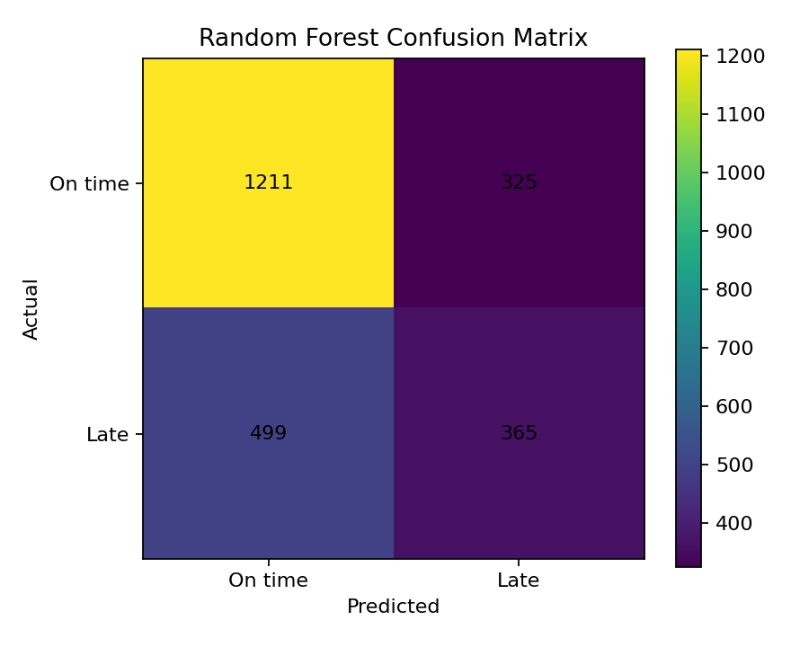
Figure 1. Classification confusion matrix.
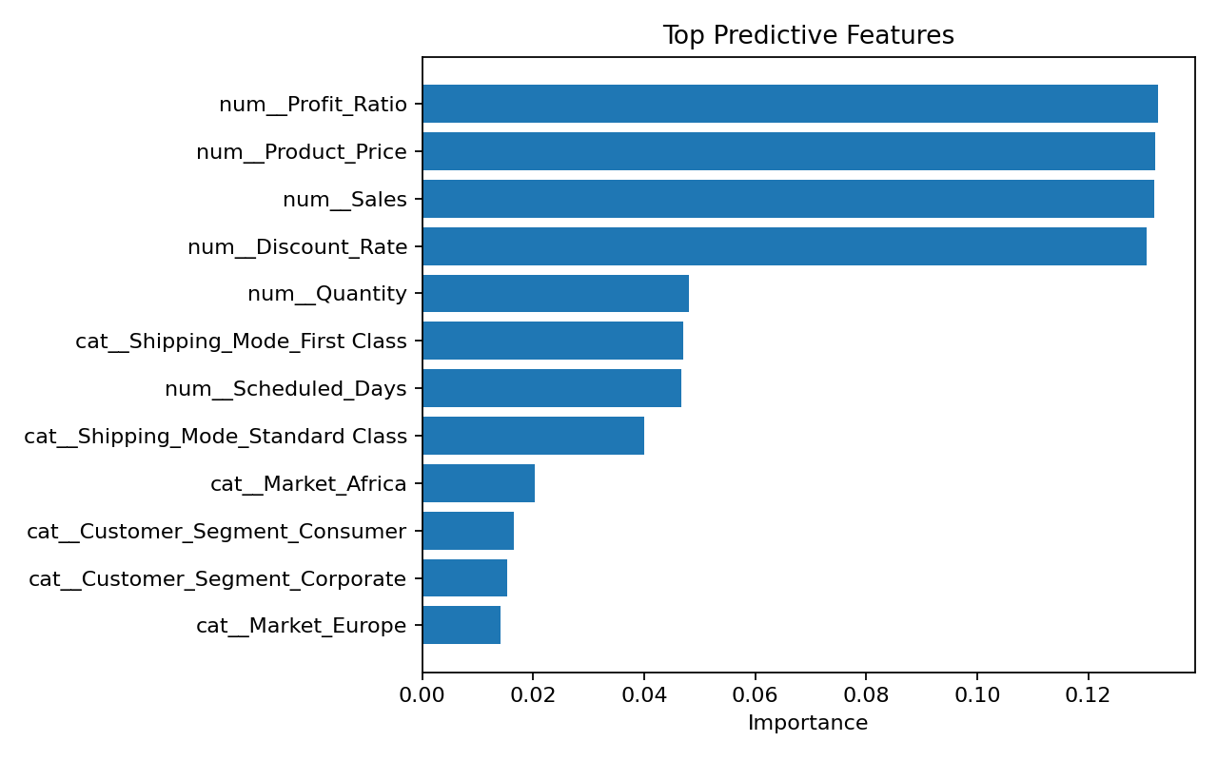
Figure 2. Top predictive features.

5. Shipping-Time Regression Results
The regression model achieved MAE=0.739 days, RMSE=0.967 days and R²=0.597. MAE is especially useful for logistics because it expresses the typical absolute forecasting error in days.

6. Optimization Strategy
The recommended optimization framework assigns operational capacity according to predicted risk, transport cost and service impact. High-risk orders should receive earlier review, carrier-capacity checks and exception handling. The project also simulates constrained shipping-mode allocation so that recommended capacity remains within operational limits.

7. Action Plan
- Create a daily risk queue for orders with predicted late probability above 0.60.
- Prioritize high-risk orders with high sales value or strategic customers.
- Review shipping-mode SLA performance and renegotiate unrealistic promises.
- Reserve limited expedited capacity for orders where the expected business impact of delay is high.
- Monitor model precision/recall monthly and retrain when the data distribution changes.

8. Conclusion
The predictive workflow converts historical logistics information into an operational early-warning system. The combination of risk prediction, shipping-time forecasting and capacity-aware recommendations can support proactive rather than reactive logistics management. Because this project uses simulated data, the results are demonstrations of methodology and should be validated on real company data before production use.

