Rally® Quick Start Guide
For Agile Project Managers and Scrum Masters

Submitted By: Madhumita Sen
Submitted On: 11/16/2024
Course Name: Writing & Managing Effective Technical Information (CAR-801-75)
Professor Name: Charles Murray

Table of Contents
Introduction 1
What are the basic components of Agile development? 1
Who will use this document? 1
What is the Agile Project Management Process? 2
Basic Agile Project Management Phases 2
Why is there a need for this document? 3
Why use Rally®? 3
Rally's project management features 4
Key Duties of a Scrum Master/Agile Project Manager 5
The Agile Team 5
The Information Dashboard 7
Team Standups 9
Team Planning 10
Reviewing the Backlog 12
Scheduling Work into Iterations 12
Identifying Issues 13
Managing Dependencies 13
Managing Tasks 13
Iteration Status 14
Iteration Retrospective 15
References 15

Introduction
Agile project management is a flexible, collaborative, and iterative approach to managing projects that emphasizes adaptability and responding to change. This method of project management is based on the idea that change should be embraced throughout the project's life cycle, and that teams should be able to think, understand and respond to change rapidly.

What are the basic components of Agile development?
Iterative: Projects are broken down into phases, called Sprints, and teams work on multiple stages simultaneously. After each Sprint, teams reflect on what could be improved and adjust their strategy for the next Sprint.
Collaborative: Responsibilities are shared among multiple roles and include a Product Owner who acts as a stand-in for the business or customer.
Customer feedback: Agile project management incorporates customer feedback at every iteration. Teams keep clients engaged by sending them small releases of working versions and gathering feedback.
Kanban boards: Kanban boards help teams visualize their workflow.
Core values: The four core values of Agile Project Management are:
- Individuals and interactions over processes and tools
- Working software over comprehensive documentation
- Customer collaboration over contract negotiation
- Responding to change over following a plan
Agile Project Management is a good fit for projects that require regular feedback, have a short time-to-market, or are highly complex. However, it may not work well in traditional organizations, or with customers or projects that have rigid processes or strict regulations.

Who will use this document?
Rally is a project management tool that can be used by varied audiences and is not limited to the audiences described below.
Agile development teams: Rally can help with detailed Sprint planning, dependency tracking, monitoring and dashboards.
Enterprise software projects: Rally can help with advanced project and portfolio management features for large and complex software development projects.
Agile methodology adopters: Rally can help with comprehensive tools to support workflows for teams that strictly follow Agile practices.
Small to medium-sized businesses: Rally can help with cost-effective Agile solutions.
Rally is a good fit for organizations that want to improve visibility and workflow management. It's also a good fit for organizations that want to streamline their project management processes and use lean software development practices.

What is the Agile Project Management Process?
The goal of Agile is to produce shorter development cycles and more frequent product releases as compared to traditional Waterfall style of project management. This shorter time frame enables project teams to react to changes in the client’s needs more effectively.

Basic Agile Project Management Phases

Project Planning: The team should understand the end goal, the value to the organization or client, and how it will be achieved.
Product roadmap creation: A roadmap is a breakdown of the product features that will make up the final product. This is a crucial component of the planning stage of Agile, because the team will build these individual features during each Sprint.
Release planning: The project uses shorter development cycles (called Sprints) with features released at the end of each cycle. The Release plan is a high-level plan for planned feature releases at the start of each Sprint.
Sprint planning: A Sprint Planning event is conducted before the start of each Sprint development cycle to determine what will be accomplished by each person during that Sprint, how it will be achieved and assess the task load based on the team’s capacity for the Sprint.
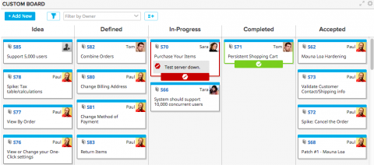
Source: techdocs.broadcom.com
Daily Stand-ups: A daily stand-up or daily check-in is a short meeting that is typically 15 minutes in length or less where the entire team meets to discuss progress. The team considers what might be impeding progress and needs attention for resolution.
Sprint Review and Retrospective: After the end of each Sprint, the team holds two meetings.
The first is a Sprint Review with the project stakeholders to show them the finished product and invite feedback. The second is the Sprint Retrospective to discuss the following.
- What went well during the Sprint?
- What could have been better?
- Was the task load too heavy or too light for each team member?
- What was accomplished during the Sprint?

Why is there a need for this document?
This document is needed to help any audience quickly and easily understand what Agile project management is and how Rally® can be adopted as an effective Agile Project Management tool.

Why use Rally®?
Rally enables project risk management with the ROAM dashboard in addition to planning and tracking of projects. ROAM is an acronym for Resolve, Own, Accept, and Mitigate. These are the four actions to take to solve a potential risk. The ROAM model encourages collaboration on every level, as the entire Agile organization is called to help identify and prioritize risks.

Rally's project management features
- Capacity planning: Helps ensure the right work is set for the next release.
- Central hub for teams: Teams can collaborate on planning, prioritizing, and tracking work.
- Visibility into bottlenecks: Cumulative flow diagrams show how work item states have progressed over time.
- Custom dashboards: Lets the team create and follow metrics that are most important to the team.
- Big Room Planning: Teams meet to plan the release, identify dependencies and challenges, and commit to doing the work.
- Portfolio Items Hierarchy: A page that shows a current list of work to be done, how user stories align to features and initiatives, and real-time progress.
- Milestone burnup chart: Tracks the progress of work leading up to a particular date.
- Rally Insights: Tracks the team’ productivity, predictability, responsiveness, and the overall quality of work.

Key Duties of a Scrum Master/Agile Project Manager
Facilitating Scrum ceremonies:
Leading and structuring key Scrum events like daily Scrums, Sprint planning, Sprint reviews, and Sprint retrospectives.
Managing product backlog:
Collaborating with the Product Owner to prioritize and refine the product backlog, ensuring it reflects the most valuable work.
Coaching the team:
Guiding the team on Agile principles and Scrum practices, helping them improve their self-organization and collaboration skills.
Removing impediments:
Identifying and actively resolving any obstacles that prevent the team from achieving their goals.
Protecting the team:
Shielding the team from external distractions and interruptions to maintain focus.
Promoting communication:
Ensuring clear communication between the team, product owner, stakeholders, and other relevant parties.
Enhancing team dynamics:
Fostering a positive and collaborative team environment, addressing conflicts constructively.
Continuous improvement:
Encouraging the team to reflect on their process and identify areas for improvement during retrospectives

The Agile Team
The ideal Agile team size is 7 ± 2. Agile teams are generally composed of software engineers, quality engineers, a product owner, and a Scrum master. Full-stack development teams are desirable because fewer dependencies on other teams exist.
A full stack team is a group of developers with the skills to work on all aspects of a project, from initial concept to final launch.
In order to set up an Agile or Scrum team for the first time, the following artifacts need to be created by the Scrum Master.
Working Agreements
Agile teams will typically have team policies or team working agreements. The team uses the working agreements to guide how they would work in a productive manner.
As part of the working agreements, the team can define exit agreements to determine when a story moves to a new column on the Team Board page. As the story card moves across the board, different team members may be engaged to work on the item.
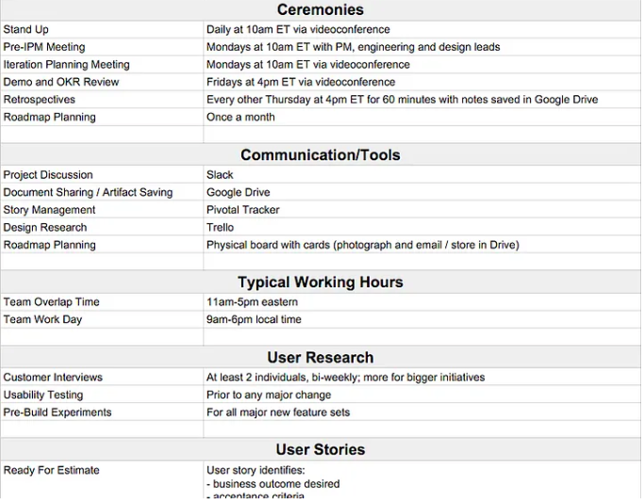Example of a team working agreement
Iterations
An iteration, or Sprint, is a pre-specified timeframe known as a timebox when development happens. The length is determined by the team and is typically between one and four weeks. An iteration includes planning, daily standups, the development work, the iteration review, and the iteration retrospective.

Ceremonies
Ceremonies include iteration planning, daily standups, iteration reviews, and iteration retrospectives. With the Scrum master's assistance, the team determines if all of these are wanted, when they occur, and who should attend.
Ceremony | Description
Planning | During planning, the team scopes out the work to be performed during the iteration and commits to delivering at the end of the iteration cycle.
Daily standup | During the 15-minute daily standup, the team discusses work planned for the day and if anything is impeding progress. The Scrum master’s responsibility is to assure that the impediments are removed and that the team remains on track.
Review | During the iteration review, the team and stakeholders view a demonstration of the working software that was developed over the course of the iteration. The product backlog is then adjusted based on stakeholder inputs. The Scrum master facilitates.
Retrospective | During the iteration retrospective, the team discusses what worked well and what can be improved during the next iteration. The Scrum master facilitates.

Definition of Done
The definition of done (DoD) in Agile is a set of criteria that a product increment must meet to be considered complete and ready for release.
A typical DoD checklist might include:
- Coding is complete and meets business and functional requirements.
- Testing is complete, with no known defects or defects acceptable for this release.
- Documentation is complete.
- The item is ready for general availability.

The Information Dashboard
A Scrum master would want to collate important information onto a single custom page or on a dashboard. Having one location to view important information about the team, particularly information on how the team performs over time, can help an organization save time, funds and improve the team's efficiency.
The dashboard helps the Scrum Master quickly view the following:
- What has changed that is relevant to the team
- If the team is going to meet their iteration commitment
- If the team needs to adapt to a revised plan
- If a team member needs help
- If any work items need the Scrum Master’s attention
Select Home, Dashboard to get started.
A Rally dashboard may be customized by adding the following apps to the dashboard template. Apps may be used to make updates, get status information, and view charts.
- Cycle/Lead Time App
- Throughput App
- Velocity Chart App
- Portfolio Item Cumulative Flow
To install an App:
- Select the gear at the top right of the page and select Add App
- In the App Catalog window, search or use the Source or Category filters to locate an app from the App Catalog window and select Add.
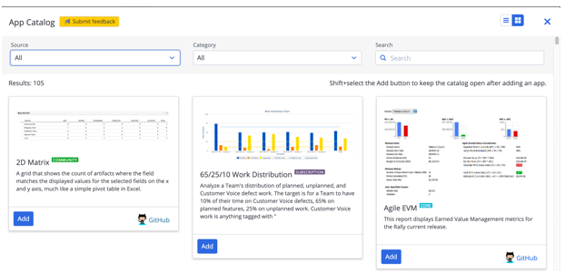
Example view of an App Catalog on Rally®.
For detailed information, please refer to the Rally® documentation on setting up and customizing Dashboards.

Team Standups
The daily standup provides a space for communication, clarity around the work, and knowledge sharing. The 15-minute daily standup is a time-boxed event for the development team to discuss work for the day and identify any possible concerns.
The Scrum master ensures that the team meets daily and helps the team maintain the time box while mitigating all disruptions, risks and impediments. This enables the team to stay on track and efficiently share their plans, communicate, collaborate and make quick decisions. It is the Scrum master’s duty to set up the Team Board page and track iteration progress. This makes the daily standup more efficient.
Team Board:
The Team Board page is easy to set up and gives teams the autonomy to work in a way this is best for them while maintaining consistent data for the enterprise by rolling up metrics to the program and portfolio levels.
On the Team Board page, all of the team’s work can be viewed in one place. A team board provides a visualization of the workflow. Team members and editors can create new cards, edit cards, and move cards on the team board.
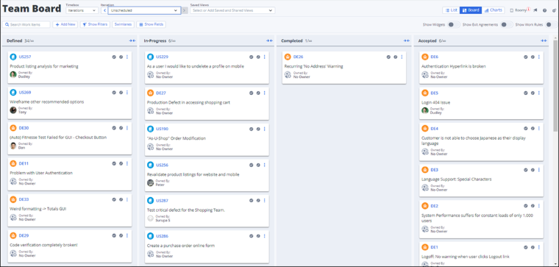
Example of a Team Board on Rally®
For additional information, refer to the following topics:
- The Daily Standup
- Team Board Page
- Iteration Status Page

Team Planning
The Team Planning page is used to pull work from the product backlog and schedule work into iterations. Team Planning allows the Scrum master and team to easily view the velocity of work items in a given iteration and determine if the team is over capacity.
Timeboxes, Iterations and Releases need to be set up in Rally before team planning can commence. The team’s capacity must also be calculated prior to team planning using the Capacity Planning Page.
To access the Team Planning Page
- Select Plan, Team Planning
- Select the timeframe that you plan to use by choosing the correct Release in the dropdown menu.
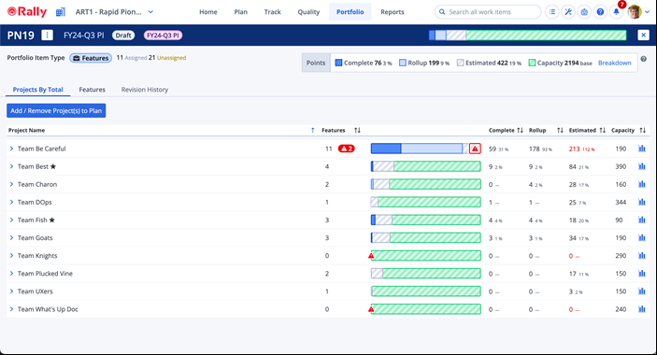
Example of Team Capacity Planning Page on Rally®
Capacity Planning Page
The Capacity Planning page is used for planning work for a Program Increment (PI) or Release for multiple teams. The planning on this page focuses on work at the portfolio item level. Once the Capacity Plan is complete and published, individual teams can use the Team Planning page to focus on work at the user story level and to schedule those stories into iterations.
To access the Capacity Planning Page
- Navigation: Go to "Portfolio" in the main navigation menu.
- Option selection: Select "Capacity Planning" within the "Portfolio" section.

A program increment (PI) is a set period of time in the Agile Release Train (ART) when teams deliver software and systems:
- Length: PIs are typically 8–12 weeks long
- Purpose: PIs help teams work at a specific pace and deliver results faster
- Planning: PI planning is a large-scale meeting where teams discuss the product roadmap, decide on features, and identify dependencies
- Outcomes: At the end of PI planning, each team leaves with clear objectives for the next PI, including a list of features, milestones, and delivery dates.
An Agile Release Train (ART) is a group of Agile teams that work together to achieve a shared goal.
Team Planning Page Views
The Team Planning page has the ability to provide different views of work to help the team and Scrum master plan faster in addition to drilling down as needed. Various views can be accessed by selecting the view icons in the upper-right corner of the page. The Team Planning page contains the following views:
Backlog View: The Backlog view helps the team identify the work that the team plans to undertake in the release. It makes it easy to refine and prioritize that work. It provides an expanded view of the backlog without the iterations, or the Release Backlog sections and has several options to filter the work that requires planning.
Planning View: The Planning view helps prioritized work items to be scheduled into iterations and are based on the size of the work and the capacity of the team. This view includes the Backlog (unscheduled work), Iterations, and the Release Backlog sections. It Provides a way to move work into a release or iteration.
Planned View: The Planned view gives the team and stakeholders an overview of the work that has been scheduled for each iteration. It includes the Backlog (unscheduled work), and the Plan and displays a more detailed view of the team’s plan.

Team planning comprises of the following areas.

Reviewing the Backlog
The product backlog can be viewed and filtered as necessary to allot User Stories into Iterations. The rank of items in the backlog section can be changed by using drag and drop or by using the gear menu. One can choose from multiple quick views (preconfigured filters) for the Backlog section of the Team Planning page.
Within the Backlog toolbar, select a view from the list. The appropriate Backlog view is displayed.
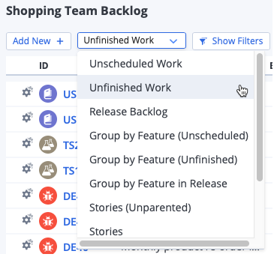
Example of a backlog tool bar view

Scheduling Work into Iterations
Once the team has reviewed the backlog, the work comprising of User Stories and Defects can be scheduled to iterations.
To schedule a work item into an iteration:
- Select Plan, Team Planning
- Select the Planning or Planned view.
- Use the drop-down at the top of the page to select the release that you want to schedule.
- Select the list (backlog, release backlog, or iteration) you want to work with.
- Hover the cursor on the left side of the work item row you want to move.
- Drag the row to a new location, either an iteration or to a backlog.

Identifying Issues
The bar next to each iteration indicates the size of each work item relative to the velocity of the iteration. The percentage is an indicator of how much capacity the team has for the iteration. If the percentage is over 100%, the iteration name and the issues icon display in red, indicating that work needs to be removed from the iteration in order to resolve the over-capacity issue.
Examples of issues may include:
- A story does not have a plan estimate.
- An iteration's velocity is greater than 100%.

Managing Dependencies
To view the predecessors or successors that are associated with a work item, the number of dependencies displays in the Dependencies column. Select the number to view those dependencies.
- Select Plan, Team Planning
- Select the value in the Dependencies column for the work item to view the Dependencies dialog box. This dialog box contains two tabs to let you see the Predecessors and the Successors for this work item.
- To view the dependencies in the full detail editor, Select Use Full Editor
- To add an existing work item as either a predecessor or successor for the current work item:
- Select Link Existing from either the Predecessors or the Successors tab.
- In the Choose dialog box, choose filters from the drop-down list and use the search field to locate the work item(s) that you want to associate.
- Select the check box for each work item that you want to associate.
- Select Done.
The new dependency is added to the list of dependencies for this work item.

Managing Tasks
To view tasks that are associated with work items or add new tasks to work items, proceed as follows.
- Select Plan, Team Planning
- Select Tasks for the work item to view the Tasks dialog box.
- To view the tasks in the full detail editor, select Use Full Editor
- To quickly add a task to this work item:
  - Select Add New
  - Enter the name of the task in the Name field.
  - Optionally, enter an estimate and select an owner for the task.
  - Select Create
The new task is added to the list of tasks for this work item.
- To add a task with more detail
  - Select Add New
  - Select Create with Details to view the task in the detail editor.
  - Complete the necessary fields.
Required fields are marked with an asterisk (*).
  - Select Create

Iteration Status
The Iteration Status page provides the team with a view of work items within an iteration organized by schedule state. The Iteration Status page can be customized to suit the needs of the team. There are two views available for viewing the work items in an iteration. These are the board view with cards representing work items or a list view that organizes work items so you can easily view relationships and dependencies.
To select and iteration: Choose an iteration from the drop-down menu from the top of the page to display the work items that apply to that iteration.
To change between List & Board views:
- Select Track, Iteration Status
- Select the List/Board toggle to switch between these two views.
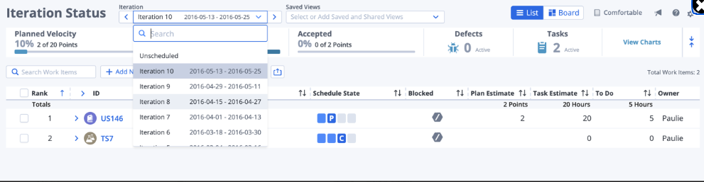
Example of Iteration Status page
To filter by owner:
- Select Show Filters
- Select Add New
- A drop-down menu appears with all available filters. There are two options that deals with Owners:
- Owner is only the top-level work item (e.g. the owner of the User Story itself).
- Owner (inc. Children) will parse all children of the primary work item, such as Tasks or Test Cases.
- Select Clear Filter to return the cards to their original state:
The age of a user story card displays the number of days that the card has spent in a specific scheduled state.
To display the age of a card:
- Select the Gear icon in the upper-right corner to open the page settings.
- Select Age of cards
- Enter a number corresponding to the number of days after which you would like the age to show on the card.
- Select Confirm

Iteration Retrospective
A retrospective meeting is held at the end of each iteration for the team to inspect and adapt their iteration, teamwork, and methods.
Rally provides centralized data, visual aids, collaborative tools and action item tracking functions for conducting successful Iteration Retrospectives. The platform's features can be used to gather feedback from a team about their recent work, identify areas for improvement, and create actionable steps to enhance future performance.
Rally provides the following reports that are related to throughput and velocity. These reports may be utilized by the Scrum master as an artifact during iteration retrospective discussions addressing team performance and missed delivery commitments.
- Cycle/Lead Time Chart
- Throughput Chart
- Velocity Chart
These charts can be accessed through the Reports menu.

References
- Broadcom Technical Documentation
- Learn Rally in five easy steps.

