**Application Program Interface**

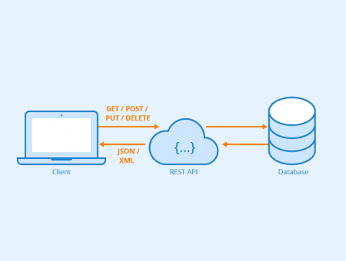

**What is API?**

Connector between Application, Database and Devices

**GET Request:**

Retrieve information from API

No modifications

**POST Request:**

Create new data

**PUT Request:**

Updating existing data

**DELETE Request:**

Deleting data

**PATCH Request:**

Partial update on data

**Difference between PUT and PATCH:**

PUT is for replacing entire data, PATCH is for updating data partially

**Common Error Codes:**

200 - OK

404 - NOT FOUND

401 – AUTHENTICATION ERROR

201 – CREATED