Student Name: | Madhumith Reddy Gadhepally
Student Id: | 20098400
Course Title: | M.Sc. Cyber Security
Lecturer Name: | Swati Dongre
Subject Title/  Module Code: | Advanced Programming Techniques  (B9CY108)
Assignment Title: | CA_ONE_ (30%)
Submission Date: | April 10, 2026
No. of Words: | 810


- By ticking this box, I am confirming that this assignment/exam is all my own work. Any sources used have been referenced. I have read the College rules regarding plagiarism in the QAH Part B Section 3 and understand that penalties will be applied accordingly if work is found not to be my own. All work uploaded is submitted via Original, whereby a text-matching report will show any similarities with other texts.

Table of Contents
Table of Contents 2
Introduction 2
Section I: Programming in C# 3
Task 1: Delicious Churros Food Truck 3
Task 2: Periodic Table System 3
Section II: Programming in Python 4
Task 3: EasyDrive TCP Client-Server 4
Task 4: Web Scraping and Data Management 4
Conclusion 5
Resources and Attributions 5

GitHub Link: https://github.com/Madhumith345/Advanced-Programming-Techniques-CA-1.git

Introduction
This report includes the implementation of four programming tasks illustrating the important concepts in Object-Oriented Programming (OOP), Data Structures, Network Programming, and Data Processing in C# and Python. Every task will be premised on a real-life scenario whereby the theoretical concepts can be applied in practice. The solutions were built keeping the goal of efficiency, modularity, scalability and robustness. The data structures, external libraries and programming paradigms used were appropriate choice to enable best performance and maintainability.

Section I: Programming in C#

Task 1: Delicious Churros Food Truck
This assignment was to design and code a menu driven console program which should simulate an order management system in a food truck where people would place orders, pay and wait in a queue to receive their orders.
Design and Object-Oriented Principles
The system was developed using two main classes:
- Churros Class: Maintains menu items and their prices using dictionaries, allowing efficient retrieval and easy modification of menu data.
- Order Class: Handles order-specific data such as item selection, quantity, total bill, and unique order number.
Key OOP concepts implemented include:
- Encapsulation through private fields and public properties
- Constructors for object initialization
- Method abstraction for operations like place_order(), pay_bill(), and collect_order()
This design ensures separation of concerns and improves code readability and maintainability.
Data Structures
A Queue<Order> was used to manage customer orders. This guarantees the First-In-First-Out (FIFO) processing, which is a correct depiction of the real-life service systems. The queue structure enables effective addition and deletion processes and therefore, it suits the situation well.
Unit Testing
A dedicated unit test project was created using MSTest to validate the pay_bill() method. Test cases covered:
- Single item billing
- Multiple quantities
- Different pricing combinations
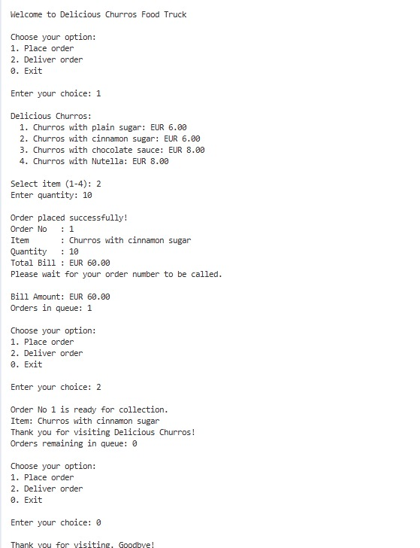

Task 2: Periodic Table System
This task required the development of an application to provide information about the first 30 elements of the periodic table based on user input.
Implementation
An Element class was developed that had qualities like name, symbol, classification and the description. This promotes structured data representation and reusability.
Data Structures and Efficiency
It was created as a Dictionary, and the atomic number was the key. This enables time (O(1)) constant lookups, and the system is very efficient as the size of the dataset increases.
The program offers an interactive interface to users to interactively query information of elements, which improves usability and user experience.
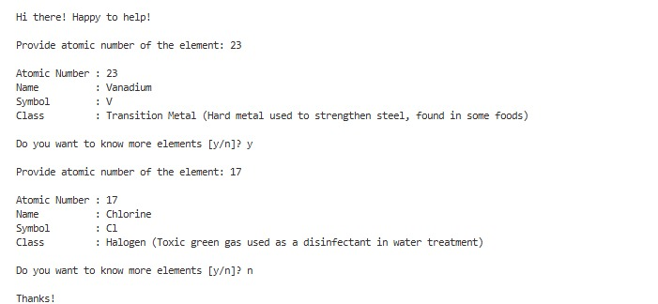

Section II: Programming in Python

Task 3: EasyDrive TCP Client-Server
This task involved developing a client-server application using a connection-oriented TCP protocol for a car rental registration system.
Client-Server Communication
The client application captures personal information of a user including the name, address, PPS number, and driving license information. Such information is formatted and sent on the server as a series of data in the form of a Jewish container in Python and socket through the socket module of Python to provide well-structured and platform-neutral exchange of data.
Server Processing and Database Integration
The server waits on connections and processes client information and logs it in a non-volatile SQLite database (easydrive.db) with the module sqlite3. This guarantees quality storage of data and will facilitate data retrieval exercises in the future.
Unique Registration Generation
Once the data have been stored successfully, the server uses a combination of prefix (REG) and a timestamp value to create a unique registration number. This ensures it is unique and will not be duplicated. This ID is in turn relayed back to the client thereby closing the communication loop.
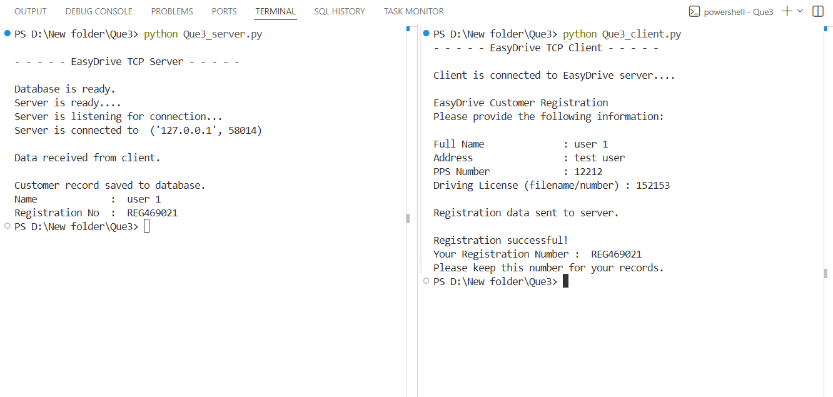

Task 4: Web Scraping and Data Management
This task focused on extracting structured data from a webpage and storing it for further use.
Web Scraping Implementation
Webpage access via the requests library followed by the HTML content of the webpage attempted with BeautifulSoup (BS4). Title of the books, their prices and ratings were also extracted using the DOM structure and locating valid HTML tags and classes.
Data Storage and Retrieval
Data were extracted and put in a CSV file (books.csv) with the help of the csv module of Python, as a guarantee of structured and enduring storage. The program is also able to write and read the data stored on the terminal and the CSV file is read which indicates that the program has features of both data writing and reading.
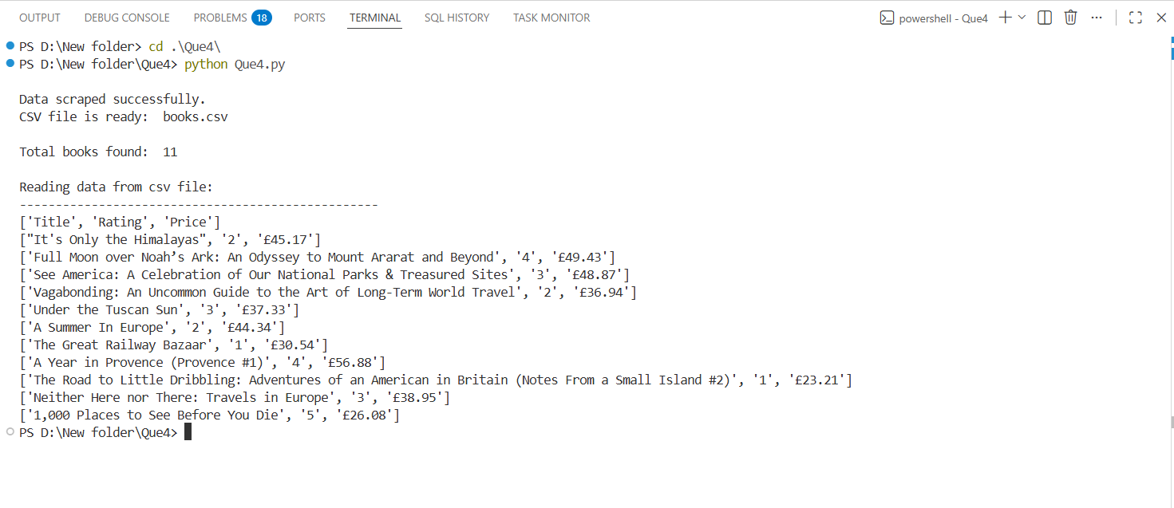

Technologies and Tools Used
- C#: OOP concepts, Queue, Dictionary, MSTest
- Python: Socket programming, JSON handling, SQLite3, Web scraping
- Libraries: Requests, BeautifulSoup, CSV
- Tools: Visual Studio / VS Code
- Version Control: GitHub

Conclusion
The assignment is a good illustration of how several concepts and technologies of programming can be integrated. Proper data structures used ensured that data was processed effectively and the object-oriented design was used to enhance modularity and maintainability. Moreover, the use of networking, database system and web scraping also indicates the capability to create real-life applications, which are scalable. All in all, the solutions are sound, effective and in line with current practices of software development.

Resources and Attributions
Bill Wagner (n.d.). C# docs - get started, tutorials, reference. [online] learn.microsoft.com. Available at: https://learn.microsoft.com/en-us/dotnet/csharp/.
GitHub (2025). GitHub. [online] GitHub. Available at: https://github.com/.
IEvangelist (n.d.). Collections and Data Structures. [online] learn.microsoft.com. Available at: https://learn.microsoft.com/en-us/dotnet/standard/collections/.
Microsoft (2025). Visual Studio Code. [online] Visualstudio.com. Available at: https://code.visualstudio.com/.
ncarandini (2025). Unit testing C# with MSTest and .NET - .NET. [online] Microsoft.com. Available at: https://learn.microsoft.com/en-us/dotnet/core/testing/unit-testing-csharp-with-mstest.
Python (2020). socket — Low-level networking interface — Python 3.8.1 documentation. [online] Python.org. Available at: https://docs.python.org/3/library/socket.html.
Python Software Foundation (2019). 3.7.3 Documentation. [online] Python.org. Available at: https://docs.python.org/3/.
Python Software Foundation (2020). csv — CSV File Reading and Writing — Python 3.8.1 documentation. [online] Python.org. Available at: https://docs.python.org/3/library/csv.html.
Python Software Foundation (2024). sqlite3 — DB-API 2.0 interface for SQLite databases — Python 3.8.2 documentation. [online] docs.python.org. Available at: https://docs.python.org/3/library/sqlite3.html.

