Endpoint Security Incident Response and Automated Remediation Assessment Report
Student Name: Madhumith Reddy Gadhepally
Student Number: 20098400
Module Code: B9CY110
Module Title: Communication and Network Security
Programme and Year: MSc Cybersecurity
Lecturer: Kingsley Ibomo
Words Count: 1801
Academic Integrity Statement
All work in this assessment is my own and I have adhered to academic honesty in completing this assessment. Appropriate referencing and citing of all sources used in this report have been done. If any generative AI tools are being used, they are marked as such and are only being used in learning, research and documentation.

Executive Summary
A fictional retail company, called Larkspur Retail Group, experienced a mock security incident with suspicious PowerShell activities, user account creation, privilege escalation attempts, and multiple failed logon attempt on endpoints using a variety of operating systems, including Windows and Linux. This project was designed to build and implement a comprehensive and secure endpoint monitoring and response solution to improve visibility, detect malicious activity and automate response.
Oracle VirtualBox was used for creating an isolated laboratory environment, comprising of a Windows 11 endpoint, an Ubuntu Linux endpoint, and a Wazuh Security Information and Event Management (SIEM) server. Endpoints were monitored with Windows Security Logs and Sysmon, PowerShell logging, Linux authentication logs and auditd. Wazuh was configured to centralise and analyse events occurring on endpoints.
To obtain representative attacker behaviour, five attack simulations were performed. It was found that the implemented detection rules were able to detect a variety of security related activities such as the creation of user accounts, modifying user accounts, attempts at privilege escalation, authentication failures, and package management activities. Implemented security environment using Docker, with Ollama and TinyLlama model for security analysis and response. Security events were reviewed with the AI component and recommendations made on remediation actions.
Testing was conducted on two remediation scenarios. The first involved disabling a suspicious user account on the Windows endpoint, the second removing an unauthorised user account from the Linux endpoint. These actions were confirmed to be used to make sure that the required security measures were applied successfully.
The project overall was a good example of how to practically implement endpoint monitoring, detection engineering, and incident response processes.
Table of Contents
Executive Summary 1
List of Figures 3
1. Introduction 4
1.1 Background 4
1.2 Objectives and Scope 5
1.3 Out of Scope 5
1.4 Report Structure 5
2. Literature Review and Standards Alignment 5
3. Scenario and Threat Model 6
3.1 Company Overview 6
3.2 Incident Narrative 6
3.3 Assumed Adversary 6
3.4 Assets and Trust Boundaries 6
3.5 Attack Path Hypotheses 6
4. Methodology 6
4.2 Vulnerable Configuration Choices 7
4.3 Telemetry Sources 7
4.4 SIEM Integration 8
4.5 Detection Engineering Approach 8
4.6 Automation and Remediation Design 8
4.7 Validation and Evaluation 8
4.8 Ethical and Safety Considerations 9
5. System Architecture and Implementation 9
5.1 High-Level Architecture 9
5.2 Endpoint Configurations 9
5.3 SIEM Configuration 10
5.4 AI Security Stack 10
6. Results 10
6.1 Evidence of Compromise 10
6.2 Detection Outcomes 10
6.3 Automated Remediation Outcomes 11
6.4 Performance and Reliability 11
6.5 Limitations 11
7. Discussion 12
9. Conclusion 12
References 12
Appendix A – Lab Network Diagram 14
Appendix B – VM Build Specifications and IP Plan 14
Appendix C – Sysmon Configuration Excerpt 15
Appendix D – auditd Rule Set 16
Appendix E – SIEM Alert Rules and Queries 16
Appendix F – Screenshots of Dashboards and Alerts 19
Appendix G – Docker Compose File and Component Descriptions 19
Appendix H – Test Cases and Results Table 22

List of Figures
Figure 1: Virtualized laboratory environment consisting of a Wazuh server, Windows 11 endpoint, and Ubuntu endpoint. 6
Figure 2: Wazuh Dashboard Successfully Accessed After Server Deployment 7
Figure 3: Windows Endpoint Successfully Registered and Active in Wazuh Dashboard 7
Figure 4: Installation and Verification of Sysmon on the Windows Endpoint 9
Figure 5: Auditd Service Enabled and Running on the Ubuntu Endpoint 9
Figure 6: Docker Containers Running for AI Security and Remediation Services 10
Figure 7: Detection of User Account Creation Activity in Wazuh Threat Hunting Dashboard 10
Figure 8: AI-Assisted Remediation Action for Suspicious User Account Activity 11
Figure 9: Lab network architecture showing Windows and Linux endpoints forwarding telemetry to Wazuh SIEM and Dockerized AI remediation stack. 13
Figure 10: Windows Endpoint Network Configuration Showing Assigned IP Address 14
Figure 11: Ubuntu Endpoint Network Configuration Showing Assigned IP Address 14
Figure 12: Wazuh Server Network Configuration Showing Assigned IP Address 14
Figure 13: auditd Service Enabled and Running on the Ubuntu Endpoint 16
Figure 14: User Account Creation Attack and Corresponding Wazuh Detection (MITRE ATT&CK T1136) 17
Figure 15: Privilege Escalation Simulation Through Addition of a User to the Local Administrators Group and Corresponding Wazuh Account Modification Detection (MITRE ATT&CK T1098). 17
Figure 16: Linux Privilege Escalation Through Successful Sudo-to-Root Execution and Corresponding Wazuh Detection (MITRE ATT&CK T1548) 17
Figure 17: Failed Linux Privilege Escalation Attempt and Corresponding Wazuh Security Event Detection (MITRE ATT&CK T1110) 18
Figure 18: Linux Package Management Activity Detection Following Execution of sudo apt update and Corresponding Wazuh Alert Events 18
Figure 19: Detailed Information View of the Registered Windows Endpoint in Wazuh Dashboard 18
Figure 20: Wazuh Agent Operational Logs Confirming Successful Communication with the Server 19
Figure 21 : Docker Installation Validation Using Hello-World Container 20
Figure 22: Docker Compose Configuration for AI Security Remediation Services 21
Figure 23: Execution of TinyLlama AI Model for Automated Security Remediation Recommendations 21
Figure 24: AI-Generated Security Recommendations for Linux-Based Security Events 21

1. Introduction

1.1 Background
In today's modern organizations, endpoint devices like workstations, laptops, and servers are vital to the business. These are the endpoints that are frequently attacked for unauthorized access, stealing credentials, escalating privileges and persistence. It is therefore important to have an effective endpoint monitoring solution to detect suspicious activity before any major damage is done.
Larkspur Retail Group is a fictional retail company with Windows and Linux endpoints deployed at various locations. The organisation needed greater visibility, threat detection and automated remediation due to indicators of compromise for suspicious PowerShell running, suspicious accounts and Linux privilege escalation.

1.2 Objectives and Scope
The main goal of this project was to create an endpoint monitoring and response solution that could:
- Collecting telemetry from Windows and Linux endpoints.
- Log centralisation in a SIEM platform.
- Identifying typical attacker techniques.
- Supporting investigation workflows.
- Application of automated controlled remediation.

1.3 Out of Scope
Enterprise network redesign, email security controls, advanced malware analysis, complete digital forensics and production-scale deployment considerations were not part of the project.

1.4 Report Structure
This report presents the literature review, threat model, methodology, implementation details, results, discussion, recommendations, and conclusions.

2. Literature Review and Standards Alignment
Endpoint security is a process of monitoring, logging, detecting and responding to attacks on devices. To monitor security events, you need end-to-end capabilities for collecting the full telemetry and centralized analysis of those events (Microsoft 2026).
Sysmon enhances the native Windows logging capabilities by adding detailed process creation, network activity, and system event visibility. Likewise, auditd enhances auditing features on Linux systems to track user activities, authentication events, and attempts at privilege escalation (Microsoft 2024).
SIEM systems centralize and correlate logs from various sources to aid detection engineering and incident response. Wazuh integrates endpoint monitoring, threat detection and endpoint alerting, and works on both Windows and Linux systems (Wazuh Inc. 2024).
Detection engineering is frequently consulted against the MITRE ATT&CK taxonomy, which offers a structured taxonomy of adversary techniques and behaviours (MITRE Corporation 2026). Mapping detections to ATT&CK helps to ensure consistency and enables threat informed defense strategies.
Automated response technologies and Security Orchestration, Automation and Response (SOAR) concepts can help organisations with faster response times and more efficient operations. However, overuse of the automated system can cause potential false-positive and the disruption problem. As a result, remediation actions need to be controlled, auditable and reversible (National Institute of Standards and Technology 2012).
This project's work is also complimentary to many security standards published, such as NIST SP 800-61, CIS Controls Version 8, CIS Benchmarks and ISO 27001. These frameworks focus on logging, monitoring, incident response, least privilege and continuous improvement (Center for Internet Security 2024).
The key components of monitoring environment were identified based on the literature review: Sysmon, auditd, Wazuh SIEM, MITRE ATT&CK mapping and AI-assisted remediation.

3. Scenario and Threat Model

3.1 Company Overview
Larkspur Retail Group is a pretend company that relies on Windows and Linux systems for its retail, inventory, and administrative needs.

3.2 Incident Narrative
The organisation detected suspicious activity such as the execution of PowerShell scripts, creation of suspicious accounts, attempts at privilege escalation and failed authentication events.

3.3 Assumed Adversary
A simulated attacker attempts to get persistent and escalate privileges through the use of legal administrative tools and processes.

3.4 Assets and Trust Boundaries
Those critical assets include endpoint systems, user accounts, authentication mechanisms, business information and monitoring infrastructure. Endpoints, SIEM components and AI remediation platform have trust boundaries.

3.5 Attack Path Hypotheses
Common avenues of attack are credential compromise, PowerShell-based execution, creating accounts, privilege escalation via administrative groups, and Linux sudo abuse.

4. Methodology
4.1 Lab Environment Build
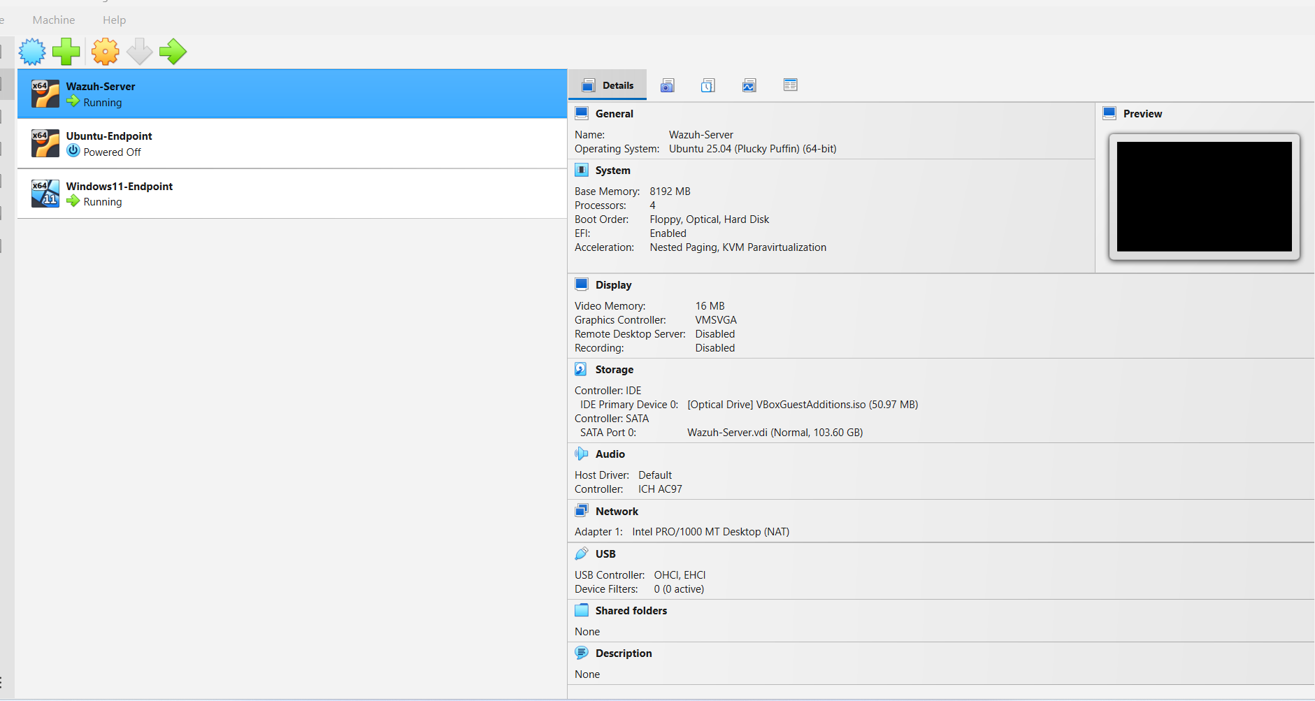
Figure 1: Virtualized laboratory environment consisting of a Wazuh server, Windows 11 endpoint, and Ubuntu endpoint.
Oracle VirtualBox was used to implement the laboratory environment. Three Virtual Machines were set up:
- Windows 11 Endpoint
- Ubuntu Linux Endpoint
- Ubuntu-based Wazuh Server
Production systems were not exposed to the environment during testing.

4.2 Vulnerable Configuration Choices
A set of intentional or controlled weaknesses were introduced to generate security events. This involved creating test accounts, changing administrative groups, etc., and privilege escalation events.

4.3 Telemetry Sources
Windows telemetry included:
- Security Event Logs
- Sysmon
- PowerShell Logging
Linux telemetry included:
- Authentication Logs
- auditd
- File Integrity Monitoring

4.4 SIEM Integration
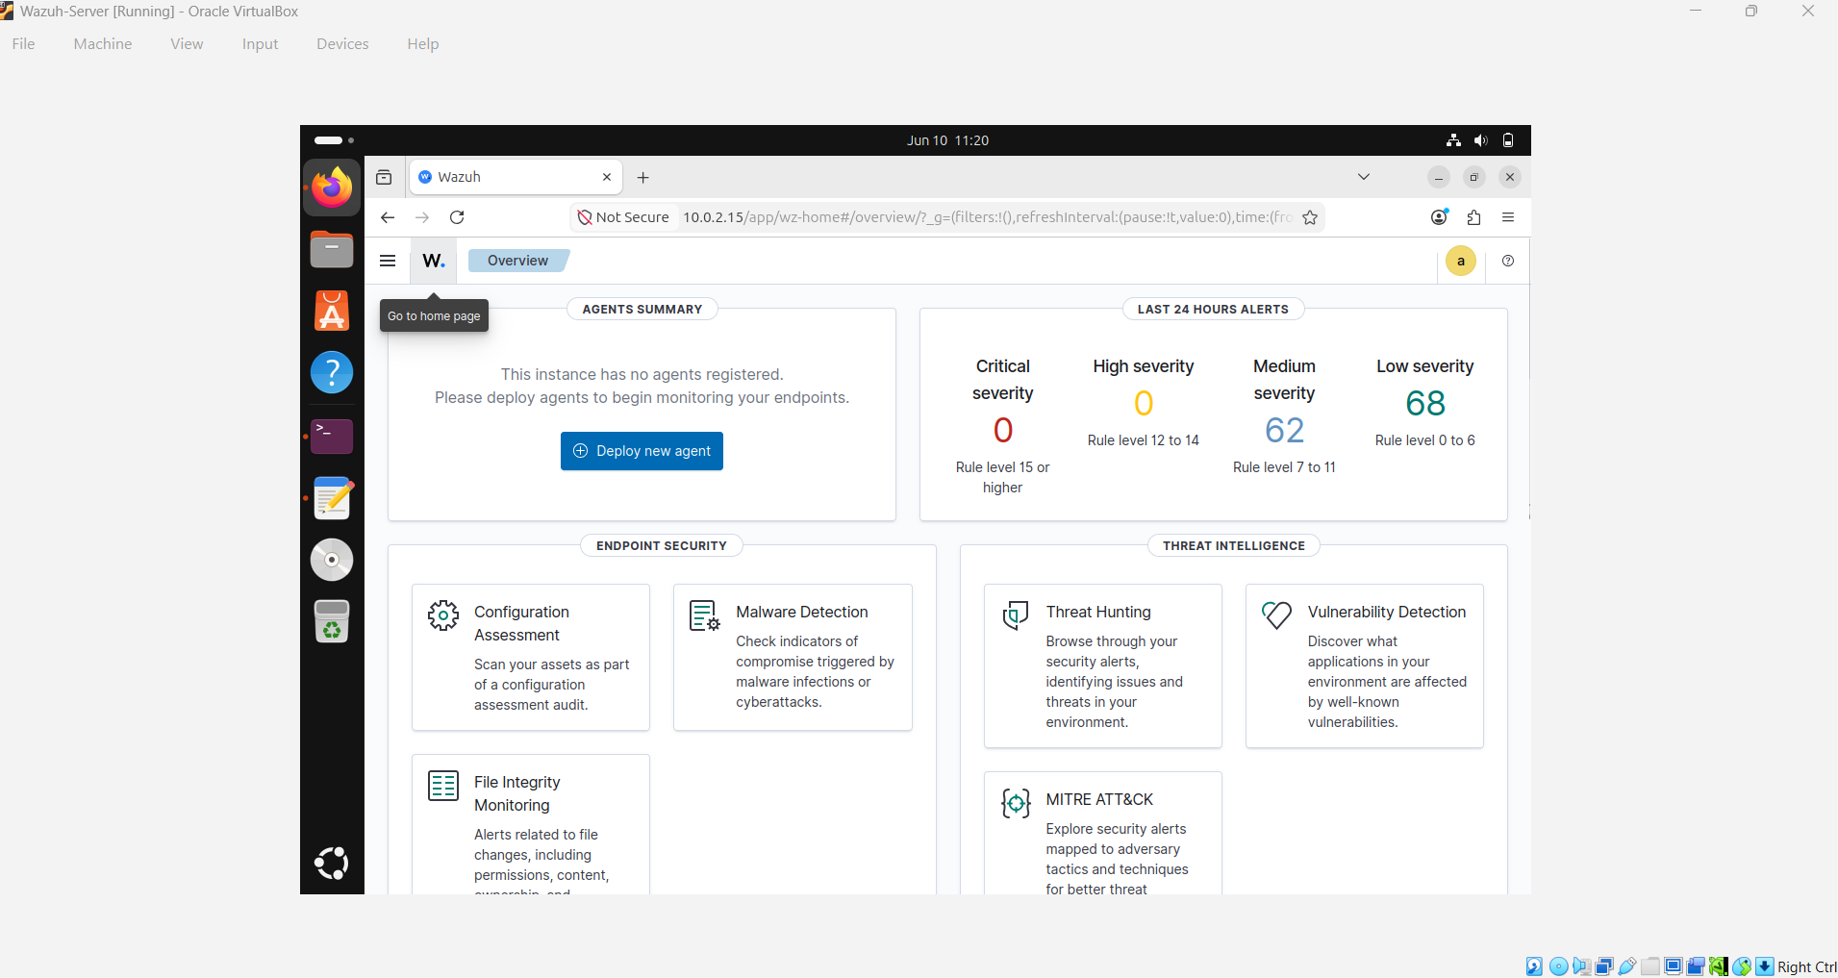
Figure 2: Wazuh Dashboard Successfully Accessed After Server Deployment
The Wazuh agents were installed on both endpoints and set up to send telemetry to the Wazuh Manager. All events are parsed, normalized, indexed, and shown in the Wazuh dashboard.
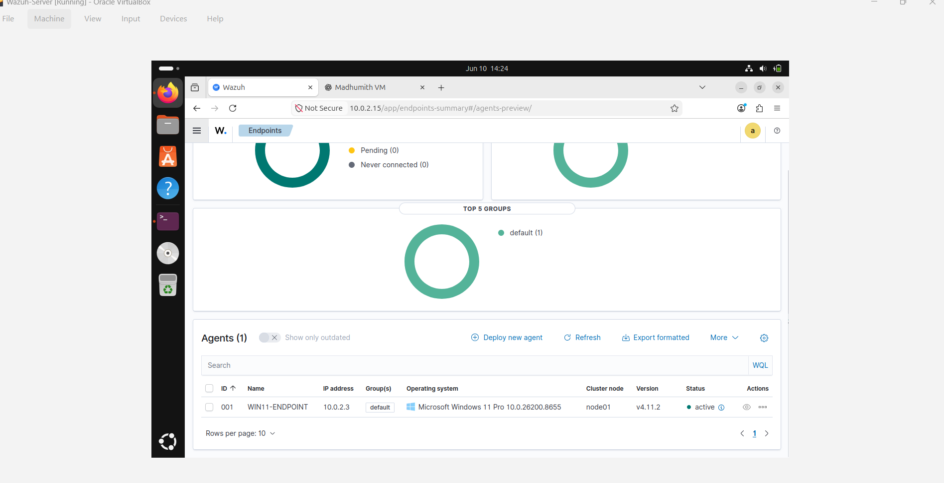
Figure 3: Windows Endpoint Successfully Registered and Active in Wazuh Dashboard

4.5 Detection Engineering Approach
Detection use cases focused on:
- User account creation
- Account modification
- Privilege escalation
- Authentication failures
- Package installation activity
MITRE ATT&CK techniques were used to categorise detections.

4.6 Automation and Remediation Design
Docker was taken advantage of at the automation level. TinyLlama was deployed using Ollama and used to give alert analysis and remediation recommendations. Remediation actions were predetermined, allowlisted and auditable.

4.7 Validation and Evaluation
The telemetry data from each attack simulation was validated inside Wazuh. Alerts for detection, remediation execution and verification activities were documented.

4.8 Ethical and Safety Considerations
No actual malwares have been used. All testing was done in an isolated virtual environment. No third-party systems were targeted or affected.

5. System Architecture and Implementation

5.1 High-Level Architecture
The architecture was composed of Windows and Ubuntu endpoints that sent their telemetry to the Wazuh server. Detection alerts were handled and analysed via the AI security stack for remediation support.

5.2 Endpoint Configurations
Windows Endpoint
Then the Windows endpoint had Sysmon, PowerShell logging, Windows Defender and enhanced auditing policies installed.
Linux Endpoint
Auditd, authentication logging, sudo monitoring and file integrity monitoring were setup on the Linux endpoint.
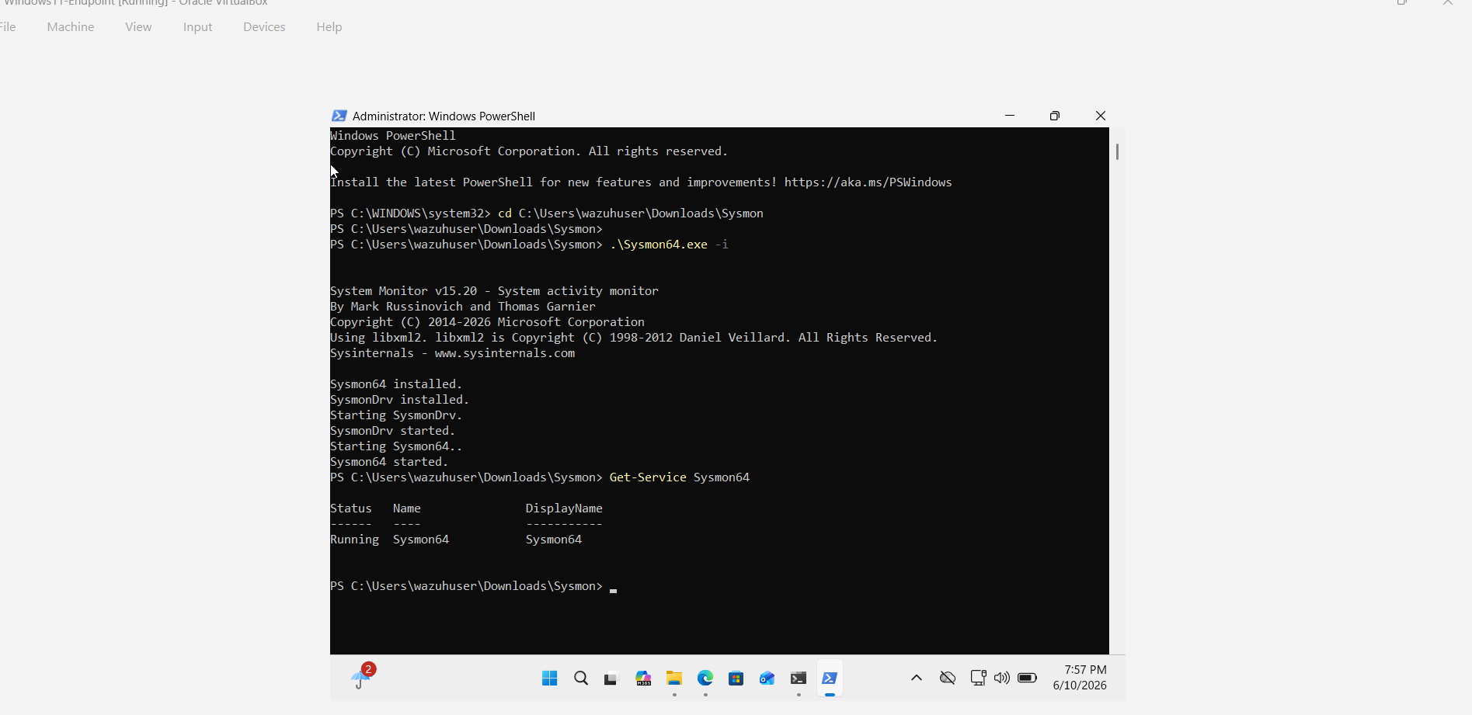
Figure 4: Installation and Verification of Sysmon on the Windows Endpoint
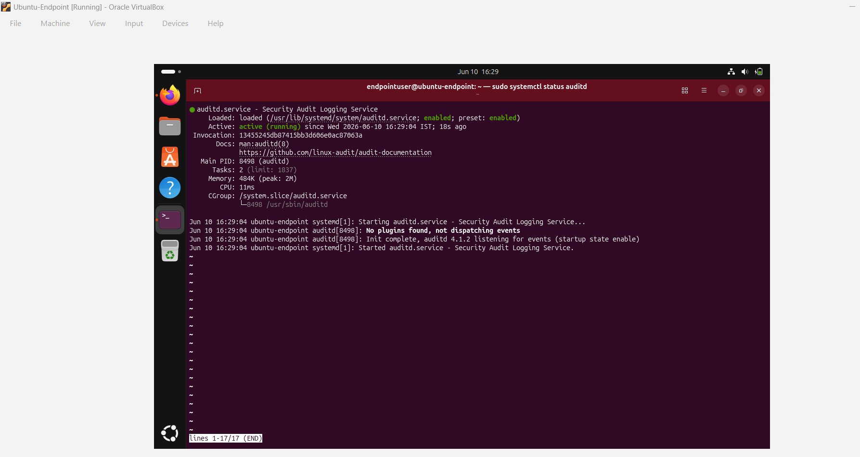
Figure 5: Auditd Service Enabled and Running on the Ubuntu Endpoint

5.3 SIEM Configuration
The monitoring of authentication events, the execution of processes, the status of endpoints, and the activities of threat hunting were visible via Wazuh dashboards. Alerts were created using a detection logic that is predefined.

5.4 AI Security Stack
This Dockerised AI security stack comprised:
- Ollama
- TinyLlama
- Remediation Service
Security controls were comprised of controlled execution, predefined actions, and verification procedures.
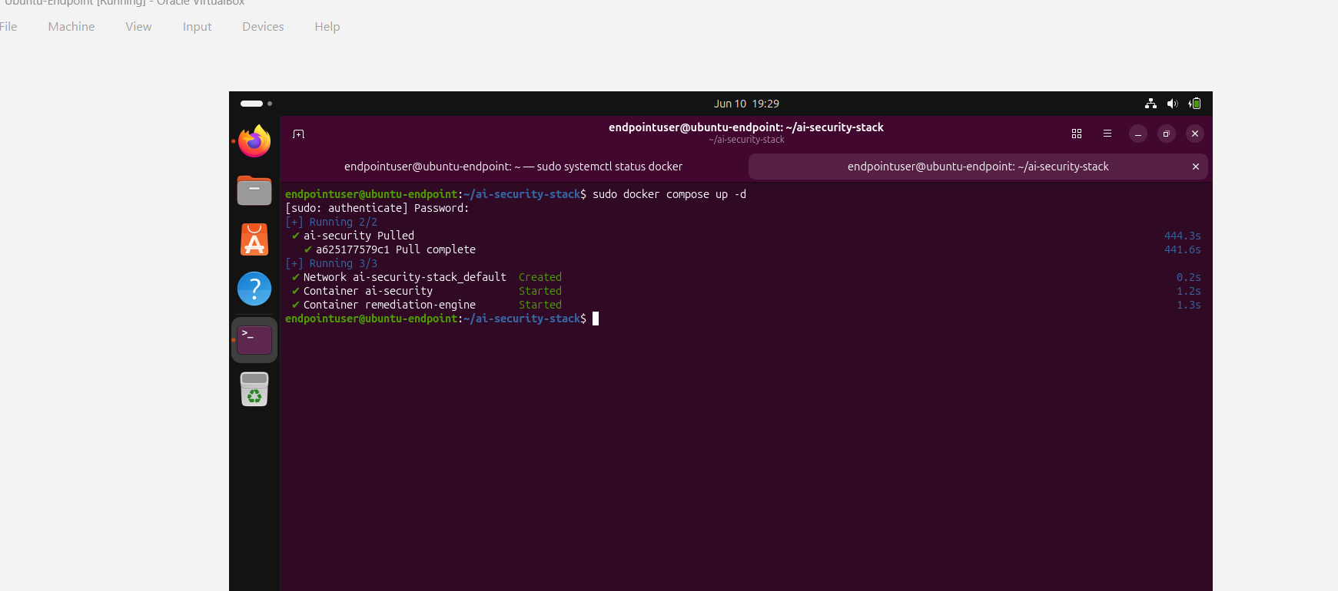
Figure 6: Docker Containers Running for AI Security and Remediation Services

6. Results

6.1 Evidence of Compromise
Representative endpoint telemetry and security alerts were created by simulated attacker activity.

6.2 Detection Outcomes
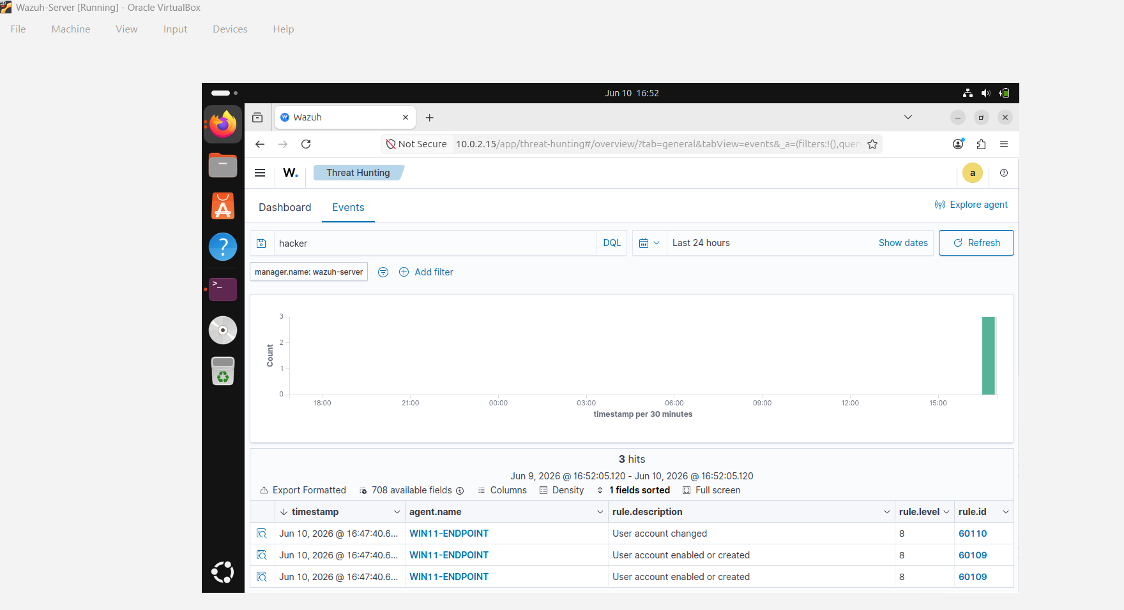
Figure 7: Detection of User Account Creation Activity in Wazuh Threat Hunting Dashboard
Use Case | Log Source | ATT&CK Technique | Trigger Condition | Severity | Result
User Creation | Windows Security Log | T1136 | New User Created | High | Detected
Account Modification | Windows Security Log | T1098 | Admin Group Modification | High | Detected
Privilege Escalation | auditd | T1068 | sudo Execution | High | Detected
Authentication Failure | Linux Auth Logs | T1110 | Failed Root Login | Medium | Detected
Package Activity | auditd | T1543 | Package Installation Activity | Medium | Detected

6.3 Automated Remediation Outcomes
Trigger | Action | Verification | Rollback
Suspicious Windows Account | Disable Account | Account Disabled | Re-enable Account
Unauthorized Linux User | Delete User | User No Longer Exists | Recreate User

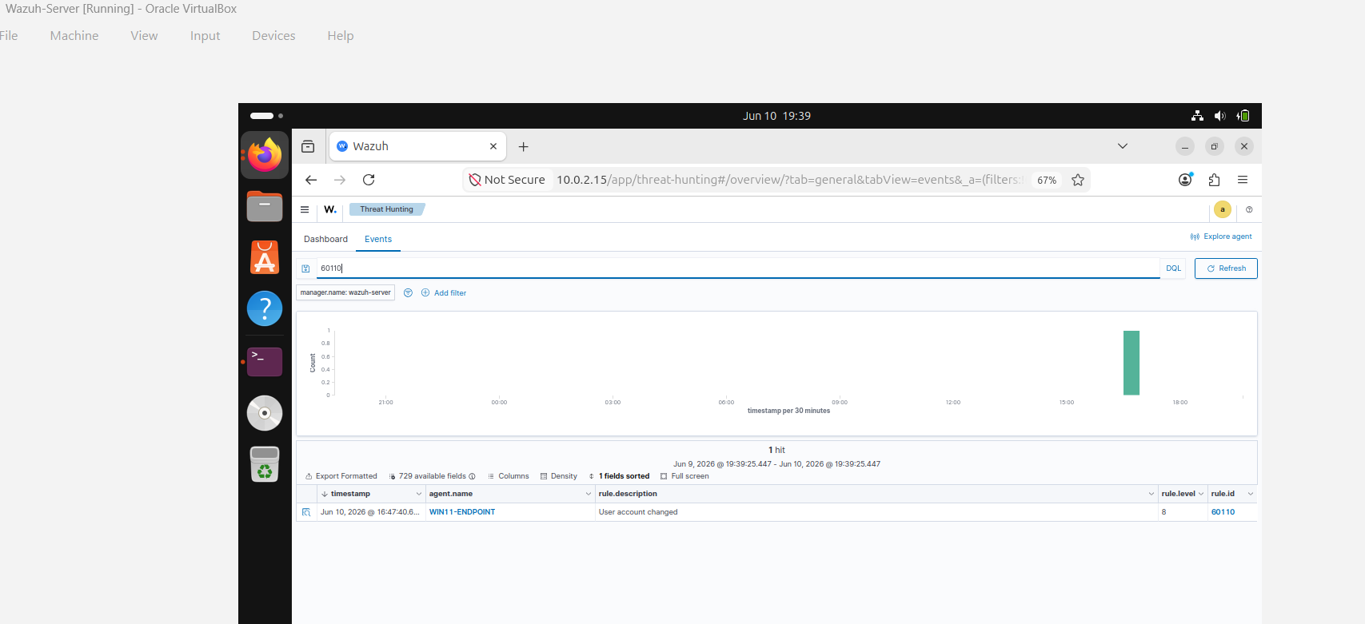
Figure 8: AI-Assisted Remediation Action for Suspicious User Account Activity

6.4 Performance and Reliability
There were no significant ingestion delays and telemetry delivery remained stable. During the testing period, Wazuh agents-maintained connectivity.

6.5 Limitations
The lab does not necessarily represent enterprise scale infrastructure, threat complexity, or production operational limitations.

7. Discussion
Detected behaviours were able to capture typical attacker behaviours. Sysmon provided a big boost in visibility for Windows process execution and PowerShell activity. The auditd was introducing some great Linux auditing features. Wazuh was able to successfully centralise telemetry and facilitate telemetry investigation workflows.
The time on the response needed to be automated for, so that the operational control remained in the caller's hands. But too much automation can pose risks if false positives lead to action taken. Human oversight and approval processes remain important for production environments.
The solution is in line with NIST incident response guidance and CIS Controls recommendations. Future deployments might feature a broader range of telemetry capabilities, threat intelligence feeds and other SOAR features..

8. Recommendations
Recommendation | Priority | Owner | Timeline
Expand Sysmon coverage | High | Security Team | 1 Month
Implement Multi-Factor Authentication | High | IT Team | 2 Months
Increase log retention periods | Medium | SIEM Team | 1 Month
Conduct regular detection tuning | Medium | SOC Team | Ongoing
Develop formal incident response procedures | High | Management | 3 Months

9. Conclusion
The tools used in this project to create an Endpoint Security monitoring and automated remediation environment were successfully deployed and used: Windows, Linux, Wazuh, Docker and TinyLlama. Endpoints were monitored, analysed and correlated for the identification of representative attacker behaviours. There are five detection use cases and two remediation actions that were successfully demonstrated. In the project, the integration of SIEM capabilities with AI-assisted remediation was demonstrated to enhance visibility, speed up incident response, and bolster the organisation's security posture in a controlled environment.

References
Center for Internet Security 2024, CIS Controls Version 8, Center for Internet Security, viewed 11 June 2026, https://www.cisecurity.org/controls/v8.
Docker Inc. 2025, Docker Documentation, Docker Inc., viewed 11 June 2026, https://docs.docker.com/.
Microsoft 2024, Sysmon – Windows Sysinternals, Microsoft Learn, viewed 11 June 2026, https://learn.microsoft.com/en-us/sysinternals/downloads/sysmon.
Microsoft 2026, Sysmon Overview, Microsoft Learn, viewed 11 June 2026, https://learn.microsoft.com/en-us/windows/security/operating-system-security/sysmon/overview.
MITRE Corporation 2026, MITRE ATT&CK Framework, MITRE Corporation, viewed 11 June 2026, https://attack.mitre.org/.
National Institute of Standards and Technology 2012, Computer Security Incident Handling Guide, Special Publication 800-61 Revision 2, NIST, Gaithersburg, viewed 11 June 2026, https://csrc.nist.gov/pubs/sp/800/61/r2/final.
Ollama 2024, Ollama Documentation, Ollama, viewed 11 June 2026, https://ollama.com/library.
Oracle Corporation 2019, Documentation – Oracle VM VirtualBox, Oracle Corporation, viewed 11 June 2026, https://www.virtualbox.org/wiki/Documentation.
Wazuh Inc. 2024, Wazuh Documentation, Wazuh Inc., viewed 11 June 2026, https://documentation.wazuh.com/current/index.html.

Appendix A – Lab Network Diagram
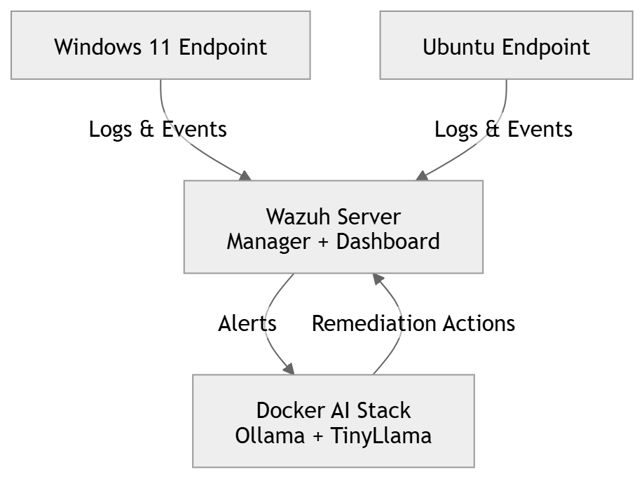
Figure 9: Lab network architecture showing Windows and Linux endpoints forwarding telemetry to Wazuh SIEM and Dockerized AI remediation stack.

Appendix B – VM Build Specifications and IP Plan
VM Name | Operating System | RAM | CPU | IP Address | Role
Wazuh Server | Ubuntu Server | 8 GB | 2 vCPU | 10.0.2.15 | SIEM Server
Windows Endpoint | Windows 11 | 6 GB | 2 vCPU | 10.0.2.3 | Monitored Endpoint
Ubuntu Endpoint | Ubuntu Desktop | 4 GB | 2 vCPU | 10.0.2.4 | Monitored Endpoint

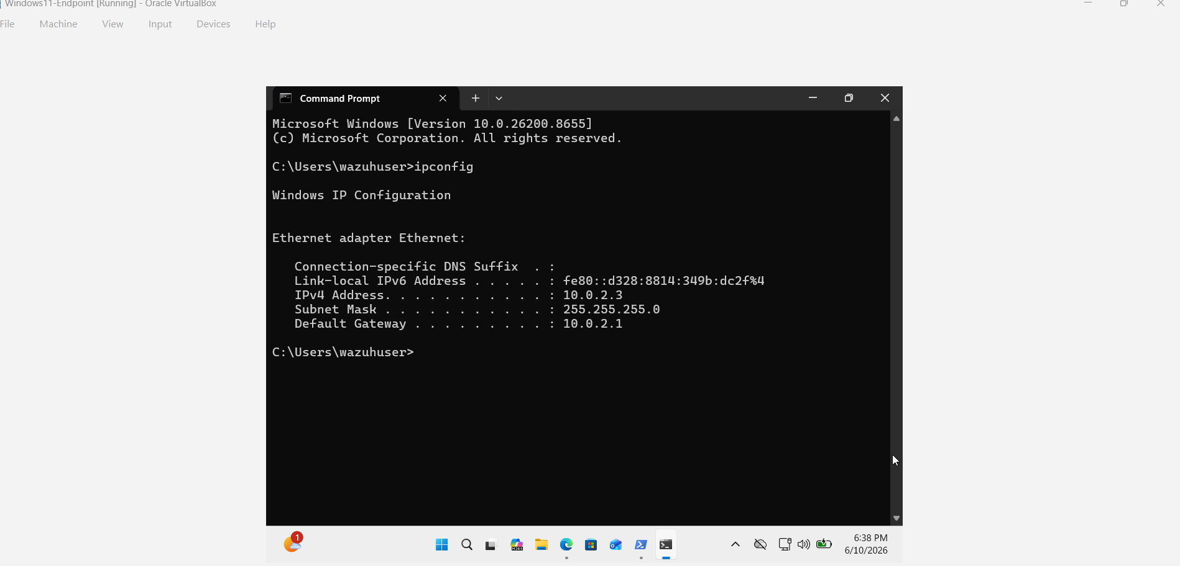
Figure 10: Windows Endpoint Network Configuration Showing Assigned IP Address
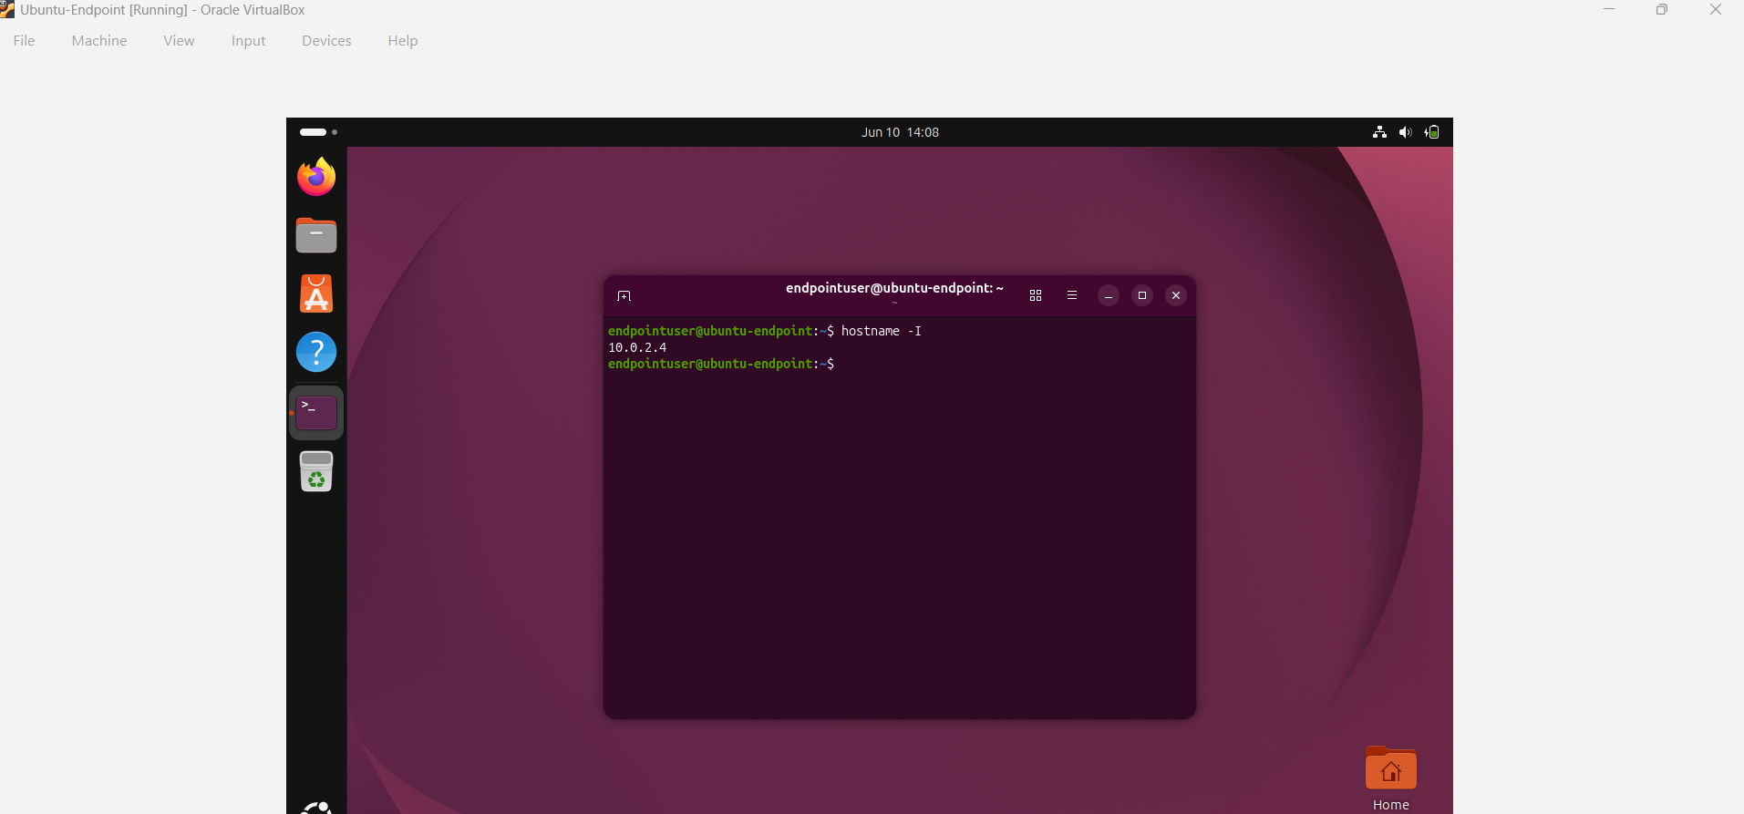
Figure 11: Ubuntu Endpoint Network Configuration Showing Assigned IP Address
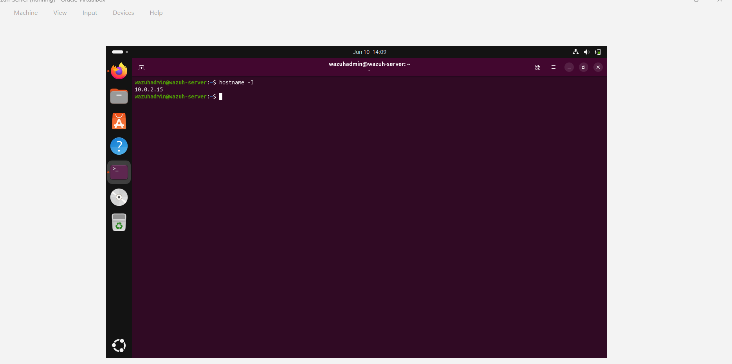
Figure 12: Wazuh Server Network Configuration Showing Assigned IP Address

Appendix C – Sysmon Configuration Excerpt
To enhance endpoint visibility and advanced telemetry collection, the Windows 11 endpoint had Sysmon (System Monitor) installed. It was possible to successfully configure and integrate the Sysmon service using the Wazuh agent with the Wazuh SIEM platform. This allowed the monitoring of system activities in detail and facilitated the detection engineering activities carried out during the assessment.
Monitored Event Types
- Event ID 1 – Process Creation
- Event ID 3 – Network Connections
- Event ID 6 – Driver Load Events
- Event ID 7 – Image Load Events
- Event ID 10 – Process Access Events
- Event ID 11 – File Creation Events
- Event IDs 12–14 – Registry Modification Events
The information gathered by the Sysmon telemetry was applied to the monitoring of suspicious PowerShell activity, process execution events, user account creation and other endpoint events of security interest. All generated events were successfully sent to the Wazuh server to be analyzed and detect threats.

Appendix D – auditd Rule Set
The service auditd (Linux Audit Daemon) has been enabled on the Linux endpoint to give more opportunities for auditing and monitoring security-related events such as authentication, privileges escalation, command execution, and system administration actions.
Monitored Activities
- User authentication events
- Failed login attempts
- Using sudo to escalate privilege
- User account management activities
- The installation and updating of packages
- System configuration changes
The auditd service was checked to be enabled and running during the assessment. Wazuh SIEM platform succeeded to receive the events generated by auditd and used them for detection engineering, such as the detection of privilege escalation in Linux systems and monitoring login failures.

Figure 13: auditd Service Enabled and Running on the Ubuntu Endpoint

Appendix E – SIEM Alert Rules and Queries
The Wazuh SIEM platform was configured to monitor endpoint telemetry for both the Windows and Linux systems. During the Assessment, the following Alert Rules and Queries were leveraged for identifying suspicious activities through controlled attack simulations.
Detection 1 – User Account Creation
Use Case: Detection of unauthorized user account creation on Windows.
Log Source: Windows Security Event Logs
ATT&CK Technique: T1136 – Create Account
Trigger Condition: New local user account created.
Result: Alert successfully generated within Wazuh.
Detection 2 – Account Modification
Use Case: Detection of user account added to the local Administrators group.
Log Source: Windows Security Event Logs
ATT&CK Technique: T1098 – Account Manipulation
Trigger Condition: User account added to Administrators group.
Result: Alert successfully generated within Wazuh.
Detection 3 – Linux Privilege Escalation
Use Case: Detection of sudo privilege escalation activity.
Log Source: auditd
ATT&CK Technique: T1068 – Privilege Escalation
Trigger Condition: Execution of sudo commands.
Result: Alert successfully generated within Wazuh.
Detection 4 – Authentication Failure
Use Case: Detection of failed authentication attempts.
Log Source: Linux Authentication Logs, also known as message authentication logs
ATT&CK Technique: T1110 – Brute Force
Trigger Condition: Authentication logs show failed logon attempts.
Result: Alert created successfully in Wazuh.
Detection 5 – Package Installation Activity
Use Case: When software is installed or updated.
Log Source: auditd
ATT&CK Technique: T1543 – Create or Modify System Process
Trigger Condition: Running package installation or update commands.
Result: Alert is successfully created in Wazuh.
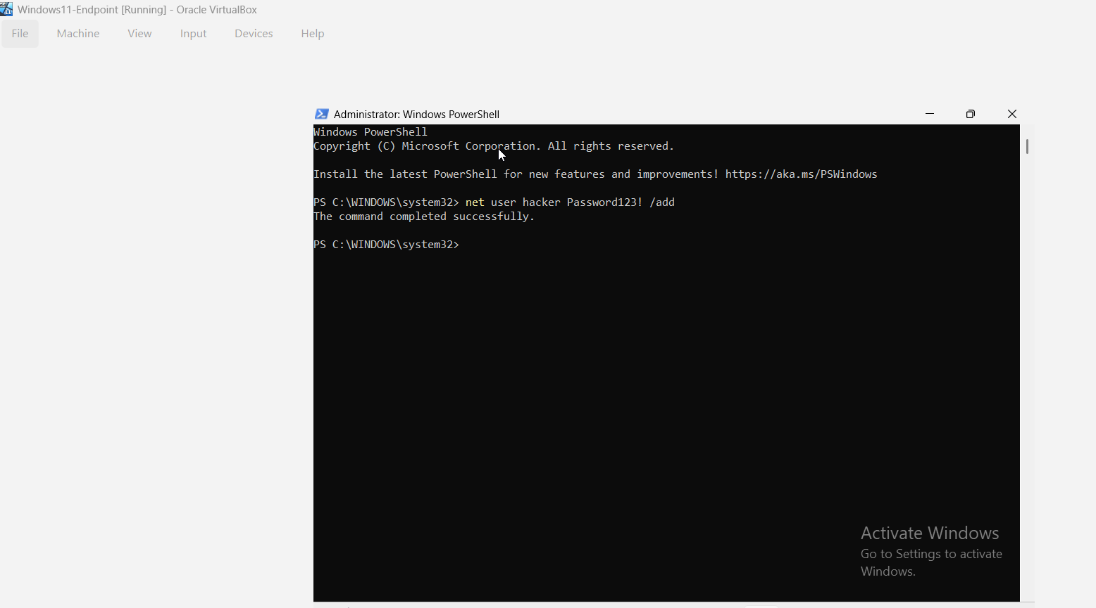 | 
Figure 14: User Account Creation Attack and Corresponding Wazuh Detection (MITRE ATT&CK T1136)
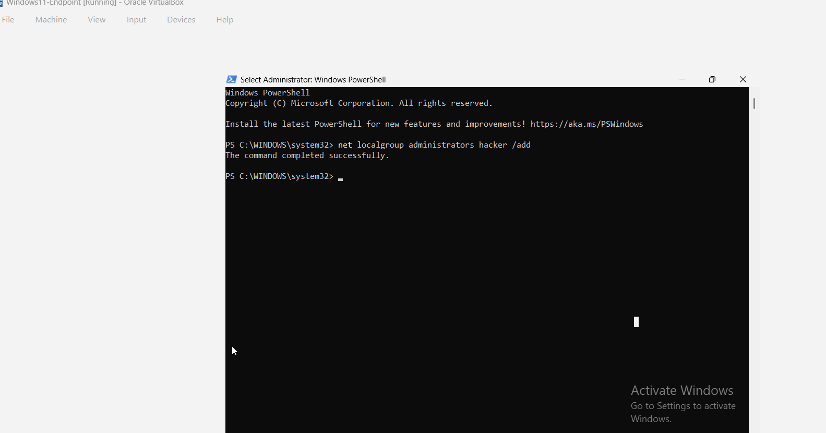 | 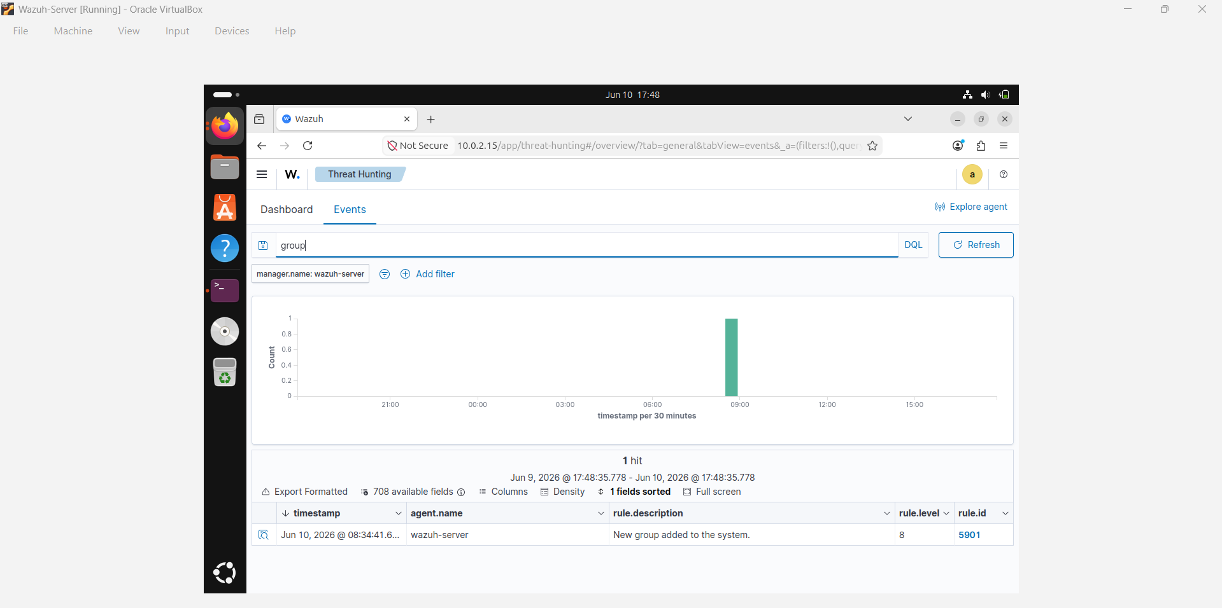
Figure 15: Privilege Escalation Simulation Through Addition of a User to the Local Administrators Group and Corresponding Wazuh Account Modification Detection (MITRE ATT&CK T1098).
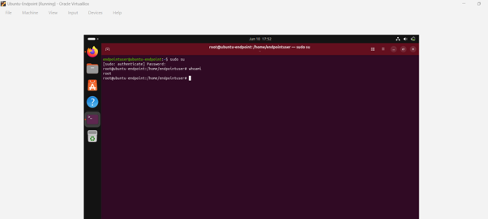 | 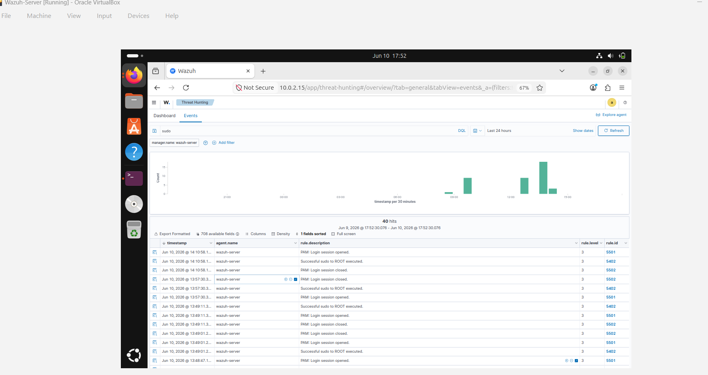
Figure 16: Linux Privilege Escalation Through Successful Sudo-to-Root Execution and Corresponding Wazuh Detection (MITRE ATT&CK T1548)
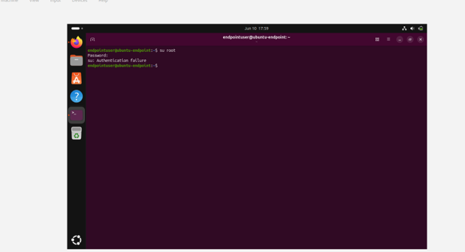 | 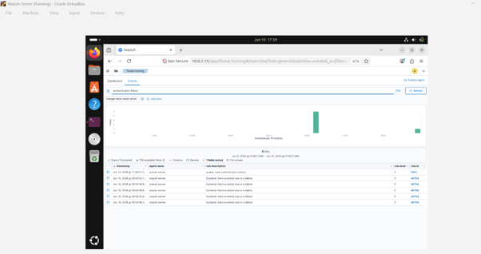
Figure 17: Failed Linux Privilege Escalation Attempt and Corresponding Wazuh Security Event Detection (MITRE ATT&CK T1110)

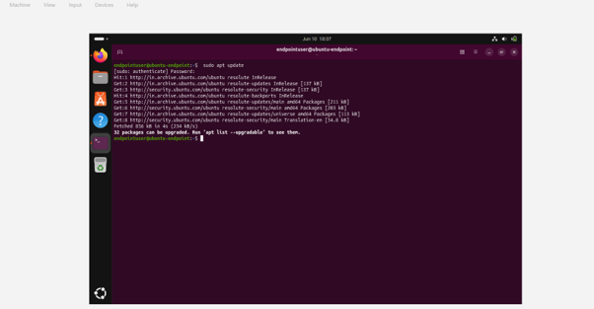 | 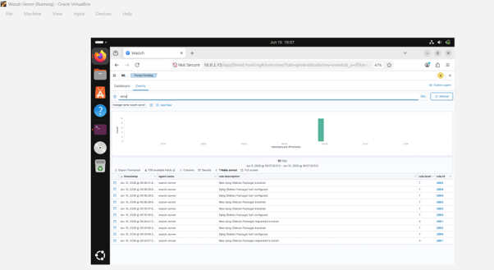
Figure 18: Linux Package Management Activity Detection Following Execution of sudo apt update and Corresponding Wazuh Alert Events

Appendix F – Screenshots of Dashboards and Alerts
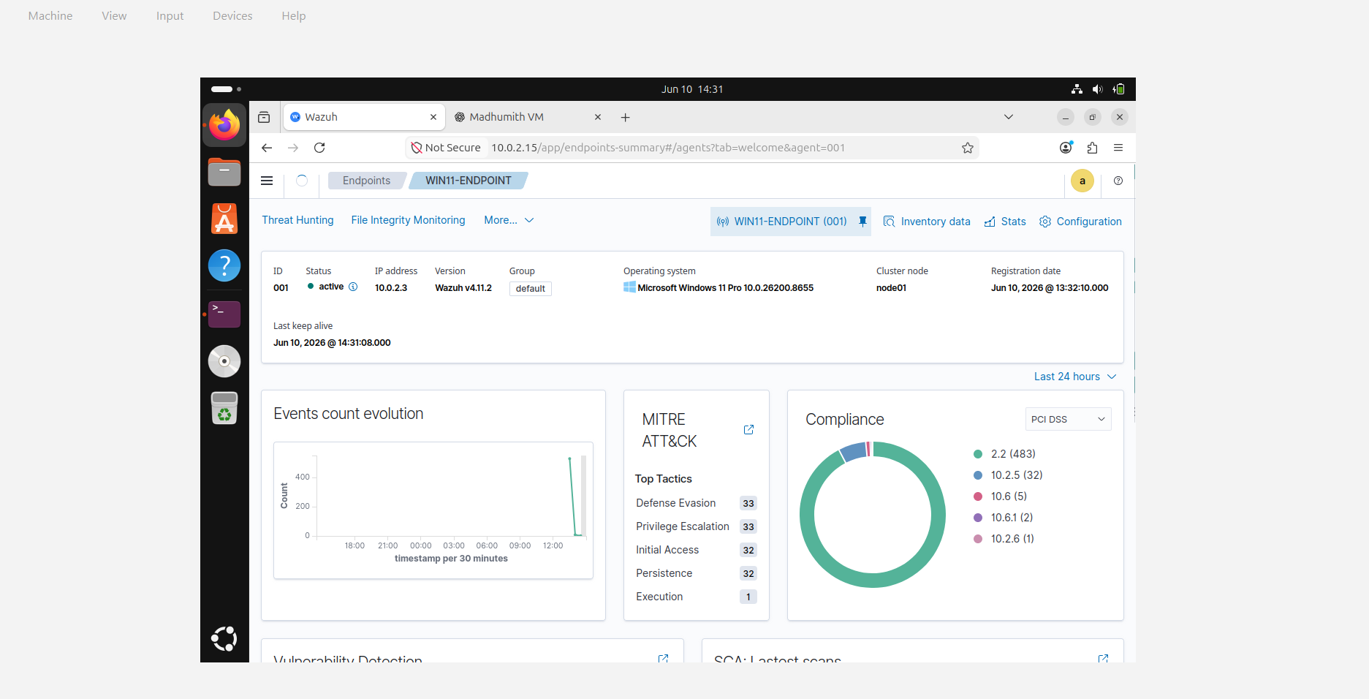
Figure 19: Detailed Information View of the Registered Windows Endpoint in Wazuh Dashboard
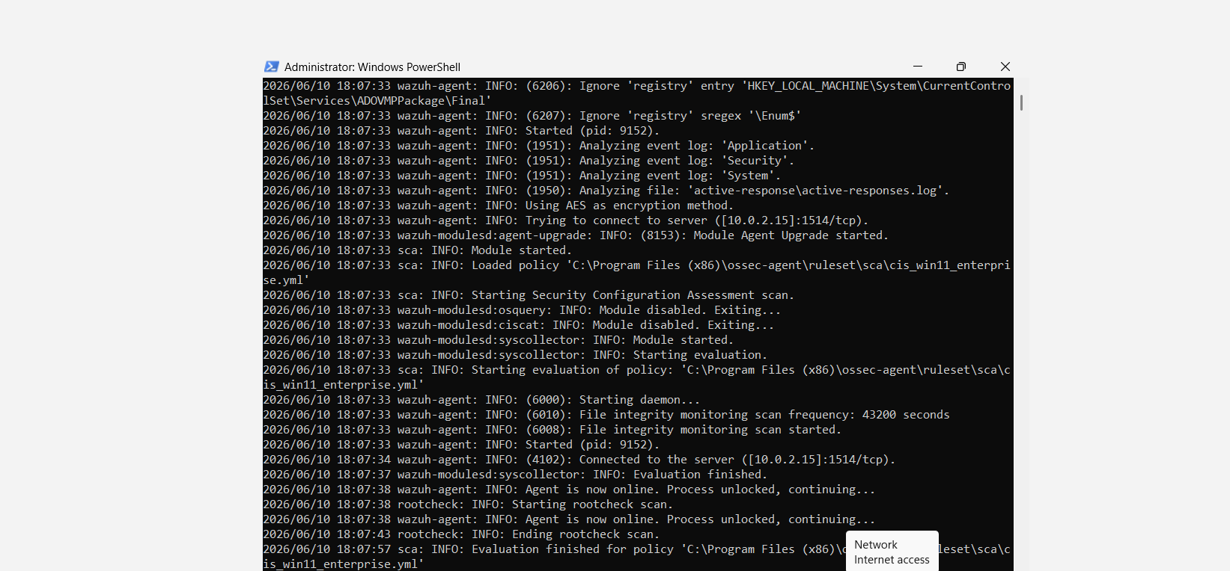
Figure 20: Wazuh Agent Operational Logs Confirming Successful Communication with the Server

Appendix G – Docker Compose File and Component Descriptions
Docker and Docker Compose were used to deploy the Dockerized AI security stack on the Ubuntu endpoint. This stack was designed to provide alert summarisation, security analysis, and remediation suggestions via an AI model.
G.1 Docker Compose File
services:
ai-security:
image: ollama/ollama
container_name: ai-security
ports:
- "11434:11434"
restart: unless-stopped

remediation-engine:
image: nginx:latest
container_name: remediation-engine
ports:
- "8080:80"
restart: unless-stopped
G.2 Component Descriptions
Component | Container Name | Purpose
Ollama AI Service | ai-security | Hosts the TinyLlama model and provides AI-assisted alert analysis and remediation recommendations.
Remediation Engine | remediation-engine | Represents the remediation service layer used to support predefined and controlled response actions.
Docker Network | ai-security-stack_default | Provides internal communication between the Dockerized services.
G.3 AI Component
TinyLlama was installed within the Ollama container to create remediation guidance for suspicious endpoint activity. The AI component was not allowed to have unrestricted command execution access. Remediation actions, rather, were prestated and manually checked.
G.4 Security Controls
- Containers were deployed using Docker Compose for repeatability.
- Remediation actions were allowlisted and controlled.
- No unrestricted command execution was provided to the AI component.
- Remediation results were manually verified.
- Rollback actions were determined for every remediation step.
G.5 Verification Evidence
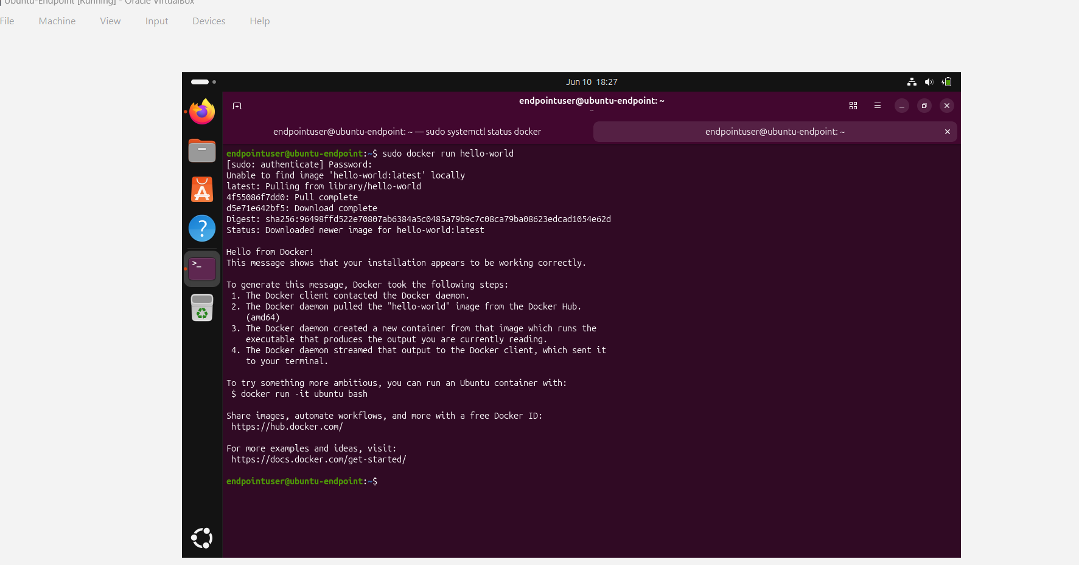
Figure 21 : Docker Installation Validation Using Hello-World Container
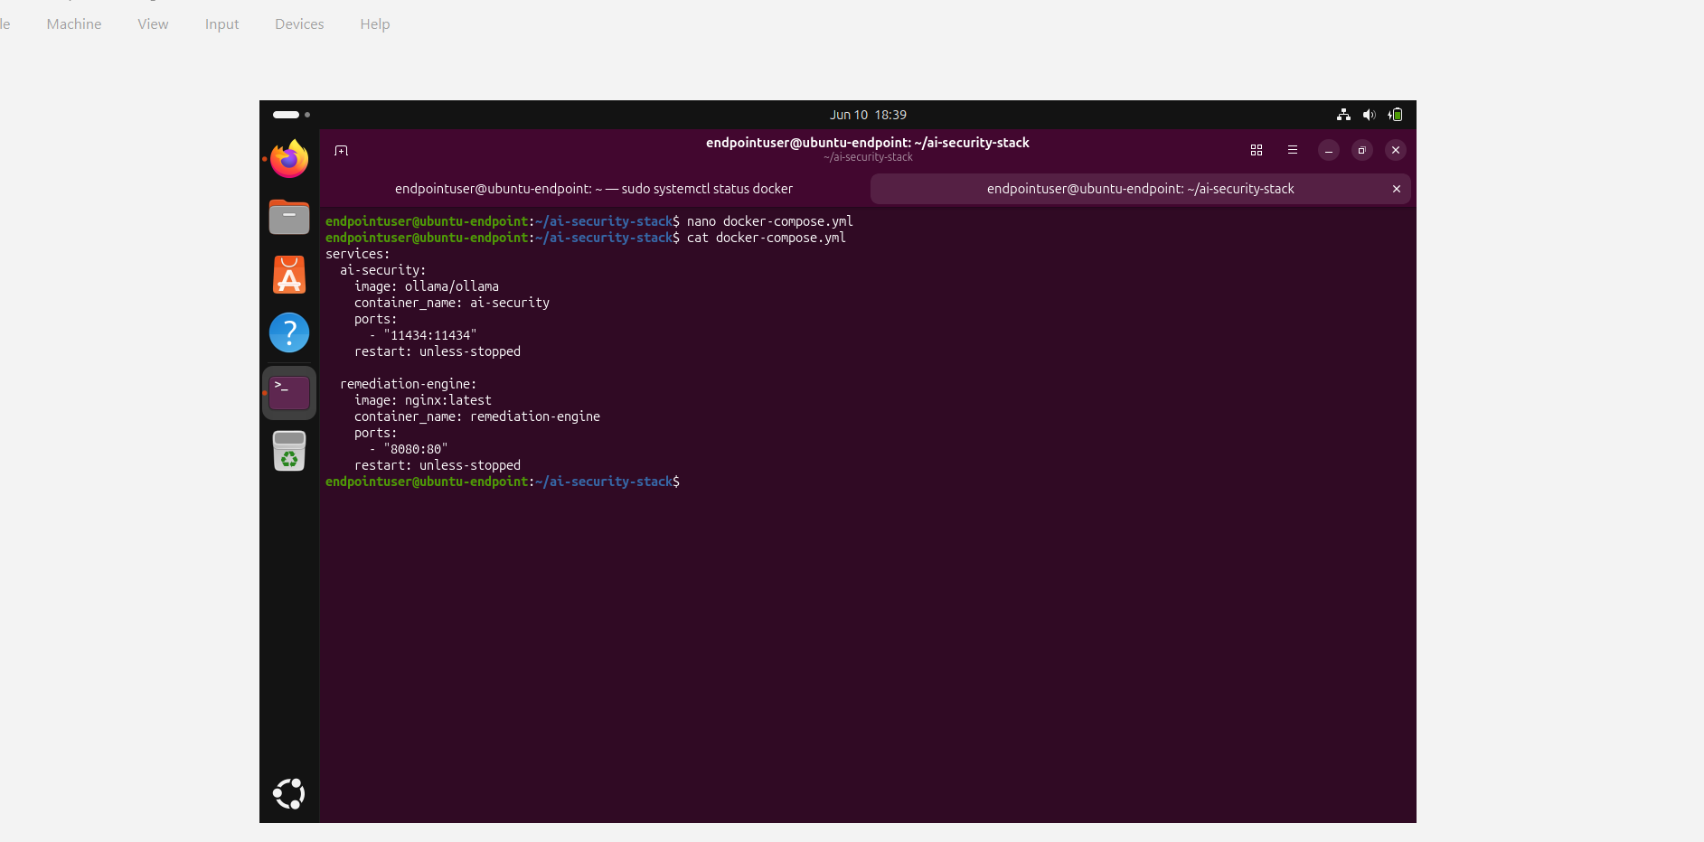
Figure 22: Docker Compose Configuration for AI Security Remediation Services
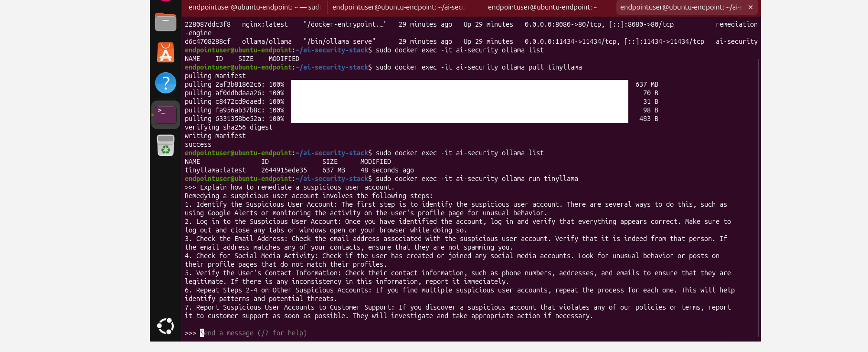
Figure 23: Execution of TinyLlama AI Model for Automated Security Remediation Recommendations
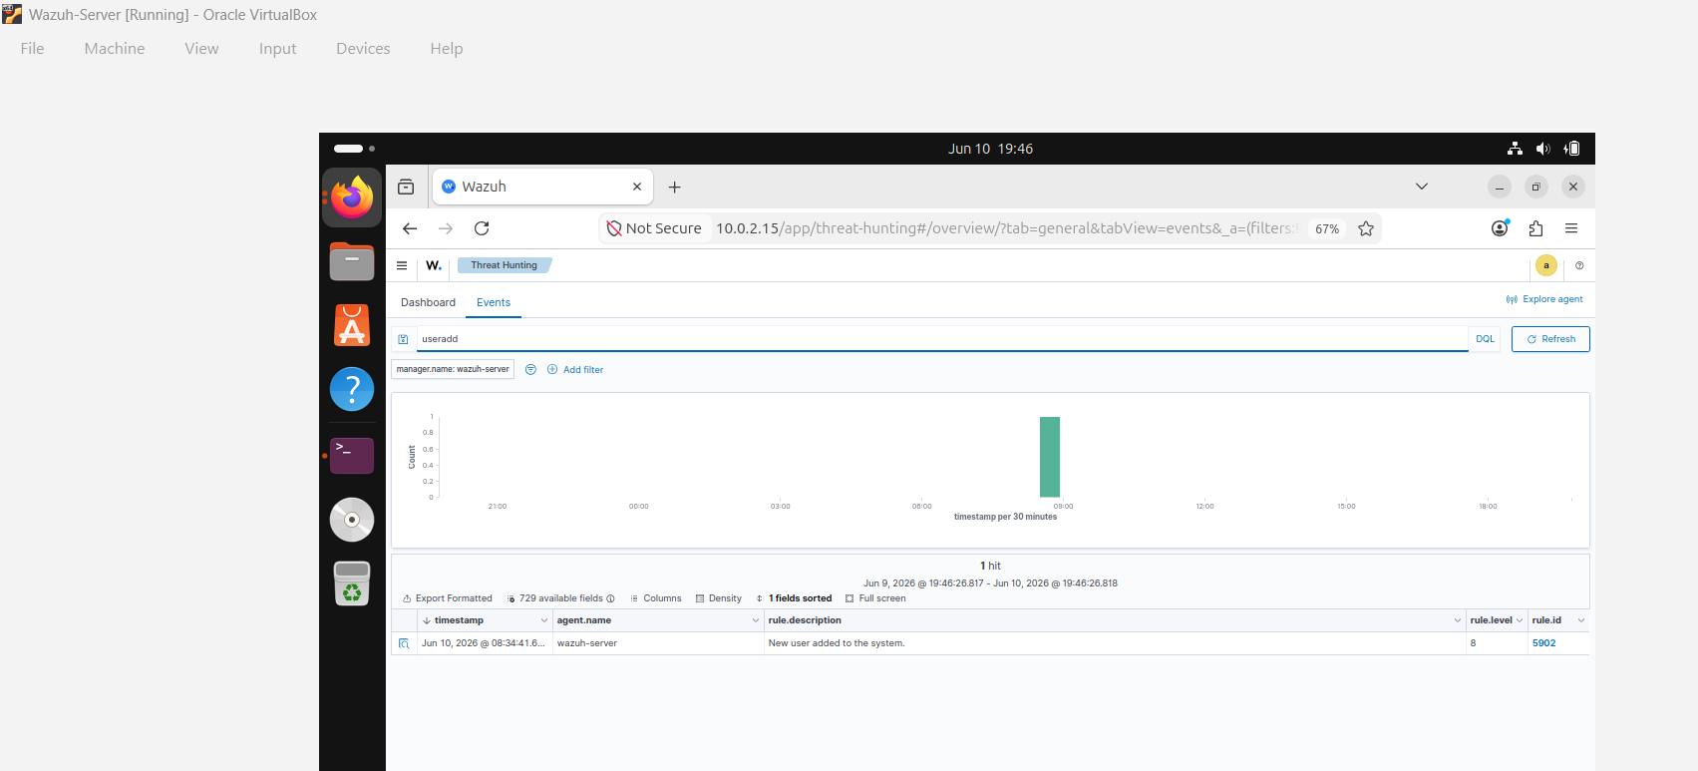
Figure 24: AI-Generated Security Recommendations for Linux-Based Security Events

Appendix H – Test Cases and Results Table
Table 1 : Endpoint Security Monitoring, Detection, and Remediation Test Results
Test Case ID | Test Description | Action Performed | Expected Result | Actual Result | Status
TC-01 | Windows User Account Creation Detection | Created user account using net user hacker Password123! /add | Wazuh generates user account creation alert | User account creation detected successfully | Pass
TC-02 | Windows Administrative Group Modification Detection | Added user to Administrators group using net localgroup administrator’s hacker /add | Wazuh generates account modification alert | Administrative group modification detected successfully | Pass
TC-03 | Linux Privilege Escalation Detection | Executed sudo su and verified root access | Wazuh generates privilege escalation alert | Privilege escalation activity detected successfully | Pass
TC-04 | Linux Authentication Failure Detection | Performed failed root authentication attempt | Wazuh generates authentication failure alert | Authentication failure detected successfully | Pass
TC-05 | Linux Package Management Activity Detection | Executed sudo apt update | Wazuh generates package management events | Package activity detected successfully | Pass
TC-06 | Docker Installation Validation | Executed Docker hello-world container | Docker service operates correctly | Docker installation validated successfully | Pass
TC-07 | Docker Compose Deployment Validation | Started AI security stack using Docker Compose | Containers start successfully | Docker Compose deployment completed successfully | Pass
TC-08 | TinyLlama AI Model Validation | Executed TinyLlama remediation prompt | AI generates remediation recommendation | Remediation recommendation generated successfully | Pass
TC-09 | Windows Remediation Validation | Disabled suspicious Windows user account | Account disabled successfully | Remediation action completed successfully | Pass
TC-10 | Linux Remediation Validation | Removed unauthorized Linux user account | Account removed successfully | Remediation action completed successfully | Pass

Ten validation tests were conducted on the Windows endpoint, Ubuntu endpoint, Wazuh SIEM platform, Docker infrastructure, and AI-assisted remediation environment. All test cases were successfully executed and showed the effectiveness of the monitoring, detection and remediation implemented in the isolated laboratory environments.

