EXP NO: 01
STUDY OF COMPUTER FORENSICS AND DIFFERENT TOOLS USED FOR FORENSIC INVESTIGATION
Aim:
To study the concept of computer forensics, its importance, and the different tools used for forensic investigation.
Procedure:
1. Study the basic concept of computer forensics and its role in investigating cybercrimes.
2. Understand the major steps involved in a forensic investigation, such as identification, collection, preservation, examination, analysis, and reporting of digital evidence.
3. Identify different sources of digital evidence, including hard disks, USB drives, computers, emails, and system logs.
4. Study the different tools used in computer forensic investigations.
5. Understand the functions and applications of each forensic tool.
6. Compare the tools based on their features and purposes.
7. Record the observations and summarize the importance of computer forensics in digital investigations.
Computer forensics is a branch of digital forensics that involves collecting, preserving, examining, and analyzing digital evidence from computers and storage devices. It helps investigators identify cybercrimes and reconstruct digital activities.

The following tools are commonly used in forensic investigations:
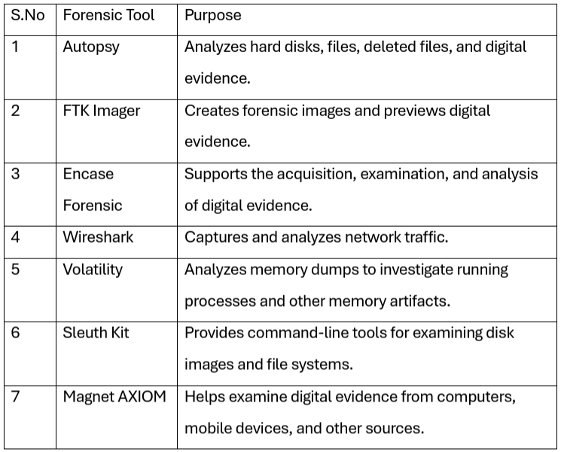
The tools serve different purposes. Some focus on disk analysis, while others are used for memory analysis, network investigation, or digital evidence acquisition. Investigators select tools based on the type of evidence and the requirements of the case.

Result:
Thus, the concept of computer forensics and the different tools used for forensic investigation were studied. The importance of digital evidence collection, preservation, examination, and analysis in investigating cybercrimes was understood.

