EXP NO: 2
LIVE FORENSIC INVESTIGATION USING AUTOPSY
Aim:
To perform a basic forensic investigation of a Windows system using Autopsy and identify files, user activity, browser history, deleted files and other digital evidence.
Procedure:
1. Download and Install Autopsy
Download Autopsy from the official website and install it on your PC by following the installation instructions.
2. Create a New Case
Launch Autopsy and select New Case. Enter the case name, base directory, and report output location.
3. Enter Case Details
Enter the case number, examiner name, and other required case details. Click Finish to create the case.
4. Add a Data Source
Select Add Data Source and choose the appropriate data source type, such as a disk image, local disk, or logical files. Browse to the evidence location and select the required source.
5. Configure Ingest Modules
Select the required ingest modules to analyze the evidence. These modules can extract file information, operating system details, user accounts, web history, downloads, cookies, email addresses, and other digital artifacts.
6. Start the Investigation
Click Finish to begin processing the selected data source. Autopsy analyzes the evidence and stores the results in the case database.
7. Examine the Investigation Results
After processing is complete, review the available results in the Autopsy interface, including:
- Devices Attached: Examine artifacts related to connected devices, if available.
- EXIF Metadata: Inspect image metadata, such as camera details and timestamps.
- Installed Programs: Identify installed software, where the relevant artifacts are available.
- Operating System Information: Examine operating system details.
- Operating System User Accounts: Identify user accounts found in the evidence.
- Recent Documents: Find artifacts related to recently accessed documents.
- Web Bookmarks and History: Examine browsing activity and saved bookmarks.
- Web Downloads and Search History: Review download records and search-related artifacts, if available.
- Web Cookies: Analyze cookies recovered from browser data.
- Email Addresses: Identify email addresses found during artifact extraction.

8. Generate the Investigation Report
Review the relevant findings and generate an investigation report using Autopsy's reporting options. Save the report for documentation and further analysis.
Output:
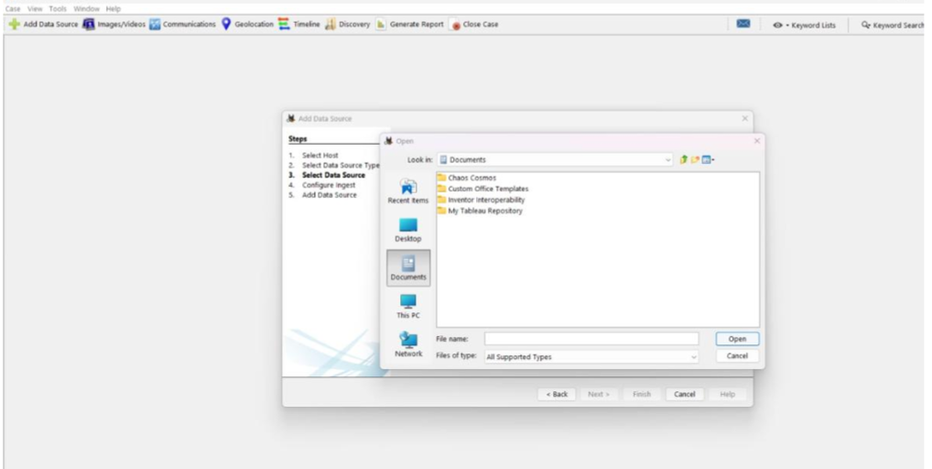
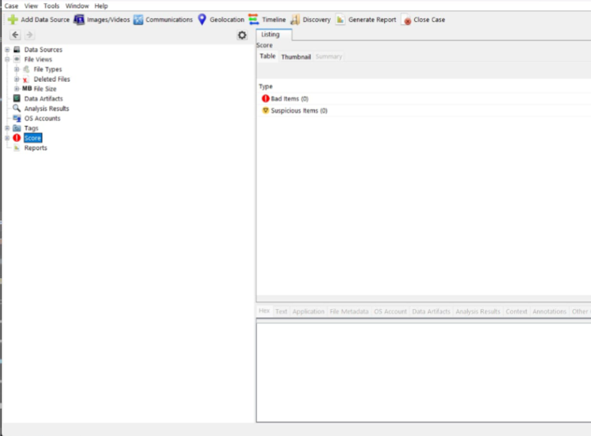
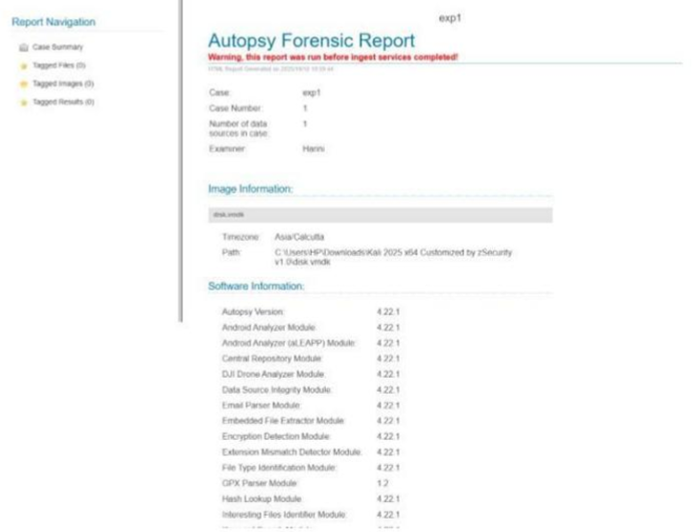
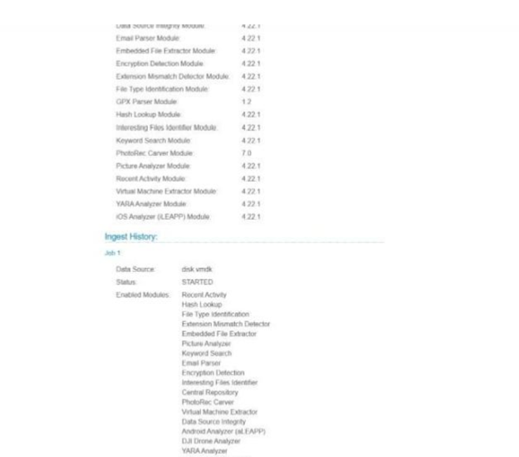
Result:
The Windows test system was successfully investigated using Autopsy. Relevant digital evidence including user files, browser activity, deleted files and file metadata was identified, examined and documented. A forensic HTML report was successfully generated.

