EXP NO: 03
FTK IMAGER - DISK IMAGING AND EVIDENCE ACQUISITION
Aim:
To study and perform disk imaging and digital evidence acquisition using FTK Imager while maintaining the integrity of the original evidence.
Procedure:
1. Download and install FTK Imager from the official AccessData/Exterro source, if it is not already installed.
2. Open FTK Imager with the necessary permissions.
3. Connect the storage device or select an authorized forensic image file for examination.
4. Select File → Create Disk Image to begin the disk imaging process.
5. Choose the appropriate source type, such as a physical drive or logical drive, depending on the experiment.
6. Select the source device and verify its details carefully.
7. Choose the required destination image format, such as E01 or Raw (dd).
8. Enter the case number, evidence number, examiner name, and other relevant details when prompted.
9. Specify the destination folder where the forensic image will be saved. Do not save the image to the original evidence device.
10. Start the imaging process and wait until it is completed.
11. If supported by the selected workflow, enable verification and compare the calculated hash values to check the integrity of the acquired image.
12. Record the image details, completion status, and hash values in the investigation notes.
Observation:
FTK Imager is a digital forensic tool used to acquire and preview digital evidence without directly modifying the source during a properly conducted acquisition. The following observations can be recorded during the experiment:
- The selected source device and its storage capacity were identified.
- The appropriate forensic image format was selected.
- The disk imaging process created an image file at the specified destination.
- The image file contained a forensic copy of the selected source data, subject to acquisition limitations.
- Hash values, such as MD5 or SHA-1, could be calculated to help verify the integrity of the acquired image.
- Matching hash values for the source and acquired image indicate that their hashed contents are identical for the data covered by the comparison.
Output:
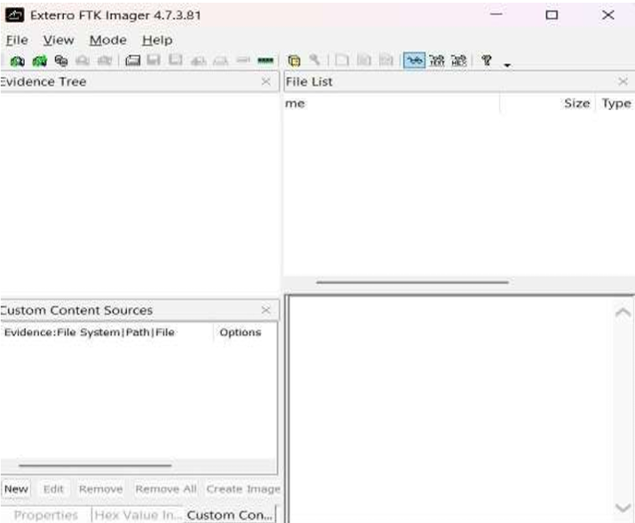
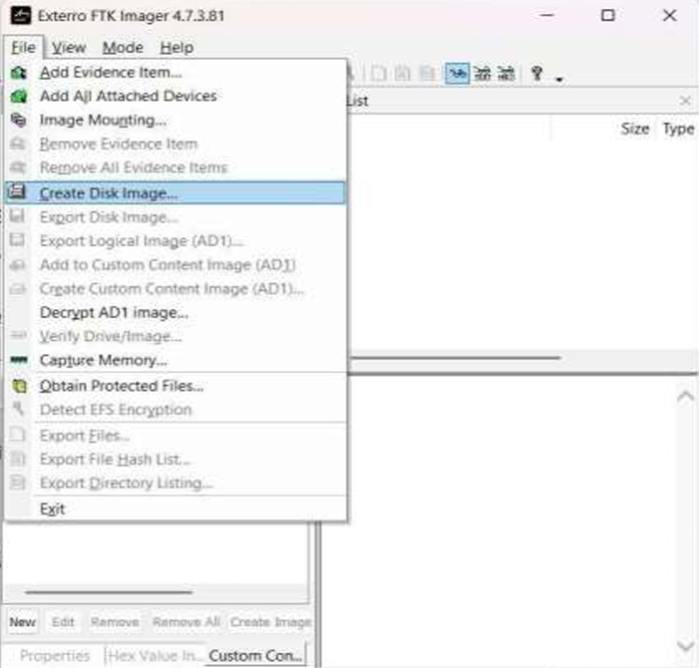
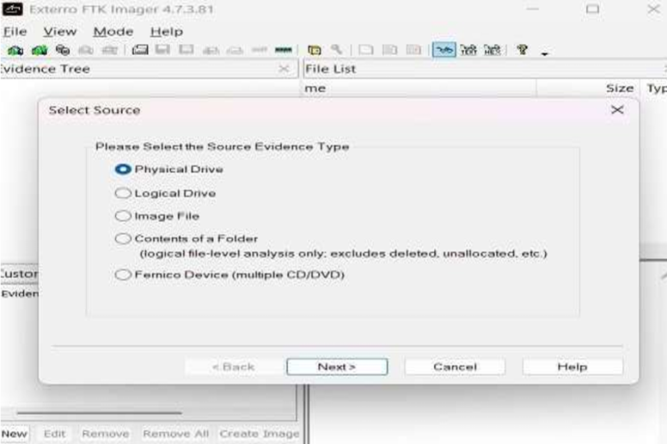
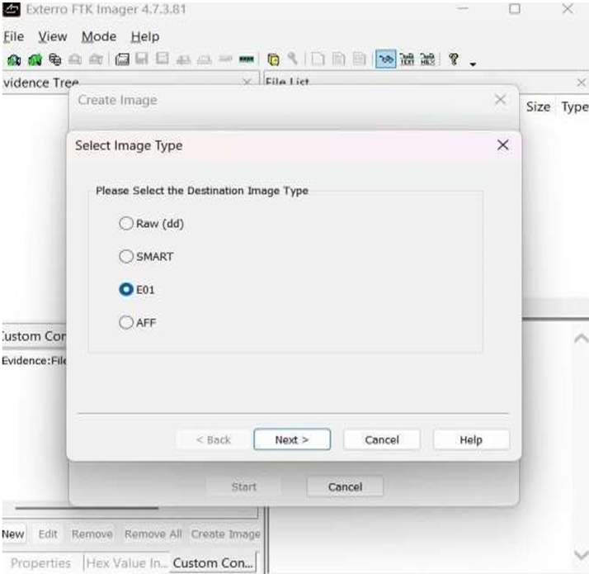
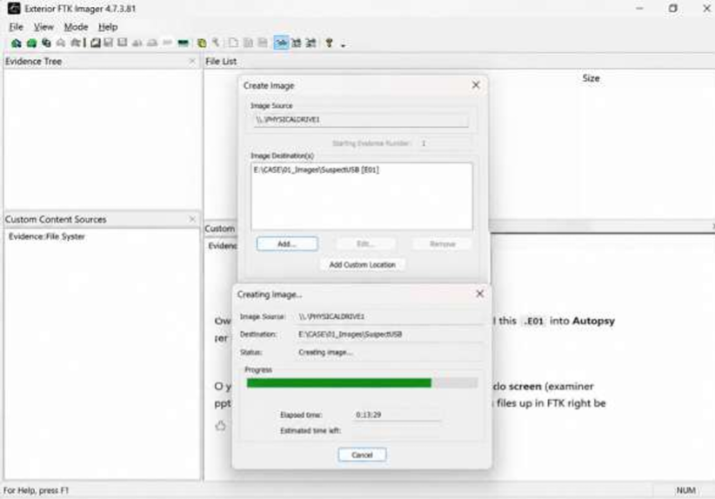
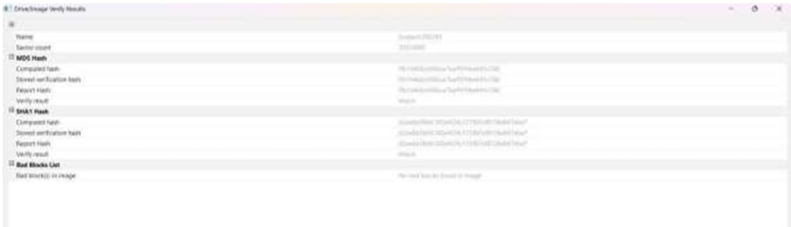

Result
Thus, disk imaging and digital evidence acquisition using FTK Imager were studied and performed. The process of creating a forensic image and verifying its integrity using hash values was understood.

